定时器闹钟与日历功能整合 RTC_CalendarAndAlarm

# 创建工程

将PA5配置为GPIO输出模式驱动LED4灯

将RCC最下方Generate the peripherals clock configuration的配置，由“TRUE”改为“FALSE”

按照下图所示配置时钟

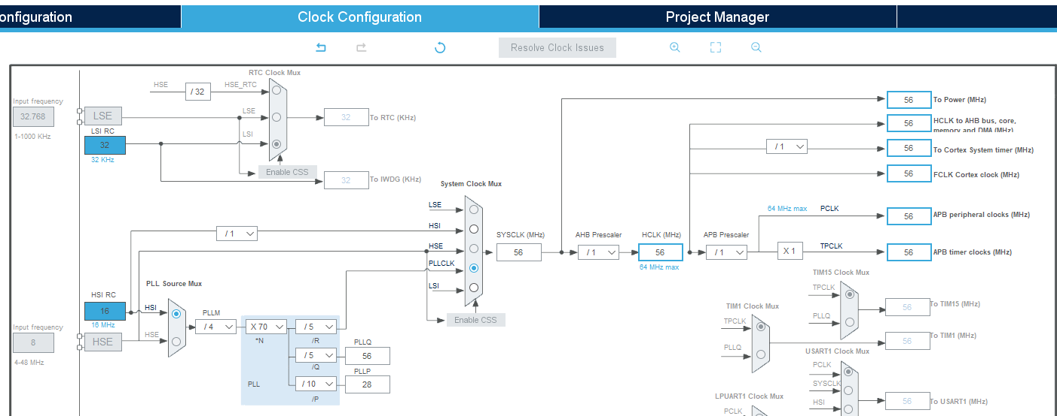

RTC闹钟、日历使能

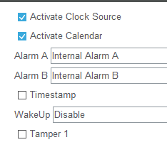

设置起始时间与日期

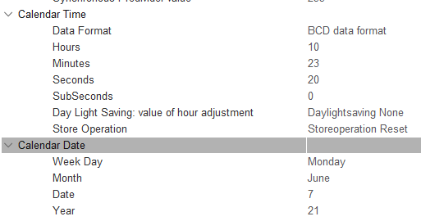

设置闹钟A与闹钟B

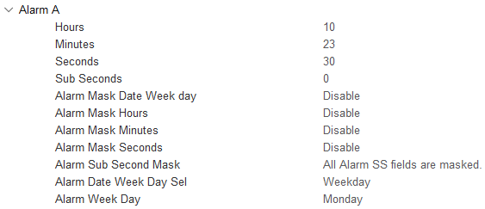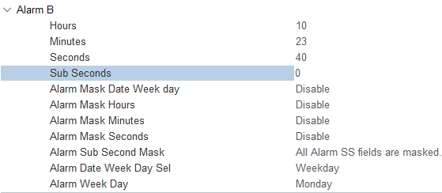

中断设置：使能19-21号RTC中断，关闭如下中断

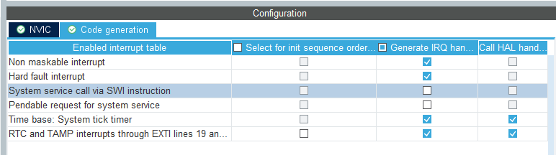

# 在mian.c文件下添加代码

头文件、函数声明、变量定义

#include <stdio.h>

uint8_t aShowTime[8] = "hh:ms:ss";

uint8_t aShowDate[10] = "dd-mm-yyyy";

__IO uint32_t RTCStatus = 0;

static void RTC_CalendarShow(uint8_t *showtime, uint8_t *showdate);

循环之前设置RTC状态RTCStatus = 1;

在循环中实时输出时间 RTC_CalendarShow(aShowTime, aShowDate);

添加两个闹钟的中断回调函数

void HAL_RTC_AlarmAEventCallback(RTC_HandleTypeDef *hrtc)

{

/* 点亮LED灯 */

HAL_GPIO_WritePin(GPIOA,GPIO_PIN_5,1);

}

void HAL_RTCEx_AlarmBEventCallback(RTC_HandleTypeDef *hrtc)

{

/* 关闭LED灯 */

HAL_GPIO_WritePin(GPIOA,GPIO_PIN_5,0);

}

添加获取时间的子函数

static void RTC_CalendarShow(uint8_t *showtime, uint8_t *showdate)

{

RTC_DateTypeDef sdatestructureget;

RTC_TimeTypeDef stimestructureget;

/* Get the RTC current Time */

HAL_RTC_GetTime(&hrtc, &stimestructureget, RTC_FORMAT_BIN);

/* Get the RTC current Date */

HAL_RTC_GetDate(&hrtc, &sdatestructureget, RTC_FORMAT_BIN);

/* Display time Format : hh:mm:ss */

sprintf((char *)showtime, "%2d:%2d:%2d", stimestructureget.Hours, stimestructureget.Minutes, stimestructureget.Seconds);

/* Display date Format : mm-dd-yy */

sprintf((char *)showdate, "%2d-%2d-%2d", sdatestructureget.Month, sdatestructureget.Date, 2000 + sdatestructureget.Year);

}

# **更改stm32g0xx_hal_msp.c文件**

全文替换为下方：

#include "main.h"

static uint32_t RtcClockSource = RCC_RTCCLKSOURCE_LSI;

void HAL_MspInit(void)

{

__HAL_RCC_SYSCFG_CLK_ENABLE();

__HAL_RCC_PWR_CLK_ENABLE();

HAL_SYSCFG_StrobeDBattpinsConfig(SYSCFG_CFGR1_UCPD1_STROBE | SYSCFG_CFGR1_UCPD2_STROBE);

}

void HAL_RTC_MspInit(RTC_HandleTypeDef* hrtc)

{

if(hrtc->Instance==RTC)

{

RCC_OscInitTypeDef RCC_OscInitStruct = {0};

RCC_PeriphCLKInitTypeDef PeriphClkInitStruct = {0};

__HAL_RCC_PWR_CLK_ENABLE();

HAL_PWR_EnableBkUpAccess();

HAL_RCCEx_GetPeriphCLKConfig(&PeriphClkInitStruct);

if (PeriphClkInitStruct.RTCClockSelection == RtcClockSource)

{ }

else

{

PeriphClkInitStruct.PeriphClockSelection = RCC_PERIPHCLK_RTC;

if (PeriphClkInitStruct.RTCClockSelection != RCC_RTCCLKSOURCE_NONE)

{

PeriphClkInitStruct.RTCClockSelection = RCC_RTCCLKSOURCE_NONE;

if (HAL_RCCEx_PeriphCLKConfig(&PeriphClkInitStruct) != HAL_OK)

Error_Handler();

}

RCC_OscInitStruct.OscillatorType = RCC_OSCILLATORTYPE_LSI | RCC_OSCILLATORTYPE_LSE;

RCC_OscInitStruct.PLL.PLLState = RCC_PLL_NONE;

RCC_OscInitStruct.LSIState = RCC_LSI_ON;

RCC_OscInitStruct.LSEState = RCC_LSE_OFF;

if (HAL_RCC_OscConfig(&RCC_OscInitStruct) != HAL_OK)

Error_Handler();

PeriphClkInitStruct.RTCClockSelection = RtcClockSource;

if (HAL_RCCEx_PeriphCLKConfig(&PeriphClkInitStruct) != HAL_OK)

Error_Handler();

}

__HAL_RCC_RTC_ENABLE();

__HAL_RCC_RTCAPB_CLK_ENABLE();

HAL_NVIC_SetPriority(RTC_TAMP_IRQn, 0, 0);

HAL_NVIC_EnableIRQ(RTC_TAMP_IRQn);

}

}

void HAL_RTC_MspDeInit(RTC_HandleTypeDef* hrtc)

{

if(hrtc->Instance==RTC)

{

__HAL_RCC_RTC_DISABLE();

__HAL_RCC_RTCAPB_CLK_DISABLE();

HAL_NVIC_DisableIRQ(RTC_TAMP_IRQn);

}

}

# 调试

进入Debug可看到时间与日期信息，闹钟A触发LED灯亮，闹钟B触发LED灯灭