System-level Workflow
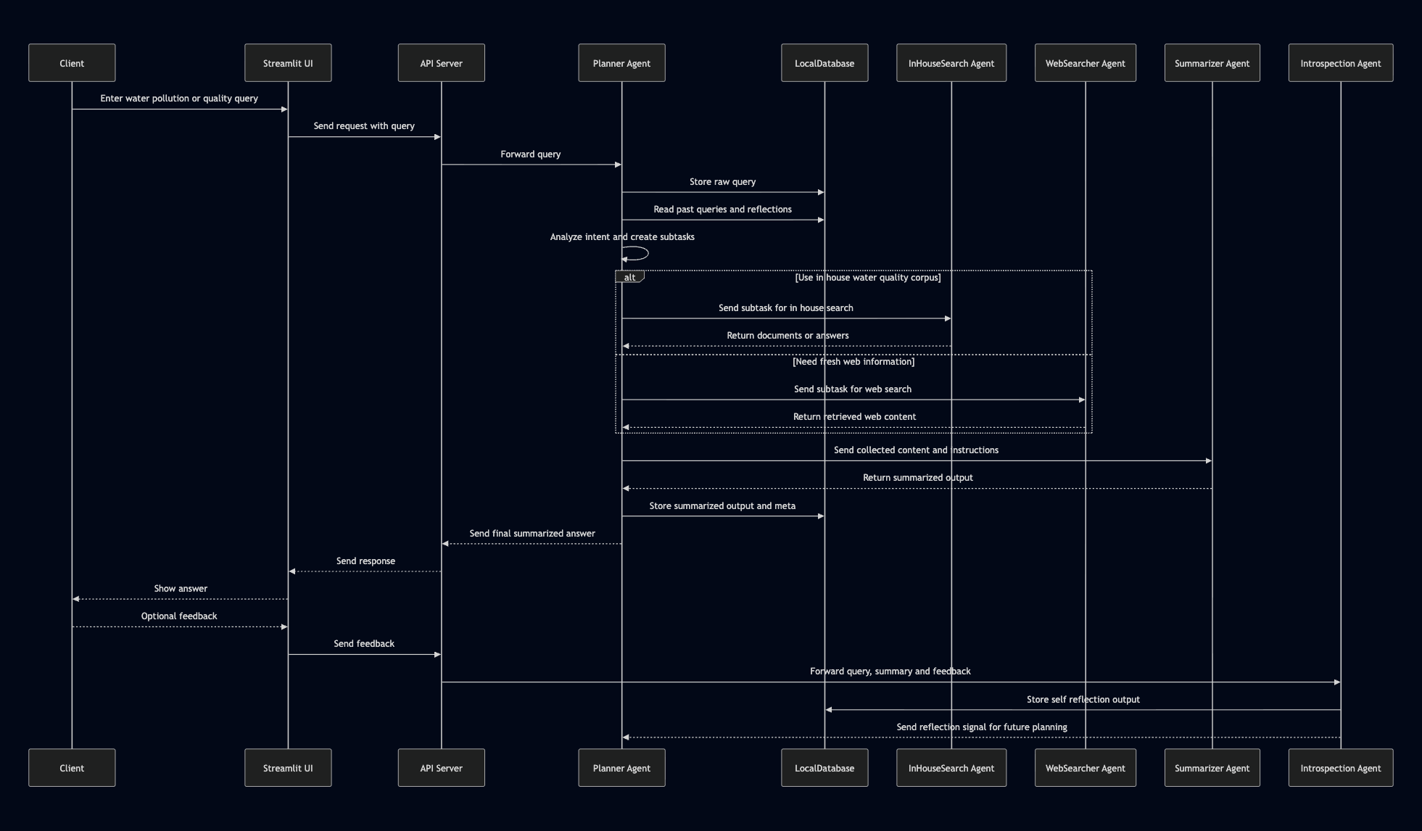

The client submits a water pollution or water quality enquiry through the Streamlit UI.
The API server forwards the query to the Planner Agent, which logs it in the local database and reads past queries and reflections.
The Planner decomposes the problem into subtasks and routes them either to the InHouseSearch Agent (for domain documents on water quality) or the WebSearcher Agent (for fresh online information).
Collected content is then passed to the Summarizer Agent, which produces a concise, user-friendly answer.
The Planner stores this summarized output in the database and returns it through the API to the UI.
User feedback and the final answer are evaluated by the Introspection Agent, which writes self-reflection data back to the database and informs the Planner for future improvements.
--------------------------------------------------------
用户通过 Streamlit 前端界面输入 水污染 / 水质相关问题。
API Server 将查询转发给 Planner Agent，Planner 先把原始问题写入本地数据库，并读取历史查询和反思记录。
Planner 将问题拆分为子任务，并根据需要路由到：
- InHouseSearch Agent：查询本地水质知识库；
- WebSearcher Agent：抓取互联网上最新的水污染相关新闻或报告。

收集到的内容统一交给 Summarizer Agent 进行整理与摘要，生成面向用户的简洁回答。
Planner 将最终摘要及元数据存入数据库，通过 API 返回给前端。
用户反馈与最终回答会发送给 Introspection Agent 进行质量评估和自我反思，其结果写回数据库，同时反馈给 Planner，帮助后续规划与路由优化。

1. Planner Agent Workflow
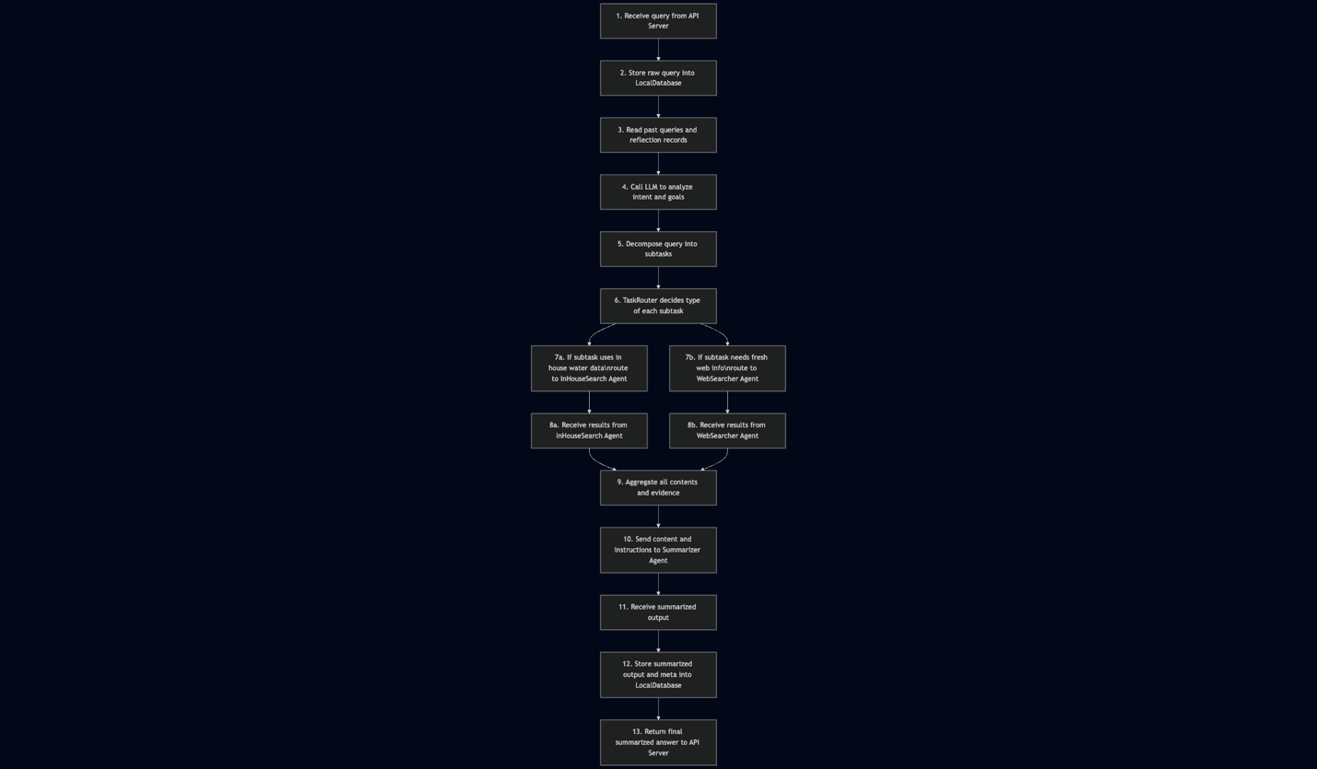
The Planner Agent logs each query and past reflections, uses an LLM (e.g., Gemma 2 7B) to understand the user’s intent about water pollution or water quality, and decomposes the question into subtasks.
The TaskRouter then decides whether each subtask should go to the InHouseSearch Agent or the WebSearcher Agent.
After gathering results, the Planner aggregates all evidence and forwards it, with clear instructions, to the Summarizer Agent.
The summarized answer is stored together with metadata in the LocalDatabase and sent back to the API server.
Planner Agent 首先记录每个新查询和历史反思记录，然后调用 LLM（如 Gemma 2 7B）理解用户在水污染/水质方面的真实意图，并将问题拆分为若干子任务。
TaskRouter 决定每个子任务的执行位置：
- 需要内部水质知识库 → 发送给 InHouseSearch Agent；
- 需要最新网络信息 → 发送给 WebSearcher Agent。
当子任务结果返回后，Planner 会对所有证据进行汇总，并携带指令发送给 Summarizer Agent。
最终生成的摘要答案和相关元数据被写入 LocalDatabase，同时返回给 API Server。

2. InHouseSearch Agent Workflow
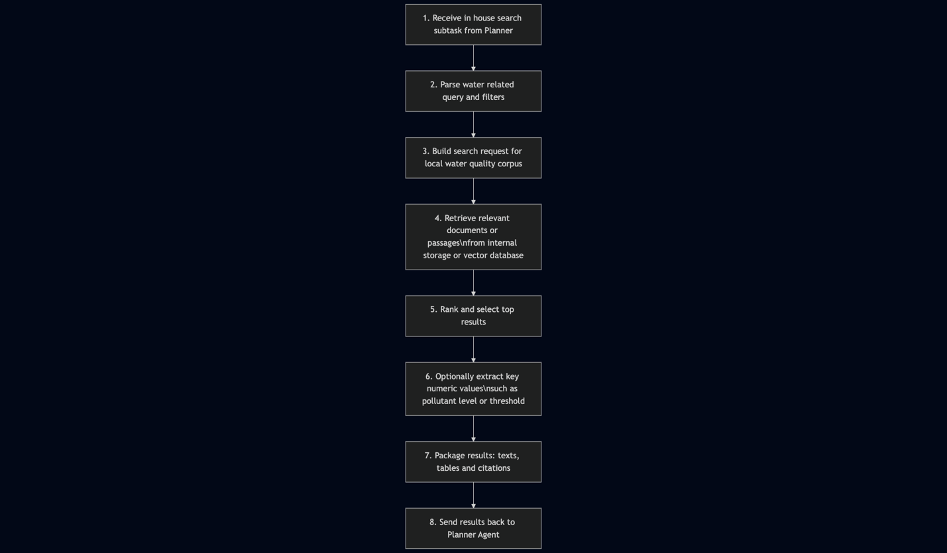
The InHouseSearch Agent handles subtasks that can be answered from the internal water-pollution corpus: reports, standards, and local measurements.
It parses the query, searches internal storage (for example, a vector database with sentence embeddings), ranks the results, and may extract key values such as contaminant concentrations or allowable limits.
It then sends the selected texts and citations back to the Planner.
InHouseSearch Agent 负责所有可以通过 内部水污染知识库 回答的子任务，例如水质报告、法规标准、本地监测数据等。
它会解析子任务中的查询条件，检索内部存储（例如向量数据库），对结果进行排序，并可提取关键数值信息（如污染物浓度、标准阈值等）。
最终将筛选后的文本、表格和引用信息返回给 Planner Agent。

3. WebSearcher / WebScraper Agent Workflow
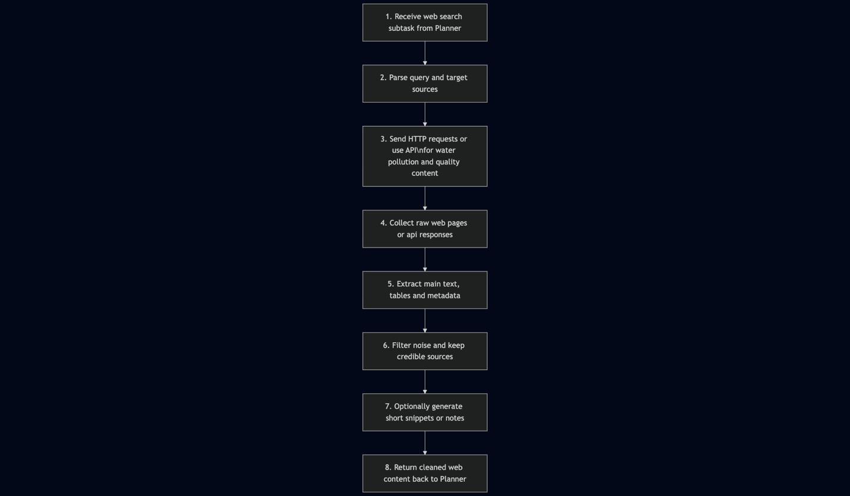
The WebSearcher Agent is responsible for acquiring fresh, online information about water pollution and water quality: recent news, public reports, alerts, or scientific updates.
It sends HTTP requests or uses APIs, parses HTML or JSON, extracts relevant text and tables, filters out low-quality sources, and returns cleaned content (plus short snippets) to the Planner.
------------------------------
WebSearcher Agent 负责从互联网获取 最新的水污染/水质相关信息，例如新闻报道、政府公告、最新研究等。
它会发起 HTTP 请求或调用外部 API，解析网页或 JSON 数据，提取核心文本和表格，过滤掉低质量或无关内容，并将清洗后的文本（及简短摘要）返回给 Planner Agent

4. Summarizer Agent Workflow
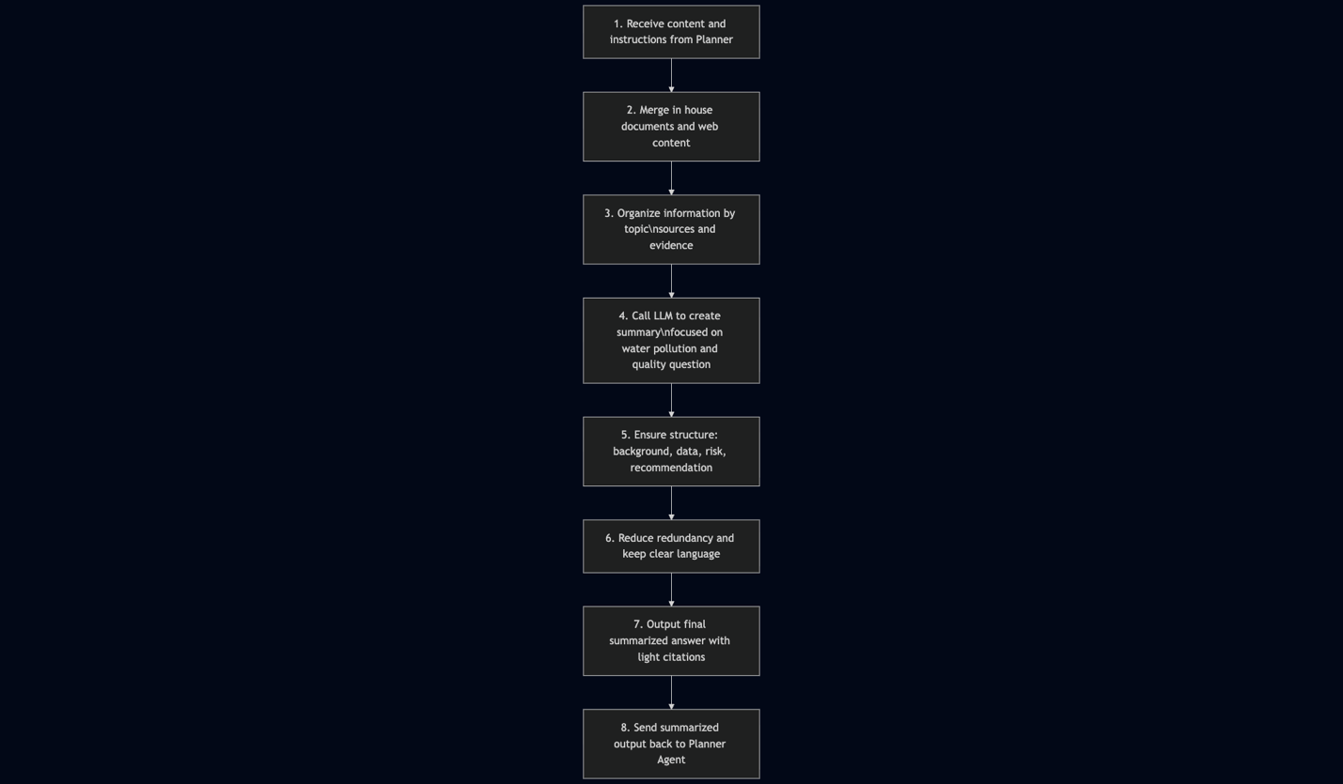
The Summarizer Agent receives all collected material plus instructions from the Planner (for example: answer length, language, and focus).
It merges internal and web sources, organizes them by topic, and calls an LLM (e.g., Mistral 7B) to generate a structured summary: background, key water-quality data, risk analysis, and recommendations.
Redundancy is removed and the final answer is written in clear language with light citations, then returned to the Planner.
Summarizer Agent 接收 Planner 发送的所有资料以及摘要指令（例如长度、语言、重点维度等）。
它会将内部文档与 Web 内容合并，并按主题进行整理，然后调用 LLM（如 Mistral 7B）生成结构化摘要：包括背景介绍、关键水质数据、风险分析与改进建议等。
在去除冗余、保证语言清晰后，Summarizer 生成最终带有简单引用的回答，并返回给 Planner Agent。

5. Introspection Agent Workflow
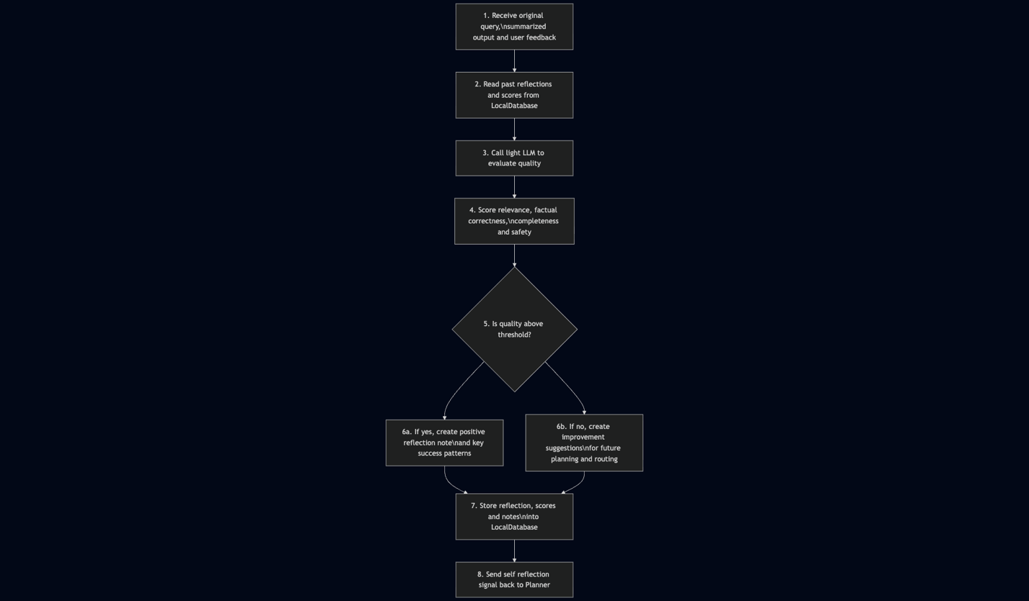
The Introspection Agent receives the original query, the final summarized answer, user feedback, and historical reflection data.
Using a lightweight LLM, it evaluates the response in terms of relevance, factual correctness, completeness, and safety.
If quality is high, it records positive patterns; if not, it generates concrete suggestions (for example, “include WHO guideline values” or “clarify pollutant units”).
All reflections and scores are stored in the LocalDatabase, and a signal is sent back to the Planner to adjust future planning and routing.
-----------------------
Introspection Agent 接收原始问题、最终摘要回答、用户反馈以及历史反思信息。
借助一个轻量级 LLM，它会从 相关性、事实正确性、完整性和安全性 等维度对回答进行打分。
若质量较高，则记录本次成功的模式；若质量不足，则生成具体改进建议（例如“下一次需要对比 WHO 标准数值”“需要说明污染物单位”等）。
这些反思和评分会写入 LocalDatabase，并以“自我反思信号”的形式反馈给 Planner，帮助后续在规划和路由上做出调整。

