1 npm i安装依赖项html-webpack-plugin和webpack

2 npm i –S react react-dom安装react和react-dom

3 app.js里导入react和react-dom，代码如下

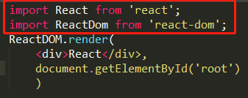

4 npm i –D babel-loader babel-core安装babel-loader和babel-core

5 webpack.config.dev.js添加module配置，使用babel-loader，options选项选择react

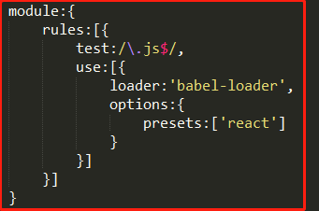

6npm i –D babel-preset-react安装babel-preset-react

7npm run dev运行