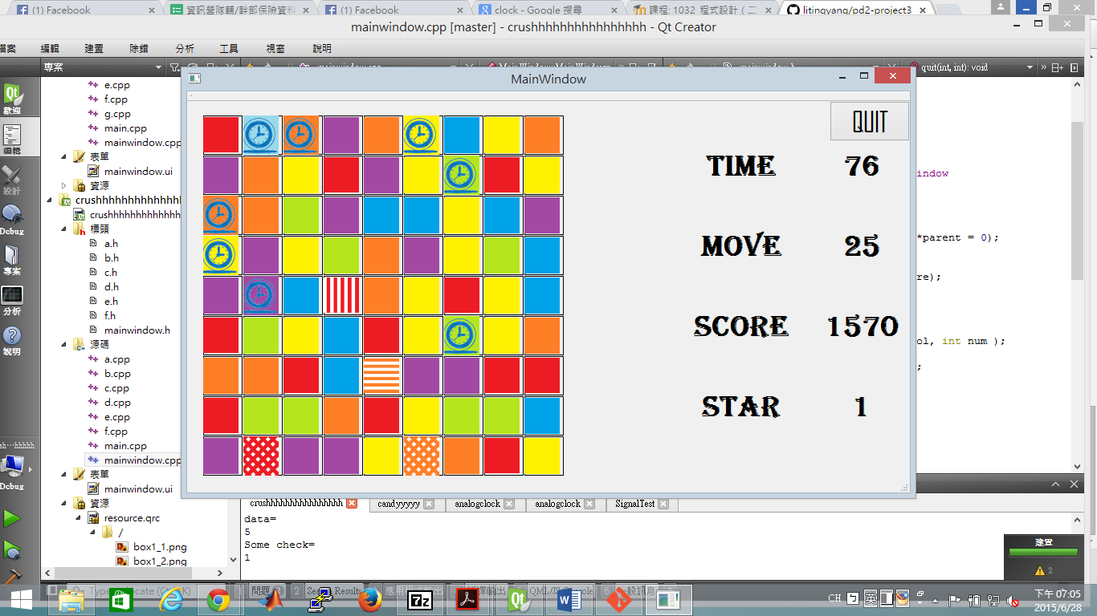

|  |
| --- |
| A |
| #turn:int  #button:QpushButton  #row:int  #col:int  #num:int |
| +operator==(a:A&):bool  +operator=(a:int)  <<constrctor>>A(parent:Qwidget, Row: int, Col: int, Num: int) |

|  |
| --- |
| MainWindow |
| - check():bool  - check2()  - ui: Ui::MainWindow*  - kj: QPushButton *  - data: QVector <int>  - data2: QVector <int>  - typ: QVector <int>  - typ2: QVector <int>  - rem[9][9]: bool  - box: QVector<A *>  - rrrr: A*  - turn: int  - move()  - Create()  - SetNum()  - check_Fr()  - check_Fv()  - check_T()  - SetPicture()  - set_special()  - set_five(a: int, b: int)  - set_T()  - tm: int  - Move: int  - star: int  - score: int  - timer: QElapsedTimer  - timer2: QTimer*  - step()  - count_score()  - clock()  - create_clock() |
| <<constructor>>MainWindow(parent: QWidget *) |