**🧠 Question:  
 You're part of a WWII research team analyzing returning aircraft. Each red dot on the image represents bullet holes on planes that made it back. Your team suggests reinforcing the areas with the most hits.  
 Where should you reinforce the plane?**

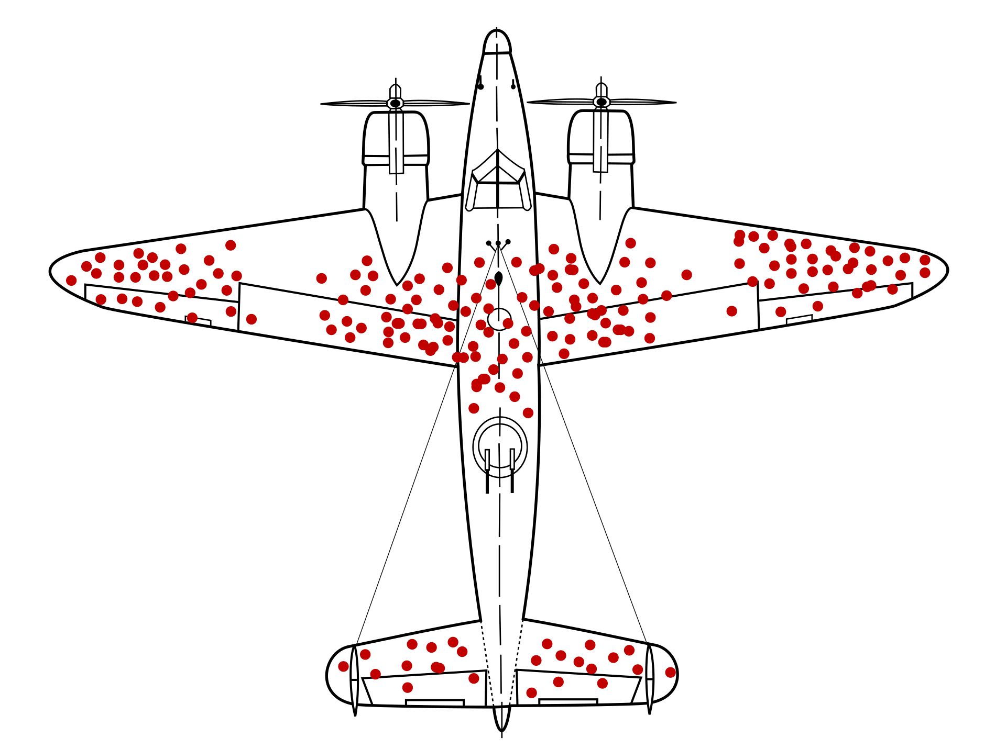

**A) The wings and tail, where most bullet holes are observed  
 B) The engine and cockpit, where fewer or no bullet holes are observed  
 C) Nowhere — the planes survived anyway**

**Prepare one slide to explain the assigned bias to the group (1-minute presentation).**

**Prepare one slide to illustrate situations where this bias might occur in other academic settings (1-minute presentation)**

**🔒 Facilitator Instructions (Do Not Share with Participants)**

**Please take 2 minutes to read this page carefully  
  
1. Please read the followinging question out loud**  *Linda is 31 years old, single, outspoken, and very bright. She majored in philosophy. As a student, she was deeply concerned with issues of discrimination and social justice, and also participated in anti-nuclear demonstrations.*

Which is more probable?

1. Linda is a bank teller.
2. Linda is a bank teller and is active in the feminist movement.

**2. Let the team members discuss**  
  
**3. Debrief**

*Most people choose B, even though it's less probable (a conjunction of two events is always less likely than one of them alone). This demonstrates the* ***conjunction fallacy****: we’re swayed by how representative something sounds, rather than actual probability.  
  
Why it's useful in an EDI context:*

It can be tied to stereotyping or snap judgments about people based on perceived traits. For example, when people over-assume based on gender, background, or interests (e.g., "this person is a woman in STEM, so she must be interested in outreach or teaching").

**4. Slide preparations**

* Prepare one slide to explain the assigned bias to the group (1-minute presentation).
* B Prepare one slide to illustrate situations where this bias might occur in other academic settings (1-minute presentation)

### **🔒 Facilitator Instructions (Do Not Share with Participants) Please take 2 minutes to read this page carefully**

1. **Split your team into two groups.**
2. **Give each group one version of the CV** — either *Alex Rivera* or *Sofía Martínez*.  
     
    *Note: The two CVs are nearly identical, except for the name and one extracurricular detail.*
3. **Ask each group to:**
   1. Read the CV carefully
   2. Rate the candidate from 1 to 10 (in terms of suitability for a PhD program)
   3. Justify their rating in a brief discussion
4. **While the groups are reading and discussing**, please review the gender bias calculator results, which highlight the differences in language used in the recommendation letters.
5. **After both groups have shared their evaluations**, reveal that the CVs were identical aside from name and minor details. Then, discuss the bias found in the letters of recommendation and how it might have influenced their perception of the candidates.
6. **Slide preparations**
   1. Prepare one slide to explain the assigned bias to the group (1-minute presentation).
   2. Prepare one slide to illustrate situations where this bias might occur in other academic settings (1-minute presentation)

**⏱ Suggested timing**

* **Group activity and discussion: 7 minutes**
* **Reveal and explain hidden bias: 5 minutes**
* **Slide preparations 5 min.  
    
    
    
  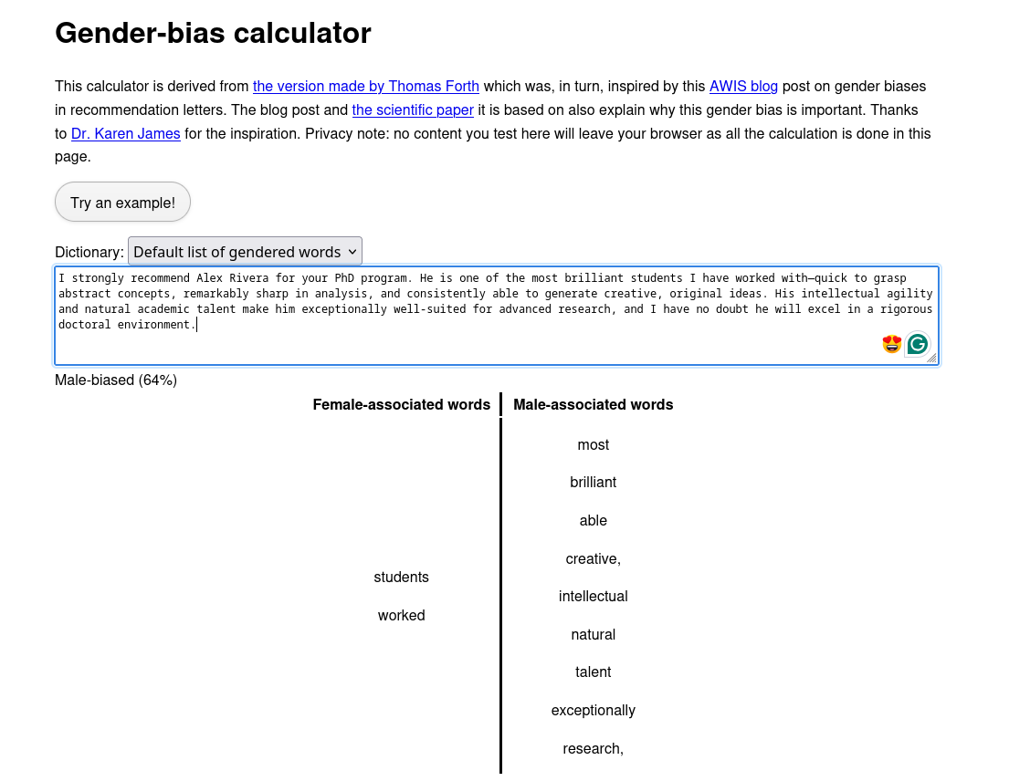**

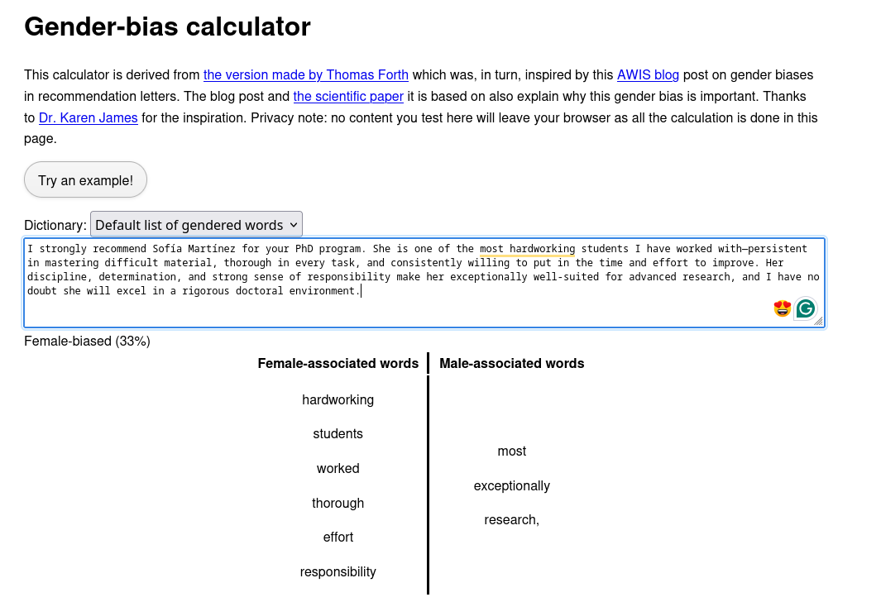

**👨‍🎓 Alex Rivera**

* **B.Sc. in Physics, Universidad Nacional – GPA: 9.1/10**
* **First-author publication in *Physical Review B* on quantum transport**
* **Presented talk at National Student Physics Conference, 2024**
* **Developed simulation code for spin chains used in group research**
* **Research internship at the National Institute for Quantum Science**
* **Plays competitive chess at national level**

### **✉️ Letter for Alex Rivera**

**I strongly recommend Alex Rivera for your PhD program. He is one of the most brilliant students I have worked with—quick to grasp abstract concepts, remarkably sharp in analysis, and consistently able to generate creative, original ideas. His intellectual agility and natural academic talent make him exceptionally well-suited for advanced research, and I have no doubt he will excel in a rigorous doctoral environment.**

### **👩‍🎓 Sofía Martínez**

* **B.Sc. in Physics, Universidad Nacional – GPA: 9.1/10**
* **First-author publication in *Physical Review B* on quantum transport**
* **Presented talk at National Student Physics Conference, 2024**
* **Developed simulation code for spin chains used in group research**
* **Research internship at the National Institute for Quantum Science**
* **Volunteers mentoring high school girls interested in STEM**

### **✉️ Letter for Sofía Martínez**

**I strongly recommend Sofía Martínez for your PhD program. She is one of the most hardworking students I have worked with—persistent in mastering difficult material, thorough in every task, and consistently willing to put in the time and effort to improve. Her discipline, determination, and strong sense of responsibility make her exceptionally well-suited for advanced research, and I have no doubt she will excel in a rigorous doctoral environment.**

### **🔒 Facilitator Instructions (Do Not Share with Participants)**

### **Please take 2 minutes to read this page carefully**

1. **Split your team into two groups.**
2. **Give each group one version of the CV** — either *Alex Rivera* or *Sofía Martínez*.  
     
    *Note: The two CVs are nearly identical, except for the name and one extracurricular detail.*
3. **Ask each group to:**
   1. Read the CV carefully
   2. Rate the candidate from 1 to 10 (in terms of suitability for a PhD program)
   3. Justify their rating in a brief discussion
4. **While the groups are reading and discussing**, please review the gender bias calculator results, which highlight the differences in language used in the recommendation letters.
5. **After both groups have shared their evaluations**, reveal that the CVs were identical aside from name and minor details. Then, discuss the bias found in the letters of recommendation and how it might have influenced their perception of the candidates.
6. **Slide preparations**
   1. Prepare one slide to explain the assigned task to the group (1-minute presentation).
   2. Prepare one slide to illustrate situations where this bias might occur in other academic settings (1-minute presentation)

**⏱ Suggested timing**

* **Group activity and discussion: 7 minutes**
* **Reveal and explain hidden bias: 5 minutes**
* **Slide preparations 5 min.  
    
    
    
  **



**Sofía Martínez**

* **B.Sc. in Physics, Universidad Nacional – GPA: 9.1/10**
* **First-author publication in *Physical Review B* on quantum transport**
* **Presented talk at National Student Physics Conference, 2024**
* **Developed simulation code for spin chains used in group research**
* **Research internship at the National Institute for Quantum Science**
* **Plays competitive chess at national level**

### **✉️ Letter for Sofía Martínez**

**I strongly recommend Sofia Martinez for your PhD program. She is one of the most brilliant students I have worked with—quick to grasp abstract concepts, remarkably sharp in analysis, and consistently able to generate creative, original ideas. Her intellectual agility and natural academic talent make her exceptionally well-suited for advanced research, and I have no doubt she will excel in a rigorous doctoral environment.**

### **Alex Rivera**

* **B.Sc. in Physics, Universidad Nacional – GPA: 9.1/10**
* **First-author publication in *Physical Review B* on quantum transport**
* **Presented talk at National Student Physics Conference, 2024**
* **Developed simulation code for spin chains used in group research**
* **Research internship at the National Institute for Quantum Science**
* **Volunteers mentoring high school girls interested in STEM**

### **✉️ Letter for Alex Rivera**

**I strongly recommend Alex Rivera for your PhD program. He is one of the most hardworking students I have worked with—persistent in mastering difficult material, thorough in every task, and consistently willing to put in the time and effort to improve. His discipline, determination, and strong sense of responsibility make him exceptionally well-suited for advanced research, and I have no doubt he will excel in a rigorous doctoral environment.**

### **🔒 Facilitator Instructions (Do Not Share with Participants)**

### **Please take 2 minutes to read this page carefully**

1. Divide participants into two groups.
2. Give **each group the same CV**, but with **different recommendation letters** (A or B).
3. Ask each group to decide:  
   * Would you hire Jordan Taylor? Why or why not?
   * Which points in the CV support your decision?
4. **Debrief:** Reveal that both groups had the **same CV**, only the recommendation letter was different. Discuss how confirmation bias led each group to highlight only the CV items that fit the narrative they received.

*What likely happened is a classic case of* ***confirmation bias****: once you read a positive or negative framing, your brain unconsciously searched for evidence in the CV to support that narrative. The same weaknesses may have seemed minor to one group but decisive to the other, depending on the initial framing.”*

1. **Slide preparations**
   * Prepare one slide to explain the assigned task to the group (1-minute presentation).
   * Prepare one slide to illustrate situations where this bias might occur in other academic settings (1-minute presentation)

**⏱ Suggested timing**

* **Group activity and discussion: 7 minutes**
* **Reveal and explain hidden bias: 5 minutes**
* **Slide preparations 5 min.**

💬 Reflection Questions (that might help the discussion)

How did the tone of the recommendation letter shape the way you read the CV?

Were there points in the CV that you downplayed or overlooked because they didn’t fit the letter’s narrative?

How might this bias show up in real academic contexts (hiring, reviewing papers, grant applications, grading)?

What strategies could we use to minimize this bias in our own decision-making?

## **📄 CV: Candidate – Jordan Taylor**

(*10 bullet points with a mix of strengths and weaknesses*)

* B.Sc. in Chemistry, GPA 8.8/10
* Published one co-authored paper in *Journal of Physical Chemistry Letters*
* Excellent presentation skills, gave a talk at a student conference
* Strong coding ability (Python, MATLAB) applied to simulations
* Needs guidance to stay on track with deadlines
* Switched research topics twice during Master’s due to mismatched interests
* Highly creative in proposing new project ideas
* Sometimes struggles to prioritize tasks effectively
* Completed internship at a well-regarded research lab abroad
* Collaborative and well-liked by peers, often mediates group conflicts

## **✉️ Recommendation Letter**

I am delighted to recommend Jordan Taylor for your program. Jordan is a **bright and promising researcher** who demonstrates strong creativity, technical skills, and a collaborative spirit. In my experience, Jordan consistently contributes original ideas, works effectively in teams, and shows great potential for independent research. While still developing time-management skills, Jordan’s talents clearly outweigh minor challenges, and I am confident Jordan will thrive in a demanding research environment.

## **📄 CV: Candidate – Jordan Taylor**

(*10 bullet points with a mix of strengths and weaknesses*)

* B.Sc. in Chemistry, GPA 8.8/10
* Published one co-authored paper in *Journal of Physical Chemistry Letters*
* Excellent presentation skills, gave a talk at a student conference
* Strong coding ability (Python, MATLAB) applied to simulations
* Needs guidance to stay on track with deadlines
* Switched research topics twice during Master’s due to mismatched interests
* Highly creative in proposing new project ideas
* Sometimes struggles to prioritize tasks effectively
* Completed internship at a well-regarded research lab abroad
* Collaborative and well-liked by peers, often mediates group conflicts

## **✉️ Recommendation Letter**

I have supervised Jordan Taylor and can confirm that while Jordan has **some technical abilities**, progress was often inconsistent. Jordan required significant guidance to meet deadlines and had difficulties focusing on one research topic, switching projects multiple times. Although personable and cooperative, Jordan’s lack of discipline raises concerns about whether Jordan is prepared for the independence expected in your program.