测试安装
docker run -dit -p 8888:8888 debian:jessie
设置apt 源
{ \
echo 'deb http://mirrors.aliyun.com/debian/ jessie main non-free contrib'; \
echo 'deb-src http://mirrors.aliyun.com/debian/ jessie main non-free contrib'; \
} > /etc/apt/sources.list
安装python-pip和python
apt-get update && apt-get install -y python-pip && rm -rf /var/lib/apt/lists/*
安装webssh
pip install --upgrade pip
pip install --upgrade setuptools
pip install webssh
启动webssh
/usr/local/bin/wssh --address='0.0.0.0' --port=8888 --fbidhttp=False

启动
docker run -dit --restart=always --name=webssh -p 10402:8888 litongjava/webssh:1.0
直接访问
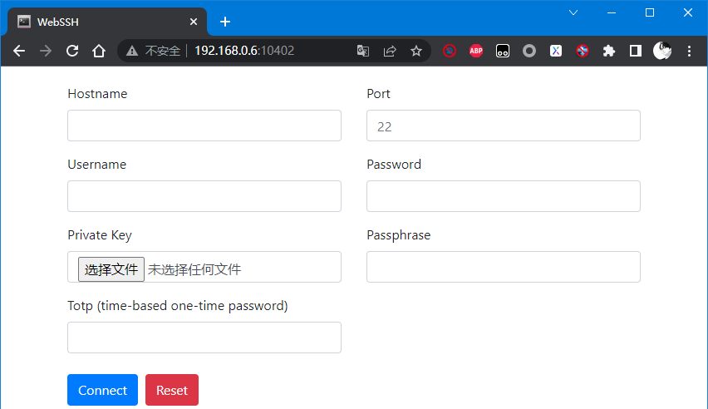
配置nginx+添加一个密码
安装htpasswd命令
yum -y install httpd-tools
apt install apache2-utils
#生成密码文件,输入密码也是xtyj%^1232
htpasswd -c /etc/nginx/webssh-pswd xtyj%^1232
配置nginx
location /webssh/ {
auth_basic "Please input password";
auth_basic_user_file webssh-pswd;
proxy_pass http://127.0.0.1:10402/;
proxy_http_version 1.1;
proxy_read_timeout 300;
proxy_set_header Upgrade $http_upgrade;
proxy_set_header Connection "upgrade";
proxy_set_header Host $host:$server_port;
proxy_set_header X-Real-IP $remote_addr;
proxy_set_header X-Real-PORT $remote_port;
}

访问nginxip:port/webssh

错误记录

NameError: name 'platform_system' is not defined
log | Cleaning up...  Exception:  Traceback (most recent call last):  File "/usr/lib/python2.7/dist-packages/pip/basecommand.py", line 122, in main  status = self.run(options, args)  File "/usr/lib/python2.7/dist-packages/pip/commands/install.py", line 290, in run  requirement_set.prepare_files(finder, force_root_egg_info=self.bundle, bundle=self.bundle)  File "/usr/lib/python2.7/dist-packages/pip/req.py", line 1266, in prepare_files  req_to_install.extras):  File "/usr/lib/python2.7/dist-packages/pkg_resources.py", line 2401, in requires  dm = self._dep_map  File "/usr/lib/python2.7/dist-packages/pkg_resources.py", line 2597, in _dep_map  self.__dep_map = self._compute_dependencies()  File "/usr/lib/python2.7/dist-packages/pkg_resources.py", line 2630, in _compute_dependencies  common = frozenset(reqs_for_extra(None))  File "/usr/lib/python2.7/dist-packages/pkg_resources.py", line 2627, in reqs_for_extra  if req.marker_fn(override={'extra':extra}):  File "/usr/lib/python2.7/dist-packages/_markerlib/markers.py", line 113, in marker_fn  return eval(compiled_marker, environment)  File "<environment marker>", line 1, in <module>  NameError: name 'platform_system' is not defined  Storing debug log for failure in /root/.pip/pip.log
desc | 安装python-pip和python 2.7.9  apt-get update && apt-get install -y python-pip && rm -rf /var/lib/apt/lists/*  安装webssh  pip install webssh  出现上面的错误
resolve | 升级pip和setuptools  pip install --upgrade pip  pip install --upgrade setuptools

