

Cocos2d project

Tower defense game By Wouter Van Hecke

Content

1. Figure list 2
2. Planning documentation 3
3. Project screenshots 4
4. Personal experiences with this project 11

Figure list

Figuur 1 - logo screen 4

Figuur 2 - main screen 4

Figuur 3 - settings screen 4

Figuur 4 adventure book sceen 1 4

Figuur 5 adventure book tower screen 5

Figuur 6 - adventure book screen enemies 5

Figuur 7 - store screen 5

Figuur 8 - store tower screen 5

Figuur 9 - store screen levels 6

Figuur 10 - store screen bought towers 6

Figuur 11 - strore screen bough levels 6

Figuur 12 - stage sceen 1 6

Figuur 13 - stage screen 2 7

Figuur 14 - stage screen 3 7

Figuur 15 - world screen 1 7

Figuur 16 - world screen 2 7

Figuur 17 - world screen 3 8

Figuur 18 - world screen 4 8

Figuur 19 - tutorial 1 8

Figuur 20 - tutorial 2 8

Figuur 21 - tutorial 3 9

Figuur 22 - tutorial 4 9

Figuur 23 - tutorial 5 9

Figuur 24 - level selection screen 9

Figuur 25 - normal level screen 1 10

Figuur 26 - normal level screen 2 10

Planning documentation

See other document.

Project screenshots



Figuur 1 - logo screen

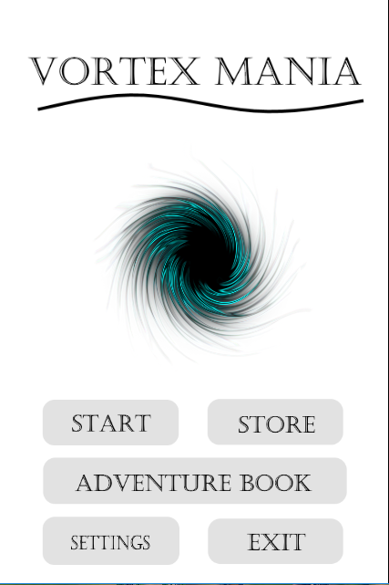

Figuur 2 - main screen

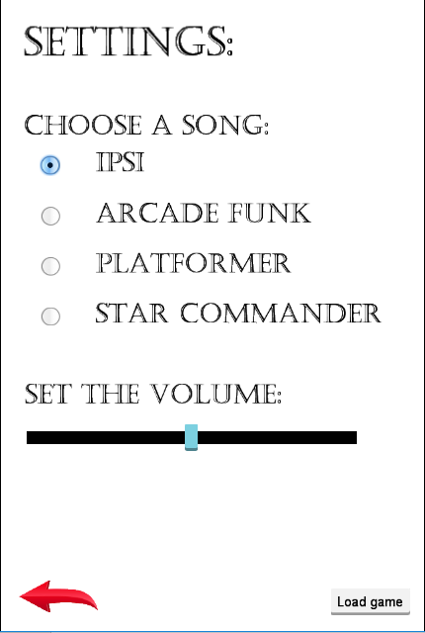

Figuur 3 - settings screen

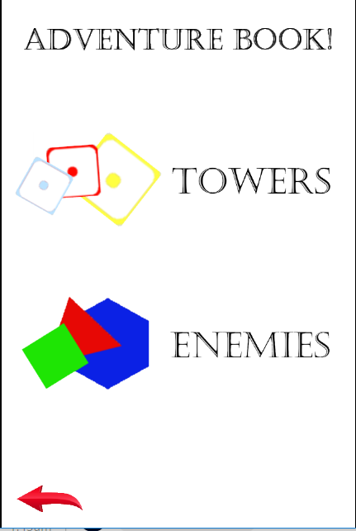

Figuur 4 adventure book sceen 1

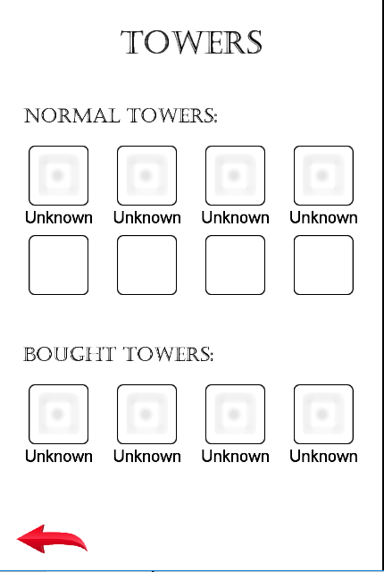

Figuur 5 adventure book tower screen

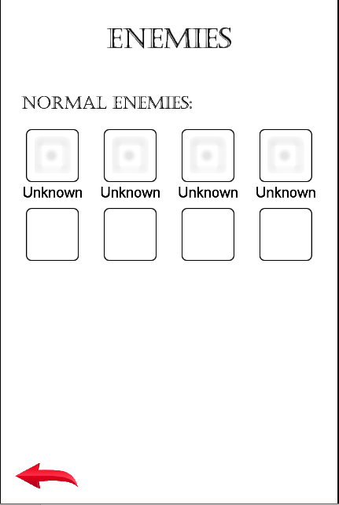

Figuur 6 - adventure book screen enemies

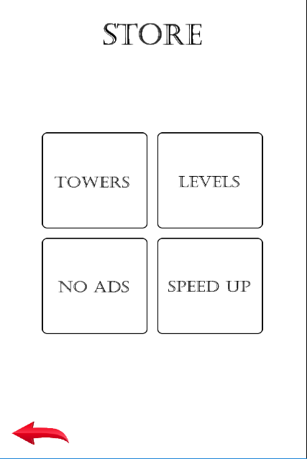

Figuur 7 - store screen

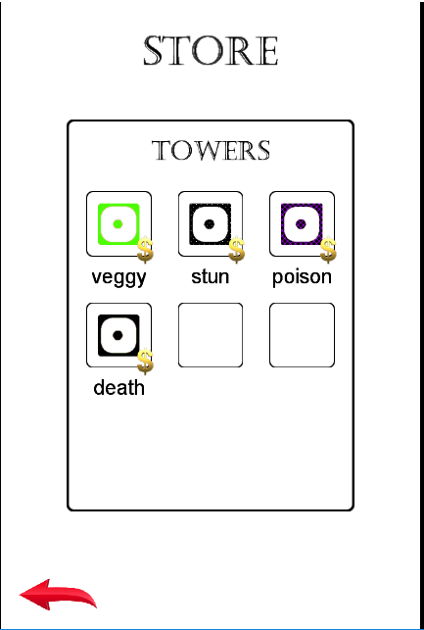

Figuur 8 - store tower screen

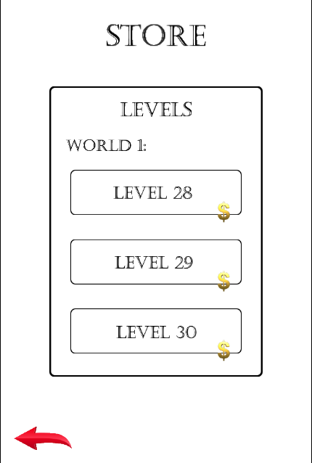

Figuur 9 - store screen levels

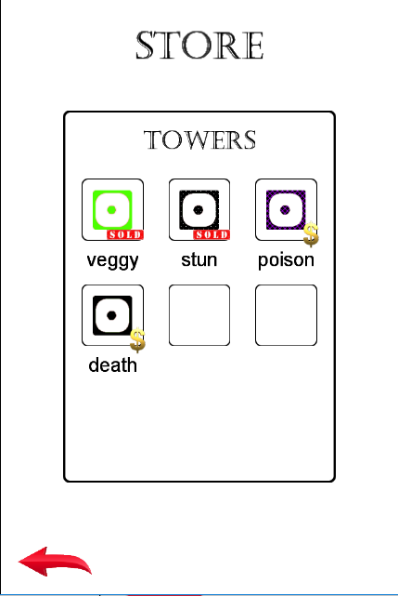

Figuur 10 - store screen bought towers

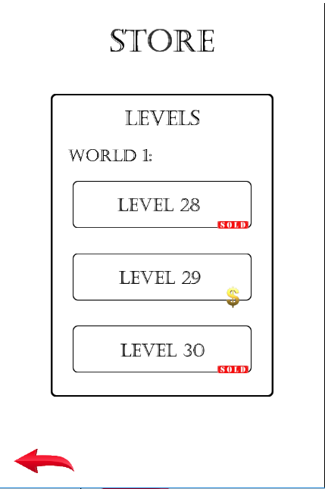

Figuur 11 - strore screen bough levels

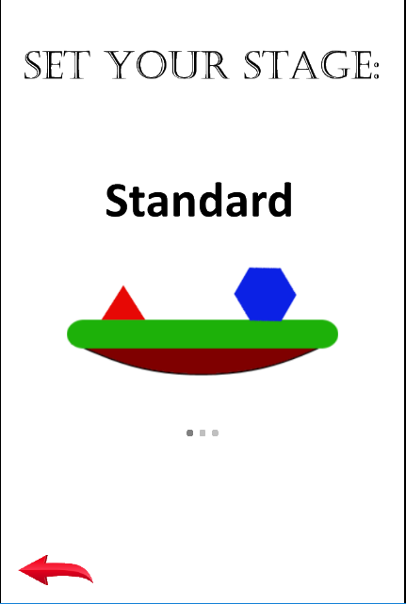

Figuur 12 - stage sceen 1

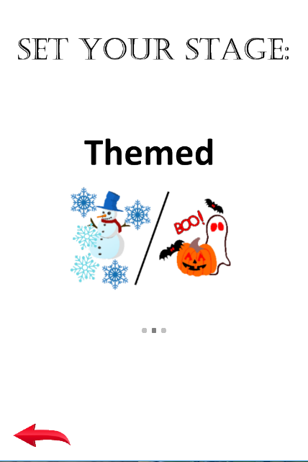

Figuur 13 - stage screen 2

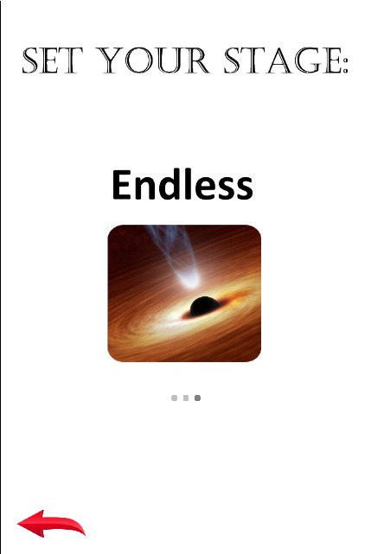

Figuur 14 - stage screen 3

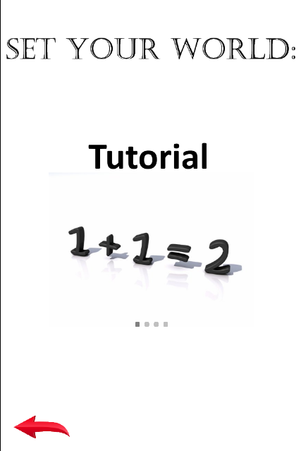

Figuur 15 - world screen 1

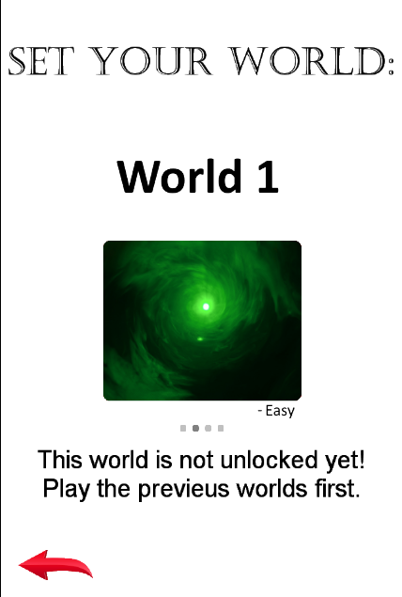

Figuur 16 - world screen 2

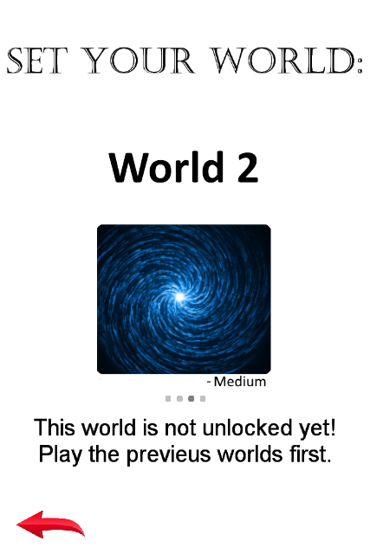

Figuur 17 - world screen 3

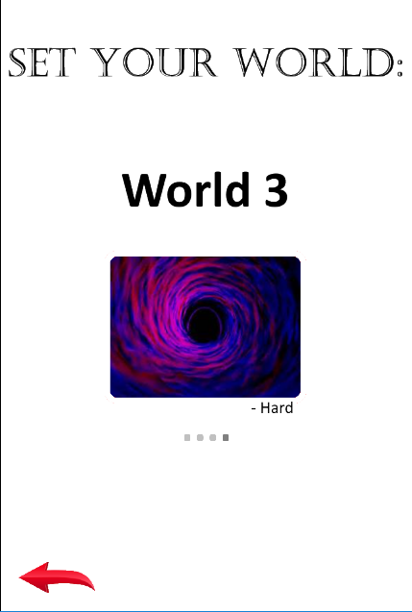

Figuur 18 - world screen 4

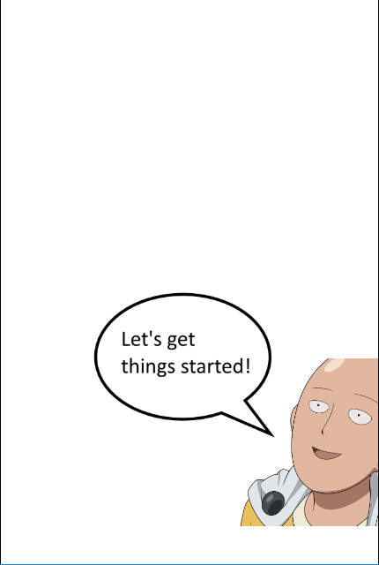

Figuur 19 - tutorial 1

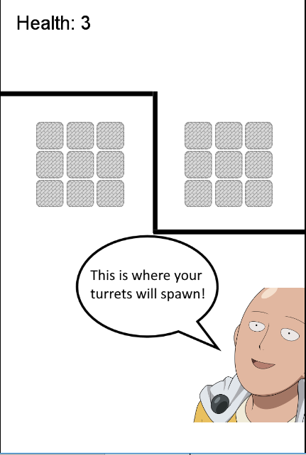

Figuur 20 - tutorial 2

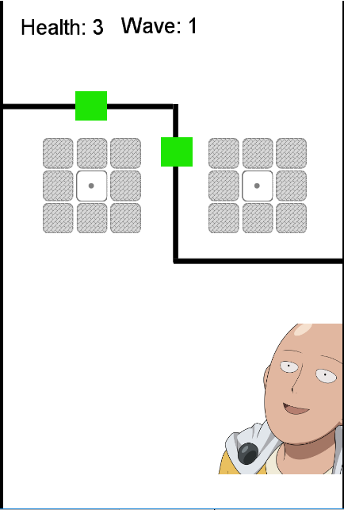

Figuur 21 - tutorial 3

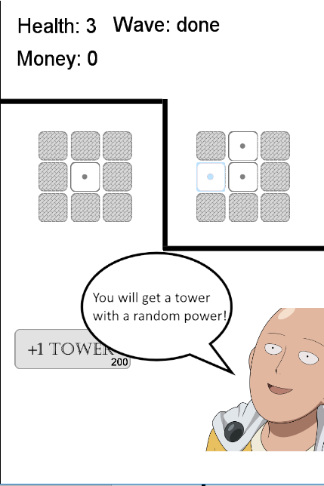

Figuur 22 - tutorial 4

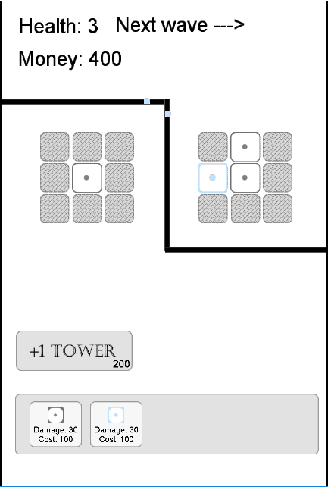

Figuur 23 - tutorial 5

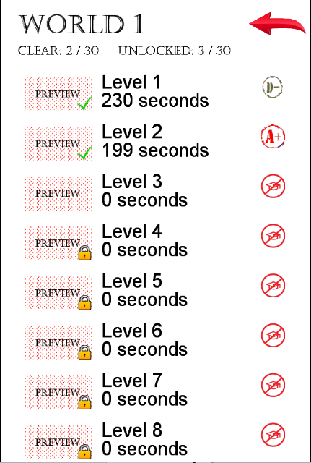

Figuur 24 - level selection screen

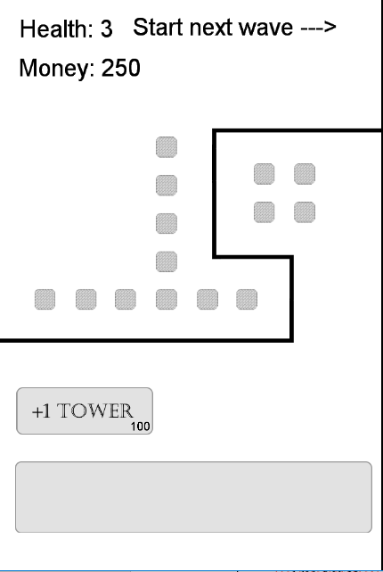

Figuur 25 - normal level screen 1

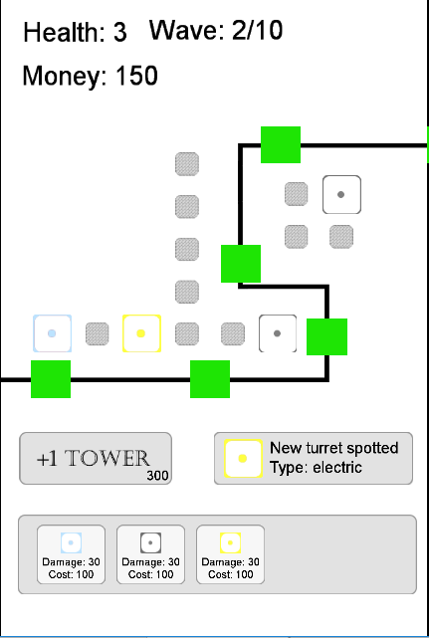

Figuur 26 - normal level screen 2

Personal experiences with this project

In the beginning it was really hard to work with cocos creator. It wasn’t easy to find out how everything work because it is not that well documented in my opinion. But after some time you start to use the same aspects but just in different scenes. Creating nodes, giving them a sprite (picture), setting a listener, moving something… About half way through the project, the documentation pages of cocos creator went down, so it got even more difficult to find the right stuff. In the end it was getting easier and more fun to try out things. For example the yellow tower (electric) has a special effect on enemies, it will electrify it and also the enemies next to them. If it is the first enemy, it only hits 2 enemies, if it is an enemy in the middle it can hit 3 enemies at once.

I decided to work alone on this project for a few reasons.

* I can work whenever I want, no one is holding me back, I like to work several hours at a time.
* It is really hard to find someone that is one the same level as you.
* There is no one holding you back.
* You can work out your own ideas.

I’m pretty happy how the game turned out. I put a lot of work in this project, but most of the time it was fun the work on.