 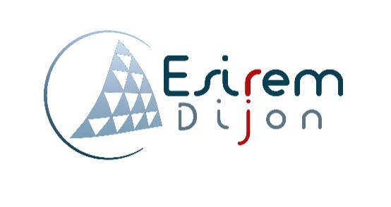

*Auteur :*

Mr. Bastien extrat

Etudiant 4A infotronique - ESIREM |

Interactive meeting room project

inernship report

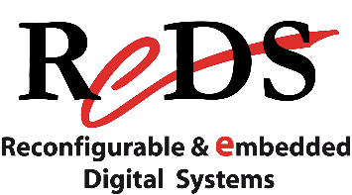

ECOLE SUPERIEUR D’INGENIEURS EN MATERIAUX / DEVELOPPEMENT DURABLE ET

INFORMATIQUE / ELECTRONIQUE

*internship adviser:*

Pr. Romuald MOSQUERON

*Academic adviser:*

Pr. Julien DUBOIS

*responsible for internships***:**

M. Charles MEUNIER

*Author:*

M. Bastien EXTRAT

*4th year student in IT & embedded electronics at ESIREM*

*Hosting company:*

ReDS insitute

Table of content

Acknowledgements 3

Introduction 4

Company presentation 5

The project 6

Project’s presentation 6

Specifications: 7

Existing solutions: 8

Production: 9

The center of the project: the operation system 9

Overview of Sootech operating system 9

Interest to the project 10

Work done around this Operating System 10

Result 11

Problems encountered 12

Conclusion 13

About this project 13

About the internship in another country 13

Figure 1 - HEIG short logo 5

Figure 2 - ReDS logo 5

Figure 3 - "ball on wheel" 5

Figure 4 - Meeting room infrastructure 6

Figure 5 - Raspberry Pi Advantages 7

Figure 6 - overview of SO3 connection 9

Figure 7 - SO3 architecture 10

Figure 8 - interactive meeting room solution 11

# Acknowledgements

I would like to thanks all the persons who has contributed to make this internship possible and helped me the realization of my project and for the redaction of this report.

First of all, I express my sincere gratitude to Professor Romuald Mosqueron for welcoming me in the Reconfigurable & embedded digital systems (ReDS) institute for this internship, his trust and advices.

I also express my sincere gratitude to Professor Daniel Rossier for his patience and all the things he gave to help me to understand, learn and progress around his own Operating system used during the project.

I thank all the Reds’ team for their help, discussions, coffee times and providing all the resources needed to try to realize this project.

I would like to express my special gratitude and thanks to Pr. Julien Dubois for his answers, confidence and his help along and before this internship, also to all the Esirem members involved.

My thanks and appreciations also go to all my friends, family who have willingly helped me out with their abilities.

# Introduction

This document establishes a report on the achievements and explanations about the following project:

**"interactive meeting room".**

The purpose of this project is to create, experiment and define a solution to provide, at its end, a complete set of working devices corresponding to the project's specifications. To explain all the context, this report has three different parts:

* **Company presentation:** a brief overview of the institute to give context and understanding of the project's position.
* **Project presentation:** an overview of the project's specifications and all the topics involved.
* **Project achievement:** a description of all the tasks done and the actual project's standing.

Of courses, some revisions were needed because of unsolved problems and strategic positioning of the all.

At the end, a conclusion is set to review the learnings of this project with all the positive and drawback points, and also a little touch about the internship itself.

Note: all the content of this report is related to his author and knowledges. If an information has been copy/pasted, it is an explanation of existing elements. Every sources are quoted (despites existing sources in some cases it will give documents at the end of the file) the rest pf this document is the production of the author only. No information is classified, all the elements are in the public domain

# Résultat de recherche d'images pour "heigvd"Company presentation

The internship took place inside the HEIG-VD: high school of engineering and management of the Vaud township/canton (Haute Ecole d’Ingenierie et de Gestion du canton de Vaud) at Yverdon-les-Bains, Switzerland (near Lausanne). This school provide bachelors and masters in various field such as telecommunications, business administrations, geomatics (tools and method to analyze/represent and acquire geographical data) for instance.

Figure 1 - HEIG short logo

This school is holding a lot of institute related to the different fields available. This gives concrete projects to the students and true applications related to real company.

 During my internship I was attached to the ReDS institute: reconfigurable & embedded digital systems institute. It is mostly composed of professors, related to the learning part and Engineers/ staff members, which are here to work on projects based on their skills but also provide assistantship to the courses. The actual director is Pr. Alberto Dassatti.

Figure 2 - ReDS logo

This institute, like the name suggest, provide research and development related to embedded electronic system based on existing (or not !) board such as fpga, raspberry, jeston …

The entity is composed of three major branches and all have a lot of project already done:

* One is more **hardware oriented** with designing an architecture to provide powerful hardware exploitation**.**
  + *the Romeo project, for instance, that gives reel-time cardiac diagnostic in an embedded system. It stores MRI data in real time and allow to interact with it.*

*(the project have, in fact a software to interact with the data).*

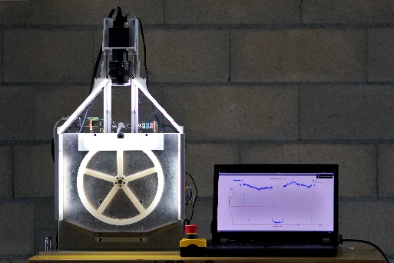

* **the integrated design** which provide concrete and custom-made board or system with all the constraint it can have (i.e. space-saving or power saving for instance).
  + *the “Ball on Wheel” project illustrate this part with the control of the balance of a ball on a wheel got by a camera and converted in a phase shift . all done on a SoC-FPGA platform to rectify the wheel rotation to keep the ball on top.*

Figure 3 - "ball on wheel"

* An other one, more **software oriented** which provide all the softs parts to have a complete embedded system. It can be a complete OS or a dedicated calculation unit.
  + *A current project is based on an Artificial intelligence to provide live following of a football player and balloon. This use a special algorithm implemented on a Jetson board to train the AI to detect the balloon and the player and following both of them during a video live acquisition.*

These three branches make together a complete entire embedded system by providing all the design and all the feature form down to top-level.

# The project

## Project’s presentation

the project is named “interactive meeting room”. The objective is to provide a smart oriented solution to interact with different display available in a meeting room. to understand the real interest of the project, an infrastructure’s description is necessary.



…

TV

PROJECTOR



TV



TV



MODERATOR ISLET

ISLET 1

ISLET 2

ISLET x

NEED TO GO TO THE PROJECTOR TO PRESENT

CAN’T CONTROL THE DIFFUSION

AND ATTENTION ON EACH SCREEN



Figure 4 - Meeting room infrastructure

the meeting room is set as show on *figure 4 – meeting room infrastructure*. As it shows, the room is composed with 2 types of islets:

* some islets are *set with several subgroups of people around a TV*.
  + In scholar context this is a subgroup of students working on a project together.
  + In general context this is a subgroup of people having a meeting on a bigger subject they are involved.
* and only *one islet is composed with one person and a projector*.
  + In a scholar context this is the teacher giving information’s or courses to the student.
  + In general context this is a moderator of a meeting.

This principle is requisite to understand the purpose of the project as follow.

This configuration is quite narrow because each islet can diffuse their own work / presentation around the entire room only with a move to the projector with the accordance of the moderator. And all questions or attention on an element need special description to the dedicated slide. Despite of that it needs special cables depending on each device. Adding to that, the moderator has no control to the element each islet display, which keep the attention down.

The project’s goal is to improve the interactions with all the islets to get a comfortable meeting with all parts involved and following directly on each screen the current diffusion. With a diffusion control made by to the moderator. In concrete application this means adding connectivity to the room.

### Specifications:

To answer that, it is necessary to identify all the constraint already present. Firstly, the solution needs to be users friendly:

* No complicated setup: Keep It Simple & Stupid (KISS). The user doesn’t have to think to get it work.
* Limiting third party software to simplify compatibility,
* Providing all services already available such as internet connection.

Secondly, identifying the investment needed to realize a solution:

* Equip each TV with an embedded system
* Adding connectivity to the room to:
  + keep the room working despite an internet connection off.
  + Access to the screen wirelessly.
* Provide a secondary screen to the moderator to manage diffusion.

Thirdly, check some technical information and constraint:

* Video must be in High Definition resolution
* No limitation to:
  + Number of displays
  + Number of people connected inside the room.
* Working on a dedicated IoT Operating system made in the Institute

The choice of raspberry Pi 3 B+ was immediately made because, it satisfied all the hardware constraint listed above.

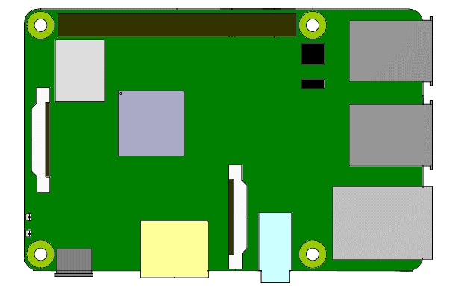

HDMI PORT for connexion to the TV

USB PORT for input stuff or USB dongles

LOW COST TINY Embedded system

WIFI ANTENNA Inside

COMPATIBLE DEDICATED OS

Figure 5 - Raspberry Pi Advantages

## Existing solutions:

In the IoT era, this kind of dispositive already exist. During the evolution of the project and problems observed, a comparative file was made around some existing solutions. they have drawback and advantages which give an opportunity, at the end, to provide a new approach of the interaction on a meeting room. a quick preview of products best sellers is set on the *table 1 – solutions advantages and drawbacks summary.*

|  |  |  |
| --- | --- | --- |
| Résultat de recherche d'images pour "clickshare" | Résultat de recherche d'images pour "solstice mersive" | Résultat de recherche d'images pour "airmedia" |
| Clickshare | Solstice | AirMedia |
| Standalone WIFI | Standalone WIFI nor not | Connect to existing WIFI |
| Cocheusb dongles | Fermerno dongles | FermerNo dongles |
| Can connect max 8 guests | Support lot of connection |  |
| FermerNo connection management | FermerManagement on pro extension package | FermerManagement online only |
| No video support | CocheVideo support | CocheVideo support |
| CocheNo necessary need of third-party software  CocheHave direct HDMI input & 2 outputs | CocheSupport many sharing possibilities:  *Document/ images / video / screen mirroring*  CocheLive arrangement of displayed files | Cochemore professional and durable stuff  Cochedesigned around a building infrastructure |

Table 1 - solutions advantages and drawbacks summary

At this point it is important to identify the real strength of the project. First of all, it is the configuration of the screens and the management we provide thanks to the dedicated operating system, which is described later.

Where the other solutions are focused on one wireless screen monitoring and managing, this project provide a simpler direct control and better management of multiple screens in one meeting room with a working infrastructure at any time.

# Production:

With all the elements and the perspective evolving, the project has grown to attain objectives. To overview that, it is important to have a special understanding of the operating system. This one gives some powerful capabilities to our project.

## The center of the project: the operation system

The institute has members skilled in various fields. One of them is Daniel Rossier. He provide a dedicated Operating system to the project called SO3 : Smart-oriented object operating (system).

This operating system has a different architecture that a conventional OS. To understand the global working and the interest of this one to the project some summary explanation has to be set.

### Overview of Sootech operating system

Mesh network

Sootech Operating system running

Direct data transfer

Figure 6 - overview of SO3 connection

According to the *figure 6 – overview of SO3 connection*, the first thing to understand is that the OS is made for being an autonomous network. It does not need internet connection. Each working device with this OS transfer data to all other thanks to the mesh networking topology. this provide a direct acquisition of data to all the network elements.

An example of application is an autonomous laboratory: 2 entities acquire measurements; another displays the data on a screen and an others adjust the parameters to the experiment.

In the case of the interactive meeting room, this topology could provide direct moderation to each screen and also a simpler transfer of each display presentation.

The second thing to understand is how it works inside. Referring to the *figure 7 – SO3 architecture*, The operating system is not conventional at all. It is based on a hypervisor.

A hypervisor is a computer software that runs virtual machines. itis a virtual machine monitor that load and afford resources to multiple operating system virtualized running on it. There is two types of hypervisor. The only to know her is the native one , which is directly implemented on the hardware.

On this hypervisor an Agency is set. It is a instance with a special link to the hypervisor. The agency provides all configurations and application running in accordance to the hardware and drivers implemented. It is based on a embedded linux operating system despite of some interaction that are made on the hypervisor (such as modules interactions).

HARWARE

AGENCY VIRTUALIZER

(HYPERVISOR)

AGENCY

- backend drivers

- native config

MOBILE ENTITY

- Frontend drivers

- Low privilege

ME

…

VIRTSHARE

for instance, it provides the configuration to the WI-FI anthennas, drivers and X server to use screen and HDMI port.

the final element is a ME: Mobile Entity. It is mostly a special unit which is linked to the agency with Virtshare , a special protocol to acquire data on specified interface of the Agency. The ME is important because it is this part that is transmitted to the others instance. All the interpretation of data is made by the Agency.

Figure 7 - SO3 architecture

The virtshare protocole is set to provide special link to the agency and the ME. the ME only provide a frontend part, all the backend part is set on the Agency. This give all the privilege to the Agency and the ME is only a tiny Operating part with data wanted inside. This keep the embedded system on a stable resources consumption.

### Interest to the project

This Operating system provide two basic elements for our project:

* a direct communication to each islets, which is powerful to transfer content displayed to another instance directly.
* A top-level interaction that gives a good and direct management possible. Using low resources in data transmission.

In concrete application, this satisfied the management by the moderator and ensure a data transfer to all the instance connected to the network.

### Work done around this Operating System

#### Build handling

The entire system is made with a custom and functional part, the Agency Hypervisor this means no interaction with this part is done. The main work is made on the Agency. The Agency is a embedded linux distribution based on a Buildroot package.

Buildroot is a special set that provide all the makefiles and automated process in order to build a bootable linux Environment. It can support many embedded plateform such as raspberry, beaglebone, Stmicroelectronics and different kind of processor architecture (32/64 bit, arm processor).

The main difference with a classic linux distribution is that Buildroot is built for embedded system, i.e. this means it is not set to be maintained online with updating packages. The embedded philosophy is focused on a thinking before making. So, to develop a solution, some tests and some packages selections and compilation were made regularly.

The buildroot package provide a menu of listed packages available, no description is made to each package, and some packages needs other in order to work properly.

So, all the work related to the project consist in knowledge about linux conception, such as graphical gestion, drivers interaction and configuration, in the way to choose the right packages to add to the S03 to obtain significative evolutions. This involve a complete comprehension of the SO3 process of building and identify each part enrolled.

## Result

The current version of the project is not working. The actual set provide a graphical interface and a connection to a central access point. No moderation is made yet because the need to diffuse something on the display is needed to do that.

Despite the current non-working solution, the overview of a first final solution is existing as illustrate the *figure 8 – interactive meeting room solution.*



…

TV

PROJECTOR



TV

MODERATOR ISLET

ISLET 1

ISLET x



ACCESS POINT

Moderation interface

* Mesh network communication
* Access point link

Usb dongle

Figure 8 - interactive meeting room solution

The room has now a access point, to connect all the screens and the members on it, and provide an internet connection to keep access to the distant applications.

The screen will display the connection link to the display to allow each student to connect to the dedicated one. A possible dongle is planned to give a easer way to diffuse to the screen, removing the connection step.

The screens will have the mesh network for themselves to keep the data transfert and the moderation on a separate and more efficiency way.

The monitor now holds a second screen with a graphical interface to see each display and control all the diffusions. At any times it would be able to stop the activity of a screen if it is not the purpose of the meeting.

Remembering the objectives, the solution provides connectivity and a working system without internet connection. The management is very simple and don’t require some adding stuff to the moderator. This is very easy to interact for the users.

With all of these steps, and a crossover to some institutes project, this one has an important evolution around the same principle. To see the proper way of evolution, the Annex 1 is added to see some steps. Another important point is the possibility that some company can be really interested in this solution.

## Problems encountered

Along the project, regular difficulties happened linked to various field. The main brake is the Buildroot limitation and manipulation. The SO3 operating system is not exactly a entire Buildroot system.

In real application, it means that a lot of work was made around finding another way to archive the stuff wanted. Buildroot is evolving since a while which is make quite difficult to get the right data about the wanted packages and its availability.

There is no serious problem encountered. The hardest one was the Access Point creation which has made loss a lot of times and keeping an evolution to the solution.

The real problem was my complete lack of knowledge on Linux platform. But some times spent around books, courses and discussion with engineers keep this lack smaller and smaller and has as measurable impact to the project.

# Conclusion

## About this project

This project is a very interesting stuff. Beside all the limited knowledge I had and have, that gave some problems sometimes. I keep managed to find solutions to give something working well. This include a lot of learnings on some elements. It is a special exercise to work manually one a linux based system, but a kind of resourcefulness gives some spot to obtain results.

I keep disappointed on myself because of the loosing times around learnings and searching information and my limited comprehension around some elements of the linux system. This might have a serious impact on the progression. And I already try to get something working at the end. Which is important for me.

But at the same time, it is relative to the steps I have made to the project. I don’t think this is a hard one, more an interesting one. Currently, the stuff made prove some work were done. And it might have some serious evolutions on various way.

This project is very focus on all the embedded meanings and This a complete resume of my professional project. The institute offered a lot of possibilities in these domains, and others by looking to the school.

so the embedded way is very valuable in various aspect from hardware to software ,and , to be close to the formation, involve the three bases of the IE field : networking for the communications, software to give applications to the users , and electronics to get a complete working system.

## About the internship in another country

Despite a real proximity to France, this country has not the same usages. It might give some take back about the vision we give to the others and what point of interest we had.

This country is a very multicultural station in Europe, with 3 different speaking languages and a lot of strangers in every kind of work, it provides some opening mind to the ways they lives.

One point I really appreciated is the real way they live. It is really set to always keep moving the people to insure the country machinery.

In different cases I have discussion with locals who gives me their point of view. it was very interesting to see how they are constantly involved to the country decision (with votation system for instance) and how mature they are with respect to all these aspects.

A different way to understand there are all involved is to see the military implication. The institute, for instance, has made some project for the army. and in a more common ways, the national services still exist, and various opportunities around this are made. (which is quite valuable to the mind opening in Switzerland I think).

On a more local way, despite the reputation of the town (the swiss chamber pot they said in some others town) Yverdon is a very small and active city with various cultural aspect. The natural center near the HEIG-VD and some museum were very interesting to see around.