 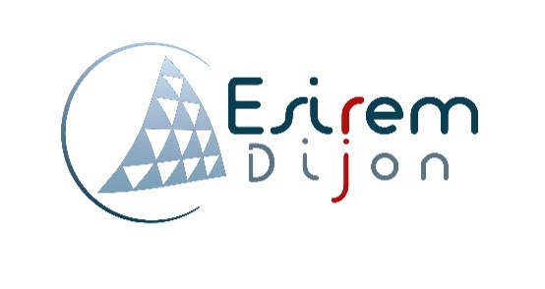

*Auteur :*

Mr. Bastien extrat

Etudiant 4A infotronique - ESIREM |

Internship report

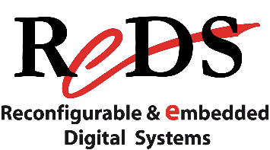

ECOLE SUPERIEUR D’INGENIEURS EN MATERIAUX / DEVELOPPEMENT DURABLE ET

INFORMATIQUE / ELECTRONIQUE

*internship adviser:*

Pr. Romuald MOSQUERON

*Academic adviser:*

Pr. Julien DUBOIS

*responsible for internships***:**

M. Charles MEUNIER

*Author:*

M. Bastien EXTRAT

*4th year student in IT & embedded electronics - ESIREM*

Table of content

Acknowledgements 3

Introduction 4

Company presentation 5

The project 6

Project’s presentation 6

Specifications: 7

Existing solutions : 7

Design of the project 7

Production 7

Table des figures et tableau abbreviations

# Acknowledgements

I would like to thanks all the persons who has contributed to make this internship possible and helped me in the realization of my project and for the redaction of this report.

First of all, I express my sincere gratitude to Professor Romuald Mosqueron for welcoming me in the Reconfigurable & embedded digital systems (ReDS) institute for this internship, his trust and advices.

I also express my sincere gratitude to Professor Daniel Rossier for his patience and all the things he gave to help me to understand, learn and progress about his own Operating system used during the project.

I thank all the Reds’ team for their help, discussions, coffee times and providing all the resources needed to try to realize this project.

I would like to express my special gratitude and thanks to Pr. Julien Dubois for his answers, confidence and his help along and before this internship, and to all the Esirem members involved.

My thanks and appreciations also go to all my friends, family who have willingly helped me out with their abilities.

# Introduction

This document establishes a report on the achievements and explanations about the following project:

**"interactive meeting room".**

The purpose of this project is to create, experiment and define a solution to provide, at its end, a complete set of working devices corresponding to the project's specifications. To explain all the context, this document have three different parts:

* **Company presentation:** a brief overview of the institute to give context and understanding of the project's position.
* **Project presentation:** an overview of the project's specifications and all the topics involved.
* **Project achievement:** a description of all the tasks done and the actual project's status.

Of courses, some revisions were needed because of unsolved problems and strategic positioning.

finally, a conclusion is set to review the learnings of this project with all the positive and drawback points, and also about the internship itself.

Note: all the content of this report is related to his author and knowledge. If an information has been copy/pasted, it is an explanation of existing elements. Every sources is quote (despites existing sources in some cases it will give documents at the end of the file) The rest of this document is the production of the author only. No information is classified, all the elements are in the public domain.

# Résultat de recherche d'images pour "heigvd"Company presentation

The internship took place inside the HEIG-VD: high school of engineering and management of the Vaud township/canton (Haute Ecole d’Ingenierie et de Gestion du canton de Vaud),at Yverdon-les-Bains, Switzerland (near Lausanne).This school provide bachelors and masters in various field such as telecommunications, business administrations, geomatics (tools and method to analyze/represent and acquire geographical data), for instance.

Figure 1 - HEIG short logo

This school is holding a lot of institute related to the different fields available. This gives concrete projects to the students and true applications related to real company.

 During my internship I was attached to the ReDS institute: reconfigurable & embedded digital systems institute. It is mostly composed of professors, related to the learning part and Engineers/ staff members, which are here to work on projects based on their skills but also provide assistantship to the courses. The actual director is Pr. Alberto Dassatti.

Figure 2 - ReDS logo

This institute, like the name suggest, provide research and development related to embedded electronic system based on existing (or future) board such as fpga, raspberry, jeston …

The entity is composed of three major branches and all have a lot of project already done:

* One is more **hardware oriented** with designing an architecture to provide powerful hardware exploitation**.**
  + *the Romeo project, for instance, that gives reel-time cardiac diagnostic in an embedded system. It stores MRI data in real time and allow to interact with it.*

*(the Romeo project have, in fact, a software, to stores the MRI data, for example).*

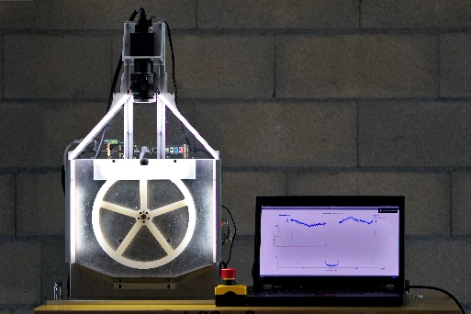

* **the integrated design** which provide concrete and custom-made board or system with all the constraint it can have (i.e. space-saving or power saving for instance).
  + *the “Ball on Wheel” project illustrate this part with the control of the balance of a ball on a wheel got by a camera and converted in a phase shift . all done on a SoC-FPGA platform to rectify the wheel rotation to keep the ball on top.*

Figure 3 - "ball on wheel"

* An other one, more **software oriented,** which provide all the softs parts to have a complete embedded system. It can be a complete OS or a dedicated calculation unit.
  + *A current project is based on an Artificial intelligence to provide live following of a football player and balloon. This use a special algorithm implemented on a Jetson board to train the AI to detect the balloon and the player and following both of them during a video live acquisition.*

These three branches make together a complete entire embedded system by providing all the design and all the feature form down to top-level.

# The project

## Project’s presentation

the project is named “interactive meeting room”. The objective is to provide a smart oriented solution to interact with different display available in a meeting room. to understand the real interest of the project, an infrastructure’s description is necessary.



TV

PROJECTOR



TV



TV



Figure 4 - Meeting room infrastructure

the meeting room is set as show on *figure 4 – meeting room infrastructure*. the room is composed with 2 types of islets:

* some islets are *set with several subgroups of people around a TV*.
  + In scholar context this is a subgroup of students working on a project together.
  + In general context this is a subgroup of people having a meeting on a bigger subject they are involved.
* and only *one islet is composed with one person and a projector*.
  + In a scholar context this is the teacher giving information’s or courses to the student.
  + In general context this is a moderator of a meeting.

this principle is requisite to understand the purpose of the project as follow.

This configuration is quite narrow because each islet can diffuse their own work / presentation around the entire room only with a move to the projector with the accordance of the moderator. And all questions or attention on an element need special description to the dedicated slide. Despite of that it needs special cables depending on each device. Adding to that, the moderator has no control to the element each islet display, which keep the attention down.

The project’s goal is to improve the interactions with all the islets to get a comfortable meeting with all parts involved and following directly on each screen the current diffusion. With a diffusion control made by to the moderator. In concrete application this means adding connectivity to the room.

### Specifications:

To answer that, it is necessary to identify all the constraint already present. Firstly, the solution needs to be users friendly:

* No complicated setup: Keep It Simple and Clear. The user doesn’t have to think to get it work.
* Limiting third party software to simplify compatibility,
* Providing all services already available such as internet connection.

Secondly, identifying the investment needed to realize a solution:

* Equip each TV with an embedded system
* Adding connectivity to the room to :
  + keep the room working despite an internet connection off.
  + Access to the screen wirelessly.
* Provide a secondary screen to the moderator to manage diffusion.

Thirdly, check some technical information and constraint:

* Video must be in High Definition resolution
* No limitation to:
  + Number of displays
  + Number of people connected inside the room.

At this point a first plan was made to make sure the project is viable.

Image du concept ?

## Existing solutions:

In the IoT era , it is clear that this kind of dispositive already exist. During the evolution of the project and problem observed, a comparative file was made around some existing solutions. Some have drawback and advantages which give an opportunity, at the end, to provide a new approach of the interaction on a meeting room. a quik preview of other product is set on the table 1 – solutions advantages and drawbacks summary.

<>

XXXXXXX

## Design of the project :

concept

# Production