3)Managing tablespaces

1)
-Use Database Control to view all tablespaces in your database. For each tablespace, record the tablespace name,type, size and percent used.
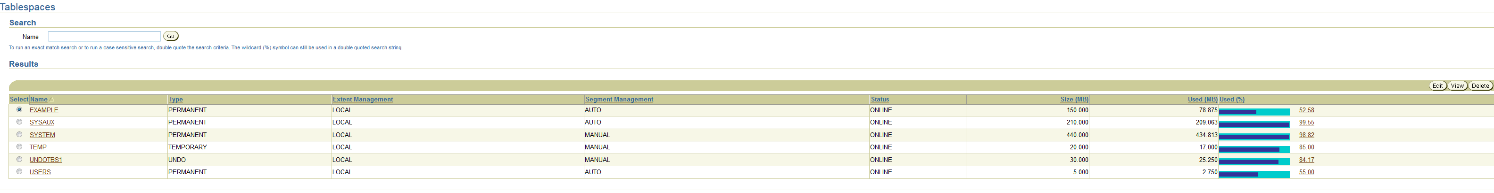

2)
-View all datafiles in your database. For each datafile record the file name, tablespace name, current size,autoextend status, and maximum file size (if autoextend is enabled).

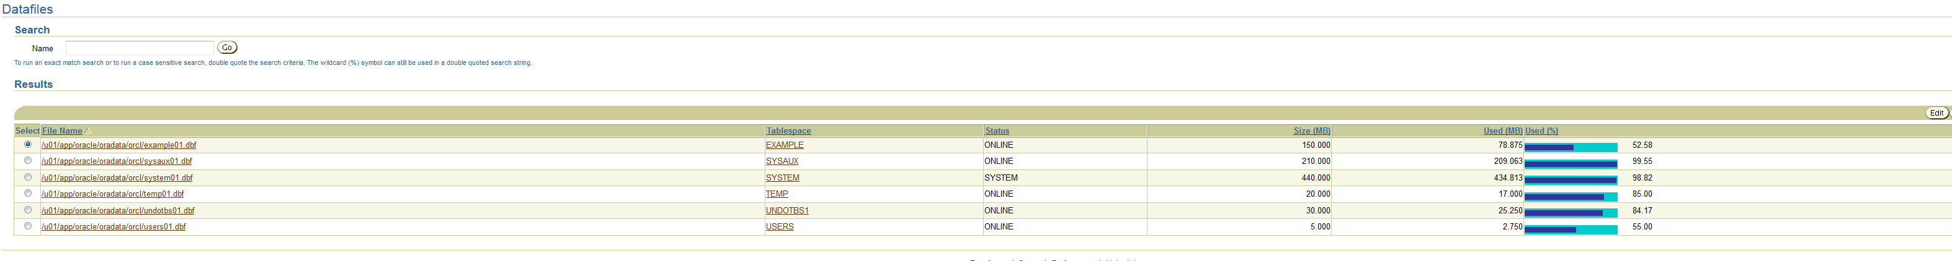

-The SYSTEM tablespace is over 90 % full. Based on the information you’ve just collected, should you be concerned?

Le tablespace SYSTEM contient le datafile /u01/app/oracle/oradata/orcl/system01.dbf, qui est lui même rempli à 98,82 %.
Au vu des infos données dans la partie "background", qui explique que les tablespaces contiennent les données pour les applications, on peut suposser que le tablespace SYSTEM contient les données système de Oracle, et qui il à été fait afin de juste contenir les informations nécessaires, d'où le fait que il soit quasiment plein.

De ce fait, il n'est pas nécessaire de s'inquiêter concernant le fait que il sois rempli à 90%.

-Why is autoextend an attribute of the data file rather than the tablespace?

Le datafile contient les données, c'est donc lui qui va augmenter au fur et à mesure que il a des nouveaux ajouts. Quand le fichier à besoin de place, le datafile augmente et le tablespace suis.

3)
-Create a new tablespace to hold information for the inventory application. Characteristics for the new tablespace
are:
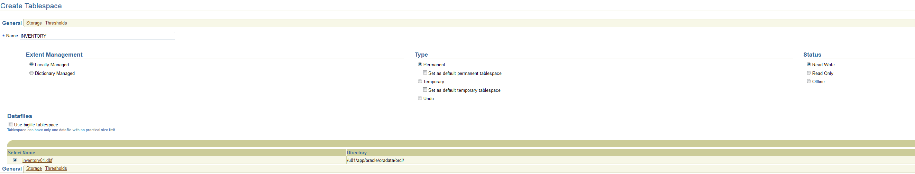
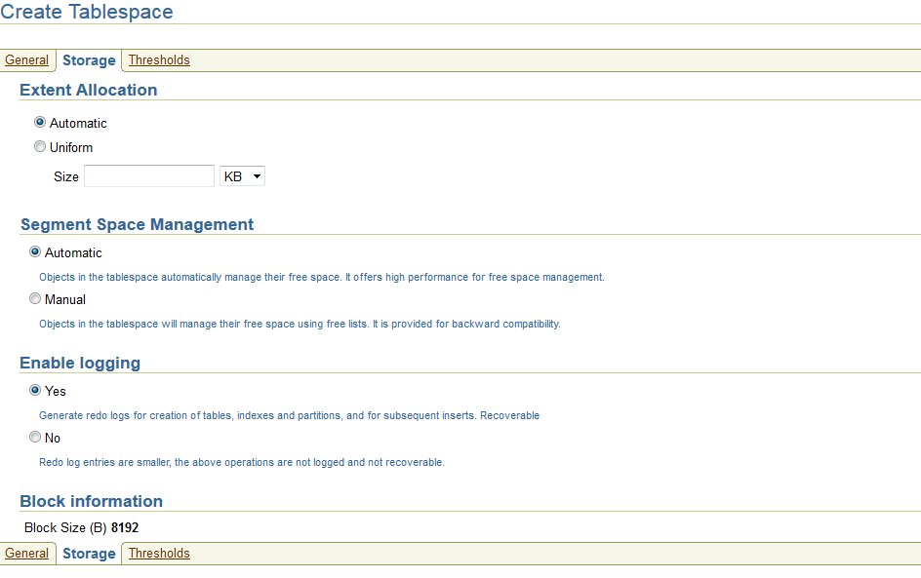

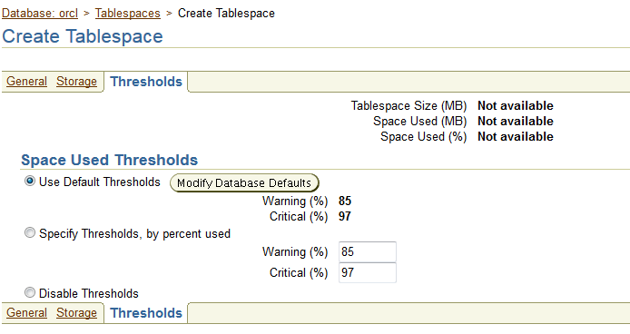

4)Administrating Database Users

1)
-Create a profile named HRPROFILE that limits idle time to 15 minutes. Leave all other fields set to DEFAULT.
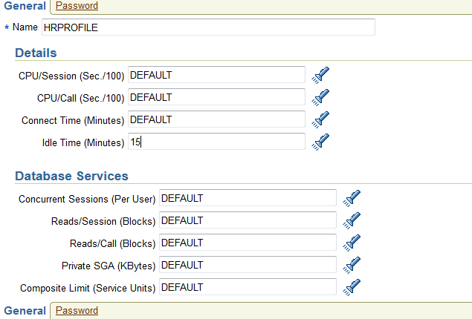

2)
-Set the initialization parameter RESOURCE_LIMIT to TRUE so that your profile limits will be enforced.

3)
-Create a role named HRCLERK without authentication and with SELECT and UPDATE permissions on the
hr.employees table. This role will be used for clerks of the HR department.

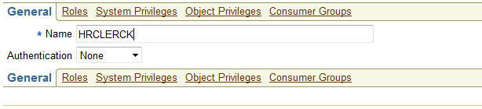

4)
-Create a role named HRMANAGER with INSERT and DELETE permissions on the hr.employees table. Grant the
HRCLERK role to the HRMANAGER role. This role will be used by managers of the HR department.

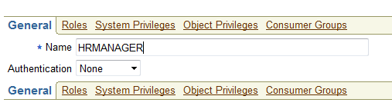

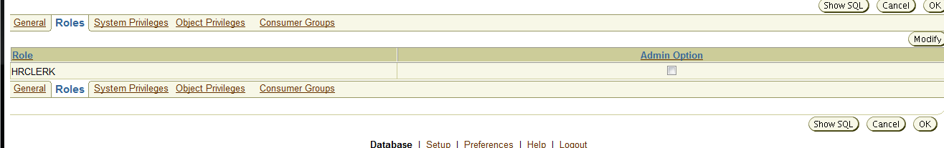

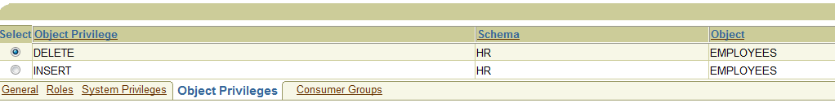
5)
-Create an account for David Hamby (DHAMBY), a new HR clerk. His profile is HRPROFILE, his password is newuser
and this one expires immediately.
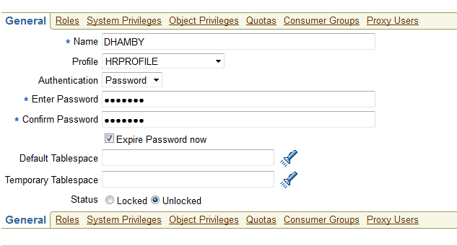

6)
-Create an account for Jenny Goodman (JGOODMAN), the HR new manager. His profile is HRPROFILE, his
password is newmanager and this one expire immediately.

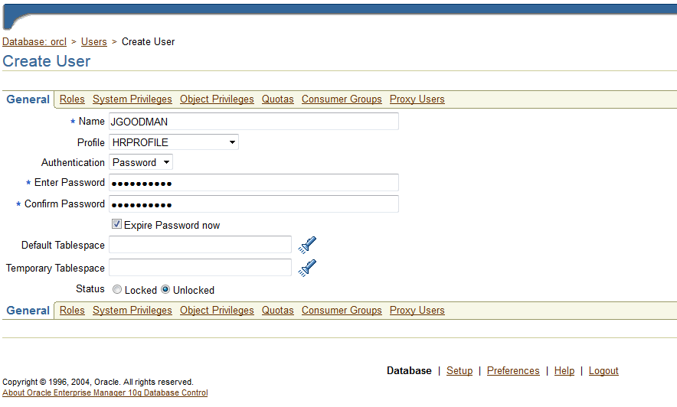
7)
-Connect to the database as user DHAMBY using SQL*Plus. Attemps to select from the hr.employees table.
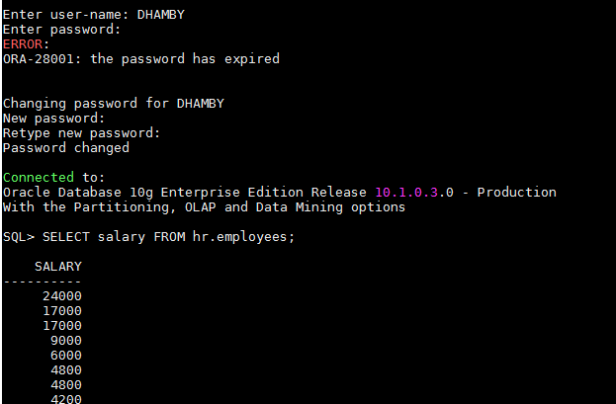

8)
-New attempt to delete a record from the hr.employees table. You may get an error.

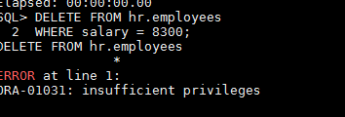

9)
-Connect to the database as JGOODMAN and attempt to select and then delete (employee_id = 143 for example)
from the hr.employees table.
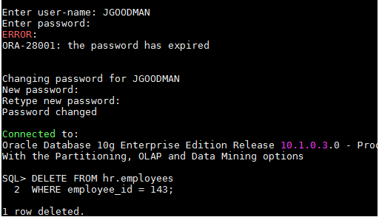

10)
-Roll back the delete operation because this was only a test.

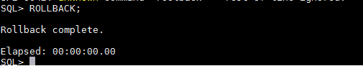

-When you created the new users you did not select a default temporary tablespace. What determines which
tablespaces the new users will use?

Dans le cas où nous avons pas décider d'un tablespace temporaire pour un utilisateur, Oracle va utiliser "TEMP", qui est la tablespace temporaire par défaut:

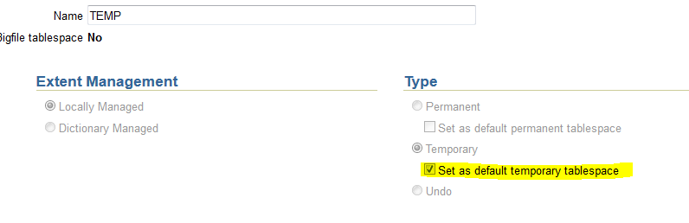

Comme on peut le voir, elle à été défini ainsi.

-You did not grant the CREATE SESSION system privilege to either of the new users, but they can both connect to
the database. Why?

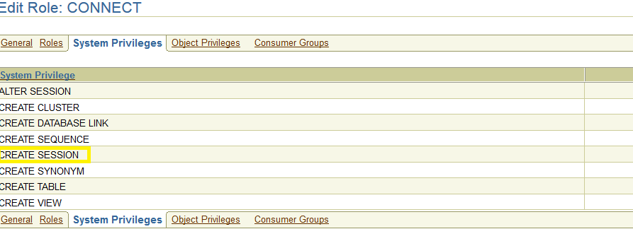
Quand nous créons un utilisateur, il obtient le rôle de "connect" par défaut.
Ce rôle possède un ensemble de privilièges, comme celui de "create session", par exemple.

-Create a new user account to own database objects for a new inventory application. The username should be
INVENTORY with a password of verysecure. Make the user’s default tablespace the INVENTORY tablespace.
Grant the user the CONNECT and RESOURCE role. Also give him the UNLIMITED_TABLESPACE system privilege.

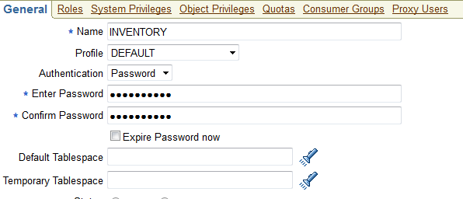

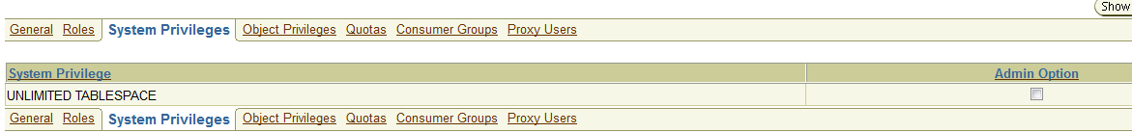
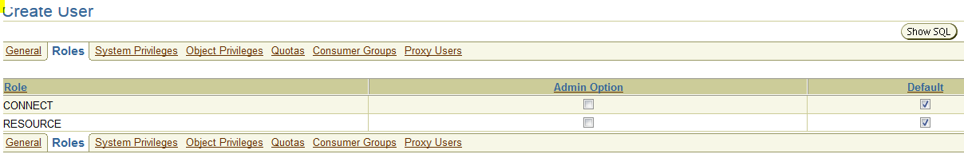
-Leave one of the new users (RPANDYA) connected to the database during the next lesson. Verify that the user is
automatically logged out after fifteen minutes.

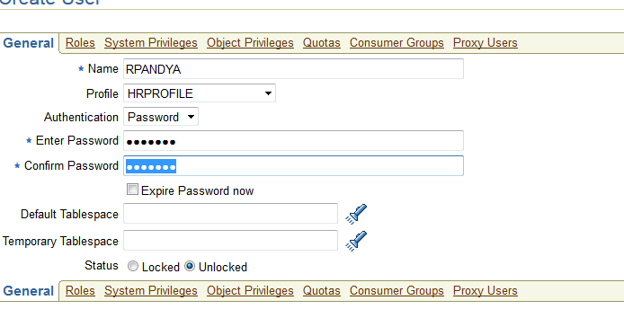
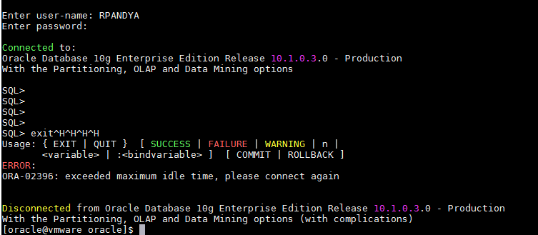
5)Managing Schema Objects

1)
-In the INVENTORY tablespace, create the PRODUCT_MASTER table, in the INVENTORY schema, using Enterprise
Manager.

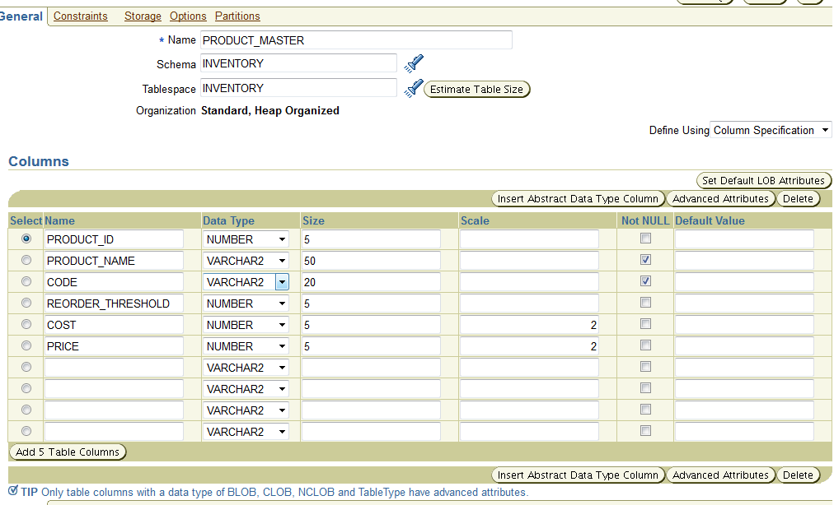

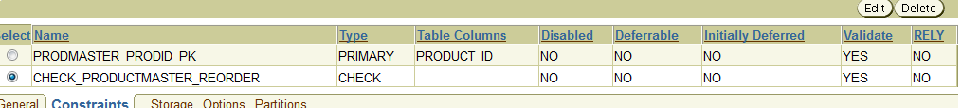

2)
-In the INVENTORY tablespace, create the PRODUCT_ON_HAND table, in the INVENTORY schema.

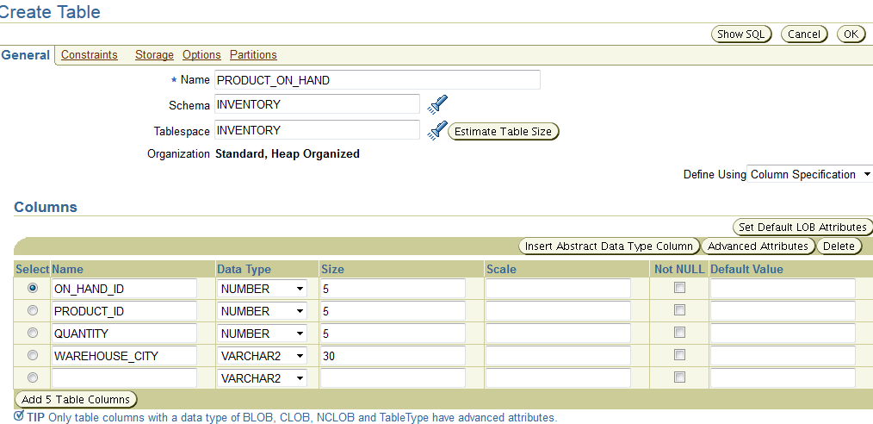
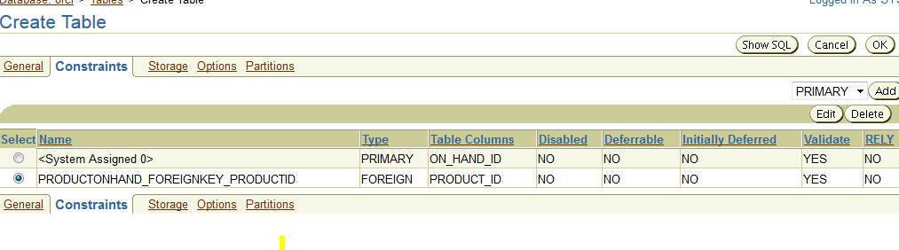
3)
-Then create the OBSOLETE_PRODUCTS table.
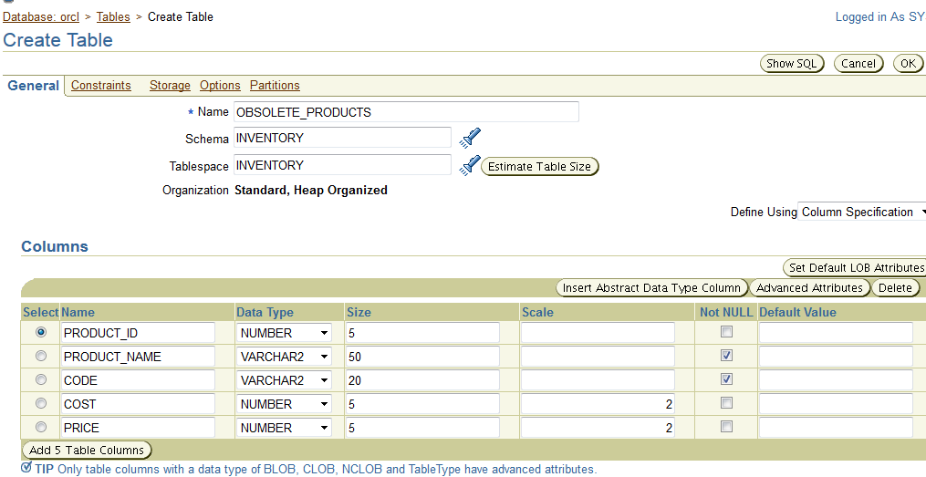
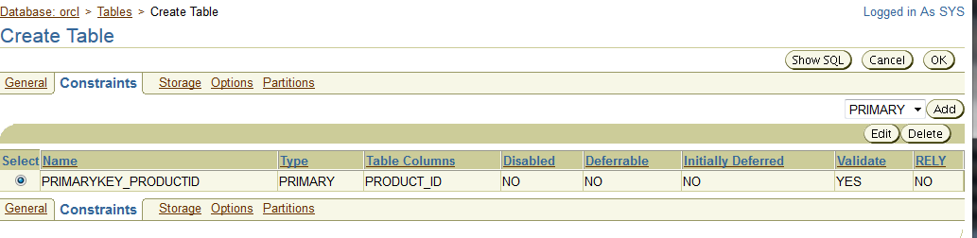
4)
-In the INVENTORY tablespace, create an index on the PRODUCT_NAME and CODE columns of the
PRODUCT_MASTER table in the INVENTORY schema.

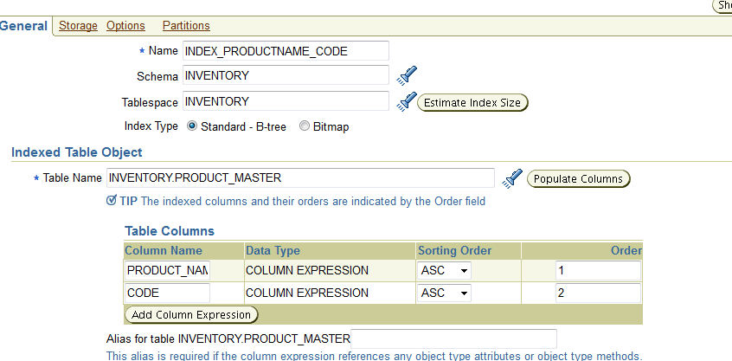
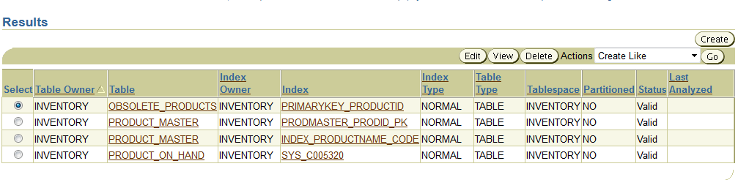
-When you click OK to create the index, you switch to a list of indexes for the INVENTORY schema. Why are there
four indexes when you’ve created only one?

En plus de l'index que je viens de créer, trois indexes ont étés créer lorsque j'ai rajouté les contraintes "clé primaire" et "clé étrangère". Elles portent le nom que j'avais indiqué lors de la création des clés, sauf "SYS_C005320", qui concerne la clé primaire sur la table PRODUCT_ON_HAND, dù à un oubli d'avoir préciser un nom.

5)
-Create an index on the PRODUCT_ID and QUANTITY columns of the PRODUCT_ON_HAND table.

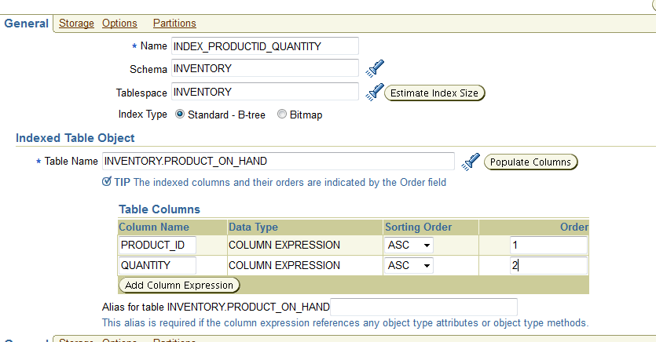

6)
-You receive an update of the inventory application that requires you add two columns to the PRODUCT_MASTER
table:
PRIMARY_SOURCE of datatype VARCHAR2(50)
SECONDARY_SOURCE, VARCHAR2(50).

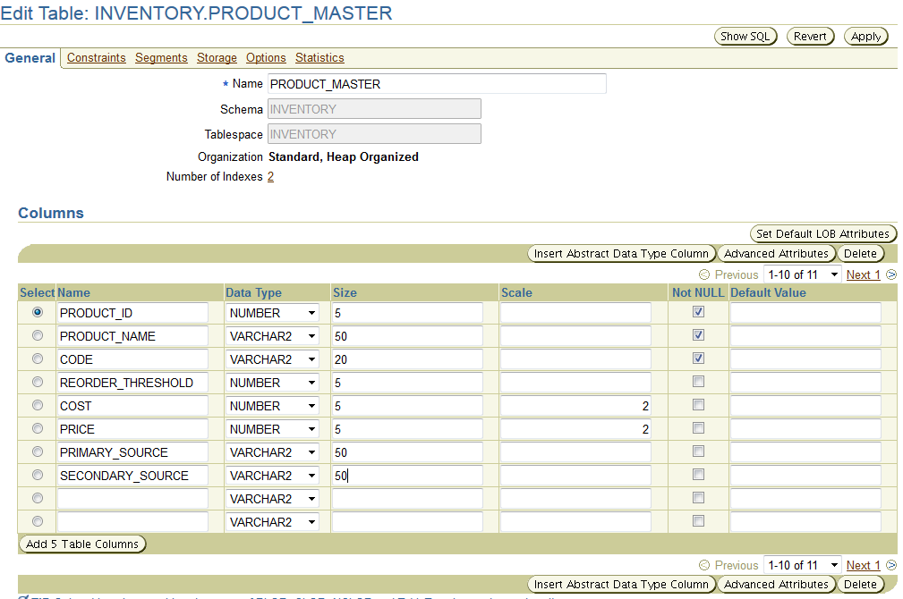
7)
-The inventory application also requires you add the column LAST_UPDATE of datatype DATE in
PRODUCT_ON_HAND table.

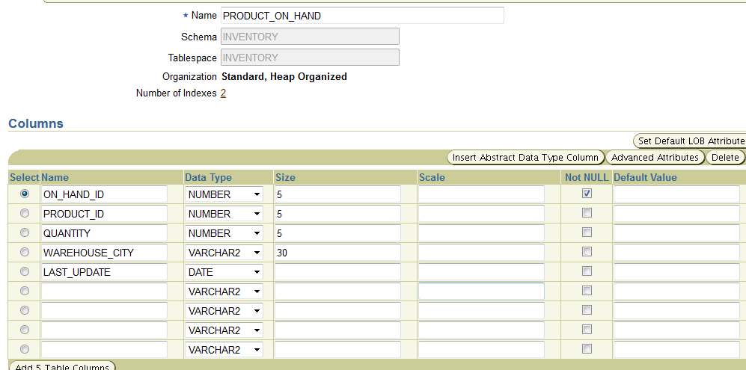

8)
-Add a column named OBSOLETED of datatype DATE to the OBSOLETE_PRODUCTS table.

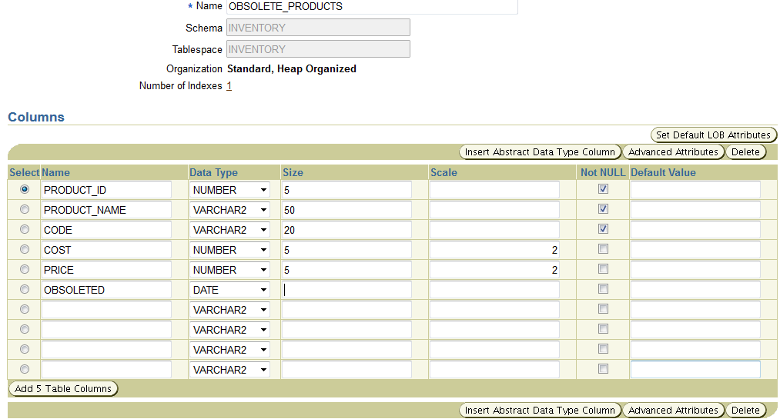

9)
-You receive another update for the inventory application. This update instructs you to drop the
OBSOLETE_PRODUCTS table and add a column OBSOLETED to the PRODUCT_MASTER table.

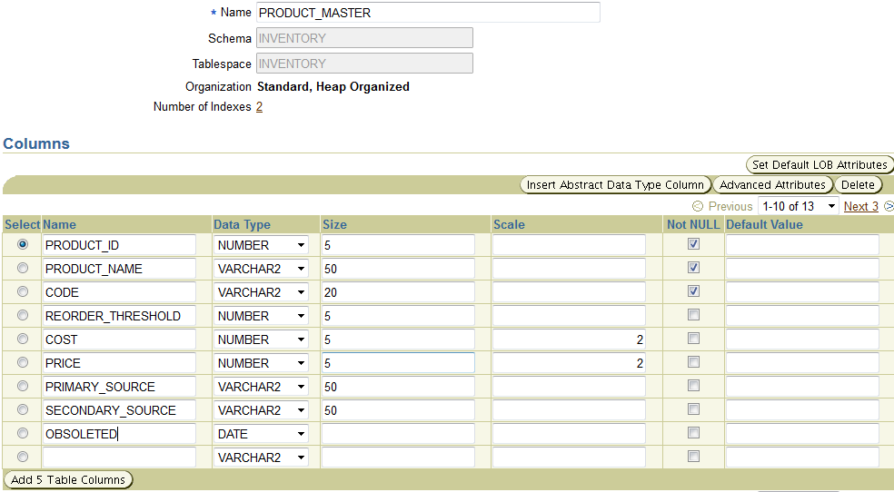

10)
-Then, you have to create a view named WAREHOUSE_VW that shows (in order):
The name of the product (product_name)
The amount of the product on hand (quantity)
The warehouse city name (warehouse_city)

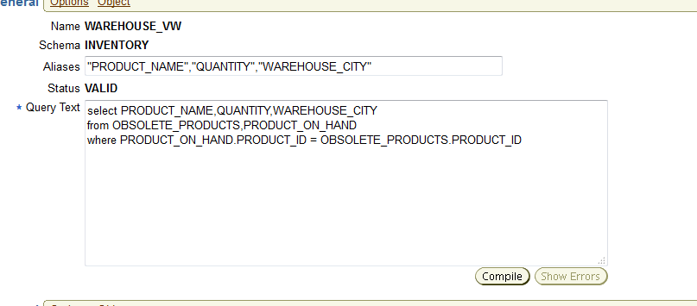

6)Manipulating Database Data

6.1) data pump

1/2/3)
-Create a directory to be used by Data Pump.
-Using SQL*Plus, log on to your instance as user SYSTEM and create a table to be used for testing Data Pump.
-Still within SQL*Plus, create the Oracle directory to be used by Data Pump and grant all users permission to read
and write to the directory.

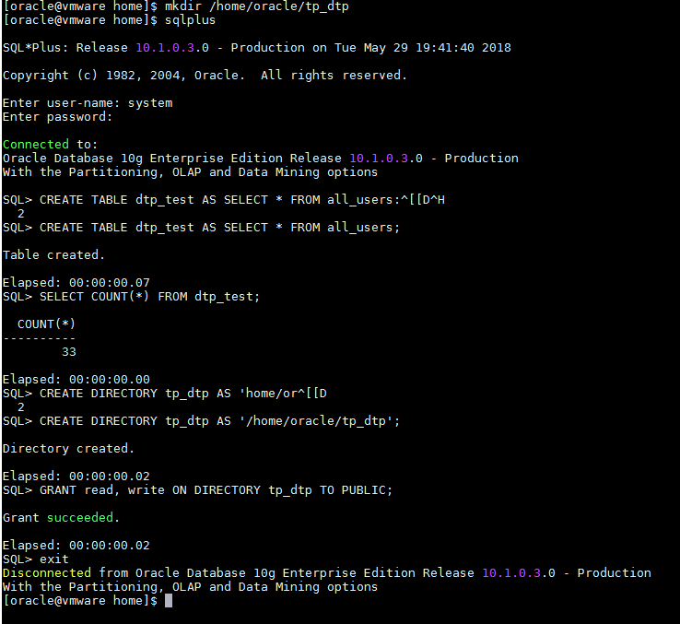

7)
-Select Tables and enter an operating system username and password with read/write permissions on the
directory specified in step 3.

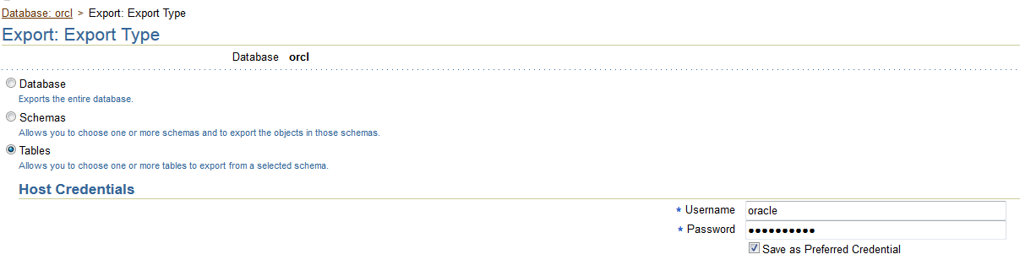

8)
-On the next screen, click Add, and specify SYSTEM as the schema and dtp_test as the table.

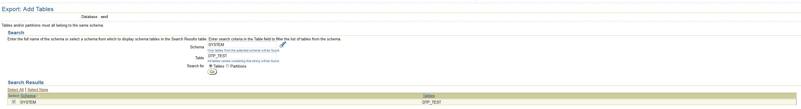
9)
-Then, choose the directory DTP_DIR as the location for the logfile.

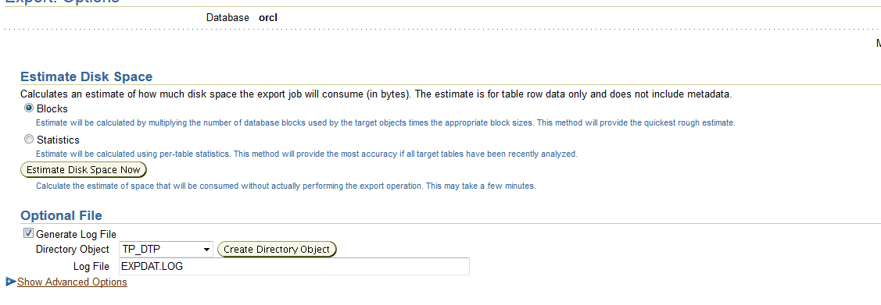

10)
-Choose dtp_dir as the location.
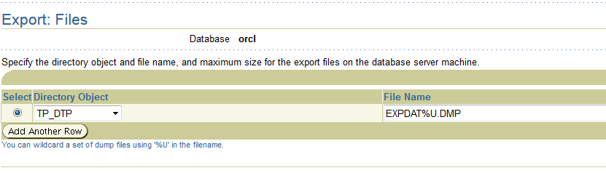

13)
-From an operating system prompt, navigate to the directory specified in step 3. There will be a file
EXPDAT01.DMP, which is the export dump file, and a lagfile, EXPDAT.LOG. Examine the logfile to check that the
job did complete successfully.

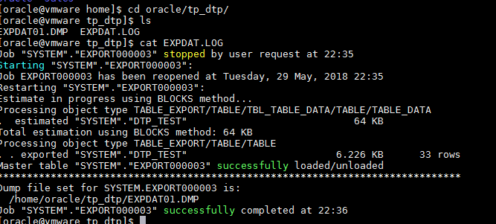

6.2) SQL loader

1)
-Use the control file lab_12_a.ctl to load data from the text file lab_12_a.dat into the PRODUCT_MASTER
table.
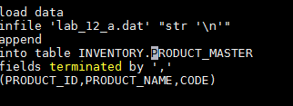

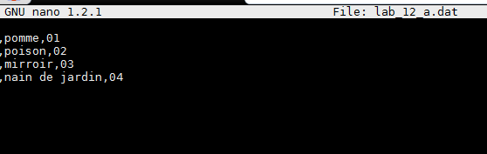

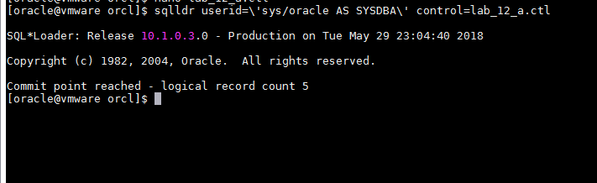
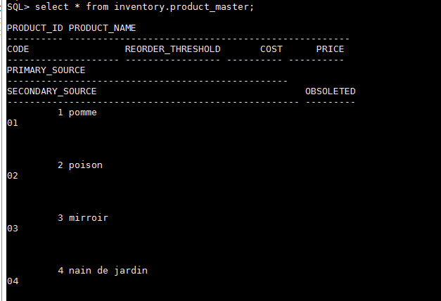

2)
-Use the control file lab_12_f.ctl to load data from the text file lab_12_f.dat into the
PRODUCT_ON_HAND table.

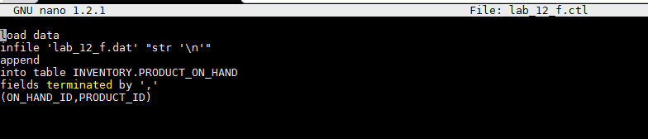
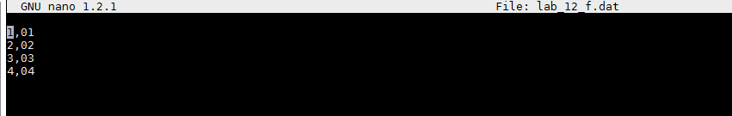
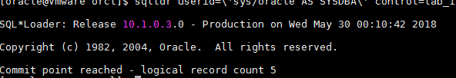

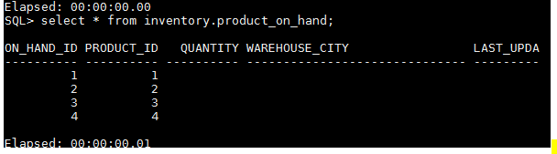

7)Creating and Using Pasword Profiles

3/4)
-Click Create to reach the Create Profile window, and enter STRICT as the profile name. Take the Password link to
reach the password controls window.
-Set limits for your STRICT profile. Users assigned to this profile will have to change their passwords after two
weeks, and they will have three days to do so. A password can only ever be used once, and after two failed login
attempts the account will be locked, but only for one minute.
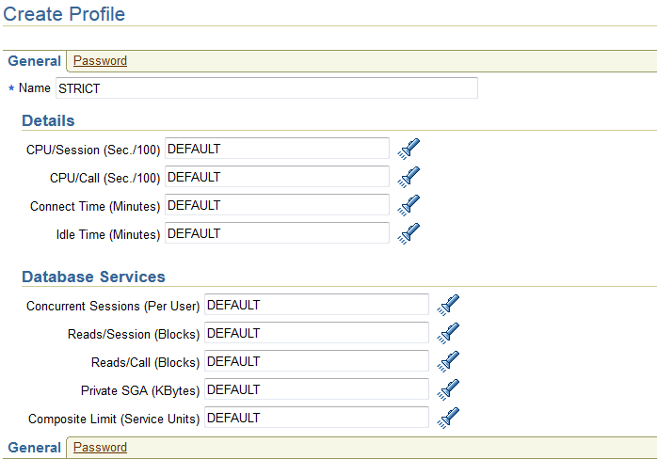

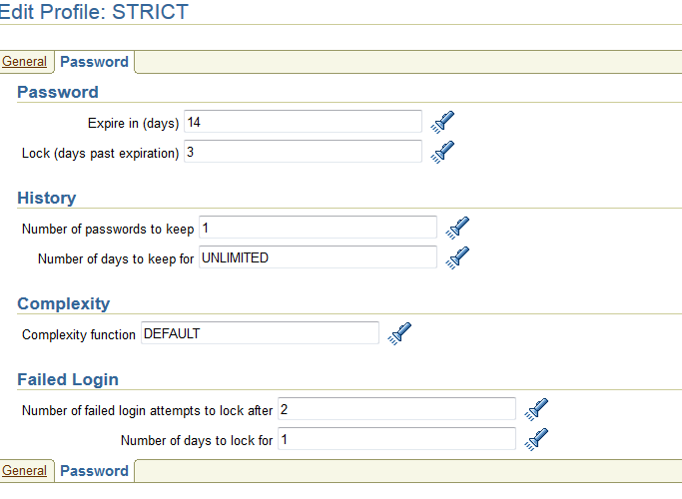

9)
-In the Edit User: SYSTEM window, select the STRICT profile and expire the password.
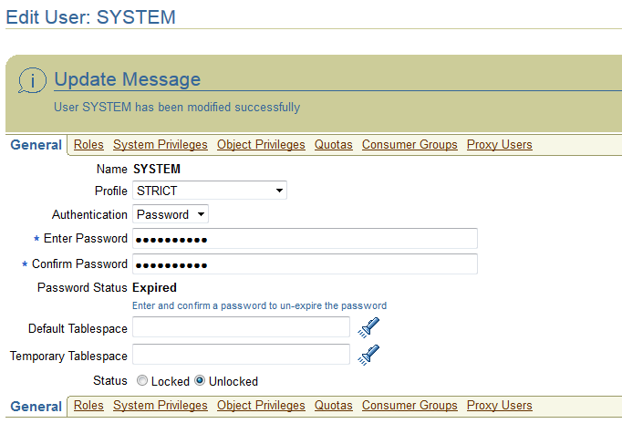
13)
-Attempt to change the password to the value it is already.

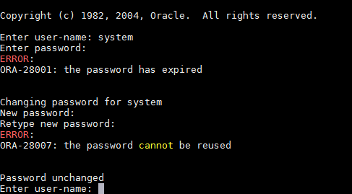

15)
-Attempt to connect three times with the wrong password. At the third attempt, you will be told that the account
is locked. Wait at least one minute, and then connect with the correct password.

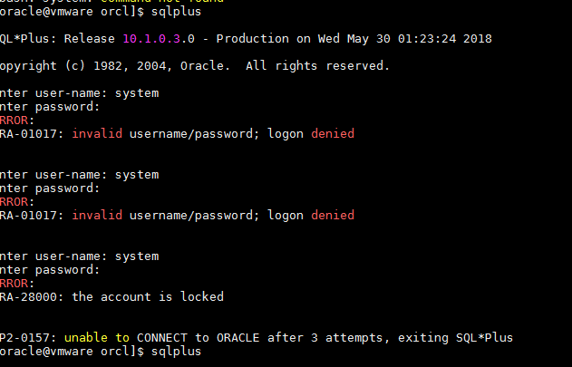
16)
-Tidy up by assigning SYSTEM back to the default profile and dropping the STRICT profile.

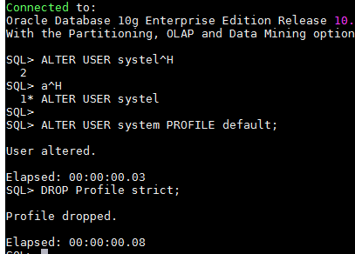

8)Enabling Auditing

2)
-Set the AUDIT_TRAIL instance parameter to enable auditing to the data dictionary. As this is a static parameter,
you must use the SCOPE clause and restart the instance.

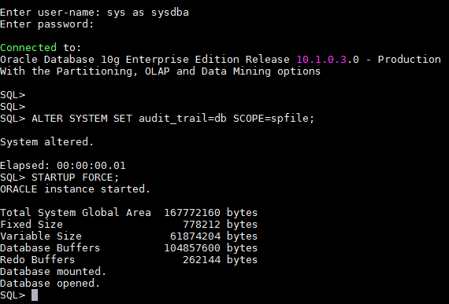

4)
-Create a table and insert some rows.

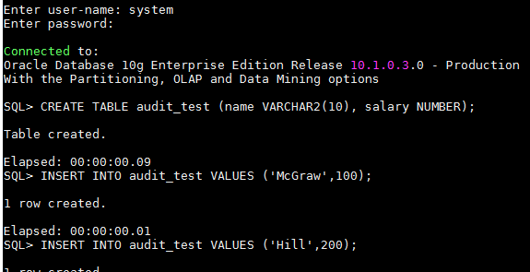

5)
-Enable database auditing of access to the table.

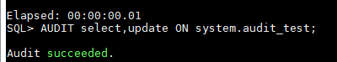

6)
-Execute some statements against the table.

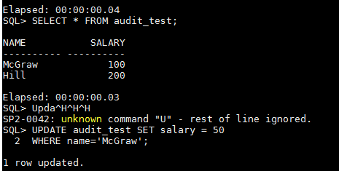

7)
-Query the DBA_AUDIT_TRAIL view to see the results of the auditing.

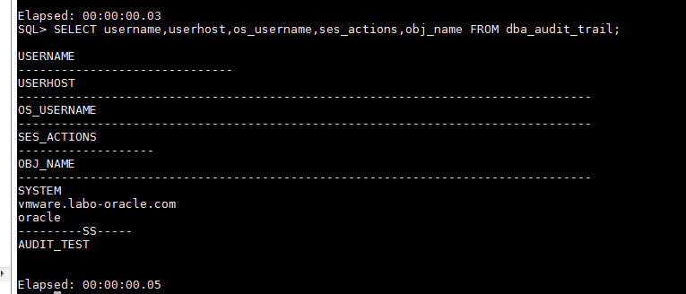
8)
-Create an FGA policy to capture all SELECTs against the AUDIT_TEST table that read the SALARY column, if the
salary retrieved is greater than 100.

9)
-Run some queries against the table.

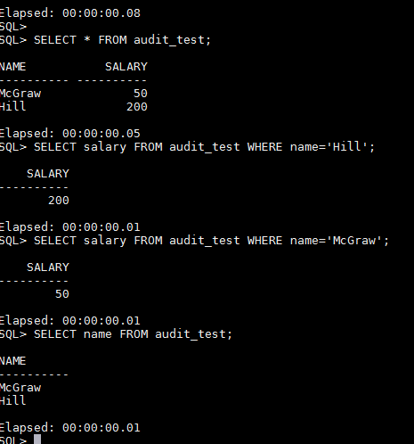

10)
-Query the fine-grained audit trail.

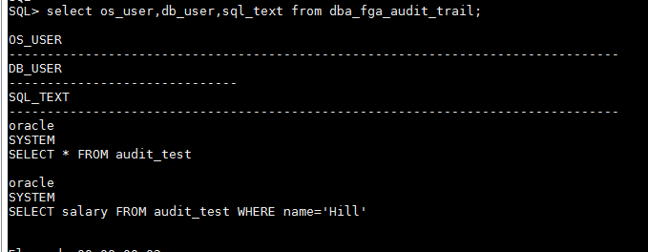

11)
-Tidy up by canceling the database auditing, dropping the FGA policy, and dropping the table.

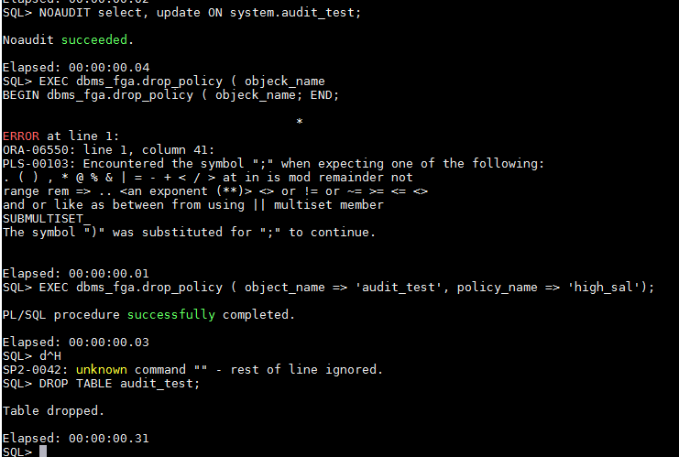
9)monitoring and Management
9.1)Managing Database Performance
9.1.1)Repairing Invalid Objects

2)
-Create a user TESTUSER to be used for this exercise; grant him the DBA privilege.

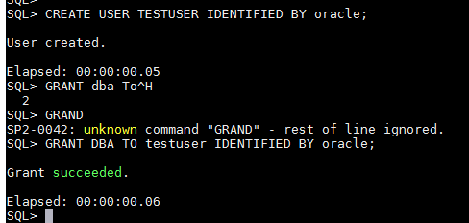

3)
-Connect as TESTUSER, and create some objects.

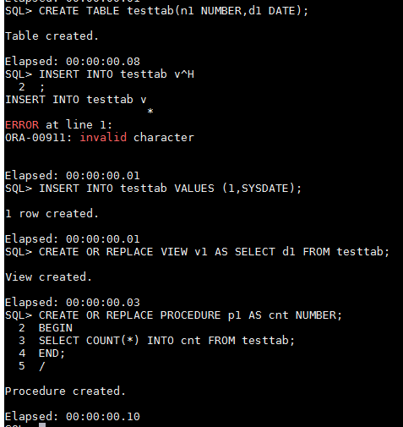

4)
-Confirm the status of the objects.

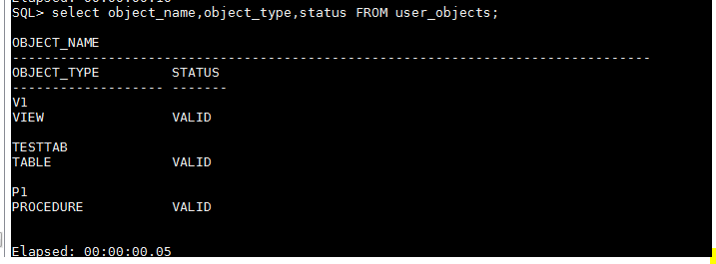

5)
-Perform a DDL command on the table.

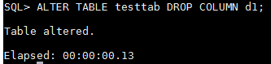

6)
-Re-run the query from step 4. Note that both the procedure and the view are now INVALID.

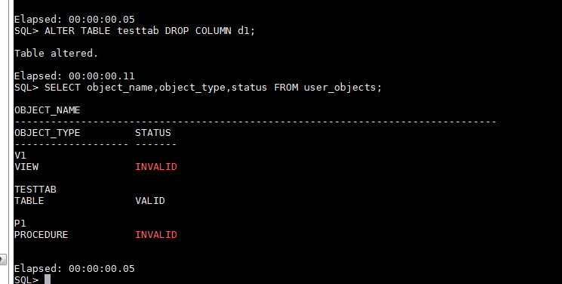
7)
-Recompile the procedure.

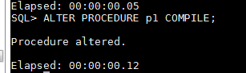

8)
-Re-compile the view.

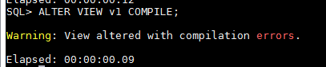

9)
-To diagnose the problem, query the DBA_DEPENDENCIES view.

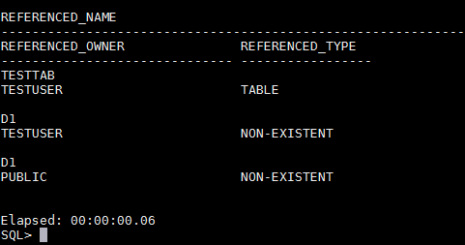

10)
-To pinpoint the exact problem, retrieve the code on which the view is based.

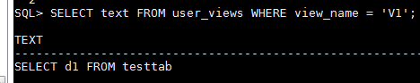

11)
-To fix the problem, add the column back to the table and recompile.

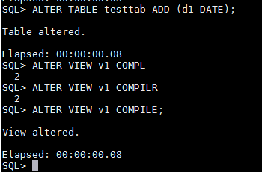

12)
-Confirm that all the objects are now valid by re-running the query from step 4.

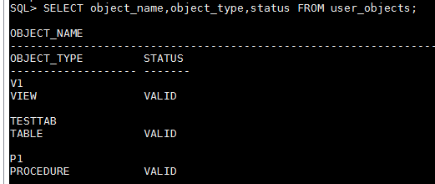

13)
-Tidy up by dropping view and procedure.

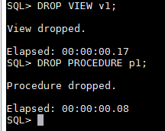

9.1.2)Repairing Unusable Indexes

1)
-In your SQL*Plus session, connect as TESTUSER and create two indexes.

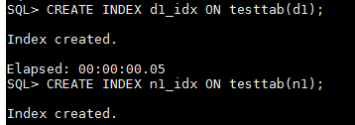

2)
-Confirm the index creation and status. Both will be VALID.

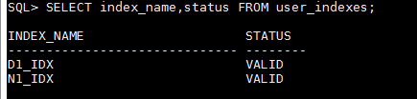

3)
-Move the table.

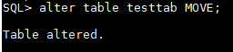

4)
-Run the query from step 2 again. The move of the table, which changed any rowids, will have rendred
the indexes unusable.

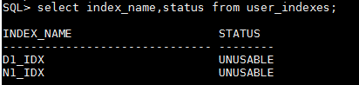

5)
-Rebuild one index, using the NOLOGGING and ONLINE options.

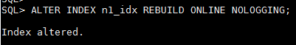

8)
-In the Search section of the Indexes window, enter TESTUSER as the Schema, and click Go. This will show
the two indexes on the TESTTAB table, one of which, D1_IDX, is still unusable.
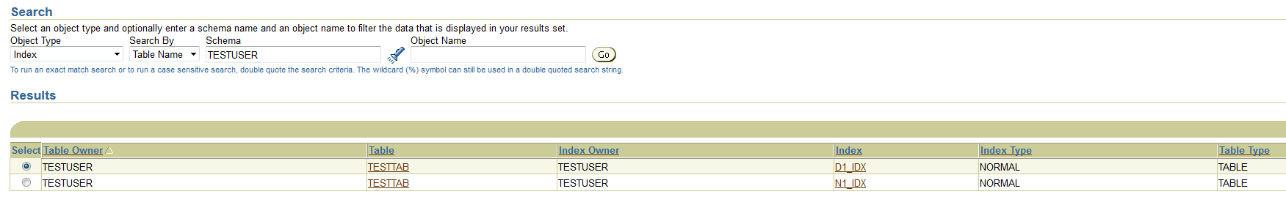

9)
-Select the radio button for the unusable index, select Reorganize in the Actions drop-down box, and click Go to
launch the Reorganize Objects Wizard.
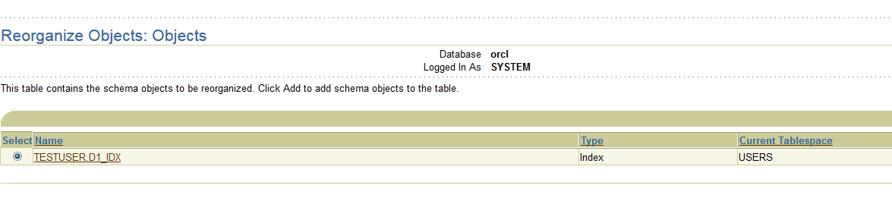

10)
-Click Next, leave all the options on default, and click Next again to generate the reorganization script and reach
the Impact Report window. This should confirm that there is sufficient free space for the operation to proceed.
Click Next to proceed.

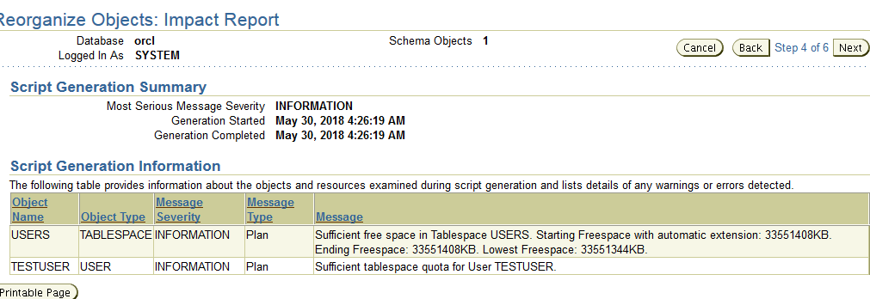

11)
-On the Reorganize Objects: Schedule window, leave everything on default to run the job immediately, and click
Next to reach the Review window.

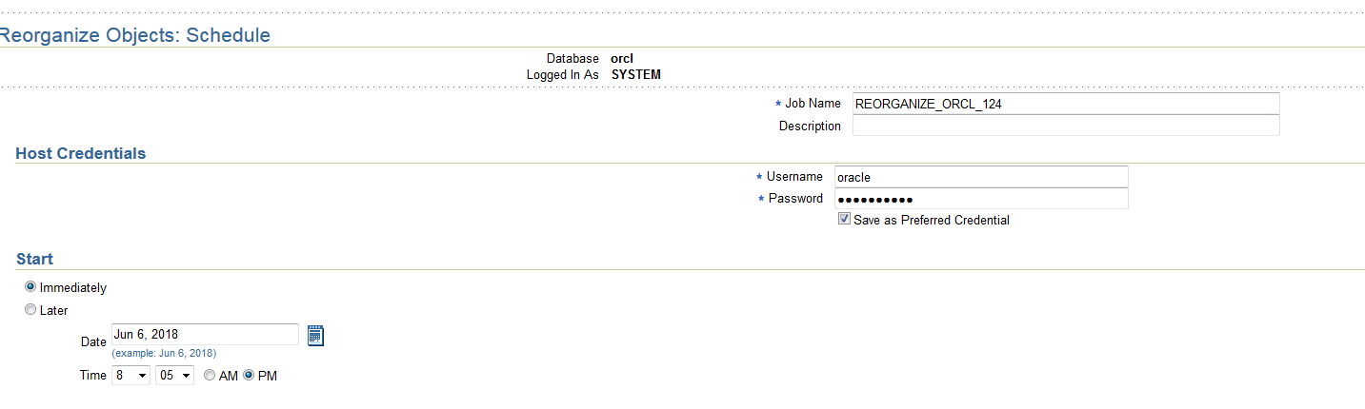

12)
-In the Review window, click Submit Job to rebuild the index
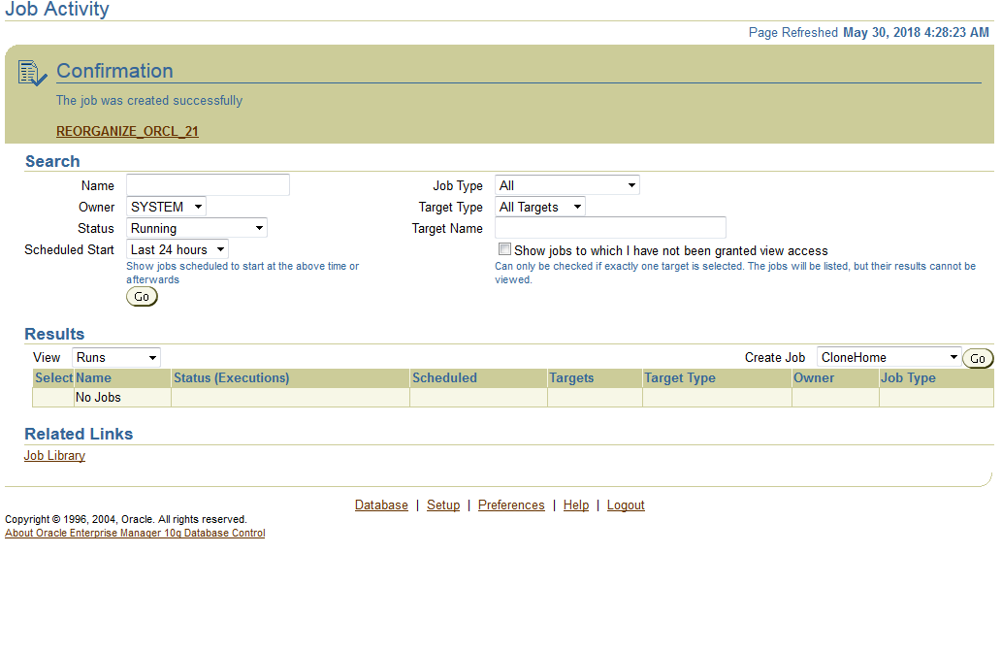
13)
-In your SQL*Plus session, confirm that the index is now valid by running the query from step 2.

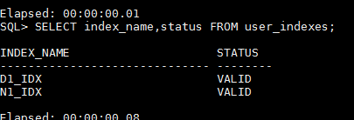

9.1.3)Automating Statistics Collection
3/4)
-Click Create to reach the Create Job window. In the Credential section, enter the Name as Analyze
testtab, and leave everything else on default.
-In the Command section, replace the sample code.
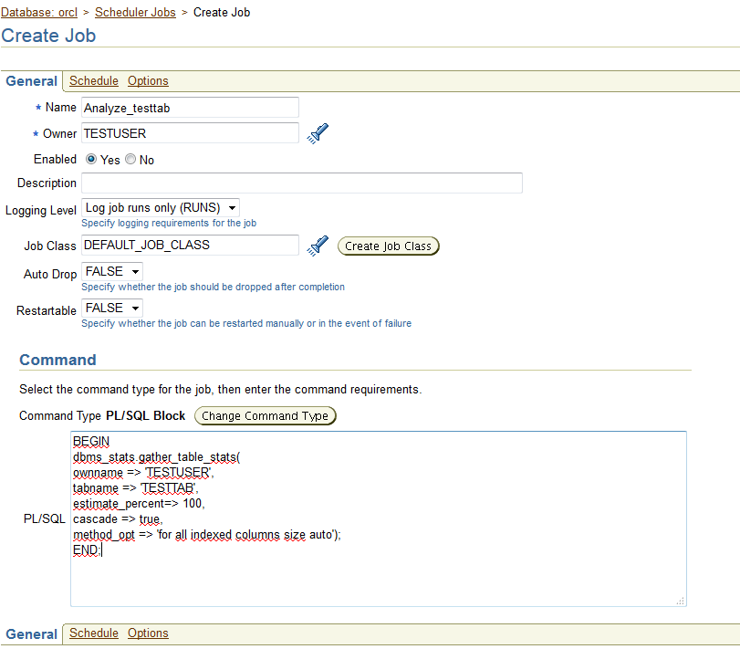

5)
-Take the Schedule link to reach the Schedule window. Leave everything on default, to run the job once only right
away, and return to the Scheduler Jobs window.

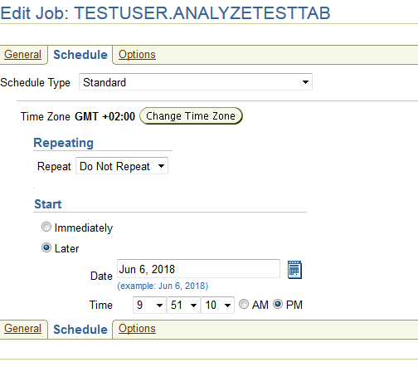

6)
-Take the Run History link, and you will see that the job has succeeded.

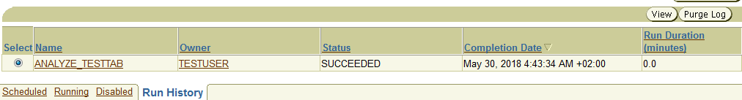
7)
-In your SQL*Plus session, set your NLS_DATE_FORMAT session parameter to show the full time and confirm that
statistics were indeed collected.

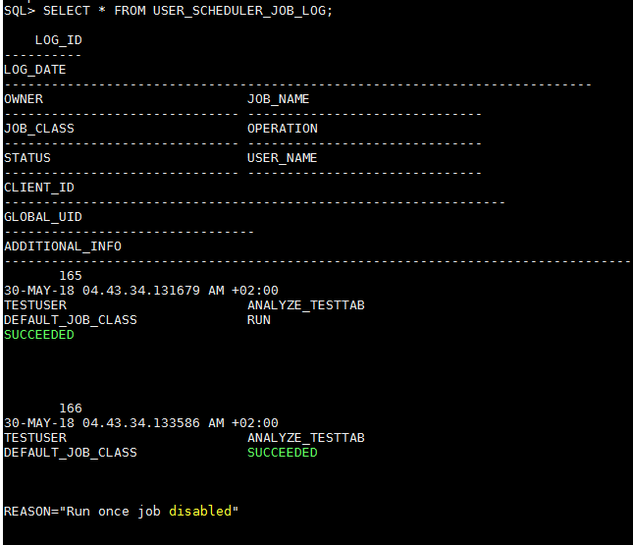
8)
-Tidy up by connecting as user SYSTEM and dropping the TESTUSER schema.

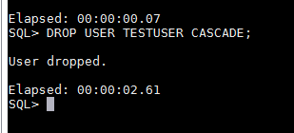

9.2) Monitoring Oracle
9.2.1) Generating an ADDM Report

2)
-Force the creation of an AWR snapshot.

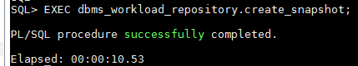

3)
-Simulate a workload by creating a table and running this anonymous PL/SQL block to generate some activity.

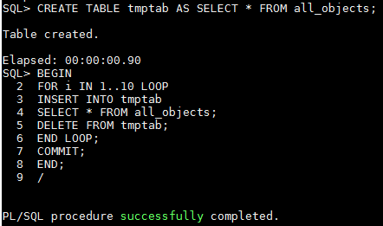

4)
-Repeat the command from step 2 to generate another snapshot.

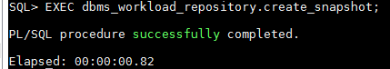

7)

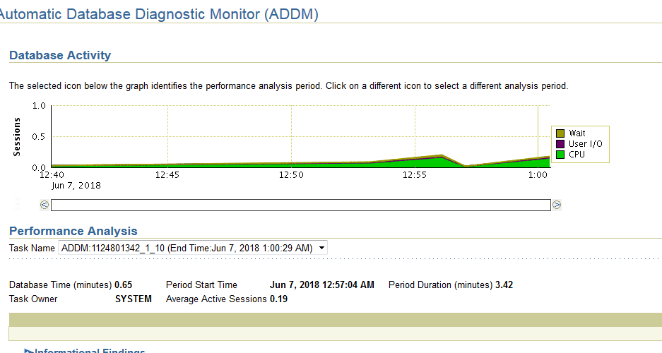
9)
-Tidy up by dropping the TMPTAB table.

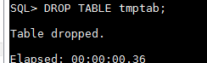

9.2.2)Configuring Alerts
4)
-Scroll down to the “User Commits (per second)” alter, and set the warning and critical value to 1 and 4.
These are artificially low thresholds that it will be simple to cross. Click OK to save this change.

5)
-Connect to your database as user SYSTEM with SQL*Plus, and issue the COMMIT command a few times
quickly.

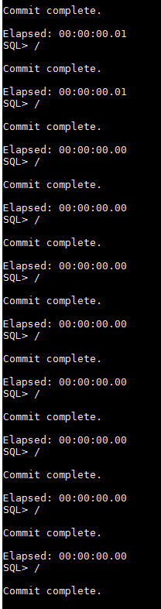

10)Managing Undo
10.1)Creating an Undo Tablespace with Database Control

4/5/6/7)
-Enter UNDO2 as the tablespace name, and set the radio buttons to Extent Management “Locally Managed”, Type
“Undo”, and Status “Read Write”.
-At the bottom of the screen, click Add to specify a datafile.
-Enter UNDO2-01.DBF as the File Name, leave everything else on default, and click Continue.
-On the Create Tablespace screen, click Show SQL, and study the statement used to create your undo tablespace.
Click Return to return to the Create Tablespace screen, and click OK to create the tablespace.

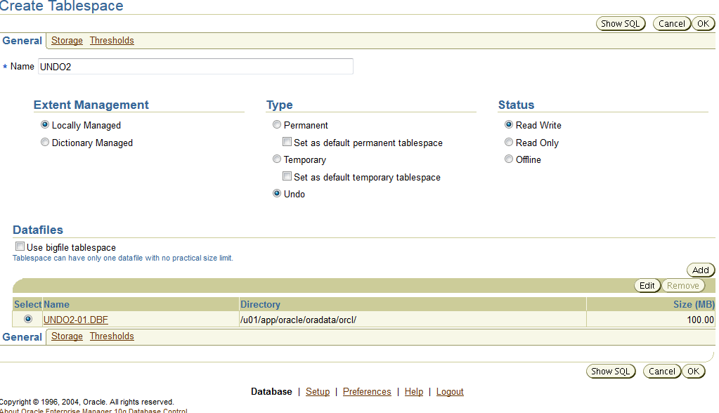
9)
-Run this query, which will return one row for each tablespace in your database, and note that your new
tablespace has contents UNDO, meaning that it can only be used for undo segments, and that retention is
NOGUARANTEE, a topic covered shortly.

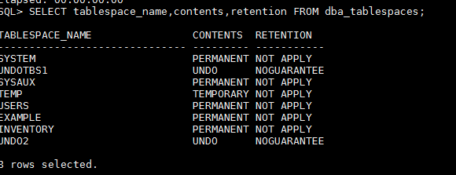

10)
-Run this query, which will return one row for each rollback or undo segment in your database, and note that a
number of undo segments have been created automatically in your new undo tablespace, but that they are all
offline. Also note that the names of the automatic undo segments are in the form of “_SYSSMUn$”, where n is
the undo segment number (usn).

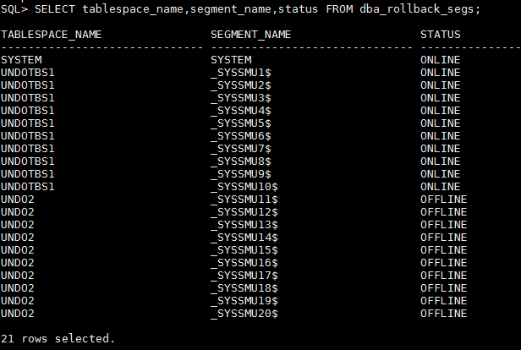

10.2)Monitoring Undo With SQL*Plus

2)
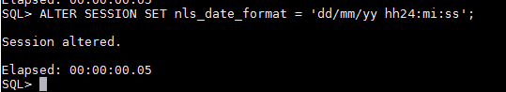
-Set up your session for displaying dates conveniently.

3)
-Query V$UNDOSTAT.
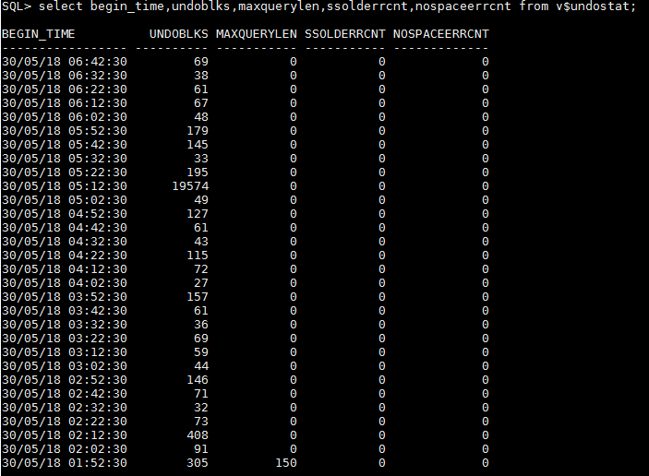
5)
-Calculate the minimum necessary size in bytes for your undo tablespace that will prevent errors, given your
current activity data.

11)Backup and Recovery
11.1)Configuring the Database for Backup and Recovery

2)
-Disable checkpoint tuning by setting the FAST_START_MTTR_TARGET parameter to zero.

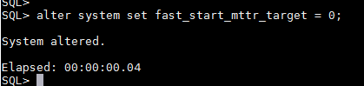

3)
-Simulate a workload by creating a table and starting a transaction.

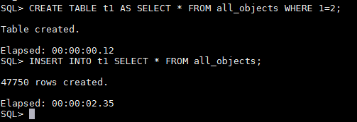

4)
-Run a query to see how much work would be required to recover the instance if it crashed right now.

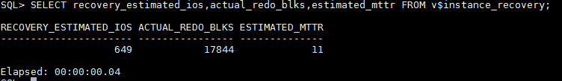
6)
-Commit the transaction, and re-run the query from Step 3. Note that nothing much has changed: COMMIT has no
effect on DBWn and will not advance the checkpoint position.

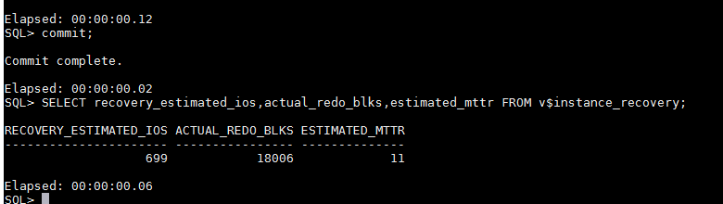
7)
-Issue a manual checkpoint.

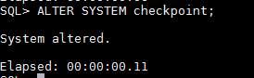

8)
-Re-run the query from Step 4. Note that the RECOVERY_ESTIMATED_IOS and ACTUAL _REDO_BLKS columns have
dropped substantially, perhaps to zero. The ESTIMATED_MTTR column may not have reduced, because this
column is not updated in real time.

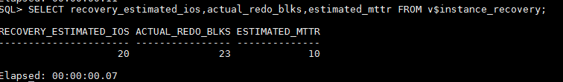

9)
-Tidy up by dropping the table.

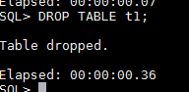

11.2) Backing Up an Oracle Database
11.2.1)Part One

2)
-In the Backup Strategy drop-down box, select Customized and click the Whole Database radio button. In the
Host Credentials section, enter an operating system username and password. Click Next to reach the Schedule
Backup: Options window.

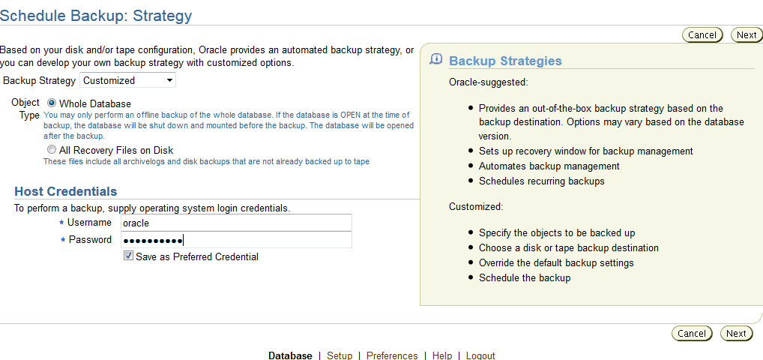

3)
-Leave everything on defaults: a full, online backup with all archive logs. Click Next to reach the Schedule Backup:
Settings window.
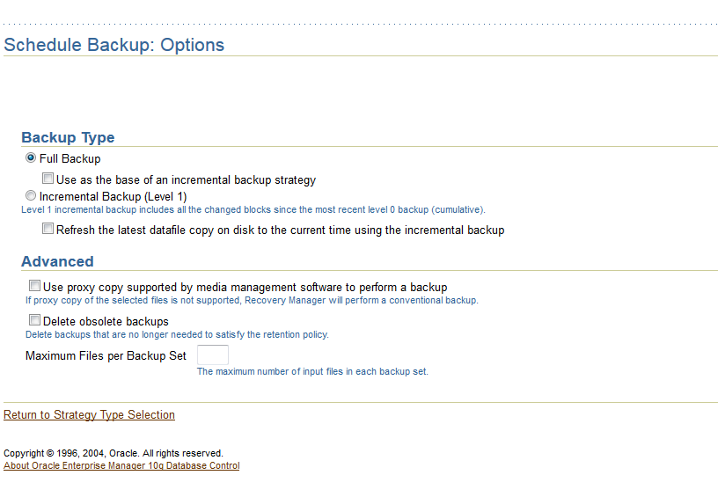
4)
-Leave everything on default to schedule a disk backup to your flash recovery area directory. Click Next to reach
the Schedule Backup: Schedule window.
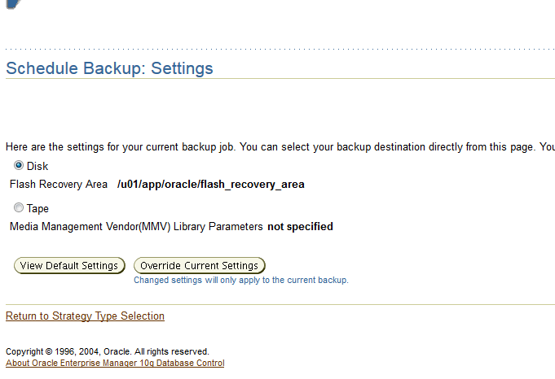

5)
-Leave everything on default to run the backup immediately as a one-off job. Click Next to reach the Schedule
Backup: Review window.

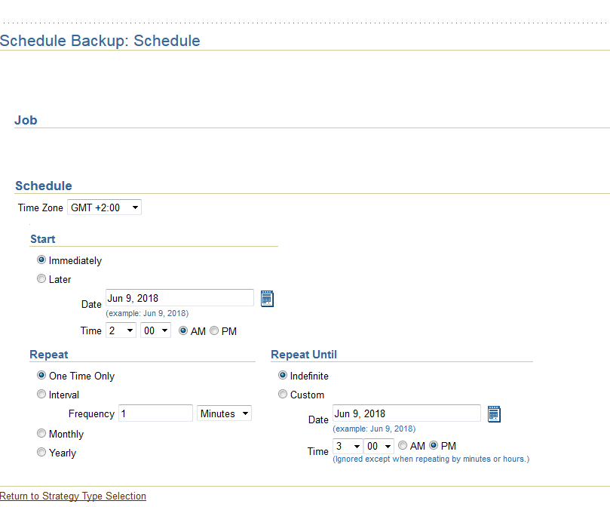

6)
-Click the Submit Job button to launch the backup.

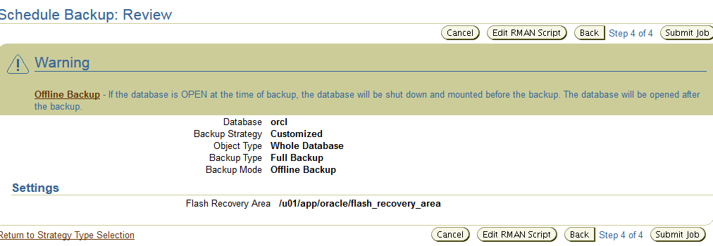

7)
-Click the View Job button to check how the job is running, and then refresh the browser window to monitor
progress.

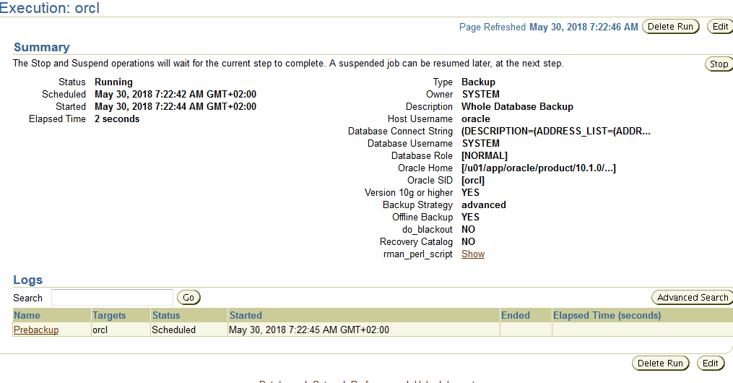
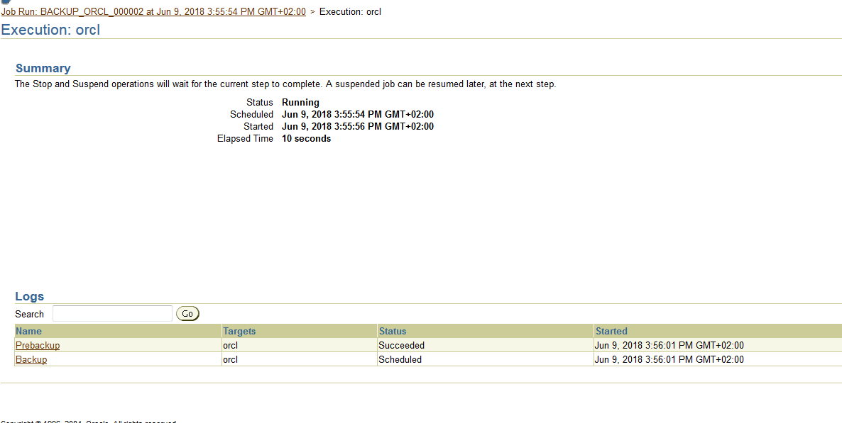

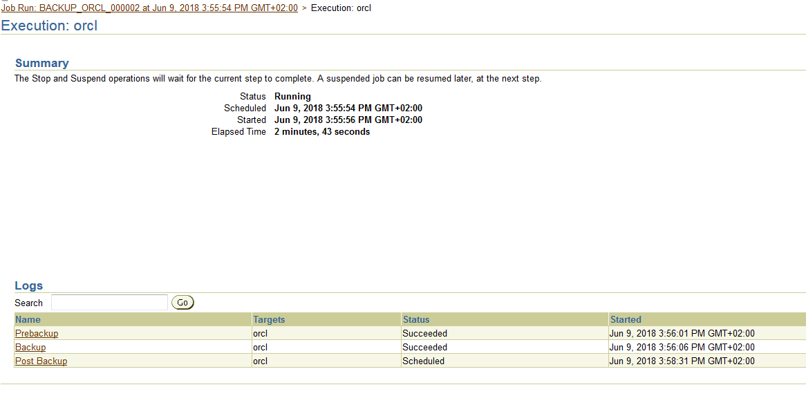

11.2.2)Part Two

2)
-Issue this command:

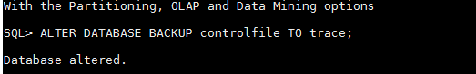

3)
-Locate your user dump destination.

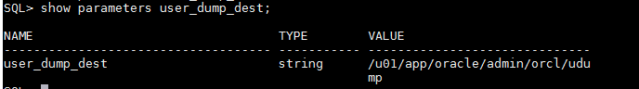

5)
-Identify the newest file in the directory.Open the trace file with any editor you please and study the contents.

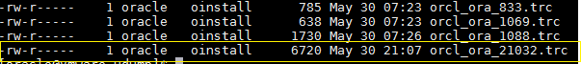

11.3)Recovering Oracle Databases
11.3.1)Part One

1)
-Connect to your database with SQL*Plus, and ensure that your controlfile is multiplexed.

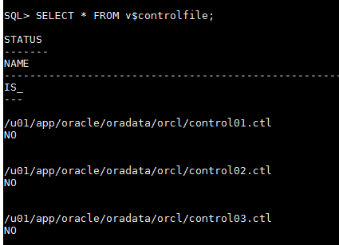

3)
-Issue a startup command. The startup will stop in nomount mode, with an “ORA-00205: error in identifying
controlfile, check alert log for more info” error message.

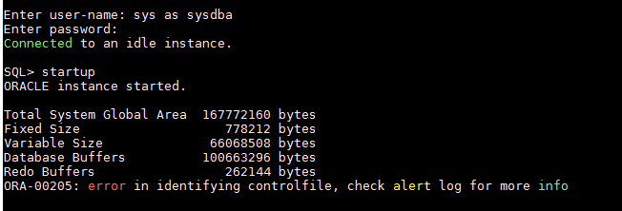

4)
-Copy your surviving controlfile to the name and location of the file you renamed.

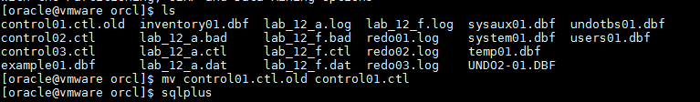

5)
-Issue another startup command, which will be successful.

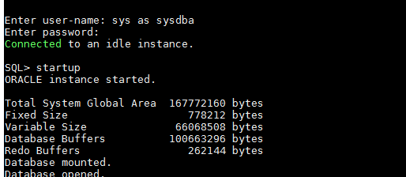

11.3.2)Part Two

2)
-Observe the state of your online logs.

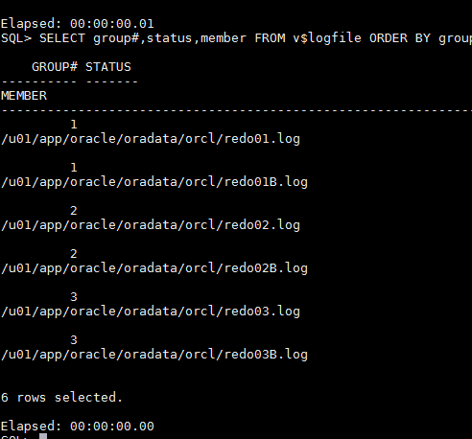

4)
-Shut down the database

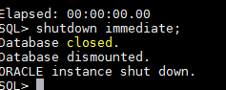

5)
-Using an operating system command, simulate media failure by deleting one of the members.

6)
-Start up the database and simulate user activity by performing a few log switches.

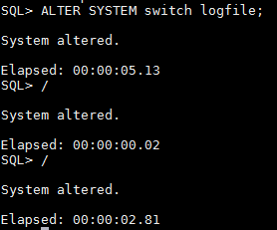

7)
-Check the state of your logfile members.

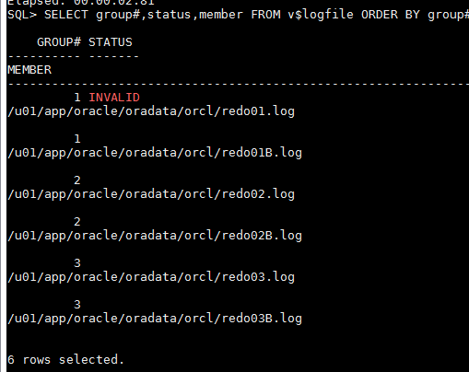

11)
-Clear the logfile group by selecting its radio button using the Clear Logfile choice in the Actions drop-down list,
and clicking Go.

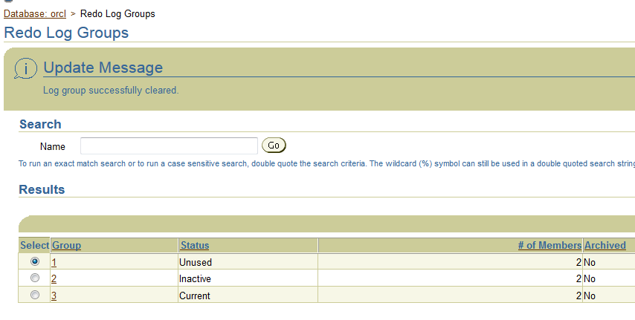

12)
-In your SQL*Plus session, confirm that the problem has been fixed.

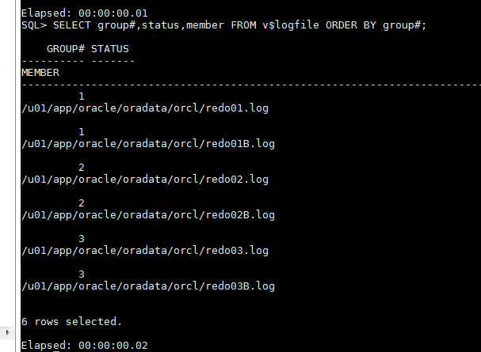

11.3.3)Part Three

1)
-Connect to your database as user SYSTEM using SQL*Plus, and create a tablespace.

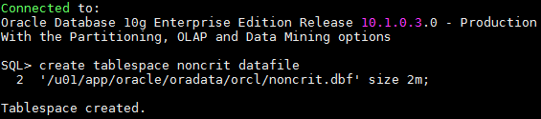

2)
-Create a table within the new tablespace and insert a row into it.
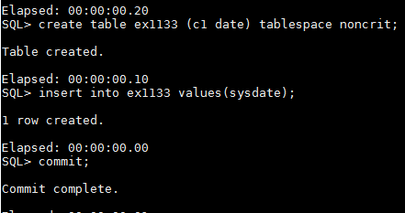

5)
-In the Schedule Backup: Strategy window, select Customized in the Backup Strategy drop-down box.

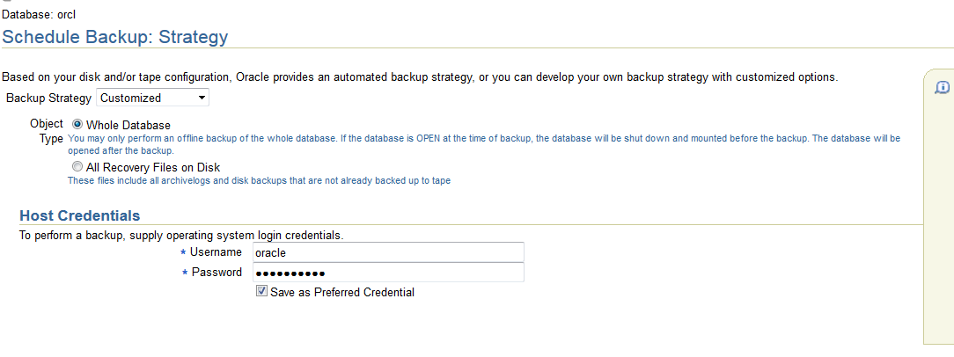

A partir de ce point, je n'ai pas pu malheuresement trouvé une manière de faire un backup des tablespaces. Comme on peut le voir sur la capture d'écran, je n'ai pas d'option pour effectuer la sauvegarde des tablespaces.
Je me suis donc permis de faire un peu de recherche afin de trouver une manière de corriger ce problème. J'ai cru comprendre que il était possible de configurer ces propres backups avec le lien "Configure Backup Settings":

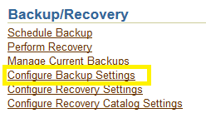

Mais je n'ai pas reussi à trouver une manière de configurer un backup des tablespaces via cette option là.

Cependant, comme on peut voir dans la partie 12 "Recovery manager", il est possible de faire un backup du tablespace avec RMAN et la commande "backup tablespace NONCRIT".

12)recovery manager
12.1)Recovery Manager Configuration

1)
-Connect to your database as the target database in the default NOCATALOG mode as the SYSTEM user.

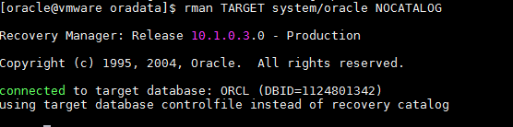

2)
-Use the RMAN SHOW ALL command to generate a listing of the RMAN configuration settings.

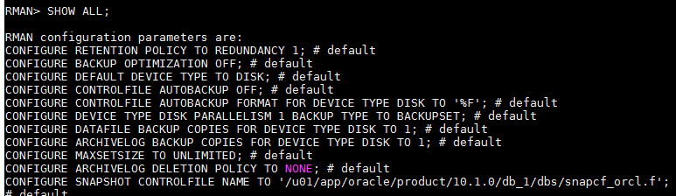

3)
-Configure RMAN to automatically back up the control file and SPFILE whenever a backup of the database or data
files is taken.

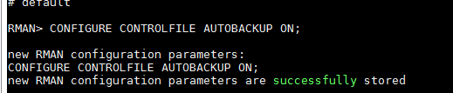

9)
-Choose "Retain backups that are necessary for a recovery to any time within the specified number of days and
specify a value of 2. To save the modified details, entrer the Host Credentials of oracle/oracle and click OK.

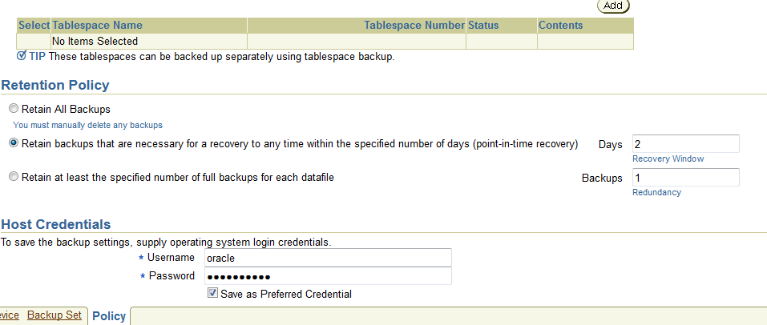
10)
-Verify the backup retention policy setting using the RMAN utility and the SHOW command.

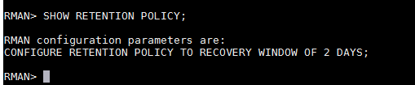

12.2)Using Recovery Manager

4)
-To check using SQL*Plus, use the ARCHIVE LOG LIST command.

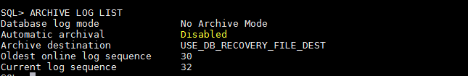

5)
-The database is not currently archiving. Correct this problem with the following commands, or use Enterprise
Manager.

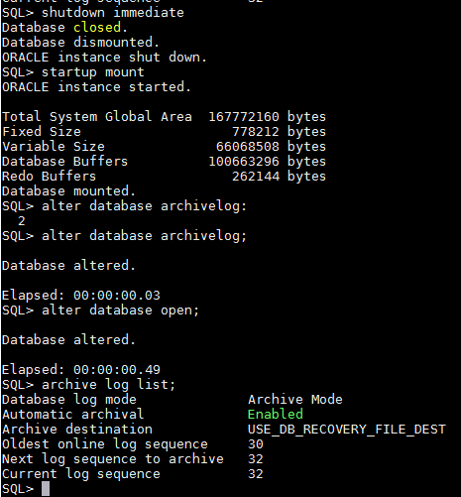

7)
-Use the RMAN REPORT command to generate a listing of your database structure.

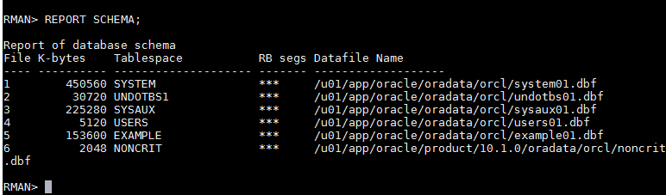

8)
-Obtain a listing of all database backup sets that currently exist.

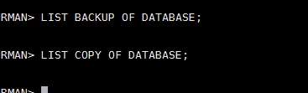

9)
-Use RMAN to back up the data files belonging to the EXAMPLE and USERS tablespaces. Be sure you also make a
copy of the current control file and server parameter file.
Your backups should be placed in the $HOME/DONTTOUCH/ directory and should use the format df_%d_%s_
%p.bak for the file names.

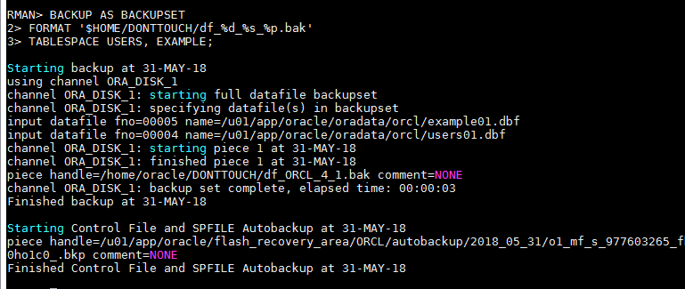
10)
-Create an image copy of two data files. Use the following information:
• Copy the SYSTEM tablespace and name the copy sys01.cpy with a tag of SYSTEM01
• Copy the SYSAUX tablespace and name the copy sysaux01.cpy with a tag of SYSAUX01
• The files should be written to the Flash Recovery Area.

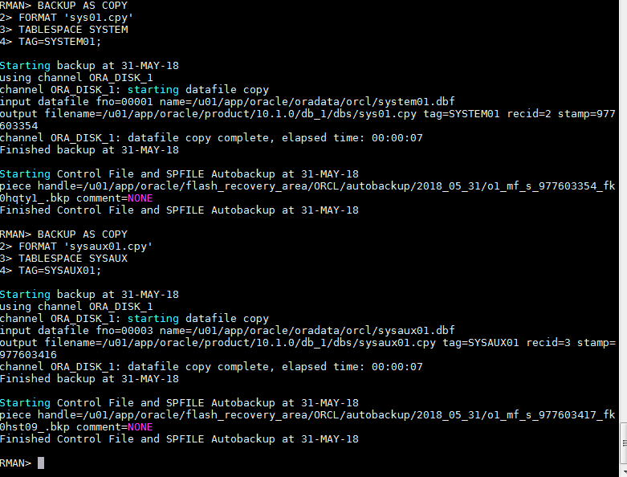

11)
-Obtain a listing of all database files that have not been backed up.

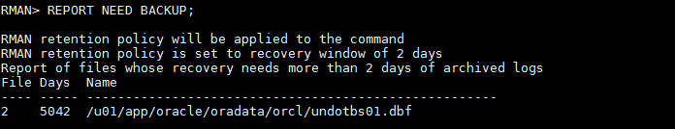
12)
-Take a full backup of the database, including archived logs. Use as little space as possible to store the backup.

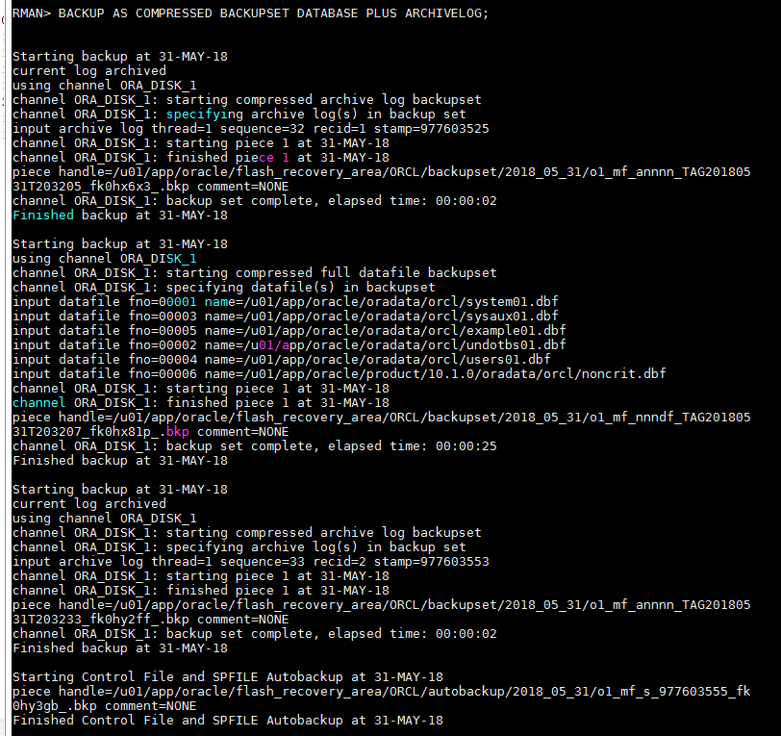

13)Managing Data Recovery

13.1)Recovering from Noncritical Losses

1)
-Get the name of the default temporary tablespace from the DATABASE_PROPERTIES view and the data files
associated with this tablespace from DBA_TEMP_FILES.

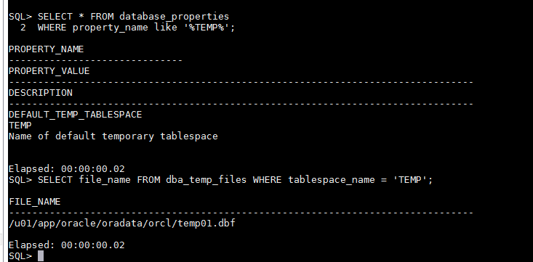

2)
-Delete the temporary tablespace data files at the operating system level.

3)
-Connect to the database as a SYSDBA user, shutdown the instance, and restart it.

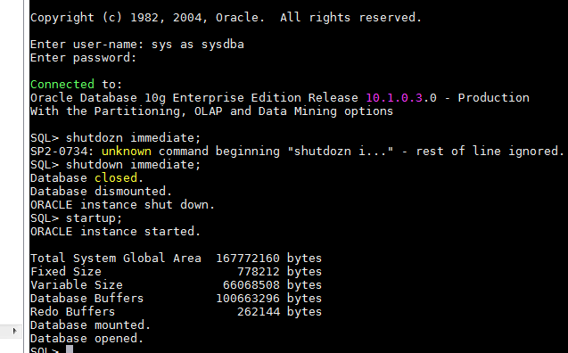

4)
-Perform a query against a table in the database that involves sorting of data. What happens?

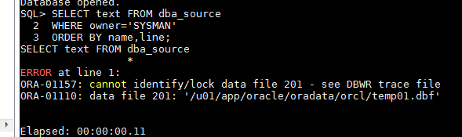

La table dba_source, comme on à pu voir dans la question 1, à comme pour fichier temporaire /u01/app/oracle/oradata/orl/temp01.dbf. Or, le fichier à été supprimé. L'exécution de la requête à donc été interrompu à cause de l'abscence de ce fichier.

5)
Attempt to take the temporary tablespace offline before recovering it. What happens?

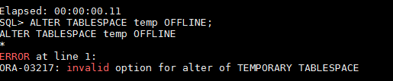

Il semblerait que il n'arrive pas a reconnaitre la tablespace "temp". Cela doit être le tablespace contenu dans le fichier temp01.dbf.

6)
-Drop the temporary tablespace. What happens?

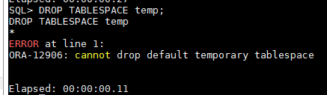

7)
-Create a new temporary tablespace named TEMP1 containing a single data file named temp1.dbf which is 100
MB in size.

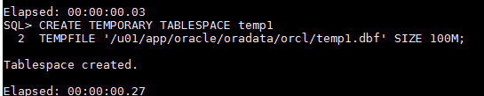

8)
-Change the database default temporary tablespace to TEMP1.

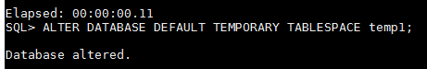

9)
-Retry your query that involved a sort operation. What happens now?

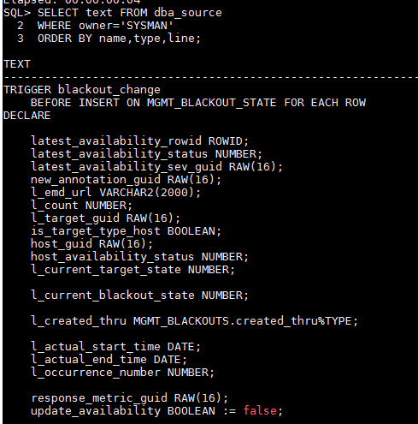

10)
-Drop the temporary tablespace with the missing data files. You must remove the tablespace and the file
associated using a single SQL command.

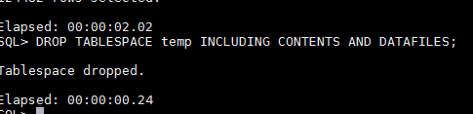

11)
-Perform a backup of the database.

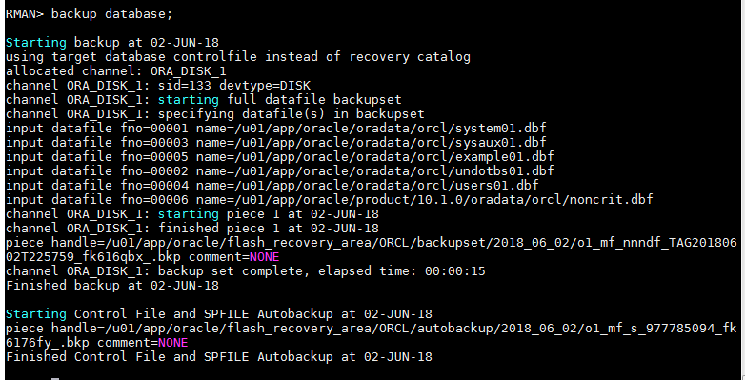
13.2) Database Recovery
13.2.1)Part One

1)
-As user system/oracle create the table HR.DEPARTMENTS2 by selecting all rows from the HR.DEPARTMENTS
table. Confirm that the new table exists, and record the total number of rows in the table.
View the active log by querying V$LOG. Perform a log switch when finished.

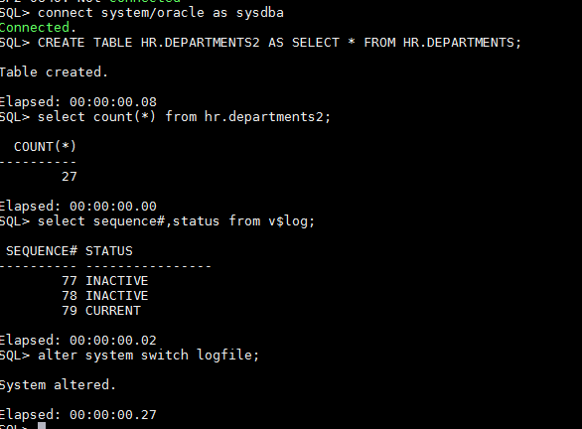

2)
-Check and record the system time and date.

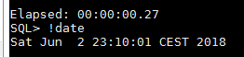

3)
-Query V$LOG again to confirm the switch and then insert three lines into the HR.DEPARTMENTS2 table and
commit. Confirm the number of row in the table. These INSERTs represent the introduction of questionable data
into the table.

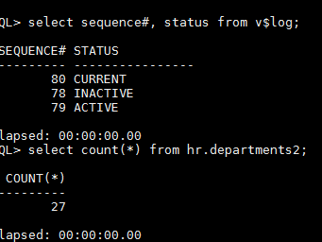

4)
-Shutdown the database, and restart it in mount mode.

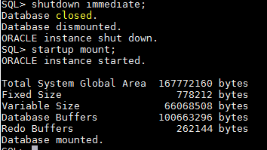

5)
-Using RMAN, recover the database to a point in time before the new data was introduced using the information
you recorded before the inserts were performed.

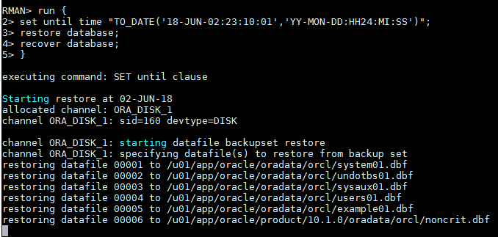
6)
-Open the database with the RESETLOGS option and confirm the recovery.

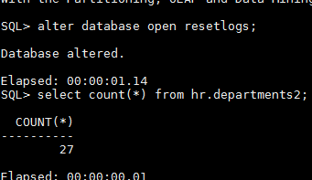

13.2.1)Part Two

1)
-Determine the current log sequence and write it down.

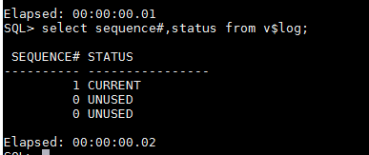

2)
-Verify the row count for the HR.DEPARTMENTS2 table.

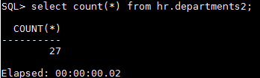

3)
-Force a log switch and verify the switch has taken place. Perform several inserts into the HR.DEPARTMENTS2
table and commit the changes. Verify the new row count. Then exit your SQL*Plus session.

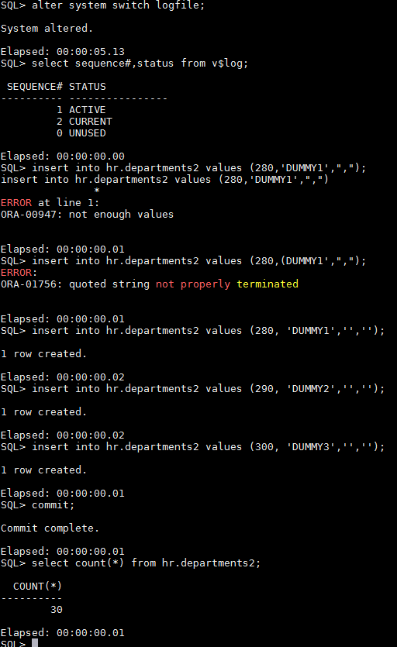

4)
-Using Enterprise Manager while logged in as a SYSDBA user, recover the database to a point in time before the
new data was introduced using the information you recorded before the inserts were performed.

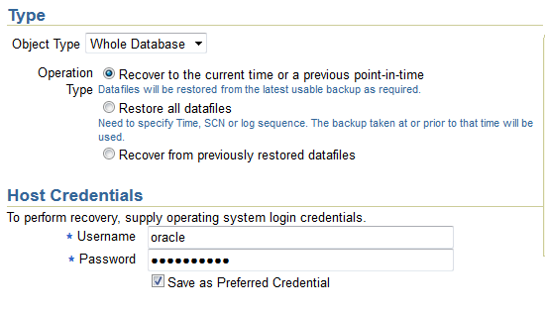

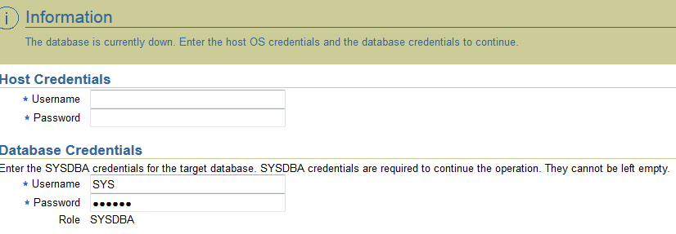

5)
-Wait until the Operation Succeeded message is displayed, then use SQL*Plus to verify that the recovery was
successful by checking the row count in the HR.DEPARTMENTS2 table.

