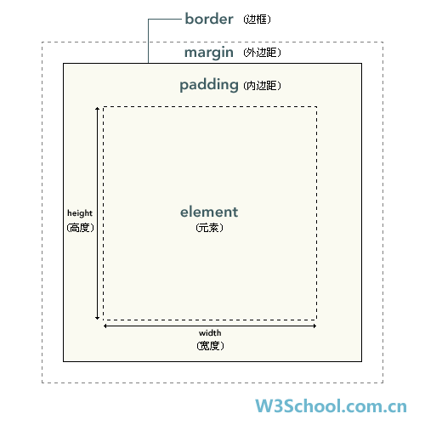

**<script src="/jquery/jquery-1.11.1.min.js"></script>**

Google CDN地址

**<script src="//ajax.aspnetcdn.com/ajax/jQuery/jquery-1.8.3.min.js"></script>**

Microsoft CDN地址