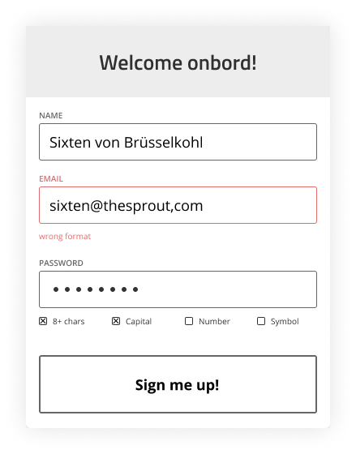

SubmitButton

InputFields

CreateUserForm

CreateUserFormBox

UserFormHeading