We mainly use wolftram’s word frequency data to get the frequency words in Wordle, and use python NKTL tool to analyze word’s sentiments and POS

Firstly, we draw 3 pictures to reflect the correlation between sentiment, word frequency, and pos directly. Since there’re many words with POS that are less than 10 word in word set (359), thus we drop these data out in order to increase the robustness of our model

“Picture1,2,3”

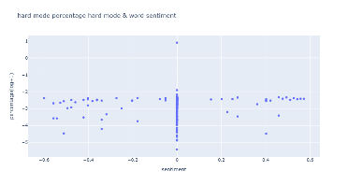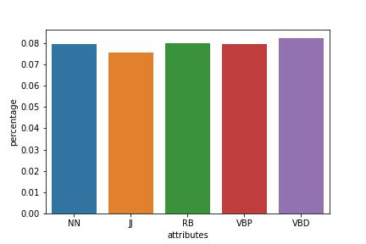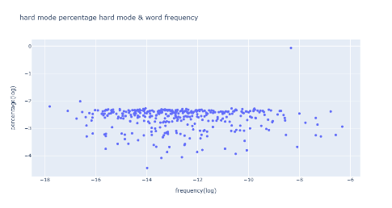

Seen for the data, we assume that these data do not have a strong correlation with each other, In order to test our assumption, we did Pearson correlation coefficient analysis and hypothesis testing. The result of which are as following:

#输入相关系数和显著性表格,依据下面的数据

Since all the correlation are small (absolute value<0.1) and p value in hypothesis testing’s absolute value are much greater than 0.05, thus we’re 95% sure the correlation between them is not significant, so the assumption holds.

