聚合函数：
–COUNT：统计行数量
–SUM：获取单个列的合计值
–AVG：计算某个列的平均值
–MAX：计算列的最大值
–MIN：计算列的最小值

1.show databases; 显示服务器当前所有数据库
2.create database 数据库名； 创建数据库
3.use 数据库名； 进入指定数据库
4.show tables; 查看当前数据库的表
5.create table 表名； 创建表
6.PRIMARY KEY 主键
7.UNIQUE 唯一约束
8.查询表中所有数据
select * from 表名;
9.查询表中所有的name和age
select name,age from 表名;
10.查询属性值为。。的这一行数据
select * from 表名 where属性='属性值';
11.模糊查询
select * from表名 where属性 like '_ %';
12.Null
select * from 表名 where 属性 is null;
13.查询表下不重复的某个列
select distinct 列名 from表名;
14.查询某个表中60到80之间的记录
select * from表名 where列名 between 60 and 80;
15.查询表中属性为85，86或88的记录
select * from 表名where属性 in (85,86,88);
16.以列升序查询表的所有记录
select * from 表名 order by 列名 asc;
- 以列降序查询表的所有记录
select * from 表名 order by 列名desc;
18.查询“95031”班的学生人数
select count(1) from students where class='95031';
- .查询Score表中的最高分的学生学号和课程号
limit x, y : 检索 x - y, 获取从x开始到y结束. x可以不写, 系统默认0

select sno,cno from scores order by degree desc limit 1;

20.查询平均数
select avg(列名) from 表名;
21.查询最大数
select max(列名) from 表名;
22.查询最小数
Select min(列名) from 表名;

子查询
select * from 表名 where id in（ select id from 表名 where 属性);
关联查询
select * from 表名 where 属性=' ' and属性=' ';
select * from 表名 where 属性=' ' or 属性=' ';
插入数据
Insert into 表名 (属性) values(属性值);
删除指定数据
Delete from表名 where属性='属性值';
修改
update 表名 set 属性='属性值' where 属性=属性值;

插入insert

单表插入
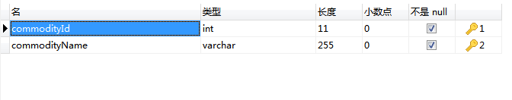

INSERT INTO `commodity_type`(commodityId,commodityName) VALUES(11,"幼儿装")

将查询结果插入到指定数据表
INSERT [INTO] tbl_name [(col_name, ... )] SELECT...
说明：此方法可以将查询结果插入到指定数据表
mysql> SELECT * FROM users;
+----+----------+----------+-----+------+
| id | username | password | age | sex |
+----+----------+----------+-----+------+
| 1 | Tom | 123 | 29 | 0 |
| 2 | John | 456 | 38 | 0 |
| 3 | Tom | 123 | 27 | 0 |
| 4 | John | 456 | 27 | 0 |
| 10 | John | 456 | 21 | 0 |
| 11 | ROSE | 67 | 4 | 0 |
| 12 | Ben | 456 | 13 | NULL |
+----+----------+----------+-----+------+
mysql> CREATE TABLE TEST(
-> id TINYINT UNSIGNED PRIMARY KEY AUTO_INCREMENT,
-> username VARCHAR(20)
-> );
Query OK, 0 rows affected (0.13 sec)
mysql>
mysql> SELECT * FROM test;
Empty set (0.02 sec)
mysql> INSERT test(username) SELECT username FROM users WHERE age >=30;
Query OK, 1 row affected (0.05 sec)
Records: 1 Duplicates: 0 Warnings: 0
mysql> SELECT * FROM test;
+----+----------+
| id | username |
+----+----------+
| 1 | John |
+----+----------+
1 row in set (0.00 sec)

两表插入
MySQL无法同时向两个表插入数据.

连表查询

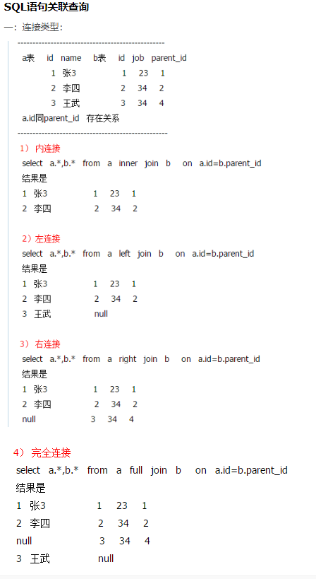

根据值查询关联表中的数据

SELECT
train.tr_id AS trId, train.tr_title AS trTitle, train.tr_description AS trDescription,
train.tr_content AS trContent, train.tr_sort AS trSort,
train.tr_type AS trType, train.tr_upload_time AS trUploadTime, train.tr_num AS trNum,
t_file.id AS id, t_file.relation_id AS relationId, t_file.file_name AS fileName,
t_file.file_url AS fileUrl, t_file.type AS type
from
train RIGHT join t_file
on
train.tr_id = t_file.relation_id
where train.tr_id= "1b5c7c5048e64e09935c5d931da86783"

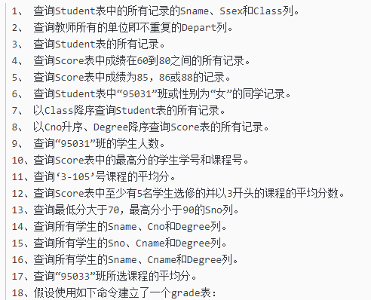
1.查询Student表中的所有记录的Sname、Ssex和Class列。
SELECT Sname,Ssex,Class FROM Student;

2.查询教师所有的单位即不重复的Depart列。

SELECT DISTINCT Depart FROM Teachers;

3.查询Student表的所有记录。

SELECT *FROM Students;

4.查询Score表中成绩在60到80之间的所有记录。

SELECT * FROM Scores WHERE Degree BETWEEN 60 AND 80;

5.查询Score表中成绩为85，86或88的记录。

SELECT * FROM Scores WHERE Degree IN (85,86,88);

6.查询Student表中“95031”班或性别为“女”的同学记录。

SELECT * FROM Students WHERE Class='95031' OR Ssex='女';

7.以Class降序查询Student表的所有记录。

SELECT * FROM Students ORDER BY Class DESC;

8.以Cno升序、Degree降序查询Score表的所有记录。
分开查询:
select sno ,cno ,degree from score order by cno;
select sno ,cno ,degree from score order by degree desc;
合在一起查询:
select sno,cno,degree from score order by cno asc,degree desc;

分组查询
根据班级查询考试人数和平均成绩
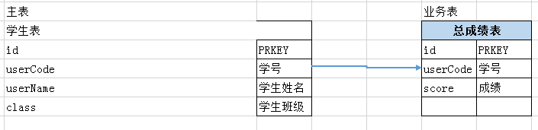
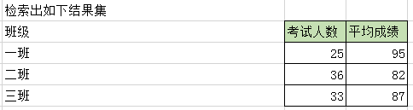
SELECT class AS 班级, count(*) as 考试人数，avg（score）as 平均成绩 FROM 学生表 as a INNER JOIN 总成绩 as b ON a.id=b.id group by class

INNER JOIN
内连接inner join等同于join, 返回量表中共同的数据.
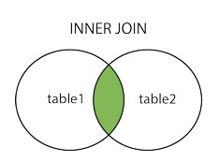

LEFT JOIN 左外连接
LEFT JOIN 左外连接, 关键字从左表（table1）返回所有的行，即使右表（table2）中没有匹配。如果右表中没有匹配，则结果为 NULL。

SQL LEFT JOIN 语法
SELECT column_name(s)
FROM table1
LEFT JOIN table2
ON table1.column_name=table2.column_name;
或：
SELECT column_name(s)
FROM table1
LEFT OUTER JOIN table2
ON table1.column_name=table2.column_name;
注释：在某些数据库中，LEFT JOIN 称为 LEFT OUTER JOIN。
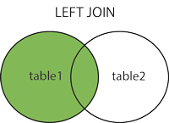

RIGHT JOIN 右外连接
RIGHT JOIN 关键字从右表（table2）返回所有的行，即使左表（table1）中没有匹配。如果左表中没有匹配，则结果为 NULL。

SQL RIGHT JOIN 语法
SELECT column_name(s)
FROM table1
RIGHT JOIN table2
ON table1.column_name=table2.column_name;
或：
SELECT column_name(s)
FROM table1
RIGHT OUTER JOIN table2
ON table1.column_name=table2.column_name;
注释：在某些数据库中，RIGHT JOIN 称为 RIGHT OUTER JOIN。
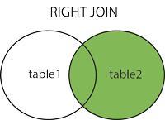

FULL OUTER JOIN 全外连接
FULL OUTER JOIN 关键字只要左表（table1）和右表（table2）其中一个表中存在匹配，则返回行.
FULL OUTER JOIN 关键字结合了 LEFT JOIN 和 RIGHT JOIN 的结果。

SQL FULL OUTER JOIN 语法
SELECT column_name(s)
FROM table1
FULL OUTER JOIN table2
ON table1.column_name=table2.column_name;
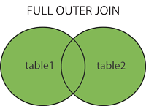

分页查询
LIMIT语句, 分页查询是最常用的场景之一，但也通常也是最容易出问题的地方。比如对于下面简单的语句，一般 DBA 想到的办法是在 type, name, create_time 字段上加组合索引。这样条件排序都能有效的利用到索引，性能迅速提升。

SELECT * FROM operation WHERE type = 'SQLStats' AND name = 'SlowLog' ORDER BY create_time LIMIT 1000, 10;
好吧，可能90%以上的 DBA 解决该问题就到此为止。但当 LIMIT 子句变成 “LIMIT 1000000,10” 时，程序员仍然会抱怨：我只取10条记录为什么还是慢？
要知道数据库也并不知道第1000000条记录从什么地方开始，即使有索引也需要从头计算一次。出现这种性能问题，多数情形下是程序员偷懒了。
在前端数据浏览翻页，或者大数据分批导出等场景下，是可以将上一页的最大值当成参数作为查询条件的。SQL 重新设计如下：

SELECT * FROM operation WHERE type = 'SQLStats' AND name = 'SlowLog' AND create_time > '2017-03-16 14:00:00' ORDER BY create_time limit 10;
在新设计下查询时间基本固定，不会随着数据量的增长而发生变化。

隐式转换
SQL语句中查询变量和字段定义类型不匹配是另一个常见的错误。比如下面的语句：

mysql> explain extended SELECT * > FROM my_balance b > WHERE b.bpn = 14000000123 > AND b.isverified IS NULL ;mysql> show warnings;| Warning | 1739 | Cannot use ref access on index 'bpn' due to type or collation conversion on field 'bpn'
其中字段 bpn 的定义为 varchar(20)，MySQL 的策略是将字符串转换为数字之后再比较。函数作用于表字段，索引失效。
上述情况可能是应用程序框架自动填入的参数，而不是程序员的原意。现在应用框架很多很繁杂，使用方便的同时也小心它可能给自己挖坑。

关联更新 删除
虽然 MySQL5.6 引入了物化特性，但需要特别注意它目前仅仅针对查询语句的优化。对于更新或删除需要手工重写成 JOIN。
比如下面 UPDATE 语句，MySQL 实际执行的是循环/嵌套子查询（DEPENDENT SUBQUERY)，其执行时间可想而知。

UPDATE operation o SET status = 'applying' WHERE o.id IN (SELECT id FROM (SELECT o.id, o.status FROM operation o WHERE o.group = 123 AND o.status NOT IN ( 'done' ) ORDER BY o.parent, o.id LIMIT 1) t);
执行计划：

+----+--------------------+-------+-------+---------------+---------+---------+-------+------+-----------------------------------------------------+| id | select_type | table | type | possible_keys | key | key_len | ref | rows | Extra |+----+--------------------+-------+-------+---------------+---------+---------+-------+------+-----------------------------------------------------+| 1 | PRIMARY | o | index | | PRIMARY | 8 | | 24 | Using where; Using temporary || 2 | DEPENDENT SUBQUERY | | | | | | | | Impossible WHERE noticed after reading const tables || 3 | DERIVED | o | ref | idx_2,idx_5 | idx_5 | 8 | const | 1 | Using where; Using filesort |+----+--------------------+-------+-------+---------------+---------+---------+-------+------+-----------------------------------------------------+
重写为 JOIN 之后，子查询的选择模式从 DEPENDENT SUBQUERY 变成 DERIVED，执行速度大大加快，从7秒降低到2毫秒。

UPDATE operation o JOIN (SELECT o.id, o.status FROM operation o WHERE o.group = 123 AND o.status NOT IN ( 'done' ) ORDER BY o.parent, o.id LIMIT 1) t ON o.id = t.id SET status = 'applying'
执行计划简化为：

+----+-------------+-------+------+---------------+-------+---------+-------+------+-----------------------------------------------------+| id | select_type | table | type | possible_keys | key | key_len | ref | rows | Extra |+----+-------------+-------+------+---------------+-------+---------+-------+------+-----------------------------------------------------+| 1 | PRIMARY | | | | | | | | Impossible WHERE noticed after reading const tables || 2 | DERIVED | o | ref | idx_2,idx_5 | idx_5 | 8 | const | 1 | Using where; Using filesort |+----+-------------+-------+------+---------------+-------+---------+-------+--

混合排序
MySQL 不能利用索引进行混合排序。但在某些场景，还是有机会使用特殊方法提升性能的。

SELECT * FROM my_order o INNER JOIN my_appraise a ON a.orderid = o.id ORDER BY a.is_reply ASC, a.appraise_time DESC LIMIT 0, 20
执行计划显示为全表扫描：

+----+-------------+-------+--------+-------------+---------+---------+---------------+---------+-+| id | select_type | table | type | possible_keys | key | key_len | ref | rows | Extra +----+-------------+-------+--------+-------------+---------+---------+---------------+---------+-+| 1 | SIMPLE | a | ALL | idx_orderid | NULL | NULL | NULL | 1967647 | Using filesort || 1 | SIMPLE | o | eq_ref | PRIMARY | PRIMARY | 122 | a.orderid | 1 | NULL |+----+-------------+-------+--------+---------+---------+---------+-----------------+---------+-+
由于 is_reply 只有0和1两种状态，我们按照下面的方法重写后，执行时间从1.58秒降低到2毫秒。

SELECT * FROM ((SELECT * FROM my_order o INNER JOIN my_appraise a ON a.orderid = o.id AND is_reply = 0 ORDER BY appraise_time DESC LIMIT 0, 20) UNION ALL (SELECT * FROM my_order o INNER JOIN my_appraise a ON a.orderid = o.id AND is_reply = 1 ORDER BY appraise_time DESC LIMIT 0, 20)) t ORDER BY is_reply ASC, appraisetime DESC LIMIT 20;

嵌套子查询
MySQL 对待 EXISTS 子句时，仍然采用嵌套子查询的执行方式。如下面的 SQL 语句：

SELECT *FROM my_neighbor n LEFT JOIN my_neighbor_apply sra ON n.id = sra.neighbor_id AND sra.user_id = 'xxx' WHERE n.topic_status < 4 AND EXISTS(SELECT 1 FROM message_info m WHERE n.id = m.neighbor_id AND m.inuser = 'xxx') AND n.topic_type <> 5
执行计划为：

+----+--------------------+-------+------+-----+------------------------------------------+---------+-------+---------+ -----+| id | select_type | table | type | possible_keys | key | key_len | ref | rows | Extra |+----+--------------------+-------+------+ -----+------------------------------------------+---------+-------+---------+ -----+| 1 | PRIMARY | n | ALL | | NULL | NULL | NULL | 1086041 | Using where || 1 | PRIMARY | sra | ref | | idx_user_id | 123 | const | 1 | Using where || 2 | DEPENDENT SUBQUERY | m | ref | | idx_message_info | 122 | const | 1 | Using index condition; Using where |+----+--------------------+-------+------+ -----+------------------------------------------+---------+-------+---------+ -----+
去掉 exists 更改为 join，能够避免嵌套子查询，将执行时间从1.93秒降低为1毫秒。

SELECT *FROM my_neighbor n INNER JOIN message_info m ON n.id = m.neighbor_id AND m.inuser = 'xxx' LEFT JOIN my_neighbor_apply sra ON n.id = sra.neighbor_id AND sra.user_id = 'xxx' WHERE n.topic_status < 4 AND n.topic_type <> 5
新的执行计划：

+----+-------------+-------+--------+ -----+------------------------------------------+---------+ -----+------+ -----+| id | select_type | table | type | possible_keys | key | key_len | ref | rows | Extra |+----+-------------+-------+--------+ -----+------------------------------------------+---------+ -----+------+ -----+| 1 | SIMPLE | m | ref | | idx_message_info | 122 | const | 1 | Using index condition || 1 | SIMPLE | n | eq_ref | | PRIMARY | 122 | ighbor_id | 1 | Using where || 1 | SIMPLE | sra | ref | | idx_user_id | 123 | const | 1 | Using where |+----+-------------+-------+--------+ -----+----------------------------------------

条件下推
外部查询条件不能够下推到复杂的视图或子查询的情况有：

聚合子查询；

含有 LIMIT 的子查询；

UNION 或 UNION ALL 子查询；

输出字段中的子查询；

如下面的语句，从执行计划可以看出其条件作用于聚合子查询之后：

SELECT * FROM (SELECT target, Count(*) FROM operation GROUP BY target) t WHERE target = 'rm-xxxx'

+----+-------------+------------+-------+---------------+-------------+---------+-------+------+-------------+| id | select_type | table | type | possible_keys | key | key_len | ref | rows | Extra |+----+-------------+------------+-------+---------------+-------------+---------+-------+------+-------------+| 1 | PRIMARY | <derived2> | ref | <auto_key0> | <auto_key0> | 514 | const | 2 | Using where || 2 | DERIVED | operation | index | idx_4 | idx_4 | 519 | NULL | 20 | Using index |+----+-------------+------------+-------+---------------+-------------+---------+-------+------+-------------+
确定从语义上查询条件可以直接下推后，重写如下：

SELECT target, Count(*) FROM operation WHERE target = 'rm-xxxx' GROUP BY target
执行计划变为：

+----+-------------+-----------+------+---------------+-------+---------+-------+------+--------------------+| id | select_type | table | type | possible_keys | key | key_len | ref | rows | Extra |+----+-------------+-----------+------+---------------+-------+---------+-------+------+--------------------+| 1 | SIMPLE | operation | ref | idx_4 | idx_4 | 514 | const | 1 | Using where; Using index |+----+-------------+-----------+------+---------------+-------+---------+-------+------+--------------------+
关于 MySQL 外部条件不能下推的详细解释说明请参考文章：
http://mysql.taobao.org/monthly/2016/07/08

提前缩小范围
先上初始 SQL 语句：

SELECT * FROM my_order o LEFT JOIN my_userinfo u ON o.uid = u.uid LEFT JOIN my_productinfo p ON o.pid = p.pid WHERE ( o.display = 0 ) AND ( o.ostaus = 1 ) ORDER BY o.selltime DESC LIMIT 0, 15
该SQL语句原意是：先做一系列的左连接，然后排序取前15条记录。从执行计划也可以看出，最后一步估算排序记录数为90万，时间消耗为12秒。

+----+-------------+-------+--------+---------------+---------+---------+-----------------+--------+----------------------------------------------------+| id | select_type | table | type | possible_keys | key | key_len | ref | rows | Extra |+----+-------------+-------+--------+---------------+---------+---------+-----------------+--------+----------------------------------------------------+| 1 | SIMPLE | o | ALL | NULL | NULL | NULL | NULL | 909119 | Using where; Using temporary; Using filesort || 1 | SIMPLE | u | eq_ref | PRIMARY | PRIMARY | 4 | o.uid | 1 | NULL || 1 | SIMPLE | p | ALL | PRIMARY | NULL | NULL | NULL | 6 | Using where; Using join buffer (Block Nested Loop) |+----+-------------+-------+--------+---------------+---------+---------+-----------------+--------+----------------------------------------------------+
由于最后 WHERE 条件以及排序均针对最左主表，因此可以先对 my_order 排序提前缩小数据量再做左连接。SQL 重写后如下，执行时间缩小为1毫秒左右。

SELECT * FROM (SELECT * FROM my_order o WHERE ( o.display = 0 ) AND ( o.ostaus = 1 ) ORDER BY o.selltime DESC LIMIT 0, 15) o LEFT JOIN my_userinfo u ON o.uid = u.uid LEFT JOIN my_productinfo p ON o.pid = p.pid ORDER BY o.selltime DESClimit 0, 15
再检查执行计划：子查询物化后（select_type=DERIVED)参与 JOIN。虽然估算行扫描仍然为90万，但是利用了索引以及 LIMIT 子句后，实际执行时间变得很小。

+----+-------------+------------+--------+---------------+---------+---------+-------+--------+----------------------------------------------------+| id | select_type | table | type | possible_keys | key | key_len | ref | rows | Extra |+----+-------------+------------+--------+---------------+---------+---------+-------+--------+----------------------------------------------------+| 1 | PRIMARY | <derived2> | ALL | NULL | NULL | NULL | NULL | 15 | Using temporary; Using filesort || 1 | PRIMARY | u | eq_ref | PRIMARY | PRIMARY | 4 | o.uid | 1 | NULL || 1 | PRIMARY | p | ALL | PRIMARY | NULL | NULL | NULL | 6 | Using where; Using join buffer (Block Nested Loop) || 2 | DERIVED | o | index | NULL | idx_1 | 5 | NULL | 909112 | Using where |+----+-------------+------------+--------+---------------+---------+---------+-

中间结果集下推
再来看下面这个已经初步优化过的例子(左连接中的主表优先作用查询条件)：

SELECT a.*, c.allocated FROM ( SELECT resourceid FROM my_distribute d WHERE isdelete = 0 AND cusmanagercode = '1234567' ORDER BY salecode limit 20) a LEFT JOIN ( SELECT resourcesid， sum(ifnull(allocation, 0) * 12345) allocated FROM my_resources GROUP BY resourcesid) c ON a.resourceid = c.resourcesid
那么该语句还存在其它问题吗？不难看出子查询 c 是全表聚合查询，在表数量特别大的情况下会导致整个语句的性能下降。
其实对于子查询 c，左连接最后结果集只关心能和主表 resourceid 能匹配的数据。因此我们可以重写语句如下，执行时间从原来的2秒下降到2毫秒。

SELECT a.*, c.allocated FROM ( SELECT resourceid FROM my_distribute d WHERE isdelete = 0 AND cusmanagercode = '1234567' ORDER BY salecode limit 20) a LEFT JOIN ( SELECT resourcesid， sum(ifnull(allocation, 0) * 12345) allocated FROM my_resources r, ( SELECT resourceid FROM my_distribute d WHERE isdelete = 0 AND cusmanagercode = '1234567' ORDER BY salecode limit 20) a WHERE r.resourcesid = a.resourcesid GROUP BY resourcesid) c ON a.resourceid = c.resourcesid
但是子查询 a 在我们的SQL语句中出现了多次。这种写法不仅存在额外的开销，还使得整个语句显的繁杂。使用 WITH 语句再次重写：

WITH a AS ( SELECT resourceid FROM my_distribute d WHERE isdelete = 0 AND cusmanagercode = '1234567' ORDER BY salecode limit 20)SELECT a.*, c.allocated FROM a LEFT JOIN ( SELECT resourcesid， sum(ifnull(allocation, 0) * 12345) allocated FROM my_resources r, a WHERE r.resourcesid = a.resourcesid GROUP BY resourcesid) c ON a.resourceid = c.resourcesid

9.查询“95031”班的学生人数。

SELECT COUNT(1) AS StuNum FROM Students WHERE Class='95031';

10.查询Score表中的最高分的学生学号和课程号。

SELECT Sno,Cno FROM Scores ORDER BY Degree DESC LIMIT 1;

11.查询‘3-105’号课程的平均分。

SELECT AVG(Degree) FROM Scores WHERE Cno='3-105';

12.查询Score表中至少有5名学生选修的并以3开头的课程的平均分数。

SELECT Cno,AVG(Degree) FROM Scores WHERE Cno LIKE '3%'
GROUP BY Cno HAVING COUNT(Sno) >= 5;

13.查询最低分大于70，最高分小于90的Sno列。
“Where” 是一个约束声明，使用Where来约束来之数据库的数据，Where是在结果返回之前起作用的，且Where中不能使用聚合函数。
“Having”是一个过滤声明，是在查询返回结果集以后对查询结果进行的过滤操作，在Having中可以使用聚合函数。having一定要和group by连用.

select distinct sno from score
where sno in (select sno from score group by sno having MIN(degree)>70)
and sno in (select sno from score group by sno having MAX(degree)<90)
select sno from score group by sno having MAX(degree)<90 and MIN(degree)>70

14.查询所有学生的Sname、Cno和Degree列。

SELECT Sname,Cno,Degree
FROM Students INNER JOIN Scores
ON(Students.Sno=Scores.Sno)
ORDER BY Sname;

15.查询所有学生的Sno、Cname和Degree列。

SELECT Sno,Cname,Degree

FROM Scores INNER JOIN Courses

ON(Scores.Cno=Courses.Cno)

ORDER BY Sno;

16.查询所有学生的Sname、Cname和Degree列。

SELECT Sname,Cname,Degree

FROM Students INNER JOIN Scores
ON(Students.Sno=Scores.Sno) INNER JOIN Courses
ON(Scores.Cno=Courses.Cno)
ORDER BY Sname;

17.查询“95033”班所选课程的平均分。

SELECT Cname,AVG(Degree)

FROM Students INNER JOIN Scores

ON(Students.Sno=Scores.Sno) INNER JOIN Courses

ON(Scores.Cno=Courses.Cno)

WHERE Class='95033'

GROUP BY Courses.Cno
ORDER BY Cname;

Student(Sid,Sname,Sage,Ssex)学生表
Sid：学号
Sname：学生姓名
Sage：学生年龄
Ssex：学生性别

Course(Cid,Cname,T#)课程表
Cid：课程编号
Cname：课程名称
Tid：教师编号

SC(Sid,Cid,score)成绩表
Sid：学号
Cid：课程编号
score：成绩

Teacher(Tid,Tname)教师表
Tid：教师编号：
Tname：教师名字

问题：

1、查询“001”课程比“002”课程成绩高的所有学生的学号
select a.sid from
(select sid,score from sc where cid='001')a,
(select sid,score from sc where cid='002')b
where a.sid = b.sid and a.score>b.score;
1
2
3
4
2、查询平均成绩大于60分的同学的学号和平均成绩
select sid,avg(score) from sc
group by sid
having avg(score)>60;
1
2
3
3、查询所有同学的学号、姓名、选课数、总成绩
select s.sid,s.sname,count_cid as 选课数,
sum_score as 总成绩
from student s
left join
(select sid,count(cid) as count_cid,sum(score) as sum_score
from sc group by sid )sc
on s.sid = sc.sid;
1
2
3
4
5
6
7
4、查询姓‘李’的老师的个数：
select count(tname)
from teacher
where tname like '李%';
1
2
3
5、查询没有学过“叶平”老师可的同学的学号、姓名：
select s.sid,s.sname
from student as s
where s.sid not in (
select DISTINCT sid
from sc as sc
where sc.cid in (
select cid
from course as c
left join teacher as t on c.tid = t.tid
where t.tname = '叶平')
);
1
2
3
4
5
6
7
8
9
10
11
6、查询学过“叶平”老师所教的所有课的同学的学号、姓名：
select s.sid,s.sname
from student as s
where s.sid in (
select distinct sc.sid
from sc as sc
where sc.cid in (
select cid
from course as c
left join teacher as t on c.tid = t.tid
where t.tname = '叶平')
group by sc.sid
HAVING count(cid)=
(select count(cid)
from course as c left join teacher as t on c.tid = t.tid
where t.tname = '叶平')
);
1
2
3
4
5
6
7
8
9
10
11
12
13
14
15
16
7、查询学过“011”并且也学过编号“002”课程的同学的学号、姓名：
SELECT s.sid,s.sname
from student as s
left join sc as sc on s.sid = sc.sid
where sc.cid = '001'
and EXISTS(
select * from sc as sc_2
where sc.sid = sc_2.sid
and sc_2.cid='002');

select s.sid,s.sname
from student as s
left join sc as sc
on sc.sid = s.sid
where sc.cid = '001'
and s.sid in (
select sid from sc as sc_2
where sc_2.cid='002'
and sc_2.sid = sc.sid);
1
2
3
4
5
6
7
8
9
10
11
12
13
14
15
16
17
18
8、查询课程编号“002”的成绩比课程编号“001”课程低的所有同学的学号、姓名：
select sid,sname
from (select student.sid,student.sname,score,
(select score from sc as sc_2
where sc_2.sid = student.sid
and sc_2.cid = '002') as score2
from student,sc
where student.sid=sc.sid and cid = '001') s_2
where score2<score;
1
2
3
4
5
6
7
8
9、查询所有课程成绩小于60的同学的学号、姓名：
select sid,sname
from student
where sid not in
(select s.sid
from student s,sc
where s.sid=sc.sid and score>60 );

select sid,sname
from student s
where not EXISTS (
select s.sid from sc
where sc.sid = s.sid and sc.score>60);
1
2
3
4
5
6
7
8
9
10
11
12
10、查询没有学全所有课的同学的学号、姓名：
select s.sid,s.sname
from student s ,sc sc
where s.sid = sc.sid
group by s.sid,s.sname
having count(sc.cid)<(
select count(cid)
from course);

select s.sid,s.sname
from student s
right join sc sc on s.sid = sc.sid
group by s.sid,s.sname
having count(sc.cid)<
(select count(cid) from course);
1
2
3
4
5
6
7
8
9
10
11
12
13
14
11、查询至少有一门课与学号为“1001”同学所学相同的同学的学号和姓名：
select student.sid,sname
from student,sc
where student.sid = sc.sid
and cid in
(select cid from sc where sid='1001');

select s.sid,s.sname
from sc sc left join student as s
on sc.sid = s.sid
where sc.cid in (select cid from sc where sid='1001');

select sc_1.sid,s.sname
from sc sc_1 left join student as s
on sc_1.sid = s.sid
where
exists (select sc_2.cid from sc as sc_2
where sc_1.cid = sc_2.cid
and sc_2.sid = '1001');
1
2
3
4
5
6
7
8
9
10
11
12
13
14
15
16
17
18
12、查询至少学过学号为“001”同学所有一门课的其他同学学号和姓名；
13、把“SC”表中“叶平”老师教的课的成绩都更改为此课程的平均成绩：
update sc set score =
(select avg(sc_2.score) from sc sc_2
where sc_2.cid = sc.cid)
where cid in
(select c.cid from course c
left join teacher t on t.tid = c.tid
where t.tname = '叶平');
1
2
3
4
5
6
7
14、查询和“1002”号的同学学习的课程完全相同的其他同学学号和姓名：
select sc_1.sid
from (select cid from sc where sid='1002')a
left join sc sc_1 on a.cid = sc_1.cid
where sc_1.sid<>'1002'
group by sc_1.sid
having count(sc_1.cid) =
(select count(cid) from sc where sid='1002');

select a.sid,s.sname from
(select sid,GROUP_CONCAT(cid order by cid separator ',') as cid_str
from sc where sid='1002')b,
(select sid,GROUP_CONCAT(cid order by cid separator ',') as cid_str
from sc group by sid)a
left join student s
on a.sid = s.sid
where a.cid_str = b.cid_str and a.sid<>'1002';
1
2
3
4
5
6
7
8
9
10
11
12
13
14
15
16
15、删除学习“叶平”老师课的SC表记录：
delete from sc WHERE
cid in (
select c.cid from course c
LEFT JOIN teacher t on c.tid=t.tid
where t.tname = '叶平');
1
2
3
4
5
16、向SC表中插入一些记录，这些记录要求符合以下条件：没有上过编号“003”课程的同学学号、002号课的平均成绩：
insert into sc select sid,'002',
(select avg(score) from sc where cid='0022')
from student
where sid not in (select sid from sc where cid='002');
1
2
3
4
17、按平均成绩从高到低显示所有学生的“数据库”、“企业管理”、“英语”三门的课程成绩，按如下形式显示：学生ID，数据库，企业管理，英语，有效课程数，有效平均分：
select sid as 学生id,
(SELECT score from sc
where sc.sid = t.sid and cid='004') as 数据库,
(select score from sc
where sc.sid = t.sid and cid='001') as 企业管理,
(select score from sc
where sc.sid = t.sid and cid='015') as 英语,
count(cid) as 有效课程数, avg(t.score) as 平均成绩
from sc as t
group by sid
order by avg(t.score);
1
2
3
4
5
6
7
8
9
10
11
18、查询各科成绩最高和最低的分：以如下的形式显示：课程ID，最高分，最低分
select l.cid as 课程id,l.score as 最高分,
r.score as 最低分
from sc l,sc r
where l.cid = r.cid
and l.score =
(select max(t.score) from sc t
where l.cid = t.cid group by t.cid)
and r.score = (select min(t.score) from sc t
where r.cid = t.cid group by t.cid)
order by l.cid;

select cid as 课程id,max(score) as 最高分,
min(score) as 最低分
from sc
group by cid;
1
2
3
4
5
6
7
8
9
10
11
12
13
14
15
19、按各科平均成绩从低到高和及格率的百分数从高到低顺序：
SELECT t.cid as 课程号,
c.cname as 课程名,
COALESCE(avg(score),0) as 平均成绩,
100*sum(case
when COALESCE(score,0)>=60
then 1 else 0 END)/count(*) as 及格百分数
from sc t
left join course c
on t.cid = c.cid
group by t.cid
order by 100*sum(case
when COALESCE(score,0)>=60
then 1 else 0 END)/count(*);
1
2
3
4
5
6
7
8
9
10
11
12
13
20、查询如下课程平均成绩和及格率的百分数(用”1行”显示): 企业管理（001），马克思（002），OO&UML （003），数据库（004）：
21、查询不同老师所教不同课程平均分从高到低显示：
select t.tid as 教师id,
t.tname as 教师姓名,
sc.cid as 课程id,
avg(score) as 平均成绩
from sc as sc
LEFT JOIN course c on sc.cid = c.cid
left join teacher t on c.tid = t.tid
group by sc.cid
order by avg(sc.score) desc;

用户登录
select from t_admin where adminId = #{adminid,jdbcType=CHAR} and adminpwd = #{adminpwd}

22、查询如下课程成绩第3名到第6名的学生成绩单：企业管理(001)，马克思(002)，UML(003)，数据库(004)：
23、统计下列各科成绩，各分数段人数：课程ID，课程名称，[100-85],[85-70],[70-60],[ 小于60] ：
select sc.cid as 课程id,cname as 课程名称,
sum(case when score between 85 and 100 then 1 else 0 end) as '[100-85]',
sum(case when score between 70 and 85 then 1 else 0 end) as '[85-70]',
sum(case when score between 60 and 70 then 1 else 0 end) as '[70-60]',
sum(case when score<60 then 1 else 0 end) as '[60-0]'
from sc as sc
left join course as c
on sc.cid = c.cid
group by sc.cid;
1
2
3
4
5
6
7
8
9
24、查询学生平均成绩及其名次：
select 1+(select count(distinct 平均成绩)
from (select sid,avg(score) as 平均成绩
from sc group by sid)t1
where 平均成绩>t2.平均成绩) as 名次,
sid as 学生学号,平均成绩
from (select sid,avg(score) 平均成绩 from sc group by sid) as t2
order by 平均成绩 desc;
1
2
3
4
5
6
7
25、查询各科成绩前三名的记录（不考虑成绩并列情况）：
select sid,cid,score
from sc sc_1
where (
select count(3) from sc sc_2
where sc_1.cid = sc_2.cid
and sc_2.score>=sc_1.score)<=2
order by sc_1.cid
);
1
2
3
4
5
6
7
8
26、查询每门课程被选修的学生数：
select cid, count(sid)
from sc
group by cid;
1
2
3
27、查询出只选修一门课程的全部学生的学号和姓名：
select sc.sid,s.sname,
count(sc.cid) as 课程数
from sc as sc
LEFT JOIN student as s
on sc.sid = s.sid
group by sc.sid
having count(sc.cid)=1;
1
2
3
4
5
6
7
28、查询男生、女生人数：
select count(ssex) as 男生人数
from student
group by ssex
having ssex = '男';
select count(2) from student
where ssex = '女';
1
2
3
4
5
6
29、查询姓“张”的学生名单：
select sid,sname
from student
where sname like '张%';
1
2
3
30、查询同名同姓的学生名单，并统计同名人数：
select sname,count(8)
from student
group by sname
having count(8)>1;
1
2
3
4
31、1981年出生的学生名单（注：student表中sage列的类型是datetime）:
32、查询平均成绩大于85的所有学生的学号、姓名和平均成绩：
select s.sname,sc.sid,avg(sc.score) as 平均成绩
from sc as sc
left join student as s
on sc.sid = s.sid
group by sc.sid
having avg(sc.score)>85;
1
2
3
4
5
6
33、查询每门课程的平均成绩，结果按平均成绩升序排序，平均成绩相同时，按课程号降序排列：
select cid,avg(score)
from sc
group by cid
order by avg(score),cid desc;
1
2
3
4
34、查询课程名称为“数据库”，且分数低于60的学生名字和分数：
select c.cname,s.sid,s.sname,sc.score
from course c
left join sc on sc.cid = c.cid
LEFT JOIN student s on s.sid = sc.sid
where c.cname = '数据库' and sc.score<60;
1
2
3
4
5
35、查询所有学生的选课情况：
select sc.sid,sc.cid,s.sname,c.cname
from sc
LEFT JOIN course c on sc.cid = c.cid
left join student s on sc.sid = s.sid;
1
2
3
4
36、查询任何一门课程成绩在70分以上的姓名、课程名称和分数：
select distinct s.sid,s.sname,sc.cid,sc.score
from sc
left join student s on sc.sid = s.sid
left join course c on sc.cid = c.cid
where sc.score>70;
1
2
3
4
5
37、查询不及格的课程，并按课程号从大到小的排列：
select cid
from sc
where score<60
ORDER BY cid;
1
2
3
4
38、查询课程编号为“003”且课程成绩在80分以上的学生的学号和姓名：
select sc.sid,s.sname
from sc
left join student s on sc.sid = s.sid
where sc.cid = '003' and sc.score>80;
1
2
3
4
39、求选了课程的学生人数：
select count(2) from
(select distinct sid from sc)a;
1
2
40、查询选修“叶平”老师所授课程的学生中，成绩最高的学生姓名及其成绩：
select s.sname,sc.score
from sc sc
left join student s on sc.sid = s.sid
left join course c on sc.cid = c.cid
left join teacher t on c.tid = t.tid
where t.tname = '叶平'
and sc.score = (
select max(score)
from sc sc_1
where sc.cid = sc_1.cid);

41、查询各个课程及相应的选修人数：
select cid,count(*) from sc group by cid;
1
42、查询不同课程成绩相同的学生和学号、课程号、学生成绩：
select DISTINCT a.sid,a.cid,a.score
from sc as a ,sc as b
where a.score = b.score
and a.cid <> b.cid;

43、查询每门课程成绩最好的前两名：
44、统计每门课程的学生选修人数(超过10人的课程才统计)。要求输出课程号和选修人数，查询结果按人数降序排序，若人数相同，按课程号升序排序：
select cid as 课程号,count(8) as 选修人数
from sc
group by cid
HAVING count(sid)>10
order by count(8) desc,cid;
45、检索至少选修两门课程的学生学号：
select sid
from sc
group by sid
having count(8)>=2;
1
2
3
4
46、查询全部学生选修的课程和课程号和课程名：
select cid,cname
from course
where cid in (select cid from sc group by cid);
1
2
3
47、查询没学过”叶平”老师讲授的任一门课程的学生姓名：
select sname
from student
where sid not in (
select sid
from sc,course,teacher
where course.tid = teacher.tid and sc.cid = course.cid
and teacher.tname='叶平'
);
48、查询两门以上不及格课程的同学的学号以及其平均成绩：
select sid,avg(COALESCE(score,0))
from sc
where sid in (
select sid
from sc
where score<60
group by sid
having count(8)>2
)
group by sid;
49、检索“004”课程分数小于60，按分数降序排列的同学学号：
select sid,score
from sc
where cid='004'
and score<60
order by score desc;
50、删除“002”同学的“001”课程的成绩：
delete from sc
where sid = '002'
and cid = '001';

updata

数据库:
库存表(商品编号(PK), 商品名, 在库数量[数值型],单位, 报警量[数值型], 商品描述)
供应商商品关系表(商品编号(PK), 供应商番号(PK), 商品名, 产地)
供应商信息表(供应商番号(PK), 商品名, 供应商所属地, 联系电话, 合作开始日期[日期型], 合作状态)
问题:
数据更新:如果某供应商的所属地和提供商品的产地不同，并且都不是”长春,那么将报警量提高20%并更新到数据库。
解决方案:
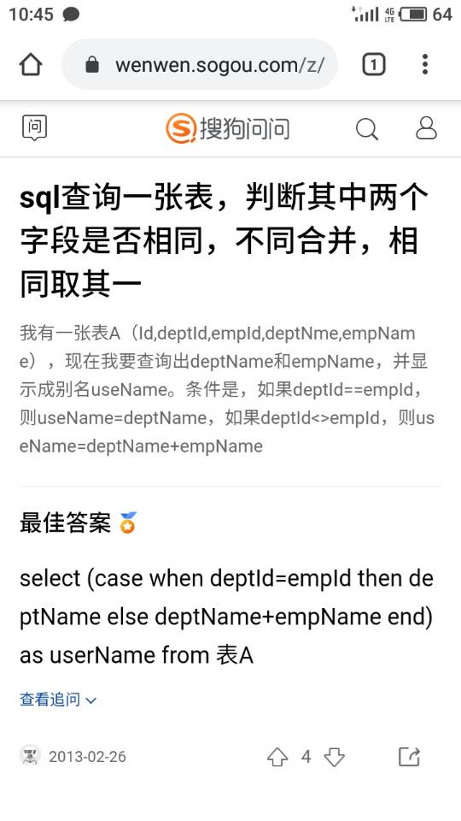
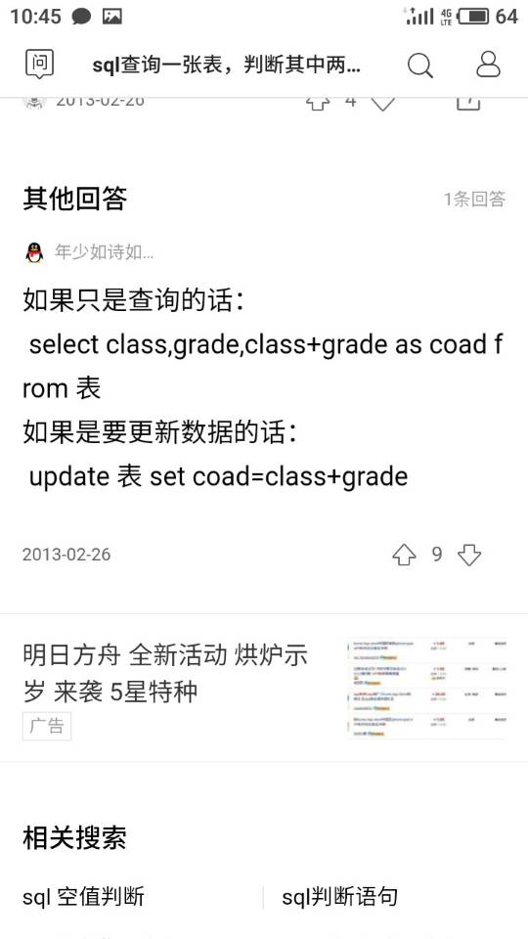
update punchcard_tbl a
inner join punchcard_tbl b on b.id=1 and a.id=b.id
set a.percheck=3

MyBatis参数传递
dao-->mapper
dao层示例
Public User selectUser(@param(“userName”) String name,@param(“userpassword”) String password);
xml映射对应示例

- <select id=" selectUser" resultMap="BaseResultMap">
- select * from user_user_t where user_name = #{userName，jdbcType=VARCHAR} and user_password=#{userPassword,jdbcType=VARCHAR}
- </select>
注意：采用#{}的方式把@Param注解括号内的参数进行引用（括号内参数对应的是形参如 userName对应的是name）；
实例二 @Param注解JavaBean对象
dao层示例
public List<user> getUserInformation(@Param("user") User user);
xml映射对应示例

- <select id="getUserInformation" parameterType="com.github.demo.vo.User" resultMap="userMapper">
- select
- <include refid="User_Base_Column_List" />
- from mo_user t where 1=1
- <!-- 因为传进来的是对象所以这样写是取不到值得 -->
- <if test="user.userName!=null and user.userName!=''"> and t.user_name = #{user.userName} </if>
- <if test="user.userAge!=null and user.userAge!=''"> and t.user_age = #{user.userAge} </if>
- </select>

1，使用@Param注解
当以下面的方式进行写SQL语句时：
@Select("select column from table where userid = #{userid} ")
public int selectColumn(int userid);
当你使用了使用@Param注解来声明参数时，如果使用 #{} 或 ${} 的方式都可以。
@Select("select column from table where userid = ${userid} ")
public int selectColumn(@Param("userid") int userid);

当你不使用@Param注解来声明参数时，必须使用使用 #{}方式。如果使用 ${} 的方式，会报错。
@Select("select column from table where userid = ${userid} ")
public int selectColumn(@Param("userid") int userid);

2，不使用@Param注解
不使用@Param注解时，参数只能有一个，并且是Javabean。在SQL语句里可以引用JavaBean的属性，而且只能引用JavaBean的属性。
// 这里id是user的属性
@Select("SELECT * from Table where id = ${id}")
Enchashment selectUserById(User user);

MyBatis-Plus逆向工程方法

selectById
此方法是通过id值查询数据库中的信息, 但是只能查出一条, 不能查出多条, 所以不能使用List<>

selectByMap
通过数据库中的字段名, 查询数据.
Map<String, Object> columnMap = new HashMap<String, Object>();
columnMap.put("relation_id", id);
tFileService.selectByMap(columnMap)

deletById
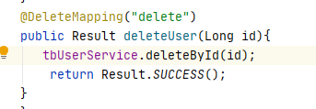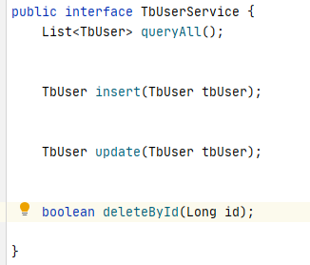
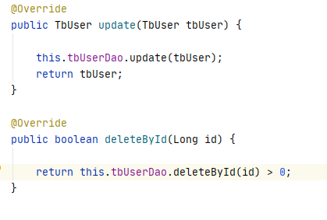
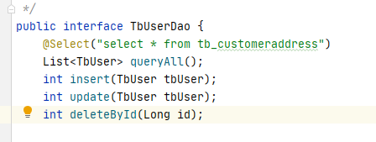

deleteBatchIds
批量删除id字段的值, 使用列表的方式.
@ResponseBody
@PostMapping("/batchDeleteTFile")
public int deleteTFile(String relationId){
int count = 0;
try {
List<Long> ids = (List<Long>) JSON.parse(relationId);
count = tFileService.deleteBatchIds(ids) ? 1 : 0;
}catch (Exception e){
logger.error("trainBatchDelete -=- {}",e.toString());
}
return count;
}

前端发送请求
// 声明集合
var array = new Array();
// 添加元素
array.push($(this).val())

