COLLEGE OF TECHNOLOGY

Department of Information Technology

COURSE FILE

Branch Information Technology

Semester IV, Forth

Session Jan-July, 2014

Subject Name Analysis and Design of Algorithm

Subject Code IT-404

Prepared by: Approved by:
Institute Name: COLLEGE OF TECHNOLOGY
Branch: INFORMATION TECHNOLOGYC)

Session: EVEN Year: 2013-14 Semester: IV

Course Code / Name: IT-404/ Analysis and Design of algorithm
OCT/IT/2012-13/CF-
Dept. Library Accession No-

S.NO. | CONTENTS | PAGE NO.
1 | Course Objective
2 | Academic Calendar
3 | University Scheme
4 | University Syllabus
5 | Time Table
6 | Lesson Plan
7 | OHP Transparencies- Single Sheet / Overlays (Optional)
8 | Power Point Presentation - 4 or 6 Slides per page Prints (Optional)
9 | Class-Notes / Seminar Papers of students for self-study
10 | University Question Papers of Previous Years
11 | Class Test Papers
12 | Mid Term Test Papers (Attach Answer Books 3 above 70 %, 3 between 40-60 % Score)
13 | Question Bank for Self-Learning
14 | Objective Questions Test Papers
15 | Class Assignments
16 | Tutorial Sheets
17 | Content Beyond Syllabus
18 | Teacher’s Remarks and Suggestions for Improvements (Year Wise)
19 | Softcopy of all Formats on CDs.

Prepared By:

Checked By: ________________________________ (Sign of HOD)

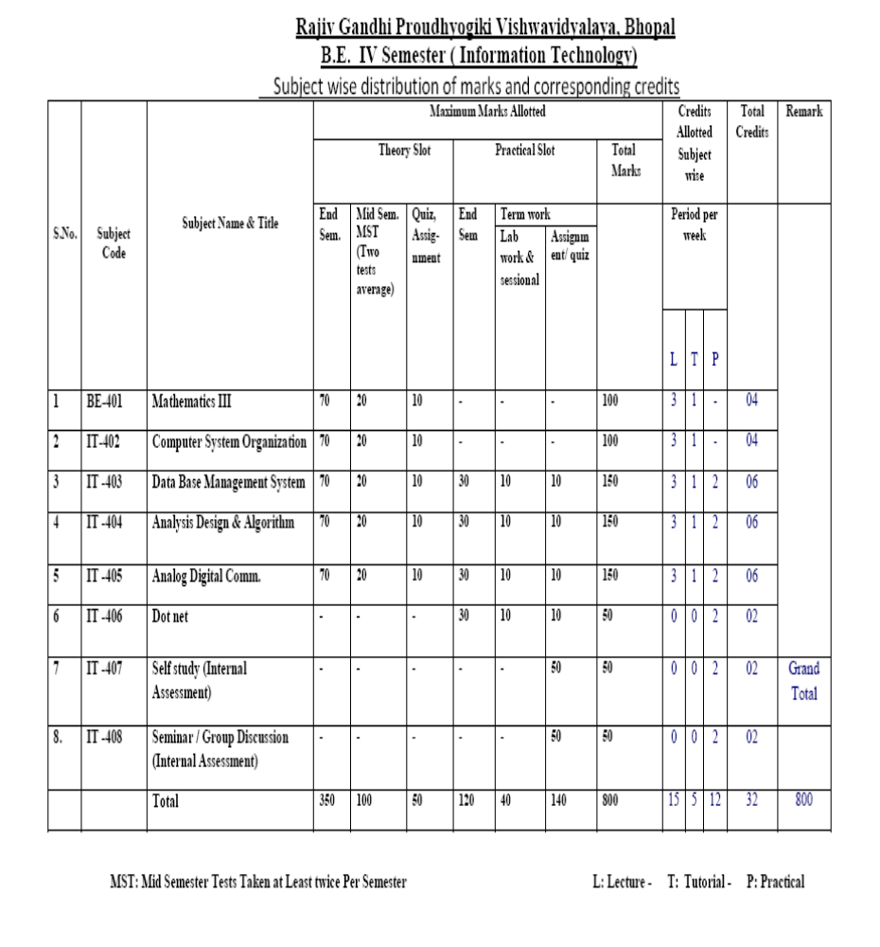

Rajiv Gandhi Proudyogiki Vishwavidyalaya
PROGRAMME: B.E. Information Technology, IV Semester
Course:- IT 404- ANALYSIS AND DESIGN OF ALGORITHM

Unit I
Algorithms, Designing algorithms, analyzing algorithms, asymptotic notations, heap and heap sort. Introduction to divide and conquer technique, analysis, design and comparison of various algorithms based on this technique, example binary search, merge sort, quick sort, strassen’s matrix multiplication.

Unit II
Study of Greedy strategy, examples of greedy method like optimal merge patterns, Huffman coding, minimum spanning trees, knapsack problem, job sequencing with deadlines, single source shortest path algorithm

Unit III
Concept of dynamic programming, problems based on this approach such as 0/1 knapsack, multistage graph, reliability design, Floyd-Warshall algorithm

Unit IV
Backtracking concept and its examples like 8 queen’s problem, Hamiltonian cycle, Graph coloring problem etc. Introduction to branch & bound method, examples of branch and bound method like traveling salesman problem etc. Meaning of lower bound theory and its use in solving algebraic problem, introduction to parallel algorithms.

Unit V
Binary search trees, height balanced trees, 2-3 trees, B-trees, basic search and traversal techniques for trees and graphs (In order, preorder, postorder, DFS, BFS), NP-completeness.

References:
1. Coremen Thomas, Leiserson CE, Rivest RL; Introduction to Algorithms; PHI.
2. Horowitz & Sahani; Analysis & Design of Algorithm
3. Dasgupta; algorithms; TMH
4. Ullmann; Analysis & Design of Algorithm;
5. Michael T Goodrich, Robarto Tamassia, Algorithm Design, Wiely India

List of Experiments( expandable):
1. Write a program for Iterative and Recursive Binary Search.
2. Write a program for Merge Sort.
3. Write a program for Quick Sort.
4. Write a program for Strassen’s Matrix Multiplication.
5. Write a program for optimal merge patterns.
6. Write a program for Huffman coding.
7. Write a program for minimum spanning trees using Kruskal’s algorithm.
8. Write a program for minimum spanning trees using Prim’s algorithm.
9. Write a program for single sources shortest path algorithm.
10. Write a program for Floye-Warshal algorithm.
11. Write a program for traveling salesman problem.
12. Write a program for Hamiltonian cycle problem.

Institute Name: COLLEGE OF TECHNOLOGY.

Branch: INFORMATION TECHNOLOGY.
nication (EC)
Session: EVEN Year: 2013-14 Semester: IV

Course Code / Name: IT-404/ Analysis and Design of algorithm

Lesson Plan

S.No. | Lecture No. | Topics to be covered | Date | Reference
 |  | UNIT-1
1. |  | Introduction of Algorihm, definition,  key aspects. |  | R1 (1-4)
2. |  | Analysis of algorithm (Complexity)  Space Complexity  Time complexity |  | R1 (14-19)
3. |  | Asymptotic Notation |  | R3 (34-64)
4. |  | Recursion and its types  Programs  - Factorial  - Fibonacci series |  | R2 (6.18-6.21)
5. |  | Divide and Conquer Technique  Description  Algorithm  Examples |  | R1 (136-141)
6. |  | Binary Search  Description  Algorithm  Numerical |  | R1 (145-152)
7. |  | Quick Sort  Description  Algorithm  Numerical |  | R1 (168-172)
8. |  | Merge Sort  Description  Algorithm  Numerical |  | R1 (159-162)
9. |  | Strassen’s matrix Multiplication  Description  Numerical |  | R1 (192-194)
10. |  | Tutorial
 |  | UNIT-2
11. |  | Greedy Strategy  Description  Examples  Knapsack Problem  Description  Algorithm  Numerical |  | R1 (210-213)
12. |  | Optimal merge pattern  Description  Algorithm  Numerical  Huffman Coding  Description  Numerical |  | R1 (253-255)  R1 (257-260)
13. |  | Spanning Tree  Description  Minimum Spanning Tree  Numerical  Prism Algorithm.  Numerical |  | R1 (236-239)
14. |  | Kruskal Algorithm.  Numerical |  | R1 (239-243)
15. |  | Tutorial
 |  | UNIT-3
16. |  | Dynamic Programming  Description  Examples  0/1 Knapsack  Description  Algorithm  Numerical |  | R1 (272-276)  R1 (305-312)
17. |  | Multistage Graph  Description  Algorithm  Numerical |  | R1 (276-282)
18. |  | Reliability Design  Description |  | R1 (315-317)
19. |  | Reliability Design Numerical |  | R1 (315-317)
 |  | UNIT-4
20. |  | Backtracking Concept  Description  Examples  4 Queen Problem  8 Queen Problem |  | R1 (359-362)  R1 (373-377)
21. |  | Sum of Subset  Graph Coloring  Hamiltonian Cycle |  | R1 (377-387)
22. |  | Branch and Bound Method  Description  Examples  15 Puzzle Problem  Numerical |  | R3 (345-347)  R1 (403-406)
23. |  | Traveling Salesman Problem  Numerical |  | R1 (422-430)
24. |  | Floyd-Warshall Algorithm  Algorithm  Numerical |  | R1 (284-288)
25. |  | Tutorial
 |  | UNIT-5
26. |  | Tree:  Introduction  Binary Tree  Terminology  Complete Binary Tree  Full Binary Tree |  | R2 (7.1-7.5)
27. |  | Representation Binary Tree in memory  Linked Representation  Sequential Representation |  | R2 (7.5-7.9)
28. |  | Traversing in Binary Tree  Inorder  Preorder  Postorder  Numerical |  | R2 (7.9-7.18)
29. |  | Binary Search Tree  Description  Searching  Insertion  Numericals |  | R2 (7.24-7.30)
30. |  | Deletion  Case 1  Case 2  Case 3  Numerical |  | R2 (7.30-7.35)
31. |  | Tutorial
32. |  | General Tree  Conversion of General Tree to Binary Tree  Numerical |  | R2 (7.30-7.35)
33. |  | Heap  Description  Max and Min Heap  Numerical |  | R2 (7.55-7.62)
34. |  | Heap sort  Description and algorithm.  Numerical |  | R2 (7.63-7.65)
35. |  | AVL Tree OR Height Balanced Tree  Description  Insertion  Deletion  Left Rotation  Right Rotation  Numericals |  | R2 (7.35-7.41)
36. |  | Deletion in AVL Tree  Numerical |  | R2 (7.42-7.45)
37. |  | Tutorial
38. |  | B-Tree  Description  Insertion  Deletion  Numerical |  | R2 (7.51-7.53)
39. |  | Deletion in B-Tree  Numerical |  | R2 (7.54-7.55)
40. |  | Graph:  Introduction  Terminology  Graph  MultiGraph  Directed Graph  Weighted Graph |  | R3 (351-364)
41. |  | Graph Searching  BFS  Numerical |  | R3 (375-380)
42. |  | DFS  Numerical |  | R3 (380-383)
43. |  | Memory Representation of Graph  Adjacent Matrix  Adjacency List  Adjacency Multilist |  | R3 (367-375)
44. |  | Dijktra’s Algorithm.  Numericals |  | R3 (400-403)
45. |  | NP Hard and NP Completeness |  | R3(438-442)
46. |  | Tutorial

ReferenceBooks:-

S.No | Reference | Title | Author | Publisher
1. | R1 | Fundamentals of Computer Algorithms | Ellis Horowitz, Sartaj Sahani | Galgotia Publications
2. | R2 | Data Structure | Shaum’s Outlines | Shaum’s Outlines
3. | R3 | The Design and Analysis of algorithm | Nitin Upadhyay.

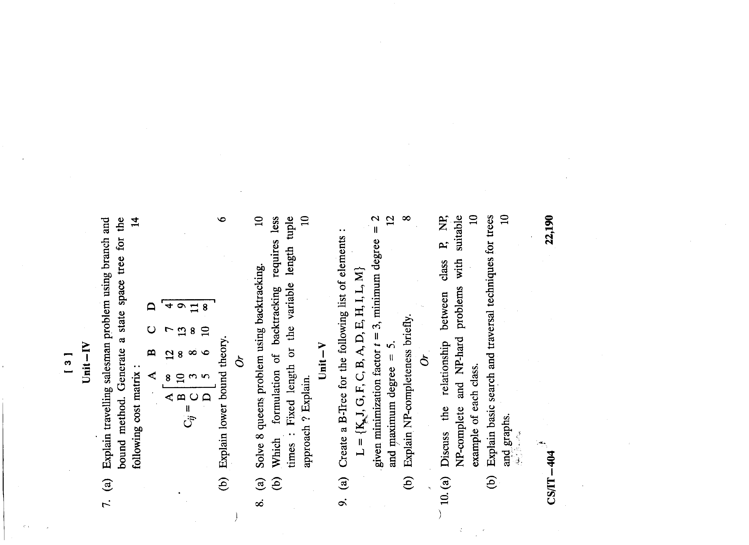
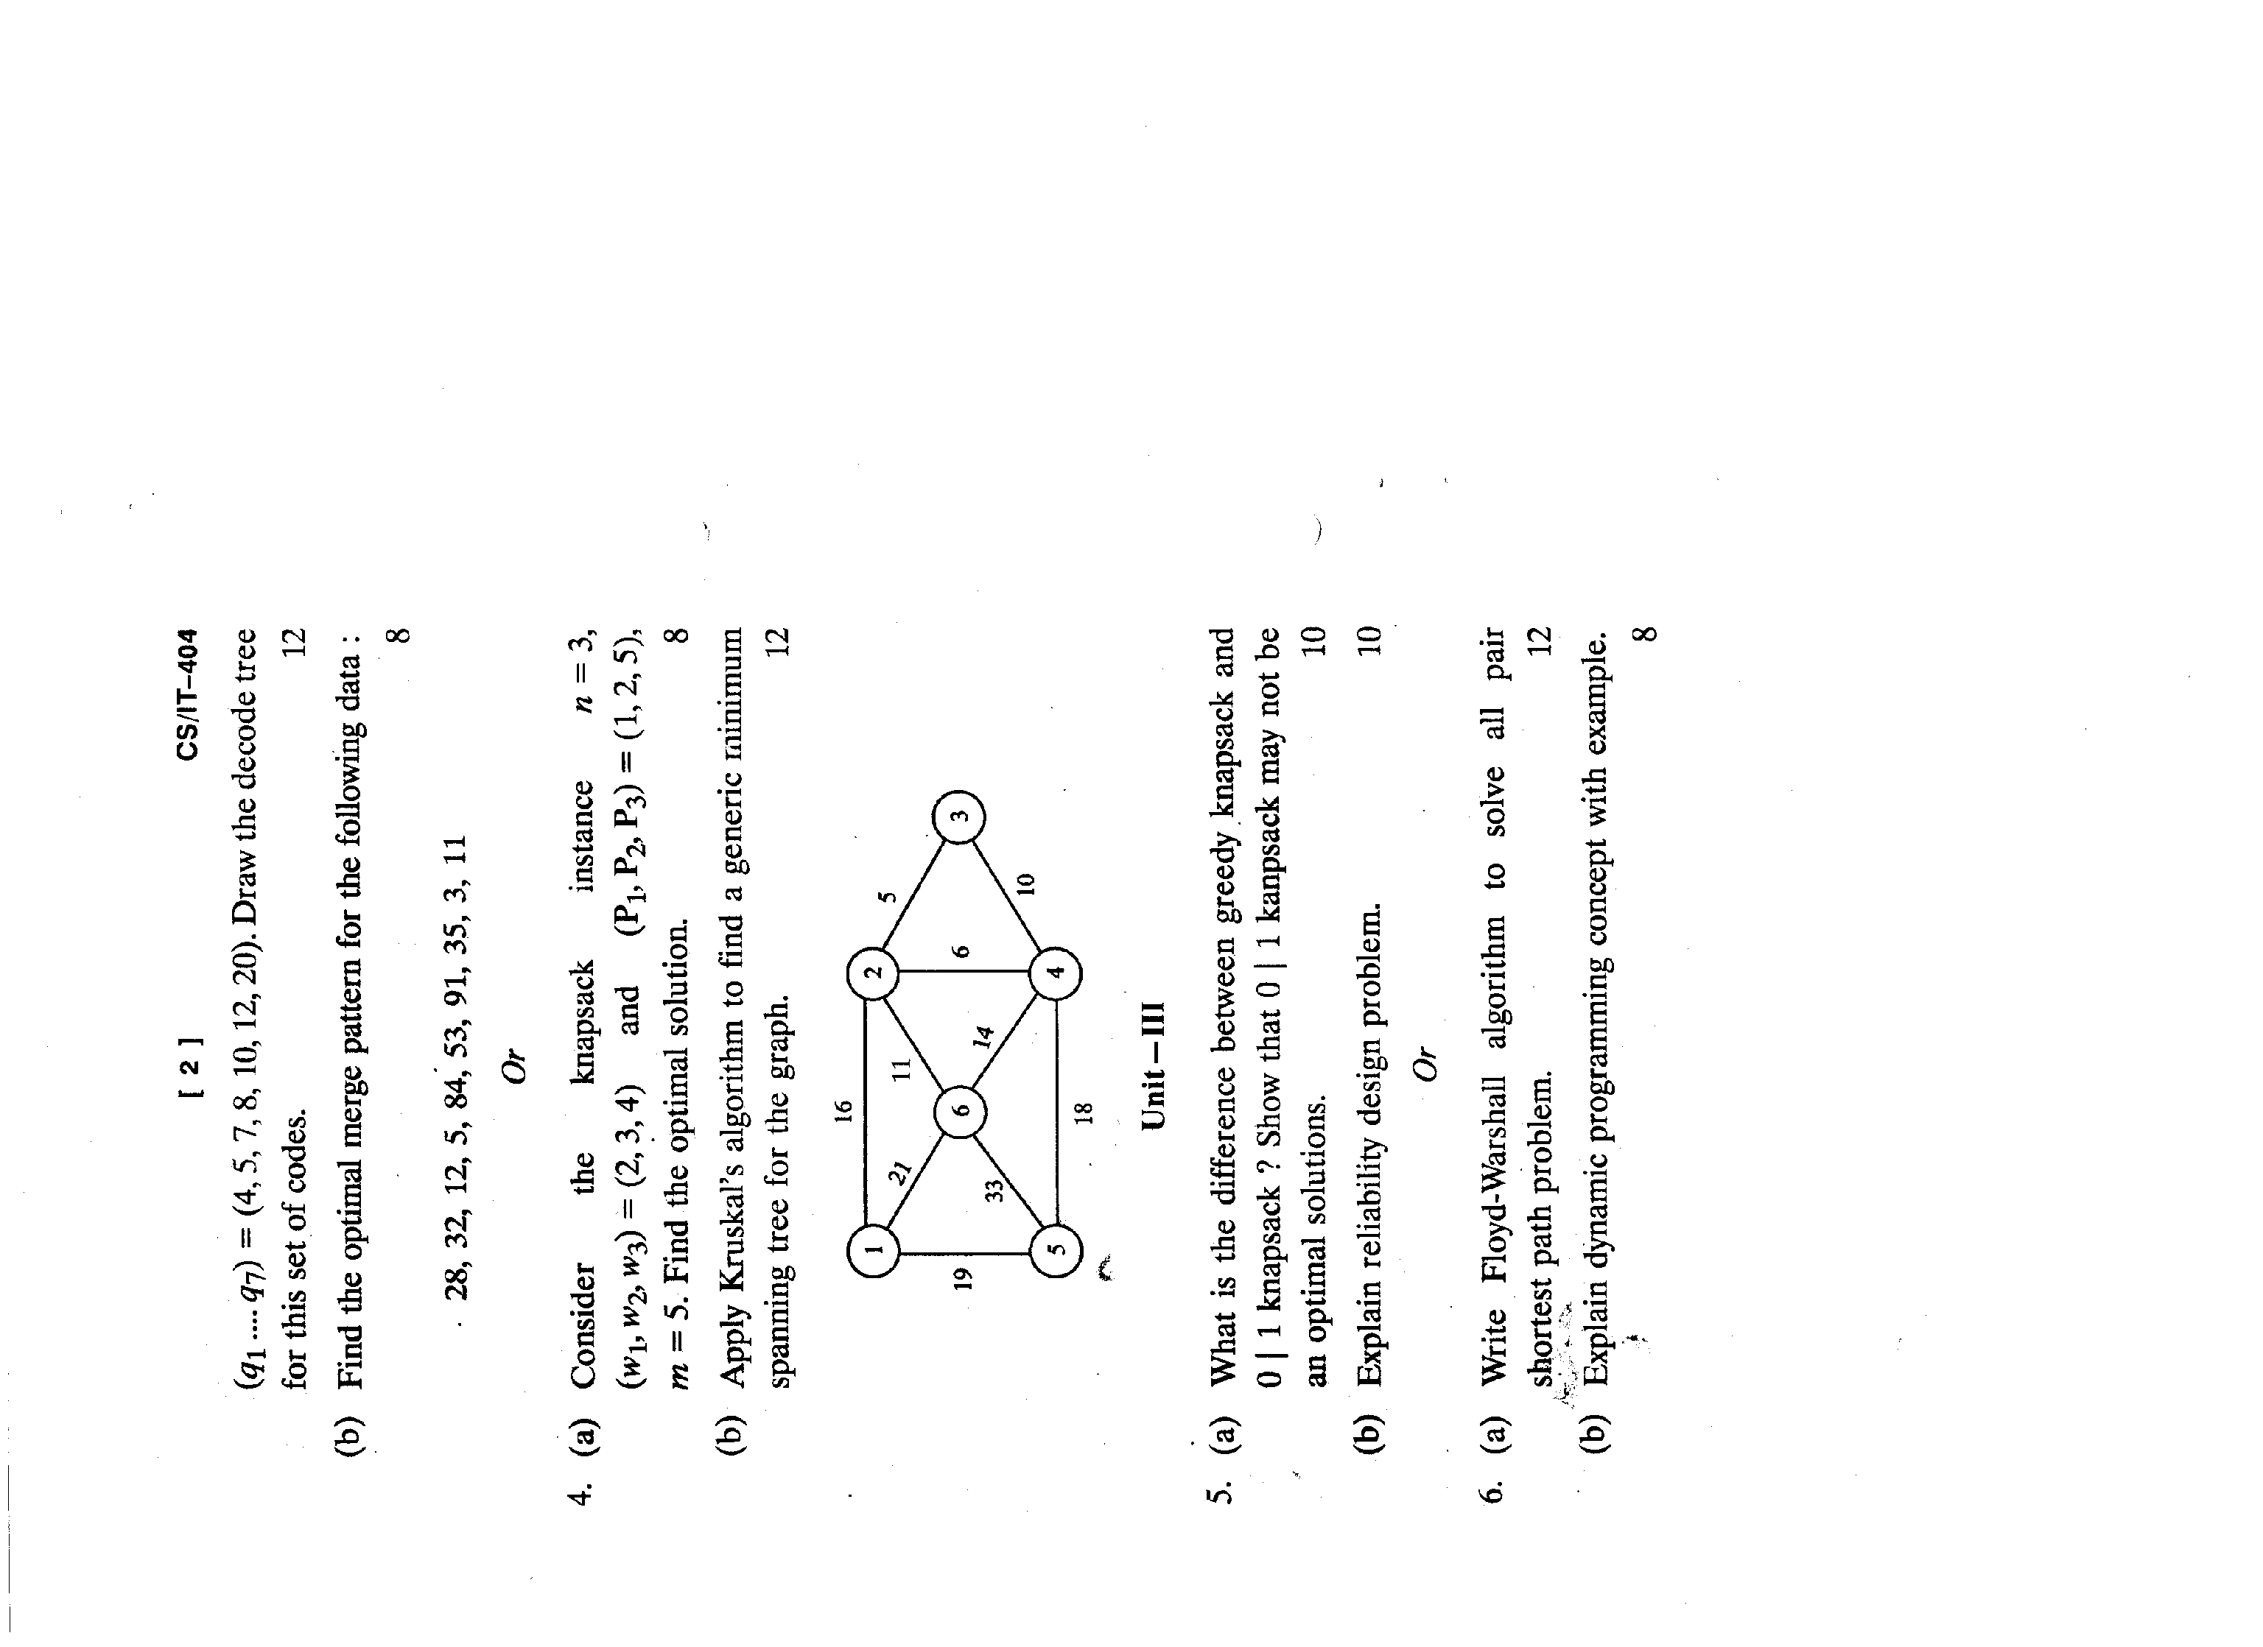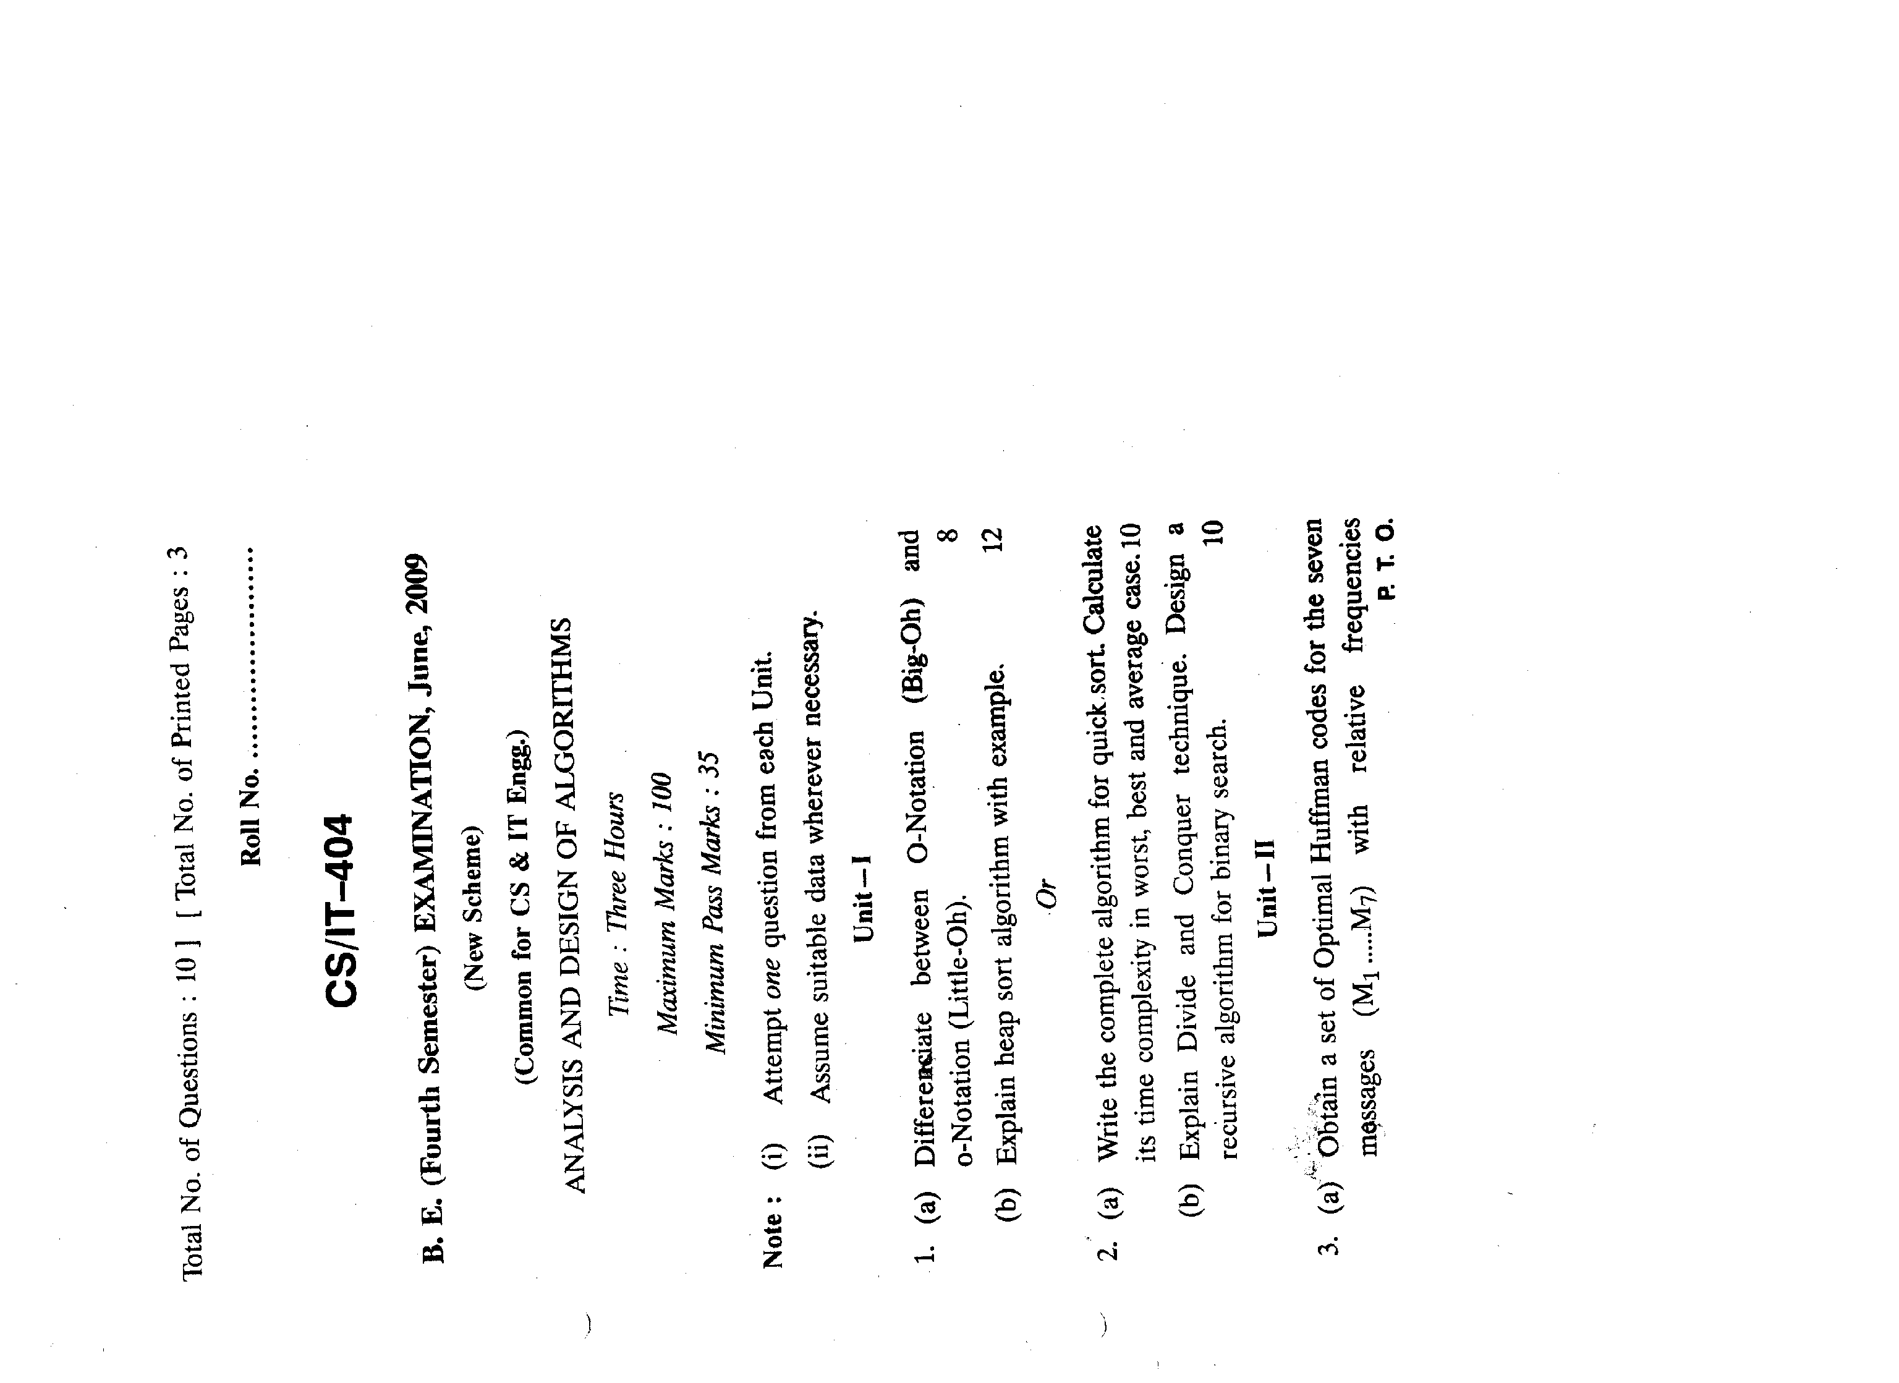

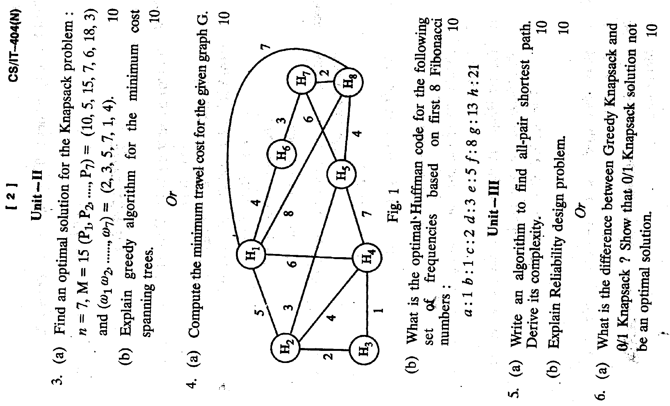

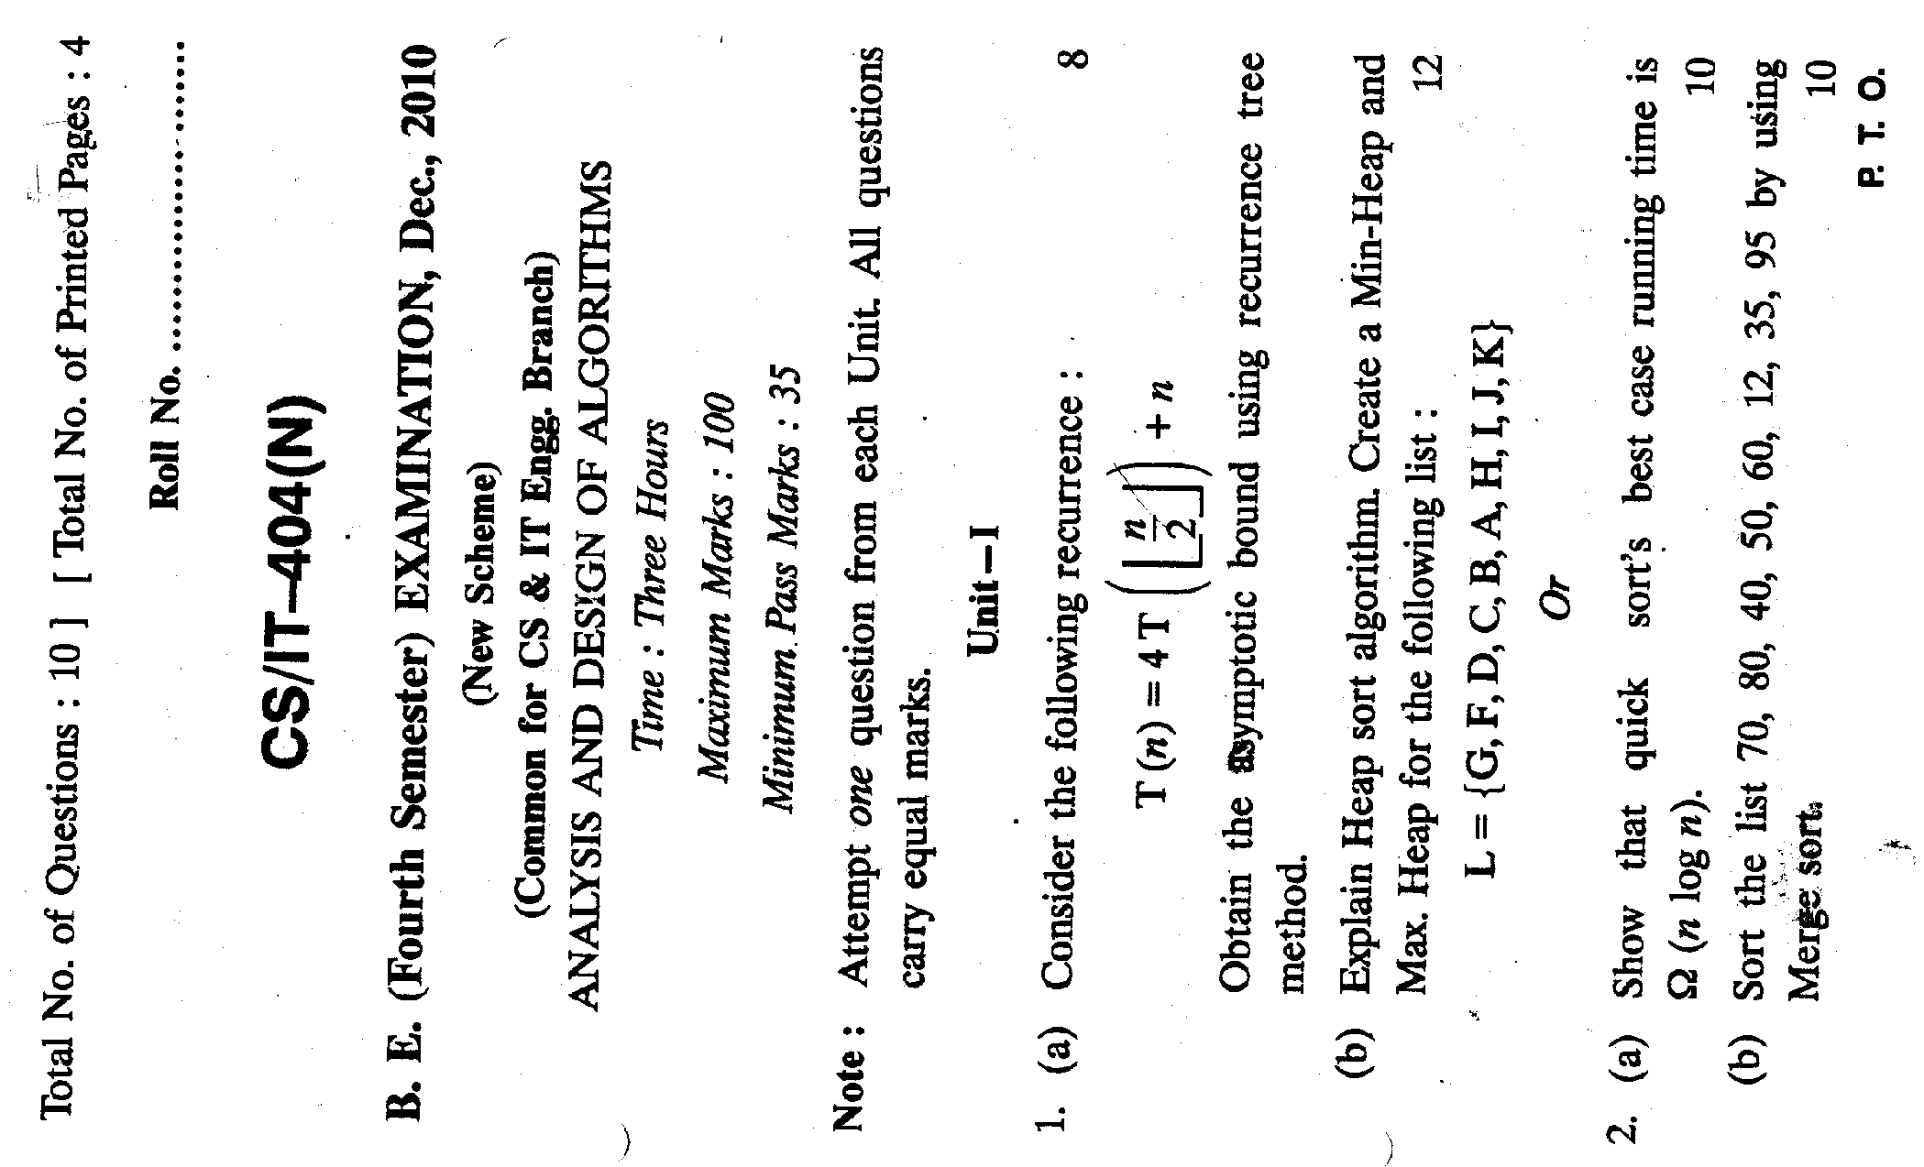

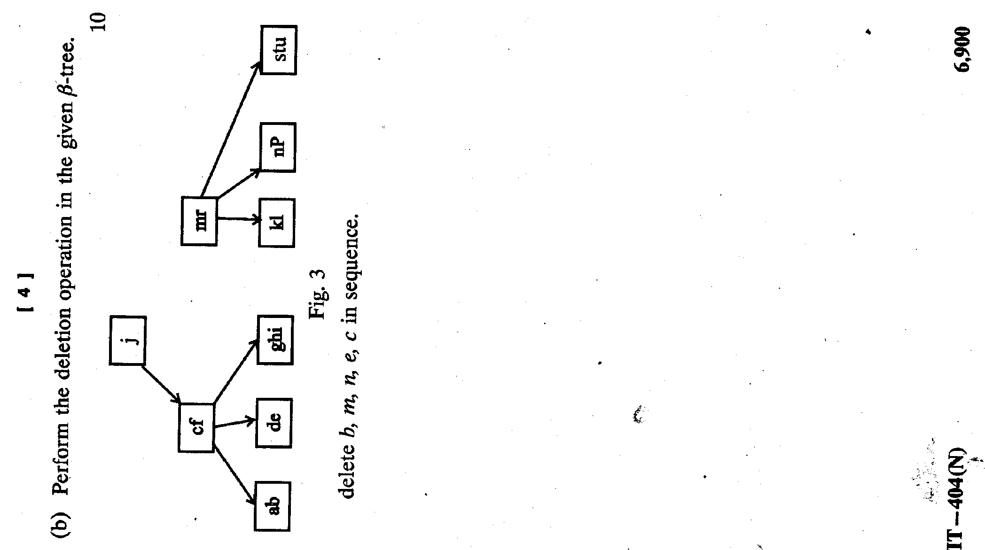

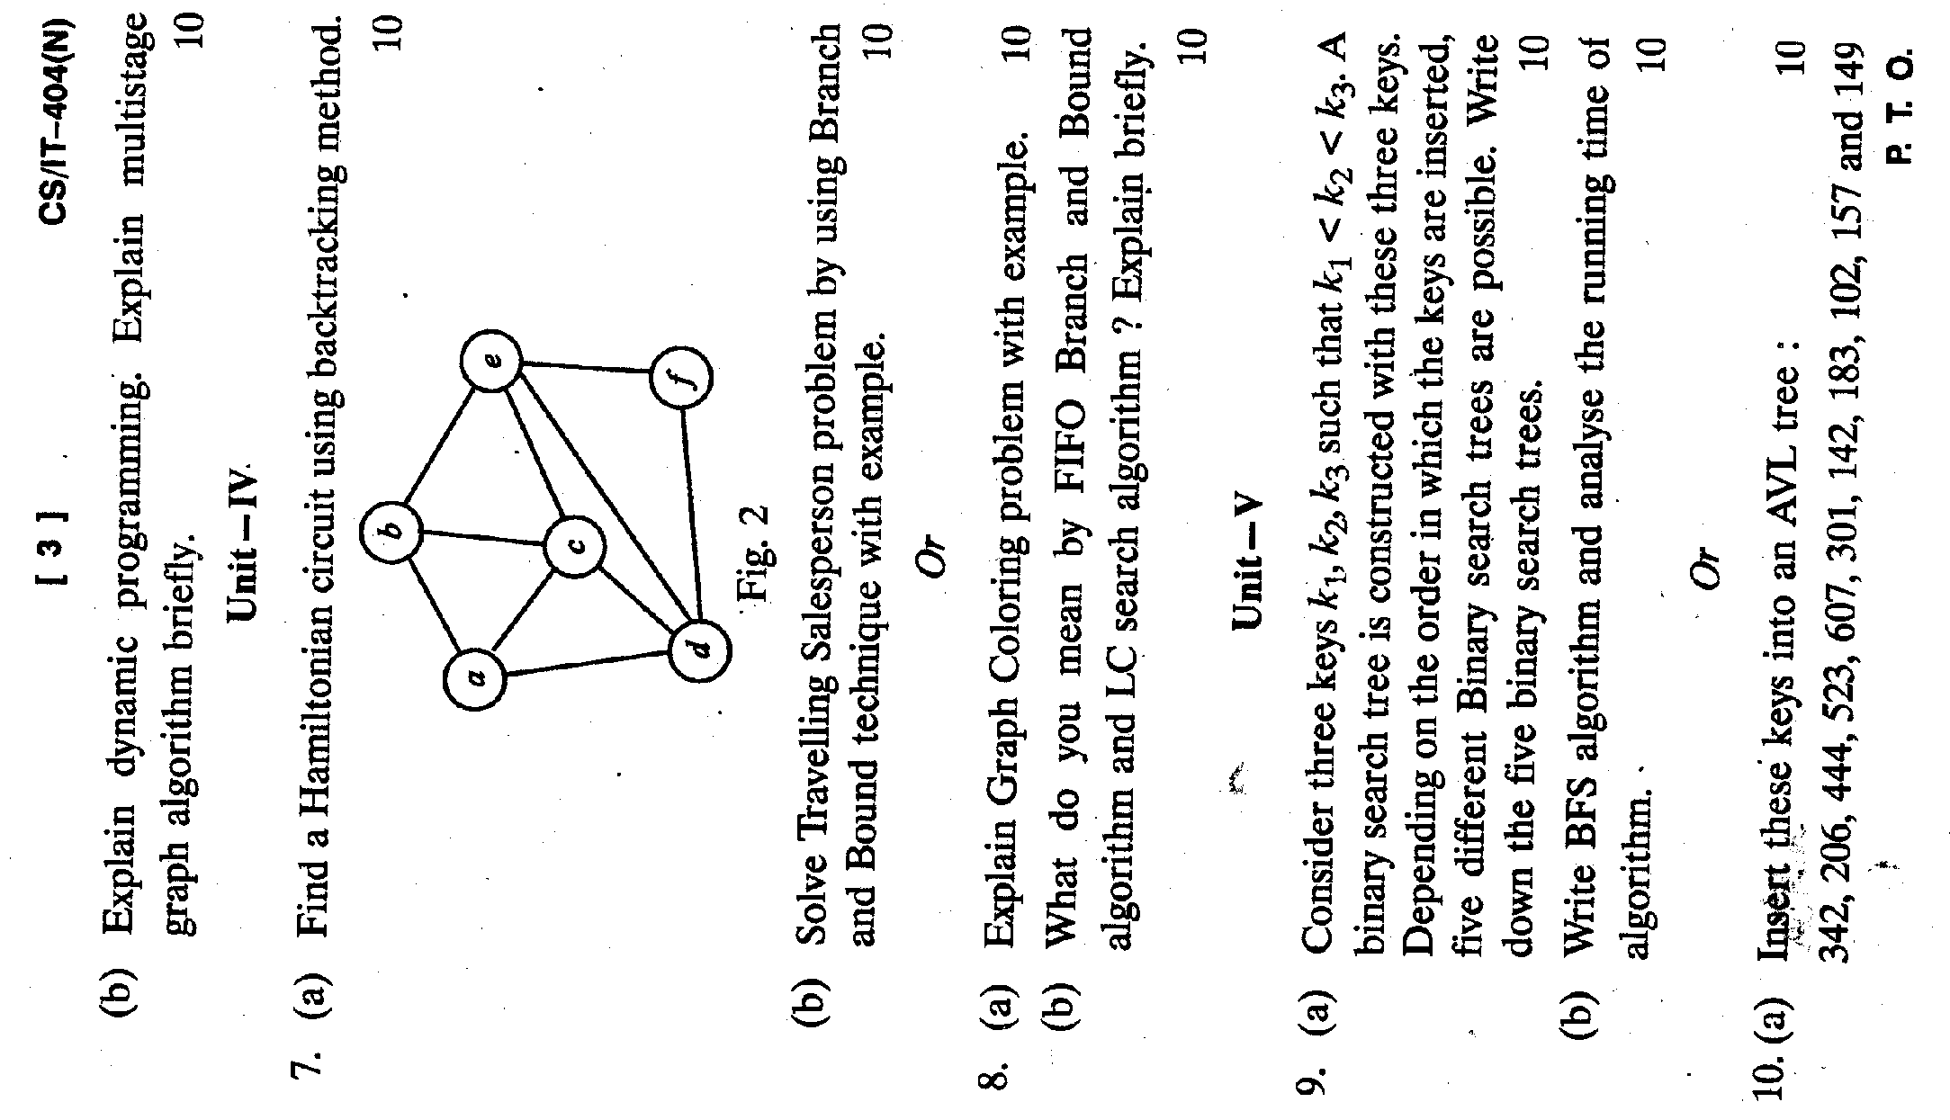
Tutorial-1

- What is recursion? Write a recursive algorithm to generate Fibonacci sequence.
- Calculate the value of ‘x’ at the end of program as a function of ‘n’:
X= 0
I=n
J=1
While( I > 1)
{
X=x+1
= 2*j
I= i/2j
}
- Explain how various control structures are analyzed with example.
- Discuss the time and space complexity of an algorithm
- Write Recursive Binary search procedure and analyze its time complexity

Tutorial-2

- What are the two phases in heap sort algorithm ? Sort the following data using heap sort and show all the intermediate steps: complexity of heap sort
88,12,91,23,10,36,45,55,15,39,81
- Write the procedure Heap sort and implement the algorithm on the array of 10 elements given below:
24,24,36,54,33,24,36,33,05,39
- Construct an AVL tree the following list {5,6,8,3,2,4,7} by inserting the elements successively starting with empty tree what is AVL tree.
- Construct AVL Tree if the following insertions r to be done on empty tree show the rotations during insertion
10,7,12,5,3,1,9,12,18,15,6,13,2
- What is binary search tree?
- Obtain AVL tree starting with empty tree on the following instruction.
Dec, Jan, Apr, Mar, Jul, Aug, Oct, Feb, Nov, May, Jun
- Construct AVL Tree if the following insertions are to be done on empty tree show the rotations during insertion
A,Z,B,Y,C,X,D,W,E,V,F
- Construct AVL Tree if the following insertions are to be done on empty tree show the rotations during insertion
10,7,12,5,3,1,9,12,18,15,6,13,2
Also construct BST for the above insertion in empty tree.
- Write short notes on the following
  - BST
  - AVL Tree
  - 2-3 Tree

Tutorial-3

- Draw a B-tree of order 3 for the following sequence of the keys:
{2,4,9,8,7,6,3,1,5,10}
- Construct a B-tree of order 5 of the following elements: 1,7,6,2,11,4,8,13,10,5,19,9,18,24,3,12,14,20,21,16
Now delete 8,18,16,4 show different states of your tree
- Explain Breadth first search ?
- Which data structure are required to store waiting vertices during depth first and breadth first traversal and why?
- Draw a B-tree for the following sequence of the keys:
L={86,50,40,3,94,10,70,90,110,113,116}
Given minimum factor t=3, minimum degree =2 and maximum degree =5
- Construct B-Tree if the following insertions are to be done on empty tree. Consider degree of B-tree equal to five:
4,12,9,7,15,21,18,8,6,24,3,5,11,13,2,16,25

Tutorial-4

- Give Strassen,s algorithm for multiplication’s explain it ,s improvement over Divide and conquer
- Explain the Divide and Conquer technique .Write down the algorithm of finding out maximum and minimum in give array using this technique
- Sort the following list using Quick sort
10.5.13.4.15.11.6.12
- Write Recursive Binary search procedure and analyze its time complexity
- Sort the given list using merge sort
70, 80, 40,50,60,12,35,95,10
- Explain Strassen’s matrix multiplication with the help of example.

Tutorial-5

- Write Down Greedy strategy .Explain the Knapsack problem .show that greedy strategy will not work for 0-1 knapsack problem .give a dynamic programming based solution for this problem
- Write an algorithm to find the minimum spanning tree of a graph and analyze your algorithm.
Problem solving with methods Prism
- Find an Optimal merge pattern for 11 files whose length are: 28,32,12,5,84,5,3,9,35,3,11
- Write prims algorithm for finding minimum spanning tree.
- What is the difference between prim’s and Kruskal algorithm for finding the minimum spanning tree.
- Explain Knapsack problem. Find the optimal solution for following Knapsack instance:
No. of object=7
Knapsack capacity=15
Weights (w1,w2,…..w7)=(2,3,5,7,1,4,1)
Profits (p1,p2,…….p7)=(10,5,15,7,6,18,3)

Tutorial-6

- What s Multistage graph problem ?Discuss its solution based on dynamic programming approach
- Explain Dynamic Programming
How is knapsack problem solved by dynamic programming method? How does it differ from greedy algorithm?
- What is reliable design problem?
- Design a 3-stage with devices D1, D2 and D3. The cost are Rs. 30,15 and 20 respectively. Total system cost cannot be more than Rs 105. Reliability of each device is 0.9, 0.8 and 0.5 respectively. Determine the best design, its reliability and cost of the system using dynamic programming.
- Define how Knapsack problem is solved by using dynamic programming approach? Consider : n=3 (w1,w2,w3)=(2,3,3)
(p1,p2,p3)=(1,2,4) and m=6, find optimal solution for the given data.
- Discuss backtracking technique for designing an algorithm & use backtracking formulation to slove 4 queen problem.
Algorithm based on this concept ,that generates the possible colors for Kth node of graph after color for nodes 1thru K-1 have already been defined
- Hamiltonian cycle .using backtracking give an algorithm to find Hamiltonian
- Represent the map in the form of planar graph. Apply Graph-colorings algorithm.

Tutorial-7

- Consider the traveling salesperson instance defined by the cost matrix:
∞ | 7 | 3 | 12 | 8
3 | ∞ | 6 | 14 | 9
5 | 8 | ∞ | 6 | 18
9 | 3 | 5 | ∞ | 11
18 | 14 | 9 | 8 | ∞
Obtain reduce cost matrix and solve it.
- Discuss NP- Completeness
- Show that Traveling salesman problem is NP-Complete
- Discuss the relationship between class P, NP, NP complete and NP hard problem with example of each class.

COLLEGE OF TECHNOLOGY
INFORMATION TECHNOLOGY DEPARTMENT
Assignment 1
Subject: Analysis & Design of Algorithm
Subject Code: IT 404

- What is an Algorithm? What is the need to study Algorithms?

- Explain the Algorithm design and analysis process with a neat diagram.

- Define space and time complexity.

- Define asymptotic notation.

- Explain Strassen’s matrix multiplication.

COLLEGE OF TECHNOLOGY
INFORMATION TECHNOLOGY DEPARTMENT
Assignment 2
Subject: Analysis & Design of Algorithm
Subject Code: IT 404

- What is Knapsack problem? Give the solution to solve it using dynamic programming technique.

- Give an algorithm to solve the knapsack problem.

- Explain the concept of Greedy technique.

- Explain Prim's algorithm with an eg.
- Explain Kruskal's algorithm with an eg.

COLLEGE OF TECHNOLOGY
INFORMATION TECHNOLOGY DEPARTMENT
Assignment 3

- Give the Warshall's algorithm and analyze the efficiency.

- Explain how do you solve the All-Pairs-Shortest-Paths problem with an eg.

- Give the Flloyd's algorithm and analyze the efficiency.

- Define Dynamic programming.

- Define Multistage graph.

COLLEGE OF TECHNOLOGY
INFORMATION TECHNOLOGY DEPARTMENT
Assignment 4

- What are Huffman trees? Explain how to construct Huffman trees with an eg.

- Explain the concept of Backtracking with an eg.

- What is a state space tree? Explain how to construct a state space tree?

- What is n-Queen's problem? Generate the state space tree for n = 4.

- Explain the subset sum problem with an eg.

COLLEGE OF TECHNOLOGY
INFORMATION TECHNOLOGY DEPARTMENT
Assignment 5

- Define P, NP and NP-Complete problems.

- Explain the Branch and Bound technique with an eg.

- Give the Approximation Algorithm for NP-Hard problems.

- Define AVL tree.

- Define B-tree.

COLLEGE OF TECHNOLOGY
INFORMATION TECHNOLOGY DEPARTMENT
MID SEMESTER I
Subject: Analysis & Design of Algorithm
Subject Code: IT 404
MAX-MARKS: 20 TIME: 2 hrs
Remarks: (a) All questions carry equal marks.
(b) All Questions are compulsory

Q1.What is algorithm and writes its characterstics? Define the analysis and design of algorithm.

Q2.Write the algorithm for Heap sort. Sort the following data using heap sort and show all the intermediate steps:
88,12,91,23,10,36,45,55,15,39,81

Q3. Solve the recurrence:
T(n) = T(n/3) + T(2n/3) + O(n)

Q4. What is greedy strategy? Solve the problem through Haffman codes.
4,5,7,8,10,12,20

Q5.What do you mean by minimum spanning tree problem? Define Prim’s and Kruskal’s Algorithm.

COLLEGE OF TECHNOLOGY
INFORMATION TECHNOLOGY DEPARTMENT
MID SEMESTER II
Subject: Analysis & Design of Algorithm
Subject Code: IT 404
MAX-MARKS: 20 TIME: 2 hrs
Remarks: (a) All questions carry equal marks.
(b) All Questions are compulsory

Q1. What is dynamic programming? Find the optimal solution for 0/1 Knapsack problem(w1,w2,w3,w4)=(10,15,6,9),(p1,p2,p3,p4)=(2,5,8,1) and m=30.

Q2. What is multistage graph problem? Discuss its solution based on dynamic programming approach.

Q3. Define backtracking. Solve the 4-queen problem by backtracking method.

Q4. What are Hamiltonian cycles? Write the algorithm which finds all Hamiltonian cycles in a graph.

Q5. What is AVL tree? Define NP completeness.

Overview of Units
UNIT 1
Algorithm:
An algorithm is an effective method expressed as a finite list of well-defined instructions for calculating a function. Algorithms are used for calculation, data processing, and automated reasoning. Starting from an initial state and initial input, the instructions describe a computation that, when executed, will proceed through a finite number of well-defined successive states, eventually producing "output"and terminating at a final ending state.
Analysis of Algorithm:
To analyze an algorithm is to determine the amount of resources (such as time and storage) necessary to execute it. Most algorithms are designed to work with inputs of arbitrary length. Usually the efficiency or running time of an algorithm is stated as a function relating the input length to the number of steps (time complexity) or storage locations (space complexity). Algorithm analysis is an important part of a broader computational complexity theory, which provides theoretical estimates for the resources needed by any algorithm which solves a given computational problem. These estimates provide an insight into reasonable directions of search for efficient algorithms.
Asymptotic Notations:
Asymptotic Notations describes the limiting behavior of a function when the argument tends towards a particular value or infinity, usually in terms of simpler functions. Big O, Big omega, Big theta, Small omega and Small O are different asymptotic notaions that we use.
Divide and Conquer Technique:
Divide and conquer (D&C) is an important algorithm design paradigm based on multi-branched recursion. A divide and conquer algorithm works by recursively breaking down a problem into two or more sub-problems of the same (or related) type, until these become simple enough to be solved directly. The solutions to the sub-problems are then combined to give a solution to the original problem.
Binary Search:
Binary search or half-interval search algorithm locates the position of an item in a sorted array. Binary search works by comparing an input value to the middle element of the array. The comparison determines whether the element equals the input, less than the input or greater. When the element being compared to equals the input the search stops and typically returns the position of the element. If the element is not equal to the input then a comparison is made to determine whether the input is less than or greater than the element.

Merge Sort:
Merge sort is an O(n log n) comparison-based sorting algorithm. Most implementations produce a stable sort, meaning that the implementation preserves the input order of equal elements in the sorted output. It is based on divide and conquer algorithm.
Quick Sort:
Quicksort is a sorting algorithm developed by C. A. R. Hoare that, on average, makes O(nlogn) (big O notation) comparisons to sort n items. In the worst case, it makes O(n²) comparisons, though if implemented correctly this behavior is rare. Typically, quicksort is significantly faster in practice than other O(nlogn) algorithms. It is also based on divide and conquer algorithm.
Strassen’s Matrix Multiplication:
Strassen's algorithm, devised by Volker Strassen in 1969 and often referred to as "fast matrix multiplication", is based on a clever way of multiplying two 2 × 2 matrices which requires only 7 multiplications (instead of the usual 8), at the expense of several additional addition and subtraction operations.

UNIT 2
Greedy Strategy:
A greedy algorithm is any algorithm that follows the problem solving metaheuristic of making the locally optimal choice at each stage with the hope of finding the global optimum. Greedy algorithms produce good solutions on some mathematical problems, but not on others.
Huffman coding:
Huffman coding is an entropy encoding algorithm used for lossless data compression. The term refers to the use of a variable-length code table for encoding a source symbol (such as a character in a file) where the variable-length code table has been derived in a particular way based on the estimated probability of occurrence for each possible value of the source symbol.
Minimum spanning tree:
A minimum spanning tree (MST) or minimum weight spanning tree is a spanning tree with weight less than or equal to the weight of every other spanning tree. More generally, any undirected graph (not necessarily connected) has a minimum spanning forest, which is a union of minimum spanning trees for its connected components.
Knapsack Problem:
The knapsack problem or rucksack problem is a problem in combinatorial optimization: Given a set of items, each with a weight and a value, determine the number of each item to include in a collection so that the total weight is less than or equal to a given limit and the total value is as large as possible.
Single Source Shortest path problem:
Single Source Shortest path problem is the problem of finding a path between two vertices (or nodes) such that the sum of the weights of its constituent edges is minimized. An example is finding the quickest way to get from one location to another on a road map; in this case, the vertices represent locations and the edges represent segments of road and are weighted by the time needed to travel that segment.

UNIT 3
Dynamic Programming:
Dynamic programming is a method for solving complex problems by breaking them down into simpler subproblems. It is applicable to problems exhibiting the properties of overlapping subproblems which are only slightly smaller and optimal substructure .The key idea behind dynamic programming is quite simple. In general, to solve a given problem, we need to solve different parts of the problem (subproblems), then combine the solutions of the subproblems to reach an overall solution. Often, many of these subproblems are really the same. The dynamic programming approach seeks to solve each subproblem only once, thus saving a lot of computation.
0/1 Knapsack problem:
0/1 knapsack problem is based on dynamic programming approach. This problem is similar to simple knapsack problem but in this problem we cannot add fraction of any object into knapsack.
Multistage Graph:
A Multistage graph is a directed graph in which the vertices are partitioned into k>= 2 disjoint sets Vi. In addition, if (u,v) is an edge in E, then u belongs Vi and v belongs to Vi+1 for some i . A multistage graph problem is to find a minimum cost path from source to sink
Reliability Design Problem:
Reliability Design Problem is a problem to design a system that is composed of several devices connected in series. Our problem is to use device duplication to maximize reliability. This maximization is to be carried out under a cost constraint.
All Pair shortest path Problem:
All Pair shortest path problem is to determine a matrix A such that A (i,j) is the length of a shortest path i to j . This problem is based on dynamic programming and that’s why holds principle of optimality.

UNIT 4
Backtracking:
The backtracking algorithm enumerates a set of partial candidates that, in principle, could be completed in various ways to give all the possible solutions to the given problem. The completion is done incrementally, by a sequence of candidate extension steps. The classic textbook example of the use of backtracking is the eight queens puzzle, that asks for all arrangements of eight queens on a standard chessboard so that no queen attacks any other. In the common backtracking approach, the partial candidates are arrangements of k queens in the first k rows of the board, all in different rows and columns. Any partial solution that contains two mutually attacking queens can be abandoned, since it cannot possibly be completed to a valid solution.
8 Queen’s Problem:
The eight queens puzzle is the problem of placing eight chess queens on an 8×8 chessboard so that none of them can capture any other using the standard chess queen's moves. The queens must be placed in such a way that no two queens attack each other. Thus, a solution requires that no two queens share the same row, column, or diagonal. The eight queens puzzle is an example of the more general n-queens problem of placing n queens on an n×n chessboard, where solutions exist only for n = 1 or n ≥ 4.
Hamiltonian Cycle:
A Hamiltonian cycle (or Hamiltonian circuit) is a cycle in an undirected graph which visits each vertex exactly once and also returns to the starting vertex. Determining whether such paths and cycles exist in graphs is the Hamiltonian path problem which is NP-complete. A Hamiltonian path or traceable path is a path that visits each vertex exactly once. A graph that contains a Hamiltonian path is called a traceable graph.
Graph Coloring Problem:
Graph coloring is a special case of graph labeling; it is an assignment of labels traditionally called "colors" to elements of a graph subject to certain constraints. In its simplest form, it is a way of coloring the vertices of a graph such that no two adjacent vertices share the same color.
Branch and Bound:
Branch and bound (BB or B&B) is a general algorithm for finding optimal solutions of various optimization problems, especially in discrete and combinatorial optimization. It consists of a systematic enumeration of all candidate solutions, where large subsets of fruitless candidates are discarded, by using upper and lower estimated bounds of the quantity being optimized. The method was first proposed by A. H. Land and A. G. Doig in 1960 for discrete programming.
Traveling salesperson Problem:
The Travelling Salesman Problem (TSP) is an NP-hard problem in combinatorial optimization studied in operations research and theoretical computer science. Given a list of cities and their pairwise distances, the task is to find a shortest possible tour that visits each city exactly once. The TSP has several applications even in its purest formulation, such as planning, logistics, and the manufacture of microchips.

UNIT 5
Tree:
In computer science, a tree is a widely-used data structure that emulates a hierarchical tree structure with a set of linked nodes. A node is a structure which may contain a value, a condition, or represent a separate data structure (which could be a tree of its own). Each node in a tree has zero or more child nodes, which are below it in the tree (by convention, trees are drawn growing downwards). A node that has a child is called the child's parent node (or ancestor node, or superior). A node has at most one parent.
Binary search Tree:
In computer science, a binary search tree (BST), which may sometimes also be called ordered or sorted binary tree, is a node-based binary tree data structure which has the following properties:
- The left subtree of a node contains only nodes with keys less than the node's key.
- The right subtree of a node contains only nodes with keys greater than the node's key.
- Both the left and right subtrees must also be binary search trees.
Height Balance Tree:
A Height balance tree or AVL tree is a self-balancing binary search tree, and it was the first such data structure to be invented. In an AVL tree, the heights of the two child subtrees of any node differ by at most one. The balance factor of a node is the height of its left subtree minus the height of its right subtree and a node with balance factor 1, 0, or −1 is considered balanced. A node with any other balance factor is considered unbalanced and requires rebalancing the tree.
2-3 Tree:
A 2-3 tree in computer science is a type of data structure, a tree where every node with children (internal node) has either two children and one data element (2-nodes) or three children and two data elements (3-nodes). Nodes on the outside of the tree (leaf nodes) have no children and one or two data elements.

B-Tree:
B-tree is a tree data structure that keeps data sorted and allows searches, sequential access, insertions, and deletions in logarithmic amortized time. The B-tree is a generalization of a binary search tree in that a node can have more than two children.
Tree Traversal:
Tree-traversal refers to the process of visiting (examining and/or updating) each node in a tree data structure, exactly once, in a systematic way. Such traversals are classified by the order in which the nodes are visited. Three types of tree traversing technique are In-order, Pre-order and Post-order.

Graph:
Graph is an abstract data structure that is meant to implement the graph and hypergraph concepts from mathematics. A graph data structure consists mainly of a finite (and possibly mutable) set of ordered pairs, called edges or arcs, of certain entities called nodes or vertices.
Graph Traversal:
Graph traversal refers to the problem of visiting all the nodes in a graph in a particular manner. Tree traversal is a special case of graph traversal. In contrast to tree traversal, in general graph traversal, each node may have to be visited more than once, and a root-like node that connects to all other nodes might not exist.

Depth-first Search:
A Depth-first search (DFS) is a technique for traversing a finite undirected graph. DFS visits the child nodes before visiting the sibling nodes, that is, it traverses the depth of the tree before the breadth.
Breadth-first Search:
A Breadth-first search (BFS) is another technique for traversing a finite undirected graph. BFS visits the sibling nodes before visiting the child nodes.
NP-hard:
NP-hard (non-deterministic polynomial-time hard), in computational complexity theory, is a class of problems that are, informally, "at least as hard as the hardest problems in NP". A problem H is NP-hard if and only if there is an NP-complete problem L that is polynomial time Turing-reducible to H.
NP-Complete:
In computational complexity theory, the complexity class NP-complete (abbreviated NP-C or NPC) is a class of decision problems. A problem L is NP-complete if it has two properties,It is in the set of NP (nondeterministic polynomial time) problems: Any given solution to L can be verified quickly (in polynomial time).It is also in the set of NP-hard problems: Any NP problem can be converted into L by a transformation of the inputs in polynomial time.

Model Question Paper 2013
Branch: I.T
Subject:- Analysis and Design of Algorithm
(I.T.-404)

Time:-3 hours Max marks:-100 Min Marks:-35
Note: -All Questions carry equal marks. Assume any missing data suitably, if necessary

UNIT – I
- What is algorithm? Discuss time and space complexity of an algorithm.
- Write Recursive Binary search procedure and analyze its time complexity
OR
- Differentiate between Big O notation and Little o notation.
- Write the complete algorithm for quick sort. Calculate its time complexity in worst, best and average case.
UNIT – II
- Explain Knapsack problem. Find the optimal solution for following Knapsack instance:
No. of object=7
Knapsack capacity=15
Weights (w1,w2,…..w7)=(2,3,5,7,1,4,1)
Profits (p1,p2,…….p7)=(10,5,15,7,6,18,3)
- What is the difference between prim’s and Kruskal algorithm for finding the minimum spanning tree.
OR
- Find an Optimal merge pattern for 11 files whose length are: 28,32,12,5,84,5,3,9,35,3,11.
- Obtain asset of Optimal Huffman codes for the seven messages (M1….M7) with relative frequencies (q1….q7) = (4, 5, 7, 8, 10, 12, 20). Draw the decode tree for this set of codes.
UNIT – III
- What s Multistage graph problem ?Discuss its solution based on dynamic programming approach.
- Explain Dynamic Programming
How is knapsack problem solved by dynamic programming method? How does it differ from greedy algorithm?
OR
- What is reliable design problem?
- Design a 3-stage with devices D1, D2 and D3. The cost are Rs. 30,15 and 20 respectively. Total system cost cannot be more than Rs 105. Reliability of each device is 0.9, 0.8 and 0.5 respectively. Determine the best design, its reliability and cost of the system using dynamic programming.

UNIT – IV
- Consider the traveling salesperson instance defined by the cost matrix:
∞ | 7 | 3 | 12 | 8
3 | ∞ | 6 | 14 | 9
5 | 8 | ∞ | 6 | 18
9 | 3 | 5 | ∞ | 11
18 | 14 | 9 | 8 | ∞
Obtain reduce cost matrix and solve it.
- Explain Graph coloring problem with example.
OR
- Solve 8 queens problem using backtracking.
- What do mean by FIFO Branch and Bound algorithm and LC search algorithm?
UNIT – V
- Construct B-Tree if the following insertions are to be done on empty tree. Consider degree of B-tree equal to five:
4,12,9,7,15,21,18,8,6,24,3,5,11,13,2,16,25
- Explain NP-completeness briefly.
OR
- Construct AVL Tree if the following insertions r to be done on empty tree show the rotations during insertion
10,7,12,5,3,1,9,12,18,15,6,13,2
- Write short notes on the following
  - BST
  - 2-3 Tree

