CLGNAME COLLEGE OF TECHNOLOGY, BHOPAL

DEPARTMENT OF COMPUTER SCIENCE & ENGINEERING

COURSE FILE

Program : B.E.

Semester : V

Course Code : CS-504

Subject Name : Computer Graphics & Multimedia

Prepared By: Approved By:

 | LECTURE PLAN | Format No.
 | LECTURE PLAN | Issue
 | LECTURE PLAN | Page No:

Department | Computer Science & Enginnering | Session: | 2012
Name of Teacher | Priya Bharti | Semester | Odd
Subject | COMPUTER GRAPHICS & MULTIMEDIA | Sub. Code | CS-504

Day | Mon | Tue | Wed | Thu | Fri |  |  | Sat |  | Max. Available
No. Of
Periods
Lecture | Topics to be covered |  |  |  |  | Date of Completion |  |  | Reference Books
1 | Introduction to Raster Graphics |  |  |  |  |  |  |  | B1-67
2 | Graphics System Architecture |  |  |  |  |  |  |  | B1-25, B2-35
3 | Concept of scan Conversion (2D & 3D) |  |  |  |  |  |  |  | B2-183, B5-25
4 | Concept of Windows and View port |  |  |  |  |  |  |  | B2-217, B5-90
5 | 3D Viewing and perspective transformation |  |  |  |  |  |  |  | B2-438, B6-3.26
6 | Illumination models |  |  |  |  |  |  |  | B1-722, B2-495
7 | Shading models |  |  |  |  |  |  |  | B1-722, B2-495
8 | Colors & colors models |  |  |  |  |  |  |  | B1-584, B2-565
9 | Geometric transformation of images |  |  |  |  |  |  |  | B1-842
10 | Image composing filling algorithm |  |  |  |  |  |  |  | B6-13.9
11 | Managing windows with bitable |  |  |  |  |  |  |  | Notes
12 | Multimedia: Definition |  |  |  |  |  |  |  | B3-1, B4-1
13 | Component text, |  |  |  |  |  |  |  | B3-31, B4-4
14 | Audio |  |  |  |  |  |  |  | B3-90
15 | Graphics |  |  |  |  |  |  |  | B3-122,B4-33
16 | Video |  |  |  |  |  |  |  | B4-176
17 | Hypertext Multimedia |  |  |  |  |  |  |  | B4-176
18 | Hardware: Peripherals Connection |  |  |  |  |  |  |  | B3-211
19 | SCSI |  |  |  |  |  |  |  | B3-211
20 | IDE |  |  |  |  |  |  |  | B3-212
21 | MCI |  |  |  |  |  |  |  | Notes
22 | Optical Storage |  |  |  |  |  |  |  | B4-224
23 | CDs |  |  |  |  |  |  |  | B3-288, B6-14.14
24 | Video Disc Players |  |  |  |  |  |  |  | B3-224
25 | Input Methodology: Pens |  |  |  |  |  |  |  | B4-192, B6-14.11
26 | Image Scanners |  |  |  |  |  |  |  | B4-216
27 | Digital Camera |  |  |  |  |  |  |  | B3-222,B4-224
28 | Digital Audio |  |  |  |  |  |  |  | B4-93
29 | Full motion Video |  |  |  |  |  |  |  | B4-260
30 | Video camera devices standards |  |  |  |  |  |  |  | Notes
31 | Multimedia data & File format |  |  |  |  |  |  |  | Notes
32 | RTF |  |  |  |  |  |  |  | B3-1,B4-124, B6-16.11.4
33 | TIFF |  |  |  |  |  |  |  | B4-127, B6-16.5
34 | MIDI |  |  |  |  |  |  |  | B4-160, B6-16.11.3
35 | JPEG-DIB |  |  |  |  |  |  |  | B4-166, B6-16.12.1
36 | JPEG- AVI |  |  |  |  |  |  |  | B4-170, B6-16.12.1
37 | MPEG |  |  |  |  |  |  |  | B4-170, B6-16.12.5
38 | Multimedia Software: Basic Tools |  |  |  |  |  |  |  | B3-235
39 | Presentation tools |  |  |  |  |  |  |  | B3-238
40 | Multimedia Authoring tools & their types |  |  |  |  |  |  |  | B3-254, B6-15.2
41 | Card and Page based Authoring tools |  |  |  |  |  |  |  | B3-261, B6-15.3 to 15.4
42 | Illustrations through some authoring tools like author ware Pro. |  |  |  |  |  |  |  | Notes
43 | (Window based): Editing |  |  |  |  |  |  |  | B4-440
44 | Authoring, Presentations |  |  |  |  |  |  |  | B4-440
45 | Object Oriented Authoring tools |  |  |  |  |  |  |  | B6-15.5

Reference Books:

S. No. | TITLE | AUTHOR | PUBLISHER
1 | Computer graphics principles& practice | Foley Vandam | Pearson education (B1)
2 | Computer graphics | Hearn & Baker | PHI (B2)
3 | Multimedia: Making it work | Tay Vaughan | TMH (B3)
4 | Multimedia system design | Kiran Thakrar | PHI (B4)
5 | Computer Graphics | Schaum Series | TMH (B5)
6 | Computer Graphics & Multimedia | G. S. Baluja | Dhanpat Rai & Co. (B6)

List of Books

S. No. | TITLE | AUTHOR | PUBLISHER
1 | Computer graphics principles& practice | Foley Vandam | Pearson education
2 | Computer graphics | Hearn & Baker | PHI
3 | Multimedia: Making it work | Tay Vaughan | TMH
4 | Multimedia system design | Kiran Thakrar | PHI
5 | Computer Graphics for Engineers | Rajaraman | Narosa Publishing
6 | Computer Graphics | Anirban Mukhopadhyay, Arup Chattopadhyay | Vidhya Vikash Pub.
7 | Computer Graphics using open GL | Hill | PHI
8 | Computer Graphics | Schaum Series
9 | Multimedia Computing | James E Shuman | Vikas publishing House
10 | Fundamentals of Multimedia | Li & Drew | PHI

ORIENTAL GROUP OF INSTITUTES
MID SEMESTER–I
MAY-2011
BRANCH- COMPUTER SCIENCE & Engineering
SEMESTER: FOURTH SEMESTER
SUBJECT: Computer Science & Technology (CS-402)

Marks-40 Time: -2 Hrs
Attempt all question .
All question carry equal marks.

Ques. |  | Marks
1. | Give difference between Beam Penetration method and Shadow Mask method. | 05
2. | Digitize a line from (10, 12) to (20, 18) on raster screen using Bresenham’s Straight line algorithm. The result may be shown on a Cartesian graph. | 10
3. | Magnify the triangle P (0, 0), Q (2, 2) and R (10, 4) to four times its size while keeping R (10, 4) fixed. And also find the reflection about a line y = mx+c. | 10
4. | Write the algorithm for Cohen Sutherland clipping | 05
5. | Explain the DDA line drawing algorithm and compare it with Bresenham’s line drawing algorithm. | 10

CLGNAME College of Technology, Bhopal
Department of Computer Science & Engineering

Tutorial-1

Subject: CGM
Subject Code: CS-504

- Define the term of Computer Graphics? Explain how computer graphics is used in Industry, Business and Education?

- Explain CRT in brief.
- Explain Random and raster scan display and give their important features.
- Explain DDA line drawing Algorithm.
- Explain Mid point circle Algorithm.
- Explain applications of Computer Graphics?
- Define following with examples:
(i) Resolution (ii) Aspect Ratio

CLGNAME College of Technology, Bhopal
Department of Computer Science & Engineering

Tutorial –2

Subject: CGM
Subject Code: CS-504

- What do you mean by Transformation? Explain Basic transformation in brief.
- Scale the given square to its twice size while keeping the Point (2,2) fixed. The coordinate of the square is A(1,3), B(1,1), C(3,1), D(3,3)
- Explain the Composite Transformation in 2D?
- Perform a 45° rotation of triangle A(0,0), B(1,1)& C(5,2)
(i) About the origin and (ii) About P(-1,-1).
- Magnify the triangle with vertices A(0,0), B(1,1), and C(5,2) to twice its size while keeping C(5,2) fixed.
- Draw the matrix for rotation.
- A triangle A(2,2), B(1,1), C(3,1) is rotated 180o at point A find out the new coordinate after rotation.
- Design a 2D transformation matrix for getting mirror image relative to (a) x-axis (b) y-axis.
- How to get composite transformation matrix if mirror is parallel to y-axis at x =6. Get mirror image of triangle {(2,2) (4,6) (5,3)} relative to mirror x =6.

CLGNAME College of Technology, Bhopal
Department of Computer Science & Engineering

Tutorial –3

Subject: CGM
Subject Code: CS-504

- Write and explain Sutherland-Cohen algorithm for line clipping? Also simulate the algorithm for some example.

- Explain window to view port mapping in detail?

- Find the normalization transformation N which uses the rectangle A(1,1), B(5,3), C(4,5), D(0,3) as a window and the normalized device screen as a view port.

- How can we determine whether a point P(x,y) lies to the left or to the right of a line segment joining the point A (x1,y1) and B(x2,y2)?

- Explain Sutherland-Hodgeman polygon clipping algorithm?

- Write 3D rotation matrixes?

- Differentiate between Gourand shading and Phong Shading.

CLGNAME College of Technology, Bhopal
Department of Computer Science & Engineering

Tutorial –4

Subject: CGM
Subject Code: CS-504

- The Unit cube is projected onto the xy plane. Note the position of x,y and z axis. Draw the projected image using the standard perfective transformation with (a) d=1 and (b) d=10, where d is the distance from the view plane.

- Explain perspective projection with mathematic expression.

- Draw the Bezier curve defined by the Control points (2,1),(3,2),(5,0) and (6,2) by determining four intermediate point.

- Differentiate between parallel and perspective projection.

- Explain technique for representation of 3 D object on 2 D screen.

6. (a) What is uniform scaling and shearing? Explain with example.
(b) Write the 3D transformation equation for:
- 3D rotation about X-axis by an angle
- 3D rotation about Y-axis by an angle

7. (a) Describe 4-bits code method of Cohen-Sutherland for line clipping. How does this algorithm function?
(b) Find the transformation n matrix to reflect a polygon with vertices A(-1,0),
B (0,-2), C (1, 0) and D (0, 2) about the line y=x+2. Also find the reflected image of Polygon?

CLGNAME College of Technology, Bhopal
Department of Computer Science & Engineering

Tutorial –5

Subject: CGM
Subject Code: CS-504

- Compare Digital Audio and MIDI data.

- Explain DIB and TIFF multimedia file formats.
- What are the components of multimedia system? In what format are these data stored in computer? How are these linked to each other?
- How Multimedia Hardware helps user in creating animations. Also explain SCSI, IDE, MCI.
- Explain Multimedia authoring tools in detail.

- (a) Compare Digital Audio and MIDI data.
(b) What is Hypertext? Discuss the structure of hypertext system.

7. Discuss any two of the following:
1. Perspective Projection
2. RGB and CMY color models
3. Bezier Curves
4. Components of multimedia system

CLGNAME College of Technology, Bhopal
Department of Computer Science & Engineering

Assignment-1

Subject: CGM
Subject Code: CS-504

- What is the role of shadow mask used in graphics monitors? What do you mean by VGA and SVGA monitors?

- Write advantages of using interlaced monitors. Find the fraction of the total refresh time per frame spent in retrace of the electron beam for a non-interlaced raster system with a resolution of 1280 by 1024, a refresh rate of 60 Hz, Horizontal retrace time of 500 micro seconds.

- Describe the functioning of digitizing camera in detail with a neat diagram.

- What do you mean by scan conversion? What methods are adopted to remove the side effects of scan conversion?

- Determine the Bezier blending functions for five control points .plot each function and label the maximum and minimum values.

- Show that two successive reflections about either of the co-ordinate axis is equivalent to a single rotation about the co-ordinate origin.

- Why are homogeneous co-ordinates needed in transformation matrix ? Derive the transformation matrix for rotation about origin by angle θ in anticlockwise direction.

CLGNAME College of Technology, Bhopal
Department of Computer Science & Engineering

Assignment-2

Subject: CGM
Subject Code: CS-504

- The unit cube is projected on to the xy-plane under perspective projection with center of projection being (0,0,-10) .draw the projected image of the cube. Determine the vanishing point for this transformation. Why do specular highlights appear more realistic in Phong shading as compared to Gourad shading model?
- Compare digital audio and MIDI data.
- What is hypertext? Discuss the structure of hypertext system?
- Discuss sampling and Quantization.
- Discuss three-dimensional clipping algorithm as an extension of two- dimensional Sutherland-Hodgeman clipping algorithm.
- A number of objects having planar surface are present in a scene. The polygon surfaces may be represented by plane equation such as :
2x + 3y - 4z + 6 = 0
4x + y - 2z + 8 = 0

show that the depth buffer method can be used to detect visible surfaces of the objects ? Does the depth buffer method suffer from any drawback? If any discuss.

- Explain the XYZ colour model and the CIE chromatically diagram.
- Discuss the following:
  - JEPG and MPEG file format standards
  - WAF and AIFF sound format

CLGNAME College of Technology, Bhopal
Department of Computer Science & Engineering

Assignment-3

Subject: CGM
Subject Code: CS-504

- Write pseudo code for Bresenham’s line generation Algorithm. How it is better than DDA.
- Write any circle generating algorithm with radius x and centre position (p,q).
- How much memory is needed for the frame buffer to store a 640x400 display 16 gray level?
- Execute Bresenham’s straight line algorithm to produce a line from (0,0) to (17,12)
- Consider three raster scan system having resolution 640x480, 1280x1024 and 2560x2048, what size frame buffer is required for each of these system to store 12 bits per pixel.
- Discuss the method for storing color values in color lookup table, where each entry in the table uses 24 bits to specify an RGB color.
- Perform a 45 degree rotation of line A(12,4), B(21,14)
  - About the origin
  - About a point P(3,3)

- What is the difference between Window and Viewport. What is the use of normalized device coordinate system.
- Define the following
  - Point clipping
  - Line Clipping

- Perform a 45 degree rotation of line A(12,4), B(21,14)
About the origin.

CLGNAME College of Technology, Bhopal
Department of Computer Science & Engineering

Assignment-4

Subject: CGM
Subject Code: CS-504

- What is the difference between Window and Viewport? What is the use of normalized device coordinate system?
- Define the following
  - Point clipping
  - Line Clipping

- Write the general form of a scaling matrix with respect to a fixed point P(h,k)
- What is an Homogeneous coordinate, what is the use of it.
- Using midpoint transformation of straight line Show that there is one-to-one mapping of transformation of straight line.
- Consider the line L and triangle ABC. The equation of line L is y=1/2(x+4) and A(2,4), B(4,6), C(2,6). Reflect the triangle about L.
- Find the normalized transformation for window to viewport which uses the triangle whose lower left corner(2,2) and upper left corner(6,10)as a window and the viewport that has lower left corner at (0,0) and upper left corner at (1,1).

8. A clipping window PQRS has left corner at (3,4) and upper right corner at (10,9). Find the section of the clipped line AB whose coordinates are A(2, 11), B(9,2).

9. Find the Transformation matrix of 3D rotation about z-axis, x-axis and y-axis.

CLGNAME College of Technology, Bhopal
Department of Computer Science & Engineering

Assignment-5

Subject : CGM
Subject Code : CS-504

- Write Short notes on
  - B-spline curves
  - Bezier curves

- Determine eleven points on a Bezier curve with equidistant parametric value, having control points (x0, y0)=(50,180), ) (x1,y1)=(600,300), (x2,y2)=(600,300) and (x3,y3)=(500,50), distributed over a screen resolution 640x350.

- What are the components of multimedia system? How are they linked with each other?
- Why ATM is suitable for transporting multimedia data? Explain this using ATM protocol stack.
- Write the multimedia data and file format standards.
- What is the basic concept of hypertext? What are hypertext used for information representation in multimedia package? Name the tools to implement it.
- Discuss multimedia software and multimedia authoriting tools taking one example each in detail.
- Disscuss any four of the following in brief:-
  - Object Oriented authority tools.
  - Video Conferencing.
  - MPEG.
  - I,P,B frames
  - Managing windows with bit table
  - Aliasing and Antialiasing.

COURSE MATERIAL

COMPUTER GRAPHICS

Applications of Computer Graphics
- Computer graphics user interfaces - GUIs.
- GUI
A graphic, mouse-oriented paradigm which allows the user to interact with a computer.
- Business presentation graphics - "A picture is worth a thousand words".
- Cartography - drawing maps
- Weather Maps - real time mapping, symbolic representations
- Satellite Imaging - geodesic images
- Photo Enhancement - sharpening blurred photos
- Medical imaging - MRIs, CAT scans, etc. - non-invasive internal examination.
- Engineering drawings - mechanical, electrical, civil, etc. - replacing the blueprints of the past.
- Typography - the use of character images in publishing - replacing the hard type of the past.
- Architecture - construction plans, exterior sketches - replacing the blueprints and hand drawings of the past.
- Art - computers provide a new medium for artists.

Motivations for Graphics Use
- Training - flight simulators, computer aided instruction, etc.
- Entertainment - movies and games.
- Simulation and modeling - replacing physical modeling and enactments.
- Communications - in general.

Computer Hardware for Graphics

Input Devices
- Keyboard - good for text, awkward for graphics.
- Mouse - popular and convenient for graphics.
- Data tablet - good for accurate digitalization of existing hard copies as vector sets.
- Scanner - - good for digitalization of existing hard copies as pixel sets.
- Light pen - usually not as convenient as a mouse.
- Touch screen - more useful for menu selection than for graphics.
- Joystick - useful for interactive graphics (games).

Output Devices

Raster Devices
- CRT - the common display device for personal computers.
- LCD - A smaller, lighter, lower powor replacement for the CRT.
- LED - A smaller, lighter, lower powor replacement for the CRT.
- Plasma screens - a more expensive but brighter alternative to LCDs.
- Printers - today's printers are good for both text and graphics

Vector Devices
- Plotters - good for vector graphics.
- Oscilloscope - an early vector graphics output device

Vector Graphics and Raster Graphics
- vector graphics
Generation of images from mathematical descriptions that determine the position, length, and direction in which lines are drawn.
- Vector graphics is also called stroke or line drawing.
- Oscilloscopes and some plotters are vector graphics devices.
- raster graphics
Generation of images as a collection of small, independently controlled dots (pixels) arranged in rows and columns.
- Raster graphics is also referred to as pixel graphics.
- Almost all current computer output devices, including CRTs, LCDs, LEDs, and plasma screens, use raster graphics.
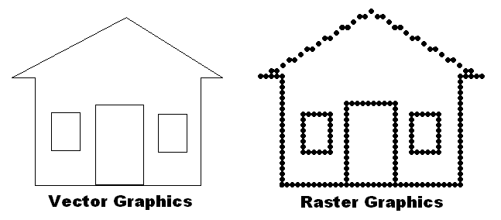

- Raster graphics cannot draw perfect curved or slopping lines.
- The appearance of curved or sloping lines improves as the size of the pixels decreases.
- Software techniques can also be used to improve the visual appearance of pixel based lines.

Computer Software for Graphics

Portability
- portability
The ability to be easily accessed or run by different systems and applications.
- Software can be portable at the source code level, or at the object code (executable) level.
- Most non-graphic programs are portable at the source code level, but must be recompiled to produce executable files for each separate system.
- Most graphics programs are non-portable, even at the source level.
TRANSFORMATIONS
- Transformations are one of the primary vehicles used in computer graphics to manipulate objects in three-dimensional space. Their development is motivated by the process of converting coordinates between frames, which results in the generation of a matrix. We can generalize this process and develop matrices that implement various transformations in space.
- In these notes, we discuss the basic transformations that are utilized in computer graphics - translation, rotation, scaling - along with several useful complex transformations, including those that work directly with the definition of a camera and the projections to image space.
- The reader should read and understand the notes on frames before pursuing these notes.

TRANSLATION
Overview
Translation is one of the simplest transformations. A translation moves all points of an object a fixed distance in a specified direction. It can also be expressed in terms of two frames by expressing the coordinate system of object in terms of translated frames.
Development of the Transformation in Terms of Frames
Translation is a simple transformation. We can develop the matrix involved in a straightforward manner by considering the translation of a single frame. If we are given a frame 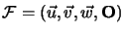, a translated frame would be one that is given by 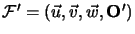- that is, the origin is moved, the vectors stay the same.
If we write in terms of the previous frame by
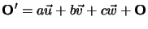
then we can write the frame in terms of the frame by
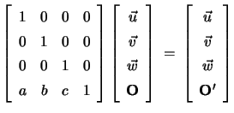
So a matrix implements a frame-to-frame transformation for translated frames, and any matrix of this type (for arbitrary 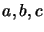) will translate the frame . We call any matrix
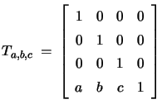
a translation matrix and utilize matrices of this type to implement translations.
Applying the Transformation Directly to the Local Coordinates of a Point
Given a frame and a point that has coordinates 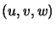in , if we apply the transformation to the coordinates of the point we obtain
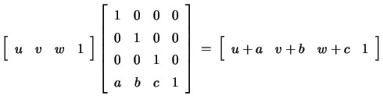
That is, we can translate the point within the frame . An illustration of this is shown in the following figure
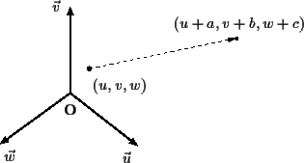
Summary
Translation is a simple transformation that is calculated directly from the conversion matrix for two frames, one a translate of the other. The translation matrix is most frequently applied to all points of an object in a local coordinate system resulting in an action that moves the object within this system.
SCALING

Overview
Scaling, like translation is is a simple transformation which just scales the coordinates of an object. It is specified either by working directly with the local coordinates, or by expressing the coordinates in terms of Frames
Development of the Transformation via Scaled Frames
Given a frame , a scaled frame would be one that is given by 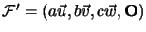- that is, we just expand (or contract) the lengths of the vectors defining the frame. It is fairly easy to see that we can write the frame in terms of the frame by
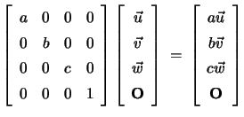

So a matrix implements a scaling transformation on frames, and any matrix of this type (for arbitrary ) will scale the frame . We call the matrix
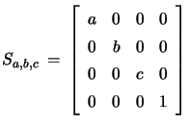

a scaling matrix and utilize matrices of this type to implement our scaling operations.
Applying the Transformation Directly to the Local Coordinates
Given a frame and a point that has local coordinates in , if we apply the transformation 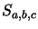to the local coordinates of the point, we obtain
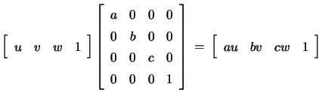

and we have scaled the point within the frame . An illustration of this is shown in the following figure
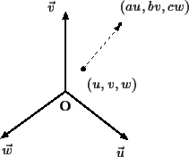
Scaling about Points other than the Origin
It is difficult to see the origin of the scaling operation when working only with coordinates - so for example, consider the eight vertices of a cube centered at the origin in the Cartesian frame.
(-1, -1, 1 )
(-1, 1, 1 )
(1, 1, 1 )
(1, -1, 1 )
(-1, -1, -1 )
(-1, 1, -1 )
(1, 1, -1 )
(1, -1, -1 )
If we consider the ``scaling'' transformation given by
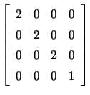

and apply this matrix to each of the coordinates of the points relative to the standard frame, we obtain a new set of points
(-2, -2, 2 )
(-2, 2, 2 )
(2, 2, 2 )
(2, -2, 2 )
(-2, -2, -2 )
(-2, 2, -2 )
(2, 2, -2 )
(2, -2, -2 )
which is an effective scaling of the cube (The resulting cube has volume 8 times the original). This operation is illustrated in the following figure (Note that this figure is viewing the cube from along the axis).
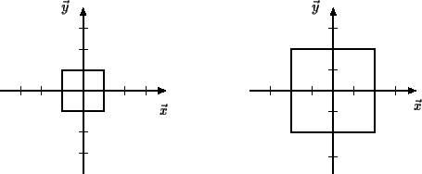
We note that this operation scales about the origin of the coordinate system. If the center of the object is not at the origin, this operation will move the object away from the origin of the frame. If we consider a cube with the following coordinates at its corners
(1, 1, 1 )
(1, 3, 1 )
(3, 3, 1 )
(3, 1, 1 )
(1, 1, 3 )
(1, 3, 3 )
(3, 3, 3 )
(3, 1, 3 )
Then by applying the above transformation, this cube is transformed to a cube with the following coordinates
(2, 2, 2 )
(2, 6, 2 )
(6, 6, 2 )
(6, 2, 2)
(2, 2, 6)
(2, 6, 6)
(6, 6, 6)
(6, 2, 6 )
which is a cube with volume 8 times the original, but centered at the point 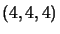. This is illustrated in the following figure.
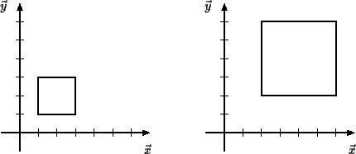
If the desired scaling point is not at the origin of the frame, we must utilize a combination of transformations to get an object to scale correctly. If the scaling point is at 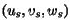in the frame, we can utilize the translation 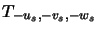to first move the point to the origin of the frame, then scale the object, and finally use the translation 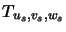to move the point back to the origin of the scaling. These transformations are all represented by matrices:
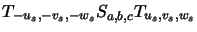

and we take their matrix product to create one matrix that gives the transformation.
Summary
The scaling transformation can be represented by a simple matrix whose only entries are on the diagonal. This transformation, when applied to an object multiplies each of the local coordinates of the object by a factor - effectively scaling the object about the origin. Scaling about other points can be done by combining the scaling transformation with two translation transformations
ROTATION
Overview
Rotations are complex transformations. The primary complexity is that in three-dimensions, rotations are performed about an axis - usually specified by a point and a vector direction. The general idea is to develop this transformation about the three coordinate axes of a frame, and then generalize this to be able to rotate about a general axis in the frame. The general idea for the matrix comes from rotation about a point in two-dimensions.
DEVELOPMENT OF THE ROTATION MATRIX
Overview
The 3-dimensional rotation matrix, when rotating about one of the coordinate axes is quite similar to the rotation matrix developed for rotation in two-dimensions. Here rotation is much simpler to describe, as rotation is about a point in two-dimensions. Here we develop the rotation matrix in two-dimensions that rotates a point about the origin in the Cartesian frame.
In Two Dimensions
In two dimensions, one rotates about a point. We will rotate about the origin, and will consider our 2-d frame to be the two-dimensional Cartesian frame. Consider the following figure
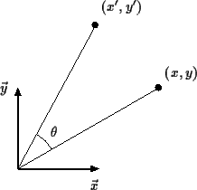
where we depict a rotation of units about the origin and the point 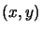is rotated into the point 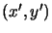. By considering the following figure,
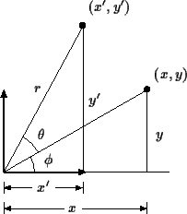
we note that can be written in polar coordinates as
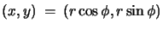

and also that can be written in polar coordinates as
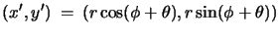

Expanding the description of , we obtain
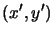 | 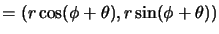
 | 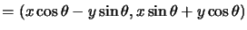

which can be written in matrix form as
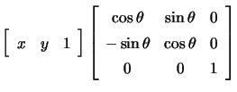

So in 2-dimensions, rotation is implemented as a matrix given by
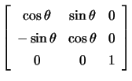
Summary
Rotation about the origin in two-dimensions is given by a simple matrix written in terms of the cosine and sine of the angle of rotation. This development can be applied directly to develop the rotation matrices for the three-dimensional rotations about the X, Y and Z axes.
ROTATION ABOUT THE X-AXIS
Overview
Rotation about the x-axis is similar to rotation specified in two-dimensional space as in the three-dimensional rotation, the x-coordinate must remain constant.
Specification of the Rotation Matrix
The transformation for rotation of radians about the -axis in the Cartesian frame is given by the matrix
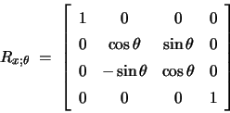
(Note that as a point is rotated about the -axis, the value of the point will not change.) If this transformation is applied to the coordinate 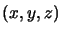, we obtain
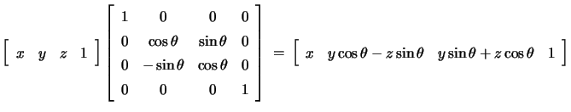
The effect of this transformation is illustrated by the following figure:
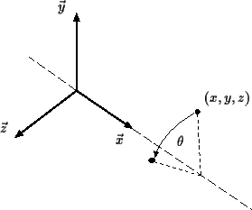
ROTATION ABOUT THE Y-AXIS
Overview
Rotation about the y-axis is similar to rotation specified in two-dimensional space as in the three-dimensional rotation, the y coordinate must remain constant.
Specification of the Rotation Matrix
The transformation for rotation of radians about the -axis is given by the matrix
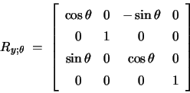
If this transformation is applied to the point , we obtain
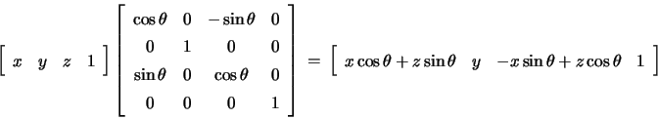
This transformation is illustrated in the following figure.
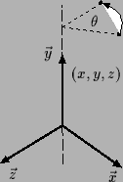

ROTATION ABOUT THE Z-AXIS
Overview
Rotation about the z-axis is similar to rotation specified in two-dimensional space as in the three-dimensional rotation, the z-coordinate must remain constant.
Specification of the Rotation Matrix
The transformation for rotation of radians about the -axis is given by the matrix
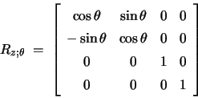
If this transformation is applied to the point , we obtain
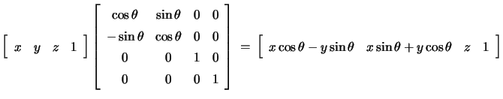
The effect of this transform is illustrated by the following figure:
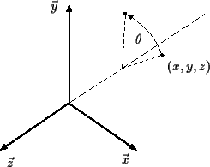
GENERAL ROTATION ABOUT AN AXIS
Overview
An axis in space is specified by a point and a vector direction . Suppose that we wish to rotate an object about this arbitrary axis.
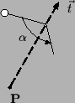
We know how to do this in the cases that the axis is the x axis, the y axis, or the z axis in the Cartesian frame (these were just generalizations of the two-dimensional rotations), but the general case is more difficult. In these notes we present a solution to this problem that utilizes both translation and the above rotation matrices to accomplish this task. (One can also approach this problem through the use of frame-to-frame-conversion transformations.)
Developing the General Rotation Matrix
First assume that the axis of rotation can be specified in terms of Cartesian coordinates, i.e. can be represented by the point 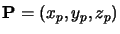and the vector 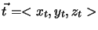. Then a rotation of degrees about this axis can be defined by concatenating the following transformations
- Translate so that the point moves to the origin
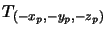 ,
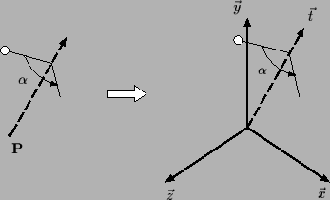
- Use the elementary rotation transformations to rotate the vector until it coincides with one of the coordinate axes. To do this, first rotate the vector until it is in the plane by using a rotation 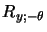about the y axis.
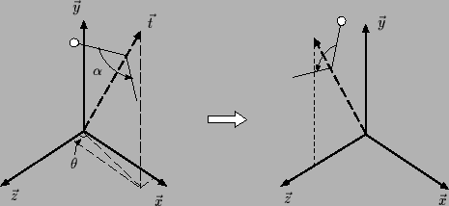
where 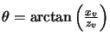, and then use an x-axis rotation, of 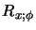, to rotate the vector until it coincides with the axis.
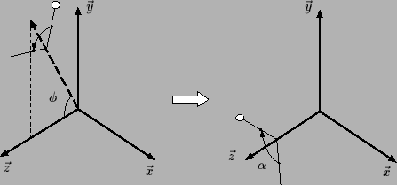
where 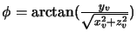
- Then use an rotation about the z axis, 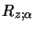.
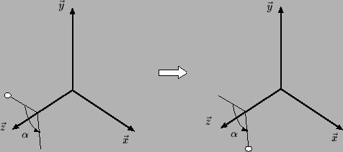
- Use rotations and translations to reverse the first two processes: First by a rotation 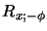, about the x axis
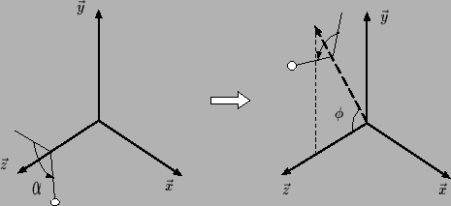
then by a rotation 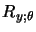about the y axis
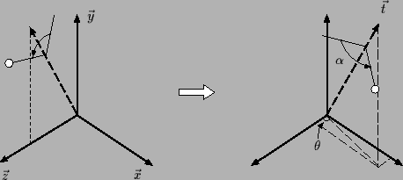
and finally using the translation, 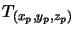to translate back to the original axis.
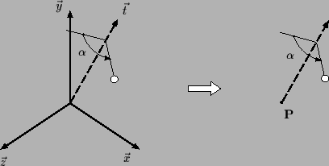
The matrix representation of the general rotation is given by the product of the above transformations.
These can be multiplied together (they are all matrices) to give one matrix which represents the general rotation.
What if the Axis was Specified in a Local Frame?
In this case, we just convert the coordinates of the point and vector defining the axis to Cartesian coordinates using the frame-to-Cartesian-frame transformation, do the above operations, and then use the Cartesian-frame-to-frame to convert the resulting coordinates back to the local system.
Summary
We have developed a simple method using only basic transformations by which general rotation can be accomplished. It utilizes translation and the basic rotations about the x axis, the y axis, and the z axis to accomplish this task. This individual matrices specified may be multiplied together to give one matrix that represents the general rotation.

Viewing Transformation
