COLLEGE NAME,CITY

DEPARTMENT OF COMPUTER SCIENCE & ENGG.

COURSE FILE

Programme : BE
Semester : IV
Course Code : CS-302
Subject Name : Discrete Structures

Prepared By: Approved By:

Index

S.No. Contents Page No.

- Scheme
- Syllabus
- Time Table
- Lecture Plan
- List of Books
- Mid Semester Exam Question Papers
- RGPV Question Paper
- Tutorial Questions
- Assignment Questions
- Hand-Written Notes
- Transparencies/Power Point Presentation Slides
- Mid Semester Exam Result
- Attendance Sheet
Scheme
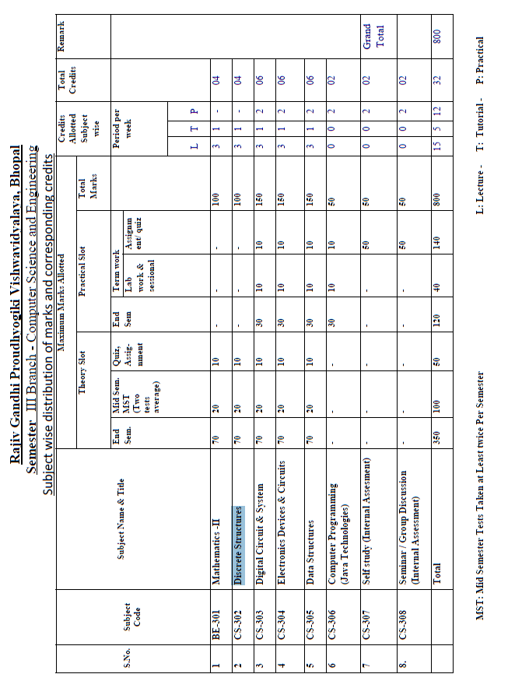
Syllabus
CS- 302 Discrete Structures
Unit-I
Set Theory, Relation, Function, Theorem Proving Techniques : Set Theory: Definition of sets, countable and uncountable sets, Venn Diagrams, proofs of some general identities on sets Relation: Definition, types of relation, composition of relations, Pictorial representation of relation, Equivalence relation, Partial ordering relation, Job-Scheduling problem Function: Definition, type of functions, one to one, into and onto function, inverse function, composition of functions, recursively defined functions, pigeonhole principle. Theorem proving Techniques: Mathematical induction, Proof by contradiction.
Unit-II
Algebraic Structures: Definition, Properties, types: Semi Groups, Monoid, Groups, Abelian group, properties of groups, Subgroup, cyclic groups, Cosets, factor group, Permutation groups, Normal subgroup, Homomorphism and isomorphism of Groups, example and standard results, Rings and Fields: definition and standard results.
Unit-III
Propositional Logic: Proposition, First order logic, Basic logical operation, truth tables, tautologies, Contradictions, Algebra of Proposition, logical implications, logical equivalence, predicates, Normal Forms, Universal and existential quantifiers. Introduction to finite state machine Finite state machines as models of physical system equivalence machines, Finite state machines as language recognizers
Unit-IV
Graph Theory: Introduction and basic terminology of graphs, Planer graphs, Multigraphs and weighted graphs, Isomorphic graphs, Paths, Cycles and connectivity, Shortest path in weighted graph, Introduction to Eulerian paths and circuits, Hamiltonian paths and circuits, Graph coloring,chromatic number, Isomorphism and Homomorphism of graphs.
Unit V
Posets, Hasse Diagram and Lattices: Introduction, ordered set, Hasse diagram of partially,
ordered set, isomorphic ordered set, well ordered set, properties of Lattices, bounded and
complemented lattices. Combinatorics: Introduction, Permutation and combination, Binomial Theorem, Multimonial Coefficients Recurrence Relation and Generating Function: Introduction to Recurrence Relation and Recursive algorithms , Linear recurrence relations with constant coefficients, Homogeneous solutions, Particular solutions, Total solutions , Generating functions ,Solution by method of generating functions,

College name,city
Department of Computer Science & Engg.
LESSON PLAN
Department: |  |  | CSE |  |  |  |  | Session:
Name of Faculty: |  |  |  |  |  |  |  | Semester: |  |  | III
Subject: |  |  | DISCREATE STRUCTURE |  |  |  |  | Sub Code: |  |  | CS-302
Time Schedule : Total expected period – 45 Extra Periods (if required)-

Day |  | Mon |  | Tue | Wed | Thu | Fri |  |  | Sat |  | Max. Available | 04
No. of Period |  |  |  |  |  |  |  |  |  |  |  | Max. Available | 04
Lect | Lecture to be Covered |  |  |  |  |  |  |  | Date of Completion |  |  | References | Remarks
 | UNIT -1  Introduction, Sets, Finite and to sets uncountable. |  |  |  |  |  |  |  |  |  |  | R1(1-6), R2(9)
 | Infinite sets Mathematical induction |  |  |  |  |  |  |  |  |  |  | R1(25),R2(12), C(11)
 | Principles of inclusion and exclusion |  |  |  |  |  |  |  |  |  |  | R1(20)
 | Multi sets. |  |  |  |  |  |  |  |  |  |  | R1(20)
 | Relations and functions |  |  |  |  |  |  |  |  |  |  | R1(40)
 | A relational model for' data bases, |  |  |  |  |  |  |  |  |  |  | R2(32)
 | Properties of binary relations, equivalence relations |  |  |  |  |  |  |  |  |  |  | R2(32)
 | Partitions partial ordering relations |  |  |  |  |  |  |  |  |  |  | R1(35), R2(34)
 | Lattices chains and antichains |  |  |  |  |  |  |  |  |  |  | R1(73,74,85)
 | A job scheduling problem functions |  |  |  |  |  |  |  |  |  |  | R1(97), R3(122)
 | Pigeonhole principle. |  |  |  |  |  |  |  |  |  |  | R1(98)
 | UNIT TEST-1
 | UNIT 2:  Prepositional logic, Conjunction |  |  |  |  |  |  |  |  |  |  | R2(78,79) R1(104,106)
 | Dysfunctions and negation interpretation of formulas in prepositional logic. |  |  |  |  |  |  |  |  |  |  | R1(116,117)
 | Validity and consistency, |  |  |  |  |  |  |  |  |  |  | R1(118,119)
 | Normal form in prepositional logic and logic and logic consequences |  |  |  |  |  |  |  |  |  |  | R1(152,153)
 | Introduction to Finite state machine |  |  |  |  |  |  |  |  |  |  | R1(157,159),R3(230)
 | Finite state machines as models of physical system equivalence machines |  |  |  |  |  |  |  |  |  |  | R1(163)
 | Finite state machines as language recognizers. |  |  |  |  |  |  |  |  |  |  | R1(170), R3(241)
 | UNIT TEST-2
 | UNIT-3:  Introduction and basic terminology of graphs, Planner graphs |  |  |  |  |  |  |  |  |  |  | R1(175-180), R2(190-196)
20 | Multigraphs and weighted graphs(1) |  |  |  |  |  |  |  |  |  |  | R1(175-180), R2(190-196
21 | Multigraphs and weighted graphs(2) |  |  |  |  |  |  |  |  |  |  | R1(175-180), R2(190-196
22 | Shortest path in weighted graph, |  |  |  |  |  |  |  |  |  |  | R1(191), R3(145)
23 | Introduction to Eulerian paths and circuits |  |  |  |  |  |  |  |  |  |  | R1(196)
24 | Hamiltonian paths and circuits, |  |  |  |  |  |  |  |  |  |  | R1(199)
25 | Introduction to trees, Rooted trees, |  |  |  |  |  |  |  |  |  |  | R2(236), R3(187), R1(213)
26 | Path length in rooted trees prefix codes |  |  |  |  |  |  |  |  |  |  | R2(237,238)
27 | Spanning trees and cut trees. |  |  |  |  |  |  |  |  |  |  | R2(194,199)
 | UNIT TEST-3
28 | UNIT 4:  Introduction to discrete numeric functions and generating functions |  |  |  |  |  |  |  |  |  |  | R1(241), R3(277)
29 | Introduction to combinational problems |  |  |  |  |  |  |  |  |  |  | R1(255)
30 | Introduction to recurrence relations and recursive algorithms linear recurrence |  |  |  |  |  |  |  |  |  |  | R1(267), R3(306)
31 | Relations with constant coefficients Homogeneous' solutions |  |  |  |  |  |  |  |  |  |  | R1(268,264)
32 | Particular solutions total solutions. |  |  |  |  |  |  |  |  |  |  | R1(274,275),R3(314,319)
 | UNIT TEST-4
33 | UNIT-5:  Introduction to groups and rings. |  |  |  |  |  |  |  |  |  |  | R1(309,310),R3(342)
34 | Sub groups generations and evaluation of power, |  |  |  |  |  |  |  |  |  |  | R1(315,316),
35 | Cosets and Lagrange's theorem |  |  |  |  |  |  |  |  |  |  | R1(381), R3(352)
36 | Codes and groups codes. |  |  |  |  |  |  |  |  |  |  | R3(359), R1(387)
37 | Isomorphism and auto orphisms, |  |  |  |  |  |  |  |  |  |  | R1(399)
38 | Homomorphism and normal subgroups |  |  |  |  |  |  |  |  |  |  | R1(412)
39 | Rings |  |  |  |  |  |  |  |  |  |  | R1(421)
40 | Integral domains and fields. |  |  |  |  |  |  |  |  |  |  | R1(431,435)
 | UNIT TEST-5

References:
R1. DISCRETE STRUCTURE. Dr.D.C. AGARWAL
R2. DISCRETE MATHEMATICS SCHAUM’S OUTLINES
R3. ELEMENTS OF DISCRETE MATHEMATICS C.L.LIU

Prepared by Approved by

(Name of faculty with designation) HOD

List of Books
1. C.L.Liu, “Elements of Discrete Mathematics” Tata Mc Graw-Hill Edition.
2. Trembley, J.P & Manohar; “Discrete Mathematical Structure with Application CS”, McGraw Hill.
3. Kenneth H. Rosen, “Discrete Mathematics and its applications”, McGraw Hill.
4. Lipschutz; Discrete mathematics (Schaum); TMH
5. Deo, Narsingh, “Graph Theory With application to Engineering and Computer.Science.”, PHI.
6. Krishnamurthy V; “Combinatorics Theory & Application”, East-West Press Pvt. Ltd., New Delhi.
7. S k Sarkar “ Discrete Mathematics”, S. Chand Pub
COLLEGE NAME,CITY
Session: July – Dec, Year
Dept. Of CSE
MID Semester Examination I
CSE-III Semester
Subject: Discrete Structure (CS-302)

Note- Attempt any five questions. All questions carry equal marks.
Max time: 2 hours Max Marks: 20

Q1. Show that A ∩ (BUC) = (A∩.B) U (A∩ C)
Q2 .Among 100 students 32 study mathematics,20 study physics,45 study Biology,15 study mathematics and Biology, 7 study mathematics and physics , 10 study physics and Biology and 30 do not study any of the three subjects.
(i) Find the number of students studying all the three subjects
(ii)Find the number of student studying exactly one of the three subjects
Q3 . 11 ^{n+2} + 12^{2n+1} is divisible by 133 n ∈N
Q4. let I be the set of all integer and R= {(a, b): a, b ∈ I and a-b is divisible by 3}
Is an equivalence relation. find equivalence classes.
Q5 .Show that the set I of all integers (positive or negative including zero) I=(……, -4,-3,-2,-1,0,1,2,3,4……) is an infinite abelian group with respect to operation of addition of integers.
Q 6.Show that the set of cube root of unity is an abelian group with respect to multiplication.
Q7.prove that the set G={0,1,2,3,4,5} is a finite abelian group of order 6 with respect to addition modulo 6 as the composition in G
Q 8 (A) prove that (p ↔ q) ^ (q ↔ r)→(p ↔ r) is a tautology
(B) prove that following statements are logically equivalent
- (p ^ q) ^ r ≈ p ^ (q ^ r)
- (p → q) ∨ r ≈ (p ∨ r) → (q ∨ r)
COLLEGE NAME,CITY
Session: July – Dec, Year
Dept. Of CSE
MID Semester Examination II
CSE-III Semester
Subject: Discrete Structure (CS-302)
Time: 02 hrs Marks: 100
Note: Attempt any five questions. All questions carry equal marks
Q1. (a) Out of a total of 130 students, 60 are wearing hats to class 51 are wearing scarves and 30 are wearing both hats and scarves. Of the 54 student who are wearing sweaters 26 are wearing hats 21 are wearing scarves and 12 are wearing both hats and scarves. Everyone wearing neither a hat nor a scarf is wearing gloves
- How many students are wearing gloves?
- How many students not wearing a sweater are wearing hats but not scarves?
Q1. (b) Let R be a binary relation on the set of all positive integers such that
R={(a,b) :a-b is an odd positive integer}
Is R refelexive? Symmetric? Anti-Symmetric? Transitive ? An equivalence relation?
OR
Q2 (a) if the function f:R→R is defined by f(x)=cos x and the function g: R→R is defined by g(x) find (gof)(x) and (fog)(x) and prove that they are not equal
Q2 (b) 7^{2n}+2 ^{3n-3}.3^{n-1} is divisible by 25 for all n Є N
Q3 (a). the set of all integers I is a ring i,e. (I , + , .) is a ring with the composition of addition and multiplication. Such a ring is called ring of integers.
Q3 (b).In a field (F,+,.) prove that if a, b ,c ,d ЄF and db≠0,d≠0,then
(i)a/b=c/d ad=bc
(ii)a/b+c/d = ad+bc/bc
(iii)a/b.c/d = ac/bd
OR
Q4 (a).show that set G={a+√2b : a , b ЄQ} is a group with respect to addition
Q4 (b).show that the set of cube roots of unity is an abelian group with respect to multiplication
Q5(a).prove that the given statement is logically equivalent
(P q) v r ≈ (p v r) (q v r)
Q5(b).Test the validity of the argument:
If two sides of a triangle are equal then the opposite angles are equal.
Two sides of a triangle are not equal
∴ The opposite angles are not equal
OR
Q6(a).Express the following formula into disjunctive normal form:
⌐(p V q) ↔ (p ^ q)
Q6(b).minimize the finite state machine given by the following state table
State | Input  0 1 | Output
A | D B | 1
B | E B | 0
C | D A | 1
D | C D | 0
E | B A | 1

Q7.find out the shortest path from a to z for weighted graph shown below where number associated with the edges are the weights
OR
Q8(a)Draw a graph with six vertices containing an Eulerian circuit but not Hamiltonian circuit
Q8(b) Explain planar Graph
Q9(a).Let A= {a,b,c,d} and p(A) its power set. Draw Hasse diagram of (p(A), ⊆)
Q9(b). Prove that the relation “a divides b” , if there exists an integer c such that ac=b and is denoted by a/b on the set of all positive integers N is a partial order relation.
OR
Q10(a).Let L={1,2,3,4,,6,8,9,12,18,24} be ordered by the relation’│’ where x│y means ‘x divides y’. Show that D₂₄ the set of all divisors of the integer 24 of L is a sub-lattice of the lattice(L, │).
Q10(b).Determine the particular solution for the difference equation a_{r}-2a_{r-1}= f(r) where f(r)=7r
RGPV Old Question Papers

COLLEGE NAME,CITY
DEPARTMENT OF CSE
Session: July-December, Year

TUTORIAL-I

Branch/Semester : CS/III
Subject : Discrete Structure Subject Code : CS-302
Topic to be covered :

Q1. Out of a total of 130 students, 60 are wearing hats to class 51 are wearing scarves and 30 are wearing both hats and scarves. Of the 54 student who are wearing sweaters 26 are wearing hats 21 are wearing scarves and 12 are wearing both hats and scarves. Everyone wearing neither a hat nor a scarf is wearing gloves
- How many students are wearing gloves?
- How many students not wearing a sweater are wearing hats but not scarves?
Q2.let R be a binary relation on the set of all positive integers such that
R={(a,b) :a-b is an odd positive integer}
Is R refelexive? Symmetric? Anti-Symmetric? Transitive ? An equivalence relation?
Q3 if the function f:R→R is defined by f(x)=cos x and the function g: R→R is defined by g(x) find (gof)(x) and (fog)(x) and prove that they are not equal
Q4 7^{2n}+2 ^{3n-3}.3^{n-1} is divisible by 25 for all nЄN
Q5.prove that among 1,00,000 people there are two who are born on same time.

COLLEGE NAME,CITY
DEPARTMENT OF CSE
Session: July-December, Year

TUTORIAL-II

Branch/Semester : CS/III
Subject : Discrete Structure Subject Code : CS-302
Topic to be covered :

Q1.show that set G={a+√2b : a , b ЄQ} is a group with respect to addition
Q2.show that the set of cube roots of unity is an abelian group with respect to multiplication
Q3. the set of all integers I is a ring i,e. (I , + , .) is a ring with the composition of addition and multiplication. Such a ring is called ring of integers.
Q4.In a field (F,+, .) prove that if a, b ,c ,d ЄF and db≠0,d≠0,then
(i)a/b=c/d ad=bc
(ii)a/b+c/d = ad+bc/bc
(iii)a/b.c/d=ac/bd
Q5.show that the polynomial x²+x+4 is irreducible over F, the field of integers modulo 11.

COLLEGE NAME,CITY
DEPARTMENT OF CSE
Session: July-December, Year

TUTORIAL-III

Branch/Semester : CS/III
Subject : Discrete Structure Subject Code : CS-302
Topic to be covered :

Q1.prove that (p q) ^ (q r) (p r) is a tautology
Q2.prove that the given statement is logically equivalent
(p q) v r ≈ (p v r) (q v r)
Q3.Test the validity of the argument:
If two sides of a triangle are equal then the opposite angles are equal.
Two sides of a triangle are not equal
∴ The opposite angles are not equal
Q4.Express the following formula into disjunctive normal form:
⌐(p V q) ↔ (p ^ q)
Q5.minimize the finite state machine given by the following state table
State | Input  0 1 | Output
A | D B | 1
B | E B | 0
C | D A | 1
D | C D | 0
E | B A | 1

COLLEGE NAME,CITY
DEPARTMENT OF CSE
Session: July-December, Year

TUTORIAL-IV

Branch/Semester : CS/III
Subject : Discrete Structure Subject Code : CS-302
Topic to be covered :

Q1.find out the shortest path from a to z for weighted graph shown below where number associated with the edges are the weights
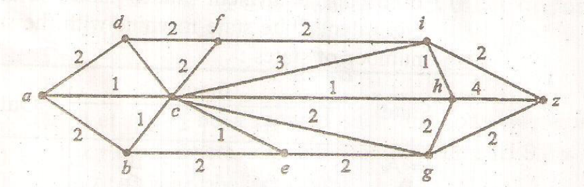
Q2. (a) Define the following :
- Regular graph
- Homeomorphism graph
- Eulerian graph
- Hamiltonian graph
- Eccentricity and centre of a tree
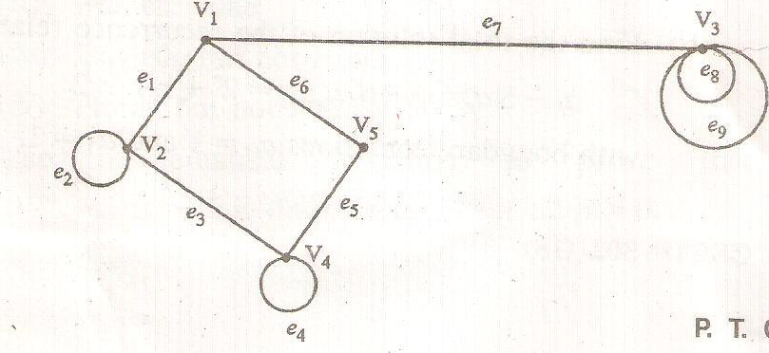
Q3.find the incidence and adjacency matrix of the diagraph shown below

Q4.explain graph coloring and chromatic number of graph.
Q5.Show that the following graphs are planar and state their regions.
COLLEGE NAME,CITY
DEPARTMENT OF CSE
Session: July-December, Year

TUTORIAL-V

Branch/Semester : CS/III
Subject : Discrete Structure Subject Code : CS-302
Topic to be covered :

Q1.Let A= {a,b,c,d} and p(A) its power set. Draw Hasse diagram of (p(A), ⊆)
Q2. Prove that the relation “a divides b” , if there exists an integer c such that ac=b and is denoted by a/b on the set of all positive integers N is a partial order relation.
Q3.Let L={1,2,3,4,,6,8,9,12,18,24} be ordered by the relation’│’ where x│y means ‘x divides y’. Show that D₂₄ the set of all divisors of the integer 24 of L is a sub-lattice of the lattice(L, │).
Q4.Determine the particular solution for the difference equation a_{r}-2a_{r-1}= f(r) where f(r)=7r
Q5.Apply the generating function technique to solve the initial value problem ^{y}_{h+1}-2^{y}_{h}=0 with ^{y}₀=1

COLLEGE NAME,CITY
DEPARTMENT OF CSE
Session: July-December, Year

ASSIGNMENT-I

Branch/Semester : CS/III
Subject : Discrete Structure Subject Code : CS-302
Topic to be covered :

Q1. Out of a total of 130 students, 60 are wearing hats to class 51 are wearing scarves and 30 are wearing both hats and scarves. Of the 54 student who are wearing sweaters 26 are wearing hats 21 are wearing scarves and 12 are wearing both hats and scarves. Everyone wearing neither a hat nor a scarf is wearing gloves
- How many students are wearing gloves?
- How many students not wearing a sweater are wearing hats but not scarves?
Q2.let R be a binary relation on the set of all positive integers such that
R={(a,b) :a-b is an odd positive integer}
Is R refelexive? Symmetric? Anti-Symmetric? Transitive ? An equivalence relation?
Q3 if the function f:R→R is defined by f(x)=cos x and the function g: R→R is defined by g(x) find (gof)(x) and (fog)(x) and prove that they are not equal
Q4 7^{2n}+2 ^{3n-3}.3^{n-1} is divisible by 25 for all nЄN
Q5.prove that among 1,00,000 people there are two who are born on same time.

COLLEGE NAME,CITY
DEPARTMENT OF CSE
Session: July-December, Year

ASSIGNMENT -II

Branch/Semester : CS/III
Subject : Discrete Structure Subject Code : CS-302
Topic to be covered :

Q1.show that set G={a+√2b : a , b ЄQ} is a group with respect to addition
Q2.show that the set of cube roots of unity is an abelian group with respect to multiplication
Q3. the set of all integers I is a ring i,e. (I , + , .) is a ring with the composition of addition and multiplication. Such a ring is called ring of integers.
Q4.In a field (F,+, .) prove that if a, b ,c ,d ЄF and db≠0,d≠0,then
(i)a/b=c/d ad=bc
(ii)a/b+c/d = ad+bc/bc
(iii)a/b.c/d=ac/bd
Q5.show that the polynomial x²+x+4 is irreducible over F, the field of integers modulo 11.

COLLEGE NAME,CITY
DEPARTMENT OF CSE
Session: July-December, Year

ASSIGNMENT -III

Branch/Semester : CS/III
Subject : Discrete Structure Subject Code : CS-302
Topic to be covered :

Q1.prove that (p q) ^ (q r) (p r) is a tautology
Q2.prove that the given statement is logically equivalent
(p q) v r ≈ (p v r) (q v r)
Q3.Test the validity of the argument:
If two sides of a triangle are equal then the opposite angles are equal.
Two sides of a triangle are not equal
∴ The opposite angles are not equal
Q4.Express the following formula into disjunctive normal form:
⌐(p V q) ↔ (p ^ q)
Q5.minimize the finite state machine given by the following state table
State | Input  0 1 | Output
A | D B | 1
B | E B | 0
C | D A | 1
D | C D | 0
E | B A | 1

COLLEGE NAME,CITY
DEPARTMENT OF CSE
Session: July-December, Year

ASSIGNMENT -IV

Branch/Semester : CS/III
Subject : Discrete Structure Subject Code : CS-302
Topic to be covered :

Q1.find out the shortest path from a to z for weighted graph shown below where number associated with the edges are the weights
Q2. (a) Define the following :
- Regular graph
- Homeomorphism graph
- Eulerian graph
- Hamiltonian graph
- Eccentricity and centre of a tree
Q3.find the incidence and adjacency matrix of the diagraph shown below

Q4.explain graph coloring and chromatic number of graph.
Q5.Show that the following graphs are planar and state their regions.
COLLEGE NAME,CITY
DEPARTMENT OF CSE
Session: July-December, Year

ASSIGNMENT -V

Branch/Semester : CS/III
Subject : Discrete Structure Subject Code : CS-302
Topic to be covered :

Q1.Let A= {a,b,c,d} and p(A) its power set. Draw Hasse diagram of (p(A), ⊆)
Q2. Prove that the relation “a divides b” , if there exists an integer c such that ac=b and is denoted by a/b on the set of all positive integers N is a partial order relation.
Q3.Let L={1,2,3,4,,6,8,9,12,18,24} be ordered by the relation’│’ where x│y means ‘x divides y’. Show that D₂₄ the set of all divisors of the integer 24 of L is a sub-lattice of the lattice(L, │).
Q4.Determine the particular solution for the difference equation a_{r}-2a_{r-1}= f(r) where f(r)=7r
Q5.Apply the generating function technique to solve the initial value problem ^{y}_{h+1}-2^{y}_{h}=0 with ^{y}₀=1

