NAME COLLEGE OF TECHNOLOGY, BHOPAL

DEPARTMENT OF COMPUTER SCIENCE & ENGINEERING

COURSE FILE

Program : B.E.

Semester : VII

Course Code : CS-702

Subject Name : Distributed Systems

Prepared By: Approved By

Index

S.No. Contents Page No.

- Scheme
- Syllabus
- Time Table
- Lecture Plan
- List of Books
- Mid Semester Exam Question Papers
- RGPV Question Paper
- Tutorial Questions
- Assignment Questions
- Hand-Written Notes
- Transparencies/PPT Slides
- Mid Semester Exam Result
- Attendance Sheet
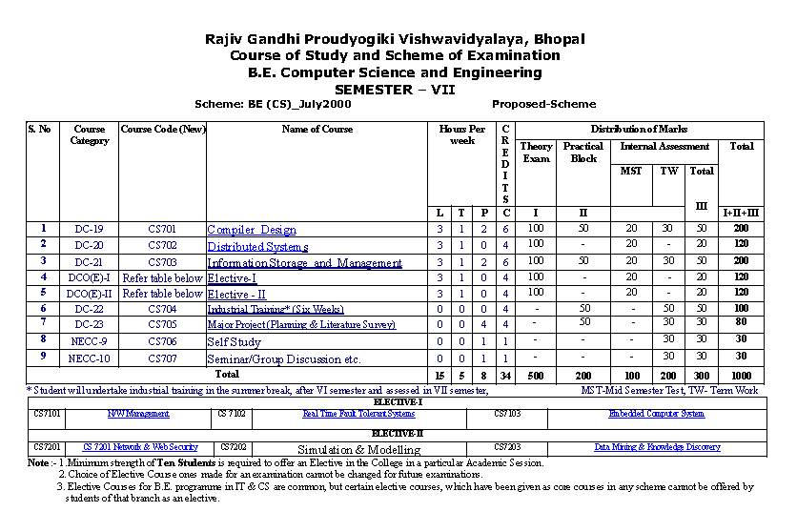
Syllabus

CS702 Distributed System
Unit-I
Introduction to distributed systems
Architecture for Distributed System, Goals of Distributed system, Hardware and Software concepts, Distributed Computing Model, Advantages & Disadvantage distributed system, Issues in designing Distributed System

Unit-II
Distributed Share Memory and Distributed File System
Basic Concept of Distributed Share Memory (DSM), DSM Architecture & its Types, Design & Implementations issues In DSM System, Structure of Share Memory Space, Consistency Model, and Thrashing. Desirable features of good Distributed File System, File Model, File Service Architecture, File Accessing Model, File Sharing Semantics, File Catching Scheme, File Application & Fault tolerance. Naming: - Features, System Oriented Names, Object Locating Mechanism, Human Oriented Name.

Unit-III
Inter Process Communication and Synchronization
API for Internet Protocol, Data Representation & Marshaling, Group Communication, Client Server Communication, RPC- Implementing RPC Mechanism, Stub Generation, RPC Messages. Synchronization: - Clock Synchronization, Mutual Exclusion, Election Algorithms:- Bully & Ring Algorithms.

Unit-IV
Distributed Scheduling and Deadlock
Distributed Scheduling-Issues in Load Distributing, Components for Load Distributing Algorithms, Different Types of Load Distributing Algorithms, Task Migration and its issues. Deadlock-Issues in deadlock detection & Resolutions, Deadlock Handling
Strategy, Distributed Deadlock Algorithms,

Unit-V
Distributed Multimedia & Database system
Distributed Data Base Management System (DDBMS), Types of Distributed Database, and Distributed Multimedia: - Characteristics of multimedia Data, Quality of Service Managements. Case Study of Distributed System: - Amoeba, Mach, Chorus

Time Table

Lecture Plan
Department | Computer Science and Engineering | Session : | 2013
Name of Teacher | Saurabh Jain | Sem | 7th(S2)
Subject | Distributed Systems | Sub. Code | CS-702
(B) TIME SCHEDULE : Total expected periods:___, Extra periods (if required)_____
Day | Mon | Tue | Wed | Thu | Fri | Sat | Max. available
No. of  Periods | 01 | 01 | 01 | 01 | 01 | 01
Lecture. | Topics to be covered |  |  |  |  | Planned Date of Completion | Remarks
Unit-I Introduction to Distributed Systems

1 | Distributed System and its Type |  |  |  |  |  | R1:1-3/R2:1-3
2 | Design Issues of distributed system |  |  |  |  |  | R1:19-34/  R2:22-31
3 | Architecture for Distributed System |  |  |  |  |  | NOTES
4 | Goals of Distributed system |  |  |  |  |  | R1:12-16/ R2:3-5
5 | Hardware concepts |  |  |  |  |  | R2:8-15
6 | Software concepts |  |  |  |  |  | R2:15-22
7 | Distributed Computing Model |  |  |  |  |  | R1:5-12
8 | Advantages & Disadvantage of DS |  |  |  |  |  | R2:6-8
9 | Distributed Vs Centralized Systems |  |  |  |  |  | NOTES
Unit-II Distributed Share Memory and Distributed File System
10 | Distributed Shared Memory |  |  |  |  |  | R2:289-292/ R1:421-423
11 | DSM Architecture & its Types |  |  |  |  |  | R2:292-312/ R1:231-234
12 | Design & Implementations issues of DSM |  |  |  |  |  | R1:234-235
13 | Structure of Share Memory Space |  |  |  |  |  | NOTES/ R1:237
14 | Consistency Model ,Thrashing |  |  |  |  |  | R2:315-331/ R1:238-265
15 | File Model, File Service Architecture |  |  |  |  |  | R1:426
16 | File Accessing Model |  |  |  |  |  | R2:246-251/ R1:427-430
17 | File Sharing Semantics |  |  |  |  |  | R2:253-256/ R1:430-433
18 | File Caching Scheme, Fault tolerance |  |  |  |  |  | R2:262-285/ R1:433-440
19 | Naming, System Oriented Names |  |  |  |  |  | R2:251-252/ R1:496-511
20 | Object Locating Mechanism, Human Oriented Name. |  |  |  |  |  | NOTES/  R1:512-515
Unit-III Inter Process Communication and Synchronization
21 | Data Representation & Marshaling |  |  |  |  |  | NOTES/R1:177
22 | Group Communication |  |  |  |  |  | R2:99-115
23 | Client Server Communication |  |  |  |  |  | R2:50-55
24 | RPC- Implementing RPC Mechanism |  |  |  |  |  | R2:65-72/ R1:171-173
25 | Stub Generation, RPC Messages |  |  |  |  |  | R2:68-82/ R1:174-177
26 | Synchronization, Clock Synchronization |  |  |  |  |  | R2:118-133/ R1:283-291
27 | Mutual Exclusion |  |  |  |  |  | R2:134-140/ R1:299-304
28 | Election Algo. (Bully and Ring) |  |  |  |  |  | R2:140-143 R1:332-336
Unit-IV Distributed Scheduling and Deadlock
29 | Distributed Scheduling-Issues in Load Distributing |  |  |  |  |  | R1:347-350
30 | Components for Load Distributing Algorithms |  |  |  |  |  | R1:351-367
31 | Different Types of Load Distributing Algorithms |  |  |  |  |  | NOTES
32 | Task Migration and its issues |  |  |  |  |  | R1:381-414
33 | Deadlock detection |  |  |  |  |  | R2:158-163/R1:320-330
34 | Resolutions |  |  |  |  |  | NOTES/R1:316-319
35 | Deadlock Handling Strategy |  |  |  |  |  | R2:163-163,312-316
36 | Distributed Deadlock Algorithms |  |  |  |  |  | NOTES
Unit-V Distributed Multimedia & Database System
37 | Distributed Data Base Management System(DDBMS) |  |  |  |  |  | NOTES
38 | Types of Distributed Database |  |  |  |  |  | NOTES
39 | Characteristics of multimedia Data |  |  |  |  |  | NOTES
40 | Quality of Service Management |  |  |  |  |  | NOTES
41 | Case Study of Amoeba |  |  |  |  |  | R2:376-407 R1:642-658
42 | Case Study of Mach |  |  |  |  |  | R2:431-469,R1:674-695
43 | Case Study of Chorus |  |  |  |  |  | R2:475-510 R1:695-712

References Books

- R1: Pradeep K.Sinha, Distributed Operating System Concept & Design, PHI
- R3:Singhal and Shivaratri, Advance Concept in Operating System, McGraw Hill
- R2: Andrew S Tanenbaum

List of Books

- Sinha, Distributed Operating System Concept & Design, PHI
- Coulouris & Dollimore, Distributed System Concepts and Design, Pearson Pub
- Singhal & Shivratari, Advance Concept in Operating System, McGraw Hill
- Attiya & Welch, Distributed Computing, Wiley Pub.

NAME GROUP OF INSTITUTES
MID SEMESTER–I
BRANCH- COMPUTER SCIENCE & TECHNOLOGY
SEMESTER: VII
SUBJECT: Distributed Systems (CS-702)
Marks-40 Time: -2 Hrs
Attempt any five questions.
All question carry equal marks. Answers should be laconic.

Q 1 a) What are distributed systems? Give some advantages of distributed systems.
Q 1 b) What are the main difference between a Centralized system and Distributed system?

Q 2 a) Differentiate between the following:
1. Multiprocessor system and multicomputer system
2. Monolithic and Micro kernel model.
Q 2 b) Compare minicomputer model and hybrid model.

Q 3 a) Explain design and implementation issues of Distributed shared memory.
Q 3 b) Make comparison between Weak and Release consistency model.

Q.4 a) Explain the various services which can be performed on a file in a distributed file system.
Q 4 b) What is file caching? Explain which cache location provides highest performance gain.

Q.5 a) Discuss remote procedure call (RPC) mechanism in brief. Also discuss client and server stub.
Q 5 b) Give a brief introduction to Group Communication.
Q 6 Write short note on(any three)
- Tightly coupled system
- DFS
- DSM
- Transparency
- NUMA System

NAME GROUP OF INSTITUTES
MID SEMESTER–II
BRANCH- COMPUTER SCIENCE & TECHNOLOGY
SEMESTER: VII
SUBJECT: Distributed Systems (CS-702)
1.a) What are the main difference between a Network operating system and Distributed operating system.
b) Explain the distributed system characteristics. Also explain its advantages and disadvantages.
2.a) Differentiate between the following:
1. Stateless and Stateful server
2.Monolithic and Microlithic server
b) Compare and contrast the techniques of caching disk blocks locally on a client system and remotely on a server.
Ques. 3 a)Prove the presence of cycle in general resource allocation graph is necessary but not a sufficient condition of the existing of deadlock.
b) Differentiate between replication and caching.
Q.4 a) Explain design and implementation issues of Distributed shared memory.
b) A directory service is very similar to Yellow Pages service: entities are looked up by specifying properties instead of exact names (such as in DNS).Why it is it so difficult to have an efficient Distributed directory service?
Q.5 a) Explain bully algorithm. What will happen in a bully algorithm for electing a coordinate when two or more process almost simultaneously discover that coordinator has crashed.
b) Make comparison between Weak and Release consistency.
Q.6 a) Differentiate between NFS and Coda file system on various characteristics.
b) What is timestamping ? Does using timestamping for concurrency control ensure serializability ? Discuss.
Q.7 a) Give reason why :
1. Calling the printf statement of C language using RPC is impossible.
2.Call by reference is not possible through RPC.
Q.8 ) Write short note of any three of the following:
1.Unix emulation in MACH 2.DCE directory services
3. Object based DSM. 4.Load balancing
5.RPC time service

NAME College of Technology, Bhopal
Department of Computer Science & Engineering

Assignment-1

Subject: Distributed Systems
Subject Code: CS-702

Unit-1
Q.1) Compare centralized system and distributed system.
Q.2) Discuss Processor pool model.
Q.3) Briefly describe advantages and disadvantages of distributed system.
Q.4) List some difference between diskless system and disk full system.
Q.5) Explain the distributed system characteristics.
Q.6) Explain various advantages and disadvantages of distributed systems.
Q.7) Describes the architectural models of distributed system.
Q.8)Describe the layered structure of distributed system software.
Q.9) Explain security mechanism in distributed system.
Q.10) Discuss failure transparency in distributed system.

NAME College of Technology, Bhopal
Department of Computer Science & Engineering

Assignment-2

Subject: Distributed Systems
Subject Code: CS-702

Unit-2

Q.1) Make comparison between Weak and Release consistency model.
Q.2) Explain the various services which can be performed on a file in a distributed file system.
Q.3) What is file caching? Explain which cache location provides highest performance gain.
Q.4) What is Object Locating Mechanism.
Q.5) Discuss Human Oriented Name.
Q.6) What is immutable file ? Can a file system be designed to function correctly by using only immutable files ?
Q.7) Discuss whether message passing or DSM is preferable for fault tolerant application.
Q.8) Explain in which respects is suitable or unsuitable for client server system.
Q.9) Explain the various operations which can be performed on a file in a distributed file system.
Q.10) Explain consistency models with examples.

NAME College of Technology, Bhopal
Department of Computer Science & Engineering

Assignment-3

Subject: Distributed Systems
Subject Code: CS-702

Unit-3

Q 1) Write short note on physical clock.
Q.2 ) Define the term clock skew.
Q.3 ) Explain drifting of clocks. Differentiate internal and external clock synchronization in distributed systems.
Q.4 ) Write short note on critical regions.
Q.5) How do clock synchronization issues differ in centralized and distributed systems?
Q.6) Make comparison between Bully and ring algorithm.
Q.7) How clock synchronization is achived through Berkeley algorithm?
Q.8) Explain “Election algorithms requires 2(n-1) messages”.
Q.9) What are the design issues of Group communication?
Q.10) Differentiate the following:
i) Peer vs Hierarchical group
ii) Closed vs Open group.

NAME College of Technology, Bhopal
Department of Computer Science & Engineering

Assignment-4

Subject: Distributed Systems
Subject Code: CS-702

Unit-4

Q.1 ) Describe various task migration mechanisms?
Q.2 ) Define safe and unsafe states of system in deadlock avoidance scheme.
Q 3) Explain different Types of Load Distributing Algorithms .
Q 4) Short note on fault tolerance systems.

NAME College of Technology, Bhopal
Department of Computer Science & Engineering

Assignment-5

Subject: Distributed Systems
Subject Code: CS-702

Unit-5

Q.1) Give different MACH design goals and features.
Q 2) Write short note on process management in Chorus system.
Q 3) Discuss Types of Distributed Database.
Q 4) Explain DCE with example.

NAME College of Technology, Bhopal
Department of Computer Science & Engineering

Tutorial-1

Subject: Distributed Systems
Subject Code: CS-702

Unit-1

Q 1) Describes the concepts of Network Operating System(NOS).
Q 2) What is the role of middleware in a distributed system?
Q 3) Compare the minicomputer model and hybrid model.
Q 4) Discuss the advantages of workstation server model.
Q.5) Why are distributed system more difficult to design than centralized time sharing system?
Q.6) Discuss Architecture for Distributed System.
Q.7) Compare bus based multiprocessor and bus based multi computers.
Q.8) How failure masking is done through replication in distributed system ?
Q.9) In what respect are distributed computing systems superior to parallel systems?
Q.10) What are the advantages of distributed systems over independent PC’s?

NAME College of Technology, Bhopal
Department of Computer Science & Engineering

Tutorial-2

Subject: Distributed Systems
Subject Code: CS-702

Unit-2

Q.1) Write Short note Release consistency model.
Q.2) Design issues of good distributed shared memory.
Q.3) Discuss various design and implementation issues of DFS.
Q.4) List some difference between multiprocessor and multicomputer as per hardware concept and software concept.
Q.5) Explain various types of Shared memory.
Q.6) Explain the various trends in distributed file system?
Q.7) Discuss various types of distributed shared memory systems.
Q.8) Discuss various file accessing models.
Q.9) Explain the various file caching scheme key decisions.
Q.10) Which cache location gives best performance in DFS.

NAME College of Technology, Bhopal
Department of Computer Science & Engineering

Tutorial-3

Subject: Distributed Systems
Subject Code: CS-702

Unit-3

- Give a brief description of type checking.
- Give the difference between implicit type conversion and explicit type conversion with help of an example.
- Differentiate between static and dynamic binding.
- Explain the importance of run time storage management in compiler.
- What do you mean by activation record? Why this record is maintained by the compiler?
- Explain various fields of activation record.
- Describe storage allocation strategies.
- What do you mean by static allocation? What are its drawback?

NAME College of Technology, Bhopal
Department of Computer Science & Engineering

Tutorial-4

Subject: Distributed Systems
Subject Code: CS-702

Unit-4

- Write a translation scheme to generate intermediate code for assignment statement with array references.
- Write syntax directed definition to translate ‘switch’ statement. With a suitable example, show translation of the source language ‘switch’ statement.
- Write short note on back patching.
- Write short note on code generation.
- What are general issues in designing a code generator?
- Explain code generation algorithm.
- What is basic block? With suitable example discuss various transformations on the basic blocks.
- What are the different types of intermediate codes? Explain in brief.

NAME College of Technology, Bhopal
Department of Computer Science & Engineering

Tutorial-5

Subject: Distributed Systems
Subject Code: CS-702

Unit-5

- Explain why code optimization is called optional phase?
- Explain the principal sources of optimization with suitable example.
- Describe the necessary and sufficient condition performing constant propagation and dead code eliminations.
- Explain the following optimizing transformations with suitable examples-
- Code movement
- Common sub-expression elimination
- Define dominators.

B.E. (IV Semester)
Distributed Systems[CS-702]
Time : Three Hours Maximum Marks : 100
Minimum Pass Marks : 35
Note: Attempt one question from each Unit. Draw neat diagrams where needed. All questions carry equal marks.

UNIT-I

1. (a) What are the design issues for good distributed system ?

(b) Where NUMA system is used and why ?
OR
2. (a) Differentiate between multiprocessor and multicomputer systems.
- What is single point of failure and how distribution can help here?
UNIT-II
3. (a) Compare sequential consistency and release consistency of DSM.
(b) What are various approaches of implementation of DSM?

OR

4 .(a) Draw the file service architecture and explain all modules with example.
(b) What do you understand about naming system is Distributed systems? Explain object locating mechanism.
UNIT-III
5. (a) How does a procedure call at remote system take place ?
(b) Discuss one to one and one to many in Group Communication.

OR

6 (a) Discuss DCE remote object.
(b) Explain the Lamport’s time stamp and its application in distributed system.

UNIT-IV

7.(a) How does distributed deadlocks can be prevented ? Give any one strategy with explanation.
(b) Compare the various types of deadlocks in distributed systems..
OR
8.(a) What are issues in distributed scheduling in load distributing ?
(b) Discuss Task Migration and its issues
UNIT-V

9. Discuss Mach case study of Distributed system.

OR
10. Write short notes on the following :
(i) Quality of Service Management in distributed systems.
(ii) Characteristics of distributed multimedia.

Unit Wise Blow-up
Unit-I

Introduction to distributed systems
Distributed System: Definition
A distributed system is a piece of software that ensures that: A collection of independent
Computers that appears to its users as a single coherent system
Two aspects:
(1) Independent computers and
(2) Single system _ middleware.
Distributed computing is a field of computer science that studies distributed systems. A distributed system consists of multiple autonomous computers that communicate through a computer network. The computers interact with each other in order to achieve a common goal. A computer program that runs in a distributed system is called a distributed program, and distributed programming is the process of writing such programs.

Introduction

The word distributed in terms such as "distributed system", "distributed programming", and "distributed algorithm" originally referred to computer networks where individual computers were physically distributed within some geographical area. The terms are nowadays used in a much wider sense, even when referring to autonomous processes that run on the same physical computer and interact with each other by message passing. While there is no single definition of a distributed system, the following defining properties are commonly used:
  There are several autonomous computational entities, each of which has its own local memory.
  The entities communicate with each other by message passing. In this article, the computational entities are called computers or nodes. A distributed system may have a common goal, such as solving a large computational problem. Alternatively, each computer may have its own user with individual needs, and the purpose of the distributed system is to coordinate the use of shared resources or provide communication services to the users. Other typical properties of distributed systems include the following:
  The system has to tolerate failures in individual computers.
  The structure of the system (network topology, network latency, number of computers) is not known in advance, the system may consist of different kinds of computers and network links, and the system may change during the execution of a distributed program.
  Each computer has only a limited, incomplete view of the system. Each computer
may know only one part of the input.

Architecture for Distributed System

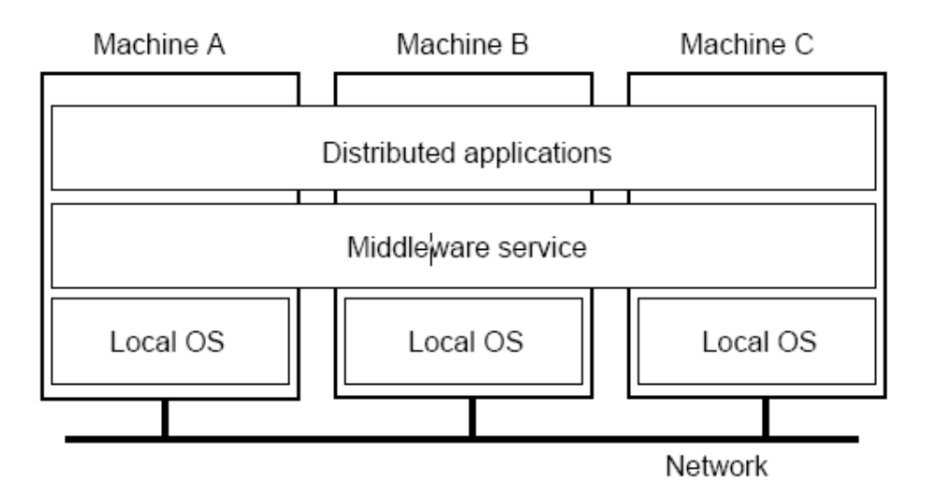

Various hardware and software architectures are used for distributed computing. At a lower level, it is necessary to interconnect multiple CPUs with some sort of network, regardless of whether that network is printed onto a circuit board or made up of loosely coupled devices and cables. At a higher level, it is necessary to interconnect processes running on those CPUs with some sort of communication system. Distributed programming typically falls into one of several basic architectures or categories: client–server, 3-tier architecture, n-tier architecture, distributed objects, loose coupling, or tight coupling.
  Client–server: Smart client code contacts the server for data then formats and displays it to the user. Input at the client is committed back to the server when it represents a permanent change.
  3-tier architecture: Three tier systems move the client intelligence to a middle tier so that stateless clients can be used. This simplifies application deployment. Most web applications are 3-Tier.
  n-tier architecture: n-tier refers typically to web applications which further forward their requests to other enterprise services. This type of application is the one most responsible for the success of application servers.
  Tightly coupled (clustered): refers typically to a cluster of machines that closely work together, running a shared process in parallel. The task is subdivided in parts that are made individually by each one and then put back together to make the final result.
  Peer-to-peer: an architecture where there is no special machine or machines that provide a service or manage the network resources. Instead all responsibilities are uniformly divided among all machines, known as peers. Peers can serve both as clients and servers.
  Space based: refers to an infrastructure that creates the illusion (virtualization) of one single address-space. Data are transparently replicated according to application needs. Decoupling in time, space and reference is achieved. Another basic aspect of distributed computing architecture is the method of communicating and coordinating work among concurrent processes. Through various message passing protocols, processes may communicate directly with one another, typically in a master/slave relationship. Alternatively, a "database-centric" architecture can enable distributed computing to be done without any form of direct inter process communication, by utilizing a shared database.

Goals of Distributed system
•  Connecting resources and users
•  Distribution transparency
•  Openness
•  Scalability

Hardware and Software concepts

Hardware Concepts
1. Multiprocessors
2. Multi computers
3. Networks of Computers

DistinguishingFeatures:

•  Private versus shared memory
•  Bus versus switched interconnection

Networks of Computers

High degree of node heterogeneity:
•  High-performance parallel systems (multiprocessors as well as multicomputers)
•  High-end PCs and workstations (servers)
•  Simple network computers (offer users only network Access)
•  Mobile computers (palmtops, laptops)
•  Multimedia workstations
High degree of network heterogeneity:
•  Local-area gigabit networks
•  Wireless connections
•  Long-haul, high-latency connections
•  Wide-area switched megabit connections

Observation: Ideally, a distributed system hides these Differences

Software Concepts
•  Distributed operating system
•  Network operating system
•  Middleware

Distributed Computing Model

Many tasks that we would like to automate by using a computer are of question–answer type: we would like to ask a question and the computer should produce an answer. In theoretical computer science, such tasks are called computational problems. Formally, a computational problem consists of instances together with a solution for each instance. Instances are questions that we can ask, and solutions are desired answers to these questions. Theoretical computer science seeks to understand which computational problems can be solved by using a computer (computability theory) and how efficiently (computational complexity theory). Traditionally, it is said that a problem can be solved by using a computer if we can design an algorithm that produces a correct solution for any given instance. Such an algorithm can be implemented as a computer program that runs on a general-purpose computer: the program reads a problem instance from input, performs some computation, and produces the solution as output. Formalisms such as random access machines or universal Turing machines can be used as abstract models of a
Sequential general-purpose computer executing such an algorithm. The field of concurrent and distributed computing studies similar questions in the case of either multiple computers, or a computer that executes a network of interacting processes: which computational problems can be solved in such a network and how efficiently? However, it is not at all obvious what is meant by “solving a problem” in the case of a concurrent or distributed system: for example, what is the task of the algorithm designer, and what is the concurrent and/or distributed equivalent of a sequential general-purpose computer?

The discussion below focuses on the case of multiple computers, although many of the issues are the same for concurrent processes running on a single computer. Three viewpoints are commonly used:

Parallel algorithms in shared-memory model
  All computers have access to a shared memory. The algorithm designer chooses the program executed by each computer.
  One theoretical model is the parallel random access machines (PRAM) are used. However, the classical PRAM model assumes synchronous access to the shared memory.
  A model that is closer to the behavior of real-world multiprocessor machines and takes into account the use of machine instructions such as Compare-and-swap (CAS) is that of asynchronous shared memory. There is a wide body of work on this model, a summary of which can be found in the literature.

Parallel algorithms in message-passing model
  The algorithm designer chooses the structure of the network, as well as the program executed by each computer.
  Models such as Boolean circuits and sorting networks are used. A Boolean circuit can be seen as a computer network: each gate is a computer that runs an extremely simple computer program. Similarly, a sorting network can be seen as a computer network: each comparator is a computer.

Distributed algorithms in message-passing model
  The algorithm designer only chooses the computer program. All computers run the same program. The system must work correctly regardless of the structure of the network.
  A commonly used model is a graph with one finite-state machine per node. In the case of distributed algorithms, computational problems are typically related to graphs. Often the graph that describes the structure of the computer network is the problem instance. This is illustrated in the following example.
An example
Consider the computational problem of finding a coloring of a given graph G. Different fields might take the following approaches:

Centralized algorithms
The graph G is encoded as a string, and the string is given as input to a computer. The computer program finds a coloring of the graph, encodes the coloring as a string, and outputs the result.
Parallel algorithms
  Again, the graph G is encoded as a string. However, multiple computers can access the same string in parallel. Each computer might focus on one part of the graph and produce a coloring for that part.
  The main focus is on high-performance computation that exploits the processing power of multiple computers in parallel.
Distributed algorithms
  The graph G is the structure of the computer network. There is one computer for each node of G and one communication link for each edge of G. Initially, each computer only knows about its immediate neighbors in the graph G; the computers must exchange messages with each other to discover more about the structure of G. Each computer must produce its own colour as output.
  The main focus is on coordinating the operation of an arbitrary distributed system. While the field of parallel algorithms has a different focus than the field of distributed algorithms, there is a lot of interaction between the two fields. For example, the Cole– Vishkin algorithm for graph colouring was originally presented as a parallel algorithm, but the same technique can also be used directly as a distributed algorithm. Moreover, a parallel algorithm can be implemented either in a parallel system (using shared memory) or in a distributed system (using message passing). The traditional boundary between parallel and distributed algorithms (choose a suitable network vs. run in any given network) does not lie in the same place as the boundary between parallel and distributed systems (shared memory vs. message passing).

Advantages & Disadvantage distributed system

1: Incremental growth: Computing power can be added in small increments
2: Reliability: If one machine crashes, the system as a whole can still survive
3: Speed: A distributed system may have more total computing power than a mainframe
4: Open system: This is the most important point and the most characteristic point of a distributed system. Since it is an open system it is always ready to communicate with other systems. An open system that scales has an advantage over a perfectly closed and self-contained system.
5. Economic: Microprocessors offer a better price/performance than mainframes

Disadvantages of Distributed Systems over Centralized ones

1:As it is previously told you distributed systems will have an inherent security issue.
2:Networking: If the network gets saturated then problems with transmission will surface.
3:Software:There is currently very little less software support for Distributed system.
4:Troubleshooting: Troubleshooting and diagnosing problems in a distributed system can also become more difficult, because the analysis may require connecting to remote nodes or inspecting communication between nodes.

Issues in designing Distributed System
•  Secure communication over public networks ACI: who sent it, did anyone see it, did anyone change it
•  Fault-tolerance : Building reliable systems from unreliable components  nodes fail independently; a distributed system can “partly fail” [Lamport]: “A distributed system is one in which the failure of a machine I’ve never heard of can prevent me from doing my work.” Replication, caching, naming Placing data and computation for effective resource sharing, hiding latency, and finding it again once you put it somewhere. Coordination and shared state  What should the system components do and when should they do it?  Once they’ve all done it, can they all agree on what they did and when?

Synchronization

Clock synchronization is a problem from computer science and engineering which deals with the idea that internal clocks of several computers may differ. Even when initially set accurately, real clocks will differ after some amount of time due to clock drift, caused by clocks counting time at slightly different rates. There are several problems that occur as a repercussion of rate differences and several solutions, some being more appropriate than others in certain contexts. In serial communication, some people use the term "clock synchronization" merely to discuss getting one metronome-like clock signal to pulse at the same frequency as another one frequency synchronization and phase synchronization. Such "clock synchronization" is used in synchronization in telecommunications and automatic baud rate detection.

Process scheduling
Preemptive scheduling is widespread in operating systems and in parallel processing on symmetric multiprocessors. However, in distributed systems it is practically unheard of. Scheduling in distributed systems is an important issue, and has performance impact on parallel processing, load balancing and meta computing. Non-preemptive scheduling can perform well if the task lengths and processor speeds are known in advance and hence job placement is done intelligently

Deadlock handling
Deadlocks in Distributed Systems: Deadlocks in Distributed Systems Deadlocks in distributed systems are similar to deadlocks in single processor systems, only worse. They are harder to avoid, prevent or even detect. They are hard to cure when tracked down because all relevant information is scattered over many machines. People sometimes might classify deadlock into the following types: Communication deadlocks -- competing with buffers for send/receive Resources deadlocks -- exclusive access on I/O devices, files, locks, and other resources. We treat everything as resources; there we only have resources deadlocks. Four best-known strategies to handle deadlocks: The ostrich algorithm (ignore the problem) Detection (let deadlocks occur, detect them, and try to recover) Prevention (statically make deadlocks structurally impossible) Avoidance (avoid
deadlocks by allocating resources carefully)

The FOUR Strategies for handling deadlocks : The FOUR Strategies for handling deadlocks The ostrich algorithm No dealing with the problem at all is as good and as popular in distributed systems as it is in single-processor systems. In distributed systems used for programming, office automation, process control, no system-wide deadlock mechanism is present -- distributed databases will implement their own if they need one. Deadlock detection and recovery is popular because prevention and avoidance are so difficult to implement. Deadlock prevention is possible because of the presence of atomic transactions. We will have two algorithms for this. Deadlock avoidance is never used in distributed system, in fact, it is not even used in single processor systems. The problem is that the banker’s algorithm need to know (in advance) how much of each resource every process will eventually need. This information is rarely, if ever, available. Hence, we will just talk about deadlock detection and deadlock prevention.

Load Balancing
Resource Scheduling (RS)
RS continuously monitors utilization across resource pools and intelligently aligns resources with business needs, enabling you to:
•  Dynamically allocate IT resources to the highest priority applications. Create rules and policies to prioritize how resources are allocated to virtual machines. • Give IT autonomy to business organizations. Provide dedicated IT infrastructure to business units while still achieving higher hardware utilization through resource pooling.
•  Empower business units to build and manage virtual machines within their resource pool while giving central IT control over hardware resources.

File Sharing
File sharing is the practice of distributing or providing access to digitally stored information, such as computer programs, multi-media (audio, video), documents, or electronic books. It may be implemented through a variety of storage, transmission, and distribution models and common methods of file sharing incorporate manual sharing using removable media, centralized computer file server installations on computer networks, World Wide Web-based hyper linked documents, and the use of distributed peer-to-peer (P2P) networking. The Distributed File System is used to build a hierarchical view of multiple file servers and shares on the network. Instead of having to think of a specific machine name for each set of files, the user will only have to remember one name; which will be the 'key' to a list of shares found on multiple servers on the network. Think of it as the home of all file shares with links that point to one or more servers that actually host those shares. DFS has the capability of routing a client to the closest available file server by using Active
Directory site metrics. It can also be installed on a cluster for even better performance and reliability. Medium to large sized organizations are most likely to benefit from the use of DFS - for smaller companies it is simply not worth setting up since an ordinary file server would be just fine.

Concurrency Control
In computer science, especially in the fields of computer programming (see also concurrent programming, parallel programming), operating systems (see also parallel computing), multiprocessors, and databases, concurrency control ensures that correct results for concurrent operations are generated, while getting those results as quickly as possible. Distributed concurrency control is the concurrency control of a system distributed over a computer network.

Failure handling
In a distributed system, failure transparency refers to the extent to which errors and subsequent recoveries of hosts and services within the system are invisible to users and applications. For example, if a server fails, but users are automatically redirected to another server and never notice the failure, the system is said to exhibit high failure transparency.
Failure transparency is one of the most difficult types of transparency to achieve since it
is often difficult to determine whether a server has actually failed, or whether it is simply responding very slowly. Additionally, it is generally impossible to achieve full failure transparency in a distributed system since networks are unreliable.

Configuration
Dynamic system configuration is the ability to modify and extend a system while it is running. The facility is a requirement in large distributed systems where it may not be possible or economic to stop the entire system to allow modification to part of its hardware or software. It is also useful during production of the system to aid incremental integration of component parts, and during operation to aid system evolution.

Unit-II
Distributed Share Memory and Distributed File System

Distributed Shared Memory (DSM), also known as a distributed global address space (DGAS), is a term in computer science that refers to a wide class of software and hardware implementations, in which each node of a cluster has access to shared memory in addition to each node's non-shared private memory.
Software DSM systems can be implemented in an operating system, or as a programming library. Software DSM systems implemented in the operating system can be thought of as extensions of the underlying virtual memory architecture. Such systems are transparent to the developer; which means that the underlying distributed memory is completely hidden from the users. In contrast, Software DSM systems implemented at the library or language level are not transparent and developers usually have to program differently. However, these systems offer a more portable approach to DSM system implementation. Software DSM systems also have the flexibility to organize the shared memory region in different ways. The page based approach organizes shared memory into pages of fixed size. In contrast, the object based approach organizes the shared memory region as an abstract space for storing shareable objects of variable sizes. Other commonly seen implementation uses tuple space, in which unit of sharing is a tuple.
Shared memory architecture may involve separating memory into shared parts distributed amongst nodes and main memory; or distributing all memory between nodes. A coherence protocol, chosen in accordance with a consistency model, maintains memory coherence.
Examples of such systems include:
  Delphi DSM
  JIAJIA
  Kerrighed
  NanosDSM
  OpenSSI
  MOSIX
  Strings
  Terracotta
  TreadMarks
  DIPC
  Intel Cluster OpenMP is internally a Software DSM.
  ScaleMP ?
  RNA networks

DSM Architecture & its Types,
•  DSM Subsystem
•  DSM Server
•  KEY Server

DSM Subsystem
•  Routines to handle page faults relating to virtual addresses corresponding to a DSM region.
•  Code to service system calls which allow a user process to get, attach and detach a DSM region.
•  Code to handle system calls from the DSM server.

DSM Server
•  In-server :Receives messages from remote DSM servers and takes appropriate action. (E.g. Invalidate its copy of a page)
•  Out-server :Receives requests from the DSM subsystem and communicates with its peer DSM servers at remote nodes. Note that the DSM subsystem itself does
not directly communicate over the network with other hosts.
•  Communication with key Server.

Key Sever
•  Each region must be uniquely identifiable across the entire LAN. When a process executes system call with a key and is the first process at that host to do so, the key server is consulted.
•  Key server‘s internal table is looked-up for the key, if not found then it stores the specified key in the table as a new entry.
Design & Implementations issues In DSM System

There are various factors that have to be kept in mind while designing and implementing the DSM systems. They are as follows:

1.Block Size:
As we know, transfer of the memory blocks is the major operation in the DSM systems. Therefore block size matters a lot here. Block size is often referred to as the Granularity. Block size is the unit of sharing or unit of data transfer in the event of network block fault. Block size can be few words, pages or few pages. Size of the block depends on various factors like, paging overhead, thrashing, false sharing, and directory size.

2. Structure of Shared Memory Space:
How the shared memory space is organized with data determines the structure of the shared memory space. It refers to the layout of shared data. It depends upon the type of application the DSM is going to handle.

3. Replacement Strategy:
It may happen that one node might be accessing for a memory block from DSM when its own local memory is completely full. In such a case, when the memory block migrating from remote node reaches, it finds no space to get placed. Thus a replacement strategy of major concern in the design and implementation of the DSM systems. Certain block must be removed so as to place the new blocks in such a situation. Several techniques are used for the replacement of old blocks such as removal of Least Recently Used memory blocks.
4. Thrashing:
Sometimes two or more processes might access the same memory block. Suppose two processes need to perform write operation on the same memory block. Since, to accomplish this, the block has to migrate in both directions at a very small interval of time, so it will be transferred back and forth at such a high rate that none of the two processes will be able to perform the operation accurately and completely. As such no real work is done. This condition is called thrashing. A technique should be incorporated, while designing the DSM systems to avoid thrashing.

5. Heterogeneity:
DSM systems should be able to function on computers with different architectures. Issues Involved in
DSM Issues
•  Network Communication
•  Consistency
•  Data Granularity
•  Coherence

Consistency Model
• Strict consistency in shared memory systems.
• Sequential consistency in shared memory systems –Our focus.
• Other consistency protocols
• Casual consistency protocol.
• Weak and release consistency protocol

Desirable features of good Distributed File System

In computing, a distributed file system or network file system is any file system that allows access to files from multiple hosts sharing via a computer network. This makes it possible for multiple users on multiple machines to share files and storage resources. The client nodes do not have direct access to the underlying block storage but interact over the network using a protocol. This makes it possible to restrict access to the file system depending on access lists or capabilities on both the servers and the clients, depending on how the protocol is designed. In contrast, in a shared disk file system all nodes have equal access to the block storage where the file system is located. On these systems the access control must reside on the client. Distributed file systems may include facilities for transparent replication and fault tolerance. That is, when a limited number of nodes in a file system go offline, the system continues to work without any data loss. The difference between a distributed file system and a distributed data store can be
vague, but DFSes are generally geared towards use on local area networks.

Features
DFS offers many features that make managing multiple file servers much simpler and effective.

•  Unified Namespace
DFS links multiple shared folders on multiple servers into a folder hierarchy. This hierarchy is same as a physical directory structure on a single hard disk. However, in this case, the individual branch of the hierarchy can be on any of the participating servers.

•  Location Transparency
Even if the files are scattered across multiple servers, users need to go to only one network location. This is a very powerful feature. Users do not need to know if the actual file location has changed. There is no need to inform everyone about using new paths or server names! Imagine how much time and energy this can save. It reduces downtime required during server renames, planned or unplanned shutdowns and so on.

•  Continuous Availability
As mentioned, during planned shutdowns, the file resources can be temporarily made available from another standby server, without users requiring to be notified about it. This way downtime related to maintenance or disaster recovery tasks is completely eliminated. This is very useful especially in Web servers. The Web server file locations can be configured in such a way that even when the physical location of the files changes to another server, the HTML links continues to work without breaking.

•  Replication
It is possible to replicate data to one or more servers within the DFS structure. This way, if one server is down, files will be automatically served from other replicated locations. What’s more, users will not even know the difference.

•  Load Balancing
This is a conceptual extension of replication feature. Now that you can put copies of the same file across multiple locations. If the file is requested by more than one user at the same time, DFS will serve it from different locations. This way, the load on one server is balanced across multiple servers, which increases performance. At a user level, they do not even come to know that the file came from a particular replica on DFS.

•  Security
DFS utilises the same NTFS security and file sharing permissions. Therefore, no special configuration is required to integrate base security with DFS.

•  Ongoing hard disk space management
What happens when your hard disk space is exhausted? You typically add another hard disk. Now, this hard disk will have another name. What if this disk is on another server? Things would get worse. With DFS, you can keep adding new directories to the namespace on completely separate servers. Users never have to bother about the physical server name. This way, you can grow your storage in steps without having to worry about destabilizing file access by users.

•  Unifying heterogeneous platforms
DFS also supports NetWare. This way, administrators can unify data access by combining servers running heterogeneous operating systems from a file access perspective.

•  Fault tolerance or higher availability of data
DFS works with clustering services. This combination offers higher availability than just using clustering.

File Model
The Distributed File System is used to build a hierarchical view of multiple file servers and shares on the network. Instead of having to think of a specific machine name for each set of files, the user will only have to remember one name; which will be the 'key' to a list of shares found on multiple servers on the network. Think of it as the home of all file shares with links that point to one or more servers that actually host those shares. DFS has the capability of routing a client to the closest available file server by using Active Directory site metrics. It can also be installed on a cluster for even better performance and reliability. Medium to large sized organizations are most likely to benefit from the use of DFS - for smaller companies it is simply not worth setting up since an ordinary file server would be just fine.
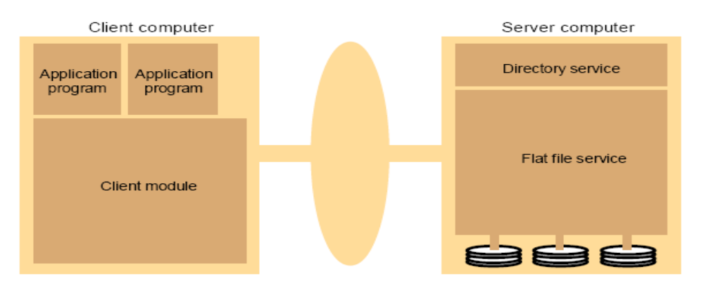

File Service Architecture : Following figure shows the architecture of file service. Client computer can communicate with server using client module to flat file service.

File Sharing Semantics
Sequential semantics: Read returns result of last write
Easily achieved if
– Only one server
– Clients do not cache data
BUT
– Performance problems if no cache
• Obsolete data
– We can write-through
• Must notify clients holding copies
• Requires extra state, generates extra traffic
Session semantics
Relax the rules
• Changes to an open file are initially visible only to the process (or machine) that modified it.
• Last process to modify the file wins.

File Catching Scheme
File caching has implemented in several file system for centralized time-sharing systems to improve file I/O performance. The idea in file caching in there systems is to retain recently accessed file data in main memory, so that repeated accesses to the same information can be handled without additional disk transfers. Because of locality in file access patterns, file caching reduces disk transfers substantially, resulting in better overall performance of the file system. The property of locality in file access patterns can as well be exploited in distributed systems by designing a suitable file-caching scheme. In addition to better performance, a file-caching scheme for a distributed file system may also contribute to its scalability and reliability because it is possible to cache remotely located data on a client node. Therefore, every distributed file system in serious use today uses some form of file caching.

File Application & Fault tolerance

In engineering, fault-tolerant design, also known as fail-safe design, is a design that enables a system to continue operation, possibly at a reduced level (also known as graceful degradation), rather than failing completely, when some part of the system fails. The term is most commonly used to describe computer-based systems designed to continue more or less fully operational with, perhaps, a reduction in throughput or an increase in response time in the event of some partial failure. That is, the system as a whole is not stopped due to problems either in the hardware or the software. An example in another field is a motor vehicle designed so it will continue to be drivable
if one of the tires is punctured. Distributed fault-tolerant replication of data between nodes (between servers or servers/clients) for high availability and offline (disconnected) operation. Distributed file systems, which also are parallel and fault tolerant, stripe and replicate data over multiple servers for high performance and to maintain data integrity. Even if a server fails no data is lost. The file systems are used in both high-performance computing (HPC) and high-availability clusters.
Naming: - Features, System Oriented Names
Naming in distributed systems is modeled as a string translation problem. Viewing names as strings and name resolution mechanisms as syntax directed translators provides a formal handle on the loosely understood concepts associated with naming: we give precise definitions for such informal terminology as name spaces, addresses, routes, source-routing, and implicit-routing; we identify the properties of naming systems, including under what conditions they support unique names, relative names, absolute names, and synonyms; and we discuss how the basic elements of the model can be implemented by name servers. The resources in a distributed system are spread across different computers and a naming scheme has to be devised so that users can discover and refer to the resources that they need.
An identifier that:
• Identifies a resource
– Uniquely
– Describes the resource
• Enables us to locate that resource
– Directly
– With help
• Is it really an identifier
– Bijective, persistent
An example of such a naming scheme is the URL (Uniform Resource Locator) that is used to identify WWW pages. If a meaningful and universally understood identification scheme is not used then many of these resources will be inaccessible to system users.
  Objects:
• processes, files, memory, devices, processors, and networks.
  Object access:
• Each object associate with a defined access operation.
• Accesses via object servers
  Identification of a server by:
• Name
• Physical or Logical address
• Service that the servers provide.
  Identification Issue:
• Multiple server addresses may exist requiring a server to move requiring the name to be changed.

Object Locating Mechanism

Distributed systems based on objects are one of the newest and most popular approaches to the design and construction of distributed systems. CORBA platform is built from several standards published by the organization OMG (Object Management Group), whose objective is to provide a common system for the construction of distributed systems in a heterogeneous environment. The role of the ORB is to deliver the tasks the system the following services: network communication, locating objects, sending notifications too objects, the results to clients. The basic features of CORBA are: independence from the programming language by using language IDL and the independence of the system, hardware, communication (IIOP).

Java RMI (Remote Method Invocation) is a second example of a distributed system platform based on objects. RMI is a structure built based on Java. The model presupposes the existence of the facility, located in the address space of the server and client, which causes the object operations. Remote state of the object is located on a single machine, and the local interface of an object is released.
Human Oriented Name

Names allow us to identify objects. to talk about them and to access them. Naming is therefore an important issue for large scale distributed systems. It becomes a critical issue when those systems are intended to support collaboration between humans. A large volume of research has already been published on the subject of naming, particularly within the context of name servers and directories. However, it can be argued that the hierarchical nature of many of the naming mechanisms so far proposed is too constraining to fully support the great flexibility of human naming practice, particularly where group work is concerned.
Unit-III
Inter Process Communication and Synchronization

In computer networking, an Internet socket or network socket is an endpoint of a bidirectional inter-process communication flow across an Internet Protocol based computer network, such as the Internet. The term Internet sockets is also used as a name for an application programming interface (API) for the TCP/IP protocol stack, usually provided by the operating system. Internet sockets constitute a mechanism for delivering incoming data packets to the appropriate application process or thread, based on a combination of local and remote IP addresses and port numbers. Each socket is mapped by the operating system to a communicating application process or thread.
A socket address is the combination of an IP address (the location of the computer) and a port (which is mapped to the application program process) into a single identity, much like one end of a telephone connection is the combination of a phone number and a particular extension. An Internet socket is characterized by a unique combination of the following:
  Protocol: A transport protocol (e.g., TCP, UDP), raw IP, or others. TCP port 53 and UDP port 53 are different, distinct sockets.
  Local socket address: Local IP address and port number
  Remote socket address: Only for established TCP sockets. As discussed in the Client-Server section below, this is necessary since a TCP server may serve several clients concurrently. The server creates one socket for each client, and these sockets share the same local socket address.

Sockets are usually implemented by an API library such as Berkeley sockets, first introduced in 1983. Most implementations are based on Berkeley sockets, for example Winsock introduced in 1991. Other socket API implementations exist, such as the STREAMS-based Transport Layer Interface (TLI). Development of application programs that utilize this API is called socket programming or network programming. These are examples of functions or methods typically provided by the API library:
  socket() creates a new socket of a certain socket type, identified by an integer number, and allocates system resources to it.
  bind() is typically used on the server side, and associates a socket with a socket address structure, i.e. a specified local port number and IP address.
  listen() is used on the server side, and causes a bound TCP socket to enter listening state.
  connect() is used on the client side, and assigns a free local port number to a socket. In case of a TCP socket, it causes an attempt to establish a new TCP connection.
  accept() is used on the server side. It accepts a received incoming attempt to create a new TCP connection from the remote client, and creates a new socket associated with the socket address pair of this connection.
  send() and recv(), or write() and read(), or recvfrom() and sendto(), are used for sending and receiving data to/from a remote socket.
  close() causes the system to release resources allocated to a socket. In case of TCP, the connection is terminated.
  gethostbyname() and gethostbyaddr() are used to resolve host names and addresses.
  select() is used to prune a provided list of sockets for those that are ready to read, ready to write or have errors
  poll() is used to check on the state of a socket. The socket can be tested to see if it can be written to, read from or has errors.

Data Representation & Marshaling

In computer science, marshalling (similar to serialization) is the process of transforming the memory representation of an object to a data format suitable for storage or transmission. It is typically used when data must be moved between different parts of a computer program or from one program to another. The opposite, or reverse, of marshalling is called unmarshalling (or demarshalling, similar to deserialization).

Group Communication
Computer systems consisting of multiple processors are becoming commonplace. Many companies and institutions, for example, own a collection of workstations connected by a local area network (LAN). Although the hardware for distributed computer systems is advanced, the software has many problems. We believe that one of the main problems is the communication paradigms that are used. This thesis is concerned with software for distributed computer systems. In it, we will study an abstraction, called group communication that simplifies building reliable efficient distributed systems. We will discuss a design for group communication, show that it can be implemented efficiently, and describe the design and implementation of applications based on group communication. Finally, we will give extensive performance measurements. Our goal is to demonstrate that group communication is a suitable abstraction for distributed systems.

Client Server Communication
Client–server model of computing is a distributed application structure that partitions tasks or workloads between service providers, called servers, and service requesters, called clients. Often clients and servers communicate over a computer network on separate hardware, but both client and server may reside in the same system. A server machine is a host that is running one or more server programs which share its resources with clients. A client does not share any of its resources, but requests a server's content or service function. Clients therefore initiate communication sessions with servers which await (listen for) incoming requests.

RPC- Implementing RPC Mechanism
In computer science, a remote procedure call (RPC) is an Inter-process communication that allows a computer program to cause a subroutine or procedure to execute in another address space (commonly on another computer on a shared network) without the programmer explicitly coding the details for this remote interaction. That is, the programmer writes essentially the same code whether the subroutine is local to the executing program, or remote. When the software in question uses object oriented principles, RPC is called remote invocation or remote method invocation.
The steps in making a RPC
1. The client calling the Client stub. The call is a local procedure call, with parameters pushed on to the stack in the normal way.
2. The client stub packing the parameters into a message and making a system call to send the message. Packing the parameters is called marshaling.
3. The kernel sending the message from the client machine to the server machine.
4. The kernel passing the incoming packets to the server stub.
5. Finally, the server stub calling the server procedure. The reply traces the same in other direction

Stub Generation, RPC Messages.
Following figure illustrates the basic operation of RPC. A client application issues a normal procedure call to a client stub. The client stub receives arguments from the calling procedure and returns arguments to the calling procedure. An argument may instantiate an input parameter, an output parameter, or an input/output parameter. In the discussion of this Section, the term input argument refers to a parameter which may be either an input parameter or an input/output parameter, and the term output argument refers to either an output parameter or an input/output parameter. The client stub converts the input arguments from the local data representation to a
common data representation, creates a message containing the input arguments in their common data representation, and calls the client runtime, usually an object library of routines that supports the functioning of the client stub. The client runtime transmits the message with the input arguments to the server runtime which is usually an object library that supports the functioning of the server stub. The server runtime issues a call to the server stub which takes the input arguments from the message, converts them from the common data representation to the local data representation of the server, and calls the server application which does the processing. When the server application has completed, it returns to the server stub the results of the processing in the output arguments. The server stub converts the output arguments from the data representation of the server to the common data representation for transmission on the network and encapsulates the output arguments into a message which is passed to the server runtime. The server runtime transmits the message to the client runtime which passes the message to the client stub. Finally, the client stub extracts the arguments from the message and returns them to the calling procedure in the required local data representation.
Synchronization: - Clock Synchronization

Clock synchronization is a problem from computer science and engineering which deals with the idea that internal clocks of several computers may differ. Even when initially set accurately, real clocks will differ after some amount of time due to clock drift, caused by clocks counting time at slightly different rates. There are several problems that occur as a repercussion of rate differences and several solutions, some being more appropriate than others in certain contexts. In a centralized system the solution is trivial; the centralized server will dictate the system time. Cristian's algorithm and the Berkeley Algorithm are some solutions to the clock synchronization problem in a centralized server environment. In a distributed system the problem takes on more complexity because a global time is not easily known. The most used clock synchronization solution on the Internet is the Network Time Protocol (NTP) which is a layered client-server architecture based on UDP message passing. Lamport timestamps and Vector clocks are concepts of the logical clocks in distributed systems.

Cristian's algorithm
Cristian's algorithm relies on the existence of a time server. The time server maintains its clock by using a radio clock or other accurate time source, then all other computers in the system stay synchronized with it. A time client will maintain its clock by making a procedure call to the time server. Variations of this algorithm make more precise time calculations by factoring in network propagation time.

Berkeley algorithm
This algorithm is more suitable for systems where a radio clock is not present, this system has no way of making sure of the actual time other than by maintaining a global average time as the global time. A time server will periodically fetch the time from all the time clients, average the results, and then report back to the clients the adjustment that needs be made to their local clocks to achieve the average. This algorithm highlights the fact that internal clocks may vary not only in the time they contain but also in the clock rate. Often, any client whose clock differs by a value outside of a given tolerance is disregarded when averaging the results. This prevents the overall system time from being drastically skewed due to one erroneous clock.

Network Time Protocol
This algorithm is a class of mutual network synchronization algorithm in which no master or reference clocks are needed. All clocks equally participate in the synchronization of the network by exchanging their timestamps using regular beacon packets. CS-MNS is suitable for distributed and mobile applications. It has been shown to be scalable, accurate in the order of few microseconds, and compatible to IEEE 802.11 and similar standards.

Reference broadcast synchronization
This algorithm is often used in wireless networks and sensor networks. In this scheme, an initiator broadcasts a reference message to urge the receivers to adjust their clocks.

Mutual Exclusion,
Assumptions
The system consists of n processes; each process Pi resides at a different processor Each process has a critical section that requires mutual exclusion Basic Requirement If Pi is executing in its critical section, then no other process Pj is executing in its critical section The presented algorithms ensure the mutual exclusion execution of processes in their critical sections. Mutual exclusion must be enforced: only one process at a time is allowed in its critical section A process that hales in its non critical section must do so without interfering with other processes. It must not be possible for a process requiring access to a critical section to be delayed indefinitely: No deadlock or starvation When no process is in a critical section, any process that requests entry to its critical section must be permitted to enter without delay No assumptions are made about relative process speeds or number of processors A process remains inside its critical section for a finite time Only
Election Algorithms:- Bully & Ring Algorithms
  There are at least two basic strategies by which a distributed system can adapt to failures.
  Operate continuously as failures occur and are repaired
  The second alternative is to temporarily halt normal operation and to take some time out to reorganize the system.
  The reorganization of the system is managed by a single node called the coordinator.
 So as a first step in any reorganization, the operating or active nodes must elect a coordinator.
  Similar
  Like Synchronization, all processors must come to an agreement about who enters the critical region (i.e. who is the leader)
  Different
  The election protocol must properly deal with the case of a coordinator failing. On the other hand, mutual exclusion algorithms assume that the process in the critical region (i.e., the coordinator) will not fail.
  A new coordinator must inform all active nodes that it is the coordinator. In a mutual exclusion algorithm, the nodes not in the critical region have no need to know what node is in the region.
  The two classical election algorithms by Garcia-Molina
  Bully Algorithm
  Invitation Algorithm
  Ring Algorithm

Election algorithms
We often need one process to act as a coordinator. It may not matter which process does this, but there should be group agreement on only one. An assumption in election algorithms is that all processes are exactly the same with no distinguishing characteristics. Each process can obtain a unique identifier (for example, a machine address and process ID) and each process knows of every other process but does not know which is up and which is down.

Bully algorithm
The bully algorithm selects the process with the largest identifier as the coordinator. It works as follows:
1. When a process p detects that the coordinator is not responding to requests, it initiates an election:
a. p sends an election message to all processes with higher numbers.
b. If nobody responds, then p wins and takes over.
c. If one of the processes answers, then p's job is done.
2. If a process receives an election message from a lower-numbered process at any time, it:
a. sends an OK message back.
b. holds an election (unless its already holding one).
3. A process announces its victory by sending all processes a message telling them that it is the new coordinator.
4. If a process that has been down recovers, it holds an election.

Ring algorithm
The ring algorithm uses the same ring arrangement as in the token ring mutual exclusion algorithm, but does not employ a token. Processes are physically or logically ordered so that each knows its successor.
  If any process detects failure, it constructs an election message with its process I.D. (e.g. network address and local process I.D.) and sends it to its successor.
  If the successor is down, it skips over it and sends the message to the next party. This process is repeated until a running process is located.
  At each step, the process adds its own process I.D. to the list in the message. Eventually, the message comes back to the process that started it:

1. The process sees its ID in the list.
2. It changes the message type to coordinator.
3. The list is circulated again, with each process selecting the highest numbered ID in the list to act as coordinator.
4. When the coordinator message has circulated fully, it is deleted. Multiple messages may circulate if multiple processes detected failure. This creates a bit of overhead but produces the same results.
Unit-IV
Distributed Scheduling and Deadlock

Distributed Scheduling
Distributed scheduling (DS) is an approach that enables local decision makers to create schedules that consider local objectives and constraints within the boundaries of the overall system objectives. Local decisions from different parts of the system are then integrated through coordination and communication mechanisms. Distributed scheduling attracts the interest of many researchers from a variety of disciplines, such as computer science, economics, manufacturing, and service operations management. One reason is that the problems faced in this area include issues ranging from information architectures, to negotiation mechanisms, to the design of scheduling algorithms.

Issues in Load Distributing
In computer networking, load balancing is a technique to distribute workload evenly across two or more computers, network links, CPUs, hard drives, or other resources, in order to get optimal resource utilization, maximize throughput, minimize response time, and avoid overload. Using multiple components with load balancing, instead of a single component, may increase reliability through redundancy. The load balancing service is usually provided by a dedicated program or hardware device (such as a multilayer switch or a DNS server). The problem of judiciously and transparently redistributing the load of the system among its nodes so that overall performance is maximized is discussed. Several key issues in load distributing for general-purpose systems, including the motivations and design trade-offs for load-distributing algorithms, are reviewed. In addition, several load distributing algorithms are described and their performances are compared.
Components for Load Distributing Algorithms

Load balancing algorithms
You can select a round-robin algorithm or a biasing algorithm for load balancing.

Different Types of Load Distributing Algorithms,

The round-robin algorithm
The round-robin algorithm assumes that all CICS regions are equally valid for selection. In the round-robin algorithm, when the Client daemon is initially started, it reads from the configuration file a list of all possible CICS regions to which any ECI or EPI request can be sent. The Workload Manager also records the last region selected. When a new ECI or EPI request is made, the next region in the list is selected as the target. When it reaches the last region it loops around to the first one.

The Biasing algorithm
The biasing algorithm provides a way of balancing workload by specifying that workload distribution should favor particular regions. For example, if there are two regions with a bias of 75 and 25, program requests are sent in a ratio of 3:1 to the first region. If a region fails, the internal biasing calculation changes. If two regions are available, one with a bias of 100 and the other with a bias of 0, all requests are sent to the first value of 0 is a special case, meaning use only if no other region is available.

Task Migration and its issues
Process migration means moving a process in the middle of its execution from one processor or host to another, for a variety of reasons. Usually, processes are migrated with the aim of balancing the work load across the cluster so that the capacity of underutilized nodes is also exploited. The idea of process migration is borne out of the fact that in the over whelming cases of non migratory scenarios, the capacity of most nodes are under utilized. Allocation can be static or dynamic. By its very nature, process migration presents a difficult task with many complex issues to be resolved -
Transparency, scheduling and allocation policies, interaction with file system, naming, and scaling.

Migration issues
Obviously, achieving the goals of load balancing and transparency with as low over head as possible presents a formidable task. The following are some of the main issues to be dealt with:
(1) Allocation and scheduling: How is a target node chosen? What are the factors taken into consideration while choosing a destination host? Is load balanced dynamically, or only reallocated during special circumstances like eviction or imminent host failure? Does the previous history of allocation on a node make that node more attractive due to the presence of "warm caches" , also known as cache affinity scheduling ? Considering that all of the above systems represent loosely coupled environments, how much of a difference can such a consideration make? Similarly, what is the best allocation policy for an I/O intensive process?
(2) Once a target has been chosen, how is the process state saved and transferred? For e.g., would virtual memory pages be transferred all at once, increasing the latency between process suspension and resumption, or transferred on a demand-paged basis thus speeding up migration?
An important consideration over here is how much of "residual dependency" do we allow on the ex-host?
(3) How is migration supported by the underlying file system for kernel level schemes? Are files assumed to be accessible from any point? For transparency, a transparent file system would itself seem to be a prerequisite.
(4) How are name spaces dealt with? Do process Ids, file descriptors etc change with migration? How does global naming help? How are sockets and signals managed?
(5) What are the scaling considerations that have been incorporated into the design?
(6) What is the level of transparency?

Deadlock-Issues in deadlock detection & Resolutions
A deadlock is a situation wherein two or more competing actions are each waiting for the other to finish, and thus neither ever does. This situation may be likened to two people who are drawing diagrams, with only one pencil and one ruler between them. If one person takes the pencil and the other takes the ruler, a deadlock occurs when the person with the pencil needs the ruler and the person with the ruler needs the pencil to finish his work with the ruler. Neither request can be satisfied, so a deadlock occurs. Distributed deadlocks can occur in distributed systems when distributed transactions or concurrency control is being used. Distributed deadlocks can be detected either by constructing a global wait-for graph, from local wait-for graphs at a deadlock
detector or by a distributed algorithm like edge chasing. In a Commitment ordering based distributed environment (including the Strong strict two-phase locking (SS2PL, or rigorous) special case) distributed deadlocks are resolved automatically by the atomic commitment protocol (e.g. two-phase commit (2PC)), and no global wait-for graph or other resolution mechanism are needed. Similar automatic global deadlock resolution occurs also in environments that employ 2PL that is not SS2PL (and typically not CO; see Deadlocks in 2PL). However 2PL that is not SS2PL is rarely
utilized in practice. Phantom deadlocks are deadlocks that are detected in a distributed system due to system internal delays, but no longer actually exist at the time of detection.

Deadlock Handling Strategy

Distributed Deadlock Algorithms,
Classification of Distributed Deadlock Detection Algorithms
•  Path-Pushing Algorithms
•  Probe-based Algorithms
•  Edge–Chasing
•  Diffusion Computation based
•  Global state Detection

Unit-V
Distributed Multimedia & Database system

Distributed Multimedia Database involves network technology, distributed control, security, and multimedia computing. This chapter discusses fundamental concepts and introduces issues of image database and digital libraries, video-on-demand systems, multimedia synchronization, as well as some case studies of distributed multimedia database systems. Requirements of multimedia database management systems and their functions are also presented.

Distributed Data Base Management System (DDBMS)
A distributed database management system ('DDBMS') is a software system that permits the management of a distributed database and makes the distribution transparent to the users. A distributed database is a collection of multiple, logically interrelated databases distributed over a computer network. Sometimes "distributed database system" is used to refer jointly to the distributed database and the distributed DBMS.

Overview
Distributed database management system is software for managing databases stored on multiple computers in a network. A distributed database is a set of databases stored on multiple computers that typically appears to applications on a single database. Consequently, an application can simultaneously access and modify the data in several databases in a network. DDBMS is specially developed for heterogeneous database platforms, focusing mainly on heterogeneous database management system (HDBMS).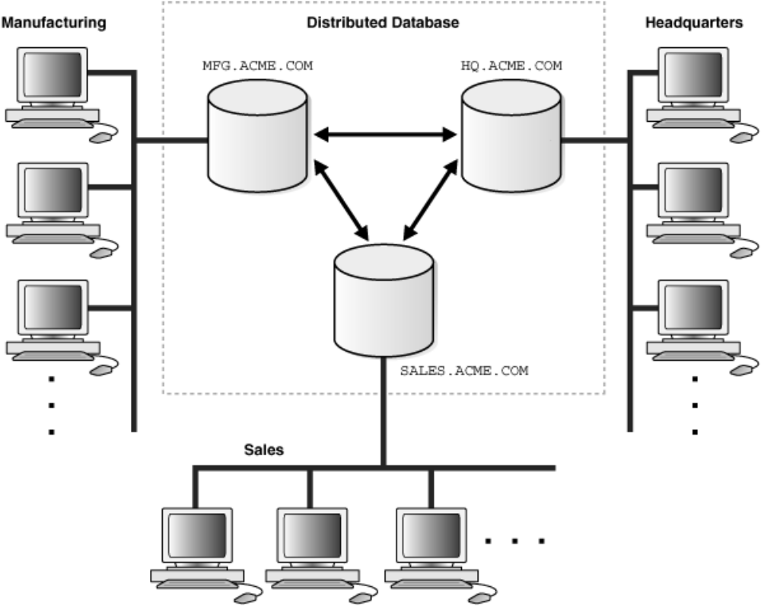
Types of Distributed Database

The distributed database can be defined as consisting of a collection of data with different parts under the control of separate DBMS, running an independent computer system. A distributed database is a database that is under the control of a central database management system (DBMS) in which storage devices are not all attached to a common CPU. It may be stored in multiple computers located in the same physical location, or may be dispersed over a network of interconnected computers. Collections of data (eg. in a database) can be distributed across multiple physical locations. A distributed database can reside on network servers on the Internet, on corporate intranets or extranets, or on other company networks. Replication and distribution of databases improve database performance at end-user worksites. To ensure that the distributive databases are up to date and current, there are two processes: replication and duplication. Replication involves using specialized software that looks for changes in the distributive database. Once the changes have been identified, the replication process makes all the databases look the same. The replication process can be very complex and time consuming depending on the size and number of the distributive databases. This process can also require a lot of time and computer resources. Duplication on the other hand is not as complicated. It basically identifies one database as a master and then duplicates that database. The duplication process is normally done at a set time after hours. This is to ensure that each distributed location has the same data. During the duplication process, changes to the master database only are allowed. This is to ensure that local data will not be overwritten. Both of the processes can keep the data current in all distributive locations. Besides distributed database replication and fragmentation, there are many other distributed database design technologies. For example, local autonomy, synchronous and asynchronous distributed database technologies. These technologies' implementation can and does depend on the needs of the business and the sensitivity/confidentiality of the data to be stored in the database, and hence the price the business is willing to spend on ensuring data security, consistency and integrity.

Advantages of distributed databases
  Management of distributed data with different levels of transparency.
  Increase reliability and availability.
  Easier expansion.
  Reflects organizational structure — database fragments are located in the departments they relate to.
  Local autonomy — a department can control the data about them (as they are the ones familiar with it.)
  Protection of valuable data — if there were ever a catastrophic event such as a fire, all of the data would not be in one place, but distributed in multiple locations.
  Improved performance — data is located near the site of greatest demand, and the database systems themselves are parallelized, allowing load on the databases to be balanced among servers. (A high load on one module of the database won't affect other modules of the database in a distributed database.)
  Economics — it costs less to create a network of smaller computers with the power of a single large computer.
  Modularity — systems can be modified, added and removed from the distributed database without affecting other modules (systems).
  Reliable transactions - Due to replication of database.
  Hardware, Operating System, Network, Fragmentation, DBMS, Replication and Location Independence.
  Continuous operation.
  No reliance on central site.
  Distributed Query processing.
  Distributed Transaction management.
Single site failure does not affect performance of system. All transactions follow A.C.I.D. property: a-atomicity, the transaction takes place as whole or not at all; consistency, maps one consistent DB state to another; i-isolation, each transaction sees a consistent DB; d-durability, the results of a transaction must survive system failures. The Merge Replication Method used to consolidate the data between databases.

Disadvantages of distributed databases
  Complexity — extra work must be done by the DBAs to ensure that the distributed nature of the system is transparent. Extra work must also be done to maintain multiple disparate systems, instead of one big one. Extra database design work must also be done to account for the disconnected nature of the database — for example, joins become prohibitively expensive when performed across multiple systems.
  Economics — increased complexity and a more extensive infrastructure means extra labour costs.
  Security — remote database fragments must be secured, and they are not centralized so the remote sites must be secured as well. The infrastructure must also be secured (e.g., by encrypting the network links between remote sites).
  Difficult to maintain integrity — in a distributed database, enforcing integrity over a network may require too much of the network's resources to be feasible.
  Inexperience — distributed databases are difficult to work with, and as a young field there is not much readily available experience on proper practice.
  Lack of standards – there are no tools or methodologies yet to help users convert a centralized DBMS into a distributed DBMS.
  Database design more complex – besides of the normal difficulties, the design of a distributed database has to consider fragmentation of data, allocation of fragments to specific sites and data replication.
  Additional software is required.
  Operating System should support distributed environment.
  Concurrency control: it is a major issue. It is solved by locking and time stamping.
Distributed Multimedia:- Following figure shows basic of Distributed Multimedia.

Characteristics of Multimedia Data
Real-time multimedia data is expensive to transport and must be received in a timely manner, with utmost importance placed on preserving the linear progression of sequential timed data at the user's end. Two major obstacles stand in the way of high-fidelity, real-time multimedia data transport over an internet: limited available network bandwidth and dynamically varying transmission delays. Understandably, the larger problem of the two is the high bandwidth requirement necessitated by real time audio and video. In the MPEG-2 compression standard, for example, the Main profile at the Low level allows for a 30 frame per second 352x288 pixel resolution image, requiring a communication channel bandwidth of 4Mbit/s for successful transport. This is a high data transmission rate that is nonetheless supportable on a modern LAN. For a packet switching internet work, the transmission latency is inherently nondeterministic, and when networks become congested, extreme latencies, many orders of magnitude greater than that of any average expected latency, can result. Figure 1 represents a set of images that comprise a timely delivered movie of a bouncing ball. Transporting this video stream across an internet with an unbuffered connection can undesirably vary the inter-frame temporal spacing, distorting the presentation of timed sequential data beyond what is acceptable to the viewer. (Figure 2)
Figure 1: Frames in the complete video stream of a bouncing ball.
Figure 2: Frames in a video stream that doesn't preserve the linear time progression relationships.
The motion depicted by the images in figure 2 defies our kinematic sense about what happens when a ball bounces, and is different than figure 3, in which a frame is skipped, with the inter-frame timing relationships preserved.
Figure 3: Frames in a damaged but linear time progression relationship preserving video stream of a bouncing ball. Multimedia streaming was developed to attempt to overcome, or at least stave off in moderate cases, the effects of varying transmission delays. By buffering a sufficient amount of the data before presenting it to the user, multimedia streaming can allow an application to maintain the inter-frame timing in the face of variable delivery rates. The rate of data output is independent of the input rate, as long as there is enough data in the buffer to source the required amount of output. If the input rate lags behind the output rate, eventually there will not be enough data in the buffer to support the high output rate, resulting in the depletion of the multimedia reservoir, forcing the presented data stream to follow the variable rate network data supply. Although this method of multimedia data presentation offers high-fidelity output at the user's end, it can tend to utilize quite a bit more of the available network bandwidth than is acceptable for a ``nicely behaved application.'' If the streaming protocol is built on top of a fully reliable protocol such as TCP, segments of data that are lost due to congestion will be retransmitted until they have been acknowledged properly, adding to the congestion of the network. Reliable data transmission protocols such as TCP were not designed to handle the special requirements of real-time applications. They were designed for low bandwidth interactive applications such as telnet and potentially high bandwidth non-interactive applications such as electronic mail handling and ftp. The best-effort transport services inherent to UDP are more suited for delivering multimedia data payloads. The User Datagram Protocol is becoming important in the realm of multimedia protocols. Because it is essentially an interface to the low-level Internet Protocol, and because it offers a speedy checksum and I/O multiplexing through Berkeley sockets, it is an ideal choice for applications that do not wish to be constrained to the flow control mechanism in TCP. However, operation without any flow control in place will quickly fill the local socket-level buffers and UDP datagrams will be discarded before they even reach the physical network. In effect, protocols such as TCP, with a highly refined flow control mechanism, attempt to dynamically estimate the optimum transmission rate through the this observation, operation without flow control is out of the question for high-bandwidth multimedia applications.

Quality of Service Managements
Multimedia data such as audio and video streams have started to be incorporated into mission-critical scenarios such as medical applications and digital television studios. Because of the enrichment they bring to application content we believe that this trend will continue and more and more mission critical applications will begin to incorporate multimedia data. In these scenarios the quality of the media being presented is important and resources have to be properly allocated and scheduled in order to preserve this quality. Furthermore, there is a requirement for applications to be modifiable while they run, while still meeting their Quality of Service (QoS) constraints

Case Study of Distributed System:-

Amoeba
Amoeba is the open source microkernel-based distributed operating system developed by Andrew S. Tanenbaum and others at the Vrije Universiteit. The aim of the Amoeba project is to build a timesharing system that makes an entire network of computers appear to the user as a single machine. Development at Vrije Universiteit was stopped: the files in the latest version (5.3) were last modified on 12 February 2001. Recent development is carried forward by Dr. Stefan Bosse at BSS Lab. Amoeba runs on several platforms, including SPARC, i386, i486, 68030, Sun 3/50 and
Sun 3/60. The system uses FLIP as a network protocol. The Python programming language was originally developed for this platform.

WHAT IS AMOEBA?
Amoeba is a general-purpose distributed operating system. It is designed to take a collection of machines and make them act together as a single integrated system. In general, users are not aware of the number and location of the processors that run their commands, nor of the number and location of the file servers that store their files. To the casual user, an Amoeba system looks like a single old-fashioned time-sharing system. Amoeba is an ongoing research project. It should be thought of as a platform for doing research and development in distributed and parallel systems, languages, protocols and applications. Although it provides some UNIX emulation, and has a definite UNIX-like flavor (including over 100 UNIX-like utilities), it is NOT a plug-compatible replacement for UNIX. It should be of interest to educators and researchers who want the source code of a distributed operating system to inspect and tinker with, as well as to those who need
a base to run distributed and parallel applications. Amoeba is intended for both ‘‘distributed’’ computing (multiple independent users working on different projects) and ‘‘parallel’’ computing (e.g., one user using 50 CPUs to play chess in parallel). Amoeba provides the necessary mechanism for doing both distributed and parallel applications, but the policy is entirely determined by user-level programs. For example, both a traditional (i.e. sequential) ‘make’ and a new parallel
‘amake’ are supplied.

DESIGN GOALS
The basic design goals of Amoeba are:
Distribution—Connecting together many machines
Parallelism—Allowing individual jobs to use multiple CPUs easily
Transparency—Having the collection of computers act like a single system
Performance—Achieving all of the above in an efficient manner
Amoeba is a distributed system, in which multiple machines can be connected together. These machines need not all be of the same kind. The machines can be spread around a building on a LAN. Amoeba uses the high performance FLIP network protocol for LAN communication. If an Amoeba machine has more than one network interface it will automatically act as a FLIP router between the various networks and thus connect the various LANs together. Amoeba is also a parallel system. This means that a single job or program can use multiple processors to gain speed. For example, a branch and bound problem such as the Traveling Salesman Problem can use tens or even hundreds of CPUs, if available, all working together to solve the problem more quickly. Large ‘‘back end’’ multiprocessors, for example, can be harnessed this way as big ‘‘compute engines.’’ Another key goal is transparency. The user need not know the number or the location of the CPUs, nor the place where the files are stored. Similarly, issues like file replication
are handled largely automatically, without manual intervention by the users. Put in different terms, a user does not log into a specific machine, but into the system as a whole. There is no concept of a ‘‘home machine.’’ Once logged in, the user does not have to give special remote login commands to take advantage of multiple processors or do special remote mount operations to access distant files. To the user, the whole system looks like a single conventional timesharing system. Performance and reliability are always key issues in operating systems, so substantial effort has gone into dealing with them. In particular, the basic communication mechanism has been optimized to allow messages to be sent and replies received with a minimum of delay, and to allow large blocks of data to be shipped from machine to machine at high bandwidth. These building blocks serve as the basis for implementing high performance subsystems and applications on Amoeba.
Mach
Mach is an operating system microkernel developed at Carnegie Mellon university to support operating system research, primarily distributed and parallel computation. It is one of the earliest examples of a microkernel, and its derivatives are the basis of the modern operating system kernels in Mac OS X and GNU Hurd.

Goals of Mach
•  Providing a base for building other operating systems (UNIX)
•  Supporting large sparse address spaces
•  Allowing transparent access to network resources
•  Exploiting parallelism in both the system and the applications
•  Making Mach portable to a larger collection of Machines
•  Chorus Task: an execution environment
•  Thread: the basic unit of execution and must run in the context of a task.
•  Port: a communication channel with an associated message queue
•  Port set: a group of ports sharing a common message queue
•  message: a typed collection of data objects used in communication between threads(can contain port rights in addition to pure data)
•  memory object: a source of memory

Features of Mach
•  Multiprocessor operation
•  Transparent extension to network operation
•  User-level servers
•  operating system emulation
•  Flexible virtual memory implementation
•  Portability
Mach was designed to execute on a shared memory multiprocessor so that both kernel threads and user-mode threads could be executed by any processor.

Chorus
The evolution of computer applications has led to the design of large, distributed systems for which the requirement for efficiency and availability has increased, as has the need for higher level tools used in their construction, operation, and administration. This evolution has introduced the following requirements for new system structures that are difficult to fulfill merely by assembling networks of cooperating systems:
•  Separate applications running on different machines, often from different suppliers, using different operating systems, and written in a variety of programming languages, need to be tightly coupled and logically integrated. The loose coupling provided by current computer networking is insufficient. A requirement exists for a higher-level coupling of applications.
•  Applications often evolve by growing in size. Typically, this growth leads to distribution of programs to different machines, to treating several geographically distributed sets of files as a unique logical file, and to upgrading hardware and software to take advantage of the latest technologies. A requirement exists for a gradual on-line evolution.
•  Applications grow in complexity and become more difficult to understand, specify, debug, and tune. A requirement exists for a straightforward underlying architecture which allows the modularity of the application to be mapped onto the operational system and which conceals unnecessary details of distribution from the application. These structural properties can best be accomplished through a basic set of unified and coherent concepts which provide a rigorous framework that is well adapted to constructing distributed systems. The CHORUS architecture has been designed to meet these requirements. Its foundation is a generic Nucleus running on each machine. Communication and distribution are managed at the lowest level by this Nucleus. The generic CHORUS Nucleus implements the real-time services required by real-time applications. Traditional operating systems are built as subsystems on top of the generic Nucleus and use its basic services. User application programs run in the context of these operating systems. CHORUS provides a UNIX subsystem as one example of a host operating system running on top of the CHORUS Nucleus. UNIX programs can run unmodified under this subsystem, optionally taking advantage of the distributed nature of the CHORUS environment.

The CHORUS Architecture
Overall Organization
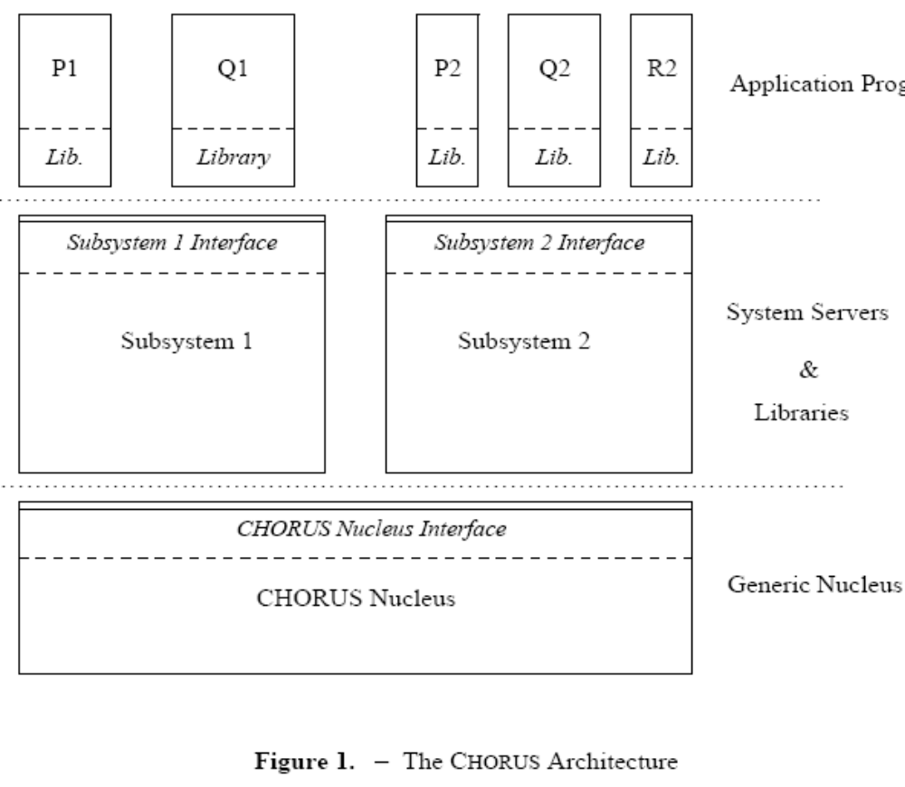
A CHORUS System is composed of a small Nucleus and a set of system servers, which cooperate in the context of subsystems (Figure 1). This overall organization provides the basis for an open operating system. It can be mapped onto a centralized as well as a distributed configuration. At this level, distribution is hidden.
The choice was made to build a two-level logical structure, with a generic Nucleus at the lowest level and almost autonomous subsystems providing applications with traditional operating system services. Therefore, the CHORUS Nucleus is not the core of a specific operating system, rather it provides generic tools designed to support a variety of host subsystems, which can co-exist on top of the Nucleus. This structure supports application programs, which already run on an existing operating system, by reproducing the operating system’s interfaces within a subsystem. An example of this approach is given using a UNIX emulation environment called CHORUS/MiX.
The classic idea of separating the functions of an operating system into groups of services provided by autonomous servers is central to the CHORUS philosophy. In monolithic systems, these functions are usually part of the ‘‘kernel’’. This separation of functions increases modularity, and therefore the portability of the overall system.

The CHORUS Nucleus
The CHORUS Nucleus manages, at the lowest level, the local physical resources of a site. At the highest level, it provides a location transparent inter-process communication (IPC) mechanism.
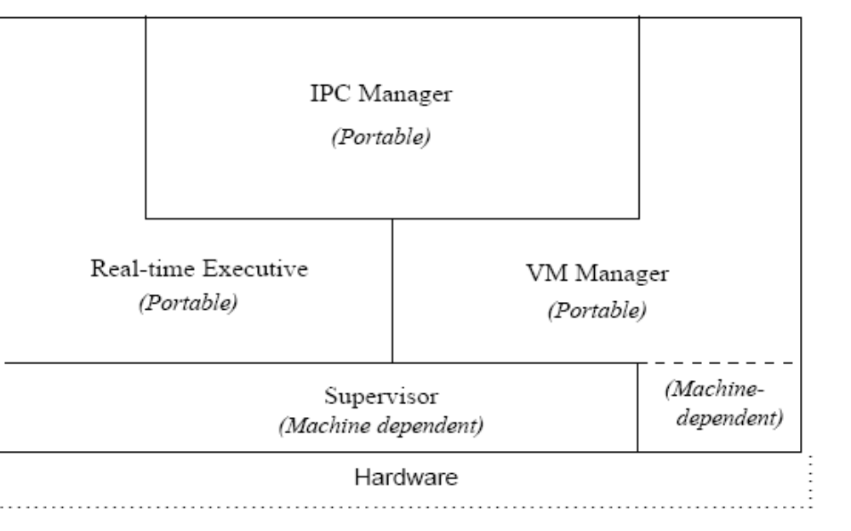
The Nucleus is composed of four major components providing local and global services (Figure 2):
•  The CHORUS supervisor dispatches interrupts, traps, and exceptions delivered by the hardware;
•  The CHORUS real-time executive controls the allocation of processors and provides fine grained synchronization and priority-based preemptive scheduling;
•  The CHORUS virtual memory manager is responsible for manipulating the virtual memory hardware and local memory resources;
• T he CHORUS inter-process communication manager provides asynchronous message exchange and remote procedure call (RPC) facilities in a location independent fashion. There are no interdependencies among the four components of the CHORUS Nucleus. As a result, the distribution of services provided by the Nucleus is almost hidden. Local services deal with local resources and can be mostly managed using only local information. Global services involve cooperation between Nuclei to provide distribution. In CHORUS−V3 it was decided, based on experience with CHORUS-V2 efficiency, to include in the Nucleus some functions that could have been provided by system servers: actor and port management, name management, and RPC management. The standard CHORUS IPC mechanism is the primary means used to communicate with managers in a CHORUS system. For example, the virtual memory manager uses CHORUS IPC to request remote data to service a page fault. The Nucleus was also designed to be highly portable, which, in some instances, may preclude the use of some underlying hardware features. Experience gained from porting the Nucleus to

The Subsystems
System servers work cooperatively to provide a coherent operating system interface, referred to as a subsystem.

System Interfaces
A CHORUS system provides different levels of interface (Figure 1).
•  The Nucleus interface provides direct access to the low-level services of the CHORUS Nucleus.
•  A subsystem interface is implemented by a set of cooperating, trusted servers, and typically represents complex operating system abstractions. Several different subsystems may be resident on a CHORUS system simultaneously, providing a variety of operating system or high-level interfaces to different application procedures.
•  User libraries, such as the ‘‘C’’ library, further enhance the CHORUS interface by providing commonly used programming facilities.

