NAME COLLEGE OF TECHNOLOGY, BHOPAL

DEPARTMENT OF INFORMATION TECHNOLOGY

COURSE FILE

Programme : BE
Semester : VII
Course Code : IT-721
Subject Name : E COMMERCE AND GOVERNANCE

Prepared By: Approved By:

Index

S.No. Contents Page No.

- Scheme
- Syllabus
- Time Table
- Lecture Plan
- List of Books
- Unit Test papers
- Mid Semester Exam Question Papers
- RGPV Question Paper
- Tutorial Questions
- Assignment Questions
- Hand-Written Notes
- Transparencies/Power Point Presentation Slides
- Mid Semester Exam Result
- Attendance Sheet
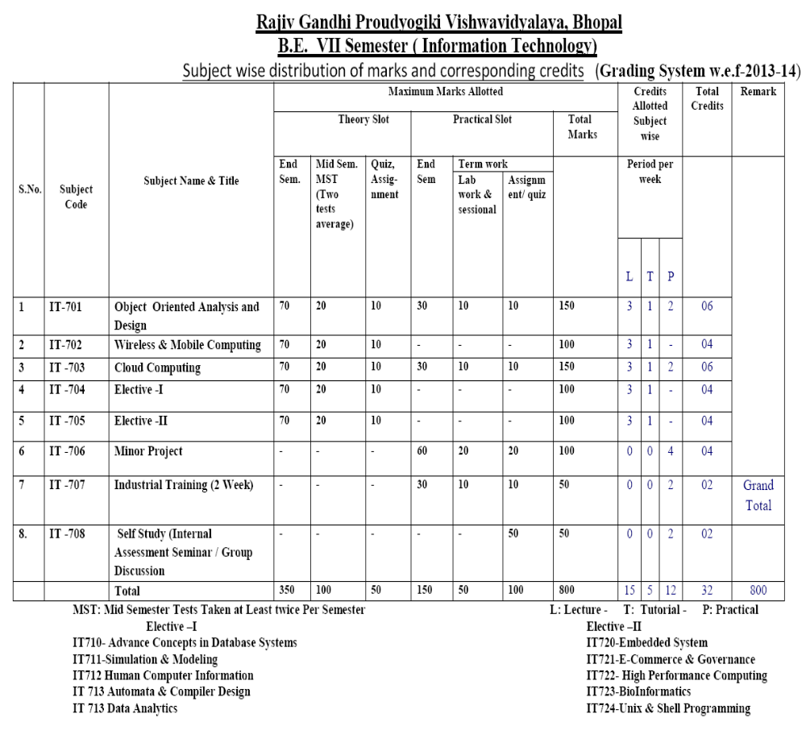

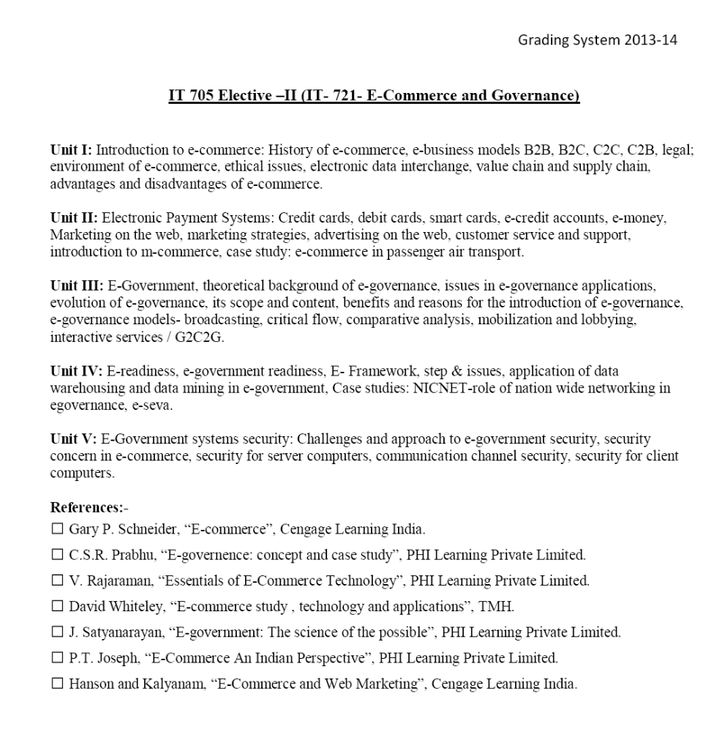

 | NAME COLLEGE OF TECHNOLOGY  TIME TABLE  PERIOD WISE DETAILS |  |  |  |  |  |  |  | Format No
 |  |  |  |  |  |  |  |  | ISSUE NO
 |  |  |  |  |  |  |  |  | YEAR | 2014-15
Name: |  |  |  |  | Department: Information Technology
Day | 10:00AM  to 10:50AM  I | 10:50AM  to 11:40AM  II |  | 11:40AM  to 12:30PM  III | 12:30PM  to 01:20PM | 01:10PM  to 02:00PM  IV | 02:00PM  to 02:50PM  V |  | 02:50PM  to 03:40PM  VI | 03:40PM to  4:30 PM  VII
Monday
Tuesday
Wednesday
Thursday
Friday
Saturday
 | IT 721 ECOMM |  |  |  |  |  |  | APPROVED BY :  (HOD)
APPROVED BY :
(PRINCIPAL)

Name College of Technology, Bhopal
Department of Information Technology
LESSON PLAN
Department: |  |  | IT |  |  |  |  | Session: |  |  | July-Dec 2014
Name of Faculty: |  |  |  |  |  |  |  | Semester: |  |  | VII
Subject: |  |  | E COMMERCE AND GOV. |  |  |  |  | Sub Code: |  |  | IT-721
Time Schedule : Total expected period – 45

Day |  | Mon |  | Tue | Wed | Thu | Fri |  |  | Sat |  | Max. Available
No. of Period |  | 1 |  | 1 | 1 | 1 | 1 |  |  | 1 |  | Max. Available
Lect | Lecture to be Covered |  |  |  |  |  |  |  | Date of Completion |  |  | References | Remarks
 | UNIT I
1 | Introduction to e-commerce: History of e-commerce, |  |  |  |  |  |  |  |  |  |  | R1(1-39)&  R2(1-13)
2 | e-business models B2B, B2C, C2C, C2B, legal; |  |  |  |  |  |  |  |  |  |  | R1(40-96)
3 | environment of e-commerce, ethical issues, |  |  |  |  |  |  |  |  |  |  | R1(98-100) &R2(16-27)
4 | electronic data interchange, |  |  |  |  |  |  |  |  |  |  | R1(112-115)  &R2(39-50)
5 | ethical issues, |  |  |  |  |  |  |  |  |  |  | R1(98-100)
6 | value chain |  |  |  |  |  |  |  |  |  |  | R1(116-118)
7 | supply chain, |  |  |  |  |  |  |  |  |  |  | R1(116-118)
8 | Advantages and disadvantages of e-commerce. |  |  |  |  |  |  |  |  |  |  | R1(120-122)
 | UNIT – II
9 | Electronic Payment Systems |  |  |  |  |  |  |  |  |  |  | R2(116-122)
10 | Credit cards |  |  |  |  |  |  |  |  |  |  | R2(116-122)
11 | debit cards, |  |  |  |  |  |  |  |  |  |  | R2(116-122)
12 | smart cards, e-credit accounts, e-money, |  |  |  |  |  |  |  |  |  |  | R2(123-150)
13 | Marketing on the web, |  |  |  |  |  |  |  |  |  |  | R1(158-175)
14 | marketing strategies, |  |  |  |  |  |  |  |  |  |  | R1(158-175)
15 | advertising on the web |  |  |  |  |  |  |  |  |  |  | R1(176-190)
16 | customer service and support |  |  |  |  |  |  |  |  |  |  | R1(192-207)
17 | introduction to m-commerce |  |  |  |  |  |  |  |  |  |  | R2(173-185)
18 | case study: e-commerce in passenger air transport. |  |  |  |  |  |  |  |  |  |  | R2(215-226)
 | UNIT – III
19 | Introduction to E-Government, |  |  |  |  |  |  |  |  |  |  | R3(1-3)
20 | theoretical background of e-governance, |  |  |  |  |  |  |  |  |  |  | R3(1-3)
21 | Meaning of e-governance |  |  |  |  |  |  |  |  |  |  | R3(2-3)
22 | Scope of e-governance |  |  |  |  |  |  |  |  |  |  | R3(3-4)
23 | issues in e-governance applications, |  |  |  |  |  |  |  |  |  |  | R3(3-5)
24 | evolution of e-governance, |  |  |  |  |  |  |  |  |  |  | R3(3-5)
25 | its scope and content, |  |  |  |  |  |  |  |  |  |  | R3(6-10)
26 | benefits of e-governance |  |  |  |  |  |  |  |  |  |  | R3(6-10)
27 | reasons for the introduction of e-governance |  |  |  |  |  |  |  |  |  |  | R3(6-10)
28 | e-governance models- broadcasting, |  |  |  |  |  |  |  |  |  |  | R3(11-13)
29 | comparative analysis, . |  |  |  |  |  |  |  |  |  |  | R3(13-15)
30 | mobilization and lobbying. |  |  |  |  |  |  |  |  |  |  | R3(13-15)
31 | interactive services / G2C2G. |  |  |  |  |  |  |  |  |  |  | R3(13-15)
32 | critical flow, |  |  |  |  |  |  |  |  |  |  | R3(14-15)
 | UNIT – IV
33 | Introduction to E-readiness, e-government readiness, |  |  |  |  |  |  |  |  |  |  | R3(26-27)
34 | e-government readiness, |  |  |  |  |  |  |  |  |  |  | R3(26-27)
35 | E- Framework of E-government |  |  |  |  |  |  |  |  |  |  | R3(28-29)
36 | step & issues of E-government |  |  |  |  |  |  |  |  |  |  | R3(28-29)
37 | application of data warehousing |  |  |  |  |  |  |  |  |  |  | R3(38-40)
38 | application of data mining in e-government, |  |  |  |  |  |  |  |  |  |  | R3(38-40)
39 | Case studies: NICNET-role of nationwide networking in e-  governance, |  |  |  |  |  |  |  |  |  |  | R3(45-46)
40 | Case studies: e-seva. |  |  |  |  |  |  |  |  |  |  | R3(47-48)
 | UNIT – V
41 | E-Government systems security: |  |  |  |  |  |  |  |  |  |  | W1
42 | Challenges and approach to e-government security, |  |  |  |  |  |  |  |  |  |  | W1&W2
43 | Security concern in e-commerce, |  |  |  |  |  |  |  |  |  |  | W3
44 | security for server computers |  |  |  |  |  |  |  |  |  |  | W2&W3
45 | communication channel security |  |  |  |  |  |  |  |  |  |  | W2
46 | security for client computers. |  |  |  |  |  |  |  |  |  |  | W2&W3

Refernce Books
S.no | Ref No | Title | Author | Publisher
1 | R1 | E-commerce | Gary P. Schneider | Cengage Learning India
2 | R2 | Essentials of E-Commerce Technology | V. Rajaraman | PHI Learning Private Limited
3 | R3 | “Egovernence: concept and case study | C.S.R. Prabhu | PHI Learning Private Limited.

Web Reference:-

Ref NO | Title
W1 | http://en.wikipedia.org/wiki/E-Services
W2 | http://en.wikipedia.org/wiki/Internet_marketing
W3 | http://ubiquity.acm.org/article.cfm?id=763945
W4 | http://www.free-ecommerce-information.com
W5 | www.tutorialspoint.com/e_commerce
W6 | www.dynamicwebs.com.au/tutorials/e-commerce.htm

Prepared by Approved by

HOD
NAME GROUP OF INSTITUTES
UNIT TEST–I

Branch- Information Technology Semester: VII

Subject: IT-721E Commerce and Governance Max.Marks-10

- What do you mean by Electronic commerce and its uses.
- Write the different models of ecommerce.
- Discuss the ethical issues, value chain and supply chain.
- Describe the advantages and disadvantages of E-commerce.
- What is Electronic data interchange.

NAME GROUP OF INSTITUTES
UNIT TEST–II

Branch- Information Technology Semester: VII

Subject: IT-721E Commerce and Governance Max.Marks-10

- What is electronic payment system? How this system is useful in modern trends
- Differentiate between the Credit card and Debit card
- How marketing on web is easy and cheap?
- Discuss various issues in E governance
- What are the benefits and scope of e governance?

NAME GROUP OF INSTITUTES
UNIT TEST–III

Branch- Information Technology Semester: VII

Subject: IT-721E Commerce and Governance Max.Marks-10

- What are the various components of electronic commerce applications?

- What are the characteristics of internet-based EDI?

- What are the classifications of E-commerce field by the nature of the transaction?
- What are the major methods used for advertisement?

NAME GROUP OF INSTITUTES
MID SEMESTER–I
2013
Branch- Information Technology Semester: VII SEM.

Subject:IT-721 E Commerce and Governance Max.Marks-40
Time: 2Hrs

Ques. | All Questions are compulsory: | Marks
1. | Explain E-commerce in detail. | 8
2. | What are the different models involved in e-business? | 8
3. | Explain some of the electronic payment methods employed in e-business. | 8
4. | Define m-commerce. | 8
5. | What do you mean by value chain and supply chain? | 8

NAME GROUP OF INSTITUTES
MID SEMESTER–II
2013
Branch- Information Technology Semester: VII SEM.

Subject: E – Commerce & Governance Max.Marks-40
Time: 2Hrs

Ques. | All Questions are compulsory: | Marks
1. | Explain Ethical Issue, Value Chain Model Supply and EDI ? | 8
2. | Explain SET protocol | 8
3. | What is Payment System and explain Credit Card and Debit Card? | 8
4. | Explain digital signature | 8
5. | Describe the procedure of risk assessment in e governance. | 8

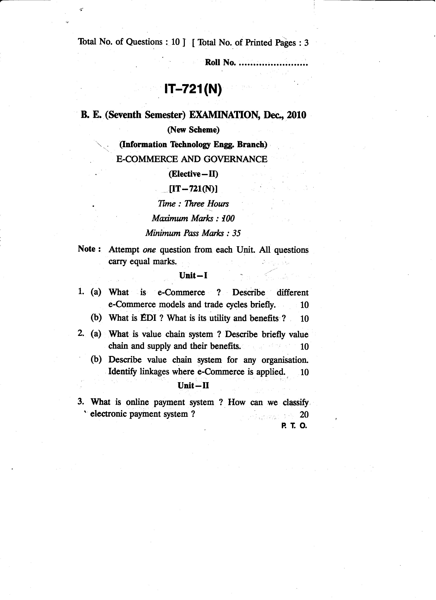
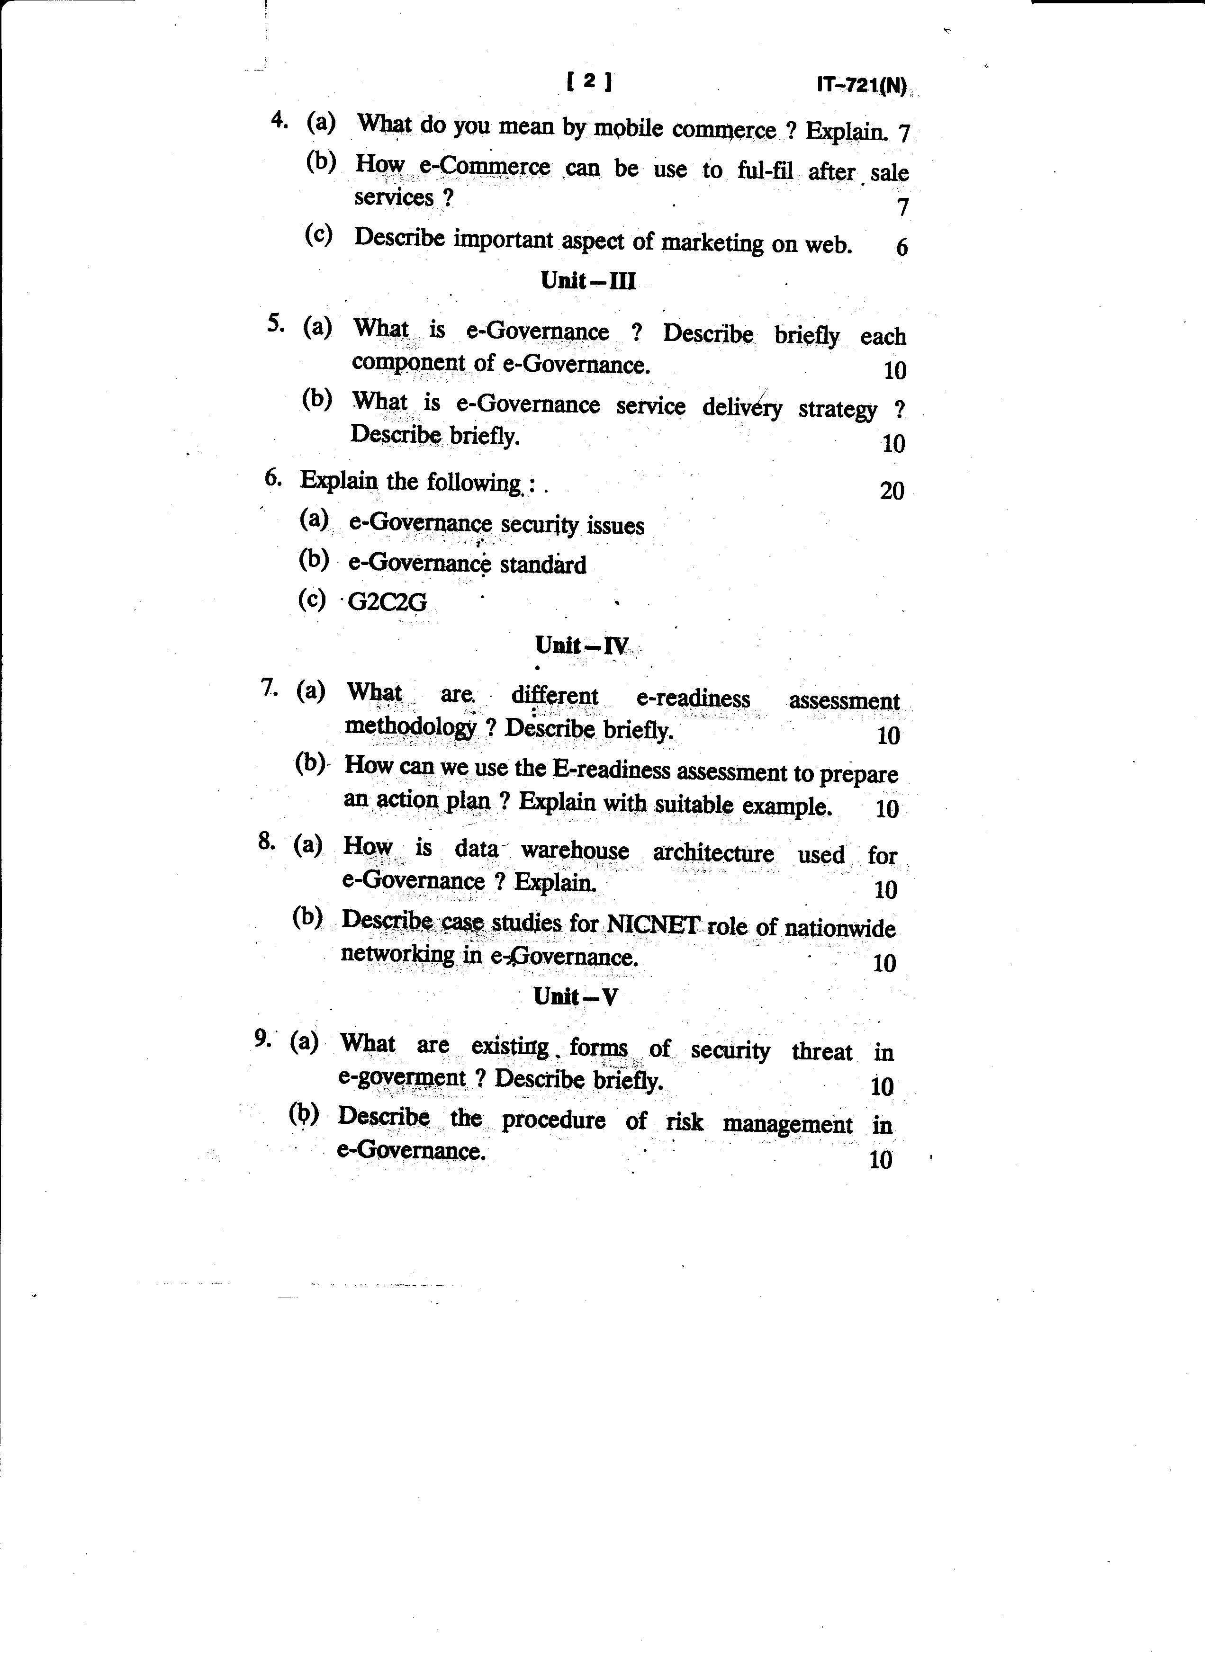

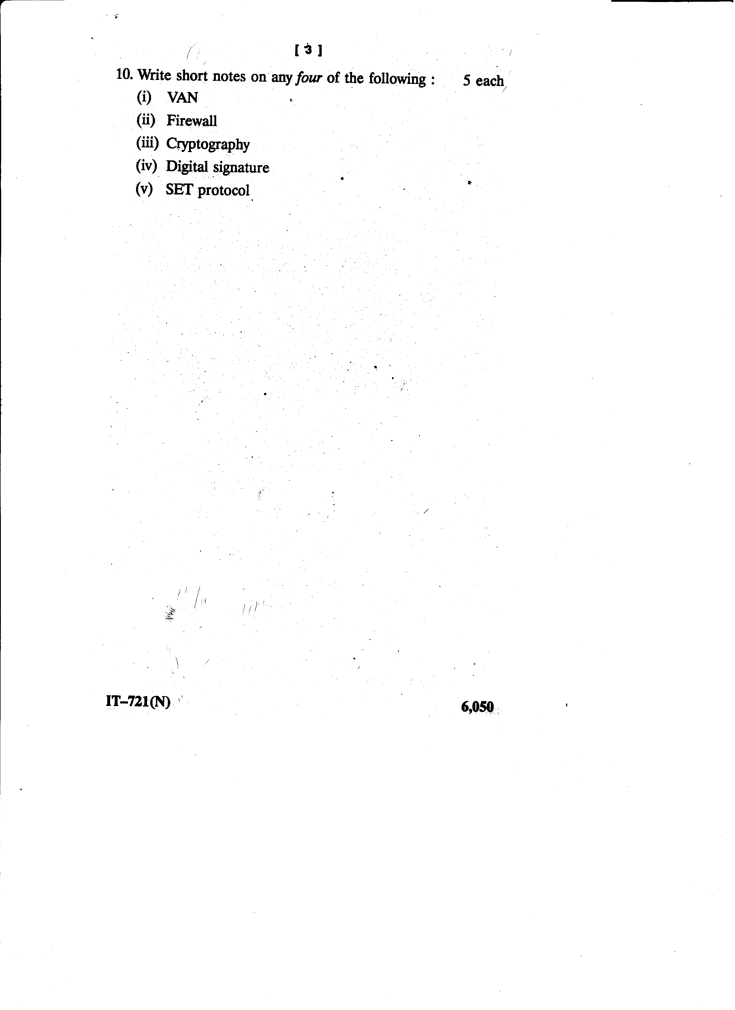
NAME COLLEGE OF TECHNOLOGY,BHOPAL
DEPARTMENT OF INFORMATION TECHNOLOGY
Session: July-December, 2014

TUTORIAL-I

Branch/Semester : IT/VII
Subject : E COMMERCE AND GOVERNANCE
Subject Code : IT 721

1. Explain E-Commerce and Classification of E-commerce models?

2. Explain Ethical Issue, Value Chain Model Supply and EDI ?

3. What is Payment System and explain Credit Card and Debit Card?

4. Explain Advertising on the web?

5. Explain any five model of Digital E-Governance?

6. Which are areas in E-Governance in which security concerns is used?

NAME COLLEGE OF TECHNOLOGY,BHOPAL
DEPARTMENT OF INFORMATION TECHNOLOGY
Session: July-December, 2014

TUTORIAL-II

Branch/Semester : IT/VII
Subject : E COMMERCE AND GOVERNANCE
Subject Code : IT 721

- Explain Communication Channel Security and Security for Client Computer?

- Explain any five key factors in E-Governance Information System Security?

- What are challenges in E-Governance?

- Explain Advertising on the web?

- Explain the uses on online transactions.

- Explain the security threads.

NAME COLLEGE OF TECHNOLOGY,BHOPAL
DEPARTMENT OF INFORMATION TECHNOLOGY
Session: July-December, 2014

TUTORIAL-III

Branch/Semester : IT/VII
Subject : E COMMERCE AND GOVERNANCE
Subject Code : IT 721

- How E business is help in this era?
- What do you mean by M-commerce.
- How products and advertised are helpful in the modern market trends.
- Describe importance of marketing on web.
- What are the needs of providing after sales services in e marketing?
- Explain the process of purchasing online products.

NAME COLLEGE OF TECHNOLOGY,BHOPAL
DEPARTMENT OF INFORMATION TECHNOLOGY
Session: July-December, 2014

TUTORIAL-IV

Branch/Semester : IT/VII
Subject : E COMMERCE AND GOVERNANCE
Subject Code : IT 721

- Explain any five key factors in E-Governance Information System Security?.
- Explain Ethical Issue, Value Chain Model Supply and EDI ?.
- What is Payment System and explain Credit Card and Debit Card?
- Explain any five key factors in E-Governance Information System Security?
- Explain any five model of Digital E-Governance?
- Explain the importance of E-marketing.

NAME COLLEGE OF TECHNOLOGY,BHOPAL
DEPARTMENT OF INFORMATION TECHNOLOGY
Session: July-December, 2014

TUTORIAL-V

Branch/Semester : IT/VII
Subject : E COMMERCE AND GOVERNANCE
Subject Code : IT 721

- What is EDI? Explain its importance in detail
- Discuss Value chain system.
- What are the important aspects of marketing on web?
- What is cryptography? How it is useful in secure communication and transactions
- Write short note on digital signature. Needs of digital signature.
- What are the different risks in the E-commerce?
- What is the usage of firewall in the security of the system?

NAME COLLEGE OF TECHNOLOGY,BHOPAL
DEPARTMENT OF INFORMATION TECHNOLOGY
Session: July-December, 2014

ASSIGNMENT-I

Branch/Semester : IT/VII
Subject : E COMMERCE AND GOVERNANCE
Subject Code : IT 721

- What do you mean by Electronic commerce and its uses?
- Write the different models of ecommerce.
- Differentiate between business to customer and customer to customer model.
- Discuss the ethical issues, value chain and supply chain.
- Describe the advantages and disadvantages of E-commerce.
- Why Electronic data interchange is required.
- What are the key technologies for B2B E-commerce? Explain architectural model.
- Explain different steps for developing an E-Commerce web site.
- What is an EDI? List its benefits and limitations.
- Discuss at least two e-marketing strategies in detail.
- Write about the major methods of Internet advertisement and discuss how product comparison process can be used as an opportunity of advertisement.

NAME COLLEGE OF TECHNOLOGY,BHOPAL
DEPARTMENT OF INFORMATION TECHNOLOGY
Session: July-December, 2014

ASSIGNMENT-II

Branch/Semester : IT/VII
Subject : E COMMERCE AND GOVERNANCE
Subject Code : IT 721

- What is electronic payment system? How this system is useful in modern trends
- Differentiate between the Credit card and Debit card
- How marketing on web is easy and cheap?
- Discuss various issues in E governance
- What are the benefits and scope of e governance?
- Describe the functional requirements for online selling and what specialized services and servers perform these functions.
- Explain the role and support of E-Commerce in the following applications
(i)Real estate business
(ii)Insurance sector
(iii)Jobs and employment sites
(v)Travel
- Briefly explain the various electronic payment systems.
- What are the security requirements for using online e-cash services?

NAME COLLEGE OF TECHNOLOGY,BHOPAL
DEPARTMENT OF INFORMATION TECHNOLOGY
Session: July-December, 2014

ASSIGNMENT-III

Branch/Semester : IT/VII
Subject : E COMMERCE AND GOVERNANCE
Subject Code : IT 721

- What are the various components of electronic commerce applications?
- What is the importance of JIT delivery in B2B E-commerce?
- What are the characteristics of internet-based EDI?
- What are the classifications of E-commerce field by the nature of the transactions?
- Why do the companies usually choose to implement SAP?
- What is the need of collaborative computing?
- What are the three different types of transitions and mobility within a wireless network?
- What do you mean by Supply Chain Execution Framework?
- What are the major methods used for advertisement?
- What do you mean by Data Encryption Standard?

NAME COLLEGE OF TECHNOLOGY,BHOPAL
DEPARTMENT OF INFORMATION TECHNOLOGY
Session: July-December, 2014

ASSIGNMENT-IV

Branch/Semester : IT/VII
Subject : E COMMERCE AND GOVERNANCE
Subject Code : IT 721

- Discuss the benefits and limitations of E-Commerce
- What are Internet Security Services? Explain each one of them with an example.
- What is E-readiness?
- Write about the security service that is to be offered in E-Payment systems. Discuss any one E-Payment system in detail.
- Explain different steps for developing an E-Commerce web site.
- What is an EDI? List its benefits and limitations
- Write in short about
a) Smart cards
b) Digital or Electronic cash
c) Features of an e-payment system
- Briefly explain the various electronic payment systems.
- What are the security requirements for using online e-cash services?

NAME COLLEGE OF TECHNOLOGY,BHOPAL
DEPARTMENT OF INFORMATION TECHNOLOGY
Session: July-December, 2014

ASSIGNMENT-V

Branch/Semester : IT/VII
Subject : E COMMERCE AND GOVERNANCE
Subject Code : IT 721
- How is e-mail useful for E-Commerce? Is it secure to transact through e- mail? Explain.
- What is MIME? When is it used? Explain how security is implemented in MIME.
- Write about the internet technologies essential and relevant to E- Commerce.
- What is a web server? What is the data held in web server in the context of EC.
- Write about Internet advertisement categories in the E-commerce scenario.
- How is revenue generated through advertisements in EC.
- Write about the Search engine functions and uses.
- Discuss about Internet applications for E-Commerce.

