COLLEGE OF TECHNOLOGY, BHOPAL

DEPARTMENT OF INFORMATION TECHNOLOGY

COURSE FILE

Programme : BE
Semester : III
Course Code : IT-303
Subject Name : OOPS Methodology

Prepared By: Approved By:

Index

S.No. Contents Page No.

- Scheme
- Syllabus
- Time Table
- Lecture Plan
- List of Books/Web references
- Unit test question papers
- Mid Semester Exam Question Papers
- RGPV Question Paper
- Tutorial Questions
- Assignment Questions
- Hand-Written Notes
- Transparencies/Power Point Presentation Slides
- Mid Semester Exam Result
- Attendance Sheet

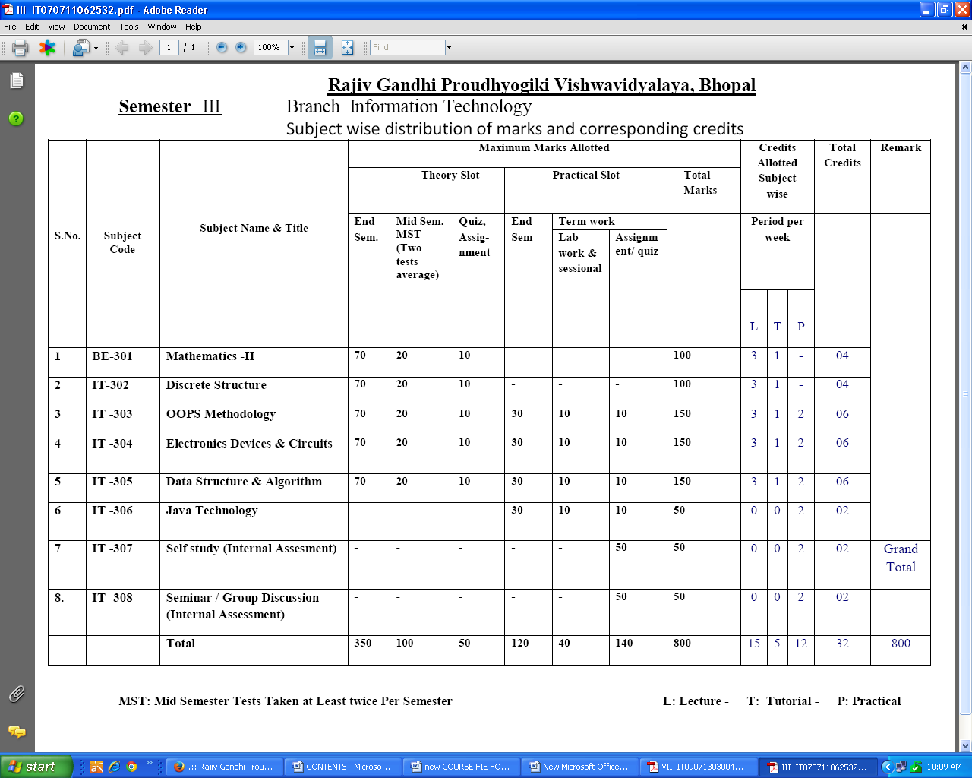

SYLLABUS

IT 303 OOPS Methodology
Unit I

Introduction, Object Oriented Programming Concepts, Flow chart, Objects, Objects as software modules, Objects interaction, Classes, Method lookup, Hierarchies of classes, Inheritance, Polymorphism, Abstract classes.

Unit II

Identifying objects and classes, Representation of objects, Modeling, objects and classes, Relationships. Association between objects, aggregate components of objects. Storage Management : Memory allocation, Dynamic allocation.

Unit III

Object oriented programming languages, Class declarations, Object declarations, Mandatory profiles, Message sending, Association, Recursive association, Many to many association, Argument passing.

Unit IV

Inherited methods, Redefined methods, protected interface, Abstract base classes, Public and protected properties, Private operations, Disinheritance, Multiple inheritance.

Unit V

Study of C++ as object oriented programming language.

References:
1. Object oriented programming in C++ by Robert Lafore.
2. J. Rumbaugh, Object-Oriented Modeling and Design using UML, Pearson Education.
3. Balagurusamy; Object oriented programming with C++; TMH
4. Rajesh K Shukla, Object Oriented Programming by C++, Wiley, India

College of Technology, Bhopal
Department of Information Technology
LESSON PLAN

Department: |  | IT |  |  |  |  | Session: |  | July-Dec 2014
Name of Faculty: |  |  |  |  |  |  | Semester: |  | III
Subject: |  | OOPS Methodology |  |  |  |  | Sub Code: |  | IT-303
Time Schedule : Total expected period – 50 Extra Periods (if required)-

Day | Mon |  | Tue | Wed | Thu | Fri |  | Sat |  | Max. Available | 6+4
No. of Period | 1 |  | 1 | 1 | 1 | 1 |  | 1 |  | Max. Available | 6+4

Lecture No. | Topics to be covered | Date of Completion | References | Remarks
 | Introduction & Basic Concept of OOP |  | R1 5,7-12
 | Features of OOPS |  | R1 25-32
 | Flowcharts, Objects as software modules |  | Notes
 | Object ,classes Access Specifier |  | Notes
 | Data member and Member function |  | Notes
 | Token & Control Statement, Data Types |  | R1 75-78  84-86
 | Hierarchies of classes, Inheritance, Polymorphism, Abstract classes. |  | R1 80-81
 | Static member data and function |  | R1 82-83
 | Introduction to constructor & Default Constructor |  | R1 97-98
 | Parameterized Constructor |  | R1 99-100
 | Copy constructor & Destructor |  | R1 106-110
 | Association and aggregatiuon |  | R1 57-58
 | Function Overloading |  | R1 88-91
 | Introduction to Polymorphism & Introduction to Overloading |  | R1 114
 | Storage management :Memory allocation |  | R1 61
 | Operator Overloading, overload unary operator |  | R1 114-116
 | Operator Overloading , overload binary operator with one operand |  | R1 71
 | Operator Overloading , overload binary operator with two operand |  | R1 120
 | Operator Overloading , overload Relational operator |  | Notes
 | Operator Overloading , overload increment or decrement operator |  | Notes
 | Operator Overloading , overload assignment operator |  | Notes
 | Introduction to Inheritance, method overriding |  | R1 135- 136
 | Single Inheritance , Inherit constructor |  | R1 137-141
 | Multiple Inheritance |  | R1 149-152
 | Multilevel Inheritance |  | R1 143-146
 | Hierarchical & Hybrid Inheritance |  | R1 152-154
 | Virtual Base Class |  | R1 156-160
 | Introduction to pointers |  | R1 172
 | Pointer Arithmetic |  | Notes
 | Pointer and classes & objects |  | Notes
 | Early Binding (Compile time polymorphism ), Late Binding(Run time polymorphism) |  | Notes
 | Virtual function |  | R1 181-185
 | Pure Virtual Function |  | R1 186
 | this pointer |  | R1 177-178
 | Dynamic memory allocation new and delete operator |  | Notes
 | Class declarations |  | R1 189-190
 | Object declarations, Mandatory profiles, |  | R1 214-222
 | Exception handling, try , catch and throw |  | R1 274
 | Template |  | R1 274  Notes
 | Introduction to Object Modeling Technique |  | R2 16
 | Object and Classes , Relationship : Link & Association, Qualification |  | R2 21-37
 | Aggregation , Inheritance : Generalization & Specilization |  | R2 38-42,57, Notes
 | Design of Association , Object Design, Class Design |  | R2 245-251
 | Recursive association |  | R1,R2
 | Many to many association, Argument passing. |  | R1
 | Redefined methods, protected interface |  | Notes
 | Private operations, Disinheritance |  | R3
 | Study of C++ as object oriented programming language like java smartalk,.net. |  | R4

Reference Books

- Balagurusawmy “Object Orienter Programming with C++”.
- Object Oriented Modeling & Design by James Rumbaugh , PHI
- Lafore R. “Object Oriented Programming in C++”, Galotia Pub.
- Lee “UML & C++ a practical guide to Object Oriented Development 2 ed, Pearson.
- Schildt “C++ the complete reference 4ed, 20

Prepared by Approved by

Reference Books

- Balagurusawmy “Object Orienter Programming with C++”.
- Object Oriented Modeling & Design by James Rumbaugh , PHI
- Lafore R. “Object Oriented Programming in C++”, Galotia Pub.
- Lee “UML & C++ a practical guide to Object Oriented Development 2 ed, Pearson.
- Schildt “C++ the complete reference 4ed, 2003.
- Hans Erit Eriksson “UML 2 toolkit” Wiley.
- B.G., Boach “Object Oriented Analysis & Design with Applications”, Addision, Wesly.
- S. Parate “C++ Programming”, BPB.
- Boggs “Mastering UML” BPB Publication

- www.codeproject.com/.../Introduction-to-Object-Oriented-Programming.
- www.aonaware.com/OOP1.htm
- www.processing.org/tutorials/objects
- www.tutorialspoint.com/cplusplus/cpp_object_oriented.htm
- www.aspdotnet-suresh.com/2010/04/introduction-to-object-oriented.html

GROUP OF INSTITUTES
Department of IT
MID SEMESTER–I
July- Dec 2013
Branch- IT Semester: III
Subject: Object OOPs Methodology Max. Marks-40
Subject Code: IT 303 Time: 2Hrs

Attempt any five questions all questions carry equal marks:

- a) What is object oriented programming? Explain it characteristics
b) What are classes ? Explain with example as to how would you be able to identify objects and classes in program
- a)What do you mean by early and late binding?
b) What is the difference between multiple and multilevel inheritance? Explain with example
- What are access modifiers in the class? Explain each with example.
- a) Discuss the advantages of scope resolution operator. Is it useful when the member data of a class whose member function is invoked in derived class is public or private ?
b) What do you mean by function overloading? Write a program using function overloading to calculate area of circle, triangle and rectangle.
- a) Discuss the role of inheritance in object oriented programming .
b) Differentiate between Association and aggregation.
- a) Explain Inline functions and the situations where inline expansion may not work and why ?
b) Define the following terms
(i) Encapsulation
(ii) Class variables and class functions
(iii) Repeated inheritance
(iv) Overloading
GROUP OF INSTITUTES
MID SEMESTER–II
NOV- 2013
Branch- Information Technology Semester: III.
Subject: Object OOPs Methodology
Subject Code: IT-303 Max.Marks: 40
Time: 2 Hrs
All Questions are compulsory:

Ques. |  | Marks
1. | - What do you mean by association? How it is difference from aggregation.  - Define redefined methods and its uses? | 8
2. | - Define Abstract base class? Give the purpose of abstract base class.  - Write an oops programming to implement multiple inheritance | 8
3. | - Discuss aggregation, generalization and association.  - Discuss how C++ supports object oriented programming? | 8
4. | Explain what do you understand by polymorphism? Illustrate a suitable C++ program for Operator overloading. | 8
5. | Write short notes on any four of the following  - Generalization  - UML diagrams  - Virtual functions  GROUP OF INSTITUTES  UNIT TEST–I  2014  Branch- Information Technology Semester: III.  Subject: Object OOPs Methodology  Subject Code: IT-303 Max.Marks: 10  All Questions are compulsory:  - What is object? How a is real world object exist.  - What the needs are of object oriented programming.  - Write the characteristics of object oriented programming languages.  - How procedure oriented programming is different from oops.  - What is the need of data hiding in programming?  GROUP OF INSTITUTES  UNIT TEST–II  2014  Branch- Information Technology Semester: III.  Subject: Object OOPs Methodology  Subject Code: IT-303 Max.Marks: 10  All Questions are compulsory:  - Explain different forms of inheritance? Give an example of multiple inheritance.  - What do you mean by access modifiers? Where does protected access find its use?  - What are pointers to class members? How do they differ from normal pointers?  - Write C++ code to overload an add function to add int, float and char.  - What are constructors .Explain dynamic constructors.  GROUP OF INSTITUTES  UNIT TEST–III  2014  Branch- Information Technology Semester: III.  Subject: Object OOPs Methodology  Subject Code: IT-303 Max.Marks: 10  All Questions are compulsory:  - Differentiate between pointer to base and derived class  - What do you mean by Polymorphism? Explain its types  - What is abstract class?  - Write C++ code to overload an == operator overloading.  - What is static member function?  GROUP OF INSTITUTES  UNIT TEST–IV  2014  Branch- Information Technology Semester: III.  Subject: Object OOPs Methodology  Subject Code: IT-303 Max.Marks: 10  All Questions are compulsory:  - Explain friend function with the help of a C++ program  - What do you mean by virtual function? Explain pure virtual function.  - What is Association?  - What is exception handling ?Write a C++ code for exceptional handling. | 8

B.E. (Third semester) EXAMINATION, Dec, 2013
(Information Technology Engg. Branch)
(OBJECT ORIENTED PROGRAMMING AND METHODOLOGY)
[IT-303(N)]

Note: Attempt any five questions. All question carry equal marks.
1. (a) What do you understand by abstraction ? Explain Entity abstraction, Action abstraction, virtual Machine abstraction .
(b) What is Containership ‘? Compare it with inheritance.

2. (a) Write code including class declaration and methods to implement the following using pointers in any object oriented language :
(i) One to one association which is traversed in both direction.
(ii) Many to many association which is traversed in both direction. The association is considered Ordered in one direction and unordered in other direction.
(b) Demonstrate the use of friend function by writing a C++ program.

3. (a) Write a program in C++ to demonstrate the use of command line arguments.
(b) Explain nesting of classes by giving suitable example.

4. (a) Explain strong and memory management in C++ ?
(b) Describe dynamic allocation in C++ .

5. (a) Explain abstract class and abstract method. Why it is needed?
(b) Explain disadvantages of multiple inheritances with example.

6. (a) What are different types of polymorphism ? Describe them.
(b) What are the benefits and risks of object oriented development?

7. (a) What is object pointer ? How to declare object pointer and access the object using it ?
(b) What are different types of aggregation? Define them with examples.
8. Write short notes on any four of the following:
(a) Method lookup
(b) Virtual function
(c) Inline function
(d) I/O stream
(e) object identity

COLLEGE OF TECHNOLOGY,BHOPAL
DEPARTMENT OFINFORMATION TECHNOLOGY
Session: July-December, 2014

TUTORIAL-I

Branch/Semester : IT/III
Subject :OOPs Methodology Subject Code : IT303
Topic to be covered: UNIT -I

- What the benefits are of object oriented programming? Discuss the 'problems associated with Object orientation.
- Explain the purpose of using constructors and destructors in a program. Write a program using a class stack to demonstrate the working of stack data structure. Use constructor and destructor functions.
- How and why objects are passed by reference to a function? Write a short program to illustrate the aspect of. Passing object by reference.
- What is the default mechanism of arguments? How it permits you to achieve function overloading?
- Define various data type conversions available in C++ and the method of accomplishing each conversion
- What are the different forms of Looping and condition statements? Give examples of each.
- Write the merits and demerits of object oriented programming languages.
- Discuss about various data types and operators available in C++.
- What are inline functions? What is the restriction in this function?
- What are static variables? Give a small example illustrating use of static variable.

COLLEGE OF TECHNOLOGY,BHOPAL
DEPARTMENT OFINFORMATION TECHNOLOGY
Session: July-December, 2014

TUTORIAL-II

Branch/Semester : IT/III
Subject :OOPs Methodology Subject Code : IT303
Topic to be covered : UNIT –II

- What are the different steps involved in object oriented analysis? Explain.
- Define a class distance containing data members meter, centimeter and millimeter.
Using new operator, dynamically store four objects of class distance. Now create a
function add-distance( ) to add these 4 objects, also print added value
- Describe the following terms with one example each in the context of C++ :
I) This pointer
- Type casting between two user defined classes
- Multiple Inheritance

- Define data member and member function?Write a function using reference variables as arguments to swap the values of a pair of integers.
- Define inheritance, multiple inheritance and virtual base class.
- Explain with suitable example the use of protected access specifier in inheritance.
- What do you mean by constructors and Destructors?
- Explain different types of constructors Dynamic, Copy etc constructor.
- What is the use of pointers in the programming?
- How we represent pointer and add values in pointers. Explain with the example.

COLLEGE OF TECHNOLOGY,BHOPAL
DEPARTMENT OFINFORMATION TECHNOLOGY
Session: July-December, 2014

TUTORIAL-III

Branch/Semester : IT/III
Subject :OOPs Methodology Subject Code : IT303
Topic to be covered : UNIT –III

- What is Inheritance. Explain different types of inheritance.
- What is the use of Polymorphism in Oops.
- What is function overloading? Why is it needed? Write a program to overload function which returns bigger of two entities and overload it so that it can be used for float, integer and character data types.
- Why do you need operator overloading? Write a program to create a class containing as private data float meter, centimeter, millimeter. Overload + operator so that you can add two objects of this class. Print the added value.
- Write a C++ program which overloads > operator the statement d₁ > d₂ can be used to give bigger of two objects belonging to this class.
- Using friend function overload unary operator, relative to class distance with data members meter, centimeter and millimeter. 10
- What do you understand by operator overloading? Write a program to overload the operator [ ] ( ), function in such a way that [ ] can be used in both sides of an assignment statement.
- Write a function Locate ( S, Pattern) which returns – 1 if the string pattern does not exist in S, otherwise returns location at which it is found. Write main ( ) program also.
- Illustrate the use of this pointer in a small programming example.

COLLEGE OF TECHNOLOGY,BHOPAL
DEPARTMENT OFINFORMATION TECHNOLOGY
Session: July-December, 2014

TUTORIAL-IV

Branch/Semester : IT/III
Subject :OOPs Methodology Subject Code : IT303
Topic to be covered : UNIT –IV

- Why do we need virtual functions? When do we make a virtual function pure?
- Write a program that creates a class student containing roll number, students name and his semester as private data of the class. Create two public functions get-data () and show () to store and show values of an object. Accept values of three object and display them in three lines.
- What are abstract classes? Write a program having student as an abstract class and create the derived classes Engineering and Medical from the student class. Create their objects and process them.
- Can you restrict the types of exceptions thrown by a function? Give the syntax when a function xyz (int n, int m, float a) is restricted to throw only integer and character exceptions.
- What is function overloading? Why is it needed? Write a program to overload function which returns bigger of two entities and overload it so that it can be used for float, integer and character data types.
- What do you mean by Association and generalization.
- What do you mean by recursive association and many to many association.
- What is Implicit Type Conversion?

COLLEGE OF TECHNOLOGY,BHOPAL
DEPARTMENT OFINFORMATION TECHNOLOGY
Session: July-December, 2014

TUTORIAL-V

Branch/Semester : IT/III
Subject :OOPs Methodology Subject Code : IT303
Topic to be covered : UNIT –V

- What is method overriding? Why we sue method overriding. Difference between overloading and overriding?
- How can we call the base method without creating an instance?
- What is dynamic or run time polymorphism?
- Which OOPS concept is used as reuse mechanism?
- What is Dynamic memory allocation? How memory management is performed dynamically in C++/
- List the different types of parameter passing techniques.
- What is the default access modifier in a class?

COLLEGE OF TECHNOLOGY,BHOPAL
DEPARTMENT OFINFORMATION TECHNOLOGY
Session: July-December, 2014

ASSIGNMENT-I

Branch/Semester : IT/III
Subject :OOPs Methodology Subject Code : IT303
Topic to be covered: UNIT –I

- C++ Program to find Even and Odd number.
- Write a C++ Program to find prime number .
- Program Take Hours, Minutes, Seconds And Print It In 24 Hours & 12 Hours Format.
- Program to find greatest number between 3 number using nested if andusing logical operators.
- Write a C++ program to find factorial of number.
- Write a C++ Program to convert decimal number to binary number.

COLLEGE OF TECHNOLOGY,BHOPAL
DEPARTMENT OFINFORMATION TECHNOLOGY
Session: July-December, 2014

ASSIGNMENT -II

Branch/Semester : IT/III
Subject :OOPs Methodology Subject Code : IT303
Topic to be covered: UNIT –II

- WAP to find the roots of a quadratic equation using Class.
- Write a menu driven program to calculate the total surface area and volume of a cube, cuboid, or sphere depending upon user’s choice. The program should continue until the user selects the option to exit the program.
- WAP to input a string and then display this string in reverse order.
- WAP to illustrate the use of multiple inheritances.
- Write a C++ program for applying function overloading for calculating area of circle, rectangle and cone.
- Explain encapsulation and importance of encapsulation on oops.

COLLEGE OF TECHNOLOGY,BHOPAL
DEPARTMENT OFINFORMATION TECHNOLOGY
Session: July-December, 2014

ASSIGNMENT -III

Branch/Semester : IT/III
Subject :OOPs Methodology Subject Code : IT303
Topic to be covered: UNIT –III

- Write a C++ to explain + operator overloading to add feet and inches respectively
- Write a program to illustrate , how to apply [ ] bracket overloading as operator overloading.
- Linear search in C++ programming code Example.
- Recursive function in C++ linear search
- Program to sort an list using Bubble sort method

COLLEGE OF TECHNOLOGY,BHOPAL
DEPARTMENT OFINFORMATION TECHNOLOGY
Session: July-December, 2014

ASSIGNMENT -IV

Branch/Semester : IT/III
Subject :OOPs Methodology Subject Code : IT303
Topic to be covered: UNIT –IV
- How the use of pointers are applied in C++.Explain with a program.
- Write a program showing Hybrid inheritance.
- Differentiate between multiple inheritance and multi level inheritance
- Show multiple inheritances can be applied. Explain with and example.
- What do you mean by Association?

COLLEGE OF TECHNOLOGY,BHOPAL
DEPARTMENT OFINFORMATION TECHNOLOGY
Session: July-December, 2014

ASSIGNMENT -V

Branch/Semester : IT/III
Subject :OOPs Methodology Subject Code : IT303
Topic to be covered: UNIT –V

- Explain the use of Virtual Function. What sre pure virtual functions
- Write a C++ program showing the use of Virtual function and polymorphism.
- Write a program to find the complex numbers using unary operator overloading
- How java is different with C++.
- Explain the features of java and other oops languages.

