Session: Jan- July 2014

DEPARTMENT OF COMPUTER SCIENCE & ENGINEERING

COURSE FILE

Program : B.E.

Semester : VI

Course Code : CS-603

Subject Name : Software Engineering And Project Manag.

Prepared By: Approved By:

List of Books

1. Pankaj Jalote,”An Integrated Approach to Software Engineering”, Narosa Pub, 2005
2. Rajib Mall, “Fundamentals of Software Engineering” Second Edition, PHI Learning
3. R S. Pressman,”Software Engineering: A Practitioner's Approach”, Sixth edition
2006, McGraw-Hill.
4. Sommerville,”Software Enginerring”,Pearson Education.
5. Richard H.Thayer,”Software Enginerring & Project Managements”,Willey India
6. Waman S.Jawadekar,”Software Enginerring”, TMH
7. Schwalbe,”IT Project Managements”,Cengage Learning.
Department Computer Science &Engg. Session : 2015
Faculty Semester VI
Subject Software Engineering Sub. Code CS-603
(B) TIME SCHEDULE: Total expected periods: 45, Extra periods If required.
Day Mon Tue Wed Thu Fri Sat Max. available
No. of
Period
Lect. No. Topics to be covered Date of completion Remarks

1. Unit 1:The Software Product and Software Process Software Engineering - A layered Technology P53,S26
2. Software Process Models: Linear Sequential Model P79
3. Prototyping Model, Evolutionary Model P83
4. RAD Model P81,S427
5. Software Process Models: Incremental Model P80,S93
6. Spiral Model P86,S95
7. Component Assembly Model, Formal Methods, Fourth Generation Techniques.
P91,92, S92
UNIT TEST 1
8. Unit 2: Requirement Elicitation, Analysis, and Specification. . Functional and Non-functional requirements,
P157
9. Requirement Sources and Elicitation Techniques, Analysis, System and Software Requirement Specifications,
Requirement Validation, Traceability S321,392
10. Modeling for Function-oriented and Object-oriented software
development, Use case Modeling P161
11. Unit 3`: Software Design The Software Design Process, Design Concepts and Principles P268,S89
12. Software Modeling and
UML, P211, S199
13. Architectural Design, Architectural Views and Styles,. P249, S195
14. User Interface Design S33
15. Function-oriented Design S221
16. Unit 4: Software Analysis and Testing
Software Static and Dynamic analysis P265
17. Code inspections, Software Testing Fundamentals P265
18. Software Test Process, Testing Levels, Test Criteria P275, S263
19. Test Case Design, Test Oracles, Test Techniques S384
20. White-Box Unit Testing Unit
S385
21. Unit Testing Frameworks P421, S89-102
22. Black-Box Testing. P423, P434
23. White-Box Testing. P424
24. Software Testing Strategies P390-391
25. Test Metrics P388, S102,
26. Testing Tools. , Introduction to Object-oriented
analysis P393, P394
27. Integration Testing P397
28. Validation Testing P406
29. System Testing
P408
30. Design and comparison with structured software engg. P426
31. Unit 5: Software Maintenance & Software Project Measurement P466
32. Need and Types of Maintenance P650
33. Software Configuration Management (SCM P654
34. Software Change Management P661
35. Version Control, Change control and Reporting P629, S115
36. Program Comprehension Techniques, Re-engineering S118
37. Reverse Engineering, Tool Support.
Project Management Concepts P675
38. Feasilibility Analysis, Project and Process Planning P639, S221,223
39. Resources Allocations, Software efforts, Schedule, and Cost estimations P691
40. Project Scheduling and Tracking P670
41. Risk Assessment and Mitigation P666
42. Software Quality Assurance (SQA) S119
43. Project Management Concepts P626
44. Project Plan, Project Metrics. P778

Reference Books:

1) Software Engineering: A Practitioner’s approach(6th edition) by Rogers
S.Pressman publication : Mc Graw.Hill International Edition

2) Software Engineering (7th edition) by Somourville
Publication: Pearson Education Legends
P: Roger S. Pressman
S: Somourville

Department of Computer Science & Engineering

Tutorial-1

Subject: SEPM
Subject Code: CS-603

- Define Software Engineering.

- What is a Process Framework?

- What are the Generic Framework Activities?

- Define Stakeholder.

- How the Process Model differ from one another?

- Explain waterfall model? Write out the reasons for the Failure of Water Fall Model?

- Explain RAD model? What are the Drawbacks of RAD Model?

- Why Formal Methods are not widely used?

- What is Cross Cutting Concerns?

- What are the different Phases of Unified Process?

Department of Computer Science & Engineering

Tutorial –2

Subject: SEPM
Subject Code: CS-603

- What are the Classifications of System Engineering?

- What are the Factors to be considered in the System Model Construction?

- What does a System Engineering Model accomplish?

- Explain SDLC

- What is Structured Analysis? Explain all the tools of structured Analysis?

- What are the Objectives of Requirement Analysis ?

- Explain design Process & also its various methods?

- Define System Context Diagram [SCD]?

- Define System Flow Diagram [SFD]?

- Explain the role of system analyst and explain its interpersonal and
Technical skills.

Department of Computer Science & Engineering

Tutorial –3

Subject: SEPM
Subject Code: CS-603

- How the Architecture Design can be represented?

- What is the Advantage of Information Hiding?

- What types of Classes does the designer create?

- What is Coupling and Cohesion?

- Define Refactoring.

- What are the Five Types of Design classes?

- What are the Different types of Design Model? Explain.

- List out the Different elements of Design Model?

- What are the Types of Interface Design Elements?

Department of Computer Science & Engineering

Tutorial –4

Subject : SEPM
Subject Code : CS-603

- What are the Basic Principles of Software Testing?

- List out the Characteristics of Testability of Software?

- List out various Methods for finding Cyclomatic Complexity ?

- Define Smoke Testing ?

- What are the Attributes of Good Test?

- Define White Box Testing.

- Define Basic Path Testing.

- Define the terms :
a) Graph Matrices
b) Connection Matrices

- What is Behavioral Testing?

- What are the Benefits of conducting Smoke Testing?

Department of Computer Science & Engineering

Tutorial –5

Subject: SEPM
Subject Code: CS-603

- How do we define Software Quality?

- Define Software Reliability?

- What is the difference between SRS document and design document? What are the contents we should contain in the SRS document and design document.
- Explain all the phases involved in the implementation phase.

- List and explain different types of testing done during the testing phase?

- What is change management?

- What is user acceptance testing? Explain different testings in user acceptance testing. Why is it necessary?

- What are functional and non-functional requirements?

- Explain the steps involved in the prototyping.

- What is a class and object? Give the diagrams and representation of class and object?

- What is generalization? Give an example of generalization

Department of Computer Science & Engineering

Assignment-1

Subject : SEPM
Subject Code : CS-603

- Define the terms :
  - Agility
  - Agile Team

- Define the terms:
  - Agile Methods
  - Agile Process

- What is the Use of Process Technology Tools?

- Explain Data Flow diagram (DFD) with an Example?

- What is the Objective of the Project Planning Process?

- What are the Decomposition Techniques?

- How do we compute the “Expected Value” for Software Size?

- What is an Object Point?

- What is the difference between the “Known Risks” and Predictable Risks”?

- List out the basic principles of software project scheduling ?

Department of Computer Science & Engineering

Assignment-2

Subject : SEPM
Subject Code : CS-603

- What are the Requirements Engineering Process Functions?

- What are the Benefits of Analysis Pattern?

- What is System Modeling?

- List out the Factors of Data Modeling?

- Define Swim Lane Diagram?

- What are the Selection Characteristic for Classes?

- Define Steps in Behavioral Model.

- What do you mean by reliability of software product? Why it is said that measurement of software reliability is difficult?

- What is meant by Software Configuration Management (SCM)? What are the various Software Configuration Management functions? Name important tasks in SCM. Name the typical configuration items.

- What is software crisis? What are the factors which lead to software crisis?

.

Department of Computer Science & Engineering

Assignment-3

Subject : SEPM
Subject Code : CS-603

- What Types of Design Patterns are available for the software Engineer?

- What is the Objective of Architectural Design?

- What are the important roles of Conventional component within the Software Architecture?

- What are the Basic Design principles of Class-Based Components?

- What should we consider when we name components?

- What are the Different Types of Cohesion and Coupling

- What do you understand by CMM? Explain all the levels of CMM ?

- Which process model will be used to develop the following system? Justify your answer?
Airline Reservation System, which is intended to replace an existing system.
Railways Interactive System, which allows railway passengers to find train times from terminals installed in stations.
Discuss the different categories of software development projects according to the COCOMO estimation model?

Department of Computer Science & Engineering

Assignment-4

Subject : SEPM
Subject Code : CS-603

- What errors are commonly found during Unit Testing?

- What problems may be encountered when Top-Down Integration is chosen?

- What are the Steps in Bottom-Up Integration?

- What is Regression Testing?

- What are the Characteristics of “Critical Module”?

- What are the Properties of Connection Matrices?

- What is Flow Graph Notation?

- Define Cyclomatic Complexity?

- List out the possible errors of Black Box Testing?

- Differentiate between Flow chart and Data Flow Diagram (DFD). Draw a DFD representing student registration in IETE.\

- Explain Alpha testing and Beta testing.

Department of Computer Science & Engineering

Assignment-5

Subject: SEPM
Subject Code: CS-603

- What are the Components of the Cost of Quality?

- What is Software Quality Control?

- What is Software Quality Assurance?

- What are the Objective of Formal Technical Reviews?

- What Steps are required to perform Statistical SQA?

- Define SQA Plan.

- What is Baseline criteria in SCM ?

- Define Status Reporting ?

- What is the Origin of changes that are requested for software?

- List out the Elements of SCM?

Course Material
Basic Concepts in Software Engineering

Data

Data is a collection of facts, figures and statistics related to an object. Data can be
Processed to create useful information..
Data is very useful for generating reports, graphs and statistics.
Example
Students fill an admission form when they get admission in college. The form consists of raw facts about the students. These raw facts are student's name, father name, address etc. The purpose of collecting this data is to maintain the records of the students during their study period in the college.

Information
The manipulated and processed form of data is called information. It is more meaningful than data. It is used for making decisions.
Data is used as input for processing and information output of this processing.
Example
Data collected from census is used to generate different type of information. The government can use it to determine the literacy rate in the country. Government can use the information in important decision to improve literacy rate.

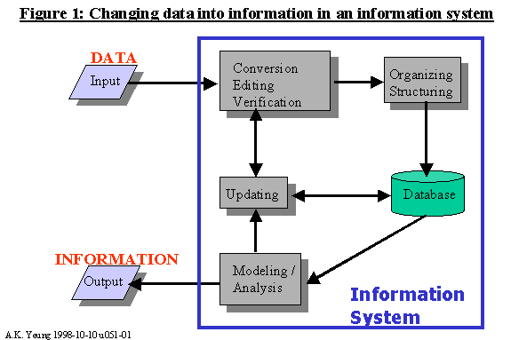

Difference between data and information
Data | Information
Data is collection of raw facts and figures. | Information is processed data.
Data is unarranged and unorganized.. | Information is arranged and organized
Data is un-meaningful | Information is meaningful.
Data is input. | Information is output.
Data is used less frequently. | Information is used frequently.
Data represents facts before processing | Information represents results ( after processing).
Data is not helpful in decision-making. | Information is helpful in decision-making.
Data is raw material for information. | Information is the final product of data.
Data are unprocessed records | Information contains processed records
Data is in large amounts | Information is in small amounts
If data is lost, it is very difficult (or even impossible in some situations) to re collect. | If information is lost, it is easily derived from stored data, again.
Data depends upon the sources | Information depends upon data

What is software?

Software is defined as computer programs, procedures, rules and possibly associated documentation and data pertaining to the operation of a computer based systems..
- “Computer Software” is synonymous with “software product”.
- It includes the source code and all the associated documents and documentation that constitute a software product. Requirements documents, design specifications, source code, test plans, quality assurance procedures, maintenance procedures, installation instructions and training aids are all components of software product.

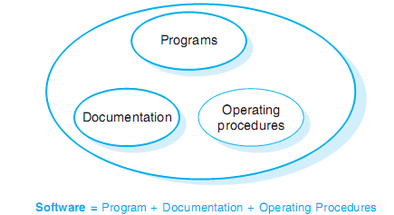

Software is a general term for the various kinds of programs used to operate
computers and related devices.
Hard ware:
The term hardware describes the physical aspects of computers and related devices.
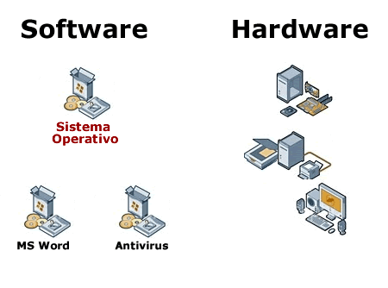
Software costs
Software costs often dominate computer system costs. The costs of software on a PC are often greater than the hardware cost.
Software costs more to maintain than it does to develop. For systems with a long life,maintenance costs may be several times development costs.
Software engineering is concerned with cost-effective software development.
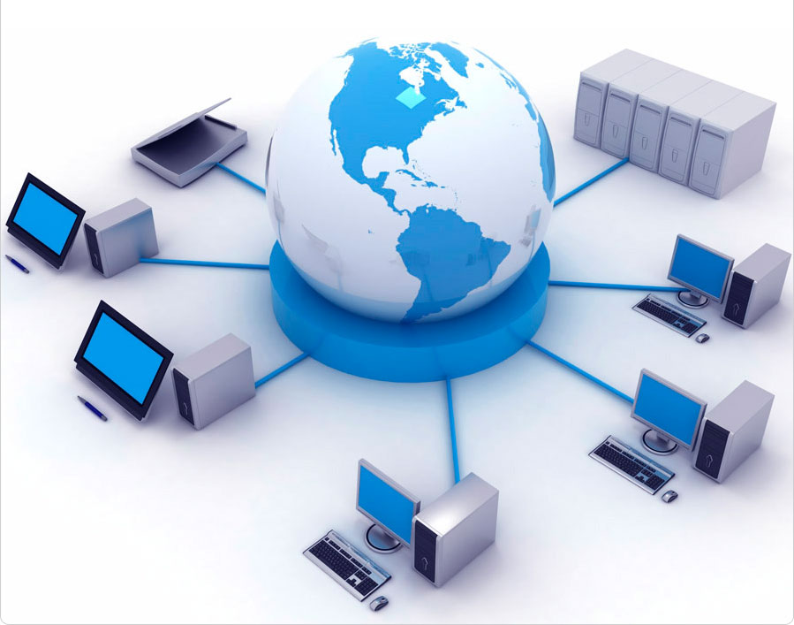
What is software engineering?

IEEE software engineering definition:
Software engineering is the application of a systematic disciplined quantifiable approach to the development, operation and maintenance of software; the application of engineering to software.
Software engineering can be defined as “The establishment and use of sound engineering principles in order to obtain economically software that is reliable and woks efficiently on real time machines.”
Software engineering is the technological and managerial discipline concerned with systematic production and modified on time and in cost estimates

- Software Engineering deals with the engineering problems, opportunities and needs associated with the development and utilization of computer software.
- The discipline also addresses the design of computers, computer science and the integration of software into computer systems, as well as the applications of software systems.
- The software industry is growing rapidly and of increasing importance to our economy and standard of living.
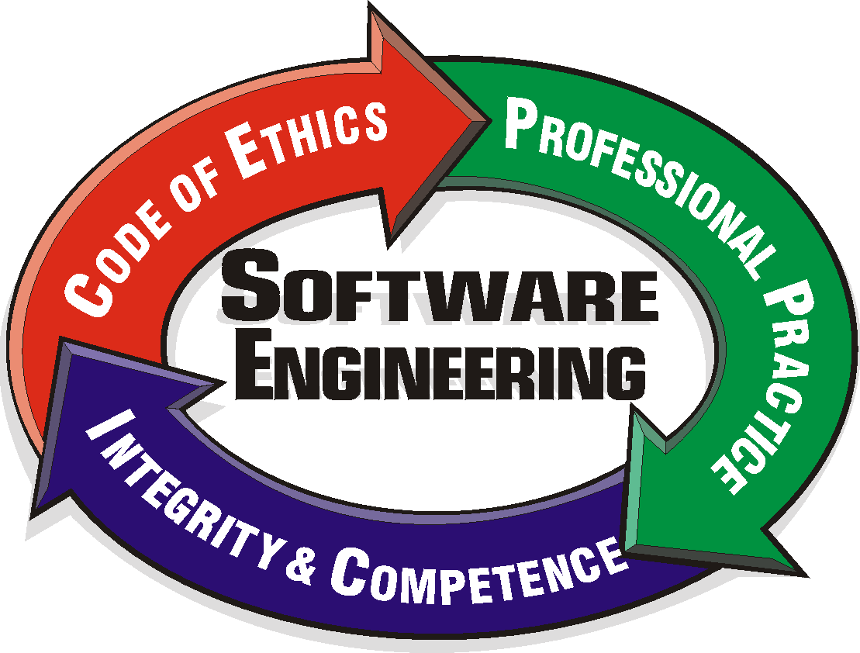
Software engineering
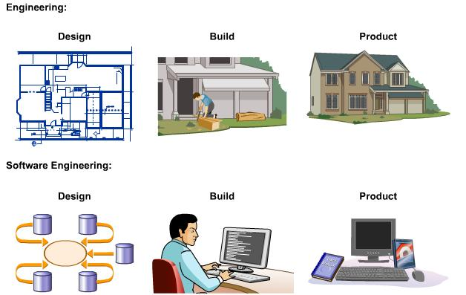

Software engineering is finding its way into many industries, including telecommunications, power generation, biomedical and industrial product companies.
- The software engineering sector is continually advancing.
.
- The primary goals of software engineering are to improve the quality of software products and to increase the productivity and job satisfaction of software engineers, with cost effectively.
- Software engineers should
- adopt a systematic and organised approach to their work
- use appropriate tools and techniques depending on
- the problem to be solved,
- the development constraints and
- the resources available
Software engineering is about solving problems. It can be broken into analyzing (problem) and synthesis (solution)
Software Engineering - A Layered Technology

Software engineering encompasses a process, the management of activities, technical methods, and use of tools to develop software products
a “quality” focus
process model
methods
tools

Layers of Software engineering

- The foundation for software engineering is the process layer. It is the glue that holds the technology layers together and enables rational and timely development of computer software.

- Process defines a framework that must be established for effective delivery of software engineering technology.

- The software process forms the basis for management control of software projects and establishes the context in which technical methods are applied, work products (models, documents, data, reports, etc.) are produced, milestones are established, quality is ensured, and change is properly managed.

- Software engineering methods provide the technical “how to’s” for building software. Methods encompass a broad array of tasks that include communication, req. analysis, design, coding, testing and support.

- Software engineering tools provide automated or semi-automated support for the process and the methods.
When tools are integrated so that info. Created by one tool can be used by another, a system for the support of software development called computer-aided software engineering is established

