DEPARTMENT OF COMPUTER SCIENCE & ENGINEERING

COURSE FILE

Program : B.E.

Semester : VIII

Course Code : CS-802

Subject Name : Web Engineering

Prepared By: Approved By:

 |  |  | LECTURE PLAN
Department | Computer science and engineering | Session: 2012
Name of Teacher |  | Semester: VIII
Subject | Web Engineering | Subject Code: CS-802

Day | Mon | Tues | Wed | Thurs | Fri | Sat
No of Period | 01 | 01 | 01 | 01 | 01 | 01

Lect. |  | Topics to be covered |  | Date of Completion | Remarks
 |  | An Introduction to Web Engineering, History of web Development |  |  | R1-12
 |  | Time line, Motivation, Categories of Web Applications, Characteristics of Web Applications. |  |  | R1-121
 |  | Evolution and Need for Web Engineering, Web Engineering Models, Software Engineering v/s Web Engineering
 |  | World Wide Web: Introduction to TCP/IP and WAP, DNS |  |  | R2-483
 |  | Email, TelNet, HTTP and FTP |  |  | NOTES
 |  | Introduction to Browser and search engines, Search fundamentals, Search strategies, Directories search engines and Meta search engines |  |  | NOTES
 |  | Working of the search engines , Miscellaneous Web Browser details |  |  | NOTES
 |  | Introduction to Web Servers: Features of web servers, caching, case study-IIS |  |  | NOTES
 |  | Apache, Configuring web servers |  |  | NOTES
 |  | Information Architecture: The role of the Information Architect, Collaboration and Communication |  |  | NOTES
 |  | Organizing Information, Organizational Challenges, Organizing Web sites parameters and Intranets Creating |  |  | NOTES
 |  | Cohesive Websites: Conceptual Overview Website Development |  |  | NOTES
 |  | Website Design issues, Conceptual Design, High-Level Design, Indexing the Right Stuff, Grouping Content |  |  | NOTES
 |  | Architectural Page Mockups, Design Sketches, Navigation Systems. Searching Systems Good & bad web design, |  |  | NOTES
 |  | Process of Web Publishing. Phases of Web Site development, enhancing your web-site |  |  | NOTES
 |  | submission of website to search engines Web security issues, security audit of websites |  |  | NOTES
 |  | Web effort estimation, Productivity, Measurement, Quality usability and reliability. |  |  | NOTES
 |  | Requirements Engineering for Web Applications: Introduction, Fundamentals, Requirement Source, Type, Notations Tools |  |  | NOTES
 |  | Principles Requirements Engineering Activities, Adapting RE Methods to Web Application |  |  | NOTES
 |  | Technologies for Web Applications: HTML and DHTML, HTML Basic Concepts, Static and dynamic HTML, Structure of HTML documents |  |  | NOTES
 |  | HTML Elements, Linking in HTML, Anchor Attributes, Image Maps |  |  | NOTES
 |  | Meta Information, Image Preliminaries, Layouts, Backgrounds, Colors and Text, Fonts, Tables, Frames and layers |  |  | NOTES
 |  | Audio and Video Support with HTML Database integration |  |  | NOTES
 |  | CSS, Positioning with Style sheets, Forms Control, Form |  |  | NOTES
 |  | Elements. Introduction to CGI PERL, JAVA SCRIPT, PHP |  |  | NOTES
 |  | ASP , Cookies Creating and Reading Cookies |  |  | NOTES
 |  | Technologies for Web Applications: Introduction of XML, Validation of XML documents |  |  | NOTES
 |  | DTD, Ways to use XML, XML for data files, HTML Vs XML, Embedding XML into HTML documents |  |  | NOTES
 |  | Converting XML to HTML for Display |  |  | NOTES
 |  | Displaying XML using CSS and XSL |  |  | NOTES
 |  | Rewriting HTML as XML, Relationship between HTML |  |  | NOTES
 |  | SGML and XML, web personalization |  |  | NOTES
 |  | Semantic web, Semantic Web Services, Ontology |  |  | NOTES
 |  | E- Commerce, E-commerce Business Models |  |  | NOTES
 |  | The Internet and World Wide Web: E-commerce Infrastructure |  |  | NOTES
 |  | Building an E-commerce Web Site |  |  | NOTES
 |  | Electronic Commerce Environment and Opportunities. |  |  | NOTES
 |  | Modes of Electronic Commerce, Approaches to safe Electronic Commerce |  |  | NOTES
 |  | Electronic Cash and Electronic Payment Schemes ,Online Security and Payment Systems |  |  | NOTES
 |  | E- commerce Marketing Concepts |  |  | NOTES
 |  | Advertising on the Internet: issues an Technologies, E- commerce Marketing Concepts |  |  | NOTES
 |  | Electronic Publishing issues, approaches, legalities and technologies |  |  | NOTES
 |  | Privacy and Security Topics: Introduction, Web Security |  |  | NOTES
 |  | Encryption schemes, Secure Web document, Digital Signatures and Firewalls, Cyber crime and laws, IT Act. |  |  | NOTES
 |  | An Introduction to Web Engineering, History of web Development |  |  | NOTES
 |  | Time line, Motivation, Categories of Web Applications, Characteristics of Web Applications. |  |  | NOTES
 |  | Evolution and Need for Web Engineering, Web Engineering Models, Software Engineering v/s Web Engineering |  |  | NOTES

References Books

R1. Roger S.Pressman, David Lowe, “Web Engineering”, Tata Mcgraw Hill Publication.
R2. Achyut S Godbole and Atul Kahate, “Web Technologies”, Tata McGraw Hill
R3. Gopalan N P ,Akilandeswari “Web Technology: A Developer s Perspective” PHI
R4. NEIL GRAY “Web server Programming” WIley
R5. CHRIS BATES “Web Programming: Building Internet applications” Wiley
R6. Moller, “An Introduction to XML and Web Technologies”, Pearson Education New Delhi,

List of Books

- Roger S.Pressman, David Lowe, “Web Engineering”, Tata Mcgraw Hill Publication.
- Achyut S Godbole and Atul Kahate, “Web Technologies”, Tata McGraw Hill
- Gopalan N P ,Akilandeswari “Web Technology: A Developer s Perspective” , PHI
- NEIL GRAY “Web server Programming” WIley
- CHRIS BATES “Web Programming: Building Internet applications” Wiley
- Moller, “An Introduction to XML and Web Technologies”, Pearson Education New Delhi,
- Hnter, Refter, Fawset ,“Beginning XML” 4th Edition, Wiley India
- “Internet & World Wide Web How to Program”, Pearson education, 3rd edition, by: H.M. Deitel, P.J. Deitel, A.B. Goldberg.
- C. Xavier, “Web Technology & Design ”, Tata McGraw Hill.
- Ivan Bay Ross, “HTML,DHTML,Java script,Perl CGI” , BPB

Department of Computer Science & Engineering

Tutorial-1

Subject: WE
Subject Code: CS-802

Q1. : Define Web Engineering. Draw a diagram to categorize web applications.
Q2: What are the characteristics of Web Applications?
Q3: Differential Software Engineering with Web Engineering?
Q4: Write the steps to show how search engine works.
Q5: What are main organizational challenges to develop a website?
Q6: Explain the steps to develop design of a web site. What are the main characteristics of a good web design?
Q7. Differential Software Engineering with Web Engineering ?
Q8. Write the steps to show how search engine works.
Q9. What are main organizational challenges to develop a web site?
Q10. Explain the steps to develop design of a web site. What are the main
Characteristics of a good web design?

Department of Computer Science & Engineering

Tutorial –2

Subject:WE
Subject Code: CS-802

- Write the role of the Information Architect.
- Explain the role of web crawlers in searching. Also, give an example of web crawling processing for a website.
- Differentiate Conceptual Design, High-Level Design.
- How SEO works can be done? What are web security issues? Explain in brief.
- Write short notes on CGI and Perl. Why they are popular?
- What are advantages and disadvantages of using Java Script?
- Explain all the usages of Cookies. Also describe its drawbacks.
- How XML is different from HTML? Are they complementing to each other?
- Define DTD, XSL and XSLT. How CSS can be integrated.
- What is web personalization? What are various ways to personalize the page?

Department of Computer Science & Engineering

Tutorial –3

Subject: WE
Subject Code: CS-802

Q1. Write down the difference between HTML and DHTML.
Q2. Explain HTML Basic Concepts.
Q3. Explain Static and dynamic HTML with Example
Q4. Explain Structure of HTML documents, HTML Elements & Linking in HTML.
Q5. Show the use of different tags of HTML like Anchor Attributes, Image Maps, and Meta Information.
Q6.Write a HTML coding and show the Image Preliminaries, Layouts, Backgrounds, Colors and Text, Fonts, Tables, Frames and layers.
Q7. Develop a home page of an organization of your choice using HTML, CSS and Java Script. It must have navigational menus etc.
Q8. Design a table using XML and XSL etc.
Q9. Explain structure of xml in ORM tool like hibernate
Q10. Develop a login application using Ajax and Java script to drop down values in Text Box when user clicks on user name.

Department of Computer Science & Engineering

Tutorial –4

Subject: WE
Subject Code: CS-802

Q-1: Give the list with definition of HTML components. How CSS can be used to change the view.

Q-2: Write short notes on CGI and Perl. Why they are popular?

Q-3: What are advantages and disadvantages of using Java Script?

Q-4: Explain all the usages of Cookies. Also describe its drawbacks.

Q-5: How XML is different from HTML? Are they complementing to each other?

Q-6: Define DTD, XSL and XSLT. How CSS can be integrated.

Q-7: What is web personalization? What are various ways to personalize the page?

Q-8: Define the term semantic web and Ontology.

Q-9: Write the steps to implement Web Services in any language.

Q-10: Define the term semantic web and Ontology

Department of Computer Science & Engineering

Tutorial –5

Subject: WE
Subject Code: CS-802

Q-1: What is e-Commerce? Draw a rough sketch of E-Commerce infrastructure?

Q-2: What are various models of E-Commerce?

Q-3: What are various online payment methods? Explain their security issues.

Q-4: How internet advertisement is published on various webs? What are its business aspects?

Q-5: Write brief notes on Digital Signature.

Q6: What are Electronic Cash and Electronic Payment Schemes

Q7: Explain Online Security and Payment Systems.

Q8: Explain the E- commerce Marketing Concepts.

Q9: what is Web Security?

Department of Computer Science & Engineering

Assignment-1

Subject: WE
Subject Code: CS-802

Q.1 what is web engineering? Explain the principles used in web engineering

Q.2 Explain the concepts of web application.

Q.3 Explain different categories of web applications

Q.4 Differentiate between web engineering and software engineering

Q.5 what is WAP?

Q.6 Explain the concepts of DNS.

Q.7 Write short note on email.

Q.8 Differentiate between HTTP and FTP

Q.9 Explain various notations used in requirement engineering

Q.10 Explain the characteristics of web applications.

Department of Computer Science & Engineering

Assignment-2

Subject: WE
Subject Code : CS-802

Q-1. Define the term requirements. Explain various types of requirement

Q-2 Explain the use of tools in requirement engineering process.

Q-3. Explain organizational scheme.

Q-4. what is the guideline for creating the cohesive organization system?

Q-5. Explain different type of searching methods used by the user

Q-6. What are the features of good and bad desigb?

Q-7. Enlist web security issues.

Q-8. What are the features of browser navigation?

Q-9. What is the role of information architect?

Department of Computer Science & Engineering

Assignment-3

Subject: WE
Subject Code: CS-802

Q-1. What are the uses of the link?

Q-2. Explain with suitable example how to display hyperlink on the web browser.

Q-3. Explain the BOX MODEL.

Q-4. Explain the concept of pseudo classes.

Q-5. Explain the concept of constructor.

Q-6. Explain the use arrays in java script with an example.

Q-7. What is the difference between JAVA and JAVA SCRIPT?

Q-8. What is function? Explain how an array can be passed function.

Q-9. What are the uses of Pearl?

Q-10. Explain working of ASP.

Department of Computer Science & Engineering

Assignment-4

Subject: WE
Subject Code: CS-802

Q-1. Explain the elements and attributes in XML.

Q-2. Explain the use of CSS in XML with suitable example.

Q-3. Explain the uses of XSL in XML with suitable example.

Q-4. Explain the method of converting XML to HTML.

Q-5. Explain the concept of semantic web?

Q-6. .What is DTD?

Q-7. What are the data types used in XML schema?

Department of Computer Science & Engineering

Assignment-5

Subject : WE
Subject Code : CS-802

Q-1. Explain the concept of firewall.1.

Q-2. Explain the concept of cryptography.

Q-3. Explain the different modes of E-commerce.

Q-4. Explain the concept of E-marketing.

Q-5.Explain the E-commerce infrastructure
Course Material

The OSI Model

1. General:

The International Organization for Standardization (ISO) began developing the Open Systems Interconnection (OSI) reference model in 1977. It has since become the most widely accepted model for understanding network communication; once you understand how the OSI model works, you can use it to compare network implementations on different systems.
When you want to communicate with another person, you need to have two things in common: a communication language and a communication medium. Computer networks are no different; for communication to take place on a network composed of a variety of different network devices, both the language and medium must be clearly defined. The OSI model (and networking models developed by other organizations) attempts to define rules that cover both the generalities and specifics of networks:

- How network devices contact each other and, if they have different languages, how they communicate with each other
- Methods by which a device on a network knows when to transmit data and when not to
- Methods to ensure that network transmissions are received correctly and by the right recipient
- How the physical transmission media is arranged and connected
- How to ensure that network devices maintain a proper rate of data flow
- How bits are represented on the network media

The OSI model isn’t a product. It’s just a conceptual framework you can use to better understand the complex interactions taking place among the various devices on a network. It doesn’t do anything in the communication process; appropriate software and hardware do the actual work. The OSI model simply defines which tasks need to be done and which protocols will handle those tasks at each of the seven layers of the model. The seven layers are as follows:

- Application (layer 7)
- Presentation (layer 6)
- Session (layer 5)
- Transport (layer 4)
- Network (layer 3)
- Data-Link (layer 2)
- Physical (layer 1)

2. Protocol Stacks

The OSI model splits communication tasks into smaller pieces called subtasks. Protocol implementations are computer processes that handle these subtasks. Specific protocols fulfill subtasks at specific layers of the OSI model. When these protocols are grouped together to complete a whole task, the assemblage of code is called a protocol stack.
The stack is just a group of protocols, arranged in layers, that implements an entire communication process. Each layer of the OSI model has a different protocol associated with it. When more than one protocol is needed to complete a communication process, the protocols are grouped together in a stack. An example of a protocol stack is TCP/IP, which is widely used by Unix and the Internet—the TCP and IP protocols are implemented at different OSI layers.
Each layer in the protocol stack receives services from the layer below it and provides services to the layer above it. It can be better explained like this: Layer N uses the services of the layer below it (layer N–1) and provides services to the layer above it (layer N+1).
For two computers to communicate, the same protocol stacks must be running on each computer. Each layer on both computers’ stacks must use compatible protocols in order for the machines to communicate with each other. The computers can have different operating systems and still be able to communicate if they are running the same protocol stacks. For example, a DOS machine running TCP/IP can communicate with a Macintosh machine running TCP/IP.
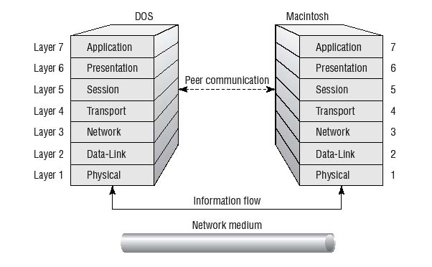
Fig.1: Each layer communicates with its counterparts on other network hosts.

4. The Physical Layer

The Physical layer is responsible for sending bits from one computer to another. Physical layer components don’t care what the bits mean; their job is to get the bits from point A to point B, using whatever kind of optical, electrical, or wireless connection that connects the points. This level defines physical and electrical details, such as what will represent a 1 or a 0, how many pins a network connector will have, how data will be synchronized, and when the network adapter may or may not transmit the data
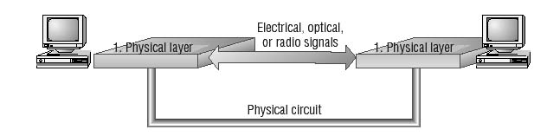
Fig.2: The Physical layer makes a physical circuit with electrical, optical, or radio signals.

The Physical layer addresses all the minutiae of the actual physical connection between the computer and the network medium, including the following:

- Network connection types, including multipoint and point-to-point connections.
- Physical topologies, or how the network is physically laid out (e.g., bus, star, or ring topologies).
- Which analog and digital signaling methods are used to encode data in the analog and digital signals.
- Bit synchronization, which deals with keeping the sender and receiver in synch as they read and write data.
- Multiplexing, or the process of combining several data channels into one.
- Termination, which prevents signals from reflecting back through the cable and causing signal and packets errors. It also indicates the last node in a network segment.

5. The Data-Link Layer

The Data-Link layer provides for the flow of data over a single physical link from one device to another. It accepts packets from the Network layer and packages the information into data units called frames; these frames are presented to the Physical layer for transmission. The Data-Link layer adds control information, such as frame type, to the data being sent.
This layer also provides for the error-free transfer of frames from one computer to another. A cyclic redundancy check (CRC) added to the data frame can detect damaged frames, and the Data-Link layer in the receiving computer can request that the CRC information be present so that it can check incoming frames for errors. The Data-Link layer can also detect when frames are lost and request that those frames be sent again.
In broadcast networks such as Ethernet, all devices on the LAN receive the data that any device transmits. (Whether a network is broadcast or point-to-point is determined by the network protocols used to transmit data over it.) The Data-Link layer on a particular device is responsible for recognizing frames addressed to that device and throwing the rest away, much as you might sort through your daily mail to separate good stuff from junk.
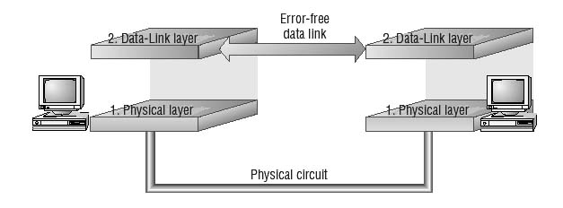
Fig.3: The Data-Link layer establishes an error-free link between two devices.

The Institute of Electrical and Electronics Engineers (IEEE) developed a protocol specification known as IEEE 802.X. (802.2 is the standard that divides this layer into two sublayers. The MAC layer varies for different network types and is described further in standards 802.3 through 802.5.) As part of that specification (which today we know as Ethernet), the Data Link layer is split into two sublayers:

- The Logical Link Control (LLC) layer establishes and maintains the logical communication links between the communicating devices.
- The Media Access Control (MAC) layer acts like an airport control tower—it controls the way multiple devices share the same media channel in the same way that a control tower regulates the flow of air traffic into and out of an airport.

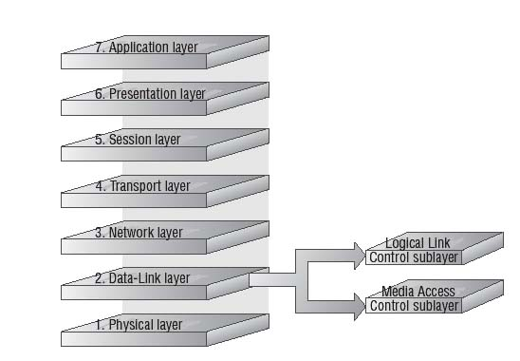
Fig.4: The IEEE split the ISO Data-Link layer into the LLC sublayer and the MAC sublayer.

The LLC sublayer provides Service Access Points (SAPs) that other computers can refer to and use to transfer information from the LLC sublayer to the upper OSI layers. This is defined in the 802.2 standard.
The MAC sublayer, the lower of the two sublayers, provides for shared access to the network adapter and communicates directly with network interface cards. Network interface cards have a unique 12-digit hexadecimal MAC address (frequently called the hardware Ethernet address) assigned before they leave the factory where they are made. The LLC sublayer uses MAC addresses to establish logical links between devices on the same LAN.

6. The Network Layer

The Network layer handles moving packets between devices that are more than one link away from each other. It makes routing decisions and forwards packets as necessary to help them travel to their intended destination. In larger networks, there may be intermediate devices and subnetworks between any two end systems. The network layer makes it possible for the Transport layer (and layers above it) to send packets without being concerned with whether the end system is on the same piece of network cable or on the other end of a large wide area network.
To do its job, the Network layer translates logical network addresses into physical machine addresses (MAC addresses, which operate at the Data-Link layer). The Network layer also determines the quality of service (such as the priority of the message) and the route a message will take if there are several ways a message can get to its destination.
The Network layer also may split large packets into smaller chunks if the packet is larger than the largest data frame the Data-Link layer will accept. The network reassembles the chunks into packets at the receiving end. Intermediate systems that perform only routing and relaying functions and do not provide an environment for executing user programs can implement just the first three OSI network layers.

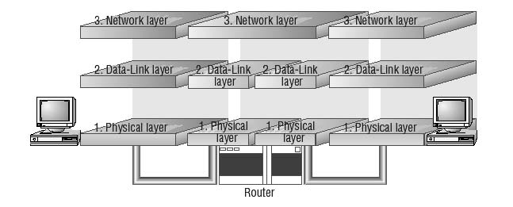
Fig.5: The Network layer moves packets across links to their destination.

The Network layer performs several important functions that enable data to arrive at its destination. The protocols at this layer may choose a specific route through an internetwork to avoid the excess traffic caused by sending data over networks and segments that don’t need access to it. The Network layer serves to support communications between logically separate networks. This layer is concerned with the following:
- Addressing, including logical network addresses and services addresses
- Circuit, message, and packet switching
- Route discovery and route selection
- Connection services, including Network layer flow control, Network layer error control, and packet sequence control
- Gateway services
In Windows Server 2000/2003, the various routing services for TCP/IP, AppleTalk, and Internetwork Packet Exchange/Sequenced Packet Exchange (IPX/SPX) perform Network layer services. In addition, the TCP/IP, AppleTalk, and IPX stacks provide routing capacity for those protocols.

7. The Transport Layer

The Transport layer ensures that data is delivered error free, in sequence, and with no losses or duplications. This layer also breaks large messages from the Session layer into smaller packets to be sent to the destination computer and reassembles packets into messages to be presented to the Network layer. The Transport layer typically sends an acknowledgment to the originator for messages received
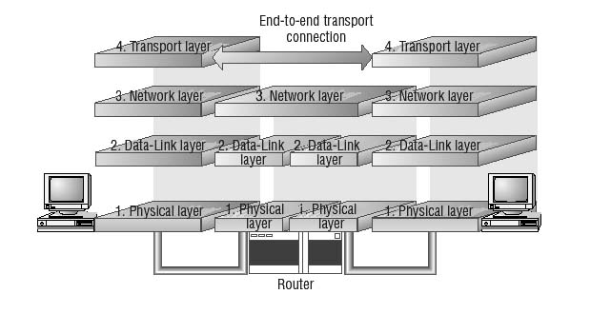
Fig.6: The Transport layer provides end-to-end communication with integrity and performance guarantees.

8. The Session Layer

The Session layer allows applications on separate computers to share a connection called a session. This layer provides services, such as name lookup and security, that allow two programs to find each other and establish the communication link. The Session layer also provides for data synchronization and checkpointing so that in the event of a network failure, only the data sent after the point of failure would need to be resent. This layer also controls the dialog between two processes and determines who can transmit and who can receive at what point during the communication
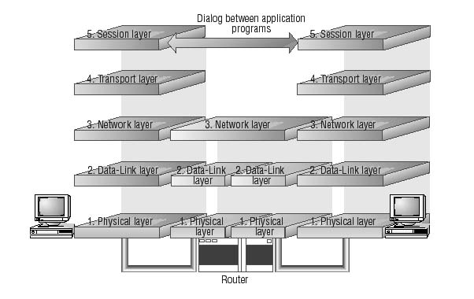
Fig.7: The Session layer allows applications to establish communication sessions with each other.

9. The Presentation Layer

The Presentation layer translates data between the formats the network requires and the formats the computer expects. The Presentation layer performs protocol conversion; data translation, compression, and encryption; character set conversion; and the interpretation of graphics commands. The network redirector, long a part of Windows networking, operates at this level. The redirector is what makes the files on a file server visible to the client computer. The network redirector also makes remote printers act as though they are attached to the local computer (see Fig.8).

10. The Application Layer

The Application layer is the topmost layer of the OSI model, and it provides services that directly support user applications, such as database access, e-mail, and file transfers. It also allows applications to communicate with applications on other computers as though they were on the same computer. When a programmer writes an application program that uses network services, this is the layer the application program will access. For example, Internet Explorer uses the Application layer to make its requests for files and web pages; the Application layer then passes those requests down the stack, with each succeeding layer doing its job (see Fig.9).

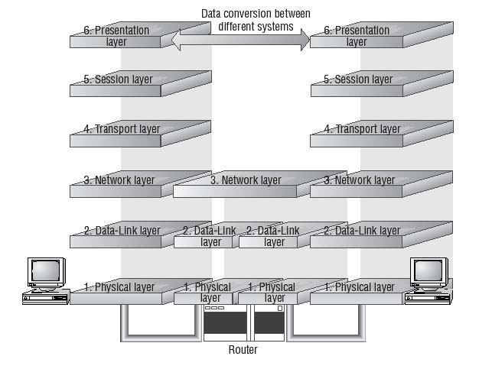
Fig.8: The Presentation layer allows applications to establish communication sessions with each other.

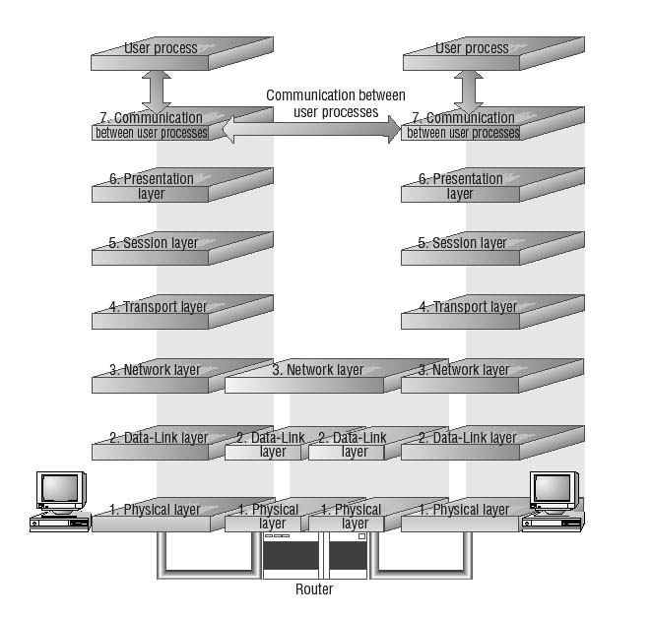
Fig.9: The Application layer is where the applications function, using lower levels to get their work done.

11. Communication between Stacks

When a message is sent from one machine to another, it travels down the layers on one machine and then up the layers on the other machine.
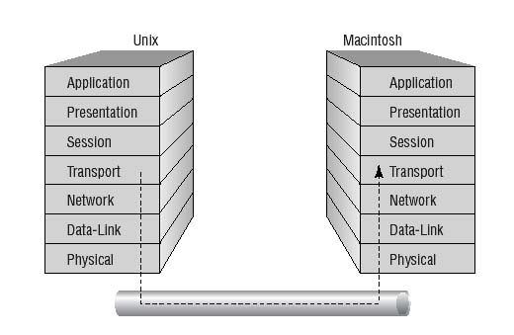
Fig.10: Traffic flows down through the stack on one computer and up the stack on the other.

As the message travels down the first stack, each layer it passes through (except the Physical layer) adds a header. These headers contain pieces of control information that are read and processed by the corresponding layer on the receiving stack. As the message travels up the stack of the other machine, each layer removes the header added by its peer layer and uses the information it finds to figure out what to do with the message contents.
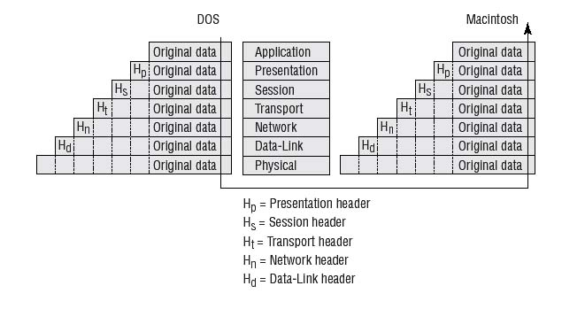
Fig.11: As packets flow up and down the stacks, each layer adds or removes necessary control information (data encapsulation).

As an example, consider the network we’re using while writing this book. It’s a TCP/IP network containing several Windows 2000, Windows Server 2003, Macintosh, and Windows NT machines, all connected using the TCP/IP protocol. When we mount a share from our Windows Server 2003 file server on the Mac desktop, at layer 7, the Mac Finder requests something from the Windows Server 2003. This request is sent to the Mac’s layer 6, which receives the request as a data packet, adds its own header, and passes the packet down to layer 5. At layer 5, the process is repeated, and it continues until the packet makes it to the Physical layer.
The physical layer is responsible for actually moving the bits across the network wiring in the office, so it carries the request packet to a place where the Windows Server 2003 machine can “hear” it. At that point, the request packet begins its journey up the layers on the Windows Server 2003 file server. The header that was put on at the Data-Link layer of the Mac OS is stripped off at the Data-Link layer on the Windows Server 2003 machine. The Windows Data-Link layer driver performs the tasks requested in the header and passes the requests to the next, higher layer. This process is repeated until the Windows Server 2003 file server receives the packet and interprets the request. The Windows Server 2003 would then formulate an appropriate response and send it to the Mac.

12. The basics of network protocols

Protocols are nothing more than an agreed-upon way in which two objects (people, computers, home appliances, etc.) can exchange information. There are protocols at various levels in the OSI model. In fact, it is the protocols at a particular level in the OSI model that provide that level’s functionality. Protocols that work together to provide a layer or layers of the OSI model are known as a protocol stack or protocol suite. The following sections explain how network protocols move data between machines.

How Protocols Work
A protocol is a set of basic steps that both computers must perform in the right order. For instance, for one computer to send a message to another computer, the first computer must perform the steps given in the following general example:
- Break the data into small sections called packets.
- Add addressing information to the packets, identifying the destination computer.
- Deliver the data to the network card for transmission over the network.

The receiving computer must perform these steps:
- Accept the data from the network adapter card.
- Remove the transmitting information that was added by the transmitting computer.
- Reassemble the packets of data into the original message.

Each computer needs to perform the same steps, in the same way and in the correct order, so that the data will arrive and be reassembled correctly. If one computer uses a protocol with different steps or even the same steps with different parameters (such as different sequencing, timing, or error correction), the two computers won’t be able to communicate with each other.

Network Packets
Networks primarily send and receive small chunks of data called packets. Network protocols construct, modify, and disassemble packets as they move data down the sending stack, across the network, and back up the OSI stack of the receiving computer. Packets have the following components:
- A source address specifying the sending computer
- A destination address specifying where the packet is being sent
- Instructions that tell the computer how to pass the data along
- Reassembly information (if the packet is part of a longer message)
- The data to be transmitted to the remote computer (often called the packet payload)
- Error-checking information to ensure that the data arrives intact

These components are assembled into slightly larger chunks; each packet contains three distinct Parts and each part contains some of the components listed
previously:
- Header A typical header includes an alert signal to indicate that the data is being transmitted,
- source and destination addresses, and clock information to synchronize the transmission.
- Data This is the actual data being sent. It can vary (depending on the network type) from 48 bytes to 4 kilobytes.
- Trailer The contents of the trailer (or even the existence of a trailer) vary among network types, but it typically includes a CRC. The CRC helps the network determine whether or not a packet has been damaged in transmission.

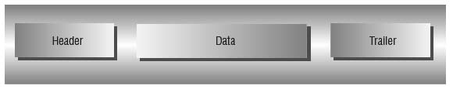
Fig.12: A packet consists of a header, the data, and a trailer.

Introduction to XML

Some of the rules for XML were listed before. This document contains more information about XML, including its tree structure, entities, attributes, CDATA sections, Unicode, and XML declarations.

An Example XML Document

The following is a very simple XML document.

<?xml version = "1.0" ?>
<address>
<name>Alice Lee</name>
<email>alee@aol.com</email>
<phone>123-45-6789</phone>
<birthday>1983-07-15</birthday>
</address>

Like in xhtml, all start tags must have matching end tags. However, while XML is case sensitive, it is not restricted to lower case. Most applications mix cases, such as in fullName or lastName. The naming requirements are similar to those in Java, but along with letters, digits, and underscores, names may include hyphens and periods. An XML document must follow these rules. If it does so, it is said to be well-formed. If it does not, it is not a true XML document.

Tree Structure

An XML document exhibits a tree structure. It has a single root node, <address> in the example above. The tree is a general ordered tree. There is a first child, a next sibling, etc. Nodes have parents and children. There are leaf nodes at the bottom of the tree. The declaration at the top is not part of the tree, but the rest of the document is.

We could expand the document above so that name and birthday have child nodes.

<?xml version = "1.0" ?>
<address>
<name>
<first>Alice</first>
<last>Lee</last>
</name>
<email>alee@aol.com</email>
<phone>123-45-6789</phone>
<birthday>
<year>1983</year>
<month>07</month>
<day>15</day>
</birthday>
</address>

Now <name> has two children and <birthday> has three. Most processing on the tree is done with a preorder traversal.

address
name
email
phone
birthday
first
last
year
month
day

Entities

As in html, certain characters are not allowed in the data. The most obvious ones are the less than signs and quotation marks. Also, ampersands are used to start the escape string, so they too have a substitution. These are escaped with the following substitutions with the greater than sign thrown in for symmetry.

< &lt;
> &gt;
& &amp;
" &quot;
' &apos;

Attributes

As in html, tags can have attributes. These are name-value pairs such as width = "300". We have seen these in applet and image tags. They can be used in XML and are required in some places.

An example from the preceding might be
<name first = "Alice" last = "Lee" />
However this is not very useful for data. It makes it harder to see the structure of the document.

There are places where attributes are necessary. One that we will be using in the future is for giving a reference to the location of a stylesheet.
<link rel="stylesheet" type="text/css" href="address.css" />

CDATA Sections

CDATA stands for character data. XML can have sections that contain characters of any kind that are not parsed. This means that they will be ignored by the XML parser that is used to put the document into a tree. These sections are similar to the pre sections in html. The browser simply displays them unchanged.

CDATA sections begin with <![CDATA[ and end with ]]>. An example might be an equation like the following:

<![CDATA[
x + 2*y = 3
]]>

Unicode

Like Java, XML uses Unicode to code for character data. There are a number of different versions of Unicode, but all have ASCII as the first 128 characters. After that they may differ. The most common version used in the west, and the XML default, is UTF-8. It is a variable length code that encodes some characters in a byte, some in two bytes and even some in four bytes.

Since many applications just use ASCII, this is the most efficient way to work with them and wastes the least space. The remaining 128 characters from code 128 to code 255 are used for some of the more common non-ascii characters used in western nations. The two-byte codes are used for some other language systems including some Asian ideographs. And finally the four-byte codes are used for more complicated ideographs.

There are a number of other flavors of Unicode. If you expect to be coding languages other than the common western ones, you should investigate all the possibilities. We will use UTF-8 for our documents.

Declarations

XML documents do not require a declaration at the top, but it is always a good idea to put one there. The simplest declaration is the one used above:
<?xml version = "1.0" ?>
To this we can add two attributes. These are encoding and standalone. The result might be
<?xml version="1.0" encoding="UTF-8" standalone ="no"?>
The meaning of encoding was given above. Standalone refers to whether or not the document has a DTD (Document Type Definition) included in-line.

There are many predefined declarations in use. The one that follows has been provided by the Apache Tomcat project to be used in configuring the web application deployment descriptor, web.xml. The encoding here is ISO-8859-1, known as Latin-1. ISO stands for International Standards Organization. The 8859 standard contains a number of encodings. Latin-1 is the only one that is the same as UTF-8 in the first 256 characters.

<?xml version="1.0" encoding="ISO-8859-1"?>

<!DOCTYPE web-app PUBLIC "-//Sun Microsystems, Inc.//DTD Web Application 2.3//EN"
"http://java.sun.com/dtd/web-app_2_3.dtd">

The DOCTYPE declaration is similar to the one used in xhtml. But this one refers to a DTD that has been created for Tomcat, version 4. It can be found as the only contents of the web.xml file, stored in the WEB-INF folder. A somewhat longer version of web.xml is included with Tomcat version 5. It uses an XML Schema. Both DTDs and Schema will be discussed later.

