DEPARTMENT

OF

ELECTRONICS & COMMUNICATION
LAB MANUAL (IT 501)
“DATA COMMUNICATION”

BACHELOR OF ENGINEERING (B.E.) COURSE
Name: ______________________________________
Semester: ___________________________________
Branch: _____________________________________
Enrollment No. _______________________________

DEPARTMENT OF ELECTRONICS
AND COMMUNICATION

LAB MONOGRAPH
DATA COMMUNICATION (IT 501)

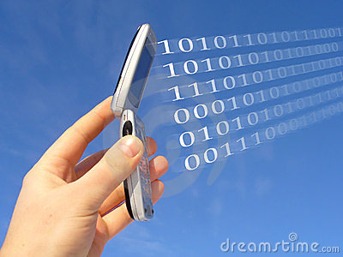

INDEX
- General Introduction

- Experiments as per RGPV Syllabus

S.NO. | EXPERIMENT | DATE | SIGN
1 | TO STUDY VARIOUS MULTIPLEXING TECHNIQUES
2 | TO STUDY OF NETWORK INTERFACE CARD (NIC)
3 | TO STUDY OF PARALLEL AND SERIAL TRANSMISSION
4 | TO STUDY OF NRZ AND RZ CODES
5 | TO STUDY OF DIFFERENT TYPES OF MODEM.
6 | TO STUDY OF INTEGRATED SERVICES DIGITAL NETWORK.
7 | TO STUDY OF TWISTED PAIR, COAXIAL CABLE AND FIBRE OPTIC CABLE.
8 | TO STUDY OF DIGITAL INTERFACE RS-232.
9 | TO STUDY DIFFERENT TOPLOGIES.
10 | TO STUDY LAN USING STAR TOPOLOGY

EXPERIMENT-- 1
AIM: TO STUDY VARIOUS MULTIPLEXING TECHNIQUES
In telecommunications and computer networks, multiplexing (also known as muxing) is a process where multiple analog dispatch signals or digital data streams are combined into onesignal over a shared medium. The aim is to share an expensive resource. For example, in telecommunications, several phone calls may be transferred using one wire. It originated in telegraphy, and is now widely applied in communications.The multiplexed signal is transmitted over a communication channel, which may be a physicaltransmission medium. The multiplexing divides the capacity of the low-level communicationchannel into several higher-level logical channels, one for each message signal or data stream tobe transferred. A reverse process, known as demultiplexing, can extract the original channels on the receiver side. A device that performs the multiplexing is called a multiplexer (MUX), and a device thatperforms the reverse process is called a demultiplexer (DEMUX). Inverse multiplexing (IMUX) has the opposite aim as multiplexing, namely to break one datastream into several streams, transfer them simultaneously over several communication channels, and recreate the original data stream.
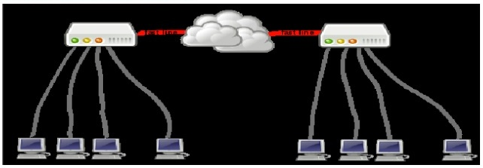

General multiplexing - demultiplexing scheme: the ν input lines-channels are multiplexed into a single fast line. The demultiplexer receives the multiplexed data stream and extracts the original channels to be transferred.
Types of multiplexing
The group of multiplexing technologies may be divided into several types, all of which have significant variations: space-division multiplexing (SDM), frequency-division multiplexing (FDM), time-division multiplexing (TDM), and code division multiplexing (CDM). Variable bit rate digital bit streams may be transferred efficiently over a fixed bandwidth channelby means of statistical multiplexing, for example packet mode communication. Packet communication is an asynchronous mode time-domain multiplexing which resembles time-division multiplexing. Digital bit streams can be transferred over an analog channel by means of code division multiplexing (CDM) techniques such as frequency-hopping spread spectrum (FHSS) and direct-sequence spread spectrum (DSSS). In wireless communications, multiplexing can also be accomplished through alternating polarization (horizontal /vertical or clockwise / counterclockwise) on each adjacent channel and satellite, or through phased multi-antenna array combined with an output communications (MIMO) scheme.
Space-division multiplexing:-
In wired communication, space-division multiplexing simply implies different point-to-point wires for different channels. One example is an analogue stereo audio cable, with one pair of wires for the left channel and another for the right channel. Another example is a switched star network such as the analog telephone access network (although inside the telephone exchange or between the exchanges, other multiplexing techniques are typically employed) or a switched Ethernet network. A third example is a mesh network. Wired space-division multiplexing is typically not considered as multiplexing. In wireless communication, space-division multiplexing is achieved by multiple antenna elements forming a phased array antenna. Examples are multiple-input and multiple-output (MIMO), single-input and multiple-output (SIMO) and multiple-input and single-output (MISO) multiplexing. For example, a IEEE 802.11n wireless router with N antennas makes it possible to communicate with N multiplexed channels, each with a peak bit rate of 54 Mbit/s, thus increasing the total peak bit rate with a factor N. Different antennas would give different multi-path propagation (echo) signatures, making it possible for digital signal processing techniques to separate different signals from each other. These techniques may also be utilized for space diversity (improved robustness to fading) or beam forming (improved selectivity) rather than multiplexing.
Frequency-division multiplexing
Frequency-division multiplexing (FDM): The spectrums of each input signal are swifted in several distinct frequency ranges.
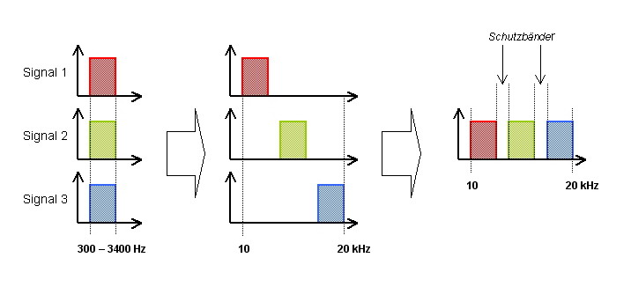

Frequency-division multiplexing (FDM) is inherently an analog technology. FDM achieves the combining of several digital signals into one medium by sending signals in several distinct frequency ranges over that medium. One of FDM's most common applications is cable television. Only one cable reaches a customer's home but the service provider can send multiple television channels or signals simultaneously over that cable to all subscribers. Receivers must tune to the appropriate frequency (channel) to access the desired signal. A variant technology, called wavelength-division multiplexing (WDM) is used in optical communications.
Time-division multiplexing
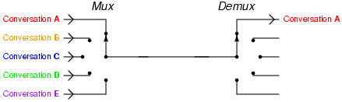

Time-division multiplexing (TDM).
Time-division multiplexing (TDM) is a digital technology. TDM involves sequencing groups of a few bits or bytes from each individual input stream, one after the other, and in such a way that they can be associated with the appropriate receiver. If done sufficiently and quickly, the receiving devices will not detect that some of the circuit time was used to serve another logical communication path. Consider an application requiring four terminals at an airport to reach a central computer. Each terminal communicated at 2400 bps, so rather than acquire four individual circuits to carry such a low-speed transmission; the airline has installed a pair of multiplexers. A pair of 9600 bps modems and one dedicated analog communications circuit from the airport ticket desk back to the airline data center are also installed.
Code-division multiplexing
Code division multiplexing (CDM) is a technique in which each channel transmits its bits as a coded channel-specific sequence of pulses. This coded transmission typically is accomplished by transmitting a unique time-dependent series of short pulses, which are placed within chip times within the larger bit time. All channels, each with a different code, can be transmitted on the same fiber and asynchronously demultiplexed. Other widely used multiple access techniques are Time Division Multiple Access (TDMA) and Frequency Division Multiple Access (FDMA). Code Division Multiplex techniques are used as an access technology, namely Code Division Multiple Access (CDMA), in Universal Mobile Telecommunications System (UMTS) standard for the third generation (3G) mobile communication identified by the ITU. Another important application of the CDMA is the Global Positioning System (GPS). However, the term Code Division Multiple access (CDMA) is also widely used to refer to a group of specific implementations of CDMA defined by Qualcomm for use in digital cellular telephony, which include IS-95 and IS-2000. The two different uses of this term can be confusing. Actually, CDMA (the Qualcomm standard) and UMTS have been competing for adoption in many markets.
Relation to multiple access
A multiplexing technique may be further extended into a multiple access method or channel access method, for example TDM into Time-division multiple access (TDMA) and statistical multiplexing into carrier sense multiple access (CSMA). A multiple access method makes it possible for several transmitters connected to the same physical medium to share its capacity. Multiplexing is provided by the Physical Layer of the OSI model, while multiple access also involves a media access control protocol, which is part of the Data Link Layer. The Transport layer in the OSI model as well as TCP/IP model provides statistical multiplexing.
Application areas
Telegraphy
The earliest communication technology using electrical wires, and therefore sharing an interest in the economies afforded by multiplexing, was the electric telegraph. Early experiments allowed two separate messages to travel in opposite directions simultaneously, first using an electric battery at both ends, then at only one end.
- Émile Baudot developed a time-multiplexing system of multiple Hughes machines in the1870s.
- In 1874, the quadruplex telegraph developed by Thomas Edison transmitted two messages in each direction simultaneously, for four messages transiting the same wire at the same time.
- Several workers were investigating acoustic telegraphy, a frequency division multiplexing technique, which led to the invention of the telephone.
Telephony
In telephony, a customer's telephone line now typically ends at the remote concentrator box down the street, where it is multiplexed along with other telephone lines for that neighborhood or other similar area. The multiplexed signal is then carried to the central switching office on significantly fewer wires and for much further distances than a customer's line can practically go. This is likewise also true for digital subscriber lines (DSL). Fiber in the loop (FITL) is a common method of multiplexing, which uses optical fiber as the backbone. It not only connects POTS phone lines with the rest of the PSTN, but also replaces DSL by connecting directly to Ethernet wired into the home. Asynchronous Transfer Mode is often the communications protocol used. Because all of the phone (and data) lines have been clumped together, none of them can be accessed except through a demultiplexer. This provides for more secure communications, though they are not typically encrypted. The concept is also now used in cable TV, which is increasingly offering the same services as telephone companies. IPTV also depends on multiplexing.
Video processing
In video editing and processing systems, multiplexing refers to the process of interleaving audio and video into one coherent MPEG transport stream (time-division multiplexing). In digital video, such a transport stream is normally a feature of a container format, which may include metadata and other information, such as subtitles. The audio and video streams may have variable bit rate. Software that produces such a transport stream and/or container is commonly called a statistical multiplexor or muxer. A demuxer is software that extracts or otherwise makes available for separate processing the components of such a stream or contain.
Digital broadcasting
In digital television and digital radio systems, several variable bit-rate data streams are multiplexed together to a fixed bitrate transport stream by means of statistical multiplexing. This makes it possible to transfer several video and audio channels simultaneously over the same frequency channel, together with various services. In the digital television systems, this may involve several standard definition television (SDTV) programmes (particularly on DVB-T, DVB-S2, ISD Band ATSC-C), or one HDTV, possibly with a single SDTV companion channel over one 6 to 8 MHz-wide TV channel. The device that accomplishes this is called a statistical multiplexer. In several of these systems, the multiplexing results in an MPEG transport stream. The newer DVB standards DVB-S2 and DVB-T2 has the capacity to carry several HDTV channels in one multiplex. Even the original DVB standards can carry more HDTV channels in a multiplex if the most advanced MPEG-4 compressions hardware is used. On communications satellites which carry broadcast television networks and radio networks, this is known as
multiple channels per carrier or MCPC. Where multiplexing is not practical (such as where there are different sources using a single transponder), single channel per carrier mode is used. Signal multiplexing of satellite TV and radio channels is typically carried out in a central signal play out and uplink centre, such as ASTRA Platform Services in Germany, which provides play out, digital archiving, encryption, and satellite uplinks, as well as multiplexing, for hundreds of digital TV and radio channels. In digital radio, both the Eureka 147 system of digital audio broadcasting and the in-band on-channel HD Radio, FMeXtra, and Digital Radio Mondi ale systems can multiplex channels. This is essentially required with DAB-type transmissions (where a multiplex is called an ensemble), but is entirely optional with IBOC systems.
Analog broadcasting
In FM broadcasting and other analog radio media, multiplexing is a term commonly given to the process of adding subcarriers to the audio signal before it enters the transmitter, where modulation occurs. Multiplexing in this sense is sometimes known as MPX, which in turn is also an old term for stereophonic FM, seen on stereo systems since the 1960s.
EXPERIMENT-- 2
AIM: - STUDY OF NETWORK INTERFACE CARD (NIC)
Definition:-
A network interface card, more commonly referred to as a NIC, is a device that allows computers to be joined together in a LAN, or local area network. Networked computers communicate with each other using a given protocol or agreed-upon language for transmitting data packets between the different machines, known as nodes. The network interface card acts as the liaison for the machine to both send and receive data on the LAN.
Types of NIC:-
Network interface cards, referred to as NICs, are PC integrate cards that give inter-networking capabilities for a particular computing solution. There are many types of NICs that are utilized in changeable situations. The biggest variation between cards is depending upon their connective medium and speed capabilities. To a lesser extent, NICs can be distinguished by their type of connectivity to PC.
- 10/100 Ethernet
These are networking cards that are utilized often in home or small office setting. As name implies, they are able of speeds up to 10 or 100 megabits per second, not to be confused with megabytes per second. These cards generally attach to PC using a PCI, PCIe or ISA motherboard interface slot. These cards are setup to utilize category 5 or 6 networking cables. The variation between category 5 and 6 networking cables is addition of more shielding in category 6 cable to decrease "cross-talk" that slows network transfer speeds.
- Gigabit Ethernet
Gigabit Ethernet NICs give network transfer speeds of up to one Gigabit per second. These cards attach to PC using same means as before mentioned, though, they are much more likely to be formed for PCIe slots. These NICs can use Category 5, 5e, 6, and 7 cabling, with a preference for latter. Though, these NICs are more frequently created to use fiber optic cables for utilize inenterprise solutions like web servers or data storage centers.
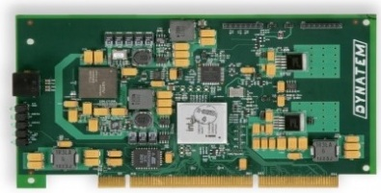

EXPERIMENT-- 3
AIM: STUDY OF PARALLEL AND SERIAL TRANSMISSION.
Data transmission:
Data transmission, digital transmission or digital communications is the physical transfer of data (a digital bit stream) over a point-to-point or point-to-multipoint communication channel. Examples of such channels are copper wires, optical fibres, wireless communication channels, and storage media. The data is represented as an electro-magnetic signal, such as an electrical voltage, radiowave, microwave or infra-red signal. While analog communications is the transfer of continuously varying information signal, digital communications is the transfer of discrete messages. The messages are either represented by a sequence of pulses by means of a line code (baseband transmission), or by a limited set of continuously varying wave forms (passband transmission), using a digital modulation method. The passband modulation and corresponding demodulation (also known as detection) is carried out by modem equipment. According to the most common definition of digital signal, both baseband and passband signals representing bit-streams are considered as digital transmission, while an alternative definition only considers the baseband signal as digital, and passband transmission of digital data as a form of digital-to-analog conversion.
Data transmitted may be digital messages originating from a data source, for example a computer or a keyboard. It may also be an analog signal such as a phone call or a video signal, digitized into a bit-stream for example using pulse-code modulation (PCM) or more advanced source coding (analog-to-digital conversion and data compression) schemes. This source coding and decoding is carried out by codec equipment.
Baseband or passband transmission:
The physically transmitted signal may be one of the following:
- A baseband signal
("digital-over-digital" transmission): A sequence of electrical pulses or light pulses produced by means of a line-coding scheme such as Manchester coding. This is typically used in serial cables, wired local area networks such as Ethernet, and in optical fiber communication. It results in a pulse amplitude modulated signal, also known as a pulse train.
- A passband signal
("digital-over-analog" transmission): A modulated sine wave signal representing a digital bit-stream. Note that this is in some textbooks considered as analog transmission, but in most books as digital transmission. The signal is produced by means of a digital modulation method such as PSK, QAM or FSK. The modulation and demodulation is carried out by modem equipment. This is used in wireless communication, and over telephone network local-loop and cable-TV networks.
Serial and parallel transmission:
serial transmission is the sequential transmission of signal elements of a group representing a character or other entity of data. Digital serial transmissions are bits sent over a single wire, frequency or optical path sequentially. Because it requires less signal processing and less chances for error than parallel transmission, the transfer rate of each individual path may be faster. This can be used over longer distances as a check digit or parity bit can be sent along it easily.
In telecommunications, parallel transmission is the simultaneous transmission of the signal elements of a character or other entity of data. In digital communications, parallel transmission is the simultaneous transmission of related signal elements over two or more separate paths. Multiple electrical wires are used which can transmit multiple bits simultaneously, which allows for higher data transfer rates than can be achieved with serial transmission. This method is used internally within the computer, for example the internal buses, and sometimes externally for such things as printers, The major issue with this is "skewing" because the wires in parallel data transmission have slightly different properties (not intentionally) so some bits may arrive before others, which may corrupt the message. A parity bit can help to reduce this. However, electrical wire parallel data transmission is therefore less reliable for long distances because corrupt transmissions are far more likely.
Asynchronous and synchronous data transmission:
Asynchronous transmission uses start and stop bits to signify the beginning bit character would actually be transmitted using 10 bits e.g.: A "0100 0001" would become "1 0100 0001 0 ". The extra one at the start and end of the transmission tells the receiver first that a character is coming and secondly that the character has ended. This method of transmission is used when data is sent intermittently as opposed to in a solid stream. In the previous example the start and stop bits are in bold. The start and stop bits must be of opposite polarity. This allows the receiver to recognize when the second packet of information is being sent.
Synchronous transmission uses no start and stop bits but instead synchronizes transmission speeds at both the receiving and sending end of the transmission using clock signal(s) built into each component. A continual stream of data is then sent between the two nodes. Due to there being no start and stop bits the data transfer rate is quicker although more errors will occur, as the clocks will eventually get out of sync, and the receiving device would have the wrong time that had been agreed sending/receiving data, so some bytes could become corrupted. Ways to get around this problem include re-synchronization of the clocks and use of check digits to ensure the byte is correctly interpreted and received

Image of synchronous and asynchronous transmission
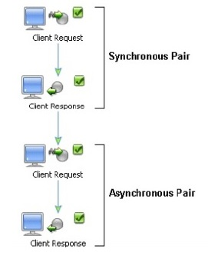

Serial data transmission: the process of transmitting binary words a bit at a time. Since the bits time-share the transmission medium, only one interconnecting lead is required. While serial data transmission is much simpler and less expensive because of the use of a single interconnecting line, it is a very slow method of data transmission. Serial data transmission is useful in systems where high speed is not a requirement. Serial data transmission techniques are widely used in transmitting data between a computer and its peripheral units. While the computer operates at very high speeds, most peripheral units are slow because of their electro mechanical nature. Slower serial data transmission is more compatible with such devices. Since the speed of serial transmission is more than adequate in such units, the advantages of low cost and simplicity of the signal interconnecting obtained.
Parallel data transmission: In a parallel data transmission system, each bit of the binary word to be transmitted must have its own data path. There are a variety of ways to implement this data path. The two basic classifications of transmission line circuits are single-ended and balanced. Single-ended transmission systems use a single-wire data path for each bit. When combined with a ground or return reference, the electrical circuit between the sending circuit and the receiving circuit is complete. In a balanced transmission line system, two conductor cables are used to send the data. The data on the dual-transmission line is complementary. The dual-transmission lines also use a ground return reference. While a single-ended transmission line is simpler and less expensive, it is subject to more noise problems than the balanced or dual-transmission line system
Parallel versus serial data transmission: there are two methods of transmitting digital data. These methods are parallel and serial transmissions. In parallel data transmission, all bits of the binary data are transmitted simultaneously. For example, to transmit an 8 bit binary number in parallel from one unit to another, eight transmission lines are required. Each bit requires its own separate data path. All bits of a word are transmitted at the same time. This method of transmission can move a significant amount of data in a given period of time. Its disadvantage is the large number of interconnecting cables between the two units. For large binary words, cabling becomes complex and expensive. This is particularly true if the distance between the two units is great. Long multi wire cables are not only expensive, but also require special interfacing to minimize noise and distortion problems.
Images of the transmission:
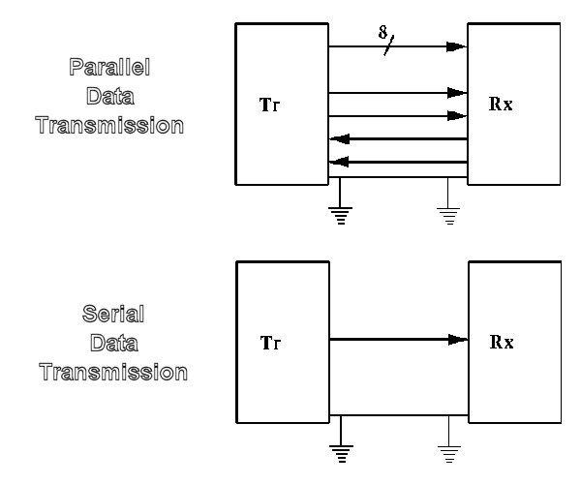

Number of channels:
Serial Communications and Parallel communications both define a way of transportation of data over networks.
- In Serial devices: transmit data bit-after-bit, serially over time. When 8 bits are received, after 8 bit-times (plus a little extra for signal synchronization), they are assembled back into a byte and delivered to the software.
- In Parallel communication: a word of some data length, say like 8 bits, travels all at once, along multiple parallel channels (one channel per bit position). At the receiver, an 8-bit byte is received every "bit time". In effect, you have 8 serial channels transmitting and receiving data simultaneously, making it (by definition) at least 8 times faster than a single serial channel using the same transceiver technology.

Advantages:
Serial Transmission:
- It is cheaper than Parallel transmission.
- Need only one communication channel and reduces the cost of transmission by factor n.
Parallel transmission:
- speed increases by the factor n.
Disadvantages of Parallel transmission:
- It is costly.
- Used for short distances only.
Disadvantages of serial transmission:
- Causes slower transmission.

EXPERIMENT-- 4
AIM:- STUDY OF RNZ AND RZ CODES.
Line coding:
Line coding consists of representing the digital signal to be transported by an amplitude- and time- discrete signal that is optimally tuned for the specific properties of the physical channel (and of the receiving equipment). The waveform pattern of voltage or current used to represent the 1s and 0s of a digital signal on a transmission link is called line encoding.
Common types of line coding are-
- Unipolar
- Bipolar
- Polar
- Manchester
Bipolar encoding:
Bipolar encoding is a type of line code (a method of encoding digital information to make it resistant to certain forms of signal loss during transmission). A duo binary signal is such an encoding.
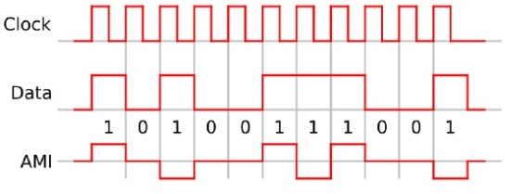
Manchester code: Manchester code (also known as Phase Encoding, or PE) is a line code in which the encoding of each data bit has at least one transition and occupies the same time. It therefore has no DC component, and is self-clocking, which means that it may be inductively or capacitively coupled, and that a clock signal can be recovered from the encoded data.
Return-to-zero:
Return-to-zero (RZ) describes a line code used in telecommunications signals in which the signal drops (returns) to zero between each pulse. This takes place even if a number of consecutive 0's or 1's occur in the signal. The signal is self-clocking. This means that a separate clock does not need to be sent along side the signal, but suffers from using twice the bandwidth to achieve the same data-rate as compared to non-return-to-zero format. The "zero" between each bit is a neutral or rest condition, such as a zero amplitude in pulse amplitude modulation (PAM), zero phase shift in phase-shift keying (PSK), or mid-frequency in frequency-shift keying(FSK). That "zero" condition is typically halfway between the significant condition representing a 1 bit and the other significant condition representing a 0 bit. Although return-to-zero (RZ) contains a provision for synchronization, it still has a DC component resulting in “baseline wander” during long strings of 0 or 1 bits, just like the line code non return to zero.
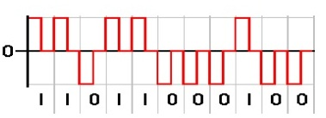
Return to zero, inverted:
Return-to-zero, inverted (RZI) is a method of mapping for transmission. The two-level RZI signal has a pulse (shorter than a clock cycle) if the binary signal is 0, and no pulse if the binary signal is 1. It is used (with a pulse 3/16 of a bit long) by the IrDA serial infrared (SIR) physic layer specification. Non-return-to-zero: In telecommunication, a non-return-to-zero (NRZ) line code is a binary code in which 1's are represented by one significant condition (usually a positive voltage) and 0's are represented by some other significant condition (usually a negative voltage), with no other neutral or rest condition. The pulses have more energy than a RZ code. Unlike RZ, NRZ does not have a rest state. NRZ is not inherently a self-synchronizing code, so some additional synchronization technique (for example a run length limited constraint, or a parallel synchronization signal) must be used to avoid bit slip.
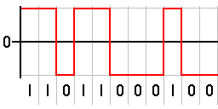
When used to represent data in an asynchronous communication scheme, the absence of a neutral state requires other mechanisms for data recovery, to replace methods used for error detection when using synchronization information when a separate clock signal is available. NRZ-Level itself is not a synchronous system but rather an encoding that can be used in either asynchronous or asynchronous transmission environment, that is, with or without an explicit clock signal involved. Because of this, it is not strictly necessary to discuss how the NRZ-Level encoding acts "on a clock edge" or "during a clock cycle" since all transitions happen in the given amount of time representing the actual or implied integral clock cycle. The real question is that of sampling--the high or low state will be received correctly provided the transmission line has stabilized for that bit when the physical line level is sampled at the receiving end.
Unipolar Non-Return-to-Zero Level:
"One" is represented by one physical level (such as a DC bias on the transmission line)."Zero" is represented by another level (usually a positive voltage).
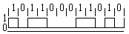
In clock language, "one" transitions or remains high on the trailing clock edge of the previous bit and "zero" transitions or remains low on the trailing clock edge of the previous bit, or just the opposite. This allows for long series without change, which makes synchronization difficult. One solution is to not send bytes without transitions. Disadvantages of on-off keying are the wastage of power due to the transmitted DC level and also the power spectrum of the transmitted signal does not approach to zero at zero frequency.
Bipolar Non-Return-to-Zero Level:
"One" is represented by one physical level (usually a negative voltage). "Zero" is represented by another level (usually a positive voltage).In clock language, in bipolar NRZ-Level the voltage "swings" from positive to negative on the trailing edge of the previous bit clock cycle. An example of this is RS-232, where "one" is −5V to −12V and "zero" is +5 to +12V.
Non-Return-to-Zero Space:
"One" is represented by no change in physical level."Zero" is represented by a change in physical level.
In clock language, the level transitions on the trailing clock edge of the previous bit to represent a "zero."This "change-on-zero" is used by High-Level Data Link Control and USB. They both avoid long periods of no transitions (even when the data contains long sequences of 1 bits) by using zero-bit insertion. HDLC transmitters insert a 0 bit after five contiguous 1 bits (except when transmitting the frame delimiter '01111110'). USB transmitters insert a 0 bit after six consecutive 1 bits. The receiver at the far end uses every transition both from 0 bits in the data and these extra non-data 0 bits to maintain clock synchronization. The receiver otherwise ignores these non-data 0bits.
Non-Return-to-Zero Inverted (NRZI):Non return to zero, inverted (NRZI) is a method of mapping a binary signal to a physical signal for transmission over some transmission media. The two level NRZI signal has a transition at a clock boundary if the bit being transmitted is a logical one, and does not have a transition if the bit being transmitted is a logical zero."One" is represented by a transition of the physical level."Zero" has no transition. In addition, NRZI might take the opposite convention, as in Universal Serial Bus (USB) signaling, when in Mode 1 (transition when signaling zero and steady level when signaling one). The transition occurs on the leading edge of the clock for the given bit. This distinguishes NRZI from NRZ-Mark. However, even NRZI can have long series of zeros (or ones if transitioning on "zero"), so clock recovery can be difficult unless some form of run length limited (RLL) coding is used on top. Magnetic disk and tape storage devices generally use fixed-rate RLL codes, while USB uses bit stuffing which is efficient, but results in a variable data rate: it takes slightly longer to send along string of 1 bits over USB than it does to send a long string of 0 bits. (USB inserts an additional 0 bit after 6 consecutive 1 bits.)
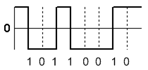

EXPERIMENT-- 5
AIM: STUDY OF DIFFERENT TYPES OF MODEM
Modem, short for modulator-demodulator is an electronic device that converts a computer’s digital signals into specific frequencies to travel over telephone or cable television lines. At the destination, the receiving modem demodulates the frequencies back into digital data. Computers use modems to communicate with one another over a network. The modem has significantly evolved since the 1970s when the 300 baud modem was used for connecting computers to bulletin board systems (BBSs). With this type of modem, each bit, represented digitally by a 1 or 0, was transmitted as a specific tone. The receiving modem responded with its own dedicated frequencies so that the modems could “talk at the same time.”
The technical term for this type of modem is Asynchronous.
Image of modem:

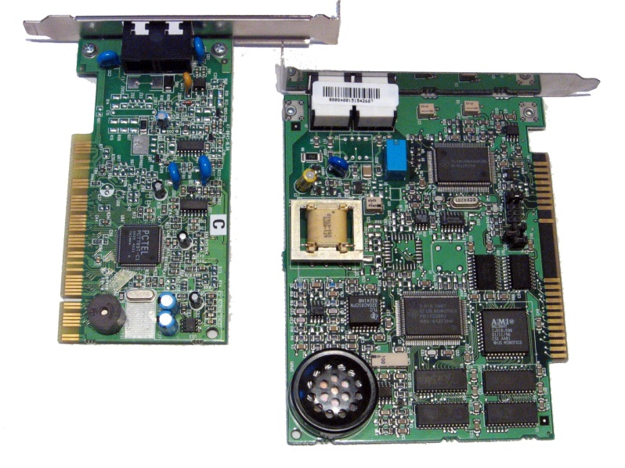
Types of modem: External modem:
External modems. It is the second term we have to consider from different types of computer modem. An External modem can be used to the same purpose and in the same conditions as internal computer modem. However, external modem is a small box that uses other kind of interfaces to be connected to the computer.
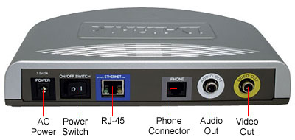

Usb modem: It could be a serial modem, named thus because it uses the serial port to connect to the computer. Usually installed on the back of the computer, the serial port is an easy-to-install option for the external modem. The same small box, on the other hand, can be an USB modem, which normally uses USB port usually placed on the back or in front of the computer.
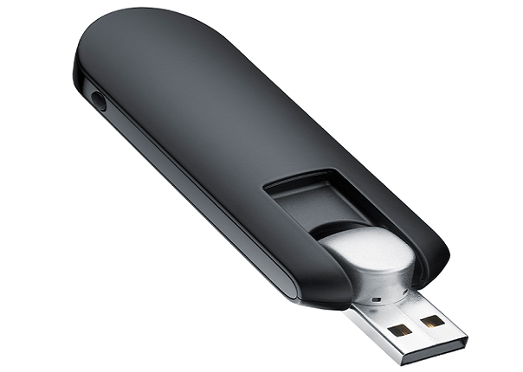
Cable modem:
Cable modem. The cable modem uses a coaxial cable television lines to provide greater bandwidth than the dial-up computer modem. An extremely fast access to the Web is providing by the cable modem with downstream transmission up to 38 Mbits/s and an upstream transmission up to 1 Mbits/s.
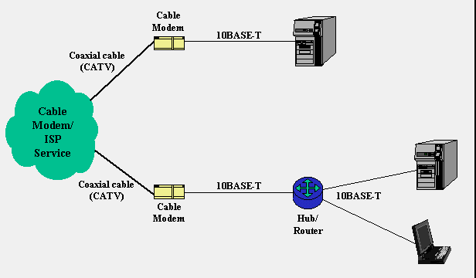
Wireless modem:
Some Internet Service Providers supports wireless internet services. The wireless modems are used for this service. These modems work similar to traditional wired modems except its structure.
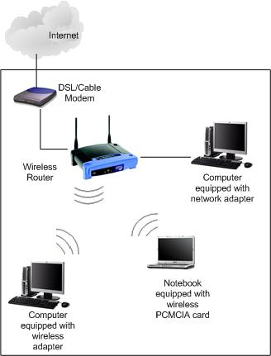
Gprs modem:
The GPRS modems are used to browser internet and for other communication using the GPRS services. The GPRS (General Packet Radio Signals) service is provided on the cellular networks. If we have cellular connection then we can communicate using the GPRS modems. The GPRS services are costly as compared with other communication services.
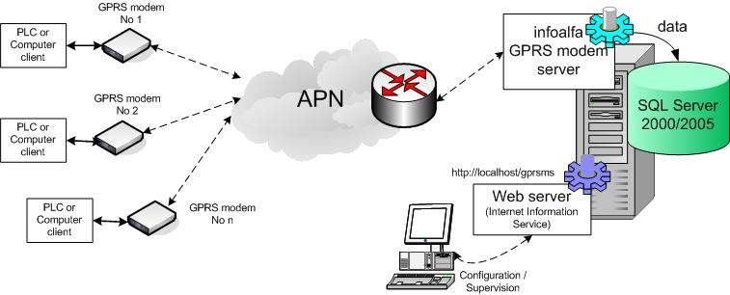
High speed modem:
56k modems are designed to take advantage of the new digital telephone networks. These use Pulse Code Modulation (PCM) to convert your voice, fax or modem signal into a digital stream at your local exchange. The amplitude of the analog signal is measured 8000 times per second. Each measurement produces a PCM code in the form of an eight bit byte to represent the amplitude.
Null modem: Null modem
is a communication method to connect two DTEs (computer, terminal, printer etc.) directly using an RS-232serial cable. The RS-232 standard is asymmetrical as to the definitions of the two ends of the communications link so it assumes that one end is a DTE and the other is a DCE e.g. a modem. With a null modem connection, the transmit and receive lines are crosslinked. Depending on the purpose, sometimes also one or more handshake lines are crosslinked. Several wiring layouts are in use because the null modem connection is not covered by a standard
Advantages:
1. More useful in connecting LAN with the Internet
2. Speed depends on the cost
Disadvantages:
1. Acts just as a interface between LAN and Internet
2. No traffic maintenance is present

EXPERIMENT-- 6
AIM:- CASE STUDY OF INTEGRATED SERVICES DIGITAL NETWORK
Integrated Services Digital Network (ISDN) is a set of communications standards for simultaneous digital transmission of voice, video, data, and other network services over the traditional circuits of the network. It was first defined in 1988 in the CCITT red book. Prior to ISDN, the phone system was viewed as a way to transport voice, with some special services available for data. The key feature of ISDN is that it integrates speech and data on the same lines, adding features that were not available in the classic telephone system. There are several kinds of access interfaces to ISDN defined as Basic Rate Interface (BRI), Primary Rate Interface (PRI) and Broadband ISDN (B-ISDN). ISDN is a circuit-switched telephone network system, which also provides access to packet switched networks, designed to allow digital transmission of voice and data over ordinary telephone copper wires, resulting in potentially better voice quality than an analog phone can provide. It offers circuit-switched connections (for either voice or data), and packet-switched connections (for data), in increments of 64kilobit/ s. A major market application for ISDN in some countries is Internet access, where ISDN typically provides a maximum of 128 kbit/s in both upstream and downstream directions. Abbreviation of
Integrated
Services
Digital
Network , an international communications standard for sending voice, video, and data over digital telephone lines or normal telephone wires. ISDN supports data of 64 Kbps (64,000 bits per second). There are two types of ISDN:
Basic Rate Interface (BRI): consists of two 64-Kbps B-channels and one D-channel for transmitting control information.
Primary Rate Interface (PRI): consists of 23 B-channels and one D-channel (U.S.) or 30B-channels and one D-channel (Europe). The original version of ISDN employs baseband transmission. Another version, called B-ISDN, uses broadband transmission and is able to support transmission rates of 1.5 Mbps. B-ISDN requires fiber optic cables and is not widely available.
ISDN elements
Integrated services refers to ISDN's ability to deliver at minimum two simultaneous connections, in any combination of data, voice, video, and fax, over a single line. Multiple devices can be attached to the line and used as needed. That means an ISDN line can take care of most people’s complete communications needs at a much higher transmission rate, without forcing the purchase of multiple analog phone lines. It also refers to Integrated Switching and Transmission in that telephone switching and carrier wave transmission are integrated rather than separate as in earlier technology.
Basic Rate Interface
The entry level interface to ISDN is the Basic(s) Rate Interface (BRI), a 128kbit/s service delivered over a pair of standard telephone copper wires. The 144 kbit/s rate is broken down into two 64 kbit/s bearer channels ('B' channels) and one 16 kbit/s signaling channel ( 'D' channel or delta channel).BRI is sometimes referred to as 2B+DThe interface specifies the following network interfaces:
The U interface is a two-wire interface between the exchange and a network terminating unit, which is usually the demarcation point in non-North American networks.
The T interface is a serial interface between a computing device and a terminal adapter, which is the digital equivalent of a modem.
The S interface is a four-wire bus that ISDN consumer devices plug into; the S & T reference points are commonly implemented as a single interface labeled 'S/T' on an NT1
The R interface defines the point between a non-ISDN device and a terminal adapter (TA) which provides translation to and from such a device. BRI-ISDN is very popular in Europe but is much less common in North America. It is also common in Japan - where it is known as INS64.
Primary Rate Interface
The other ISDN service available is the Primary Rate Interface (PRI), which is carried over an E1 (2048 kbit/s) in most parts of the world. An E1 is 30 'B' channels of 64 kbit/s, one 'D' channel of 64 kbit/s and a timing and alarm channel of 64 kbit/s. In North America PRI service is delivered on one or more T1s (sometimes referred to as 23B+D) of 1544 kbit/s (24 channels). AT1 has 23 'B' channels and 1 'D' channel for signaling (Japan uses a circuit called a J1, which is similar to a T1).In North America, Non-Facility Associated Signaling (NFAS {{ allows two or more PRIs to be controlled by a single D channel, and is sometimes called "23B+D + n*24B". D-channel backup allows for a second D channel in case the primary fails. NFAS is commonly used on a T3. PRI-ISDN is popular throughout the world, especially for connection of PSTN circuits to PBXs.
Even though many network professionals use the term "ISDN" to refer to the lower-bandwidth BRI circuit, in North America by far the majority of ISDN services are in fact PRI circuits serving PBXs.
Data channel
The bearer channel (B) is a standard 64 kbit/s voice channel of 8 bits sampled at 8 kHz with G.711encoding. B-Channels can also be used to carry data, since they are nothing more than digital channels. Each one of these channels is known as a DS0. Most B channels can carry a 64 kbit/s signal, but some were limited to 56K because they traveled over RBS lines. This was commonplace in the 20th century, but has since become less so.

Signaling channel
The signaling channel (D) uses Q.931 for signaling with the other side of the link.
X.25
X.25 can be carried over the B or D channels of a BRI line, and over the B channels of a PRI line. X.25 over the D channel is used at many point-of-sale (credit card) terminals because it eliminates the modem setup, and because it connects to the central system over a B channel, thereby eliminating the need for modems and making much better use of the central system's telephone lines.X.25 was also part of an ISDN protocol called "Always On/Dynamic ISDN", or AO/DI. This allowed a user to have a constant multi-link PPP connection to the internet over X.25 on the D channel, and brought up one or two B channels as needed.
Frame Relay
In theory, Frame Relay can operate over the D channel of BRIs and PRIs, but it is seldom, if ever, used.
Consumer and industry perspectives
There are two points of view into the ISDN world. The most common viewpoint is that of the end user, who wants to get a digital connection into the telephone/ data network from home, whose performance would be better than an ordinary analog modem connection. The typical end-user's connection to the Internet is related to this point of view, and discussion on the merits of various ISDN modems, carriers' offerings and tariffs (features, pricing) are from this perspective. Much of the following discussion is from this point of view, but it should be noted that as a data connection service, ISDN has been mostly superseded by DSL.
There is a second viewpoint: that of the telephone industry, where ISDN is a core technology. A telephone network can be thought of as a collection of wires strung between switching systems. The common electrical specification for the signals on these wires is T1or E1.Between telephone company switches, the signaling is performed viaSS7.Normally, a PBX is connected via a T1 with robbed bit signaling to indicate on-hook or off-hook conditions and MF and DTMF tones to encode the destination number. ISDN is much better because messages can be sent much more quickly than by trying to encode numbers as long (100msper digit) tone sequences. This results in faster call setup times. Also, a greater number of features are available and fraud is reduced. ISDN is also used as a smart-network technology intended to add new services to the public switched telephone network (PSTN) by giving users direct access to end-to-end circuit-switched digital services and as a backup or failsafe circuit solution for critical use data circuits.
ISDN and broadcast industry
ISDN is used heavily by the broadcast industry as a reliable way of switching low latency, high quality, long distance audio circuits. In conjunction with an appropriate codec using MPEG or various manufacturers proprietary algorithms, an ISDN BRI can be used to send stereo bi-directional audio coded with 20 Hz-20 kHz bandwidth, although commonly the G.722 algorithms used with a single 64kbps B channel to send much lower latency audio at the expense of audio quality. Where very high quality audio is required multiple ISDN BRIs can be used in parallel to provide a higher bandwidth circuit switched connection. BBC Radio 3 commonly makes use of three ISDN BRIs to carry 320kbps audio stream for live outside broadcasts. ISDN BRI services are used to link remote studios, sports grounds and outside broadcasts into the main broadcast studio. ISDN via satellite is used by field reporters around the world. It's also common to use ISDN for the return audio links to remote satellite broadcast vehicles.
Configurations
In ISDN, there are two types of channels, B (for "bearer") and D (for "delta"). B channels are used for data (which may include voice), and D channels are intended for signaling and control (but can also be used for data). There are two ISDN implementations. Basic Rate Interface (BRI), also called basic rate access (BRA) — consists of two B channels, each with bandwidth of 64 kbit/s, and one D channel with a bandwidth of 16 kbit/s. Together these three channels can be designated as 2B+D. Primary Rate Interface (PRI), also called primary rate access (PRA) in Europe — contains a greater number of B channels and a D channel with a bandwidth of 64 kbit/s. The number of B channels for PRI varies according to the nation: in North America and Japan it is 23B+1D, with an aggregate bit rate of 1.544 Mbit/s (T1); in Europe, India and Australia it is 30B+1D, with an aggregate bit rate of 2.048 Mbit/s (E1). Broadband Integrated Services Digital Network (BISDN) is another ISDN implementation and it is able to manage different types of services at the same time. It is primarily used within network backbones and employs ATM. Another alternative ISDN configuration can be used in which the B channels of an ISDN BRI line are bonded to provide a total duplex bandwidth of 128 kbit/s. This precludes use of the line for voice calls while the internet connection is in use. The B channels of several BRIs can be BONDED; a typical use is a 384K videoconferencing channel.
Types of communications
Where an analog connection requires a modem, an ISDN connection requires a terminal adapter (TA). The function of an ISDN terminal adapter is often delivered in the form of a PC card with an S/T interface, and single-chip solutions seem to exist, considering the plethora of combined ISDN- and ADSL-routers. ISDN is commonly used in radio broadcasting. Since ISDN provides a high quality connection this assists in delivering good quality audio for transmission in radio. Most radio studios are equipped with ISDN lines as their main form of communication with other studios or standard phone lines. Equipment made by companies such as Telos/Omnia (the popular Zephyr codec), Comrex, Tie line and others are used regularly by radio broadcasters. Almost all live sports broadcasts on radio are backhauled to their main studios via ISDN connection

EXPERIMENT-- 7
AIM: STUDY OF TWISTED PAIR, COAXIAL CABLE AND FIBRE OPTIC
CABLE
Twisted pair cabling is a type of wiring in which two conductors (the forward and return conductors of a single circuit) are twisted together for the purposes of canceling out electromagnetic interference (EMI) from external sources; for instance, electromagnetic radiation from unshielded twisted pair (UTP) cables, and crosstalk between neighboring pairs. It was invented by Alexander Graham Bell.
Explanation
In balanced pair operation, the two wires carry equal and opposite signals and the destination detects the difference between the two. This is known as differential mode transmission. Noise sources introduce signals into the wires by coupling of electric or magnetic fields and tend to couple to both wires equally. The noise thus produces a common-mode signal, which is cancelled at the receiver when the difference signal is taken. This method starts to fail when the noise source is close to the signal wires; the closer wire will couple with the noise more strongly and the common-mode rejection of the receiver will fail to eliminate it. This problem is especially apparent in telecommunication cables where pairs in the same cable lie next to each other for many miles. One pair can induce crosstalk in another and it is additive along the length of the cable. Twisting the pairs counters this effect as on each half twist the wire nearest to the noise-source is exchanged. Providing the interfering source remains uniform, or nearly so, over the distance of a single twist, the induced noise will remain common-mode. Differential signaling also reduces electromagnetic radiation from the cable, along with the associated attenuation allowing for greater distance between exchanges. The twist rate (also called pitch of the twist, usually defined in twists per meter) makes up part of the specification for a given type of cable. Where nearby pairs have equal twist rates, the same conductors of the different pairs may repeatedly lie next to each other, partially undoing the benefits of differential mode. For this reason it is commonly specified that, at least for cables containing small numbers of Pairs , the twisted rate must differs.
Unshielded twisted pair (UTP):
UTP cables are found in many Ethernet networks and telephone systems. For indoor telephone applications, UTP is often grouped into sets of 25 pairs according to a standard 25-pair color code originally developed by AT&T. A typical subset of these colors (white/blue, blue/white, white/orange, orange/white) shows up in most UTP cables.
For urban outdoor telephone cables containing hundreds or thousands of pairs, the cable is divided into smaller but identical bundles. Each bundle consists of twisted pairs that have different twist rates. The bundles are in turn twisted together to make up the cable. Pairs having the same twist rate within the cable can still experience some degree of crosstalk. Wire pairs are selected carefully to minimize crosstalk within a large cable.
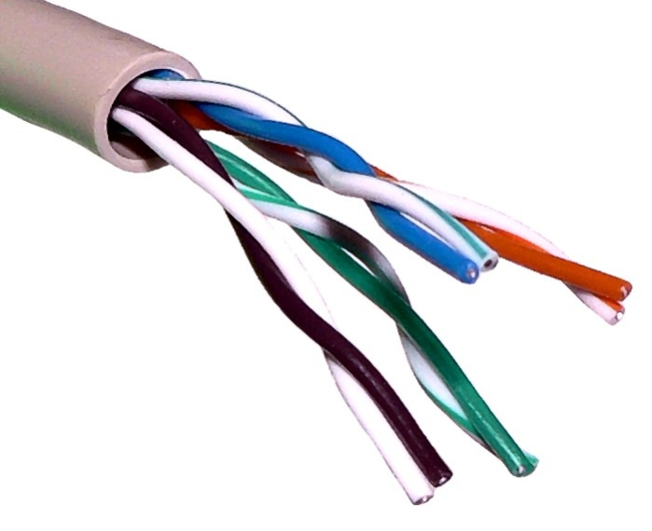
Unshielded twisted pair cable with different twist rates
UTP cable is also the most common cable used in computer networking. Modern Ethernet, the most common data networking standard, utilizes UTP cables. Twisted pair cabling is often used in data networks for short and medium length connections because of its relatively lower costs compared to optical fiber and coaxial cable. UTP is also finding increasing use in video applications, primarily in security cameras. Many middle to high-end cameras include a UTP output with setscrew terminals. This is made possible by the fact that UTP cable bandwidth has improved to match the baseband of television signals. While the video recorder most likely still has unbalanced BNC connectors for standard coaxial cable, a balun is used to convert from 100-ohm balanced UTP to 75-ohm unbalanced. A balun can also be used at the camera end for ones without a UTP output. Only one pair is necessary for each video signal.
Cable shielding
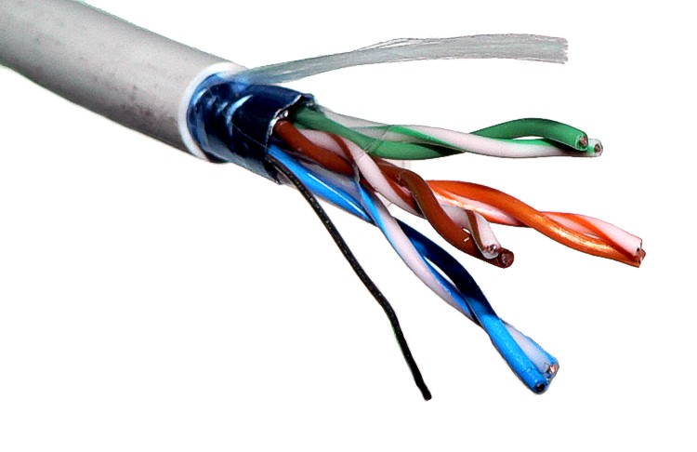
Advantages
It is a thin, flexible cable that is easy to string between walls.
More lines can be run through the same wiring ducts.
UTP costs less per meter/foot than any other type of LAN cable.
Disadvantages
Twisted pair’s susceptibility to
Electromagnetic interference greatly depends on the pair twisting schemes (usually patented by the manufacturers) staying intact during the installation. As a result, twisted pair cables usually have stringent requirements for maximum pulling tension as well as minimum bend radius. This relative fragility of twisted pair cables makes the installation practices an important part of ensuring the cable’s performance.
In video applications that send information across multiple parallel signal wires, twisted pair cabling can introduce signaling delays known as skew, which results in subtle color defects and ghosting due to the image components not aligning correctly when recombined in the display device. The skew occurs because twisted pairs within the same cable often use a different number of twists per meter to prevent common-mode crosstalk between pairs with identical numbers of twists. The skew can be compensated by varying the length of pairs in the termination box, to introduce delay lines that take up the slack between shorter and longer pairs, though the precise lengths required are difficult to calculate and vary depending on the overall cable length.
Minor twisted pair variants
Loaded twisted pair
: A twisted pair that has intentionally added inductance, common practice on telecommunication lines, except those carrying higher than voice band frequencies. The added inductors are known as load coils and reduce distortion.
Unloaded twisted pair
: A twisted pair that has no added load coils.
Bonded twisted pair
: A twisted pair variant in which the pairs are individually bonded to increase robustness of the cable. Pioneered by Belden, it means the electrical specifications of the cable are maintained despite rough handling.
Twisted ribbon cable
: A variant of standard ribbon cable in which adjacent pairs of conductors are bonded and twisted together. The twisted pairs are then lightly bonded to each other in a ribbon format. Periodically along the ribbon there are short sections with no twisting to enable connectors and pcb headers to be terminated using the usual ribbon cable IDC techniques.

Coaxial cable
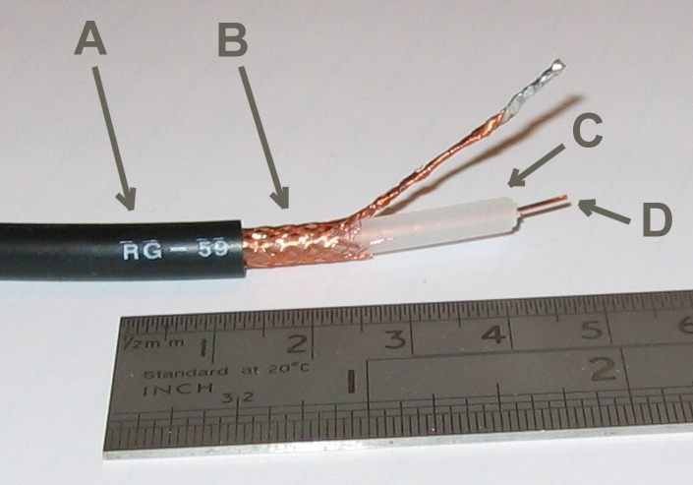
A: outer plastic sheath
B: woven copper shield
C: inner dielectric insulator
D: copper core
Coaxial cable, or coax, is an electrical cable with an inner conductor surrounded by a flexible, tubular insulating layer, surrounded by a tubular conducting shield. The term coaxial comes from the inner conductor and the outer shield sharing the same geometric axis. Coaxial cable was invented by English engineer and mathematician Oliver Heaviside, who first patented the design in 1880. Coaxial cable is used as a transmission line for radio frequency signals, in applications such as connecting radio transmitters and receivers with their antennas, computer network (Internet) connections, and distributing cable television signals. One advantage of coax over other types of radio transmission line is that in an ideal coaxial cable the electromagnetic field carrying the signal exists only in the space between the inner and outer conductors. This allows coaxial cable runs to be installed next to metal objects such as gutters without the power losses that occur in other types of transmission lines, and provides protection of the signal from external electromagnetic interference. Coaxial cable differs from other shielded cable used for carrying lower frequency signals such as audio signals, in that the dimensions of the cable are controlled to give a precise, constant conductor spacing, which is needed for it to function efficiently as a radio frequency transmission line.
Tri axial cable
Triaxial cable or triax is coaxial cable with a third layer of shielding, insulation and sheathing. The outer shield, which is earthed (grounded), protects the inner shield from electromagnetic interference from outside sources.
Twin-axial cable or twinax is a balanced, twisted pair within a cylindrical shield. It allows a nearly perfect differential signal, which is both shielded and balanced to pass through. Multi-conductor coaxial cable is also sometimes used.
Biaxial cable, biax or Twin-Lead is a figure- 8 configuration of two 50 Ω coaxial cables, externally resembling that of lamp cord, or speaker wire. Biax is used in some proprietary computer networks. Others may be familiar with 75Ω biax, which at one time was popular on many cable TV services.
Semi-rigid
Semi-rigid cable is a coaxial form using a solid copper outer sheath. This type of coax offers superior screening compared to cables with a braided outer conductor, especially at higher frequencies. The major disadvantage is that the cable, as its name implies, is not very flexible, and is not intended to be flexed after initial forming. (See "hard line")
Fiber-optic
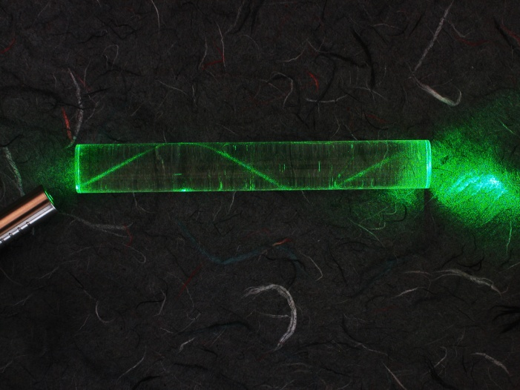
In fiber-optic communications, information is transmitted by sending light through optical fibers.
Fiber-optic communication is a method of transmitting information from one place to another by sending pulses of light through an optical fiber. The light forms an electromagnetic carrier wave that is modulated to carry information. First developed in the 1970s, fiber-optic communication systems have revolutionized the telecommunications industry and have played a major role in the advent of the Information Age. Because of its advantages over electrical transmission, optical fibers have largely replaced copper wire communications in core networks in the developed world. The process of communicating using fiber-optics involves the following basic steps: Creating the optical signal involving the use of a transmitter, relaying the signal along the fiber, ensuring that the signal does not become too distorted or weak, receiving the optical signal, and converting it into an electrical signal.
Applications
Optical fiber is used by many telecommunications companies to transmit telephone signals, Internet communication, and cable television signals. Due to much lower attenuation and interference, optical fiber has large advantages over existing copper wire in long-distance and high-demand applications. However, infrastructure development within cities was relatively difficult and time-consuming, and fiber-optic systems were complex and expensive to install and operate. Due to these difficulties, fiber-optic communication systems have primarily been installed in long-distance applications, where they can be used to their full transmission capacity, offsetting the increased cost. Since 2000, the prices for fiber-optic communications have dropped considerably. The price for rolling out fiber to the home has currently become more cost-effective than that of rolling out a copper based network. Prices have dropped to$850 per subscriber in the US and lower in countries like The Netherlands, where digging costs are low. Since 1990, when optical-amplification systems became commercially available, the telecommunications industry has laid a vast network of intercity and transoceanic fiber communication lines. By 2002, an intercontinental network of 250,000 km of submarine communications cable with a capacity of 2.56 Tb/ s was completed, and although specific network capacities are privileged information, telecommunications investment reports indicate that network capacity has increased dramatically since 2004.

EXPERIMENT-- 8
AIM:- STUDY OF DIGITAL INTERFACE RS-232
In telecommunications RS-232 (Recommended Standard 232) is a standard for serial binary single-ended data and control signals connecting between a DTE (Data Terminal Equipment) and a DCE (Data Circuit-terminating Equipment). It is commonly used in computer serial ports. The standard defines the electrical characteristics and timing of signals, the meaning of signals, and the physical size and pin out of connectors.
Scope of the standard
The Electronics Industries Association (EIA) standard RS-232-C as of 1969 defines:
- Electrical signal characteristics such as voltage levels, signaling rate, timing and slew-rate of signals, voltage withstand level, short-circuit behavior, and maximum load capacitance.
- Interface mechanical characteristics, pluggable connectors and pin identification.
- Functions of each circuit in the interface connector.
- Standard subsets of interface circuits for selected telecom applications. The standard does not define such elements as character encoding (for example, ASCII, Baudot code or EBCDIC)
- the framing of characters in the data stream (bits per character, start/stop bits, parity
- protocols for error detection or algorithms for data compression
- bit rates for transmission, although the standard says it is intended for bit rate slower than 20,000 bits per second. Many modern devices support speeds of 115,200 bit/s and above
- power supply to external devices.
History
RS-232 was first introduced in 1962. The original DTEs were electro mechanical tele typewriters and the original DCEs were (usually) modems. When electronic terminals (smart and dumb) began to be used, they were often designed to be interchangeable with teletypes, and so supported RS-232. The C revision of the standard was issued in 1969 in part to accommodate the electrical characteristics of these devices. The standard has been renamed several times during its history as the sponsoring organization changed its name, and has been variously known as EIA RS-232, EIA 232, and most recently as TIA 232. The standard continued to be revised and updated by the Electronic Industries Alliance and since 1988 by the Telecommunications Industry Association (TIA). Revision C was issued in a document dated August 1969. Revision D was issued in 1986).
Limitations of the standard
- The large voltage swings and requirement for positive and negative supplies increases power consumption of the interface and complicates power supply design. The voltage swing requirement also limits the upper speed of a compatible interface.
- Single-ended signaling referred to a common signal ground limits the noise immunity and transmission distance.
- Multi-drop connection among more than two devices is not defined. While multi-drop "work-around" has been devised, they have limitations in speed and compatibility.
- Asymmetrical definitions of the two ends of the link make the assignment of the role of a newly developed device problematic; the designer must decide on either a DTE-like or DCE-like interface and which connector pin assignments to use.
- The handshaking and control lines of the interface are intended for the setup and take down of a dial-up communication circuit; in particular, the use of handshake lines for flow control is not reliably implemented in many devices. .
- The 25-way connector recommended in the standard is large compared to current practice.
Role in modern personal computers
PCI Express x1 card with one RS-232 port In the book PC 97 Hardware Design Guide, Microsoft deprecated support for the RS-232 compatible serial port of the original IBM PC design. Today, RS-232 has mostly been replaced in personal computers by USB for local communications. Compared with RS-232, USB is faster, uses lower voltages, and has connectors that are simpler to connect and use. Both standards have software support in popular operating systems. USB is designed to make it easy for device drivers to communicate with hardware. However, there is no direct analog to the terminal programs used to let users communicate directly with serial ports
Standard details
In RS-232, user data is sent as a time-series of bits. Both synchronous and asynchronous transmissions are supported by the standard. In addition to the data circuits, the standard defines a number of control circuits used to manage the connection between the DTE and DCE. Each data or control circuit only operates in one direction, that is, signaling from a DTE to the attached DCE or the reverse. Since transmit data and receive data are separate circuits, the interface can operate in a full duplex manner, supporting concurrent data flow in both directions. The standard does not define character framing within the data stream, or character encoding.
Voltage levels
is grammatic oscilloscope trace of voltage levels for an uppercase ASCII "K" character (0x4b) with 1 start bit, 8 data bits, 1 stop bit. The RS-232 standard defines the voltage levels that correspond to logical one and logical zero levels for the data transmission and the control signal lines. Valid signals are plus or minus 3 to15 volts; the ±3 V range near zero volts is not a valid RS-232 level. The standard specifies a maximum open-circuit voltage of 25 volts: signal levels of ±5 V, ±10 V, ±12 V, and ±15 V are all commonly seen depending on the power supplies available within a device. RS-232 drivers and receivers must be able to withstand indefinite short circuit to ground or to any voltage level up to ±25 volts. The slow or how fast the signal changes between levels, is also controlled.
Connectors
RS-232 devices may be classified as Data Terminal Equipment (DTE) or Data Communication Equipment (DCE); this defines at each device which wires will be sending and receiving each signal. The standard recommended but did not make mandatory the D-subminiature 25 pin connector. In general and according to the standard, terminals and computers have male connectors with DTE pin functions, and modems have female connectors with DCE pin functions. Other devices may have any combination of connector gender and pin definitions. Many terminals were manufactured with female terminals but were sold with a cable with male connectors at each end; the terminal with its cable satisfied the recommendations in the standard.
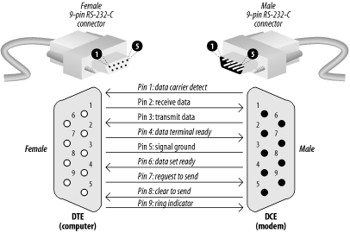
Conventions
For functional communication through a serial port interface, conventions of bit rate, character framing, communications protocol, character encoding, data compression, and error detection, not defined in RS 232, must be agreed to by both sending and receiving equipment. For example, consider the serial ports of the original IBM PC. This implementation used an 8250 UART using asynchronous start-stop character formatting with 7 or 8 data bits per frame, usually ASCII character coding, and data rates programmable between 75 bits per second and 115,200 bits per second. Data rates above 20,000 bits per second are out of the scope of the standard, although higher data rates are sometimes used by commercially manufactured equipment. In the particular case of the IBM PC, baud rates were programmable with arbitrary values, so that a PC could be connected to, for example, MIDI music controllers (31,250 bits per second) or other devices not using the rates typically used with modems. Since most devices do not have automatic baud rate detection, users must manually set the baud rate (and all other parameters) at both ends of theRS-232 connection.
RTS/CTS handshaking
Further information: Hardware flow control
In older versions of the specification, RS-232's use of the RTS and CTS lines is asymmetric: The DTE asserts RTS to indicate a desire to transmit to the DCE, and the DCE asserts CTS in response to grant permission. This allows for half-duplex modems that disable their transmitters when not required, and must transmit a synchronization preamble to the receiver when they are re-enabled. This scheme is also employed on present-day RS-232 to RS-485 converters, where the RS-232's RTS signal is used to ask the converter to take control of the RS-485 bus – a concept that doesn't otherwise exist in RS-232. There is no way for the DTE to indicate that it is unable to accept data from the DCE.
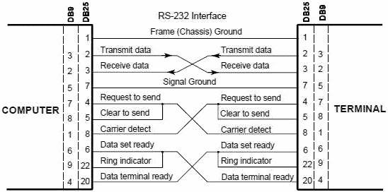
3-wire and 5-wire RS-232
A minimal "3-wire" RS-232 connection consisting only of transmit data, receive data, and ground, is commonly used when the full facilities of RS-232 are not required. Even a two-wire connection (data and ground) can be used if the data flow is one way (for example, a digital postal scale that periodically sends a weight reading, or a GPS receiver that periodically sends position, if no configuration via RS-232 is necessary). When only hardware flow control is required in addition to two-way data, the RTS and CTS lines are added in a 5-wire version.
Seldom used features
The EIA-232 standard specifies connections for several features that are not used in most implementations. Their use requires the 25-pin connectors and cables, and of course both the DTE and DCE must support them.
Signal rate selection
The DTE or DCE can specify use of a "high" or "low" signaling rate. The rates as well as which device will select the rate must be configured in both the DTE and DCE. The prearranged device selects the high rate by setting pin 23 to ON.
Loopback testing
Many DCE devices have a loopback capability used for testing. When enabled, signals are echoed back to the sender rather than being sent on to the receiver. If supported, the DTE can signal the local DCE (the one it is connected to) to enter loopback mode by setting pin 18 to ON, or the remote DCE (the one the local DCE is connected to) to enter loopback mode by setting pin21 to ON. The latter tests the communications link as well as both DCE's. When the DCE is in test mode it signals the DTE by setting pin 25 to ON.A commonly used version of loopback testing doesn't involve any special capability of either end. A hardware loopback is simply a wire connecting complementary pins together in the same connector. Loopback testing is often performed with a specialized DTE called a Bit Error Rate Tester.
Timing signals
Some synchronous devices provide a clock signal to synchronize data transmission, especially at higher data rates. Two timing signals are provided by the DCE on pins 15 and 17. Pin 15 is the transmitter clock, or send timing (ST); the DTE puts the next bit on the data line (pin 2) when this clock transitions from OFF to ON (so it is stable during the ON to OFF transition when the DCE registers the bit). Pin 17 is the receiver clock, or receive timing (RT); the DTE reads the next bit from the data line (pin 3) when this clock transitions from ON to OFF.
Related standards
Other serial signaling standards may not interoperate with standard-compliant RS-232 ports. For example, using the TTL levels of near +5 and 0 V puts the mark level in the undefined area of the standard. Such levels are sometimes used with NMEA 0183-compliant GPS receivers and depth finders. Other serial interfaces similar to RS-232:
- RS-422 (a high-speed system similar to RS-232 but with differential signaling)
- RS-423 (a high-speed system similar to RS-422 but with unbalanced signaling)
- RS-449 (a functional and mechanical interface that used RS-422 and RS-423 signals – it never caught on like RS-232 and was withdrawn by the EIA)
- RS-485 (a descendant of RS-422 that can be used as a bus in multi drop configurations)
- MIL-STD-188 (a system like RS-232 but with better impedance and rise time control)
- EIA-530 (a high-speed system using RS-422 or RS-423 electrical properties in an EIA-232 pin out configuration, thus combining the best of both; supersedes RS-449)
Development tools
When developing and/or troubleshooting RS-232, close examination of hardware signals can be very important to find problems. A serial line analyzer is a device similar to a logic analyzer but specialized for RS-232's voltage levels, connectors, and, where used, clock signals. The serial line analyzer can collect, store, and display the data and control signals, allowing developers to view them in detail. Some simply display the signals as waveforms; more elaborate versions include the ability to decode characters in ASCII or other common codes and to interpret common protocols used over RS-232 such as SDLC, HDLC, DDCMP, and X.25. Serial line analyzers are available as standalone units, as software and interface cables for general-purpose logic analyzers, and as programs that run in common personal computers.

EXPERIMENT-- 9
AIM: TO STUDY DIFFERENT TOPLOGIES
Topology in Network Design
Think of a topology as a network's virtual shape or structure. This shape does not necessarily correspond to the actual physical layout of the devices on the network. For example, the computers on a home LAN may be arranged in a circle in a family room, but it would be highly unlikely to find a ring topology there.
In computer networking, topology refers to the layout of connected devices. This article introduces the standard topologies of networking.
Network topologies are categorized into the following basic types:
- BUS
- RING
- STAR
- MESH
- TREE
More complex networks can be built as hybrids of two or more of the above basic topologies.
Bus Topology
Bus networks (not to be confused with the system bus of a computer) use a common backbone to connect all devices. A single cable, the backbone functions as a shared communication medium that devices attach or tap into with an interface connector. A device wanting to communicate with another device on the network sends a broadcast message onto the wire that all other devices see, but only the intended recipient actually accepts and processes the message.
Illustration - Bus Topology Diagram
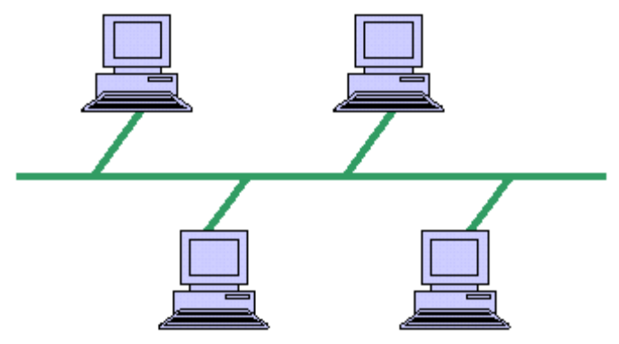
Advantages
- Cheap and easy to implement
- Require less cable
- Does not use any specialized network equipment.
Disadvantages
- Network disruption when computers are added or removed
- A break in the cable will prevent all
- Systems from accessing the network.
- Difficult to troubleshoot.
Ring Topology
In a ring network, every device has exactly two neighbors for communication purposes. All messages travel through a ring in the same direction (either "clockwise" or "counterclockwise"). A failure in any cable or device breaks the loop and can take down the entire network.
To implement a ring network, one typically uses FDDI, SONET, or Token Ring technology. Ring topologies are found in some office buildings or school campuses.
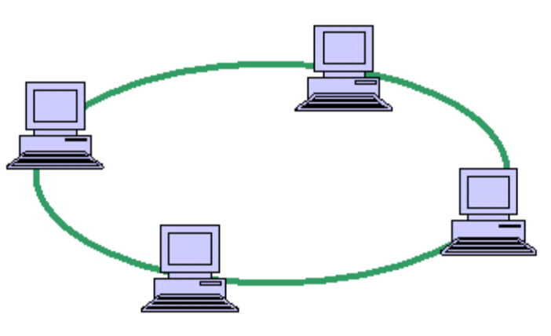
How Token Ring Works
Unlike all other standard forms of LAN interconnects, Token Ring maintains one or more common data frames that continuously circulates through the network. These frames are shared by all connected devices on the network as follows:
- A frame (packet) arrives at the next device in the ring sequence
- That device checks whether the frame contains a message addressed to it. If so, the device removes the message from the frame. If not, the frame is empty (called a token frame).
- The device holding the frame decides whether to send a message. If so, it inserts message data into the token frame and issues it back onto the LAN. If not, the device releases the token frame for the next device in sequence to pick up
- The above steps are repeated continuously for all devices in the token ring
Advantages
- Cable faults are easily located, making
- troubleshooting easier
- Ring networks are moderately easy to Install
Disadvantages
- Expansion to the network can cause network disruption
- A single break in the cable can disrupt the entire network
Star Topology
Many home networks use the star topology. A star network features a central connection point called a "hub" that may be a hub, switch or router. Devices typically connect to the hub with Unshielded Twisted Pair (UTP) Ethernet. Compared to the bus topology, a star network generally requires more cable, but a failure in any star network cable will only take down one computer's network access and not the entire LAN. (If the hub fails, however, the entire network also fails.)
Illustration - Star Topology Diagram
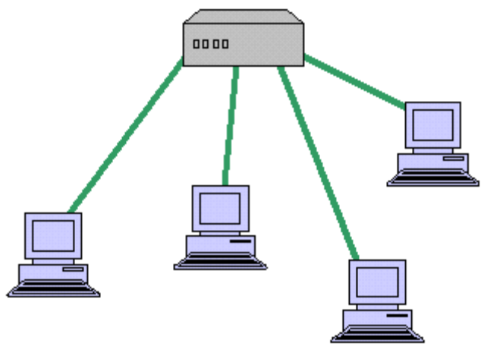
Advantages
- Easily expanded without disruption to the network
- Cable failure affects only a single user
- Easy to troubleshoot and isolate problems
Disadvantages
- Requires more cable
- A central connecting device allows for a single point of failure
- More difficult to implement
Mesh Topology
Mesh topologies involve the concept of routes. Unlike each of the previous topologies, messages sent on a mesh network can take any of several possible paths from source to destination. (Recall that even in a ring, although two cable paths exist, messages can only travel in one direction.) Some WANs, most notably the Internet, employ mesh routing. A mesh network in which every device connects to every other is called a full mesh. As shown in the illustration below, partial mesh networks also exist in which some devices connect only indirectly to others.
Illustration - Mesh Topology Diagram
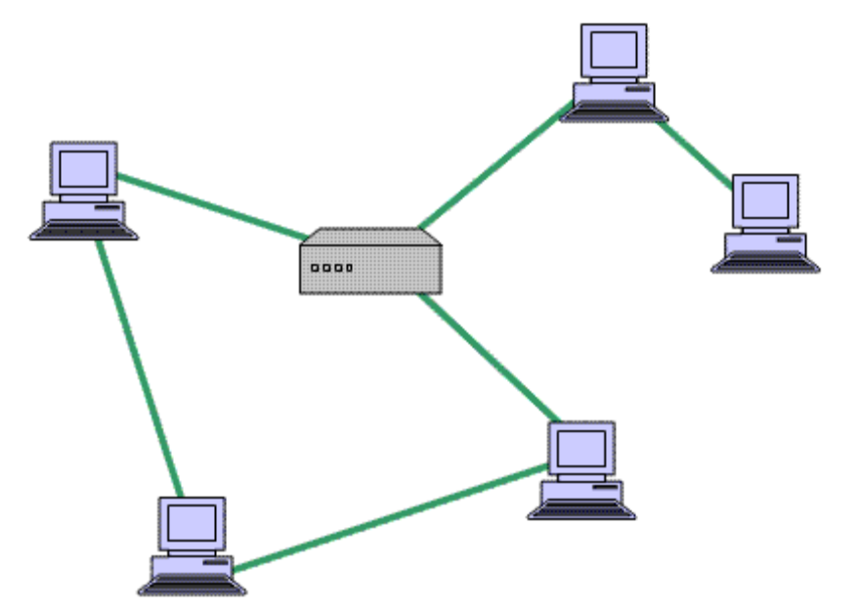
Advantages
- Provides redundant paths between devices
- The network can be expanded without disruption to current uses
Disadvantages
- Requires more cable than the other LAN topologies
- Complicated implementation
Tree Topology
Tree topologies integrate multiple star topologies together onto a bus. In its simplest form, only hub devices connect directly to the tree bus, and each hub functions as the "root" of a tree of devices. This bus/star hybrid approach supports future expandability of the network much better than a bus (limited in the number of devices due to the broadcast traffic it generates) or a star (limited by the number of hub connection points) alone.

EXPERIMENT-- 10

AIM : - To Study LAN using Star Topology

APPRATUS REQUIRED: -
Four to Five computers, cables
THEORY: -

LAN: When two or more computers are connected directly within the small well defined area such as room, building etc. The physical topology of a network refers to the configuration of cables, computers, and other peripherals.

Main Types of Network Topologies

In networking, the term "topology" refers to the layout of connected devices on a network. Network topologies are categorized into the following basic types:

•Star Topology
•Ring Topology
•Bus Topology
•Tree Topology
•Mesh Topology
•Hybrid Topology

More complex networks can be built as hybrids of two or more of the above basic topologies.

Star Topology :

Many home networks use the star topology. A star network features a ce ntral connection point called a "hub" that may be a hub, switch or router. Devices typically connect to the hub with Unshielded Twisted Pair (UTP) Ethernet. Compared to the bus topology, a star network generally requires more cable, but afailure in any star network cable will only take down one computer's network access and not the entire
LAN. (If the hub fails, however, the entire network also fails

DIAGRAM: -
PROCEDURE:-
1.Create folder of source name in both PC in C or D drive
2.Write text document in one PC (sender)
3.Open Star topology on both PC
4.Write destination IP address on both PC
5.Share folder
6.Open the folder
7.Save the parameters
8.Open the text document
9.Sent data
10.Received data on another PC Advantages of a Star

Topology
•Easy to install and wire.
•No disruptions to the network thenconnecting or removing devices.
•Easy to detect faults and to remove parts. Disadvantages of a Star Topology
•Requires more cable length than a linear topology.
•If the hub or concentrator fails, nodes attached are disabled.
•More expensive than linear bus topologies because of the cost of the concentrators. The protocols used with star configurations are usually Ethernet or Local Talk. Token Ring uses a similar topology, called the star-wired ring.

RESULT: -
Star Topology is studied

