College name ,Bhopal
Datacom Practical file
Index
Sr.  No. | Practical | Page No | Signature
1 | Signal processing blockset library.
2 | Write a program to generate CRC code for checking error
3 | To Plot Efficiency of pure Aloha and slotted ALOHA in MATLAB.
4 | To plot Channel Efficiency for Ethernet in MATLAB.
5 | Designing a digital filter using simulink
6 | Designing a adaptive filter using simulink
7 | Conversion of analog to digital signal
8 | To study sampling using simulink blockset
9 | To study Quantisation using simulink blockset
10 | Various signal operations using simulink blockset

1. Aim : Signal processing blockset library.
Accessing Blocks Directly
You can access the main Signal Processing Blockset library from the MATLAB command line. This procedure shows you how to open this library and locate the source blocks:
1. Open the library by typing dsplib at the MATLAB command prompt.
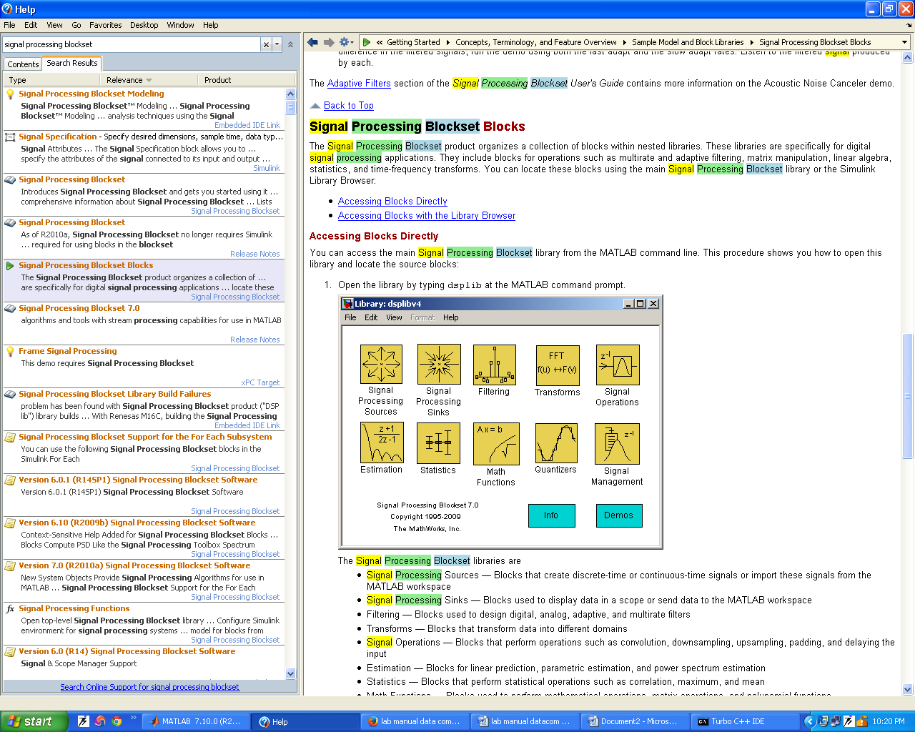
The Signal Processing Blockset libraries are
• Signal Processing Sources — Blocks that create discrete-time or continuous-time signals or import these signals from the MATLAB workspace
•Signal Processing Sinks — Blocks used to display data in a scope or send data to the MATLAB workspace
• Filtering — Blocks used to design digital, analog, adaptive, and multirate filters
•Transforms — Blocks that transform data into different domains
• Signal Operations — Blocks that perform operations such as convolution, downsampling,
upsampling, padding, and delaying the input
• Estimation - Blocks for linear prediction, parametric estimation, and power spectrum estimation
• Statistics- Blocks that perform statistical operations such as correlation, maximum, and mean
•Math Functions- Blocks used to perform mathematical operations, matrix operations, and polynomial functions
• Quantizers — Blocks that create scalar and vector quantizers as well as uniform encoders and decoders
• Signal Management — Blocks for buffering, selecting part of a signal, modifying signal attributes, and edge detection
2. Double-click the Signal Processing Sources library. The library displays the blocks it contains. You can use the blocks in this library to create discrete-time or continuous-time signals.
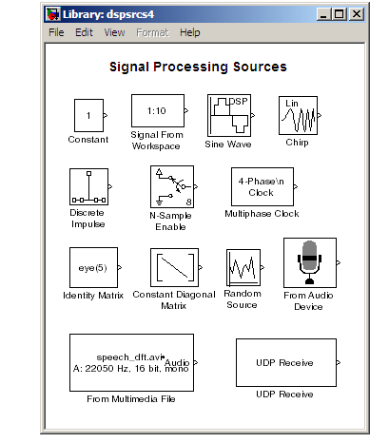

3. Drag any block into a model, double-click the block, and click Help to learn more about the block functionality.
Accessing Blocks with the Library Browser
Starting the Simulink product displays the Simulink Library Browser. To start Simulink, type simulink at the MATLAB command line. One way to explore the Signal Processing Blockset product is to expand the Signal Processing Blockset entry in the tree pane of this browser.

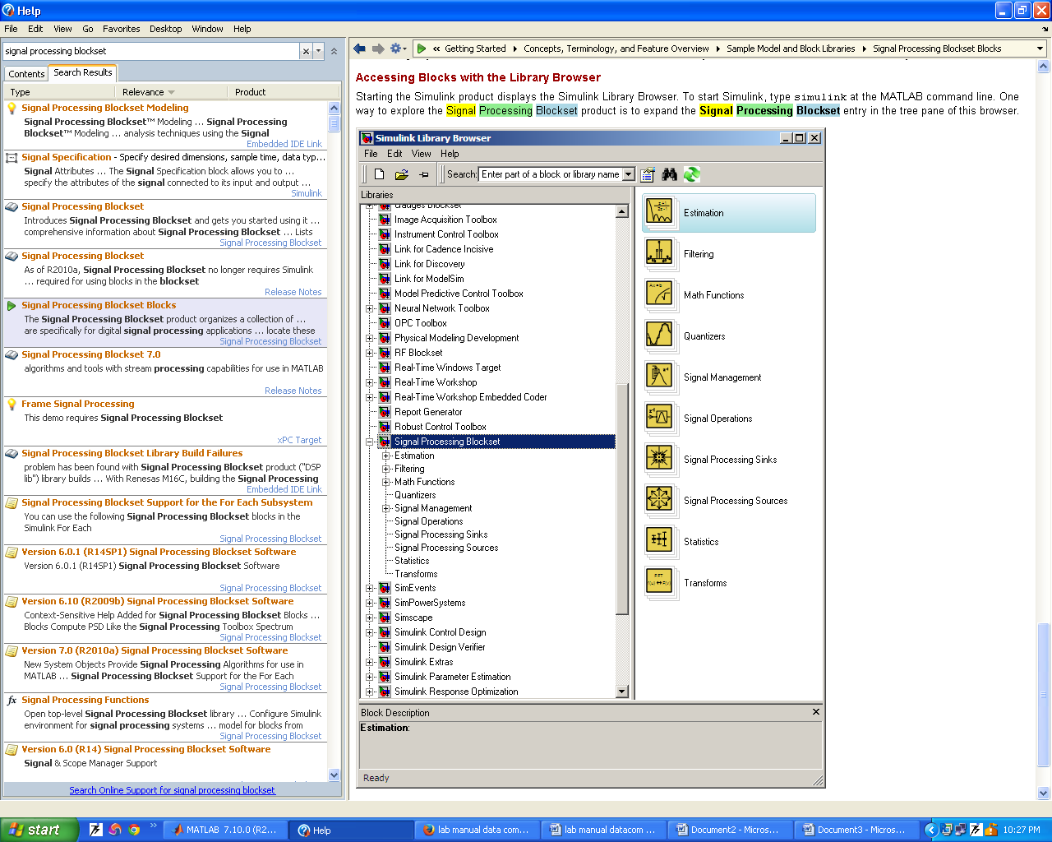

2. Aim : Write a program to generate CRC code for checking error

Cyclic Redundancy Check -The cyclic redundancy check or CRC is a technique for detecting error in digital data but not for making correction when errors are detected, it is used primarily in data transmissions. In the CRC method a certain number of check bits, often called a checksum, are appended to the message being transmitted. The receiver can determine whether or not the check bits agree with the data, to ascertain with a certain degree of probability whether or not an error occurred in transmission. If an error occurred, the receiver sends a “negative acknowledgment” (NAK) back to the sender, requesting that message is to be retransmitted.

PROGRAM:
#include <stdio.h>
#include <conio.h>
#include<string.h>
#define poly 0xd8
int crc(int msg)
{
int rem,i;
rem=msg;
for(i=8;i>0;--i)
{
if(rem & 0x80)
{
rem^=poly;
}
rem=rem<<1;
}
return (rem>>4);
}
void main()
GECD, E& C
Dept.Data Communication & Networking
{
int msg=0xe5,c;
clrscr();
c=crc(msg);
printf("%d",c);
getch(); }

3.Aim :To Plot Efficiency of pure Aloha and slotted ALOHA in MATLAB.

PROGRAM:
G=0:0.1:3;
S=G.*exp(G);
plot(G,S,'b+:');
text(1,.38,'MAX THROUGHPUT FOR SLOTTED ALOHA')
xlabel('load offered');
ylabel('throughput');
title('aloha protocol');
hold on;
S1=G.*exp(-2*G);
plot(G,S1,'rd:');
text(0.5,.2,'MAX THROUGHPUT FOR PURE ALOHA')
xlabel('load offered');
ylabel('throughput');
title('aloha protocol');
legend('Slotted ALOHA','Pure ALOHA','Location','NorthEastOutside')

4. Aim : To plot Channel Efficiency for Ethernet in MATLAB.
PROGRAM:
clc;
b=input('enter the b.w.');
l=input(
'enter the input length');
c=input('enter the input capacity');
k=1:256;
f1=64*8;
f2=128*8;
f3=256*8;
p=((k-1)/k).^(k-1);
x=(2*b*l)./(c.*p);
a1=x./f1;
a2=x./f2;
a3=x./f3;
n1=1./(1+a1);
n2=1./(1+a2);
n3=1./(1+a3);
GECD, E & CDept.
Data Communication & N etworking 25
plot(k,n1,'rd:');
hold on;
plot(k,n2,'gp:');
hold on;
plot(k,n3,'bh:');
xlabel('no of attempts');
ylabel('efficiency');
title('channel efficiency');
legend('64*a','128*8','256*8','location','northeastoutside' );
Result:-the b.w.:20000000
enter the input length:2500
enter the input capacity:100000
5. Aim : Designing a digital filter using simulink
You can design lowpass, highpass, bandpass, and bandstop filters using either the Digital Filter Design block or the Filter Realization Wizard. These blocks are capable of calculating filter coefficients for various filter structures. In Signal Processing Models, you added white noise to a sine wave and viewed the resulting signal on a scope. In this section, you use the Digital Filter Design block to convert this white noise to low frequency noise so you can simulate its effect on your system.

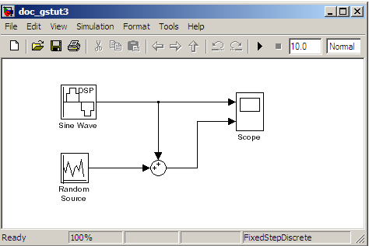

1. If the model you created in Modifying Your Model is not open on your desktop, you can open an equivalent model by typing
doc_gstut3
at the MATLAB command prompt. This model contains a Scope block that displays the original sine wave and the sine wave with white noise added.
2.Open the Signal Processing Blockset library by typing dsplib at the MATLAB command prompt.
3. Convert white noise to low frequency noise by introducing a Digital Filter Design block into your model. In the airplane scenario, the air passing over the fuselage creates white noise that is measured by a sensor. The Random Source block models this noise. The fuselage of the airplane converts this white noise to low frequency noise, a type of colored noise, which is heard inside the cockpit. This noise contains only certain frequencies and is more difficult to eliminate. In this example, you model the low frequency noise using a Digital Filter Design block. This block uses the functionality of the Filter Design and Analysis Tool (FDATool) to design a filter.
Double-click the Filtering library, and then double-click the Filter Designs sublibrary. Click-and-drag the Digital Filter Design block into your model.
4. Set the Digital Filter Design block parameters to design a lowpass filter and create low frequency noise. Open the block parameters dialog box by double-clicking the block. Set the parameters as follows:
• Response Type = Lowpass
• Design Method = FIR and, from the list, choose Window
• Filter Order = Specify order and enter 31
• Scale Passband — Cleared
• Window = Hamming
• Units = Normalized (0 to 1)
• wc = 0.5
Based on these parameters, the Digital Filter Design block designs a lowpass FIR filter with 32 coefficients and a cutoff frequency of 0.5. The block multiplies the time-domain response of your filter by a 32 sample Hamming window.
5. Click Design Filter at the bottom center of the dialog box to view the magnitude response of your filter in the Magnitude Response pane. The Digital Filter Design dialog box should now look similar to the following figure.

6. Aim : Designing a adaptive filter using simulink
Adaptive filters track the dynamic nature of a system and allow you to eliminate time-varying signals. The Signal Processing Blockset libraries contain blocks that implement least-mean-square (LMS), Block LMS, Fast Block LMS, and recursive least squares (RLS) adaptive filter algorithms. These filters minimize the difference between the output signal and the desired signal by altering their filter coefficients. Over time, the adaptive filter's output signal more closely approximates the signal you want to reproduce.
In this topic, you design an LMS adaptive filter to remove the low frequency noise in your signal:
1. If the model you created in Adding a Digital Filter to Your Model is not open on your desktop, you can open an equivalent model by typing doc_gstut5 at the MATLAB command prompt.
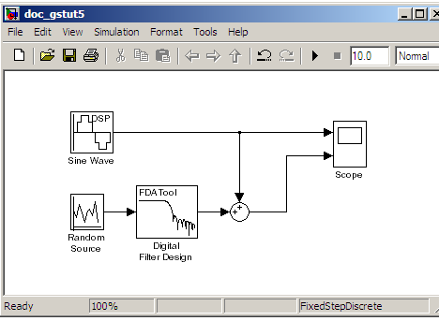
2. Open the Signal Processing Blockset library by typing dsplib at the MATLAB command prompt.
3. Remove the low frequency noise from your signal by adding an LMS Filter block to your system. In the airplane scenario, this is equivalent to subtracting the wind noise inside the cockpit from the input to the microphone. Double-click the Filtering sublibrary, and then double-click the Adaptive Filters library. Add the LMS Filter block into your model.

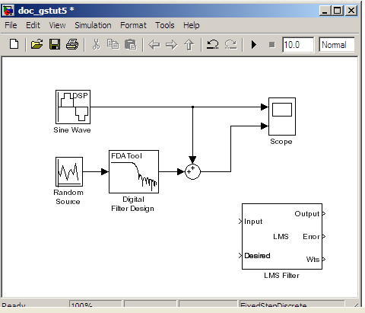
4. Set the LMS Filter block parameters to model the output of the Digital Filter Design block. Open its dialog box by double-clicking the block. Set the block parameters as follows:
• Algorithm = Normalized LMS
• Filter length = 32
• Specify step size via = Dialog
• Step size (mu) = 0.1
• Leakage factor (0 to 1) = 1.0
• Initial value of filter weights = 0
• Clear the Adapt port check box.
• Reset port = None
• Select the Output filter weights check box.

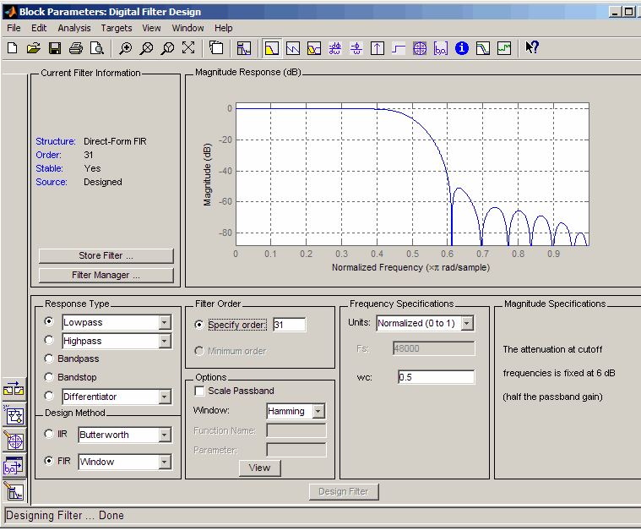

7. Aim :Conversion of analog to digital signal
1. Begin building your model. Open the main Signal Processing Blockset library by typing dsplib at the MATLAB command prompt.
2. If the model you created in Creating a Block Diagram is not open on your desktop, you can open an equivalent model by typing doc_gstut1 at the MATLAB command prompt.
3. Open the Configuration Parameters dialog box by selecting Simulation > Configuration Parameters from the model menu.
4. Set the following Solver options:
• Type: Fixed-step
• Solver: Discrete (no continuous states)
These are the recommended Solver options for Signal Processing Blockset models. For more information on recommended settings, see Configuring the Simulink Environment for Signal Processing Models.
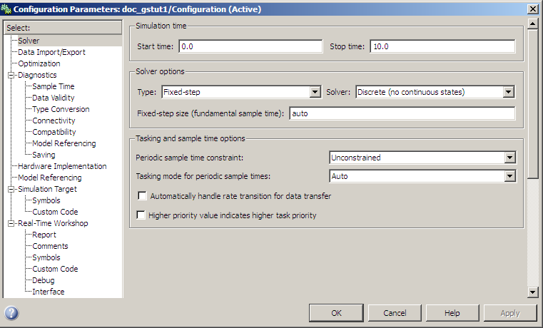

Runnig the model
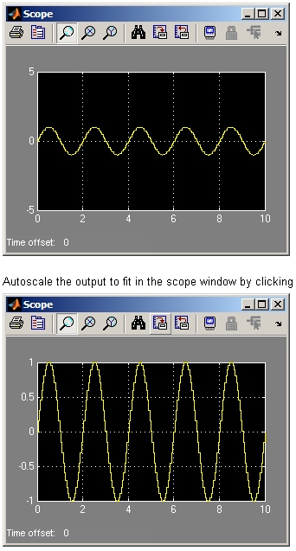

8. Aim : To study sampling using simulink blockset
You can access the main Signal Processing Blockset library from the MATLAB command line. This procedure shows you how to open this library and locate the source blocks:
1. Open the library by typing dsplib at the MATLAB command prompt.
The Signal Processing Blockset libraries are
• Signal Processing Sources — Blocks that create discrete-time or continuous-time signals or import these signals from the MATLAB workspace
• Signal Processing Sinks — Blocks used to display data in a scope or send data to the MATLAB workspace
• Filtering — Blocks used to design digital, analog, adaptive, and multirate filters
• Transforms — Blocks that transform data into different domains
• Signal Operations — Blocks that perform operations such as convolution, downsampling, upsampling, padding, and delaying the input
• Estimation — Blocks for linear prediction, parametric estimation, and power spectrum estimation
• Statistics — Blocks that perform statistical operations such as correlation, maximum, and mean
• Math Functions — Blocks used to perform mathematical operations, matrix operations, and polynomial functions
• Quantizers — Blocks that create scalar and vector quantizers as well as uniform encoders and decoders
• Signal Management — Blocks for buffering, selecting part of a signal, modifying signal attributes, and edge detection
2. Double-click the Signal Processing Sources library. The library displays the blocks it contains. You can use the blocks in this library to create discrete-time or continuous-time signals.

3. Drag any block into a model, double-click the block, and click Help to learn more about the block functionality.
Accessing Blocks with the Library Browser
Starting the Simulink product displays the Simulink Library Browser. To start Simulink, type simulink at the MATLAB command line. One way to explore the Signal Processing Blockset product is to expand the Signal Processing Blockset entry in the tree pane of this browser.

9. Aim : To study Quantisation using simulink blockset
You can access the main Signal Processing Blockset library from the MATLAB command line. This procedure shows you how to open this library and locate the source blocks:
1. Open the library by typing dsplib at the MATLAB command prompt.
The Signal Processing Blockset libraries are
• Signal Processing Sources — Blocks that create discrete-time or continuous-time signals or import these signals from the MATLAB workspace
• Signal Processing Sinks — Blocks used to display data in a scope or send data to the MATLAB workspace
• Filtering — Blocks used to design digital, analog, adaptive, and multirate filters
• Transforms — Blocks that transform data into different domains
• Signal Operations — Blocks that perform operations such as convolution, downsampling, upsampling, padding, and delaying the input
• Estimation — Blocks for linear prediction, parametric estimation, and power spectrum estimation
• Statistics — Blocks that perform statistical operations such as correlation, maximum, and mean
• Math Functions — Blocks used to perform mathematical operations, matrix operations, and polynomial functions
• Quantizers — Blocks that create scalar and vector quantizers as well as uniform encoders and decoders
• Signal Management — Blocks for buffering, selecting part of a signal, modifying signal attributes, and edge detection
2. Double-click the Signal Processing Sources library. The library displays the blocks it contains. You can use the blocks in this library to create discrete-time or continuous-time signals.

3. Drag any block into a model, double-click the block, and click Help to learn more about the block functionality.
Accessing Blocks with the Library Browser
Starting the Simulink product displays the Simulink Library Browser. To start Simulink, type simulink at the MATLAB command line. One way to explore the Signal Processing Blockset product is to expand the Signal Processing Blockset entry in the tree pane of this browser.

1. Aim : Various signal operations using simulink blockset
You can access the main Signal Processing Blockset library from the MATLAB command line. This procedure shows you how to open this library and locate the source blocks:
1. Open the library by typing dsplib at the MATLAB command prompt.
The Signal Processing Blockset libraries are
• Signal Processing Sources — Blocks that create discrete-time or continuous-time signals or import these signals from the MATLAB workspace
• Signal Processing Sinks — Blocks used to display data in a scope or send data to the MATLAB workspace
• Filtering — Blocks used to design digital, analog, adaptive, and multirate filters
• Transforms — Blocks that transform data into different domains
• Signal Operations — Blocks that perform operations such as convolution, downsampling, upsampling, padding, and delaying the input
• Estimation — Blocks for linear prediction, parametric estimation, and power spectrum estimation
• Statistics — Blocks that perform statistical operations such as correlation, maximum, and mean
• Math Functions - Blocks used to perform mathematical operations, matrix operations, and polynomial functions
• Quantizers - Blocks that create scalar and vector quantizers as well as uniform encoders and decoders
• Signal Management — Blocks for buffering, selecting part of a signal, modifying signal attributes, and edge detection
2. Double-click the Signal Processing Sources library. The library displays the blocks it contains. You can use the blocks in this library to create discrete-time or continuous-time signals.
3. Drag any block into a model, double-click the block, and click Help to learn more about the block functionality.
Accessing Blocks with the Library Browser
Starting the Simulink product displays the Simulink Library Browser. To start Simulink, type simulink at the MATLAB command line. One way to explore the Signal Processing Blockset product is to expand the Signal Processing Blockset entry in the tree pane of this browser.

