ENGINEERING MECHANICS LAB MANUAL
Engineering mechanics
----------------------------------------------------------------------------------------------------------------------------

1. To verify the law of triangle of forces and Lami`s theorem.
2. To verify the law of parallelogram of forces.
3. To verify law of polygon of forces.
4. To determine the support reactions of a given truss and verify it
analytically.
5. To determine support reaction of a Simply Supported Beam and verify it analytically using parallel beam apparatus.
6.To determine the moment of inertia of fly wheel by falling weight method.
7. To verify the law of moments by Rotating disc apparatus.
8. To verity the law of moments using a Bell crank lever.

EXPERIMENT NO. 1
LAMI’S THEOREM & LAW OF TRIANGLE OF FORCES
--------------------------------------------------------------------------------------------------------------------------------
Aim: To verify the law of Lami’s theorem and Triangle of forces.
Theory: Law of Triangle of forces states that “If three coplanar, concurrent forces are in equilibrium, the forces can be represented in magnitude and direction by the sides of triangle drawn in such a way that the sides of triangle are parallel to the forces taken in order”.
If two coplanar ,concurrent forces acting on a particle is represented in magnitude and direction by the two sides of a triangle, taken in order, their resultant can be represented in magnitude and direction by the third side of the triangle but in opposite order.
Lami’s theorem states that “If three coplanar concurrent forces acting on a body are in equilibrium, then each force is directly proportional to the sine of angle between the other two forces”.

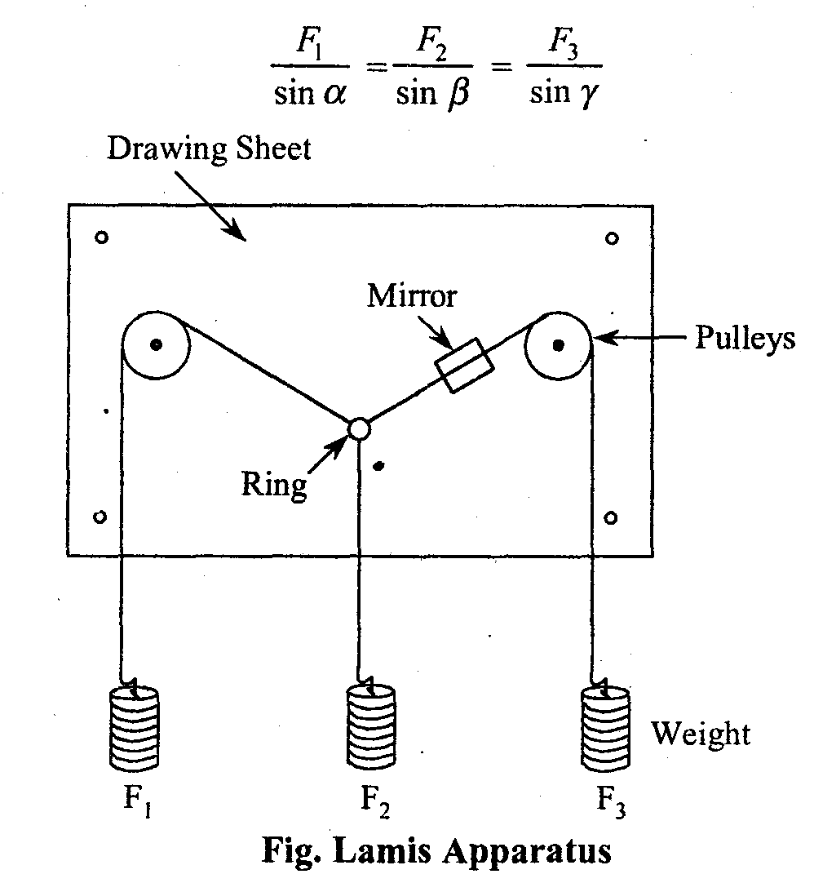

Apparatus Used:
1. Board with pulleys
2. stepped weights hanger
3. Strings,
4. Weights
5. Drawing Sheets

Procedure:
1, Take two wire apparatus and fix drawing sheet on the board.,
2; Connect the hanger at the end of each string and hang the given weight on the pivot provided.
3. Note down the reading of the two spring balances and weight F₂ so that equilibrium condition is achieved.
4. Mark the position of strings on the drawing sheet using mirror after equilibrium condition is reached.
5. Note down magnitudes of weight F₁, F₂ and F₃ in the table.
4. Repeat the above procedure for various sets of readings.
5. Measure magnitude of resultant6 force R graphically for verification of triangle law.
6. Measure the angle α, β, and γ for verification of Lamis theorm,

Observations And Calculations : Law of Triangle of Forces

S.No. | Experimental Force F₁  kg | Experimental Force F₂  kg | Experimental Force F₃  kg | Graphical Force F₃’ | % error  F₃ –F’₃ x100  F₃
1.
2.
3.
4.
5.

Result:
- Law of triangle of forces- ________________(Verified /Not verified)

- For ____ sets of observations, the observed percentage error is____________________

Observations And Calculations : Lami`s Theorem

S. No. | Observed |  |  | Observed |  |  | Analytical |  | % error
S. No. | Force F₁ | Force F₂ | Force F₃ | Angle α | Angle β | Angle γ | F’₁ | F’₂ | F₁ –F’₁ x100  F₁ | F₂ –F’₂ x100  F₂
1.
2.
3.
4.
5.
6.

Result:
- Lami’s Theorem of forces- ________________(Verified /Not verified)

- For ____ sets of observations, the observed percentage error is____________________

Precautions:
I. Pulleys should be smooth.
2. Place the weights gently.
3. Fix the drawing Sheet properly.

Viva Questions:
1. Describe the law of triangle of forces?
Ans:…………………………………………………………………………………………………………………………………………………………………………………………………………………………………………………………………………………………………………………………………………………………………………………………………………………………………………………………
2. State Lami’s theorem?
Ans:…………………………………………………………………………………………………………………………………………………………………………………………………………………………………………………………………………………………………………………………………………………………………………………………………………………………………………………………

3. What are the analytical and graphical equilibrium conditions?
Ans:…………………………………………………………………………………………………………………………………………………………………………………………………………………………………………………………………………………………………………………………………………………………………………………………………………………………………………………………

4.What are the limitations of Lami`s theorem?
Ans:…………………………………………………………………………………………………………………………………………………………………………………………………………………………………………………………………………………………………………………………………………………………………………………………………………………………………………………………

5.What is the exact no. of forces for which Lami`s theorem is applied?
Ans:…………………………………………………………………………………………………………………………………………………………………………………………………………………………………………………………………………………………………………………………………………………………………………………………………………………………………………………………

EXPERIMENT NO. 2
LAW OF PARALLELOGRAM OF FORCES
--------------------------------------------------------------------------------------------------------------------------------
Aim: To verify the law of parallelogram of forces
Theory: If two force F1 and F2 acting on a particle, be represented in magnitude and direction by the two adjacent sides of a parallelogram, then their resultant (R) is represented by the diagonal of the parallelogram ,Magnitude and direction of the resultant force is given by:
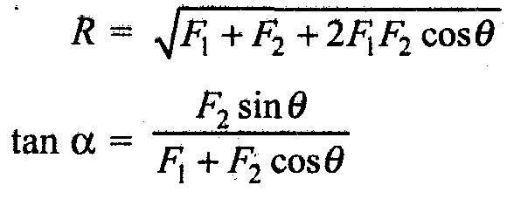
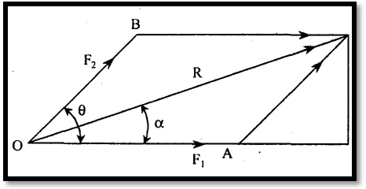
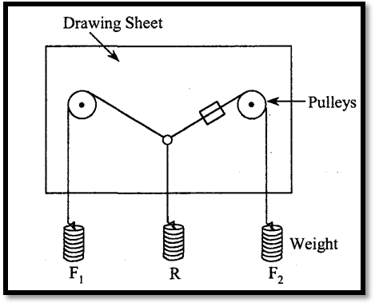
Apparatus used:
1. Board with pulleys, 2.stepped weights hanger, 3. Strings,
4. Weights 5.Drawing Sheets
Procedure:
1. Take two wire apparatus and fix drawing sheet on the board.
2. Connect the hanger at the end of each string and hang the giving weight on the pivot provided.
3. Note down the reading of two weight W₁ and W₂ &weight R so that equilibrium condition is achieved.
4. Mark the position of strings on the drawing sheet using mirror after equilibrium condition is reached.
5. Note down magnitudes of weight F₁, F₂, R and measure angle ϴ and α.
6. Repeat the above procedure for various sets of readings. in the table.
7. Repeat the above procedure for various sets of readings.

Observations And Calculations :
S. No. | Observed Forces |  |  | Observed Angles |  | Analytical values |  | % error
S. No. | F₁ | F₂ | R | θ | α | α’ | R’ | R’ – R x 100  R’ | α’ – α x100  α’
1.
2.
3.
4.
5.
6.

Result:
- Law of Parallelogram of Forces- ________________(Verified /Not verified)

- For ____ sets of observations, the observed percentage error is____________________

Precautions:
1. Pulleys should be smooth.
2. Place the weights gently.
3. Fixed the drawing Sheet properly.
Viva Questions:
1. What are units of forces? Define force?
Ans:…………………………………………………………………………………………………………………………………………………………………………………………………………………………………………………………………………………………………………………………………………………………………………………………………………………………………………………………

2. What are the various types of force?
Ans:…………………………………………………………………………………………………………………………………………………………………………………………………………………………………………………………………………………………………………………………………………………………………………………………………………………………………………………………
3.What do you understand by force?
Ans:…………………………………………………………………………………………………………………………………………………………………………………………………………………………………………………………………………………………………………………………………………………………………………………………………………………………………………………………
4.what do you understand by the term parallel forces?
Ans:…………………………………………………………………………………………………………………………………………………………………………………………………………………………………………………………………………………………………………………………………………………………………………………………………………………………………………………………

5.Distinguish between like forces and unlike forces.
Ans:…………………………………………………………………………………………………………………………………………………………………………………………………………………………………………………………………………………………………………………………………………………………………………………………………………………………………………………………

6.What are collinear, coplanar & concurrent forces?
Ans:…………………………………………………………………………………………………………………………………………………………………………………………………………………………………………………………………………………………………………………………………………………………………………………………………………………………………………………………
7.What is a couple?
Ans:…………………………………………………………………………………………………………………………………………………………………………………………………………………………………………………………………………………………………………………………………………………………………………………………………………………………………………………………
8.state the characteristics of couple?
Ans:…………………………………………………………………………………………………………………………………………………………………………………………………………………………………………………………………………………………………………………………………………………………………………………………………………………………………………………………

EXPERIMENT NO. 3
LAW OF POLYGON OF FORCES
--------------------------------------------------------------------------------------------------------------------------------
Aim: To verify the law of parallelogram of forces by universal force table apparatus.
Theory: This law states that “if a number of coplanar, concurrent forces Is represented in magnitude and direction by the sides of a polygon taken in order then their resultants represented in magnitude and direction by the closing side of the polygon but in opposite order”.
Apparatus Used:
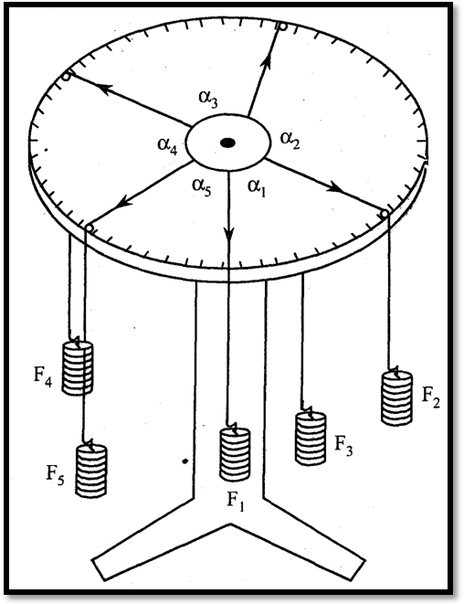
1. Universal force table
2. Strings
3. Weights
4. Hangers
5. drawing sheets
Procedure:
1. Draw the thread over the pulley and connect the hangers at one end of string whose other end is connected to the circular ring.
2. Add suitable weights in each hanger till the ring is in centre and apply load in the thread in such a way that all the forces are in equilibrium.
3. Mark the position of thread with the help of mirror on paper and join all the points.
4. Measure the angles between the strings and read the values of the corresponding weights.
5. Draw the vector diagram and calculate the percentage error.
6. Repeat the experiment for minimum five sets.

Observations And Calculations :
S. No | Experimental Angles |  |  |  |  | Experimental weights |  |  |  |  | Graphical |  | Percentage error
S. No | α₁ | α₂ | α₃ | α₄ | α₅ | F₁ | F₂ | F₃ | F₄ | F₅ | F₅’ | α₅’ | F₅ - F₅’ x 100  F₅ | α ₅ - α ₅’ x 100  α ₅
1.
2.
3.
4.
5.

Result:
- Law of Polygon of Forces- ________________(Verified /Not verified)

- For ____ sets of observations, the observed percentage error is____________________

Precaution:
1.Pulleys should be smooth.
2. Place the weights gently.
3. Plotting should he done carefully.
4. Clean the apparatus carefully.
5. The ring should be at centre for equilibrium position.

Viva Questions:
1. Define free body diagram?
Ans:…………………………………………………………………………………………………………………………………………………………………………………………………………………………
2. What is equilibrant?
Ans:…………………………………………………………………………………………………………………………………………………………………………………………………………………………
3. What are the analytical and graphical conditions of equilibrium of a ringid body?
Ans:………………………………………………………………………………………………………………………………………………………………………………………………………………………… …
4. What are the difference between force polygon and funicular polygon?
Ans:…………………………………………………………………………………………………………………………………………………………………………………………………………………………
5.Define the term Resultant.
Ans:…………………………………………………………………………………………………………………………………………………………………………………………………………………………………………………………………………………………………………………………………………………………………………………………………………………………………………………………
6. Differentiate between Resultant and Equilibrant.
Ans……………………………………………………………………………………………………………………………………………………………………………………………………………………………

EXPERIMENT NO. 4
SUPPORT REACTION OF A TRUSS
-------------------------------------------------------------------------------------------------------------------------
Aim: To determine the support reactions of a given truss and verify it analytically
Theory: The truss is one of the major types of engineering structures. It provides both a practical and
economical solution to many engineering situations, especially in Learning content the design of bridges
and buildings. A truss consists of straight members connected at joints. The truss is designed to carry
those loads which acts in its plane and thus treated as a two-dimensional structure. The applied loads are at
the joints. The load shared by the members of the truss is along their axes. These members are either in
tension tend to elongate or in compression tends to shorten. Force analysis in the members of the truss
helps in deciding their size. The ﬁrst step in the procedure of analysis is to determine the reaction on
the support.
The aim of the experiment is to ﬁnd support reaction of a given truss (in the present case it
is warren type) and verify analytically considering it simply supported. The truss is loaded at three joints
and supported on a frame through spring balances at two joints. The readings on the spring balance show
the amount of force on the support.

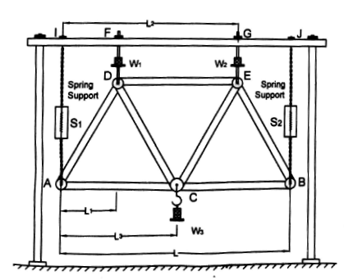

Apparatus Used:

(a) A warren- truss apparatus

(b) A set of slotted masses of known values weights (1 kg, 2 kg, ..... ..)

(c) A measuring tape

(d) Sprit level etc.

Procedure:

(a) Ensure that the truss remains in a vertical plane during the observation

(b) Note the initial reading on the scale of spring balance.

(c) Place the known masses at speciﬁed joints (here they are three)

(d) Note the changed readings on the scale of spring balances

(e) Change the loads at these joints and record the corresponding readings of spring balance scale

(f) Take at least FIVE or more sets of observations and tabulate them

(g) Measure the distance of loads from the left end of support of spring balance

(L₁, L₂, L₃ for W₁, W₂, W₃ respectively). Measure the distance L between the

spring balance support.

Considering the equilibrium of forces :

ΣV = 0

i.e., R_{A} +R_{B} =W₁ +W₂ +W₃

and

ΣM_{A}= o

R_{B}= (W₁L₁ + W₂L₂ +W₃L₃)/L

Then R_{A} =(W₁ +W₂ +W₃)-R_{B}

Observations And Calculations :

S.No. | Applied Loads |  |  | Final Reading of spring balance |  | Experimental  Reaction  R’_{A} =S”_{A} –S_{A} | Analytical  Reaction  R_{A} | % error in R_{A}  R_{A} –R’_{A} x100  R_{A} | Experimental Reaction  R’_{B} =S”_{B} –S_{B} | Analytical  Reaction  R_{B} | % error in R_{B}  R_{B} –R’_{B} x100  R_{B}
S.No. | W₁ | W₂ | W₃ | S”_{A} | S”_{B}
1.
2.
3.
4.
5.

Results
- For ____ sets of observations, the observed percentage error in R_{A} is____________________
- For ____ sets of observations, the observed percentage error in RB is____________________
Precautions

(a)Ensure the loads and the truss are in a vertical plane throughout the observation

(b) Do not put excessive load..

(c) Remove the load as the observations are over.

(d) Loads should be placed gently.

Viva questions:

What is a perfect frame?
Ans:………………………………………………………………………………………………………………………………………………………………………………………………………………………………………………………………………………………………………………………………………………………………………………………………………………………………………………

What are the methods of analysisng a perfect frame?
Ans:…………………………………………………………………………………………………………………………………………………………………………………………………………………………………………………………………………………………………………………………………………………………………………………………………………………………

Which are the various type of frames?
Ans:…………………………………………………………………………………………………………………………………………………………………………………………………………………………………………………………………………………………………………………………………………………………………………………………………………………………

What is redundant frame?
Ans:…………………………………………………………………………………………………………………………………………………………………………………………………………

Write expression for perfect frame.
Ans:…………………………………………………………………………………………………………………………………………………………………………………………………………………………………………………………………………………………………………………………………………………………………………………………………………………………

Which are the assumptions made in the analysis of a perfect frame?
Ans:…………………………………………………………………………………………………………………………………………………………………………………………………………

What is deﬁcient frame?
Ans:…………………………………………………………………………………………………………………………………………………………………………………………………………………………………………………………………………………………………………………………………………………………………………………………………………………………

EXPERIMENT NO. 5
SHEAR FORCE OF SIMPLY SUPPORTED BEAM
-------------------------------------------------------------------------------------------------------------------------
Aim: To determine support reaction of a Simply Supported Beam and draw shear force diagram.
Theory: Shear force is the algebraic sum of all vertical forces either on left hand or right hand of section.
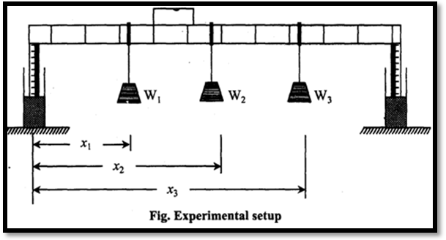
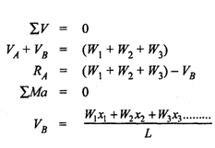
Apparatus Used:
1. Parallel beam apparatus. 2. Measuring scale. 3. Sets of weights. 4. Sprit level.
Procedure:
1. Measure the length of the beam and and note down the balance readings for no load.
2. Apply loads at various points on the beam and measure its distance from support.
3. Note down the readings of balance.
4. Repeat the above steps with changing loads for at least five sets.
5. Compare the experimental values with the analytical values.
Observations And Calculations :
S.No. | Applied Loads |  |  | Distance of Load from end A |  |  | Final reading of spring balance |  | Experimental  Reaction  R’_{A} =S”_{A} –S_{A} | Analytical  Reaction  R_{A} | % error in R_{A}  R_{A} –R’_{A} x100  R_{A} | Experimental Reaction  R’_{B} =S”_{B} –S_{B} | Analytical  Reaction  R_{B} | % error in R_{B}  R_{B} –R’_{B} x100  R_{B}
S.No. | W₁ | W₂ | W₃ | x₁ | x₂ | x₃ | S”_{A} | S”_{B}
1.
2.
3.
4.
5.

Results
- For ____ sets of observations, the observed percentage error in R_{A} is____________________
- For ____ sets of observations, the observed percentage error in R_{B} is____________________

Precautions
1. Level the beam properly at no load condition.
2. Keep the loads gently.
3. Take the spring balance reading properly.
4. Measure the span and position of the loads carefully.
Viva questions:
- Define a beam?
Ans:…………………………………………………………………………………………………………………………………………………………………………………………………………………………………………………………………………………………………………………………………………………………………………………………………………………………

- Define S.F. and B.M.?
Ans:…………………………………………………………………………………………………………………………………………………………………………………………………………………………………………………………………………………………………………………………………………………………………………………………………………………………

- What are various types of beam?
Ans:…………………………………………………………………………………………………………………………………………………………………………………………………………………………………………………………………………………………………………………………………………………………………………………………………………………………

- What are various types of supports?
Ans:…………………………………………………………………………………………………………………………………………………………………………………………………………………………………………………………………………………………………………………………………………………………………………………………………………………………

- What are various types of loadings?
Ans:…………………………………………………………………………………………………………………………………………………………………………………………………………………………………………………………………………………………………………………………………………………………………………………………………………………………

6.What is point of contraflexure?
Ans:…………………………………………………………………………………………………………………………………………………………………………………………………………………………………………………………………………………………………………………………………………………………………………………………………………………………

EXPERIMENT NO. 6
FLY WHEEL
--------------------------------------------------------------------------------------------------------------------------------
Aim: To determine the moment of inertia of fly wheel by falling weight method.
Theory: Flywheel is a device which absorb energy when demand is Less than the supply of energy ans will give out the energy when demand is more than the energy being supplied.It consists of a heavy wheel mounted on the axle and the axle is supported on small bearing.
Let N₁ be the number of revolutions made by flywheel while the mass m is falling by height ‘h’ and N₂ be the number of revolutions made by the flywheel before coming to rest. Let ’t’ be the time taken to complete the revolution N₂ ,r be the radius of flywheel ,then the moment of inertia of flywheel
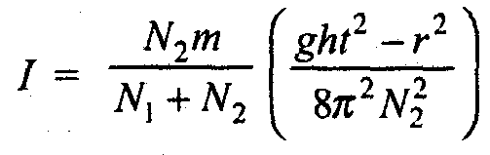
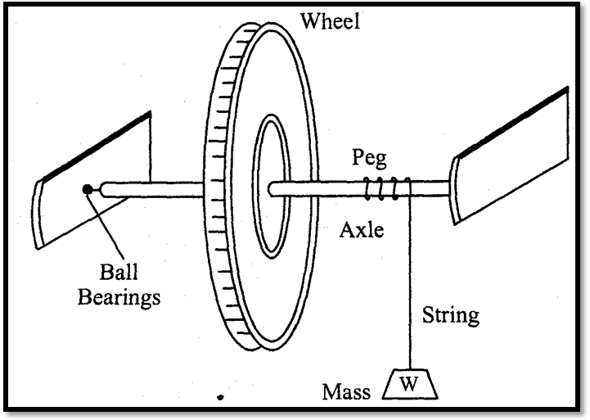
Apparatus Required:
1. Flywheel. 2. Hanger with known masses
3. Weight 4. Stop watch 5. Measuring tape
6. String 7. Vernier calipers.
Procedure:
1. Measure the radius of the axle by vernier caliper.
2. Attach the string & wind it and push the pin of string into the hole of axle &count the number of turns.
3. Attach the mass to the outer end of string and measure distance between floor and weight.
4. Release the mass. As mass falls, the wheel makes revolutions. Note the time of the fall from instant of release to the instant it gets detached.
5. Start stop watch as mass is detached and observe the time taken to come to rest. Also note the revolutions of flywheel after detachment of mass, Count the total number of revolutions made from the instant the mass is released to the instant it comes to rest.
6. The steps as mentioned above are repeated and an average are taken.
7. Repeat the procedure for different weights.
Observations And Calculations :
Radius of flywheel axle (r) =……….cm
S.No. | Suspended mass  (m) | Height of mass fall  (h) | No. of revolutions during mass fall (N₁) | No. of revolutions after mass fall (N₂) | Time (t) | Moment of inertia | Average moment of inertia
1.
2.
3.
4.
5.
6.
Result:
Observed moment of inertia of flywheel is …………………..
Precautions:
1. Measure the lengths accurately.
2. Note down the time accurately.
3. Revolve the fly wheel without jerk.

Viva Questions:
1. What is a fly wheel?
Ans:…………………………………………………………………………………………………………………………………………………………………………………………………………………………

2. Define plane Moment of Inertia?
Ans:…………………………………………………………………………………………………………………………………………………………………………………………………………………………

3. Differentiate between inertia and moment of inertia?
Ans:…………………………………………………………………………………………………………………………………………………………………………………………………………………………
4. Define radius of gyration?
Ans:…………………………………………………………………………………………………………………………………………………………………………………………………………………………

5. Explain parallel axis theorem and perpendicular axis theorem?
Ans:…………………………………………………………………………………………………………………………………………………………………………………………………………………………
- Define product of Inertia and principal Moment of Inertia?
Ans:…………………………………………………………………………………………………………………………………………………………………………………………………………………………
EXPERIMENT NO. 7
ROTATING DISC APPARATUS
--------------------------------------------------------------------------------------------------------------
Aim: To verify the law of moments by rotating disc apparatus.
Theory: As per this law we can say that if a number of coplanar forces acting on a rigid body which is in equilibrium then the algebraic sum of the moments of all forces about any point in their plane is zero.
Apparatus Used: 1. Rotating disc apparatus 2. Sets of weights 3. Scale
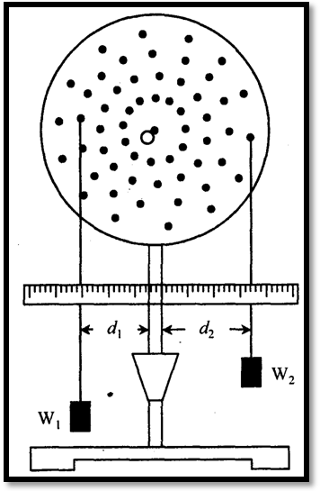
Procedure:
1. Put weights in the two pans and note down W₁ and W₂.
2. Notc down the distance d1 and d, on the scale and enter in table.
3. Take different sets of reading by changing the position of pins &find out the value of both the moments.
4. Calculate the percentage error.
5. What is the principle of moment

Observations And Calculations :
S. No. | Weight W₁ | Distance from centre d₁ | Weight W₂ | Distance from centre d₂ | M₁ = W₁ d₁ | M₂ = W₂ d₂ | Percentage error=  M₁ –M₂ x 100  M₁
1.
2.
3.
4.
5.

Results :
The average percentage error is =……………………

Precautions:
1. Note down the distance carefully.
2. Place the Weights gently.
3. Lubrication should be done.
Viva questions:
- What are the conditions of equilibrium?
Ans:…………………………………………………………………………………………………………………………………………………………………………………………………………………………………………………………………………………………………………………………………………………………………………………………………………………………
- Define Force.
Ans:………………………………………………………………………………………………… ………………………………………………………………………………………………………
- Define moment.
Ans:…………………………………………………………………………………………………………………………………………………………………………………………………………………………………………………………………………………………………………………………………………………………………………………………………………………………
- Define couple.
Ans:…………………………………………………………………………………………………………………………………………………………………………………………………………………………………………………………………………………………………………………………………………………………………………………………………………………………

- Define Force, moment ,and couple.
Ans:…………………………………………………………………………………………………………………………………………………………………………………………………………………………………………………………………………………………………………………………………………………………………………………………………………………………

- State the conditions of equilibrium.
Ans:…………………………………………………………………………………………………………………………………………………………………………………………………………………………………………………………………………………………………………………………………………………………………………………………………………………………

- state the types of equilibrium.
Ans:…………………………………………………………………………………………………………………………………………………………………………………………………………………………………………………………………………………………………………………………………………………………………………………………………………………………

- Distinguish between moment and couple.
Ans:…………………………………………………………………………………………………………………………………………………………………………………………………………………………………………………………………………………………………………………………………………………………………………………………………………………………
EXPERIMENT NO. 8
BELL CRANK LEVER
--------------------------------------------------------------------------------------------------------------------------------
Aim: To verify the law of moments using a bell crank lever.
Theory: This experiment is based on the basic engineering principle i.e., the Principle of Moments. The algebraic sum of moments of all forces about any point is equal to the moment of the resultant about same point.
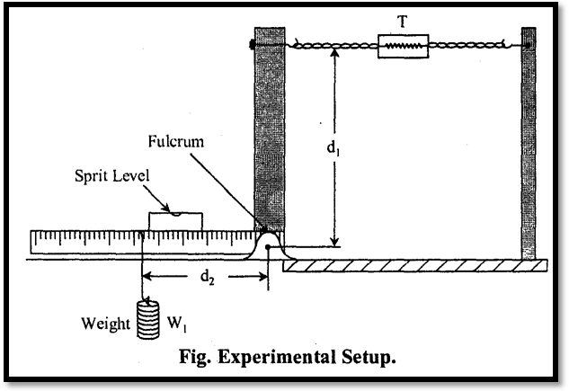
Apparatus used:
1. Bell crank lever. 2. Sets of weights. 3. Sprit level 4. Meter scale
Procedure:
1. Note down the initial reading of the spring balance when no load is applied.
2. Apply suitable load W on the arm.
3. Measure distance on the scale from the fulcrum.
4. Note down the reading of the spring balance T in equilibrium.
5. Measure vertical distance.
6. Repeat the same process for different loads.

Observations And Calculations :
Length of arm d₁ =…………………………..
S. No. | Load on lever | Length of side | Spring balance reading |  |  | moments |  | Percentage error=
S. No. | W | d₂ | initial (S₁) | Final (S₂) | T= S₂ – S₁ | M₂ = W d₂ | M₁ = W d₁ | M₁ –M₂ x 100  M₁
1.
2.
3.
4.
5.

Results
The average percentage error is =……………………
Precautions:
1. Weight should not be applied with any jerk.
2. Measure distance carefully from fulcrum.
3. Lever arm should horizontal before taking the reading.

Viva Questions:
- Define lever?
Ans:…………………………………………………………………………………………………………………………………………………………………………………………………………………………………………………………………………………………………………………………………………………………………………………………………………………………
- Draw the free body diagram of lever?
Ans:……………………………………………………………………………………………………………………………………………………………………………………………………………………
- What is a bell crank lever?
Ans:…………………………………………………………………………………………………………………………………………………………………………………………………………………………………………………………………………………………………………………………………………………………………………………………………………………………

- What is the leverage?
Ans:…………………………………………………………………………………………………………………………………………………………………………………………………………………………………………………………………………………………………………………………………………………………………………………………………………………………

5.Give the example of lever commonly used in our daily life?
Ans:…………………………………………………………………………………………………………………………………………………………………………………………………………………………

6.Explain the principle of lever.
Ans:…………………………………………………………………………………………………………………………………………………………………………………………………………………………
7.State the law of moments.
Ans:…………………………………………………………………………………………………………………………………………………………………………………………………………………………

8.What is Varignon`s principle?
Ans:…………………………………………………………………………………………………………………………………………………………………………………………………………………………

