DEPARTMENT

OF

LAB MANUAL

“FUNDAMENTALS OF ELECTRONICS ENGINEERING LAB ”

Name: ______________________________________
Semester: ___________________________________
Branch: _____________________________________
Enrollment No. _______________________________

BACHELOR OF ENGINEERING (B.E.) COURSE

SEMESTER – I

LABFILE
FUNDAMENTAL OF ELECTRONICS ENGINEERING



FUNDAMENTALS OF ELECTRONICS ENGINEERING
LIST OF EXPERIMENTS as per RGPV Syllabus

S.NO | NAME OF EXPERIMENT
1  2  3 | INTRODUCTION TO BASIC ELECTRONICS COMPONENTS.  INTRODUCTION TO BREAD BOARD.  TO OBSERVE SINE WAVE AND TRIANGULAR WAVE ON CRO (CATHODE RAY OSCILLOSCOPE).
4 | TO VERIFY THE OPERATION OF ALL LOGIC GATES: OR GATE, AND GATE, NOT GATE, NOR GATE, NAND GATE, EX-OR GATE AND EX-NOR GATE.
5  6 | TO VERIFY DEMORGAN’S THEOREMS..  TO STUDY FORWARD CHARACTERISTICS OF PN DIODE.
7 | TO STUDY REVERSE CHARACTERISTICS OF PN JUNCTION DIODE.
8  9 | TO PLOT REVERSE CHARACTERISTICS OF ZENER DIODE  STUDY AND DESIGN OF HALF WAVE RECTIFIER.
10 | STUDY AND DESIGN OF FULL WAVE RECTIFIER.

INDEX

S.No | Name of Experiment | Date of performance | Date of getting checked | Teacher Signature
1 | Introduction to basic Electronics components
2 | Introduction to Bread Board.
3 | To observe Sine Wave and Triangular Wave on CRO (Cathode Ray Oscilloscope).
4 | To verify the operation of all logic gates: OR gate, AND gate, NOT gate, NOR gate, NAND gate, Ex-OR gate and Ex-NOR gate
5 | To verify Demorgan’s Theorems...
6 | To study forward characteristics of PN Diode.
7 | To study reverse characteristics of pn junction diode.
8 | To plot reverse characteristics of Zener diode Diode
9 | Study and design of half wave rectifier.  .
10 | Study and design of full wave rectifier.

USEFUL ICs

IC NUMBER | Description of IC
7400 | Quad 2 input NAND GATE
7401 | Quad 2input NAND Gate
7402 | Quad 2 input NOR Gate
7403 | Quad 2 input NOR Gates
7404 | Hex Inverts
7408 | Quad 2 input AND Gate
7421 | Dual 4 input AND Gate
7430 | 8 input NAND Gate
7432 | Quad 2 input OR Gate
7486 | Quad 2 input EX-OR Gate

Experiment No-1
Aim: Introduction to Basic Electronics Components

Resistor
A resistor is a passive two-terminal electrical component that implements electrical resistance as a circuit element. Resistors act to reduce current flow, and, at the same time, act to lower voltage levels within circuits. In electronic circuits, resistors are used to limit current flow, to adjust signal levels, bias active elements, and terminate transmission lines among other uses. High-power resistors that can dissipate many watts of electrical power as heat may be used as part of motor controls, in power distribution systems, or as test loads for generators. Fixed resistors have resistances that only change slightly with temperature, time or operating voltage. Variable resistors can be used to adjust circuit elements (such as a volume control or a lamp dimmer), or as sensing devices for heat, light, humidity, force, or chemical activity.
Resistors are common elements of electrical networks and electronic circuits and are ubiquitous in electronic equipment. Practical resistors as discrete components can be composed of various compounds and forms. Resistors are also implemented within integrated circuits.
The electrical function of a resistor is specified by its resistance: common commercial resistors are manufactured over a range of more than nine orders of magnitude. The nominal value of the resistance will fall within a manufacturing tolerance
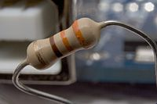
A typical axial-lead resistor
Electronic symbol
Two common schematic symbols

Capacitor
A capacitor (originally known as a condenser) is a passive two-terminal electrical component used to store electrical energy temporarily in an electric field. The forms of practical capacitors vary widely, but all contain at least two electrical conductors (plates) separated by a dielectric (i.e. an insulator that can store energy by becoming polarized). The conductors can be thin films, foils or sintered beads of metal or conductive electrolyte, etc. The nonconducting dielectric acts to increase the capacitor's charge capacity. A dielectric can be glass, ceramic, plastic film, air, vacuum, paper, mica, oxide layer etc. Capacitors are widely used as parts of electrical circuits in many common electrical devices. Unlike a resistor, an ideal capacitor does not dissipate energy. Instead, a capacitor stores energy in the form of an electrostatic field between its plates.
When there is a potential difference across the conductors (e.g., when a capacitor is attached across a battery), an electric field develops across the dielectric, causing positive charge +Q to collect on one plate and negative charge −Q to collect on the other plate. If a battery has been attached to a capacitor for a sufficient amount of time, no current can flow through the capacitor. However, if a time-varying voltage is applied across the leads of the capacitor, a displacement current can flow.
An ideal capacitor is characterized by a single constant value, its capacitance. Capacitance is defined as the ratio of the electric charge Q on each conductor to the potential difference V between them. The SI unit of capacitance is the farad (F), which is equal to one coulomb per volt (1 C/V). Typical capacitance values range from about 1 pF (10⁻¹² F) to about 1 mF (10⁻³ F).
The larger the surface area of the "plates" (conductors) and the narrower the gap between them, the greater the capacitance is. In practice, the dielectric between the plates passes a small amount of leakage current and also has an electric field strength limit, known as the breakdown voltage. The conductors and leads introduce an undesired inductance and resistance.
Capacitors are widely used in electronic circuits for blocking direct current while allowing alternating current to pass. In analog filter networks, they smooth the output of power supplies. In resonant circuits they tune radios to particular frequencies. In electric power transmission systems, they stabilize voltage and power flow.
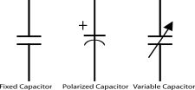
Electronic symbol

Transistor
A transistor is a semiconductor device used to amplify and switch electronic signals and electrical power. It is composed of semiconductor material with at least three terminals for connection to an external circuit. A voltage or current applied to one pair of the transistor's terminals changes the current through another pair of terminals. Because the controlled (output) power can be higher than the controlling (input) power, a transistor can amplify a signal. Today, some transistors are packaged individually, but many more are found embedded in integrated circuits.
The transistor is the fundamental building block of modern electronic devices, and is ubiquitous in modern electronic systems. Following its development in 1947 by American physicists John Bardeen, Walter Brattain, and William Shockley, the transistor revolutionized the field of electronics, and paved the way for smaller and cheaper radios, calculators, and computers, among other things.
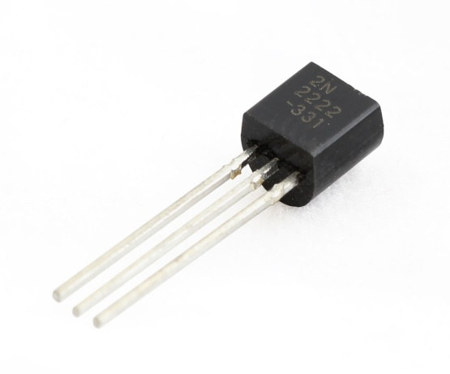

Multimeter
A multimeter or a multitester, also known as a VOM (Volt-Ohm meter or Volt-Ohm-milliammeter ), is an electronic measuring instrument that combines several measurement functions in one unit. A typical multimeter would include basic features such as the ability to measure voltage, current, and resistance. Analog multimeters use a microammeter whose pointer moves over a scale calibrated for all the different measurements that can be made. Digital multimeters (DMM, DVOM) display the measured value in numerals, and may also display a bar of a length proportional to the quantity being measured. Digital multimeters are now far more common but analog multimeters are still preferable in some cases, for example when monitoring a rapidly varying value.

A multimeter can be a hand-held device useful for basic fault finding and field service work, or a bench instrument which can measure to a very high degree of accuracy. They can be used to troubleshoot electrical problems in a wide array of industrial and household devices such as electronic equipment, motor controls, domestic appliances, power supplies, and wiring systems.
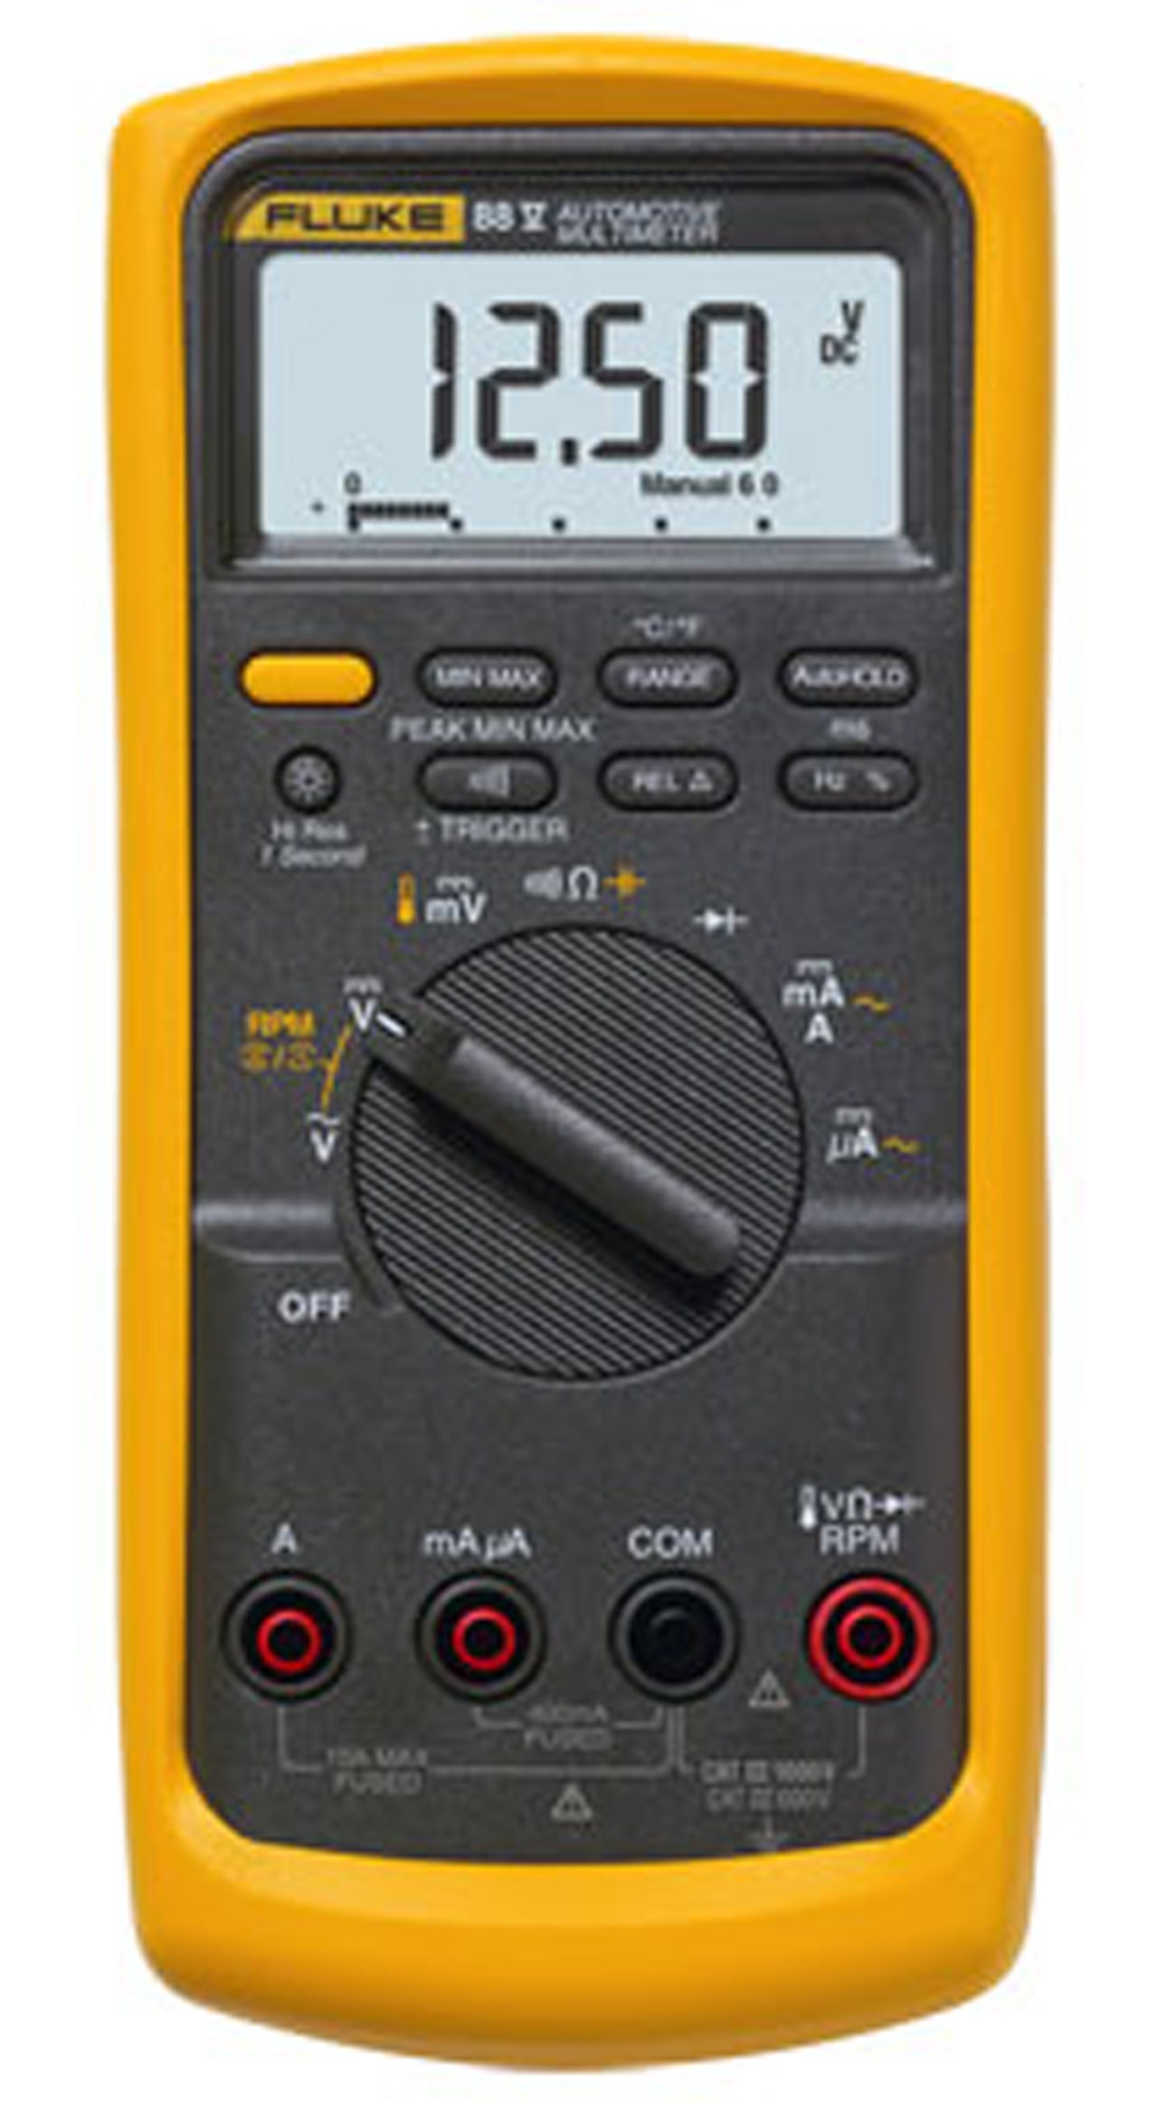

EXPERIMENT No- 2

Aim: Introduction to BreadBoard
The breadboard consists of two terminal strips and two bus strips (often broken in the centre). Each bus strip has two rows of contacts. Each of the two rows of contacts is a node. That is, each contact along a row on a bus strip is connected together (inside the breadboard). Bus strips are used primarily for power supply connections, but are also used for any node requiring a large number of connections. Each terminal strip has 60 rows and 5 columns of contacts on each side of the centre gap. Each row of 5 contacts is a node.
Circuits can be build on the terminal strips by inserting the leads of circuit components into the contact receptacles and making connections with 22-26 gauge wire. There are wire cutter/strippers and a spool of wire in the lab. It is a good practice to wire +5V and 0V power supply connections to separate bus strips.
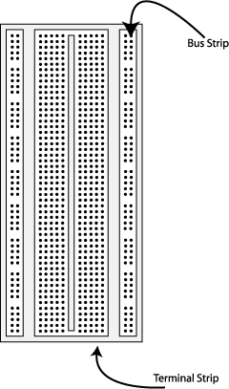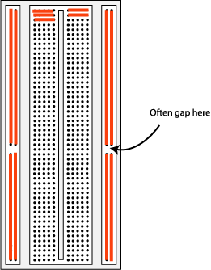
Fig 1. The breadboard. The orange lines indicate connected holes.

The 5V supply must not be exceeded since this will damage the ICs (Integrated circuits) used during the experiments. Incorrect connection of power to the ICs could result in them exploding or becoming very hot - with the possible serious injury occurring to the people working on the experiment.Ensure that the power supply plarity and all components and connections are correct before switching on power on the minilab.

Building the Circuit
Throughout these experiments we will use TTL chips to build circuits. The steps for wiring a circuit should be completed in the order described below:
- Turn the power (Minilab) off before you build anything.
- Make sure the power is off before anything build
- Connect the +5V and ground (GND) leads of the power supply to the power and ground bus strips on breadboard. The +5V supply may be found on the bottom centre of the Minilab with the black switch at the +5V fixed position. Before connecting up, use a voltmeter to check that the voltage does not exceed 5V.
- Plug the chips using for making circuit into the breadboard. Point all the chips in the same direction with pin 1 at the upper-left corner. (Pin 1 is often identified by a dot or a notch next to it on the chip package)
- Connect +5V and GND pins of each chip to the power and ground bus strips on the breadboard.
- Select a connection on schematic and place a piece of hook-up wire between corresponding pins of the chips on breadboard. It is better to make the short connections before the longer ones..
- If an error is made and is not spotted before power on. Turn the power off immediately before you begin to rewire the circuit.
- At the end of the laboratory session, collect hook-up wires, chips and all equipment and return them to the demonstrator.
- Tidy the area that you were working in and leave it in the same condition as it was before you started.

Common Causes of Problems

Not connecting the ground and/or power pins for all chips
- Not turning on the power supply before checking the operation of the circuit.
- Leaving out wires.
- Plugging wires into the wrong holes
- Driving a single gate input with the outputs of two or more gates
- Modifying the circuit with the power on.

Example Implementation of a Logic Circuit
Build a circuit to implement the Boolean function F = ( A . B)
IC Required: 7400: Quad 2 input NAND gate
7404: HEX Inverter
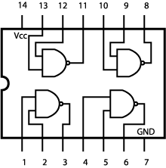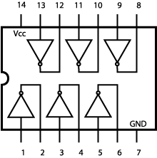
Quad 2 Input 7400 Hex 7404 Inverter
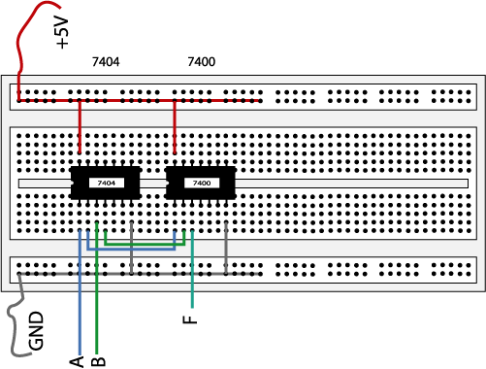
Fig 2. The complete designed and connected circuit
Sometimes the chip manufacturer may denote the first pin by a small indented circle above the first pin of the chip. Place chips in the same direction, to save confusion at a later stage. Connect power to the chips to get them to work.

EXPERIMENT NO. 3
AIM: - Study of CRO and observe Sine and Triangular wave on CRO.
Theory:- An oscilloscope is a test instrument which allows us to look at the 'shape' of electrical signals by displaying a graph of voltage against time on its screen. It is like a voltmeter with the valuable extra function of showing how the voltage varies with time. A graticule with a 1cm grid enables us to take measurements of voltage and time from the screen. The graph, usually called the trace, is drawn by a beam of electrons striking the phosphor coating of the screen making it emit light, usually green or blue. This is similar to the way a television picture is produced.

Oscilloscopes contain a vacuum tube with a cathode (negative electrode) at one end to emit electrons and an anode (positive electrode) to accelerate them so they move rapidly down the tube to the screen. This arrangement is called an electron gun. The tube also contains electrodes to deflect the electron beam up/down and left/right.

The electrons are called cathode rays because they are emitted by the cathode and this gives the oscilloscope its full name of cathode ray oscilloscope or CRO.

A dual trace oscilloscope can display two traces on the screen, allowing us to easily compare the input and output of an amplifier for example. It is well worth paying the modest extra cost to have this facility.
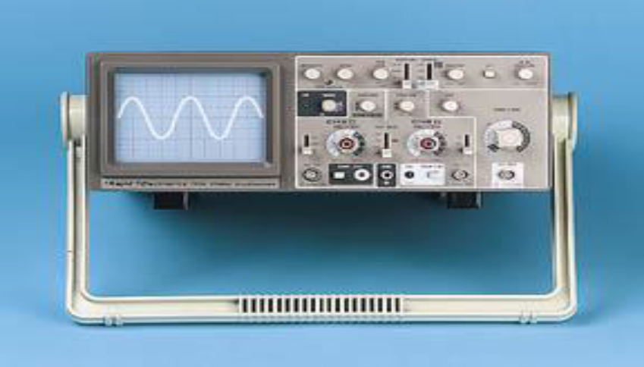
Figure 1: Front Panel of CRO
BASIC OPERATION OF CRO:-
Oscilloscopes are complex instruments with many controls and they require some care to set up and use successfully. It is quite easy to 'lose' the trace off the screen if controls are set wrongly.

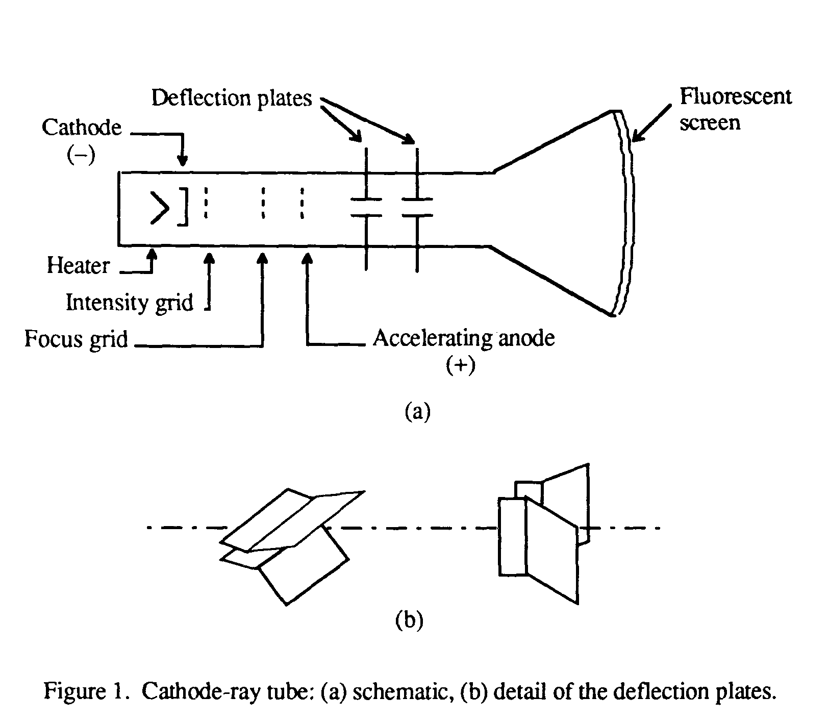
Figure 2: Internal Blocks of CRO
There is some variation in the arrangement and labeling of the many controls. So, the following instructions may be adapted for this instrument.
1. Switch on the oscilloscope to warm up (it takes a minute or two).
2. Do not connect the input lead at this stage.
3. Set the AC/GND/DC switch (by the Y INPUT) to DC.
4. Set the SWP/X-Y switch to SWP (sweep).
5. Set Trigger Level to AUTO.
6. Set Trigger Source to INT (internal, the y input).
7. Set the Y AMPLIFIER to 5V/cm (a moderate value).
8. Set the TIMEBASE to 10ms/cm (a moderate speed).
9. Turn the time base VARIABLE control to 1 or CAL.
10. Adjust Y SHIFT (up/down) and X SHIFT (left/right) to give a trace across the middle of the screen, like the picture.
11. Adjust INTENSITY (brightness) and FOCUS to give a bright, sharp trace

The following type of trace is observed on CRO after setting up, when there is no input signal connected.

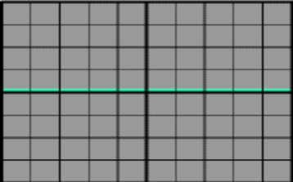

Figure 3: Absence of input signal
The trace of an AC signal with the oscilloscope controls correctly set is as shown in
Figure
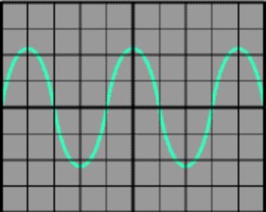

Measuring voltage and time period
The trace on an oscilloscope screen is a graph of voltage against time. The shape of this graph is determined by the nature of the input signal. In addition to the properties labeled on the graph, there is frequency which is the number of cycles per second. The diagram shows a sine wave but these properties apply to any signal with a constant shape

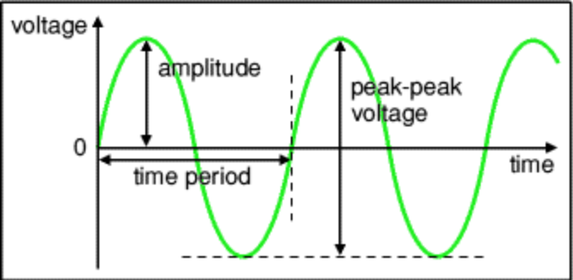
- Amplitude is the maximum voltage reached by the signal. It is measured in volts.
- Peak voltage is another name for amplitude.
- Peak-peak voltage is twice the peak voltage (amplitude). When reading an oscilloscope trace it is usual to measure peak-peak voltage.
- Time period is the time taken for the signal to complete one cycle. It is measured in seconds (s), but time periods tend to be short so milliseconds (ms) and microseconds (μs) are often used. 1ms = 0.001s and 1μs = 0.000001s.
- Frequency is the number of cycles per second. It is measured in hertz (Hz), but frequencies tend to be high so kilohertz (kHz) and megahertz (MHz) are often used. 1kHz = 1000Hz and 1MHz = 1000000Hz.

Frequency = 1/ Time period

Time period = 1/ Frequency

A) Voltage: Voltage is shown on the vertical y-axis and the scale is determined by the Y AMPLIFIER (VOLTS/CM) control. Usually peak-peak voltage is measured because it can be read correctly even if the position of 0V is not known. The amplitude is half the peak-peak voltage.

Voltage = distance in cm × volts/cm
B) Time period: Time is shown on the horizontal x-axis and the scale is determined by the TIMEBASE (TIME/CM) control. The time period (often just called period) is the time for one cycle of the signal. The frequency is the number of cycles per second, frequency = 1/time period.
Time = distance in cm × time/cm
OBSERVATION TABLE
For Sine Wave:-
S.NO. | THEORETICAL  FREQUENCY | FREQUENCY OBSERVED | %ERROR

- For Triangular Wave:-
S.NO. | THEORETICAL  FREQUENCY | FREQUENCY OBSERVED | %ERROR
EXPERIMENT NO. 4

Aim: To verify the operation of all Logic gates: OR gate, AND gate, NOT gate, NOR gate, NAND gate, Ex-OR gate and Ex-NOR gate
Objective:
- To get familiar with the usage of the available lab equipments.
- To describe and verify the operation for the AND, OR, NOT, NAND, NOR,
XOR gates.
- To study the representation of these functions by truth tables, logic diagrams
and Boolean algebra.

Appararus/ Equipment Required:
- Trainer Kit
- Digital ICs: 7404 :Hex Inverter
7408 :Quad 2 input AND
7432 :Quad 2 input OR
7400: Quad 2 input NAND
7402: Quad 2 input NOR
7486: Quad 2 input EXOR
- Connecting Wires

Theory: Introduction to Digital Logic Gates
A Digital Logic Gate is an electronic device that makes logical decisions based on the different combinations of digital signals present on its inputs. Digital logic gates may have more than one input but generally only have one digital output. Individual logic gates can be connected together to form combinational or sequential circuits, or larger logic gate functions. Standard commercially available digital logic gates are available in two basic families or forms, TTL which stands for Transistor-Transistor Logic such as the 7400 series, and CMOS which stands for Complementary Metal-Oxide-Silicon which is the 4000 series of chips. This notation of TTL or CMOS refers to the logic technology used to manufacture the integrated circuit, (IC) or a “chip” as it is more commonly called.
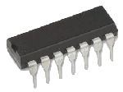
Digital Logic Gate
The Digital Logic Gate is the basic building block from which all digital electronic circuits and microprocessor based systems are constructed from. Basic digital logic gates perform logical operations of AND, OR and NOT on binary numbers.

Digital Logic States
In digital logic design only two voltage levels or states are allowed and these states are generally referred to as Logic “1” and Logic “0”, High and Low, or True and False. These two states are represented in Boolean Algebra and standard truth tables by the binary digits of “1” and “0” respectively.
A good example of a digital state is a simple light switch as it is either “ON” or “OFF” but not both at the same time. The relationship between these various digital states as being:
Boolean Algebra | Boolean Logic | Voltage State
Logic “1” | True (T) | High (H)
Logic “0” | False (F) | Low (L)
Most digital logic gates and digital logic systems use “Positive logic”, in which a logic level “0” or “LOW” is represented by a zero voltage, 0v or ground and a logic level “1” or “HIGH” is represented by a higher voltage such as +5 volts, with the switching from one voltage level to the other, from either a logic level “0” to a “1” or a “1” to a “0” being made as quickly as possible to prevent any faulty operation of the logic circuit.
There also exists a complementary “Negative Logic” system in which the values and the rules of a logic “0” and a logic “1” are reversed but in this tutorial section about digital logic gates we shall only refer to the positive logic convention as it is the most commonly used.
- The Logic “OR” Gate
A Logic OR Gate or Inclusive-OR gate is a type of digital logic gate that has an output which is normally at logic level “0” and only goes “HIGH” to a logic level “1” when one or more of its inputs are at logic level “1”. The output, Q of a “Logic OR Gate” only returns “LOW” again when ALL of its inputs are at a logic level “0”. In other words for a logic OR gate, any “HIGH” input will give a “HIGH”, logic level “1” output.
The logic or Boolean expression given for a Digital Logic OR Gate is that for Logical Addition which is denoted by a plus sign, ( + ) giving us the Boolean expression of: A+B = Q.
“If either A or B is true, then Q is true”

he 2-input Logic OR Gate
Symbol | Truth Table |  |  | LED status
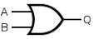  2-input OR Gate | B | A | Q
 | 0 | 0 | 0
 | 0 | 1 | 1
 | 1 | 0 | 1
 | 1 | 1 | 1
Boolean Expression Q = A+B | Read as A OR B gives Q

7432 Quad 2-input Logic OR Gate
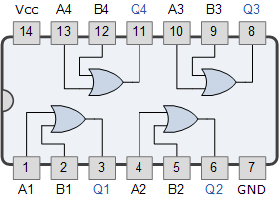

- The Logic “AND” Gate
A Logic AND Gate is a type of digital logic gate that has an output which is normally at logic level “0” and only goes “HIGH” to a logic level “1” when ALL of its inputs are at logic level “1”. The output state of a “Logic AND Gate” only returns “LOW” again when ANY of its inputs are at a logic level “0”. In other words for a logic AND gate, any LOW input will give a LOW output.The logic or Boolean expression given for a Digital Logic AND Gate is that for Logical Multiplication which is denoted by a single dot or full stop symbol, ( . ) giving us the Boolean expression of: A.B = Q.
“If both A and B are true, then Q is true”

The 2-input Logic AND Gate
Symbol | Truth Table |  |  | LED status
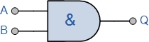  2-input AND Gate | B | A | Q
 | 0 | 0 | 0
 | 0 | 1 | 0
 | 1 | 0 | 0
 | 1 | 1 | 1
Boolean Expression Q = A.B | Read as A AND B gives Q

  - d 2-input AND Gate
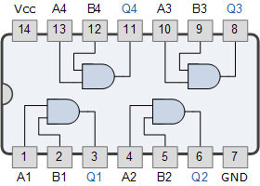
- The Logic “NOT” Gate
The digital Logic NOT Gate is the most basic of all the logical gates and is sometimes referred to as an Inverting Buffer or simply a Digital Inverter. It is a single input device which has an output level that is normally at logic level “1” and goes “LOW” to a logic level “0” when its single input is at logic level “1”, in other words it “inverts” (complements) its input signal. The output from a NOT gate only returns “HIGH” again when its input is at logic level “0” giving us the Boolean expression of: A = Q.
“If A is NOT true, then Q is true”

The Logic NOT Gate Truth Table
Symbol | Truth Table |  | LED status
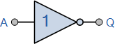  Inverter or NOT Gate | A | Q
 | 0 | 1
 | 1 | 0
Boolean Expression Q = not A or A | Read as inverse of A gives Q

Logic NOT gates provide the complement of their input signal and are so called because when their input signal is “HIGH” their output state will NOT be “HIGH”. Likewise, when their input signal is “LOW” their output state will NOT be “LOW”.

7404 NOT Gate or Inverter
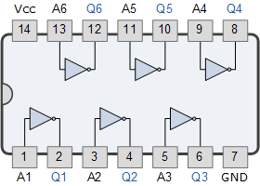

- Logic NOR Gate Definition
The Logic NOR Gate or Inclusive-NOR gate is a combination of the digital logic OR gate with that of an inverter or NOT gate connected together in series. The NOR (Not – OR) gate has an output that is normally at logic level “1” and only goes “LOW” to logic level “0” when ANY of its inputs are at logic level “1”. The Logic NOR Gate is the reverse or “Complementary” form of the OR gate we have seen previously.

Logic NOR Gate Equivalent
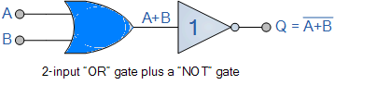

The logic or Boolean expression given for a logic NOR gate is that for Logical Multiplication which it performs on the complements of the inputs. The Boolean expression for a logic NOR gate is denoted by a plus sign, ( + ) with a line or Overline, ( ‾‾ ) over the expression to signify the NOT or logical negation of the NOR gate giving us the Boolean expression of: A+B = Q.
“If both A and B are NOT true, then Q is true”

2-input NOR Gate
Symbol | Truth Table |  |  |  |  |  | LED status
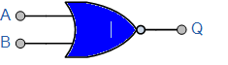  2-input NOR Gate | B |  | A |  | Q
 | 0 |  | 0 |  | 1
 | 0 |  | 1 |  | 0
 | 1 |  | 0 |  | 0
 | 1 |  | 1 |  | 0
Boolean Expression Q = A+B | Read as A OR B gives NOT Q
 | 1 | 1 |  | 1 |  | 0
Boolean Expression Q = A+B+C | Read as A OR B OR C gives NOT Q

7402 Quad 2-input NOR Gate
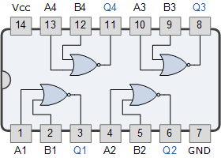

- Logic NAND Gate Definition
The Logic NAND Gate is a combination of the digital logic AND gate with that of an inverter or NOT gate connected together in series. The NAND (Not – AND) gate has an output that is normally at logic level “1” and only goes “LOW” to logic level “0” when ALL of its inputs are at logic level “1”. The Logic NAND Gate is the reverse or “Complementary” form of the AND gate we have seen previously.

Logic NAND Gate Equivalence
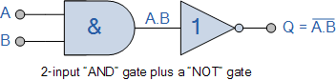

The logic or Boolean expression given for a logic NAND gate is that for Logical Addition, which is the opposite to the AND gate, and which it performs on the complements of the inputs. The Boolean expression for a logic NAND gate is denoted by a single dot or full stop symbol, ( . ) with a line or Overline, ( ‾‾ ) over the expression to signify the NOT or logical negation of the NAND gate giving us the Boolean expression of: A.B = Q.
“If either A or B are NOT true, then Q is true”

2-input Logic NAND Gate
Symbol | Truth Table |  |  | LED status
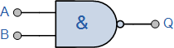  2-input NAND Gate | B | A | Q
 | 0 | 0 | 1
 | 0 | 1 | 1
 | 1 | 0 | 1
 | 1 | 1 | 0
Boolean Expression Q = A.B | Read as A AND B gives NOT Q
- CD4012 Dual 4-input

7400 Quad 2-input Logic NAND Gate
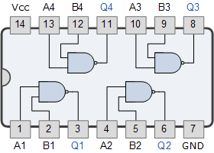
- The Exclusive-OR Gate

Exclusive-OR Gate Definition
There are two other types of digital logic gates which although they are not a basic gate in their own right as they are constructed by combining together other logic gates, their output Boolean function is important enough to be considered as complete logic gates. These two “hybrid” logic gates are called the Exclusive-OR (Ex-OR) Gate and its complement the Exclusive-NOR (Ex-NOR) Gate.
For a 2-input OR gate, if A = “1”, OR B = “1”, OR BOTH A + B = “1” then the output from the digital gate must also be at a logic level “1” and because of this, this type of logic gate is known as an Inclusive-OR function. The gate gets its name from the fact that it includes the case of Q = “1” when both A and B = “1”.
If however, an logic output “1” is obtained when ONLY A = “1” or when ONLY B = “1” but NOT both together at the same time, giving the binary inputs of “01” or “10”, then the output will be “1”. This type of gate is known as an Exclusive-OR function or more commonly an Ex-Or function for short. This is because its boolean expression excludes the “OR BOTH” case of Q = “1” when both A and B = “1”.
Q = (A B) = A.B + A.B
The Exclusive-OR Gate function, or Ex-OR for short, is achieved by combining standard logic gates together to form more complex gate functions that are used extensively in building arithmetic logic circuits, computational logic comparators and error detection circuits.

2-input Ex-OR Gate
Symbol | Truth Table |  |  | LED status
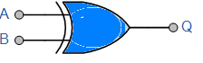  2-input Ex-OR Gate | B | A | Q
 | 0 | 0 | 0
 | 0 | 1 | 1
 | 1 | 0 | 1
 | 1 | 1 | 0
Boolean Expression Q = A B | A OR B but NOT BOTH gives Q
The truth table above shows that the output of an Exclusive-OR gate ONLY goes “HIGH” when both of its two input terminals are at “DIFFERENT” logic levels with respect to each other. If these two inputs, A and B are both at logic level “1” or both at logic level “0” the output is a “0” making the gate an “odd but not the even gate”.
Q = (A B) = A.B + A.B

7486 Quad 2-input Exclusive-OR Gate
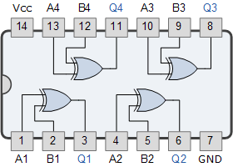

- The Digital Logic “Ex-NOR” Gate
The Exclusive-NOR Gate function or Ex-NOR for short, is a digital logic gate that is the reverse or complementary form of the Exclusive-OR function we look at in the previous tutorial. Basically the “Exclusive-NOR Gate” is a combination of the Exclusive-OR gate and the NOT gate but has a truth table similar to the standard NOR gate in that it has an output that is normally at logic level “1” and goes “LOW” to logic level “0” when ANY of its inputs are at logic level “1”.
However, an output “1” is only obtained if BOTH of its inputs are at the same logic level, either binary “1” or “0”. For example, “00” or “11”. This input combination would then give us the Boolean expression of: Q = (A B) = A.B + A.B

2-input Ex-NOR Gate
Symbol | Truth Table |  |  | LED status
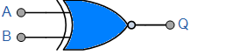  2-input Ex-NOR Gate | B | A | Q
 | 0 | 0 | 1
 | 0 | 1 | 0
 | 1 | 0 | 0
 | 1 | 1 | 1
Boolean Expression Q = A B | Read if A AND B the SAME gives Q

74266 Quad 2-input Ex-NOR Gate
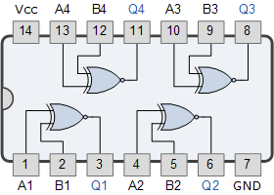

Digital Logic Gate Truth Table Summary
The following logic gates truth table compares the logical functions of the 2-input logic gates detailed above.
Inputs |  | Truth Table Outputs For Each Gate
A | B | AND | NAND | OR | NOR | EX-OR | EX-NOR
0 | 0 | 0 | 1 | 0 | 1 | 0 | 1
0 | 1 | 0 | 1 | 1 | 0 | 1 | 0
1 | 0 | 0 | 1 | 1 | 0 | 1 | 0
1 | 1 | 1 | 0 | 1 | 0 | 0 | 1

PROCEDURE :
Truth Table Output for Single-input Gates
A | NOT | Buffer
0 | 1 | 0
1 | 0 | 1
- Plug the IC chip into the breadboard.
- Connect the supply voltage.
- Set the inputs to the logic gates according to the all possible combinations.
- Once all connections have been done, turn on the power switch of the
trainer kit.

- Monitor the output for the proper indication. If the light is off, write”off” in the LED column which means that output is zero. If the light is ON, write “on” in the LED column whioch means that output is one.
- Repeat steps 1 and 2 for the remaining rows of the truth tables.
- Repeat the above steps for verifying the truth tables in the case of a 3-input AND gate by selecting 3 input switches and monitoring the output.
- Repeat the above steps for all the ICs.

RESULT: Truth tables for all the logic gates are verified.

CONCLUSION:
- AND gate - Output is high when all the inputs are high
- OR gate - Output is high when any input is high.
- NOT gate- Output is opposite to the input given.
- NOR Gate: The output is a 1 if both inputs are 0 but a 0 if one or the other or both the inputs are 1.
- NAND Gate: The output of the NAND gate is a 0 if both inputs are 1 but a 1 if one or the other or both the inputs are 0.
- 4. EX-OR gate –Output is high when number of input 1’s are odd.
- EX-NOR gate - Output is high when number of input 1’s are even.
Lab Tutorails:

1. The number of level in a digital signal is:
- one
- two
- four
- ten
2. A pure sine wave is:
- a digital signal
- analog signal
- can be digital or analog signal
- neither digital nor analog signal
3. The high voltage level of a digital signal in positive logic is:
- 1
- 0
- either 1 or 0
3. A gate in which all input must be low to get a high output is called:
- an inverter
- A NOR gate
- an AND gate
- a NAND gate
4. A NAND circuit with positive logic will operate as:
- NOR with negative logic
- AND with negative logic
- OR with negative logic input
- AND with positive logic output
5. To implement all function of the basic logic function, is sufficient to have:
- OR
- NOT
- AND NOT
- none of these
6. Which of the following ICs has only one NAND gate:
- 7410
- 7420
- 7430
- 7447
7. OR operation is:
- X + XY
- XY
- X+Y
- (X+Y) (X+Y)
8. AND operation is:
- X(X + Y)
- XY
- X+Y
- (X+Y) (X+Y)
9. NOR operation is:
- X + Y
- XY
- X+Y
- (X+Y) (X+Y)
10. NAND operation is:
- X + Y
- XY
- X+Y
- (X+Y) (X+Y)
11. What is the no. of OR IC:
- 7402
- 7486
- 7432
- 7404
12. What is the no. of AND IC:
- 7402
- 7408
- 7447
- 7492
13. What is the no. of NOR IC:
- 7402
- 7486
- 7447
- 7492
14. What is the no. of NAND IC:
- 7402
- 7404
- 7400
- 7492
15. What is the no. of NOT IC:
- 7402
- 7486
- 7404
- 7492

16. What is the no. of EX-OR IC:
- 7402
- 7486
- 7447
- 7492
17. Which of the following ICs has three input NAND gate:
- 7420
- 7430
- 7410
- 7474
18. Which of the following is Boolean eq. of EX-OR gate:
- A+B
- A+B
- AB
- A B + A B
19. Which one is the universal gate:
- AND gate
- OR gate
- NAND gate
- EX-OR gate
20. Bubbles on the gate shows:
- active high
- active low
- both a and b
- none
21. Which statement is verify NAND gate:
- if all input are high output is low
- if all input are low output is low
- any one n are low output is low
- none of them
22. In regard to NAND gate the following four statement are made:
- it is equivalent to an AND gate followed by an inverter
- if all input to it are low, the output is low
- if all input are high, the output is low
23. NAND operation on two elements is equivalent to OR operation on them. OF these, the only true statements are
- 1,2
- 1,3
- 1,4

Short Answer type questions:

1) What are logis gates?
2) What is the difference between Positive Logis and negative Logic?
3) Draw EX-OR gate using NAND and NOR gate.
4) Why NOR gate and NAND gate called "Universal logic gate"?
5) Draw the symbol and truth table of following gates.
1. NOT 2. AND 3. OR 4. NAND 5. Ex-OR.
6) Implement following expressions by NOR gate only.
1. (A + B) . (B + C)
2. (A + C) . (B)
EXPERIMENT No- 5

AIM: - To Verify Demorgan’s theorems.

EQUIPMENT REQUIRED: - Breadboard, Patch cords, ICs (7404 – NOT, 7408 – AND, 7432 - OR).

Theory:

De Morgan’s First Theorem:
• The complement of a product of variables is equal to the sum of the complement of the variables.
• In another way, the complement of two or more ANDed variables is equivalent to the OR of the complements of the individual variables.

(A · B)’ = A’ + B’

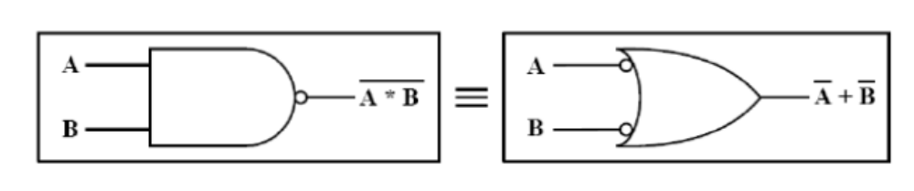

De Morgan’s Second Theorem:

• The complement of a sum of variables is equal to the product of the complements of the variables.
• In another way, the complement of two or more ORed variables is equivalent to the AND of the complements of the individual variables.

(A + B)’ = A’ · B’

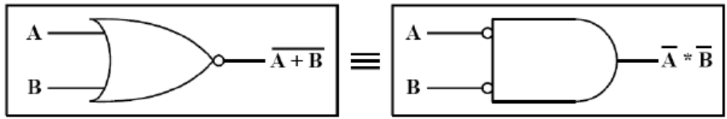

Truth Table:

To verify De Morgan’s First Theorem: (A · B)’ = A’ + B’

L.H.S. (A · B)’ |  |  | R.H.S. A’ + B’
A | B | Y | A | B | Y

To verify De Morgan’s Second Theorem: (A + B)’ = A’ · B’

L.H.S. (A + B)’ |  |  | R.H.S. A’ · B’
A | B | Y | A | B | Y

Procedure:

Collect the components necessary to accomplish this experiment.
- Plug the IC chip into the breadboard.
- Connect the supply voltage and ground lines to the chips. PIN7 = Ground and PIN14 = +5V.
- According to the pin diagram of each IC mentioned above, make the connections according to circuit diagram.
- Connect the inputs of the gate to the input switches of the LED.
- Connect the output of the gate to the output LEDs.
- Once all connections have been done, turn on the power switch of the
breadboard
- . Operate the switches and fill in the truth table ( Write "1" if LED is ON and "0" if LED is OFF Apply the various combination of inputs according to the truth table and observe the condition of Output LEDs.

RESULT: - Verification of Demorgan’s theorem is successfully done.

PRECAUTIONS: -

- The continuity of the connecting terminals should be checked before going

- It should be care that the values of the components of the circuit is does not exceed to their ratings (maximum value).

- Before the circuit connection it should be check out working condition of all the Component.

EXPERIMENT NO. 6 and 7
AIM: To plot and verify the V-I Characteristics of PN junction Diode.

APPARATUS REQUIRED:
PN diode kit, cords

THEORY:
This is a two terminal device consisting of a p-n junction formed either in Ge or Si crystal. When a p type material is intimately joined to n type a p-n junction is formed. Therefore, a p-n junction is formed from a piece of semiconductor diffusing p type material to one half side and n type material to other half side. The plane divided two zone is known as junction.
When p-n junction is formed some of the holes from p side crossover to n side where they combine with electrons and become neutral. Similarly some of the electrons from n-side crossover to p side where they combine with holes and become neutral. Thus a reasons is formed which is known as depletion layer. The potential barrier is 0.3 V & 0.7 V for Ge & Si respectively.
When an external voltage is applied to a p-n junction in such a direction that it cancels the potential barrier is called as forward bias. To apply a forward bias the positive terminal of battery is connected to p-type semiconductor while the negative terminal is connected to n type semiconductor. When as external voltage is applied to a p-n junction in such a direction that it increases the potential barrier then, it is called as reverse bias. For reverse bias the positive terminal of the battery is connected to n type semiconductor a negative terminal to p type semiconductor.
The relation between the diode current I and voltage V is given by
I = Is (e^{qV/KT}-1)
Where q is charge of electron charge, K is Boltzmann constant and T is the absolute temperature.

PROCEDURE:

FORWARD CHARACTERISTIC OF Si DIODE :
1.Make the connection as shown in fig(1).
2. Put the voltmeter range switch to 1 V and ammeter range switch to 10 mA in the circuit.
3. Vary the built in D.C. supply in steps of 0.1 volts and note down the corresponding ammeter and voltmeter readings.
4. Plot the graph of forward voltage V_{f} (on X axis) and forward current I_{f} (on Y axis).
5. Find the slope of the graph and calculate forward resistance R

FORWARD CHARACTERISTIC OF Ge DIODE
1.Repeat steps 1 to 5 above except that now Si diode is replaced by Ge diode.

Fig-1
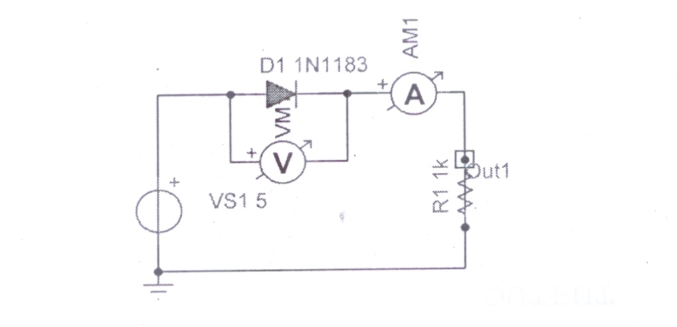

REVERSE CHARACTERISTICS OF Si DIODE :
1. Make the connection as shown in fig(2)
2. Put the voltmeter range switch to 10 V and ammeter range switch to 200 µA in the circuit.
3. Vary the built in D.C. supply in steps of 1 V and note down ammeter and voltmeter readings.
4. Plot the graph of reverse voltage (on X axis) Vs reverse current (on Y axis)
5. Find the slope of the graph and calculate reverse resistance R.
REVERSE CHARACTERISTICS OF Ge DIODE :
1.Repeat steps 1 to 5 above except that now Si diode is replaced by Ge

Fig.2

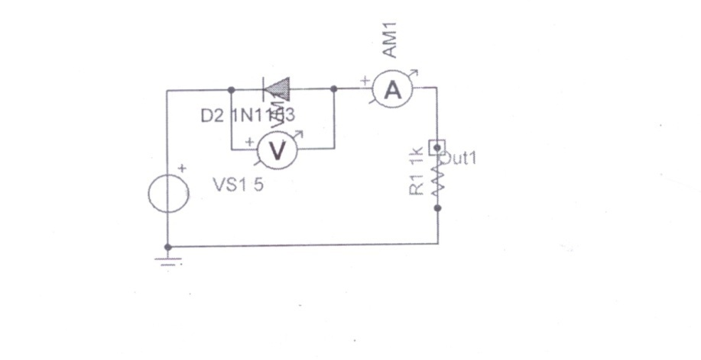

OBSERVATION TABLE

Forward Characteristics:

S.No | V_{f} (Volts) | I_{f} (m amp)

Reverse Characteristics :

S.No | V_{r}(Volts) | I_{r}(m amp)

CONCLUSION:

During forward bias the diode offers negligibly small forward resistance.
During reverse bias the diode offers very high reverse resistance.

EXPERIMENT NO. 8

AIM: To plot and verify the V-I Characteristics of Zener Diode.

APPARATUS REQUIRED:
Zener diode kit, cords.

THEORY:
Zener diode is a reverse biased heavily doped Si or Ge p-n junction diode which is operated in the breakdown reason. Zener diode is like ordinary p-n junction diode except that they are fabricated by varying the doping so that sharp and specific breakdown voltage are obtained.
When a zener is forward biased its characteristics are similar of ordinary diode but in reverse biased its characteristics is differ. As the reverse voltage applied to a p-n junction is increased, a value is reached at which the current increases greatly from its normal cut-off value. This voltage is called a zener voltage or breakdown voltage. It is observed from the figure that below knee voltage the breakdown voltage remain practically constant.
A diode in breakdown maintains an almost constant voltage across itself over a wide current range. Thus the zener diode is most suitable for voltage regulation.

PROCEDURE:
FORWARD CHARACTERISTIC OF ZENER DIODE :
1.Make the connection as shown in fig.1.
2. Put the voltmeter range switch to 1 V and ammeter range switch to 10 mA
3. Vary the built in D.C. supply in steps of 0.1 volts and note down the corresponding ammeter and voltmeter readings.
4. Plot the graph of forward voltage (on X axis) and forward current (on Y axis)
5. Calculate forward resistance.

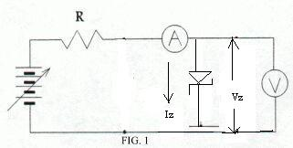

REVERSE CHARACTERISTIC OF ZENER DIODE :
- Put the voltmeter range switch to 10V and ammeter range switch to 10 mA
- Vary the built in D.C. supply in steps of 1V upto 10V and then in steps of 0.1 volts and note down the corresponding ammeter and voltmeter readings.
- Plot the graph of reverse voltage (on X axis) and reverse current (on Y axis)
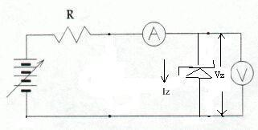

OBSERVATION TABLE :

DIODE CHARACTERISTICS(Using Kit)

Forward Characteristics :

S.No | V_{r}(Volts) | I_{r}(m amp)

Reverse Characteristics :

S.No | V_{r}(Volts) | I_{r}(m amp)

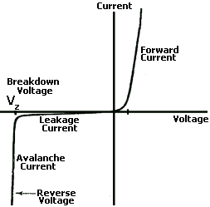

CONCLUSION:
During reverse bias the breakdown occurs at Vz, indicated on graph.

EXPERIMENT NO. 9 and 10
Aim: To design half & full wave rectifier.

Components required:
- Simple diode and resistors.
- Rectifier diode.
- Center-tap transformer.
- Function generator and oscilloscope.

Theory:

- Half Wave Rectifier
The half wave rectifier is a circuit that allows only part of a sinusoidal input signal to pass. The circuit is simply a combination of a single diode in series with a resistor, where the resistor is acting as a load.
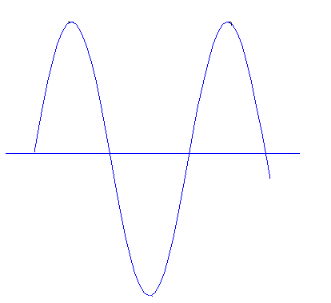
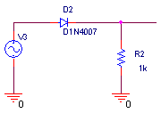
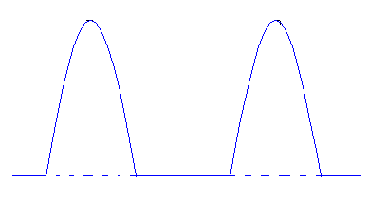

Half- Wave Rectifier Schematic
The basic parameters of the half wave rectifier circuit are:
- The DC Voltage

Vo(dc) = =

- The root mean square value of output

Vo(rms) = 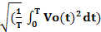 =

- The ripple Factor

R = =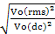 = 1.211

- Efficiency(η)

η40.5%
- Full Wave Rectification

- The Bridge Rectifier
The full wave rectifier is a circuit that allows two part of a sinusoidal input signal to pass in positive side. The circuit is simply the combination of the four diodes in series with a resistor, where the resistor is acting as a load.

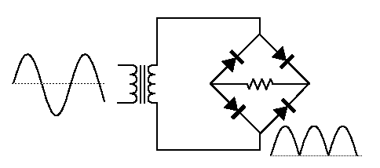
For both positive and negative swings of the transformer, there is a forward path through the diode bridge. Both conduction paths cause current to flow in the same direction through the load resistor, accomplishing full-wave rectification.
While one set of diodes is forward biased, the other set is reverse biased and effectively eliminated from the circuit.
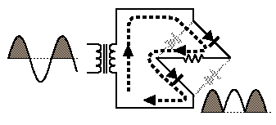
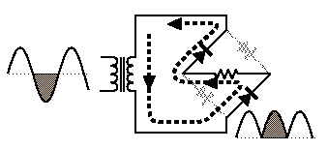

- Center-tap transformer

The center-tap circuit employs two diodes as shown below. A center tapped secondary winding is used with two diodes connected so that each uses one half cycle of input a.c voltage.
In other words the first diode utilizes the ac voltage across upper half of secondary winding for rectification while the second diode uses the lower half winding of the transformer.
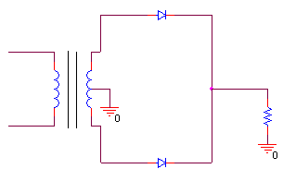
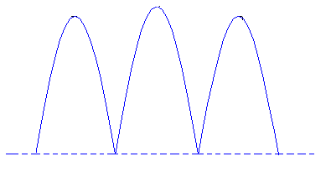

Parameters of the full wave rectifier circuit are:
- The DC Voltage
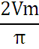
Vo(dc) = =

- The root mean square value of output
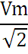
Vo(rms) = =
- The ripple Factor

R = = = 0.483

- Efficiency(η)

η81%

Procedures
- Connect the circuit as shown in figure (2-1).
- Set the function generator to a sin wave with 10Vp, 50Hz.
- Connect the circuit as shown in figure (2-2).
- Repeat step 1 to 3.
- Comment on the results of each circuit, showing the difference between half and full wave rectifiers.
