DEPARTMENT OF INFORMATION TECHNOLOGY

Lab Manual

Subject Name: OOPs Methodology
Course Code: IT-303
Course: B.E
Session:

Prepared By

TABLE OF CONTENT

Sr. No. | Particulars | Page No.
1 | Time Table
2 | University Scheme
3 | Syllabus
4 | List of Experiments
5 | Expected Viva Voice questions

UNIVERSITY SCHEME

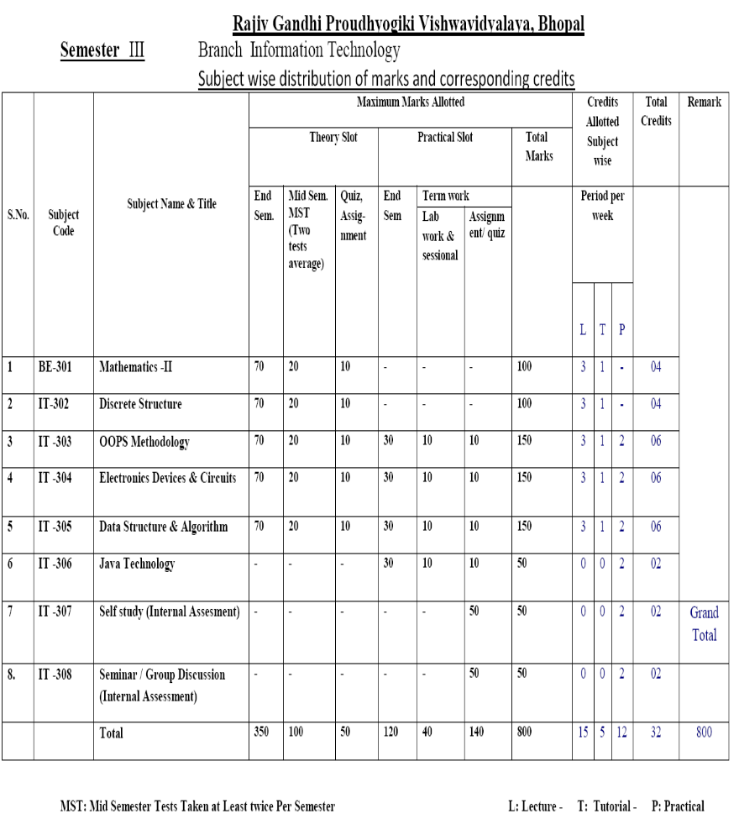

SYLLABUS

Branch: Information Technology, III Semester Course: OOPM
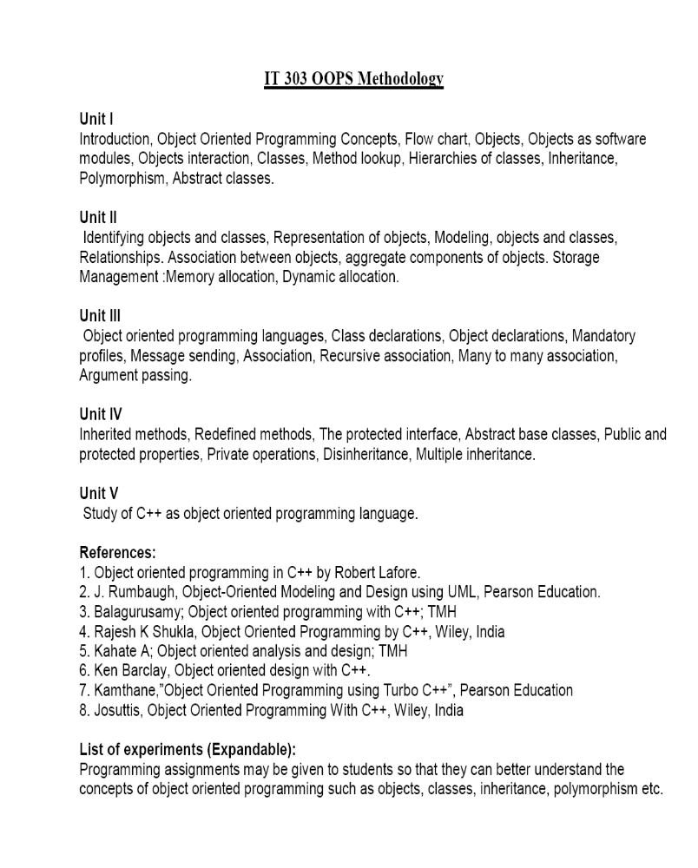

LIST OF EXPERIMENTS

S.No. | EXPERIMENTS
1. | Write a program in C++ to find largest no.
2. | Write a program in C++ to implement the multiplication of [3*3] matrix using Array.
3. | Write a program in C++ to implement quadratic equation using class & Object.
4. | Write a program in C++ to implement Copy Constructor.
5. | Write a program in C++ to implement Inheritance.
6. | Write a program in C++ to implement Polymorphism.
7. | Write a program in C++ to implement virtual class & virtual function.
8. | Write a program in C++ to implement Exception handling.
9. | Write a program in C++ for function templates.
10. | Write a program in C++ for writing file operation using file handling.
11. | To perform the write operation within a file.

EXPERIMENT-1

Aim: Write a program in C++ to find largest no.

Algorithm

1. Read the 3 nos a,b,c
2. Let larget = a
3. if b > largest then largest = b
4. if c > largest then largest = c.....
If you have to process more nos, read all of them in an array. Assume the first element be largest, do comparison through all elements of the array....
Similar algorithm can be developed for finding the lowest also.

EXPERIMENT-2

Aim: Write a program in C++ to implement the multiplication of [3*3] matrix using Array.

Algorithm
Input two matrixes.
- Output Output matrix C.
- Complexity O(n^3)

- Matrix-Multiply(A, B)
- 1 if columns [A] ≠ rows [B]
- 2 then error "incompatible dimensions"
- 3 else
- 4 for i =1 to rows [A]
- 5 for j = 1 to columns [B]
- 6 C[i, j] =0
- 7 for k = 1 to columns [A]
- 8 C[i, j]=C[i, j]+A[i, k]*B[k, j]
- 9 return C

EXPERIMENT-3

Aim: Write a program in C++ to implement quadratic equation using class & Object.

Algorithm:
1. Read the value of a , b , c
2. d = b*b - 4*a*c
3. if d < 0 then display The Roots are Imaginary.
else if d = 0
then dispaly Roots are Equal.
r = -b / 2*a
display r
else r1 = -b + √d / 2*a
r2 = -b - √d / 2*a
display Roots are real and r1 , r2
4. Stop

EXPERIMENT-4

Aim: Write a program in C++ to implement Copy Constructor.

Algorithm
STEP 2: Declare the class name as Copy with data members and member functions.
STEP 3: The constructor Copy() with argument to assign the value.
STEP 4: To cal the function calculate() do the following steps.
STEP 5: For i=1 to var do
STEP 6: Calculate fact*i to assign to fact.
STEP 7: Increment the value as 1.
STEP 8: Return the value fact.
STEP 9: Print the result.
STEP 10: Stop the program.

EXPERIMENT-5

Aim: Write a program in C++ to implement Copy Constructor.

Algorithm
Step 1: Start the program.
Step 2: Declare the base class student.
Step 3: Declare and define the function get() to get the student details.
Step 4: Declare the other class sports.
Step 5: Declare and define the function getsm() to read the sports mark.
Step 6: Create the class statement derived from student and sports.
Step 7: Declare and define the function display() to find out the total and average.
Step 8: Declare the derived class object,call the functions get(),getsm() and display().
Step 9: Stop the program.

EXPERIMENT-6

Aim: Write a program in C++ to implement method overloading.

Algorithm
STEP 1: Start the program.
STEP 2: Declare the class name as fn with data members and member functions.
STEP 3: Read the choice from the user.
STEP 4: Choice=1 then go to the step 5.
STEP 5: The function area() to find area of circle with one integer argument.
STEP 6: Choice=2 then go to the step 7.
STEP 7: The function area() to find area of rectangle with two integer argument.
STEP 8: Choice=3 then go to the step 9.
STEP 9: The function area() to find area of triangle with three arguments, two as Integer and one as float.
STEP 10: Choice=4 then stop the program.

EXPERIMENT-7

Aim: Write a program in C++ to implement virtual class & virtual function.

Algorithm for virtual base class
Step 1: Start the program.
Step 2: Declare the base class student.
Step 3: Declare and define the functions getnumber() and putnumber().
Step 4: Create the derived class test virtually derived from the base class student.
Step 5: Declare and define the function getmarks() and putmarks().
Step 6: Create the derived class sports virtually derived from the base class student.
Step 7: Declare and define the function getscore() and putscore().
Step 8: Create the derived class result derived from the class test and sports.
Step 9: Declare and define the function display() to calculate the total.
Step 10: Create the derived class object obj.
Step 11: Call the function get number(),getmarks(),getscore() and display().
Step 12: Stop the program.

Algorithm for virtual function
Step 1: Start the program.
Step 2: Declare the base class base.
Step 3: Declare and define the virtual function show().
Step 4: Declare and define the function display().
Step 5: Create the derived class from the base class.
Step 6: Declare and define the functions display() and show().
Step 7: Create the base class object and pointer variable.
Step 8: Call the functions display() and show() using the base class object and pointer.
Step 9: Create the derived class object and call the functions display() and show() using the derived class object and pointer.
Step 10: Stop the program.

EXPERIMENT-8

Aim: Write a program in C++ to implement Exception handling.

Algorithm
Step 1: Start the program.
Step 2: Declare the variables a,b,c.
Step 3: Read the values a,b,c,.
Step 4: Inside the try block check the condition.
a. if(a-b!=0) then calculate the value of d and display.
b. otherwise throw the exception.
Step 5: Catch the exception and display the appropriate message.
Step 6: Stop the program.

EXPERIMENT-9

Aim: Write a program in C++ for function templates.

Algorithm
STEP 1: Start the program.
STEP 2: Declare the template class.
STEP 3: Declare and define the functions to swap the values.
STEP 4: Declare and define the functions to get the values.
STEP 5: Read the values and call the corresponding functions.
STEP6: Display the results.
STEP 7: Stop the program

EXPERIMENT-10

Aim: Write a program in C++ for writing file operation using file handling.

Algorithm
STEP 1: Start the program.
STEP 2: Declare the variables.
STEP 3: Read the file name.
STEP 4: open the file to write the contents.
STEP 5: writing the file contents up to reach a particular condition.
STEP 6: Stop the program.

EXPERIMENT-11

Aim: To perform the write operation within a file.

Algorithm
STEP 1: Start the program.
STEP 2: Declare the variables.
STEP 3: Read the file name.
STEP 4: open the file to write the contents.
STEP 5: writing the file contents up to reach a particular condition.
STEP 6: Stop the program.

EXPECTED VIVA VOiCE QUESTIONS

1. What is C++?
C++ is created by Bjarne Stroustrup of AT&T Bell Labs as an extension of C, C++ is an object-oriented computer language used in the development of enterprise and commercial applications. Microsoft’s Visual C++ became the premier language of choice among developers and programmers.
2. What are the basic concepts of object oriented programming?
It is necessary to understand some of the concepts used extensively in object oriented programming.These include
Objects
Classes
Data abstraction and encapsulation
Inheritance
Polymorphism
Dynamic Binding
Message passing
3. Define inheritance?
The mechanism of deriving a new class (derived) from an old class (base class) is called inheritance. It allows the extension and reuse of existing code without having to rewrite the code from scratch. Inheritance is the process by which objects of one class acquire properties of objects of another class.
4. Define polymorphism?
Polymorphism means one name, multiple forms. It allows us to have more than one function with the same name in a program. It allows us to have overloading of operators so that an operation can exhibit different behaviors in different instances.
5. What are the features of C++ different from C?
All the features of C are similiar to C++ except some features, such as polymorphism, operator overloading which are supported in C++ but not in C language. Both C and C++ language is similiar in their functionality but C++ provides with more tools and options.
6. What is encapsulation?
The wrapping up of data and functions into a single unit (called class) is known as encapsulation. Encapsulation containing and hiding information about an object, such as internal data structures and code.
7. What is message passing?
An object oriented program consists of a set of objects that communicate with each other. Message passing involves specifying the name of the object, the name of the function and the information to be sent.
8. What are tokens in C++?
The smallest individual units of a program is known as tokens. c++ has the following tokens :
Keywords
Identifiers
Constants
Strings
Operators
9. What is the use of enumerated data type?
An enumerated data type is another user defined type which provides a way for attaching names to numbers thereby increasing comprehensibility of the code. The enum keyword automatically enumerates a list of words by assigning them values 0,1,2, and so on.
10. What is the use of default constructor?
A constructor that accepts no parameters is called the default constructor. If no user-defined constructor exists for a class A and one is needed, the compiler implicitly declares a default parameter less constructor A::A(). This constructor is an inline public member of its class. The compiler will implicitly define A::A() when the compiler uses this constructor to create an object of type A. The constructor will have no constructor initialize and a null body.
11. Define Constructors?
A constructor is a member function with the same name as its class. The constructor is invoked whenever an object of its associated class is created.It is called constructor because it constructs the values of data members of the class.
12. How variable declaration in c++ differs that in c?
C requires all the variables to be declared at the beginning of a scope but in c++ we can declare variables anywhere in the scope. This makes the programmer easier to understand because the variables are declared in the context of their use.
13. Define destructors?
A destructor is called for a class object when that object passes out of scope or is explicitly deleted. A destructors as the name implies is used to destroy the objects that have been created by a constructors. Like a constructor, the destructor is a member function whose name is the same as the class name but is preceded by a tilde.
- What is a class?
A class is a collection of objects.
15. What is the difference between c & c++?
C++ ia an object oriented programming but C is a procedure oriented programming.C is super set of
C++. C can’t support inheritance, function overloading, method overloading etc. but c++ can do this. In
c program the main function could not return a value but in the c++ the main function shuld return
a value.
- What are the few advantages of Inline function?
It offers an improved macro facility. By using the inline functions, the user can split a large function with many nested modules of statement blocks into many small inline functions.
17. What is copy constructor?
Copy constructor is a constructor function with the same name as the class and used to make deep copy of objects.
18. What is default constructor?
A default constructor is a constructor that either has no parameters, or if it has parameters, all the parameters have default values.
19. What is a scope resolution operator?
The scope resolution operator permits a program to reference an identifier in the global scope that has been hidden by another identifier with the same name in the local scope.
20. What is the difference between Object and Instance?
An instance of a user-defined type is called an object. We can instantiate many objects from one class. An object is an instance of a class.
21. What is the difference between macro and inline?
Inline follows strict parameter type checking, macros do not. Macros are always expanded by preprocessor, whereas compiler may or may not replace the inline definitions.
22. How variable declaration in c++ differs that in c?
C requires all the variables to be declared at the beginning of a scope but in c++ we can declare
variables anywhere in the scope. This makes the programmer easier to understand because the variables
are declared in the context of their use.
23. What are multiple inheritances?
A class can inherit properties from more than one class which is known as multiple inheritance.
24. What is the use of virtual destructor in c++?
A destructor is automatically called when the object is destroyed.
A virtual destructor in C++ is used primarily to prevent resource leaks by performing a clean-up of the object.
25. What do you mean by reference variable in c++?
A reference variable provides an alias to a previously defined variable.Data -type & reference-name = variable name
26. What is iterator class?
Iterator class provides an access to the class which are inside the containers(it holds a group of objects in an organized way). The containers include the data structure, class and abstract data type.
27. What are the types of declarations in C++?
There are so many types of declaration in C++ are :
Variable declaration ,Constant declaration, Function declaration ,Object declaration
28. What are Smart pointers?
Smart pointers are almost similar to pointers with additional features such as automatic destruction of a variable when it becomes out of scope and the throwing of exceptions that ensures the proper destruction of the dynamically allocated objects.
29. Explain function template?
Function template provides a means to write generic functions for different data types such as integer, long, float or user defined objects.
30. Explain class template?
Class template provides a means to write a generic class for different types so that a class can have members based on generic types that do not need to be defined at the moment of creating the class or whose members use these generic types.
31. What is difference between function overloading and operator overloading?
A function is overloaded when same name is given to different function.While overloading a function, the return type of the functions need to be the same.
32. What are the advantages of inheritance?
Code reusability, Saves time in program development.
33. What is a dynamic constructor?
The constructor can also be used to allocate memory while creating objects. Allocation of memory to objects at the time of their construction is known as dynamic construction of objects.The memory is allocated with the help of the new operator.
34. What is the difference between an Array and a List?
The main difference between an array and a list is how they internally store the data. whereas Array is collection of homogeneous elements. List is collection of heterogeneous elements.
35. What is the use of ‘using’ declaration?
A using declaration makes it possible to use a name from a namespace.
36. What is the difference between a template class and class template?
Template classA generic definition or a parameterized class not instantiated until the client provides the needed information. It’s jargon for plain templates.Class templateA class template specifies how individual classes can be constructed much like the way a class specifies how individual objects can be constructed. It’s jargon for plain classes.
37. What is friend function?
The function declaration should be preceded by the keyword friend. The function definitions does not use either the keyword or the scope operator :: The functions that are declared with the keyword friend as friend function. Thus, a friend function is an ordinary function or a member of another class.
38. What is a scope resolution operator?
A scope resolution operator (::), can be used to define the member functions of a class outside the class.
39. What do you mean by pure virtual functions?
A pure virtual member function is a member function that the base class forces derived classes to provide. Any class containing any pure virtual function cannot be used to create object of its own type.
40. What is a conversion constructor?
A converting constructor is a single-parameter constructor that is declared without the function specifier explicit.The compiler uses converting constructors to convert objects from the type of the first parameter to the type of the converting constructor’s class.
41.What is a container class? What are the types of container classes?
A container class is a class that is used to hold objects in memory or external storage. A container class acts as a generic holder. A container class has a predefined behavior and a wellknown interface. A container class is a supporting class whose purpose is to hide the topology used for maintaining the list of objects in memory. When a container class contains a group of mixed objects, the container is called a heterogeneous container; when the container is holding a group of objects that are all the same, the container is called a homogeneous container.
42. What is Associative container?
Associative containers are designed to support direct access to elements using keys. They are not sequential. There are four types of associatives containers : Set Multiset Map Multimap
43. What is an iterator?
Iterators are like pointers. They are used to access the elements of containers thus providing a link between algorithms and containers. Iterators are defined for specific containers and used as arguments to algorithms.
44. What are the defining traits of an object-oriented language?
The defining traits of an object-oriented langauge are : Encapsulation,Inheritance,Polymorphism
45. What is this pointer?
It is a pointer that points to the current object. This can be used to access the members of the current object with the help of the arrow operator.
46.Name some pure object oriented languages?
Smalltalk, Java, Eiffel, Sather
47. What is encapsulation?
Encapsulation (or information hiding) is the process of combining data and functions into a single unit called class.
48. What is problem with Runtime type identification?
The run time type identification comes at a cost of performance penalty. Compiler maintains the class.
49. What are the differences between new and malloc?
New initializes the allocated memory by calling the constructor. Memory allocated with new should be released with delete. Malloc allocates uninitialized memory.The allocated memory has to be released with free.new automatically calls the constructor while malloc(dosen’t)
50. What is conversion operator?

You can define a member function of a class, called a conversion function, that converts from the type of

its class to another specified type.

