Department of Basic Sciences
Lab Manual

Subject | Engineering Physics
Subject Code
Scheme | New CBCS
Class/Branch | I / II Semester

INDEX
SNo | Experiment Name | Remark
1 | Resolving power of Telescope
2 | Newton”s Ring method
3 | Diffraction by Diffraction Grating
4 | Semiconductor diode and Zener diode characteristics
5 | Energy band gap of a semiconductor diode
6 | Hall Effect and determine Hall co-efficient
7 | Frequency of A. C. mains by electric vibrator
8 | Calibration of voltmeter
9 | Calibration of ammeter
10 | Characteristics of G.M. counter
11 | Wavelength of Laser light
List of Experiments

- To determine Resolving power of Telescope.
- To determine the wavelength of Sodium light by using Newton”s Ring method.
- To determine the wavelength of violet and green light by Diffraction grating.
- To plot characteristic curve of semiconductor diode and Zener diode.
- To determine Energy band gap of a semiconductor diode.
- To study Hall Effect and determine Hall co-efficient of semiconductor.
- To determine the frequency of A. C. mains by using an Electric Vibrator.
- To calibrate given voltmeter by means of potentiometer.
- To calibrate given ammeter by means of potentiometer.
- To study characteristics of G.M. counter.
- To determine the wavelength of Laser light.
RESOLVING POWER OF TELESCOPE

Aim:-

To determine resolving power of Telescope.

Apparatus Required:-

Telescope with rectangular variable slit, a scale with black lines of equal width which measure in millimeter and meter scale.

Formula used:-

Theoretical value of R.P. of Telescope = a/1.22λ
Practical value of R.P. of Telescope =D/d
Where
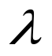= mean wavelength of light used.
a = width of variable slit at the time of resolution of two object.
d = distance between two black lines on the scale.
D = distance between object and objective of the telescope.

Diagram:

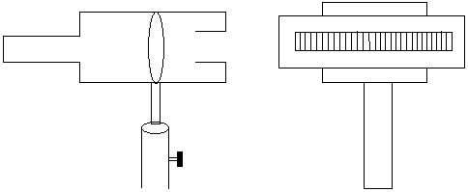

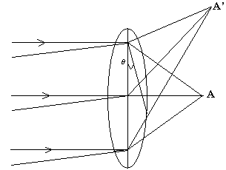

Procedure:-

1. Mount the telescope on the stand with its axis horizontal and scale on another stand as in the diagram. Measure the distance D between slit and the scale with the help of measuring tape, and set the distance between slit and scale at 100 cm.
2. With the help of micrometer screw make the slit of full width and slide the telescope in horizontal direction till the image of two nearby lines are just cease to appear as two in the position of just resolution. Take the reading of micrometer screw in this position. Now shut the slit of micrometer screw and take the reading of micrometer for non distinguishable state. Now again open the slit and take the reading for just resolution.
3. Take mean of the two readings of just resolution and then take difference of this value with the reading of shut position their difference gives the value of “a”.
4. Repeat above process for various distances from slit and scale.

Observation:-

- Mean wavelength of light used = 6000 A⁰
= 6000 x 10⁸cm

- Least count of micrometer screw = 0.001 c.m.

Table for measurement of “a”

S.No. | Distance between scale and the slit “D” cm. | Micrometer position at just resolution while closing slit (A) |  |  | When slit is completely closed (B) |  |  | Position of just resolution while opening slit (C) |  |  | Width of slit  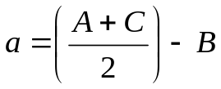
 |  | MS | CS | TR | MS | CS | TR | MS | CS | TR
1.
2.
3.
4.
5.
6.

S.No. | Distance “D” | Practical value  D/d | Theoretical value  a/1.22λ | Error
1.
2.
3.
4.
5.
6.

Mean value of Theoretical R.P. =
Mean value of Practical R.P. =

Result:-
For d = 0.1 cm. and D = ……………..cm.
- The theoretical value of resolving power = ………………cm.
- The practical value of resolving power = ………………cm.
- Percentage error ……………

Precautions:-
- Avoid backlash error in the micrometer.
- The slit and scale should be parallel to each other.

Viva questions

- What do you mean by resolving power?
Ans: The ability of an optical device to produce separate images of close objects.

- On what factors does it depend?
Ans: It depends on the wavelength of light used, slit width, distance between slit and
objects.

- What is the unit of resolving power?
Ans: Dimensionless.

- What do you mean by resolving limit?
Ans: Resolving limit is reverse of resolving power, or it is defined as the minimum
separation between the objects so that these are clearly identified by the optical
instrument.

- What is the relation between resolving power and resolving limit?
Ans: Resolving power = 1/ Resolving limit

- What is Rayleigh criterion for just resolution?
Ans: The Rayleigh criterion of just resolution said that two wavelengths of equal
intensities are said to be just resolved if in the diffraction pattern principal maxima
of one coincides with the adjacent minima of other.

- Does resolving power of telescope depend upon the distance b/w telescope and
objects?
Ans: yes

Newton’s Ring

Aim:-
To determine the wavelength of sodium light by using the method of “Newton’s Ring”

Apparatus required:-
Optical arrangement for Newton’s Ring (planoconvex lens of large radius of curvature, plane glass plate, and 45° inclined plate), Traveling microscope, Sodium lamp, Reading lens and reading lamp.

Theory:-
Newton’s Rings are formed due to interference between the wave reflected from the top and the bottom surface of the air film formed between the simple glass plate and planoconvex lens. A part is reflected at C without any phase reversed the other part is reflected along CD at point D. It is again reflected and goes out in the form of ray -2 with a phase reversal of л. The expression show that a maximum of a particular order will occur for a constant value of t. In case of this system remain constant along with a circle. Let “R” be the radius of the curvature of the surface in contact with the plate “λ” be the wavelength used. D_{n} and D_{n+p} be the diameter of _{n}^{th} and (n+p)^{th} dark ring respectively.
D²_{n} = 4n λR and D²_{n + p} = 4(n+p) λR
D²_{n + p} – D² _{n} = 4λPR

Formula:-

D²_{n + p} – D² _{n}
λ= -------------------
4pR
And 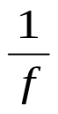= (µ - 1) [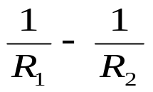] R can be calculate
R = Radius of curvature of the planoconvex lens.
λ = wavelength of light
D_{n+p} and D_{n} = Diameters of n^{th} and (n+p)^{th} Dark or Bright ring.

Diagram

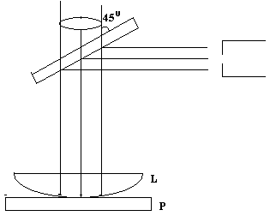

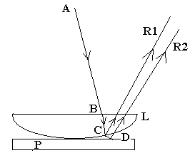

Procedure:-

First of all the eye piece of the microscope is adjusted on its cross wire. Now the distance of the microscope from the film is adjusted at the rings with dark centre is well focused. The centre of cross wire is adjusted at the centre of fringes pattern. By counting the number of fringes the microscope is moved to the extreme left pattern and crosswire is adjusted tangentially in the middle of the clear n^{th} bright or dark fringes. Reading of the microscope is noted. The microscope is moved to the right and readings of the microscope are noted carefully.
The radius of planoconvex lens can be obtained with the help of formula.

= (µ - 1) [] (R2 = ∞)
= (µ - 1) / R₁
_{Observation table:-}
S.No. | No. of Ring | Microscope Reading |  |  |  |  |  |  |  | Diameter  L–R cm. |  | Diameter  (L–R)² cm. | D²_{n+p}–D² _{n}
S.No. | No. of Ring | L.H.S. |  |  | R.H.S. |  |  |  |  |  |  | Diameter  (L–R)² cm.
S.No. | No. of Ring | MS | VS | TR | MS | VS |  | TR |  |  |  | Diameter  (L–R)² cm.
1. | 6
2. | 5
3. | 4
4. | 3
5. | 2
6. | 1

Calculation:-
D²_{n + p} – D² _{n}
λ= ------------------ where R is radius of curvature of planoconvex lens
4pR

D²₆ – D²₃
λ ₁ = ------------------ p=3
4pR

D²₅ – D²₂
λ ₂ = ------------------ p=3
4pR

D²₄ – D²₁
λ ₃ = ------------------ p=3
4pR

λ = λ₁+λ₂+λ₃
3
Standard Value – Practical value
% Error = ------------------------------------------Χ 100
Standard Value
Standard Value of wavelength of sodium light= 5893A.

Result:-

The wavelength of sodium light is ……………………A.

Precautions:-
- Surface of the glass plate and lens should be cleaned.
- Light from sodium lamp should be parallel.
- Reading should be noted very carefully.

Viva questions

1. What are Newton’s rings?
Ans. Newton’s rings are an interference pattern.

- Why the interference fringes are called rings?
Ans. Because, the fringes are circular.

- Why fringes obtained in Newton’s rings are circular?
Ans. Because these are the fringes of equal thickness.

- Why the center of Newton’s rings is dark?
Ans. Because the path difference between interfering rays is λ for the center.

- What is interference?
Ans. It is defined as the superposition of the two rays having same amplitude,
same frequency and a phase difference that remains constant with time.

- What are the types of interference?
Ans. It may be constructive and destructive.

- What is constructive and destructive interference?
Ans. In constructive interference intensity is maximum while in destructive
interference the intensity is zero.

- What are coherent sources?
Ans: Coherent sources are sources that emit light waves having same amplitude,
frequency, and the phase difference that remains constant with time.

- What are the conditions to obtained sustained interference pattern?
Ans: 1. Slit should be narrow.
2. Sources should be coherent.
3. Distance between two coherent sources should be small.

10. What is the arrangement of Newton’s ring experiment?
Ans . It consists of a planoconvex lens placed on a plane glass plate so an air film
of variable thickness is formed between lens and plate.

11. Sometimes the center of newtons ring is bright what is the reason?
Ans: Due to the presence of dust particles, thickness is not equal to zero at point of
contact the center of newtons ring is bright.

- If in place of monochromatic light white light is used what is the pattern?
Ans: If white light is used in place of monochromatic light, a few coloured rings are
observed. Each color gives rise to its own system and it gives a rainbow type
illumination. These rings soon superimpose and result in uniform illumination.

- How to find the refractive index of material by newtons ring methods?
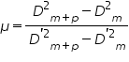
Ans:

Wavelength of light by diffraction grating

Aim:-

To determine the wavelength of violet and green light by using a diffraction grating.

Apparatus required:-

Plane transmission grating, Spectrometer, Reading lamp and Reading lens, mercury lamp,

Theory:-

If white light from a narrow slit parallel by lens is made to fall on grating and another lens employed to converge the rays issuing from the grating. We obtain image of the slit along the same direction as the incident rays of zero^{th} order and has the same colour as the source of light. Surrounding of this direct image on either side are the image of the first order the second order and soon. If be angle of diffraction for n^{th} order for wavelength λ then,
nλ = (e + d) sin
λ = (e + d) sin 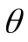 / n
Where (e + d) is grating element, n is order of spectrum, θ is angle of diffraction

Diagram:-

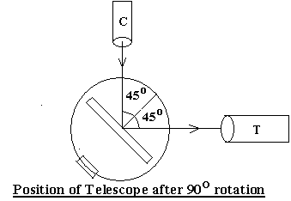

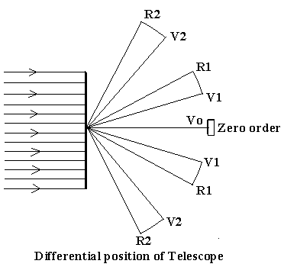

Procedure:-
- Before using the spectrometer first do the adjustment.
- Grating should normal to the axis of collimator the slit should be adjusted parallel to the lens of grating for the determination of angle of diffraction.
- Rotate the telescope to the left side of the direct image and adjust the spectral line to the cross wire vertically for first order. Note down the reading of both the vernier for each setting.
- Rotate the telescope to the right of direct image and repeat the above procedure i.e. for first order.
- Find out the difference of the same kind of vernier for each spectral line in the first order. This angle is twice time the angle of diffraction for that particular colour and order. Half of that will be the angle of diffraction.
- Find out the angle of diffraction for other colour in first order as well as second.

Observation:-

Small division on main scale = 0.5^{O}
Total no. of vernier division = 60 division
Least count of vernier = 0.5O / 60 = 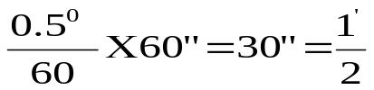x
- Table for diffraction angle

Order of spectrum | Colour of light | Vernier | Reading of telescope for left spectrum ₁ |  |  | Reading of telescope for right spectrum ₂ |  |  | 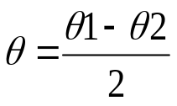
Order of spectrum | Colour of light | Vernier | MS | VS | TR | MS | VS | TR
n₁ | Violet | V1 |  |  |  |  |  |  | θ_{v11}=
n₁ | Violet | V2 |  |  |  |  |  |  | θ_{v12}=
n₁ | Green | V1 |  |  |  |  |  |  | θ_{g11}=
n₁ | Green | V2 |  |  |  |  |  |  | θ_{g12=}
n₂ | Violet | V1 |  |  |  |  |  |  | θ_{v21}=
n₂ | Violet | V2 |  |  |  |  |  |  | θ_{v22}=
n₂ | Green | V1 |  |  |  |  |  |  | θ_{g21=}
n₂ | Green | V2 |  |  |  |  |  |  | Θ_{g22=}

- The no. of lines ruled per inches on grating (N) = 15000
Grating element (e + d) = 2.54 / 15000 cm.
= 1.69 x 10⁻⁶ cm.

Calculation:-
(e + d) sinθ
λ = -------------
n

Wavelength of violet light (λ_{v})
(e+d) sinθ_{v11}
λ _{v11} = ---------------, n=1(for 1st order)
1

(e+d) sinθ_{v12}
λ _{v12}= ---------------, n=1(for 1st order)
1

(e+d) sinθ_{v21}
λ _{v21} = ---------------, n=2(for 2nd order)
2

(e+d) sinθ_{v22}
λ _{v22} = ---------------, n=2(for 2nd order)
2

So, λ _{v11} +λ _{v12} +λ _{v21} +λ _{v22}
λ_{v} = ---------------------------------------
4

Wavelength of green light (λ_{g})

(e+d) sinθ_{g11}
λ _{g11} = ---------------, n=1(for 1st order)
1

(e+d) sinθ_{g12}
λ _{g12}= ---------------, n=1(for 1st order)
1

(e+d) sinθ_{g21}
λ _{g21} = ---------------, n=2(for 2nd order)
2

(e+d) sinθ_{g22}
λ _{g22} = ---------------, n=2(for 2nd order)
2
So, λ _{g11} +λ _{g12} +λ _{g21} +λ _{g22}
λ _{g} = ---------------------------------------
4

Standard Value – Practical value
% Error = ------------------------------------------x 100

Standard Value
Result:-

The wavelength of different colour for the given source of light.

Colour of spectral line | Observed wavelength λ (Aº) | Standard wavelength λ (Aº) | Percentage error
Violet |  | 4358 Aº
Green |  | 5461 Aº

Precaution:-
- The mechanical adjustment of the telescope should be correct.
- The optical arrangement of the spectrometer must be made correctly.
- The slit used should be as narrow as permissible.
- In handling the grating do not touch the faces glass.

Viva questions

- What do you mean by diffraction of light?
Ans: Diffraction is the bending of light as it passes around the edge of an object.
The amount of bending depends on the relative size of the wavelength of
light to the size of the opening.

- What is diffraction grating?
Ans: It is an arrangement of equidistant and parallel slits drawn on any
transparent glass plate by a pointed diamond.

- What is grating element?
Ans: e + d = grating element where e is the width of opaque space and d is the
width of transparent space.

- What is grating equation?
Ans: nλ= (e+d)sinθ

- What types of diffraction do you know?
Ans: There are two types of diffraction- Fraunhofer diffraction and Fresnel
diffraction.

- What is the difference b/w Fraunhofer and Fresnel class diffraction?
Ans:
Fraunhofer diffraction | Fresnel diffraction
Source of light and screen are at infinite distance from diffracting aperture. | Source of light and screen are at finite distance from diffracting aperture.
Lenses are used. | No lens is used for observation
Wave front is always parallel | Wave front may be parallel.

- For diffraction what would be the size of aperture?
Ans: Size of aperture should be of the order of wavelength of light.

- What is the difference b/w diffraction and interference?
Ans:
Interfence | Diffraction
All the fringes have equal width. | Width of maximas and minimas are different.
All bright fringes have maximum intensity. | Intensity of maximas decreases with increasing order.
All dark fringes have zero intensity. | Intensity of minimas increases with increasing order.

- What are the various parts of spectrometer?
Ans: The various parts of spectrometer are collimator, prism table and telescope.

- What is the use of collimator?
Ans: A collimator is used to make incident light rays parallel.

- What are the difference b/w grating spectra and prism spectra?
Prism spectrum | Grating spectrum
It is due to dispersion | It is due to diffraction
Only one spectrum is obtained. | No. Of spectrums are obtained at different order.

- How angle of diffraction varies with wavelength?
Ans: Angle of diffraction is directly proportional to the wavelength.
- How a diffraction grating is formed?
Ans: It is constructed by ruling equidistant parallel lines on a transparent material
such as glass with a fine diamond point.

Characteristics of Semiconductor Diode

Aim:-
To plot characteristics curve of semiconductor diode.
Apparatus required:-
Voltmeter, Semiconductor diode, Miliammeter, Regulated power supply (0 -10V) connection wires.
Theory:-
Semiconductor diode – A diode is a two terminal device. One terminal known as the anode and other as the cathode. A semiconductor diode should work like a switch. When its anode made +ve w.r.t.its cathode the diode should act like a closed switch and when its anode made -ve w.r.t. cathode the diode should act like and open switch.
Forward biased characteristics – A test circuit that may be used to determine static characteristics of a diode. The anode current increase rapidly as the forward potential difference across the diode is increased the diode starts conduction only after a certain forward voltage known as threshold voltage is applied across it. The threshold voltage for ‘Ge’ type diode = 0.3V and for ‘Si’ type diode = 0.6V
Reverse biased characteristics – A reverse biased diode characteristics is obtained by reversing the connection here the leakage current flown in the circuit. This current is known as reverse saturation current. An increase in the operating temp. of the diode results in increased generation of e⁻ holes pair in the junction region and with this leakage current increases.

Circuit diagram

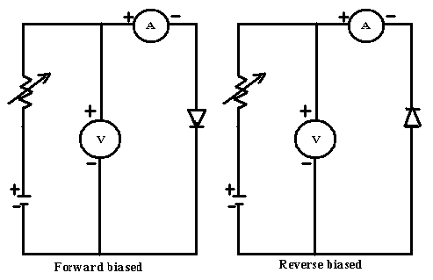

Procedure:-
Forward biased characteristics –
- Assemble the circuit as shown, keep 10V supply output at min. position.
- Switch on the supply to the board, slowly increase the 10V supply and take reading of diode current at various voltages setting about 1.5V or less.
- Plot the voltage on x- axis and current reading on y- axis which look like a forward biased characteristics.
- We observe from the above characteristics that a forward voltage of about 2V is required before diode start conduction

Reverse biased characteristics –
- Now switch of the supply to E.T.B. and reverse the connection to the diode and switch current meter to µA range, switch on the supply to the unit only.
- Slowly increases the 0-10V supply. Note down the readings of current meter for various voltage setting up to 10V
- Plot the above reading on the same graph sheet by extending the x and y axis on the –ve side.
- We observe that very little reverse current called leakage current flow through the diode in the reverse biased. The leakage current is little for Si diode.

Observation Table:- Least count of voltmeter:
Least count of ammeter:

For semiconductor diode forward biased-

S.No. | Voltage (Volt) |  | Current (mA)
S.No. | No. of Division | No. of Division  x LC | No. of Division | No. of Division  x LC
1.
2.
3.
4.
5.
6.

For semiconductor diode reverse biased-

S.No. | Voltage (Volt) |  | Current (mA)
S.No. | No. of Division | No. of Division  x LC | No. of Division | No. of Division  x LC
1.
2.
3.
4.
5.
6.

Result:-

Characteristics curves of semiconductor diode are plotted and their variations are observed.

Precautions:-
- Get your connection checked by your teacher before starting the experiment.
- Use short leads for connections.
- Make the connection tight and clear
- Do not increase the voltage instantaneously; it may be cause damage to diode.

Characteristics curve of Zener diode

Aim:-
To plot the characteristic curve of Zener diode.
Apparatus required:-
Voltmeter, Zener diode, ammeter, Regulated power supply (0-10V), Connecting wires
Theory:-
If the reverse biased applied, to a P-N junction diode is increased, a point will be reached at which the junction breaks down and current flows in reverse voltage In the current rectifier voltage. In the current rectifier diode reverse break-down should not occur within voltage rating of a diode. Reverse breakdown is also known as avalanche break down. The reverse breakdown mechanism predomination in diode having reverse breakdown voltage below about 3V. This type of breakdown is known as Zener breakdown voltage.
A Zener diode exhibits forward characteristic similar to forward biased semiconductor diode. Almost no current flow through diode till reverse voltage of diode is reached at which there is sudden increase in current. After this, current reaches to its maximum value and voltage across the diode remains constant at its voltage.

Circuit Diagram:-

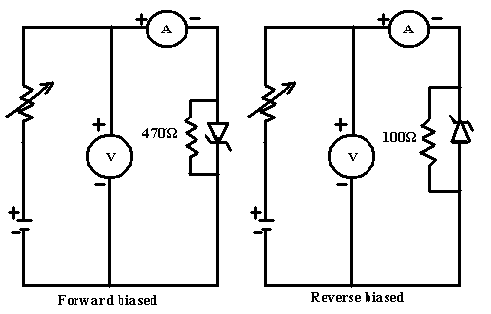

Procedure:-
Forward Biased Characteristics
- Assemble the circuit keep 0-10V supply to a minimum position supply to a board.
- Slowly increase 0-10V supply and take reading of current through the zener diode for various voltage rating.
- Plot reading on a graph paper take voltage on x-axis and current on y-axis. This plot will look like a forward biased characteristic of ‘Si’ general purpose diode. There is about 0-6V of forward voltage is required before the diode start conduction.
Reverse Biased Characteristics
- Switch off supply to E.T.E. and reverse the conduction to the Zener diode.
- Switch on board slowly increases 0-10V supply and note down the reading of current through diode at various voltage setting.
- Plot reading on same graph paper sheet by extending both axis on –ve side which take the reverse biased characteristic.
- We observe negligible current flow through zener diode till zener diode voltage is almost no variation in voltage across zener diode.

Observation Table:- Least count of voltmeter:
Least count of ammeter:
For Zener diode forward biased-

S.No. | Voltage (Volt) |  | Current (mA)
S.No. | No. of Division | No. of Division  x LC | No. of Division | No. of Division  x LC
1.
2.
3.
4.
5.
6.

For Zener diode reverse biased-

S.No. | Voltage (Volt) |  | Current (mA)
S.No. | No. of Division | No. of Division  x LC | No. of Division | No. of Division  x LC
1.
2.
3.
4.
5.
6.

Result:-
Characteristic curve of zener diode is plotted.
Precaution:-
- Get your connection checked by your teacher before starting the experiment.
- Use short leads for connections.
- Make the connection tight and clear
- Do not increase the voltage instantaneously; it may be cause damage to diode.

Energy band gap of a semiconductor diode

Aim:-

To determine the energy band gap of a semiconductor diode.

Apparatus required:-

Thermometer, Oven, Semiconductor diode, D.C. power supply, micro-ammeter (or Energy band gap kit), connecting wires.
Theory:-
A semiconductor doped or pure always posses and energy gap between its conduction band and valance band. For the conduction of electricity we have to given certain amount of energy to the electron so that it goes from valance band to conduction band. This amount of energy is measure of band gap between two bands.
When a P-N junction is reverse biased the current through the junction is due to minority current carriers i.e. electron in P-section and holes in N- section. The concentration of these carriers is dependent upon the energy band gap raised to E. The reverse current I_{s} (saturated value) is function of the temperature of the junction diode and varies according to the following relation:
Log Is = log { A1 Nn Np ( Vn / Pp + Vp / nn ) e^{E/KT} }
Where Nn = density of electron in N-type
Pp = density of holes in P-type
Vn = velocity of electrons
K = Boltzman’s constant
T = absolute temperature of junction diode
A = area of junction
(Band gap) ΔE = [slop of line / 5.036] ev
Circuit Diagram:-

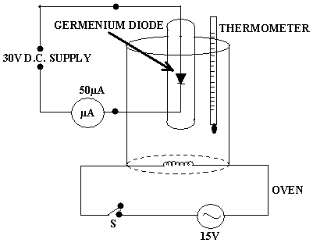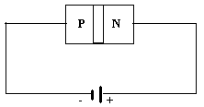
REVERSE BIASING OF P-N JUNCTION

Procedure:-

  - Make the connection and connect the diode in reverse bias.
  - Insert the thermometer and the diode in the hole of oven.
  - Now put the power on/off switch to ON position and see that the jewel light is
glowing.
  - Put the oven switch to ‘ON’ position and allow the oven temperature to
increase up to 80^{O}C.
  - When the thermometer reading reaches to 80^{O}C, turn the oven switch to
off position.
  - Now note the readings of micro-ammeter with falling temperature
at the difference of 5^{O}C till temperature reaches to 40^{O}C.
Observation table:-

S.No. | Temp. in ^{O}C (T) | Current in µ amp Is | Temp. in K  (T) | 10³/T (K) | Log Is
1. | 75^{O}C
2. | 70^{O}C
3. | 65^{O}C
4. | 60^{O}C
5. | 55^{O}C
6. | 50^{O}C
7. | 45^{O}C
8. | 40^{O}C

Calculation:-

- Slop of line = y₂ – y₁ / x₂ – x₁
- Energy band gap in ev

ΔE = [slop of line / 5.036] ev

Standard Value – Practical value
% Error = ------------------------------------------Χ 100
Standard Value
Standard Value of band gap for Ge diode= 0.67ev.

Result:-
The Energy band gap of a semiconductor diode found to be ………………..ev

Precaution:-
- Maximum temperature should not exceed 80^{O} C.
- Bulb of the thermometer and diode should be inserting.
- Silicon diode should not to be used with the setup as the temperature needed is 125^{O}C and in oven the thermometer provided will not stand to this temp.

Viva Questions

- What are semiconductors?
Ans: Semiconductors are those materials whose conductivity lies between conductors
and insulators.

- What do you mean by intrinsic and extrinsic semiconductors?
Ans: A semiconductor is in extremely pure form is known as intrinsic semiconductor.
A semiconductor which contains some impurities is known as extrinsic \
semiconductor.

- What do you mean by P&N types semiconductors?
Ans: Extrinsic semiconductor in which trivalent impurity is added is known as P type
semiconductor.
Extrinsic semiconductor in which pentavalent impurity is added is known as N
type semiconductor.

- What do you mean by pn junction diode?
Ans: A diode which is form by combining P type semiconductor and N type
semiconductor.

- What is potential barrier?
Ans: In a P-N junction, the holes from the P side and electrons from the N side tend to
move to each other due to attraction of opposite charges. Now as the flow
increases there will be enough Positive charge in N side to resist the flow of
further Positive charges from P side. Thus a Potential barrier (Which opposes
the further motion of charges) is formed.

- Which types of majority charge carriers are present in n type and p type
semiconductor?
Ans: Majority charge carriers are present in n type and p type semiconductors are
electrons and holes.

- What do you mean by forward and reverse biasing of diode?
Ans: In forward bias, the p-type is connected with the positive terminal and the n-type
is connected with the negative terminal. In reverse bias, the p-type is connected
with the negative terminal and the n-type is connected with the positive
terminal.

- What is the behaviour of semiconductor at absolute Zero?
Ans: They behave as insulators.

- How the conductivity is affected with increase in temperature in metal and
semiconductors?
Ans: In metals conductivity is decreased with increase in temperature. In
semiconductor conductivity is increased with increase in temperature.

- What is PN junction diode?
Ans: A diode which is form by combining P type semiconductor and N type
semiconductor.

- What is the difference b/w PN junction diode and Zener diode?
Ans: Diode that conduct current only in forward biasing and conduct very small (of
the order of microamp.) current in reverse biasing is called PN junction diode
whereas zener diode allows the flow of current in both the biasing.A normal
diode the conduction will be permanently damaged for a large reverse current,
but a zener diode will not.Amount of doping for P and N semiconductor layers
are different in the two devices.Diodes are normally used for rectification,
whereas zener diodes are used for voltage regulation.

- What do you mean by band gap?
Ans: The term "band gap" refers to the energy difference between the top of the
valence band and the bottom of the conduction band.

- What is the value of band gap for silicon and germanium?
Ans: Silicon – 1.1eV and germanium – 0.67eV.

- What is the value of band gap in metals?
Ans: Zero.

- On what factors energy band gap depends.
Ans: There are several factors that influence the energy band gap of semiconductors.
The defects, charged impurities, disorder at the grain boundaries as well as the
three dimensional quantum size effects, which could increase the energy band
gap with the decrease of particle size. Temperature is also another factor for
affecting the band gap of the materials. Temperature is inversely proportional to
energy band gap of the materials.

- What do you mean by Fermi level?
Ans: Fermi level is highest occupied energy level by an electron at absolute zero.

- What is Fermi energy?
Ans: The Fermi energy is defined as the maximum energy occupied by an electron at
absolute zero.

- What do you mean by breakdown?
Ans: Breakdown refers the reverse bias condition of diode when minority charge c
arriers increase rapidly to very high value so that reverse bias current is
increased to its maximum value.
In Zener breakdown the electrostatic attraction between the negative electrons
and a large positive voltage is so great that it pulls electrons out of their covalent
bonds and away from their parent atoms. ie Electrons are transferred from the
valence to the conduction band. In this situation the current can still be limited by
the limited number of free electrons produced by the applied voltage so it is
possible to cause Zener breakdown without damaging the semiconductor.
Avalanche breakdown
Avalanche breakdown occurs when the applied voltage is so large that electrons
that are pulled from their covalent bonds are accelerated to great velocities. These
electrons collide with the silicon atoms and knock off more electrons. These
electrons are then also accelerated and subsequently collide with other atoms.
Each collision produces more electrons which lead to more collisions etc. The
current in the semiconductor rapidly increases and the material can quickly be
destroyed.

- What do you mean by saturation current?
Ans: The saturation current or, more accurately, the reverse saturation current is
that part of the reverse current in a semiconductor diode caused by diffusion of
minority carriers from the neutral regions to the depletion region. This current is
almost independent of the reverse voltage.

- What is the behaviour of saturation current with increase in temperature?
Ans: It varies with temperature; this variance is the dominant term in the temperature
coefficient for a diode. A common rule of thumb is that it doubles for every
10°C rise in temperature.

The frequency of A.C. mains by using an Electric vibrator

Aim:-

To determine the frequency of A.C. mains by using an Electric vibrator.

Apparatus required:-

Electric vibrator, Weight box, finishing chord, A.C. source, meter tap etc.

Theory:-

When a chord of mass per unit length is connected to the vibrating rod of the vibrator and stretched by a tension ‘T’ the chord vibrator in segments as in Meld’s experiment if the length of the chord is adjusted until the nodes are clearly marked the frequency of the stretched string is vibrating with the frequency of A.C. mains then if ‘l’ be length of are loop of vibrating string its frequency of vibration is given by.

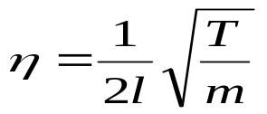 Where m is mass per unit length of chord
m = 5.4 × 10⁻³ gm/cm

Procedure:-

- Switch the current on and see that the rod of the electric vibrator begins to vibrate
- Adjust the length of the rod of it is free and perform vibrating of maximum amplitude.
- The length of the vibrating rod is adjusted by stopping the vibration fills the nodes are clearly defined.
- Mark the position of the extreme hole leaving on it the first & last loop.
- Measure the length of vibrating chord and divide it to the no. of loops to get ‘l’ for same tension take move set of reading by alternating the change of chord.
- Calculate the mean total tension applied to the chord.
- Repeat the experiment with different tension.

Circuit Diagram:-

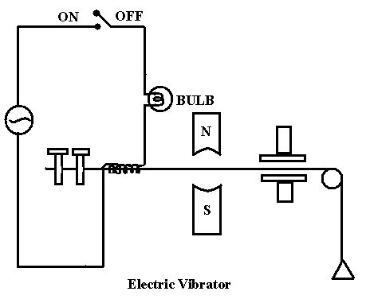

Observation Table:-

SNo | No. of loops (N) | Length of chord (L) |  | Length of per loops  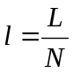 | Mass of pan  m1 | Mass on pan  m2 |  | Total mass  M =m1 + m2 |  | Tension  T = M×g
1.
2.
3.
4.
5.
6.
7.
8.

Calculation:
Mean frequency η₁ +η₂ +η₃ +η₄ +η₅ +η₆ +η₇+ η₈
η = -------------------------------------
8
Standard Value – Practical value
% Error = ------------------------------------------Χ 100
Standard Value
Standard value of frequency of A.C. mains= 50 hertz.

Result:
Frequency of A.C. mains is found ----------- hertz.
% Error= -----------

Precaution:-

- Length of steel rod must be adjusted to that it vibrated in resonance with A.C. frequency of this is obtained when the free and of the rod vibrates with maximum amplitude.
- There must be no function in pulley.
- Reading must be taken carefully.

VIVA QUESTIONS

- What is the frequency of ac and dc?
Ans: The frequency of ac and dc are 50 Hz and 0 Hz respectively.

- On what principle ac vibrator works.
Ans: Electromagnetic induction

- What are the distance b/w two nodes or two antinodes?
Ans: /2

- Why do you count no of loops?
Ans: To find the frequency.

- By length of per unit loop what will you find out?
Ans; λ/2

- What formula do you use to determine frequency?
Ans: η=

- What is the velocity of transverse waves?
Ans: v=√T/m

- Define nodes and antinodes.
Ans: Node: It is point along a standing wave where the wave has minimum
amplitude.
Antinode:It is point along a standing wave where the wave has maximum
amplitude.

- What are waves?
Ans: A wave is a propagation of disturbance or energy

- How many types of waves do you know?
Ans: There are two types of waves
- Transverse wave
- Longitudinal wave

- What is self and mutual induction.
Ans: Self induction: The generation of induced emf due to change in flux in thesame
circuit.
Mutual induction: The production of an emf in a circuit resulting due to
change of current in a neighbouring circuit.

- What is Faraday’s Law?
Ans: According to Faraday’s law, induced emf is directly proportional to rate of
change in magnetic flux.

To study Hall Effect in semiconductor

Aim: To study Hall Effect and determine Hall coefficient in semiconductor.

Apparatus Required:–
The apparatus consists of Electromagnets, Power Supply for Electromagnets, Gauss Meter for measuring magnetic Flux, Germanium Crystal, Constant Current Power Supply for Crystal.

Theory: –
Hall Effect is a magneto-electric effect. If a current I_{x} passes in X-direction of the Crystal and a magnetic field B_{z} is applied in z-direction, then a potential difference, called the Hall potential difference, is produced in y-direction. The sign of Hall potential depends on the nature of charge carriers. Thus by noting the directions of Hall potential and the magnetic field, the nature of charge carriers may be determined by the use of Fleming left hand rule.

Hall coefficient V_{H} × t
R_{H} = -----------,
I_{x}×B

Where V_{H} is hall voltage
I_{x} is current through semiconductor,
t is thickness of Ge crystal
B is applied field.

Procedure:–

- Connect the HALL Crystal to Constant Current Power supply in their respective Sockets.
- Switch ON the Power Supply and adjust the current Ix (say few mA).
- There may be some voltage in the mV meter even outside the magnetic field. This is due to imperfect alignment for four contacts of Ge. Crystal and is generally known as ‘Zero Field Potential’. In case its value is comparable to Hall voltage it should be adjusted to a minimum possible (for Ge. Crystal only). In all cases, this error should be subtracted from the Hall voltage reading.
- Now place the probe in the magnetic field as shown in figure and switch on the electromagnet power supply and adjust the current to any desired value. Rotate the Ge. Crystal Probe till it becomes perpendicular to magnetic field. Hall voltage V_{H} will be maximum in this adjustment.
- Measure Hall voltage for both the directions of current and magnetic field (i.e. four observations for a particular value of current and magnetic field).
- Change the value of Ix in steps and note corresponding values of Ix and V_{H}. Take many readings. Then plot a graph between V_{H} and Ix values. It will be straight line whose slope will be given by V_{H} / Ix.
- Measure the magnetic field B, with a gauss meter.

Observation Table:-

Magnetic Field = ------------ Gauss

S. No. | HALL CURRENT ( Ix ) | HALL VOLTAGE ( V_{H} )
1

2

3

4

5

6

7

Calculation: - Hall coefficient V_{H} × t
R_{H} = -----------
I_{x}×B

Slope of the line× t
R_{H} = ----------------------------
B

Graph:-
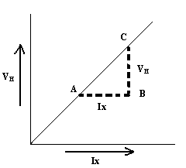

Result:- Hall coefficient is found ----------- for Ge crystal.

Precautions:-

- Handle the Ge. Crystal with care, it can break.

- Handle the Hall probe of Gauss meter with care; it may damage in mishandling.

- Does not use Electromagnets continue at full current? It may start heating.

- Gap between poles of Electromagnet must remain fixed during one reading.

Viva Questions

- What is Hall Effect?
Ans When a current carrying conductor or semiconductor is placed in crossed
magnetic field, a potential difference is generated across the conductor or
semiconductor which is perpendicular to both current and magnetic field, this
effect is called Hall Effect.

- What is hall voltage?
Ans: When a current carrying conductor or semiconductor is placed in crossed
magnetic field, a potential difference is generated across the conductor or
semiconductor which is perpendicular to both current and magnetic field, this
effect is called Hall Effect, and the potential difference is called hall voltage.

3. What is hall coefficient?
Ans: The Hall coefficient is defined as the ratio of the induced electric field to the
product of the current density and the applied magnetic field. It is a
characteristic of the material from which the conductor is made, since its value
depends on the type, number, and properties of the charge carriers that
constitute the current.

4. What is the use of hall coefficient?
Ans: Uses
i. To measure the magnetic field with hall probe.
ii. To measure the average drift velocity of the charge carriers, sign of charge
carriers and their mobility.

- What is the sign of hall coefficient for metals?
Ans: Negative.

To calibrate a given Ammeter by means of potentiometer

Aim:- To calibrate a given Ammeter by means of potentiometer.

Apparatus Required :- A Potentiometer, Two battery, Two rheostats, Daniel cell, A Galvanometer, Two way key, Two single way keys, Shunt wire, jockey, Resistance box etc.
Theory: Let a study potential difference is maintained between two ends A and B of wire the potential of A is being less than B. The +ve terminal of Daniel Cell be connected is A and –ve terminal through Galvanometer to the jockey of Potentiometer then if l length of potentiometer wire for no deflection in galvanometer, we have
E = Kl₁
Where E is the emf of the Daniel cell supposed to be known and K is the potential gradient of the potentiometer wire, thus the value of K is known. Now the Daniel cell be replaced by a standard resistance box which is activated generally on one ohm resistance through which a steady current I is flowing from its higher potential terminal being connected to the end A of the potentiometer & let the current I also flow through the ammeter to be calibrated connected in series with the one ohm resistance box. Then of l₂ be the length of the potentiometer wire for no deflection in the potentiometer. The potential difference between the terminals of the standard resistance box is given by
V = Kl₂
& current through it by
I = V/R = Kl₂ / R (R = 1Ω)

Let the reading of the ammeter be I’. Then the error in it is (I’ – I). If now the current through the standard resistance box varied and the values of (I’ – I) corresponding to different reading I’ of the ammeter may be drawn.

Circuit Diagram
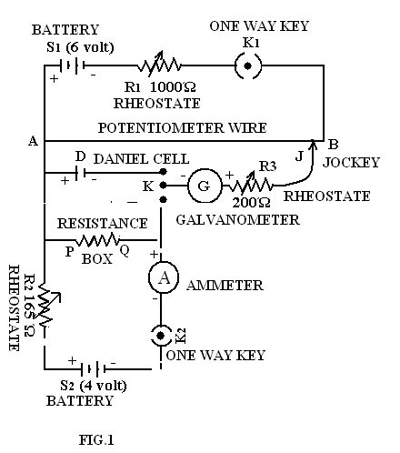
Where
R₁ & R₂ = Rheostat
AB = Potentiometer
S₁ & S₂ = Storage battery
K₁,K₂ = Keys (One way)
K = Key (Two way)
J = Jockey
D = Daniel cell
PQ = Resistance Box
A = Ammeter
G = Galvanometer
R = Resistance Box

Procedure: - As shown in circuit diagram connect the two ends A & B of the potentiometer to one of the storage batteries S₁ in series with a rheostat R₁ including a plug key K₁ in the circuit. Connect the standard resistance box R to the other storage battery S₂ in series with a rheostat R₂ and the ammeter which is to be calibrated including pole of denial cell and the higher potential terminal P of standard resistance box together to the sliding contact make X of the potentiometer which is nearer to the higher Potential end A of the potentiometer and the –ve pole of Daniel cell and the lower potential terminal Q of the standard resistance box through a two way key K to one terminal of the galvanometer the second terminal of which is connected to the jockey J which slides over the potentiometer wire.

First standardize the potentiometer wire with the Daniel cell for this connect negative pole of denial cell by means of a two way key K to be connected to the galvanometer put the slider X at the end of the 10th wire & the jockey at certain division on the slide wire & adjust the rheostat R₁ in the main circuit till there is no deflection in the galvanometer. Now the potential gradient K of the potentiometer equals 10⁻³ V/ cm.

Next place K2 & also connect the lower potential terminal Q of the standard resistance box operating at one ohm resistance by means of a two way key K to the galvanometer and determine the equivalent length l₂ of the potentiometer wire corresponding to the potential difference V between the terminals of the standard resistance. Note down the reading of the ammeter open K₂ and K₁ and calculated the true value of current corresponding to reading I’ of ammeter from equation (3). Then calculate the error (I’ – I) in the ammeter reading.

Next after this change current through the resistance box by means of a rheostat R₂ and take several sets of observations for different values of potential difference across the resistance box operating at one ohm resistance at the same time noting the reading of the ammeter & thus determine the error (I’ – I) corresponding to various reading of the ammeter covering its entire range. Finally plot the calibration curve of the ammeter taking the reading of the ammeter on X axes and corresponding errors (I’ – I) on Y axes.
Observation:-

S.No. | E.M.F. of Std. Cell E (V) | Length of potentiometer wire corresponding to E.M.F. of std. cell (l₁) cm. | Potential gradient of potentiometer wire  K = V / l₁
1

S.No. | Length of potentiometer ire corresponding to the P.D. across N.P. of resistance R_{2,} l₂ cm. | Reading of Ammeter  I Amp. | Accurate value of P.D.  I’ = Kl₂ / R | Error in the reading of Ammeter  (I’ – I) Amp.
1.
2.
3.
4.
5.
6.

Result: - The graph so obtained by plotting the errors in the readings of ammeter against the corresponding ammeter readings is the calibration curve of the given ammeter.
Precaution: - (1) The main circuit battery S1 must be of practically constant e.m.f. & preferably of large capacity so that the current in the potentiometer coils and wire may remain constant throughout the test.
(2) The magnitude of the potential difference between A & B must be greater than the maximum potential difference to be measured by the means of the potentiometer.
(3) The Galvanometer should be shunted
(4) The contact between the jockey J and the potentiometer wire should be momentary.
(5) The ammeter should be calibrated over its entire range.

Calibration of voltmeter through potentiometer

Aim:-
To calibrate given voltmeter of V volt range by means of potentiometer.
Apparatus required:-
Potentiometer, Two storage batteries, Two rheostats, Cell of constant e.m.f(Daniel cell), Weston galvanometer, Voltmeter to be calibrate, Two way key, Single way keys, Connecting wires.
Theory:-
Let a constant potential difference maintained between ends A and B of potentiometer wire. Potential of A being higher than that of B now positive terminal of Daniel cell be connected to the end A and negative terminal through a galvanometer to jockey. It is in the length of potentiometer wire for no deflection in the galvanometer we have.
E = Kl₁
Where E = e.m.f. of cell
K = Potential gradient of potentiometer
Now the Daniel cell is replaced by all position of a rheostat through which a steady current is maintained. The higher potential point M of rheostat being connected to end A of the potentiometer wire. If l₂ is the length of potentiometer wire at null point the potential difference across the MP of rheostat is given by
V = Kl₂
If potential difference across the same position MN of rheostat measured by voltmeter is V. So error in the reading of V’ of voltmeter is (V’-V)

Circuit Diagram:-

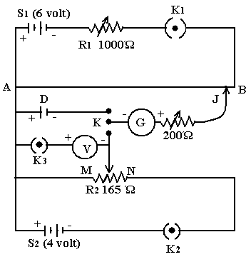
Where
R₁ & R₂ = Rheostat
AB = Potentiometer
S₁ & S₂ = Storage battery
K₁,K₂,K₃ = Keys (One way)
K = Key (Two way)
J = Jockey
D = Daniel cell

Procedure:-
- Connect the two ends of potentiometer of the storage battery S₁, in the circuit in series with rheostat R₁, a plug key K₁ in circuit. Connect two fixed terminal M and N of resistance R₂ to a battery S₂ connect one terminal of voltmeter V to be calibrated through a key K₃ to the sliding terminal P of the rheostat.
- Connect the positive terminal of Daniel cell and high potential fixed terminal finally connect the negative terminal of Daniel cell and sliding terminal P of the rheostat R though two way key and a galvanometer to jockey J which slides over potentiometer.
- Loose key K₁ of Daniel cell then place jockey on 10th wire and adjust the rheostat R₁ till there is no deflection in galvanometer. This is gives potential gradient along potentiometer wire.
- Next connect the sliding terminal P of rheostat R₁ by means of two way key and determine the equivalent difference of the potentiometer wire corresponded the potential difference across MP of rheostat R₂. Note down the reading V of the voltmeter open the key K₁ and K₂ and calculate the reading V’ of the voltmeter and then error (V’- V) in the voltmeter reading.
- Now change the potential difference between M and P by moving sliding terminal P of rheostat R_{2,} determine the potential difference through potentiometer, and find the error (V’-V). The process is repeated for various values of V.
- Now a graph is plotted between V and (V’-V), which represent the error in reading of voltmeter.

Observation Table

S.No. | E.M.F. of Std. Cell E (V) | Length of potentiometer wire corresponding to E.M.F. of std. cell (l₁) cm. | Potential gradient of potentiometer wire  K = V / l₁

S.No. | Length of potentiometer ire corresponding to the P.D. across N.P. of resistance R_{2,} l₂ cm. | Reading of voltmeter  V volt | Accurate value of P.D.  V’ = Kl₂ | Error in the reading of voltmeter  (V’ – V) volt
1.
2.
3.
4.
5.
6.

Result:-
The graph plotted between the error and the reading of voltmeter is the positive calibration curve of given voltmeter.
Precaution:-

- The galvanometer should be shunted.
- All the connection should be tight.
- The main circuit battery must be practically of constant e.m.f. better to use battery eliminator.
- Jockey should not be pressed.

Viva Questions
- What do you mean by calibration?
Ans: Calibration is a comparison between measurements – one of known magnitude
or correctness made or set with one device and another measurement made in as
similar a way as possible with a second device.

- What is potentiometer?
Ans: A potentiometer is an instrument for measuring the potential difference
(voltage) in a circuit.

- What do you mean by EMF of cell?
Ans: Emf is potential difference between two terminals of a cell in an open circuit.

- What is the principle of potentiometer?
Ans: The potential difference across any length of a wire of uniform cross-section and
uniform composition is proportional to its length when a constant current flows
through it.

- What do you mean by potential gradient?
Ans: Change in potential per unit length is known as potential gradient.

- Which material is used in potentiometer wires?
Ans: The material having high resistance like alloys examples Magneen, constantan
or eureka.

- What do you mean by standard cell?
Ans: Standard cell is that cell whose emf is considered to be constant.

- When do you get null point in galvanometer?
Ans: Galvanometer shows null deflection when no current is drawn from battery.

- What are galvanometer, ammeter and voltmeter?
Ans: A voltmeter measures the potential difference (voltage) between 2 points. It
does not need to be part of a circuit, e.g. you measure the voltage of a torch cell.
An ammeter measures the current flowing in a circuit. It registers in amperes, or
multiples or submultiples of amperes. A galvanometer is an indicator of very
small currents flowing in a circuit, it is the earliest device used to show the
presence of a current, and is very sensitive.

- How ammeter and voltmeter are made by galvanometer?
Ans: Galvanometer can be converted into ammeter by shunting it with a very small
resistance. Potential difference across the galvanometer and shunt resistance is
equal.Galvanometer can be converted into voltmeter by connecting it with a very
high resistance in series. Potential difference across the given load resistance is
the sum of p.d across galvanometer and p.d. across the high resistance.

- How ammeter and voltmeter are connected in circuits?
Ans: Ammeter is connected in series and voltmeter is connected in parallel in circuits.

- What are the requirements of cell used in main circuit?
Ans. To maintain the constant emf.

- What is the use of rheostat in primary circuit?
Ans. To standardize the primary circuit.

- What is the range of voltmeter and ammeter you are calibrating?
Ans: 1volt and 1 ampere.

- What is the need to calibrate voltmeter and ammeter?
Ans: To check their errors.

Characteristics of G.M. Counter

Aim: - To the study of Characteristics of the Geiger Muller (GM) counter and hence to determine its operating voltage.
Apparatus: - Triode Geiger counting system (GCS), GM tube and a radioactive source.
Principle: - When a gamma ray (or a charged particle) enters the gas filled GM tube it ionizes the gas inside it and the electric field applied between the electrodes drifts the electrons towards the anode. The electrons thus collected at the anode are counter for various applied voltage using Geiger Counting System. A graph is plotted for applied voltages Vs corrected counts (N - N_{B)} and hence the operating voltage is determined from the graph.
Diagram

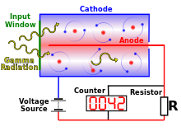

Procedure: - The Geiger counter system is connected to the GM tube, which is mounted on a stand (vertical mount). The radioactive source is placed in the source holder at a distance of about 5cm from the tube. The GCS I switched on and the counter is reset to zero. The high voltage is increased slowly from minimum until the counting just starts. This threshold voltage is noted. The preset time is set to be 20 sec. and the number of counts for this voltage is recorded. Now the voltage (V) is increased in steps (say 20V) and the number of counts (N) is recorded every time. Increasing the voltage is stopped when the count rate suddenly increases, any further increase in voltage may damage the GM tube. The number of counts starts decreasing at this point. In this particular case the voltage should not be increased more than 650V.
The voltage is checked on digital multimeter at range 1000V D.C. after every setting before taking readings the meter lead is disconnected so as to avoid unnecessary load across the GM Tube.
By removing the radioactive source the background count N_{B} is recorded for 20 seconds.
A graph is plotted for applied voltage (V) Vs corrected count rate (N - N_{B} ). The Threshold voltage and the limits of the Geiger plateau are marked. The midpoint of the plateau region gives the operating voltage of the tube. The tube must always be operated with this voltage when it is used.

Result: - (i) Threshold voltage = ………………V
(ii) Operating voltage = ………………V

Observation table:-
Reading from GCS
Background counter for 20s, N_{B} = ………………….

Trial No. | Applied voltage V volt | Counts for 20s  N | Corrected counts / 20s (N - N_{B} ).
1
2
3
4
5
6
7
8
9
10

Precaution: - 1) Reset counter after every set of reading by pressing reset switch.
2) Take Out Beta Source after every reading with the help of fork.
3) Do not hold Beta Source with fingers directly or put it in vicinity
to human body.

Viva Questions

- What is GM counter?
Ans: A Geiger counter (Geiger-Muller tube) is a device used for the detection of
charge particles.

- What is quenching?
Ans: The process of preventing the unwanted pulses is known as quenching.

- How quenching is achieved in GM counter?
Ans: Quenching is achieved by adding a quenching agent like ethyl alcohol vapour
in the tube.

- What is the dead time, recovery time, and paralysis time?
Ans: There is an interval of time following the production of a pulse in the GM
tube during which no other pulse can be recorded. This interval is called the
dead-time of the system.After dead time, the tube takes nearly 100
microseconds before regains its original working condition is known as
recovery time. Sum of the dead time and recovery time is known as
paralysis time.

- How ionization starts in GM tube?
Ans: The electrodes have a high voltage across them. The gas used is usually
Helium or Argon. When radiation enters the tube it can ionize the gas. The
ions (and electrons) are attracted to the electrodes and an electric current is
produced. A scaler counts the current pulses, and one obtains a "count"
whenever radiation ionizes the gas.

- What is threshold, and operating voltage of GM counter?
Ans: The threshold voltage is the voltage where the counter starts the counting
(where the counter gives first reading).Proper operation is when the voltage is
in the plateau region of the curve. This voltage is known as operating voltage.

- What are various regions plotted in GM counter characteristics curve?
Ans: The various regions are proportional region, plateau region and discharge
region.

- What is backward counting?
Ans: Backward counts are those counts which are already present in the GM tube.

- Why the radioactive source is needed in GM counter.
Ans: To initiate primary ionization.

- What is plateau region?
Ans: The region where number of counts is constant is called plateau region.

WAVELENGTH OF LASER LIGHT

Aim: To determine the wavelength of laser light by demonstration.

Apparatus: - Laser light source, transmission grating, spectrometer, and screen (white wall), meter tap.

Formula Used:-

(e+d) sin θ
λ = -------------------
n
n is order of maxima, (e+d) grating element
x_{n}
sin θ= -------------- x_{n}= distance of nth order from zero order
( x_{n}²+y² )^{1/2} y= distance between grating and screen

Diagram:-

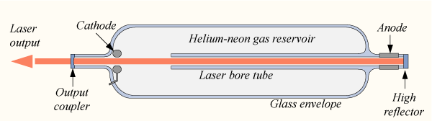

Procedure:-

- Set the spectrometer for parallel incidence.
- Place the laser as light source in front of collimator.
- Now place the grating on prism table, adjust the grating so that diffraction pattern is obtained on the white screen.
- Measure the distance from central maxima to first order and second order maxima which gives the value of x_{n.}
- Now measure the distance from grating to screen which gives value of y.
- Now calculate sinθ using x_{n} and y for first order and second order.
- By substituting the value of sinθ and (e+d) calculate λ for laser light.

Observation:-

S.NO. | Order of maxima | X_{n} distance from zero order | Distance between screen and spectrometer y | sin θ
1
2

Calculation:-

(e+d) sin θ
λ = -------------------
n
n is order of maxima, (e+d) grating element

x_{n}
sin θ= --------------
( x_{n}²+y² )^{1/2}

For first order maxima n=1
Grating element (e + d) = 2.54 / 15000 cm.
= 1.69 x 10⁻⁶ cm.

(e+d) sin θ
λ₁ = -------------------
1
(e+d) x₁
λ ₁ = ----------------,
(x₁² +y²)

For second order maxima n=2

(e+d) x₂
λ ₂ = ----------------,
(x₂² +y²)

Mean wavelength
λ₁+λ₂
λ = --------- A
2

Standard Value – Practical value
% Error = ------------------------------------------Χ 100
Standard Value
Standard wavelength of He-Ne laser is 6328A.

Result:-

The wavelength of He-Ne laser is found -----------A.

Precaution: -1) Distance of maxima should be noted carefully.
2) Adjustment of spectrometer should be proper.

Viva questions

- What is LASER?
Ans: A laser is a device that emits light through a process of optical
amplification based on the stimulated emission of electromagnetic radiation. The
term "laser" originated as an acronym for "light amplification by stimulated
emission of radiation"

- What is the principle of laser?
Ans: The principle of a laser is stimulated emission of radiation

- What is the difference b/w laser light and normal light?
Ans: Laser is monochromatic, coherent and unidirectional. Normal light is
unidirectional, non coherent.

- What do you mean by coherent sources?
Ans: Those sources of light which emit light waves continuously of same wavelength,
and time period, frequency and amplitude and have zero phase difference or
constant phase difference are coherent sources..

- What do you mean by pumping, population inversion?
Ans: If the higher energy state has a greater population than the lower energy state,
then the light in the system undergoes a net increase in intensity. And this is called
population inversion.The process of achieving population inversion is known as
pumping.

- What is metastable state?
Ans: Metastable state, is an excited state of an atom, that has a longer lifetime than
the ordinary excited states and that generally has a shorter lifetime than the ground
state.

- What do you mean by absorption, spontaneous emission and stimulated emission?
Ans: Absorption: When appropriate energy is supplied to the atom, electrons can jump
from low-energy state (ground state) to high-energy states. This process is called
absorption.
Spontaneous emission: Some of the electrons in the high-energy orbit
spontaneously return to the ground state, releasing the difference in energy in the
form of a photon, with a wavelength which depends exactly upon the difference in
energy of the 2 states and has a random phase and direction. This process is called
spontaneous emission.
Stimulated emission: This emitted photon can collide with one of the mirrors in
the resonating cavity and reflect back into the lasing medium causing further
collision with some of the already excited atoms. If an excited atom is struck, it
can be stimulated to decay back to the ground state, releasing 2 photons identical
in direction, phase, polarization and energy (wavelength). This process is termed
stimulated emission.

