@@NAME@@ COLLEGE OF TECHNOLOGY, BHOPAL

DEPARTMENT OF IT

LAB MANUAL

Programme : BE
Semester : VI
Course Code : IT 605
Subject Name : Software Engineering & Program Management

Prepared By: Approved By:

Index

S.No. Contents Page No.

- List of Experiments /Methods 3
- Solved Examples 4-17
- Viva Questions 18
- Grading Sheet 19-22

Lab Experiments List of Software Engineering and Programming Management

To solve the case study of any two of the below systems:-
- Transport Company computerization (TCC) Software.
- Hotel Automation Software:
- Bookshop Automation Software (BAS)
- Judicial Information System (JIS)
- Time Management Software
- Supermarket Automation Software(SAS)
- Restaurant Automation System (RAS)
- Road Repair and Tracking System (RRTS)

- Experiment 1:
Prepare E-R Diagram for two chosen systems.

- Experiment 2:
Prepare Data Flow Diagram for two chosen systems.

- Experiment 3:
Prepare Use Case Diagram for two chosen systems .

- Experiment 4:
Prepare Data Dictionary for the systems.

- Experiment 5:
Prepare a Documentation for for the systems under the following heads:
- Abstract
- Introduction
- Software Requirement Specification
- Software Process Model
- System Documentation
- Limitations
- Future Enhancement
- Conclusion
- References and Bibliography

CASE STUDY

1. Transport Company computerization (TCC) Software.

A transport company wishes to computerize various bookkeeping activities associated with its operations.
  - The transport company receives consignment of various sizes(measured in cubic meters) to be forwarded to different destinations across the country.
  - Once a consignment arrives at the office of the transport company, its volume, destination address, sender’s address, etc. are entered into the computer. The computer computes the transport charges and its destination and issues a bill for the consignment.
  - Once the volume of any particular destination becomes 500 cubic meters, the computer flashes a messages for the manager for requisition of a truck for dispatch of the set of consignments to its destination. After the manager enters the truck number, the computer prints the details of each consignment number, volume, sender’s name and address, and the receiver’s name and address to be forwarded along with the truck.
  - The manager of the transport company can query the status of any particular consignment and the details of volume of consignments dispatched to any particular destination and the corresponding revenue generated.

2. Hotel Automation Software:

Guests can reserve rooms in a hotel in advance or can reserve rooms on the spot depending on the availability of rooms. The operator would enter data pertaining to guests such as their arrival time, advance paid, approximate duration of stay, and the type of the room required (i.e. AC, non AC , Deluxe, Single, double). The computer should register this data and depending on the availability of a suitable room, the computer should provisionally allot a room number to the guest and assign a unique token number to him/her. If the guest cannot be accommodated, the computer generates an apology message. The hotel catering services manager would input the quantity an type of food items as and when consumed by the guests along with the token number of the guest and the corresponding date and time. You can assume that different food items have different code numbers and hence the catering service manager need not enter the full name of the different food items. When a customer prepares to check-out, the hotel automation software should generate the entire bill for the customer and the balance amount payable by him.

3. Bookshop Automation Software (BAS)

The BAS should help the users query whether a book is in stock. If in stock, the exact number of copies available and the rack number in which the book is located should be displayed. The BAS should maintain the price of various books. As soon as a customer selects a book for purchase, the sales clerk would enter the title of the book for BAS to update to stock and generate the sales receipt. This software should also allow employees to update the inventory whenever a new supply arrives. Also upon a request, the Bas should generate the sales statistics (i.e. the name of book, the name of publisher , the ISBN number , the number of copies sold and the sales revenue) for any period. The sales statistics will help the owner to know the extent of business done over any period of time and also determine the inventory levels required for various books .

4. Judiciary Information System (JIS)

The attorney general’s office has requested us to develop software to handle court cases. For each court cases, the name of the defendant, defendant’s address, the type of crime(theft, arson, etc.), the date crime committed, where committed(location) , the name of the arresting officer5, and the date of the arrest are entered by the court registrar. Each court case is identified by a unique case identification number (CIN) which is generated by the computer. Also, on completion of a court case, the summary of the judgment is recorded. Other data maintained about a case include the name of the presiding judge, the public prosecutor, the starting date, and the expected completion date of a trial. Using the JIS software, the registrar of the court should be able to query the following.
- The currently pending court cases.
In response to this query, the computer should print out the pending cases sorted by
CIN. For each pending case, the following data should be listed: the date on which the
case started, the defendant’s name, address, crime details the lawyer’s name, the public
prosecutor’s name, and the attending judge’s name.
- The cases that have been resolve over any given period. The output in this case should chronologically list the starting date of the case, the CIN, the date on which the judgment was delivered, the name of the attending judge, and the judgment summary.

5. Time Management Software :

A Company needs to develop a group diary and a time management system for its executives. The group diary should let the executive register their daily appointment schedules. When a meeting involving many executives needs to be organized, the system should automatically find a common slot in the diaries of the concerned executives, and arrange the meeting at that time. It should also inform the concerned executives. If no common slot is available, it should help the secretary to rearrange the diaries of the concerned executives for making room for a common slot.

6. Supermarket Automation Software(SAS)

The manager of a supermarket wants to have an automation software. The supermarket stocks a set of items. Customers pick up items from different counters in required quantities. The customers presents these items to the sales clerk. The sales clerk enters the code number of these items along with the respective quantity/units.
- The SAS, at the end of a sales transaction, prints the bill containing the serial number of the sales transaction, the name of each item, code number, quantity, unit price, and the total price. The bill should indicate the total amount payable.
- The SAS maintains the inventory of the various items of the supermarket. The manager upon query should be able to see the inventory details. In order to support inventory management, the inventory of an items should be decreased whenever an item is sold. The SDAS should also support an option by which an employee can update the inventory when a new supply arrives.
- The SAS should support printing the sales statistics for every item the supermarket deals with for any particular day or for any particular period. The sales statistics should indicate the quantity of an item sold, the price realized and the profit.

7. Restaurant Automation System (RAS)

- A restaurant owner wants to computerize his order processing, billing and accounting activities. He also wants the computer to generate statistical reports about sales of different items. A major goal of this computerization is to make supply ordering more accurate so that the problem of excess inventory is avoided as well as the problem of non-availability of ingredients required to satisfy orders for some popular item is minimized. The computer should generate bills whenever food items are sold. Whenever ingredients are issued for preparation of food items, the data is to be4 entered into the computer . Purchase orders are generated on a daily basis, whenever the stock of food grains for any ingredient falls below a threshold value. Whenever the ordered ingredients arrive, the invoice data regarding the quantity and price is entered. If sufficient cash balance is available, cheques are issued immediately against invoices. Monthly sales receipt and expenses data should be generated.

8. Road Repair and Tracking System (RRTS)
- Repair request for different roads of the city are raised by residents. As soon as a repair request is raised, a supervisor visits the road and studies the severity of the road condition. Depending on the severity of the road condition and the type of the locality (e.g. VIP area, busy area, relatively desert area etc. ) he sets the priority for carrying out this repair work. The supervisor also estimate the requirement of raw material for carrying out the repair work, the types and the number of machines required, and the number and types of personnel required. The supervisor inputs these data to the RRTS for every complaint that he attends to. Based on this data, the computer schedules the repair of the road depending on the priority of the repair work and availability of raw materials, machines, and personnel. The computer generates printouts on a weekly basis for the repair works to be carried out and for the resources and personnel to be assigned to such works. The mayor of the city can request for various road repair statistics such as the number and type of repairs carried out over a period of time and the repair work outstanding at any point of time.

ER Diagram Example:

In this example an ER Diagram of student-teacher relationship is prepared.
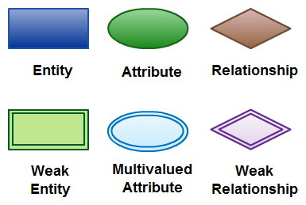

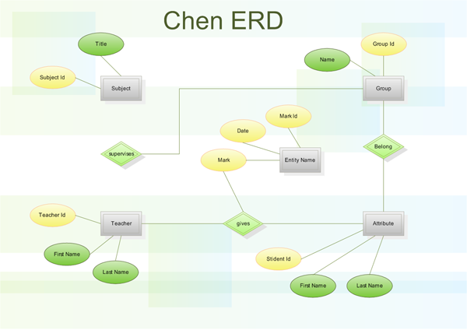

Data Flow Diagram:

In this example DFD of Library book issue system is shown.

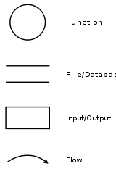

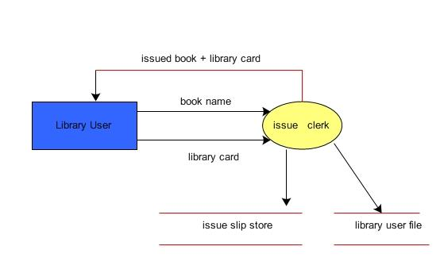

Use case diagram:

In this example use case diagram of e bidding system is shown.

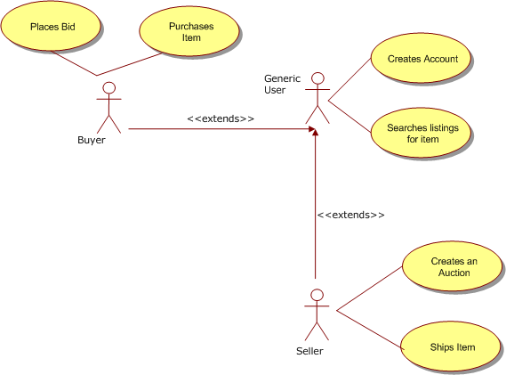

Data Dictionary:

In this example the data dictionary of the registrations of a Seminar is shown.

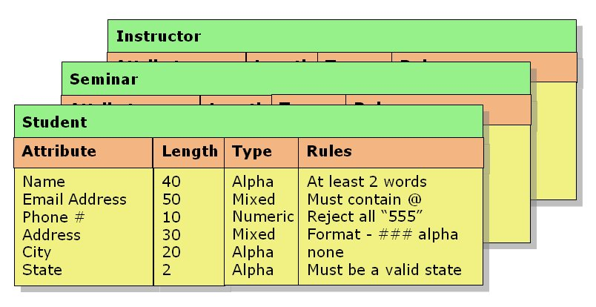

Dummy project:

Cryptography

Contents:

1. Abstract
2. Introduction
3. Software Requirement Specification
4. Software Process Model
5. System Documentation
6. Limitations
7. Future Enhancement
8. Conclusion
9. References and Bibliography

1.Abstract

- This project implements Cryptography, where we encrypt and decrypt texts or files.
- A cryptography scheme provides a procedure of a better way of securing our text and data files.
- In the proposed project we are using substitution cipher technique where each letter or group of letters are replaced by another letters to hide the actual matter. Substitution ciphers are among the earliest methods of encryption.
- Classic substitution ciphers include the well-known simple substitution ciphers are indeed simple both in terms of their use Hence, making our data secure.

2.Introduction
- Presented here is a Java program to encrypt or decrypt the texts or files.
- In this project Replace bits, characters, or blocks of characters with substitutes.
- A simple substitution cipher is easy to solve by performing a frequency analysis.
- Security in every aspect of life is important. Similarly data security also plays vital role in computer communication and networks.
- The main objective of my work is to protect information leakage what so ever manner it may be, the use of appropriate technology to provide a high level of confidentiality, integrity and authenticity to information that is exchanges over networks.

3.Software Requirement Specification

3.1 Purpose: This software is useful in securing our data or messages from illegal access. This project implements Cryptography scheme which provides a procedure of a better way of securing our private texts and data files. So, we can say that it can also be helpful at different fields as military, politics, sports etc; for secretly coding the documents or messages.

3.2 Scope: The scope of this software is for both technical and non technical users. It is a generic software i.e. multiple users.

3.4 Hardware / Software Requirements
OPERATING SYSTEM : WINDOWS XP
HARD DISK SPACE: Minimum 320 GB for installation and running.
RAM: 32 MB RAM or above for fast execution and reliability.
PROGRAMMING LANGUAGE : JAVA
DOCUMENTATION : MS-WORD2007
EDITOR : NetBeans IDE

4.Software Process Model:
- The waterfall model is a sequential model
- It is seen as flowing steadily downwards through the phases of conception, initiation, analysis, design, construction, testing, production/implementation, and maintenance.
- This hardware-oriented model was simply adapted for basic software development model.
- In waterfall model, the following phases are followed in order:
1. Software requirement specification
2. Design
3. Implementation or coding
4. Testing
5. Maintenance

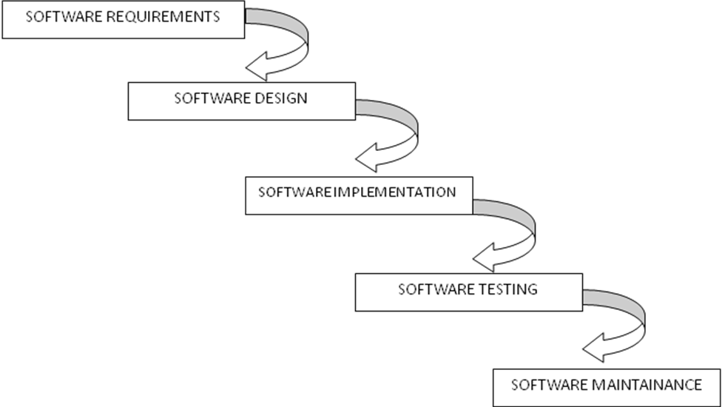

5.System Documentation:


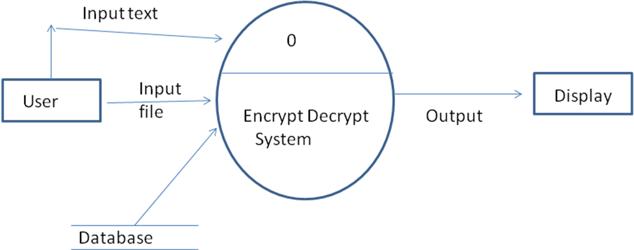

5.2 System Flow Diagram

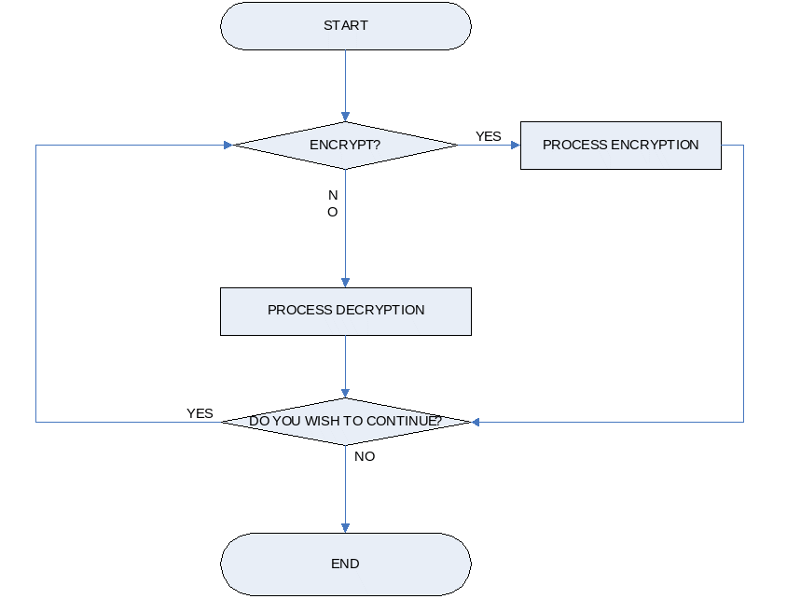

7.Limitations:
- It only works Java supporting Platform
- It only encrypt or decrypt text files i.e.( .txt extension files)

8.Future Enhancement
This Software program could be extended to higher order to
achieve a better and secure encryption of texts and files in
the network.

9.Conclusion:
The Proposed methodology will give the new area of research on cryptography. With this, it is relatively easy to secure texts and data from the illegal access.
The program written for encryption and decryption using substitution Algorithm is tested on several textual files and results are observed. The program could achieve a better secure transferring of files and texts.

10.REFRENCES & BIBLIOGRAPHY:

http://wikipedia.com
http://www.google.com
http://www.enggjournals.com
http://vedisoft.com

JAVA COMPLETE REFERECE : Herbert Shield.
CRYPTOGRAPHY AND NETWORK :William Stallings
SECURITY
COMPUTER NETWORKS :Andrew S.Tanenbaum

Viva Questions For SEPM

- What are the various phases of the software development life cycle.
- Explain with example the top down and bottom up approach in software engineering.
- What are the advantages and disadvantages of the waterfall model.
- Compare water fall model with iterative waterfall Lifecycle model.
- What do you mean by Open source software?
- Explain terms matrices, measures and indicators.
- Explain Verification and Validation.
- Elaborate white box testing.
- Discuss black-box testing.
- Differentiate unit testing and integrated testing.
- What is acceptance testing?
- Define Re-engineering,
- Explain reverse engineering.
- Explain forward engineering,
- What do you mean by web engineering?
- What are the types of designs prepared while software designing phase.
- What are the advantages of spiral model.
- Discuss the pros and cons of prototyping model.
- Under which condition build and fix model is employed?
- Define Agile model in brief.

@@NAME@@ COLLEGE OF TECHNOLOGY,BHOPAL
DEPARTMENT OF INFORMATION TECHNOLOGY
Session: January-June, 2014

Grading Sheet

Branch/Semester : IT/VI
Subject : SEPM Subject Code : IT605

