DEPARTMENT OF INFORMATION TECHNOLOGY

LAB MANUAL

Name: System Programming and Operating System
Course Code: IT-504
Course: B.E
Session:

Faculty Name Head (IT)

Submitted By-
RollNo:-
Name:-

TABLE OF CONTENTS

Sr. No. | Particulars | Page No.
1 | Scheme | 3
2 | Syllabus | 4
3 | List of Experiments | 5
4 | List of Books | 28
5 | Viva Questions | 29

- SCHEME
Scheme copy taken on- 25/06/2016

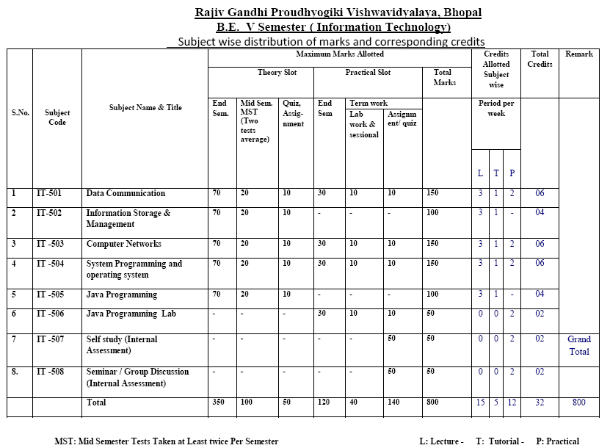

- SYLLABUS :
Syllabus copy taken on – 25/06/2016

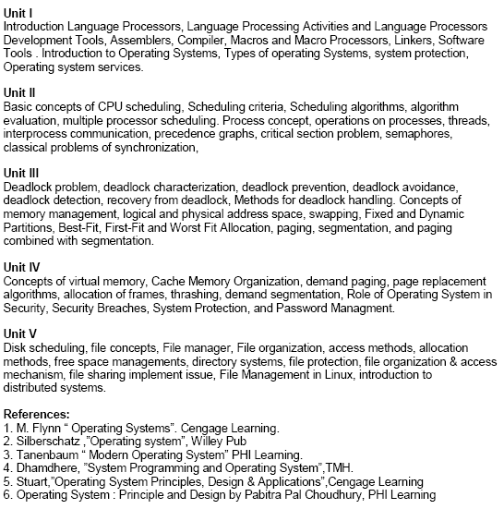

- LIST OF EXPERIMENTS
Lab No. | Topics to be covered | Date of Practical | Faculty Signature
1 | Write a program to implement basic inline assembly code.
2 | Write a program to implement sign extension operation through inline assembly code.
3 | Write a program to implement simple expression through inline assembly code.
4 | Write a program to implement nested expression through inline assembly code.
5 | Write a program to implement macros with various examples.
6 | Write a program to implement system call to identify directories and files within directory.
7 | Write a program to identify files with different extensions within directory using ffblk structure.
8 | Write a program for file handling & generate error.
9 | Write a program to enter number, string in a file.
10 | Write a program to display number, string from a file.
11 | Write a program to perform file handling operations.
12 | Write a program to implement FCFS Scheduling Algorithm.
13 | Write a program to implement SJF Scheduling Algorithm.
14 | Write a program to implement Priority Scheduling Algorithm.
15 | Write a program to implement Round Robin Scheduling Algorithm.
16 | Write a program to implement Producer Consumer Problems.
17 | Write a program to implement Dynamic allocation of memories in MVT.
18 | Write a program to implement Dynamic allocation of memories in MFT.
19 | Write a program to implement deadlock avoidance & Prevention by using Banker’s Algorithm
20 | Write a program to implement page replacement algorithms FIFO,

Experiment - One
Objective: Implementation of Inline assembly code to add, subtract two numbers.
- Algorithm:

Represent expression.
asm{
MOV AX,A
MOV BX,B
}
If(x==1)
asm{
ADD AX,BX
MOV C,AX
}
Else
asm{
SUB AX,BX
MOV C,AX
}
- Program:

- Result (Snapshot)

Experiment - Two
Objective: Implementation of Inline assembly code for sign operation.
- Algorithm:

For Division
asm{
MOV AX,-12
cwd
MOV BX,10
idiv BX
MOV C,AX
}

For Multiplication
asm{
MOV AX,-12
cwd
MOV BX,10
imul BX
MOV C,AX
}

- Program:

- Result (Snapshot)

Experiment - Three
Objective: Implementation of Inline assembly code for simple expressions.
- Algorithm:
General expressions are:-
- e = (-a*20)+b
- e = (-a*b) +c
- e = (a*5)/(b-3)
- f = (a*-5)/(-b/c)
- f = (-a*-b)+(-c*-d)

- Program:

- Result (Snapshot)

Experiment - Four
Objective: Implementation of Inline assembly code for nested expressions.
- Algorithm:
Given Expressions are:-
- If (g=1)
{ f = (-a/b) +c }
Else
{ f = (-a/-b)*c }

- If (g=1)
{ f = (a*-5)/(-b/c) }
Else if (g=2)
{ h = (-a/-b)*(-c/d) }
Else
j = (-a*-b)/(-c*-d)

- h = (a*b*-c*d)+(e*-f)

- Program:

- Result (Snapshot)

Experiment - Five
Objective: Implementation of Macros with various examples
- Algorithm:

Macros work in two passes:-
Pass I: Macro definition
Pass II: Macro Expansion

- Swap two Numbers
- Calculate area of circle
- Calculate area of triangle
- Calculate area of rectangle
Make a program in optimized way.

(b) Program:

(c) Result (Snapshot)

Experiment - Six
Objective: Implementation of System call.
- Description:

A system call is the programmatic way in which a computer program requests a service from the kernel of the operating system it is executed on. This may include hardware-related services (for example, accessing a hard disk drive), creation and execution of new processes, and communication with integral kernel services such as process scheduling. System calls provide an essential interface between a process and the operating system.

(b) Program:

(c) Result (Snapshot)

Experiment - Seven
Objective: Implementation of ffblk structure to find different extensions of file.
- Description:

*ffblk is a pointer to a ffblk structure that is used to return the search result. The structure is defined as follows:
struct ffblk
{
char name[D_NAME+1]; // The name of the file that was found
char ext[D_EXT+1]; // The extension of the file that was found
long filesize; // The size of the file that was found
char search_name[D_NAME+1]; // Internally used by the findnext() function
char search_ext[D_EXT+1]; // Internally used by the findnext() function
int slot; // Internally used by the findnext() function
// Since the OPH100x can have more than one drive, it has one extra member:
#ifdef OPH
int drive; // Internally used by the findnext() function
#endif
};

(b) Program:

(c) Result (Snapshot)

Experiment - Eight
Objective: Implementation of File Handling & generate errors.
- Description:

A file represents a sequence of bytes on the disk where a group of related data is stored. File is created for permanent storage of data. It is a readymade structure.
In C language, we use a structure pointer of file type to declare a file.
FILE * fp;
C provides a number of functions that helps to perform basic file operations. Following are the functions,
Function | description
fopen() | create a new file or open a existing file
fclose() | closes a file
getc() | reads a character from a file
putc() | writes a character to a file
fscanf() | reads a set of data from a file
fprintf() | writes a set of data to a file

(b) Program:
- Make a program to check file in read mode.
- Generate Error for checking file in read mode.

(c) Result (Snapshot)

Experiment - Nine
Objective: Implementation of File Handling to enter number, string within a file.
- Description:

- Make a program to enter number in a file.
- Make a program to enter multiple numbers in a file.
- Make a program to enter string in a file.
- Make a program to enter multiple strings in a file.

(b) Program:

(c) Result (Snapshot)

Experiment - Ten
Objective: Implementation of File Handling to display number, string from file.
- Description:

- Make a program to display entered number in a file.
- Make a program to display entered string in a file.

(b) Program:

(c) Result (Snapshot)

Experiment - Eleven
Objective: Implementation of File Handling operations.
- Description:

- Make a program to copy data from one file to other.
- Make a program to move even data, odd data from file.
- Delete existing file from directory.

(b) Program:

(c) Result (Snapshot)

Experiment - Twelve
Objective: Implementation of First Come First Serve Scheduling Algorithm
- Algorithm:

1. Start the process
2. Get the number of processes to be inserted
3. Get the value for burst time of each process from the user
4. Having allocated the burst time(bt) for individual processes , Start with the first process from it’s initial position let other process to be in queue
5. Calculate the waiting time(wt) and turnaround time(tat) as
Wt(pi) = wt(pi-1) + tat(pi-1) (i.e wt of current process = wt of previous process + tat of previous process)
tat(pi) = wt(pi) + bt(pi) (i.e tat of current process = wt of current process + bt of current process)
6. Calculate the total and average waiting time and turnaround time
7. Display the values
8. Stop the process
- Program:

- Result (Snapshot)
Experiment - Thirteen

Objective: Implementation of Shortest Job Fist Scheduling Algorithm

(b) Algorithm :

1. Start the process
2. Get the number of processes to be inserted
3. Sort the processes according to the burst time and allocate the one with shortest burst to execute first
4. If two process have same burst length then FCFS scheduling algorithm is used
5. Calculate the total and average waiting time and turnaround time
6. Display the values
7. Stop the process

(c) Program:

- Result (Snapshot)
Experiment - Fourteen

- Objective: Implementation Of Priority Scheduling Algorithm

(b) Algorithm:

1. Start the process
2. Get the number of processes to be inserted
3. Get the corresponding priority of processes
4. Sort the processes according to the priority and allocate the one with highest priority to execute first
5. If two process have same priority then FCFS scheduling algorithm is used
6. Calculate the total and average waiting time and turnaround time
7. Display the values
8. Stop the process

(c) Program:

(d) Result (Snapshot)

Experiment - Fifteen

- Objective: Implementation Of Round Robin Scheduling Algorithm

- Algorithm:

1. Start the process
2. Get the number of elements to be inserted
3. Get the value for burst time for individual processes
4. Get the value for time quantum
5. Make the CPU scheduler go around the ready queue allocating CPU to each process for the time interval specified
6. Make the CPU scheduler pick the first process and set time to interrupt after quantum. And after it's expiry dispatch the process
7. If the process has burst time less than the time quantum then the process is released by the CPU
8. If the process has burst time greater than time quantum then it is interrupted by the OS and the process is put to the tail of ready queue and the schedule selects next process from head of the queue
9. Calculate the total and average waiting time and turnaround time
10. Display the results
11. Stop the process

(c) Program:

(d) Result (Snapshot)
Experiment - Sixteen

(a) Objective: Implementation of Producer Consumer Problems.

(b) Algorithm :
The producer-consumer problem illustrates the need for synchronization in systems where many processes share a resource. In the problem, two processes share a fixed-size buffer. One process produces information and puts it in the buffer, while the other process consumes information from the buffer. These processes do not take turns accessing the buffer, they both work concurrently. Here in lies the problem. What happens if the producer tries to put an item into a full buffer? What happens if the consumer tries to take an item from an empty buffer?
In order to synchronize these processes, we will block the producer when the buffer is full, and we will block the consumer when the buffer is empty. So the two processes, Producer and Consumer, should work as follows:
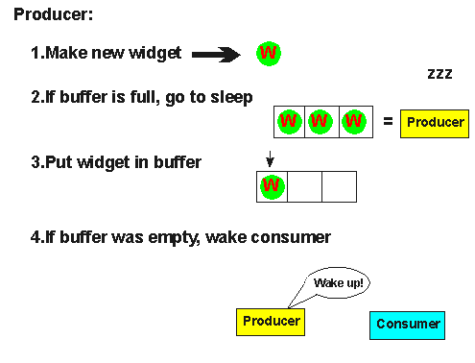
- The producer must first create a new widget.
- Then, it checks to see if the buffer is full. If it is, the producer will put itself to sleep until the consumer wakes it up. A "wakeup" will come if the consumer finds the buffer empty.
- Next, the producer puts the new widget in the buffer. If the producer goes to sleep in step (2), it will not wake up until the buffer is empty, so the buffer will never overflow.
- Then, the producer checks to see if the buffer is empty. If it is, the producer assumes that the consumer is sleeping, an so it will wake the consumer. Keep in mind that between any of these steps, an interrupt might occur, allowing the consumer to run.
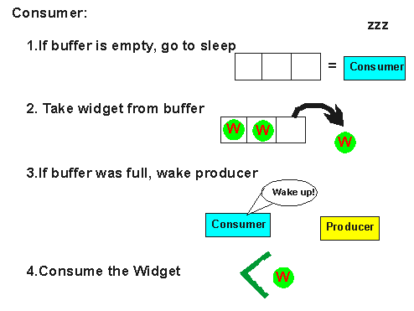
- The consumer checks to see if the buffer is empty. If so, the consumer will put itself to sleep until the producer wakes it up. A "wakeup" will occur if the producer finds the buffer empty after it puts an item into the buffer.
- Then, the consumer will remove a widget from the buffer. The consumer will never try to remove a widget from an empty buffer because it will not wake up until the buffer is full.
- If the buffer was full before it removed the widget, the consumer will wake the producer.
- Finally, the consumer will consume the widget. As was the case with the producer, an interrupt could occur between any of these steps, allowing the producer to run.
(c) Program:

(d) Result (Snapshot)
Experiment - Seventeen

(a) Objective: Write a program to implement Dynamic allocation of memories in MVT.

(b) Algorithm:

Step1: start the process.
Step2: Declare variables.
Step3: Enter total memory size.
Step4: Allocate memory for os.
Step5: allocate total memory to the pages.
Step6: Display the wastage of memory.
Step7: Stop the process

(c) Program:

(d) Result (Snapshot) :
Experiment - Eighteen

- Objective: Write a program to implement Dynamic allocation of memories in MFT.

- Algorithm:

Step1: start the process.
Step2: Declare variables.
Step3: Enter total memory size.
Step4: Allocate memory for os.
Step5: allocate total memory to the pages.
Step6: Display the wastage of memory.
Step7: Stop the process

(c) Program:

(d) Result (Snapshot)
Experiment - Ninteen

- Objective: To implement deadlock avoidance & Prevention by using Banker’s Algorithm.

- Algorithm:
Banker’s Algorithm:
When a new process enters a system, it must declare the maximum number of instances of each resource type it needed. This number may exceed the total number of resources in the system. When the user request a set of resources, the system must determine whether the allocation of each resources will leave the system in safe state. If it will the resources are allocation; otherwise the process must wait until some other process release the resources.

Data structures
- n-Number of process, m-number of resource types.
- Available: Available[j]=k, k – instance of resource type Rj is available.
- Max: If max[i, j]=k, Pi may request at most k instances resource Rj.
- Allocation: If Allocation [i, j]=k, Pi allocated to k instances of resource Rj
- Need: If Need[I, j]=k, Pi may need k more instances of resource type Rj,
Need[I, j]=Max[I, j]-Allocation[I, j];

Safety Algorithm
- Work and Finish be the vector of length m and n respectively, Work=Available and Finish[i] =False.
- Find an i such that both
  - Finish[i] =False
  - Need<=Work
If no such I exists go to step 4.
- work=work+Allocation, Finish[i] =True;
- if Finish[1]=True for all I, then the system is in safe state.

Resource request algorithm
Let Request i be request vector for the process Pi, If request i=[j]=k, then process Pi wants k instances of resource type Rj.
- if Request<=Need I go to step 2. Otherwise raise an error condition.
- if Request<=Available go to step 3. Otherwise Pi must since the resources are available.
- Have the system pretend to have allocated the requested resources to process Pi by modifying the state as follows;
Available=Available-Request I;
Allocation I =Allocation+Request I;
Need i=Need i-Request I;
If the resulting resource allocation state is safe, the transaction is completed and process Pi is allocated its resources. However if the state is unsafe, the Pi must wait for Request i and the old resource-allocation state is restored.

ALGORITHM:
- Start the program.
- Get the values of resources and processes.
- Get the avail value.
- After allocation find the need value.
- Check whether its possible to allocate.
- If it is possible then the system is in safe state.
- Else system is not in safety state.
- If the new request comes then check that the system is in safety.
- or not if we allow the request.
- stop the program.

(c) Program:

(d) Result (Snapshot)
Experiment - Twenty

- Objective: To implement page replacement algorithms.

- Algorithm:
FIFO (First In First Out)
1. Start the process
2. Declare the size with respect to page length
3. Check the need of replacement from the page to memory
4. Check the need of replacement from old page to new page in memory
5. Forma queue to hold all pages
6. Insert the page require memory into the queue
7. Check for bad replacement and page fault
8. Get the number of processes to be inserted
9. Display the values
10. Stop the process
LRU (Least Recently Used),
1. Start the process
2. Declare the size
3. Get the number of pages to be inserted
4. Get the value
5. Declare counter and stack
6. Select the least recently used page by counter value
7. Stack them according the selection.
8. Display the values
9. Stop the process

(c) Program:

(d) Result (Snapshot)

- List of Books & Websites

SNo | TITLE | AUTHOR | PUBLISHER / EDITION | YEAR
1 | Operating system | Silberschatz | Willey Pub | 2009
2 | Modern Operating System | Tanenbaum | PHI Learning | 2010
3 | System Programming and Operating System | Dhamdhere | TMH. | 2010

Suggested Wbsites:
- http://nptel.ac.in/courses/
- https://www.google.co.in/
- http://en.wikipedia.org/

- VIVA Questions
- What are the basic functions of an operating system? - Operating system controls and coordinates the use of the hardware among the various applications programs for various uses. Operating system acts as resource allocator and manager. Since there are many possibly conflicting requests for resources the operating system must decide which requests are allocated resources to operating the computer system efficiently and fairly. Also operating system is control program which controls the user programs to prevent errors and improper use of the computer. It is especially concerned with the operation and control of I/O devices.

- Why paging is used? - Paging is solution to external fragmentation problem which is to permit the logical address space of a process to be noncontiguous, thus allowing a process to be allocating physical memory wherever the latter is available.

- What resources are used when a thread created? How do they differ from those when a process is created? - When a thread is created the threads does not require any new resources to execute the thread shares the resources like memory of the process to which they belong to. The benefit of code sharing is that it allows an application to have several different threads of activity all within the same address space. Whereas if a new process creation is very heavyweight because it always requires new address space to be created and even if they share the memory then the inter process communication is expensive when compared to the communication between the threads.

- What is virtual memory? - Virtual memory is hardware technique where the system appears to have more memory that it actually does. This is done by time-sharing, the physical memory and storage parts of the memory one disk when they are not actively being used.

- What is Throughput, Turnaround time, waiting time and Response time? - Throughput -number of processes that complete their execution per time unit. Turnaround time -amount of time to execute a particular process. Waiting time -amount of time a process has been waiting in the ready queue. Response time -amount of time it takes from when a request was submitted until the first response is produced, not output (for time-sharing environment).

- What is the state of the processor, when a process is waiting for some event to occur? - Waiting state

- What is the difference between Hard and Soft real-time systems? - A hard real-time system guarantees that critical tasks complete on time. This goal requires that all delays in the system be bounded from the retrieval of the stored data to the time that it takes the operating system to finish any request made of it. A soft real time system where a critical real-time task gets priority over other tasks and retains that priority until it completes. As in hard real time systems kernel delays need to be bounded

- What is the cause of thrashing? How does the system detect thrashing? Once it detects thrashing, what can the system do to eliminate this problem? - Thrashing is caused by under allocation of the minimum number of pages required by a process, forcing it to continuously page fault. The system can detect thrashing by evaluating the level of CPU utilization as compared to the level of multiprogramming. It can be eliminated by reducing the level of multiprogramming.

- What is multi tasking, multi programming, multi threading? Multitasking: there is more than one process and the operating system somehow decides which to run next.Multithreading: threads are essentially subprocesses, which share memory (separate processes cannot normally access each other's memory) but which are independently scheduled.Multiprogramming: a form of multitasking in which a process keeps running until it tries to access an I/O device, at which point another process is chosen to run so the CPU doesn't idle waiting for a punched card reader or something.

- What is fragmentation? Different types of fragmentation? - Fragmentation occurs in a dynamic memory allocation system when many of the free blocks are too small to satisfy any request. External Fragmentation: External Fragmentation happens when a dynamic memory allocation algorithm allocates some memory and a small piece is left over that cannot be effectively used. If too much external fragmentation occurs, the amount of usable memory is drastically reduced. Total memory space exists to satisfy a request, but it is not contiguous. Internal Fragmentation: Internal fragmentation is the space wasted inside of allocated memory blocks because of restriction on the allowed sizes of allocated blocks. Allocated memory may be slightly larger than requested memory; this size difference is memory internal to a partition, but not being used

- What is Dispatcher? - Dispatcher module gives control of the CPU to the process selected by the short-term scheduler; this involves: Switching context, Switching to user mode, Jumping to the proper location in the user program to restart that program, dispatch latency Ã¢â‚¬â€œ time it takes for the dispatcher to stop one process and start another running.

- What is CPU Scheduler? - Selects from among the processes in memory that are ready to execute, and allocates the CPU to one of them. CPU scheduling decisions may take place when a process: 1.Switches from running to waiting state. 2.Switches from running to ready state. 3.Switches from waiting to ready. 4.Terminates. Scheduling under 1 and 4 is non-preemptive. All other scheduling is preemptive.

- What is Context Switch? - Switching the CPU to another process requires saving the state of the old process and loading the saved state for the new process. This task is known as a context switch. Context-switch time is pure overhead, because the system does no useful work while switching. Its speed varies from machine to machine, depending on the memory speed, the number of registers which must be copied, the existed of special instructions(such as a single instruction to load or store all registers).

- What is cache memory? - Cache memory is random access memory (RAM) that a computer microprocessor can access more quickly than it can access regular RAM. As the microprocessor processes data, it looks first in the cache memory and if it finds the data there (from a previous reading of data), it does not have to do the more time-consuming reading of data from larger memory.

- What is a Safe State and what is its use in deadlock avoidance? - When a process requests an available resource, system must decide if immediate allocation leaves the system in a safe state. System is in safe state if there exists a safe sequence of all processes. Deadlock Avoidance: ensure that a system will never enter an unsafe state.

- What is a Real-Time System? - A real time process is a process that must respond to the events within a certain time period. A real time operating system is an operating system that can run real time processes successfully

- Explain Belady's Anomaly? Also called FIFO anomaly. Usually, on increasing the number of frames allocated to a process virtual memory, the process execution is faster, because fewer page faults occur. Sometimes, the reverse happens, i.e., the execution time increases even when more frames are allocated to the process. This is Belady's Anomaly. This is true for certain page reference patterns.

- What is a binary semaphore? What is its use? A binary semaphore is one, which takes only 0 and 1 as values. They are used to implement mutual exclusion and synchronize concurrent processes.

- What are short, long and medium-term scheduling? Long term scheduler determines which programs are admitted to the system for processing. It controls the degree of multiprogramming. Once admitted, a job becomes a process. Medium term scheduling is part of the swapping function. This relates to processes that are in a blocked or suspended state. They are swapped out of real-memory until they are ready to execute. The swapping-in decision is based on memory-management criteria. Short term scheduler, also know as a dispatcher executes most frequently, and makes the finest-grained decision of which process should execute next. This scheduler is invoked whenever an event occurs. It may lead to interruption of one process by preemption.

- What are local and global page replacements? Local replacement means that an incoming page is brought in only to the relevant process address space. Global replacement policy allows any page frame from any process to be replaced. The latter is applicable to variable partitions model only.

- Define latency, transfer and seek time with respect to disk I/O. Seek time is the time required to move the disk arm to the required track. Rotational delay or latency is the time it takes for the beginning of the required sector to reach the head. Sum of seek time (if any) and latency is the access time. Time taken to actually transfer a span of data is transfer time.

- How are the wait/signal operations for monitor different from those for semaphores? If a process in a monitor signal and no task is waiting on the condition variable, the signal is lost. So this allows easier program design. Whereas in semaphores, every operation affects the value of the semaphore, so the wait and signal operations should be perfectly balanced in the program.

- What are demand-paging and pre-paging? With demand paging, a page is brought into memory only when a location on that page is actually referenced during execution. With pre-paging, pages other than the one demanded by a page fault are brought in. The selection of such pages is done based on common access patterns, especially for secondary memory devices.

- What is page cannibalizing? Page swapping or page replacements are called page cannibalizing.

- What are the possible threads a thread can have?
- Ready
- Standby
- Running
- Waiting
- Transition
- Terminated

