Department of Electrical and Electronics Engineering
EX-603- Switch Gear and Protection
List of Experiments:
1. Determination of drop out factor of an instantaneous over current relay.
2. Determination of operating characteristics of IDMT relay.
3. Determination of operating characteristics of differential relay.
4. Study and operation of gas actuated protective relay.
5. Study of Static Over current relay
6. Determination of transmission line parameters using MATLAB
7. Analysis of power system faults (Symmetrical & Asymmetrical) using MATLAB
8. Study of SF6 circuit breaker
9. Protection Simulation study of Generator, Transformer, motor and feeder.
10. Determination of dielectric Strength of transformer oil.

Experiment No 1
Aim: To Study of Instantaneous over Current relay:
- Study the construction of relay
- Study the operating and deportation of relay
- Study the current V/S time characteristics.

Apparatus required:
Voltmeter, Ammeter, Loading CT, Auto Transformer, Instantaneous relay, Time rotary switch etc.
Features:
- Continuously variable current setting
- High drop-off /pick-up ratio
- Low transient over reach.
- Wide setting range

Application:
The relay type CAG 17 relay is a highest instantaneous over current unit with low transient over-reach and a high drop –off/pick ratio.
Because of its continuously variable settings and immunity to offset transients, this relay has special advantages for the protection of transformer feeders and feeders connected to high MVA sources. Conventional instantaneous over current protection gives good discrimination and economy on these lines ,but a relay set to detect symmetrical faults at the far end will overreach and cause tripping for offset faults which are outside the protected zone .The over current setting must, therefore, be raised in proportion to the overreach of the relay, with consequent loss of coverage for symmetrical faults at the far end of the line CAG 17 can be accurately set to cover all feeder faults up to the transformer secondary bushings and ensures correct discrimination at high speed under maximum offset fault condition.
Description:
The relay comprises a standard DC hinged armature unit fed via a single phase transformer and a full wave bridge rectifier. A residual screw is fitted with armature of the relay to achieve a high drop-off/ pick up ratio. A potentiometer is connected in parallel to the relay coil and adjustment of this varies the effective operating current of the relay. The transformer primary winding is multi tapped to give further adjustment of the relay operating current and together with potentiometer gives an overall adjustment of the current setting. Selection of transformer primary tapping is by means of a miniaturized plug board.
INSTANTANTANEOUS OVER CURRENT RELAY
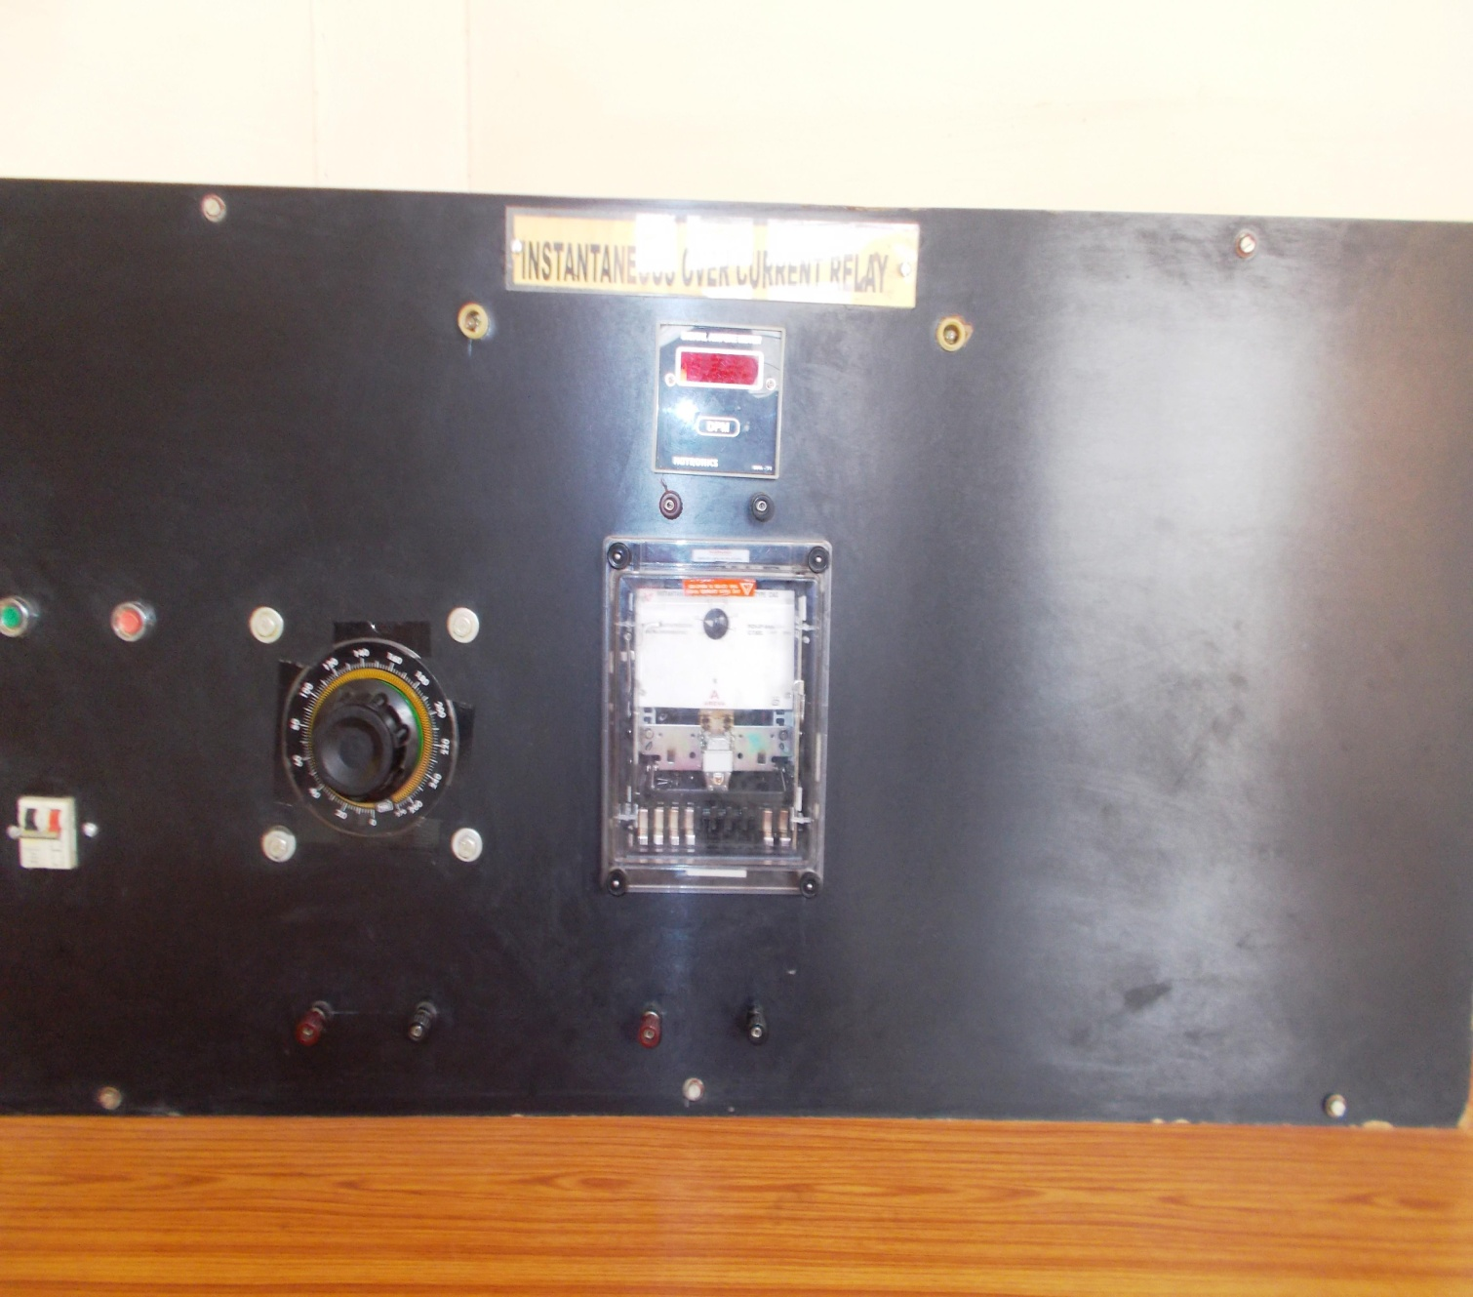
Procedure: Study the operating and de operating current of relay:
- Connections are made as shown in the diagram.
- Set the desired current in the relay.
- Switch on the MCB.
- Now to set the fault current, we will be using current source for that press the green button.
- Now increase the current by varying the Variac, at certain current the relay pickup. This current is called pickup current and notes it.
- Now decrease the current through current source .At certain current, the relay will designed or drop off .this current is called de-energizing current note it.
- Now reset the time totalizer by pressing red button fitted on the totalizer and press green button the timer will show the tripping time of the relay.
- Draw the graph between current v/s time.
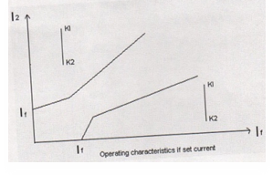
Observation table

Plug setting | Operating Current | DeoperatingCurrent(A)

(II) PS=1 A or 5A
PSM(A)=Fault Current | Operating Time

Result: From the current characteristics ,it can be concluded that with increase in PSM ,operating time decrease for a very small rise in fault current above plug setting = 1A the drop is extremely large.

Experiment No.2

Aim: -

To plot the characteristics of single pole over current or earth fault using static I.D.M.T. relays

Apparatus: -
- Timer

- IDMT relay
- Auxiliary D.C. supplies = 110V

- 1 phase Dimmer stat = 230V, 10A

- Ammeter AC (0-15A)

- Rheostat (38 ohm, 8.5 Amp)

- Experiment Kit

9)Connecting wires

Circuit diagram

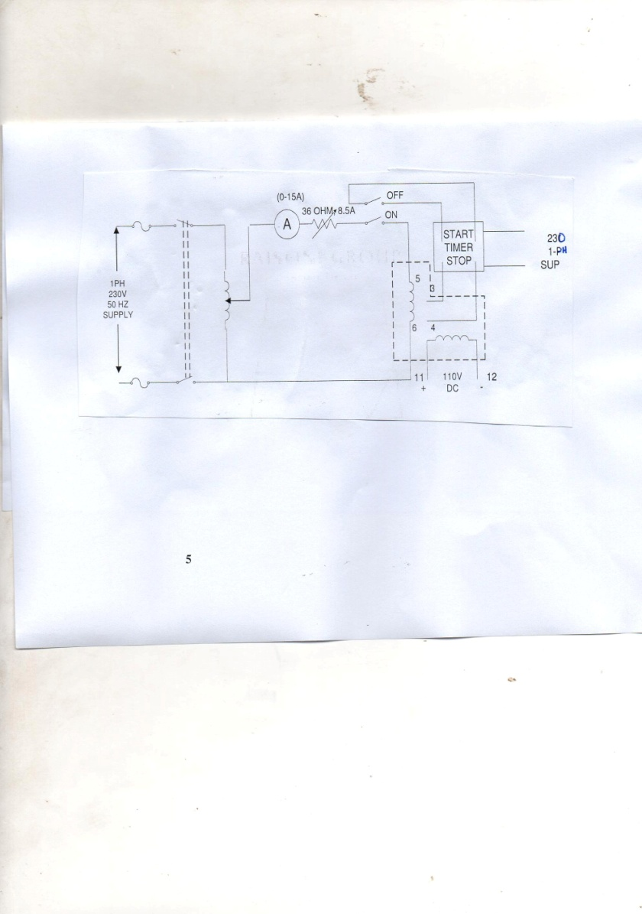

- Define PSM, TSM.

- Equation of time –current

Procedure: -
- Make the connection as shown in fig.
- Set current and time setting of relays as per requirement
- Set phase trip to 50% and set phase time at X1 with phase TMS at maximum position.
- Switch on variac and check power ON indication provided on relay front panel.
- Vary dimmer state with fault current of 1A,relayb will trip after certain time delay.
- Switch OFF dimmer state without disrobing its position and change the position of DPT switch. Also reset time.
- Switch ON dimmer state changes the position of switch and measure the relay time from timer.
- Repeat same procedure for varying a different fault current.

Repeat this procedure consider different set phase time (TMS)

Operation: -
With supply on load are continuously monitored Electronic comparator checks this value with set value (N) of phase & earth fault trip, which can be adjusted on front plate. Pick up response is (1.1 N) IDMT timing is applicable to over current above 2N as per chosen curve. Time setting multiplier for actual tripping time delay. TMS is adjusted by 11-position switch & with variable preset pot. These pots adjusted time for intermediate values indicated on TMS switch. Tripping cause is indicated by LED lamp (OC/EF). When over current trips the circuit relay ‘ NO’ contact changes to ‘NC’ when relay trips indicating LED to ‘NC’ when relay trip indicating LED to ‘NC’ when relay trips indicating LED to ‘NC’ when relay trip indicating LED flag will remain ON till manually reset.
IDMT RELAY
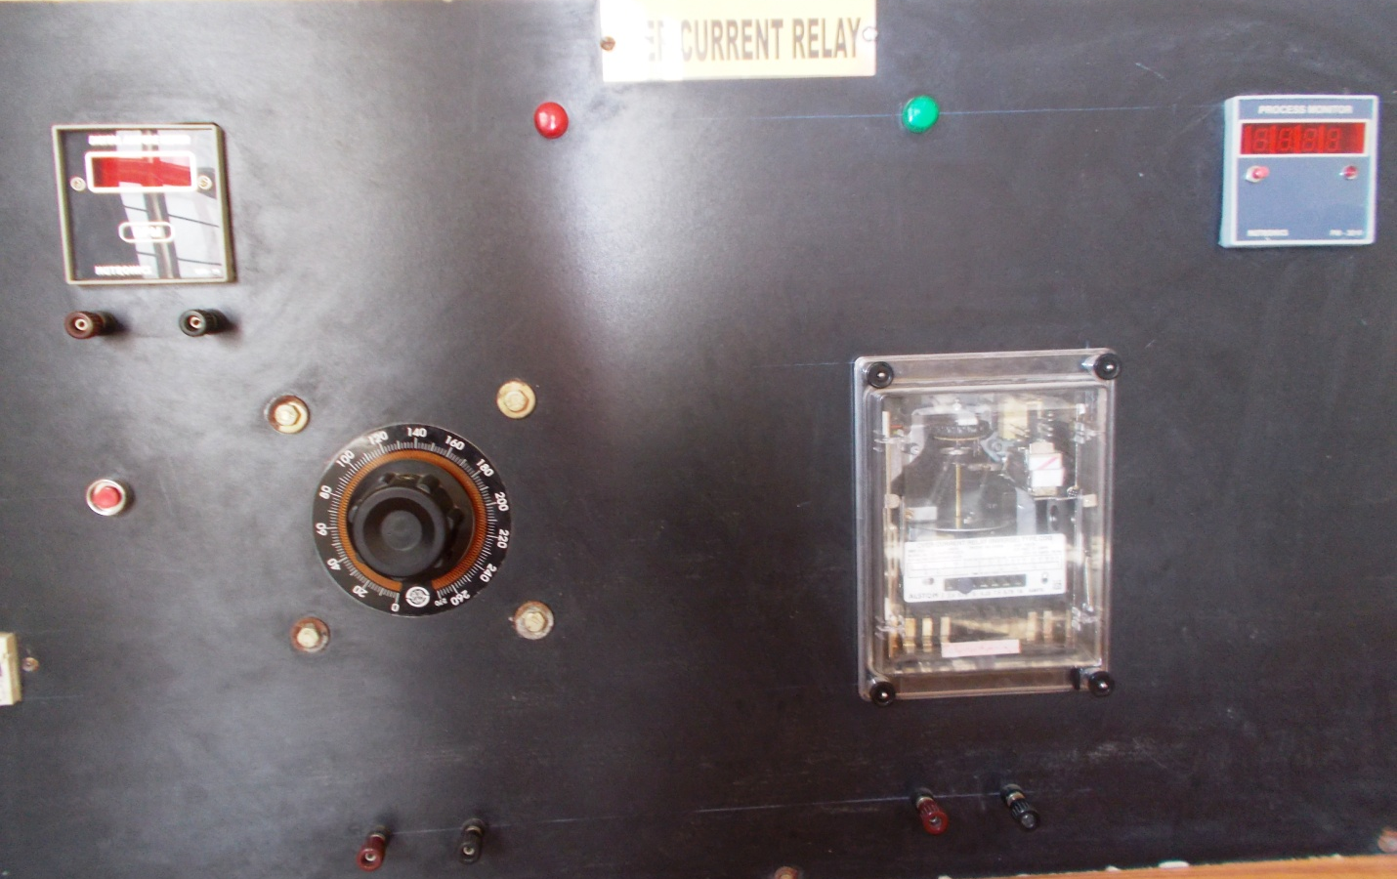

Observation table

1 Characteristics table: - current setting =……, Phase TMS

Sr. | Fault current | PSM | Timer time for | Timer time for | Timer time for
No. | (A) |  | TSM = | TSM= | TSM=
1
2
.
.
10

Result:

For lower values of current the “time current”characteristics are inverse and for higher value of current, time observed is constant.

Viva Question

1 Application of IDMT relay.

2 Draw back of IDMT relay

- Importance of DC supply

4 Detail of other Inverse type of relays

- Importance of static relays

- Why IDMT relay suitable for protection of long length of LV/MV TL.

Experiment No-3
Aim-
To determine the characteristics of the given biased differential relay.
Apparatus required:
A differential relay trainer kit
Introduction:
A Differential relay has two electromagnets one attracting magnet and one stabilizing magnet. which accurate a balanced beam in opposite directions. a spring operates together with the stabilization magnet and the tension of the spring may be altered and its position is graduated. This construction is used in high speed differential relays. Refer to when used as a differential relay, one carries the through current and the other the difference current. The force at each end of the beam is proportional to the square of the gap flux and hence to the square of the current.
Percentage Differential Relay
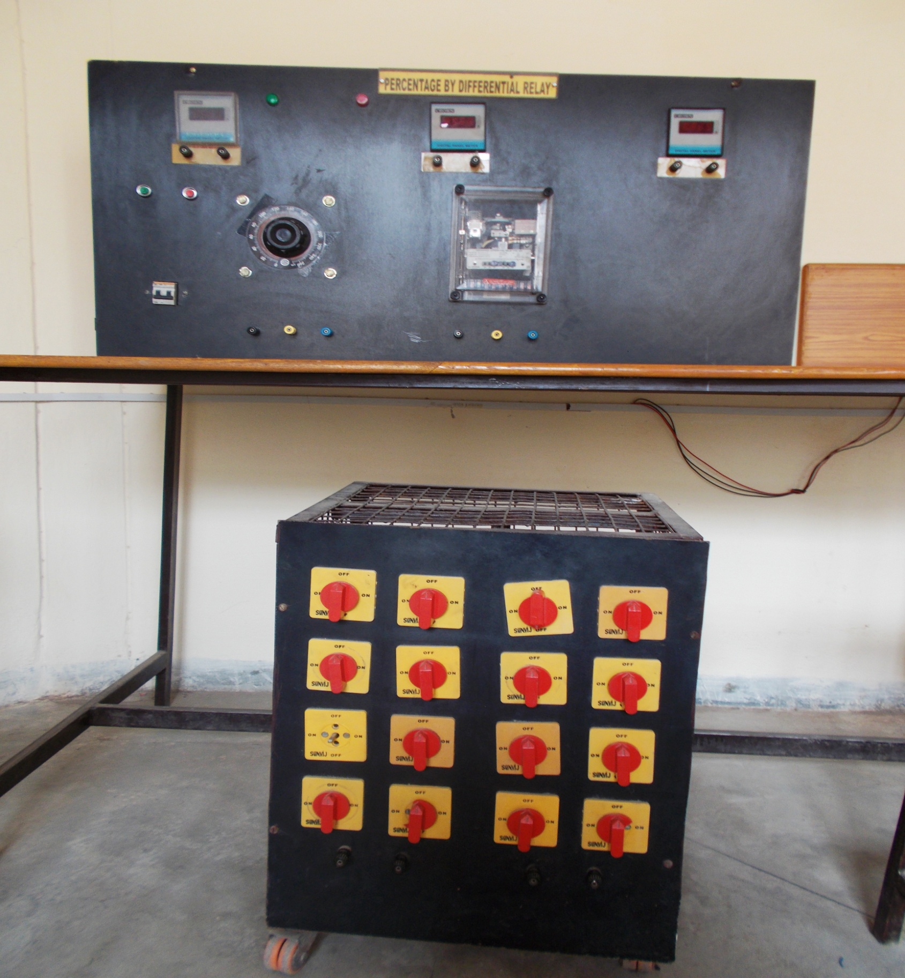

Differential protection:
Most positive way of protecting a circuit against internal fault is to arrange relay to compare the currents entering and leaving it which should be same under normal conditions and during an external fault. Any difference current must be flowing into a fault within the protected circuit.
When this system is applied to electrical equipment, it is called differential current protection and affords protection against internal faults only.
Differential protection can be applied to generators motors, transformers and transmission lines, when applied to transformers the ratio of transformation and the phase shift in 3-phase transformer must be taken in to account. in order to avoid undesirable operation, on heavy external faults due to current transformer errors a restraining winding provided which is energized by the through current and ahs fewer turns then the operating winding.
Procedure:
1. Study the operating and deoperating current of disc.
2. Switch on the MCB
3. Keep the variac at minimum position, now press green button and increase the current slowly by varying the variac. At certain current disc just move in forward direction, this is operating current of relay or pick up current.
4. Now decrease the current through current source and disc will stop. At certain current it moves in reverse direction and just after reading the current this is called deopearting current.
Characteristics:
Connect the relay as in and set the operating current to the minimum in the given relay.
1. By removing the top lid cover of relay ,adjust the bias top on both side that is either at 20% 30% or 40% for each setting, tripping time etc & as well as minimum current operate setting.
2. Adjust relay operating time which can be adjusted by movement of the disk backstop which is controlled by rotating a knurled molded disk at the base of the graduate time multiply scale at present we have TMS at 1.
3. Switch on the MCB and push green button and adjust I₁ & I₂ which is equal to the set current.
4. Keep I₁ constant and increase I₂ till your controlled circuit trip and alarm indicate and take reading of I₁, I₂& i₃ .
5. Increase i1 by 1 amp and then increase till your controlled circuit trips.
6. Repeat the above step.
7. Plot I1 vs. I2 for the application of the relay for transformer protection
8. A transformer differential relay compare the current in the winding of the transformer whose ratio are such as to make their transformable equal which is relatively small.
9. Restraining winding is provided in the relay take care of OT errors tap changing in the protected transformer and the effects of magnetizing and in rush current of the transformer.
Observation:
(i) 20% bias setting
Sr no. | Through current (A) | Differential cut(A)
1
2
3
4
5
6
7
8
9
10
(ii) 30% bias setting
Sr no. | Restraining current (A) | operating cut(A)
1
2
3
4
5
6
7
8
9
10

(iii) 40% bias setting
Sr no. | restraining current (A) | operating cut(A)
1
2
3
4
5
6
7
8
9
10

Result:
Experiment No-4
Aim- To study working of gas actuated Buchholz relay.
Apparatus required:
1. Buchholz relay fitted on stand with pipe line, valves and conservator
2. Air compressor to produce air pressure
3. Control panel
Introduction:
Gas produced by abnormal conditions in the transformer collects in the relay, which lowers the oil level show that the top float gradually comes down and ultimately operates the mercury switch which it reaches it certain level .this switch is usually connected to an external alarm circuit.
Faults which cause operation of this type are:
1. Low oil level in the transformer due to any reason
2. Accumulation of air
3. Fault in the core laminations.
4. Local over heating in the winding.
5. Bad connections.
6. Break down of core bolt insulations.
7. Bad switch contacts.
Abnormal conditions associated with major faults cause a surge in the oil which moves towards the expansion vessel .this search displaces the lower float operating the switch associated with it. it is customary to connect this switch in the trip circuit to ensure that the transformer is this connected on the operation of the switch and thus prevent further damage.
Faults which may cause operation of this switch are :
1. Internal short circuit between turns.
2. Short circuit between phase and earth.
3. phase to phase short circuit.
4. Insulation breakdown of a major nature.
The switch would also operate if the oil level false below that of float due to any reason.
The relay is provided with two glass window both of these have a graduated level to indicate the volume of gas collected in side.
The alarm and trip circuit terminals are brought in to a terminal box on the cover. The terminal box has arrangement of conduct connections from the left or right.A drain hole with plug provided under the relay body.
Installation:
the operation of the surge float (lower float) is caused by the flow of oil to the relay, consequently to the pipe connection to the relay should be straight and, as long as possible, with and up ward slope varying between three and seven degrees from the horizontal. a machined surface is provided on the top of the relay case show that the relay can be mounted with surface set horizontally at right angle to the direction of oil flow.
It is important that the connecting pipe between transformer tank and expansion vessel be so located that there is no risk of any gas being trapped under the cover or bypassing the relay.
General:
Not only does the gas and oil relay provide protection against a number of internal faults, but it also is able to indicate, in several cases, the type of fault, dour and composition, indicate where the fault may be and what its nature is.
It will thus be seen that fitting of such a relay is a must on all oil immersed power transformers particularly transformers or 1000kva and above.
The characteristics of the gas and oil relay are as follows:
1. The relay is particularly and sensitive and a simple indicator for internal faults of all kinds in all oil immersed transformer, by examining the gases collected it is possible to infer the nature of fault thus
a) If the gas is colors less odour less or with only a faint odour of oil the gas is air trapped in the oil or the insulation.
b) If the gas is grayish white with sharp and penetrating odour and none in flammable , it is due to over heated or faulty insulation.
c) If the gas is yellowish in colour inflammable it may be due to surface leakage on material like wood.
d) If the gas is dark grey in flammable it may be due to flash over in oil or due to excessive over heating of the oil, caused a fault in the winding or the core.
2. Due to high sensitivity combine with quick operation of the tripping contacts the relay effectively limits the damage and reduces the cost of repair.
3. On the operation of the alarm, investigation of the collected gas does not indicate a serious fault; it is possible to leave the transformer in the service till it is convenient to carry out a thorough inspection.
4. The relay can serve to sum extent as a protection against heavy over loads but can not be trusted for all over loads and should be backed by a temp. Operated devices to prevent sustained over loads.
5. The relay is not responsive to external fault unless they are of the nature of heavy over loads leading to excessive heating.
Description:
The gas and oil relay comprise an oil tight case with cover. it is provided with two hinged floats which separate mercury switches connected to customers protective alarm or tripping circuits. It is connected in the pipe connections between transformer and the expansion vessel so the normally it is completely filled with oil.
Buchholz Relay
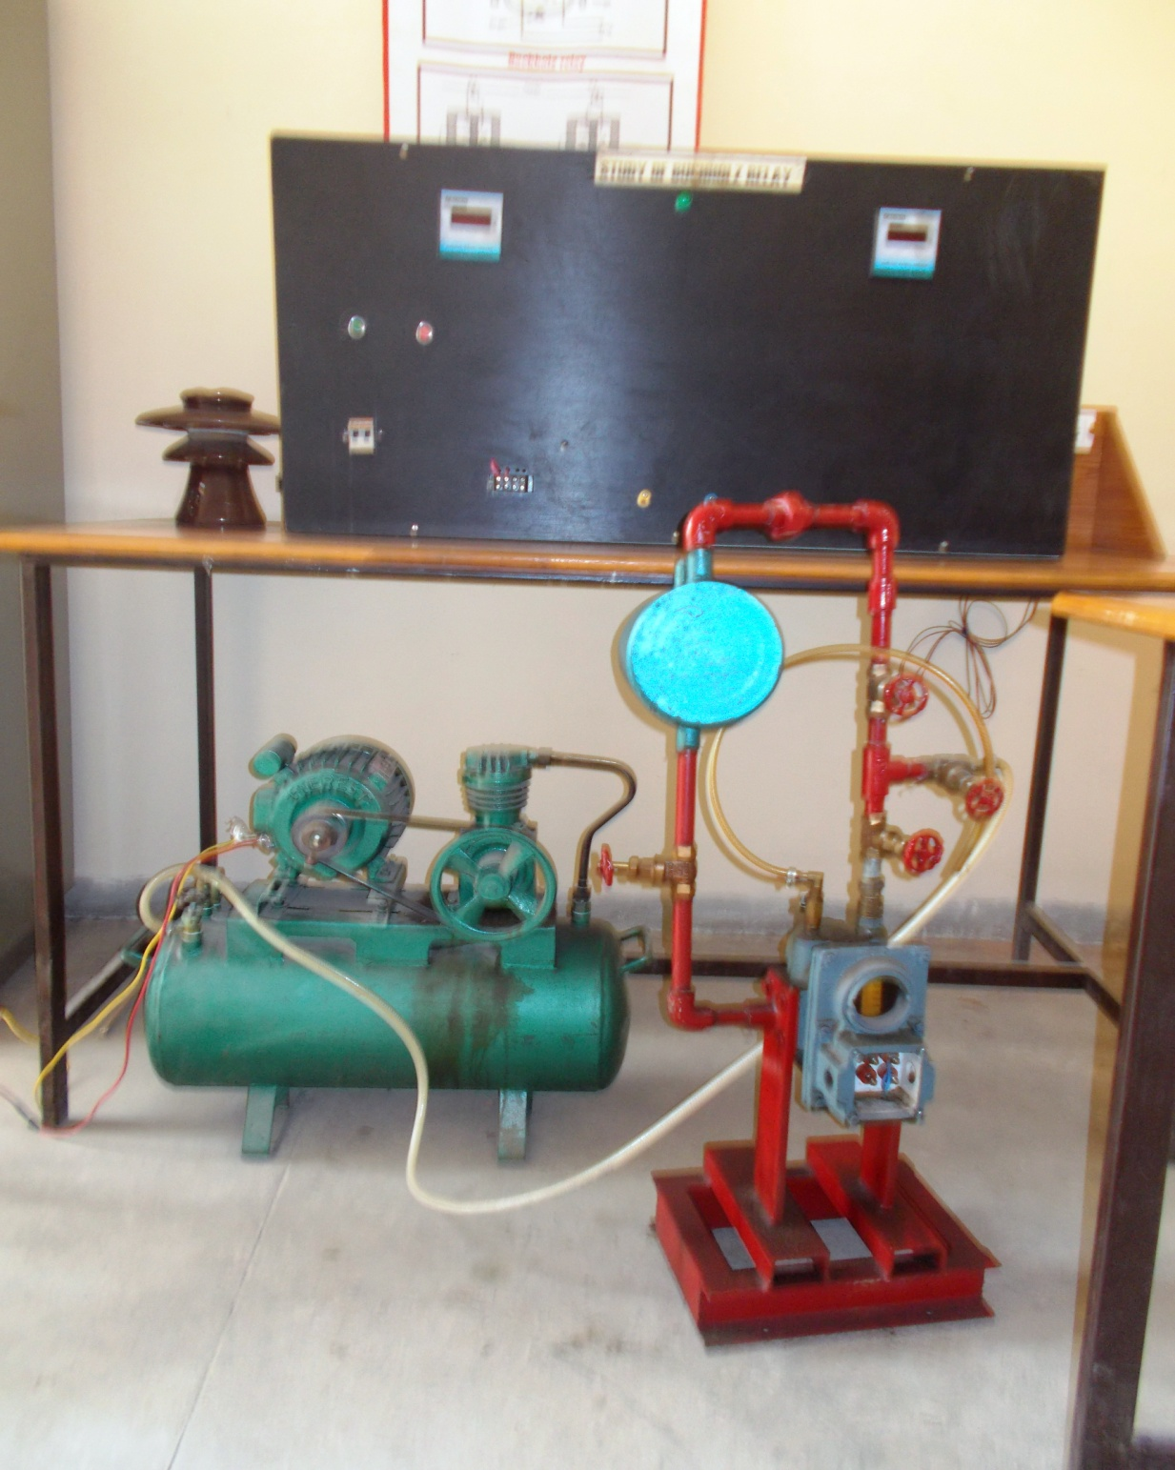
Circuit diagram
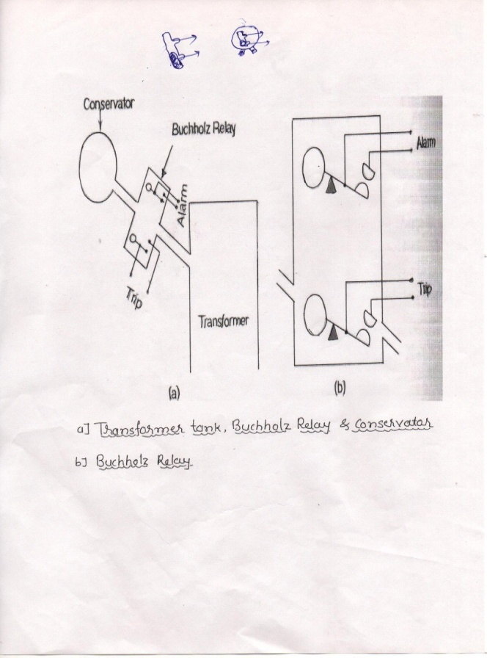

Procedure:
1. Connect the ph & N in to side strip.
2. Connect output to the motor.
3. Connect alarm point to the alarm point of the relay.
4. Connect trip point to the trip point of relay.
5. Push the green button, now motor with start.
6. By opening the wall slowly

Experiment No.05

Aim : Study and operation of Static Over Current relay

Introduction :

Static relay
The conventional relay type of electromagnet relays can be replaced by static relays which essentially consist of electronic circuitry to develop all those characteristics which are achieved by moving parts in an electro-magnetic relay.
For example, in an induction type relay, the operating time can be adjusted by adjusting the distance travelled by the disc whereas in a static relay it can be achieved by adjusting the value of the resistance in the R-C time delay circuit. In other words static relays are capable of performing the same functions with the use of electronic circuit control as an electro-magnetic relay performs with the use of moving parts or elements.
Static relays are superior to electro-magnetic relays in the following aspects:
- The moving parts and the contacts are largely eliminated. The only moving element in a static relay is the final tripping contact.
- C.T.s and P.T.s employed are of lesser VA rating as static relays require a very little volt-ampere for their operation.
- More precise and high speed operation.

Structure
Static relay consists of following units for operation:
- Auxiliary Voltage Supply:24 V DC supply is required for energizing the circuitry of the static relay. This is obtained by converting 230 V AC to 24 V DC and in some cases station battery voltage of 110 V to 24 V DC.
- Comparator:It compares the actual quantity with the pre-set quantity. For example in an over-current relay it will compare the actual current supplied by CT with the pre-determined set current over which tripping is required.
- Time delay Elements:The required operation time is achieved here by adjusting the values of R and C.
- Logic Circuit:By using the gate circuits conditions of operation of relays are set and relay can only be operated when these conditions are satisfied.
- Output Device:The actual tripping of relay can be achieved by firing the SCR or operating the attracted armature relay by feeding the signal coming from logic circuit output.

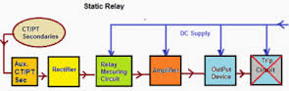

Experiment No.06
Aim: Determination of transmission line parameters using MATLAB
Over view:
Transmission line parameters are the most important aspects that can ever be considered when dealing with transmission lines. Transmission lines are often categorized in three major categories which are, the short lines, the medium lines and the long lines. Upon obtaining the transmission line parameters, it is often much easier to predict the performance of a transmission line through efficiency measurement and per unit analysis
Introduction
The steady state operation of a transmission line is a very important state when it comes to transmission line modelling. Results obtained from the steady state analysis are often ideally used in the analysis of transmission line and apply when the line conditions are balanced and also during unbalance. The ABCD parameters of a transmission line have a handful of importance and knowing them enables us to predict and manipulate the performance of a transmission line. During design one often tends to look for the most efficient power system ad yet also considers the costs to erect the power system. This all start with the analysis and acquisition of the power system’s ABCD parameters and hence continues with the further manipulation of these parameters to obtain the required system The are basically three types of transmission lines. These are the short transmission line model, the medium transmission, the model and the ling transmission line model. The medium transmission line model is further subdivided into the T lines and the PI lines.
Short transmission lines
These are transmission lines that are usually less than 80KM long.
- In the analysis of these lines, the capacitance and the leakage resistance to the earth are neglected and hence only the wire resistance and the inductive reactance are considered.

- This is a simple series circuit and hence the current flowing through the circuit is simply the same.
This is the easily analysed transmission line and it is not commonly used in power systems due to the fact that transmission lines are usually aimed to go for a long distance as to reduce the transmission costs.
Π Modeled transmission line
- Medium lines usually have a length that varies between 80KM to 250km
In the model for this line’s parameters, the total shunt capacitance is usually lumped together and is located half at each end.
T modeled transmission line
- This is another form of representing a medium transmission line. In this line model, half of the line impedance is lumped at the end of each line. This line also is analyzed by assuming a wye connected circuit.
Long transmission line
- These are the types of transmission lines that usually cover very long distances and could represent a minimum distance of 250KM.
- They represent very high voltage transmission lines because long distance transmission with high voltage reduce the line power losses.
- In this transmission lines, the current is kept to it very minimum to avoid effects of overheating and hence reduce maintenance costs as they might take long to repair in times of damages.
- The equivalent circuit is somehow very similar to the alternative PI representation but the elements are now represented using trigonometric ratios such as cosh and sinh.The ABCD parameters are now derived from the equivalent circuit diagrams and are purely functions of impedance and admittance values.
Program outline
- The program must allow for its user to enter the values that are provided and will be the baseline for the whole simulation.
- The program will then be able to evaluate the impedance and admittance of the line.
- Since the ABCD parameters are represented using the impedances and admittances, they are than evaluated.
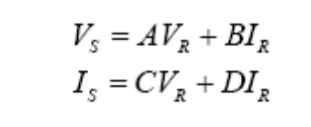
- Since the values of Vs and Is are now obtained, one is now able to evaluate the sending end power, the voltage regulation, the efficiency, the sending end power factor.
- This part of the program should than be the part where the bases of for the system are chosen in order to give all the circuit quantities in per unit.
- The per unit quantities are thus evaluated and displayed.
- The program should then go on and allow the user to enter the power factor that they want their system to be corrected to.
- It will than calculate the value of the reactive power that needs to be supplied by the capacitor bank and also the per phase capacitance of the capacitor bank.
- The program for the short line is than modified so that it accommodates a looping structure and also be able to obtain the different values of the capacitance bank when the length of line is being veried.
Codes used for the simulation of the transmission lines
%program for short lines

clear;

clc;

%continue with the program

vl = input('enter line load voltage: ');

f = input('enter local frequency: ');

l = input('enter line constant in H/KM: ');

length = input('enter length of line: ');

r = input('enter the resistive constant: ');

power = input('enter the load power: ');

pf = input('enter load power factor: ');

%evaluate the parameters

xl=l*length*pi*2*f;

p=power/3;

res=r*length;

z=complex(res,xl);

A=1;

B=z;

C=0;

D=1;

vlo=vl/sqrt(3);

%evaluate the load current

ilmag=p/(vlo*pf);

%assuming a lagging power factor

il=complex(ilmag*cos(acos(pf)),-ilmag*sin(acos(pf)));

vload=complex(vlo,0);

%evaluate the value of Vsending end and Isending end

vs=A*vload + B*il;

is=C*vload + D*il;

%calculte sending end power

s=conj(is)*vs;

%calculate voltage regulation

vr=((abs(vs)-abs(vlo))/abs(vlo))*100;

%calculate efficiency

pin=real(s);

pout=p;

n=(pout/pin)*100;

%evaluating the power factor

theta=atan(imag(s)/ real(s));

pfactor=cos(theta);

fprintf ('VS=');

disp(vs);

fprintf('IS=');

disp(is);

fprintf('power factor at sending end=');

disp(pfactor);

fprintf('sending end complex power=');

disp(s);

fprintf('voltage regulation=');

disp(vr);

fprintf('effiency=');

disp(n);

%evaluate the per unit values of the line parameters

%choosing the base values as follows

vbase=vlo;

sbase=p/pf;

zbase=mpower(vbase,2)/sbase;

ibase=sbase/vbase;

zpu=z/zbase;

vreceivingpu=vload/vbase;

ireceivingpu=il/ibase;

vsendingpu=vs/vbase;

isendingpu=is/ibase;

ssendingpu=s/sbase;

precevingpu=p/sbase;

fprintf('the per unit value of the impedance=');

disp(zpu);

fprintf('the per unit value of the receiving end voltage=');

disp(vreceivingpu);

fprintf('the per unit value of the receiving end current=');

disp(ireceivingpu);

fprintf('the per unit value of the sending end voltage=');

disp(vsendingpu);

fprintf('the per unit value of the sending end current=');

disp(isendingpu);

fprintf('the per unit value of the sending end apparent power=');

disp(ssendingpu);

fprintf('the per unit value of the receiving end real power=');

disp(precevingpu);

%for power factor correction

thetanew=acos(pfdesired);

qold=imag(s);

qnew=real(s)*tan(thetanew);

%evaluating the value of the capacitor bank

qc=qold-qnew;

pfdesired = input('enter the desired power factor: ');

c=qc/(mpower(abs(vs),2)*2*pi*f);

fprintf('value of the capacitor bank in farads=');

disp(c);

fprintf('the reactive power to be supplied by the capacitane bank invar=');

disp(qc);
%program for medium pie lines

clear;

clc;

%start with the system inputs

vl = input('enter load voltage: ');

f = input('enter local frequency: ');

l = input('enter line constant in H/KM: ');

r = input('enter the resistive constant in OHM/KM: ');

power = input('enter the load power in WATTS: ');

pf = input('enter load power factor: ');

m = input('enter your month of birth as a number: ');

d = input('enter your date of birth: ');

%evaluate the capacitive constant%specifically for the vaues assigned to myself

x=d;

ca = x*(mpower(10,-1.05*m));

%evaluate the length

length=7*d;

%evaluate the parameters

xl=l*length*pi*2*f;

p=power/3;

xc=ca*length*2*pi*f;

res=r*length;

vlo=vl/sqrt(3);

z=complex(res,xl);

yc=complex(0,xc);

squ=mpower(yc,2);

A=(0.5*(z*yc))+1;

B=z;

C=yc+(0.25*(squ*z));

D=1+(0.5*(z*yc));

%evaluate the load current and load voltage

ilmag=p/(vlo*pf);

il=complex(ilmag*cos(acos(pf)),-ilmag*sin(acos(pf)));

vload=complex(vlo,0);

%evaluate the value of Vsending end and Isending end

vs=A*vload + B*il;

is=C*vload + D*il;

%calculte sending end power

s=conj(is)*vs;

%evaluating the power factor

theta=atan(imag(s)/ real(s));

pfactor=cos(theta);

%calculate voltage regulation

vr=((abs(vs)-vlo)/vlo)*100;

%calculate efficiency

pin=3*abs(vs)*abs(is)*pfactor;

pout=3*abs(vload)*abs(il)*pf;

n=(pout/pin)*100;

fprintf ('voltage at the sending end=');

disp(vs);

fprintf('current at the sending end=');

disp(is);

fprintf('power factor at sending end=');

disp(pfactor);

fprintf('sending end complex power=');

disp(s);

fprintf('voltage regulation=');

disp(vr);

fprintf('effiency=');

disp(n);

%evaluate the per unit values of the line parameters

%choosing the base values as follows

vbase=vlo;

sbase=p/pf;

zbase=mpower(vbase,2)/sbase;

ibase=sbase/vbase;

zpu=z/zbase;

ycpu=yc/zbase;

vreceivingpu=vload/vbase;

ireceivingpu=il/ibase;

vsendingpu=vs/vbase;

isendingpu=is/ibase;

ssendingpu=s/sbase;

precevingpu=p/sbase;

fprintf('the per unit value of the impedance=');

disp(zpu);

fprintf('the per unit value of the receiving end voltage=');

disp(vreceivingpu);

fprintf('the per unit value of the receiving end current=');

disp(ireceivingpu);

fprintf('the per unit value of the sending end voltage=');

disp(vsendingpu);

fprintf('the per unit value of the sending end current=');

disp(isendingpu);

fprintf('the per unit value of the sending end apparent power=');

disp(ssendingpu);

fprintf('the per unit value of the receiving end real power=');

disp(precevingpu);

fprintf('the per unit value of the shunt admittance=');

disp(ycpu);

%for power factor correction

pfdesired = input('enter the desired power factor: ');

thetanew=acos(pfdesired);

qold=imag(s);

qnew=real(s)*tan(thetanew);

%evaluating the value of the capacitor bank

qc=qold-qnew;

capa=qc/(mpower(abs(vs),2)*2*pi*f);

fprintf('value of the capacitor bank in farads=');

disp(capa);

fprintf('the reactive power to be supplied by the capacitane bank invar=');

disp(qc);

enter load voltage: 138000
enter local frequency: 50
enter line constant in H/KM: 0.0016902
enter the resistive constant in OHM/KM: 0.11287
enter the load power in WATTS: 49000000
enter load power factor: 0.85
enter your month of birth as a number: 8.703
enter your date of birth: 25
voltage at the sending end= 9.1828e+004 +1.7327e+004i

current at the sending end= 1.9634e+002 -4.1302e+001i

power factor at sending end= 0.9234

sending end complex power= 1.7314e+007 +7.1945e+006i

voltage regulation= 17.2876

efficiency= 94.3378

the per unit value of the impedance= 0.0598 + 0.2813i

the per unit value of the receiving end voltage= 1

the per unit value of the receiving end current= 0.8500 - 0.5268i

the per unit value of the sending end voltage= 1.1525 + 0.2175i

the per unit value of the sending end current= 0.8141 - 0.1712i

the per unit value of the sending end apparent power= 0.9010 + 0.3744i

the per unit value of the receiving end real power= 0.8500

the per unit value of the shunt admittance= 0 +3.0269e-006i

enter the desired power factor: 1
value of the capacitor bank in farads= 2.6225e-006

the reactive power to be supplied by the capacitance bank invar= 7.1945e+006

Experiment No.07

AIM : ANALYSIS OF POWER SYSTEMS UNDER FAULT CONDITIONS
INTRODUCTION: During normal operating conditions, current will flow through all elements of the electrical power system within pre-designed values which are appropriate to these elements’ ratings. Any power system can be analyzed by calculating the system voltages & currents under normal & abnormal scenarios.
Unfortunately, faults could happen as a result of natural events or accidents where the phase will establish a connection with another phase, A falling tree on a transmission lines could cause a three-phase fault where all phases share a point of contact called fault location. In different occasions, fault could be a result of insulation deterioration, wind damage or human vandalism.
Faults can be defined as the flow of a massive current through an improper path which could cause enormous equipment damage which will lead to interruption of power, personal injury, or death. In addition, the voltage level will alternate which can affect the equipment insulation in case of an increase or could cause a failure of equipment start-up if the voltage is below a minimum level. As a result, the electrical potential difference of the system neutral will increase. Hence, People and equipment will be exposed to the danger of electricity which is not accepted.
In order to prevent such an event, power system fault analysis was introduced. The process of evaluating the system voltages and currents under various types of short
circuits is called fault analysis. Which can determine the necessary safety measures & the required protection system?
There are two types of faults which can occur on any transmission lines; balanced faults & unbalanced faults. In addition, unbalanced faults can be classified into single line-to-ground faults, double line faults and double line-to-ground faults.
The most common types taking place in reality are as follow: Line-to-ground fault: this type of fault exists when one phase of any transmission lines establishes a connection with the ground either by ice, wind, falling tree or any other incident. 70% of all transmission lines faults are classified under this category. Line-to-line fault: as a result of high winds, one phase could touch anther phase & line-to-line fault takes place. 15% of all transmission lines faults are considered line-to-line faults. Double line-to-ground: two phases will be involved instead of one at the line-to-ground faults scenarios. 10% of all transmission lines faults are under this type of faults . Three phase fault: in this case, falling tower, failure of equipment or even a line breaking and touching the remaining phases can cause three phase faults. In reality, this type of fault not often exists which can be seen from its share of 5% of all transmission lines faults.
In order to analyze any unbalanced power system, C.L. Fortescue introduced a method called symmetrical components in 1918 to solve such system using a balanced representation. Its mathematical model will be presented. After that, a 6-bus system will be under fault for analysis. This analysis will take place using the manual calculations. These results will be compared later with the results of Matlab codes.

Fault Analysis in Power Systems

In general, a fault is any event, unbalanced situation or any asymmetrical situation that interferes with the normal current flow in a power system and forces voltages and currents to differ from each other. It is important to distinguish between series and shunt faults in order to make an accurate fault analysis of an asymmetrical three-phase system. When the fault is caused by an unbalance in the line impedance and does not involve a ground, or any type of inter-connection between phase conductors it is known as a series fault. On the other hand, when the fault occurs and there is an inter-connection between phase-conductors or between conductor(s) and ground and/or neutral it is known as a shunt fault.Statistically, series faults do not occur as often as shunt faults does. Because of this fact only the shunt faults are explained here in detail since the emphasis in this project is on analysis of a power system under shunt faults.

Three-Phase Fault

By definition a three-phase fault is a symmetrical fault. Even though it is the least frequent fault, it is the most dangerous. Some of the characteristics of a three-phase fault are a very large fault current and usually a voltage level equals to zero at the site where the fault takes place. A general representation of a balanced three-phase fault is shown in Figure 3.8 where F is the fault point with impedances Zf and Zg . Figure 3.9 shows the sequences networks interconnection diagram.

Single Line-to-Ground Fault

The single line-to-ground fault is usually referred as “short circuit” fault and occurs when one conductor falls to ground or makes contact with the neutral wire. The general representation of a single line-to-ground fault where F is the fault point with impedances Zf. . Phase a is usually assumed to be the faulted phase, this is for simplicity in the fault analysis calculations.

Line-to-Line Fault

A line-to-line fault may take place either on an overhead and/or underground transmission system and occurs when two conductors are short-circuited. One of the characteristic of this type of fault is that its fault impedance magnitude could vary over a wide range making very hard to predict its upper and lower limits. It is when the fault impedance is zero that the highest asymmetry at the line-to-line fault occurs.

Double Line-to-Ground Fault

A double line-to-ground fault represents a serious event that causes a significant asymmetry in a three-phase symmetrical system and it may spread into a three-phase fault when not clear in appropriate time. The major problem when analyzing this type of fault is the assumption of the fault impedance Zf , and the value of the impedance towards the ground Zg
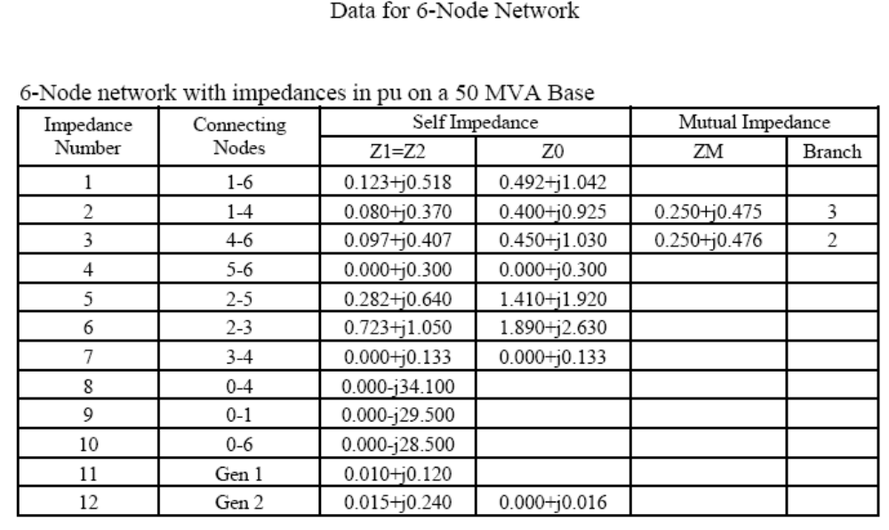

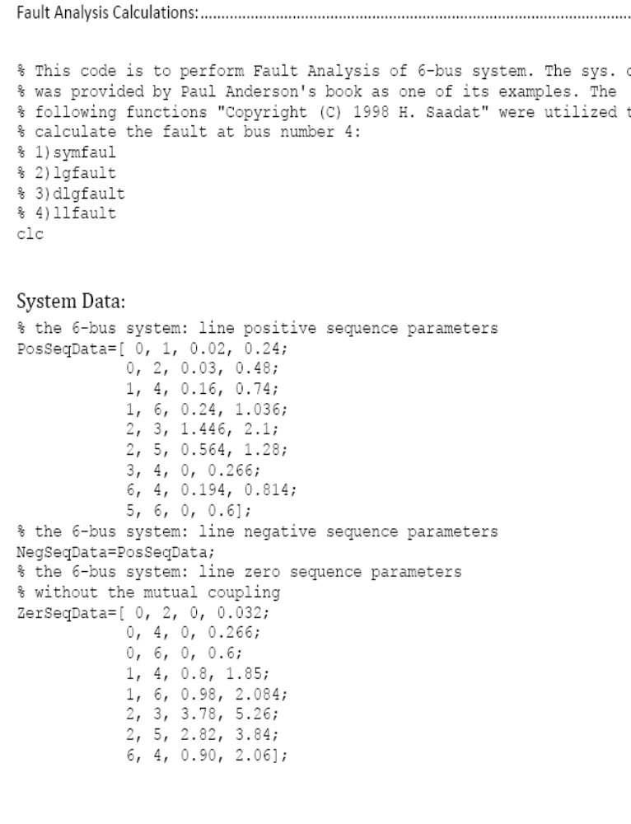

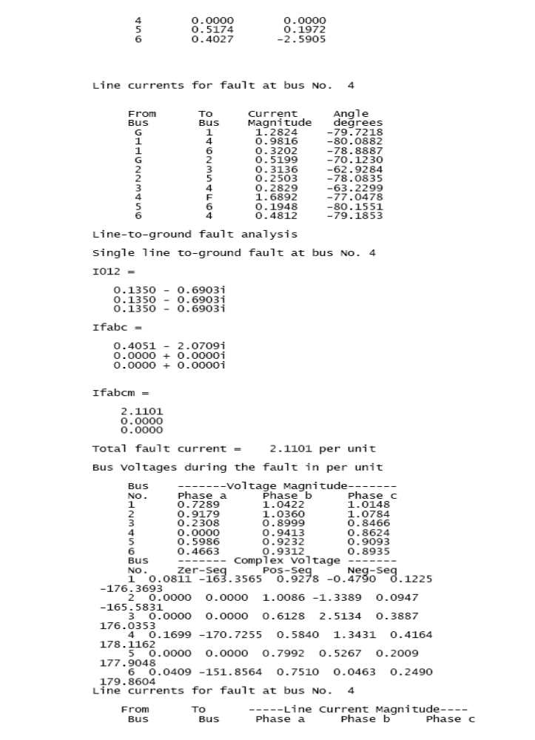
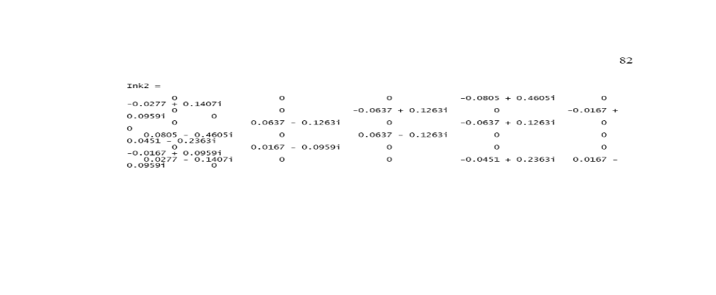
Outcome of the simulation stage can be listed in the following points:

- In three-phase fault, the voltages at faulted bus phases dropped to zero during the fault. The faulted bus is bus number four where Phase A, B and C has a zero voltage potential.
- However, only voltage at Phase A is equal to zero in single line-to-ground fault. In addition, only Phase A has current since it is the faulted phase in this type of fault as we assumed earlier in the mathematical model. This current is the second highest fault currents of all types.
- Since Phase B and Phase C are in contact in line-to-line fault, the voltages at both phases are equal. The fault current are passing from B to C. in Phase A, the current is equal to zero compared to the fault current.
- In double line-to-ground fault, Phase B and C voltages are equal to zero. The faulted current is flowing through both phases only. In addition, this type of fault is the most sever fault on the system which can be seen from its current value.
Experiment No.8
Aim:
To study Sulphur Hexafluoride (SF6) circuit breaker.
Theory:
In such circuit breaker, Sulphur hexaflouride (SF6) gas is used as the arc quenching medium. The SF6 is an electro-negative gas and has a strong tendency to absorb free electrons. The contacts of the beaker are opened in a high pressure flow of SF6 gas and an arc is struck between them. The conducting free electrons in the arc are rapidly captured by the gas to form relatively immobile negative ions. This loss of electrons in the arc are quickly builds up enough insulation strength to extinguish the arc. The SF6 circuit breakers have been found to be very effective for high power & high voltage service.
Circuit diagram
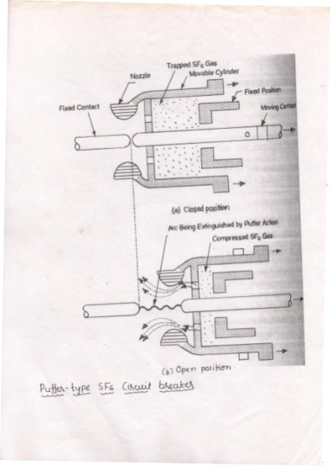

Construction:
It consists of fixed and moving contacts enclosed in a chamber called arc interruption chamber, Containing SF6 gas. This chamber is connected to SF6, gas reservoir. When the contacts of beaker arc opened, the valve mechanism permits a high pressure SF6 gas from the reservoir to flow towards the arc interruption chamber.
The fixed chamber is a hollow cylindrical current carrying contact fitted with an arc horn. The moving contact is also a hollow cylinder with rectangular holes in the sides to permit the SF6 gas to let over through these holes after flowing along and across the arc. The tips are fixed contacts, moving contacts and arcing horns are coated with copper-tungsten arc resistance materials. Since SF6 gas is costly, it is recondition and reclaimed by suitable auxiliary system after each operation of the breakers.
Working:
In the closed position of the breaker, the contacts remains surrounds by SF6 gas at a pressure of about 2-8 kg/cm2.when the break operates, the moving contacts are pulled apart and an arc is struck between the contacts. The movement of the moving contact is synchronize with the opening of valve which permits SF6 gas at 14 kg/cm2,pressure from the reservoir to the arc interruption chamber .The high pressure flow of SF6 rapidly absorb the free electrons in the arc path to form immobile negative ions which are ineffective as charge carriers. the result is that medium between the contacts quickly builds up high dielectric strength and causes the quickly the extinction of the arc. After the breaker operation, the valve is closed by the action of the a set of spring.
Application:
1. A typical SF6 circuit breaker consist of interruption units each capable of dealing with current up to 60 KA and voltage in the range of 50-80 KV
2. A no of unit are connected in series according for voltage 115 KV to 230 KV, power rating 10 MVA to 20 MVA and interrupting time less than 3 sec.

Result:
Every steps inside the working principle is explained along with the function of each part used in this relay. It work at higher voltage rating than the voltage of other circuit breaker.

Experiment No.9
Aim:
To study of Bus bar, Transformer, Alternator and Busbar
Introduction :
Busbar Protection | Busbar Differential Protection Scheme

Differential Busbar Protection

Current Differential Protection
The scheme of busbar protection, involves, Kirchoff’s current law, which states that, total current entering an electrical node is exactly equal to total current leaving the node.
Hence, total current entering into a bus section is equal to total current leaving the bus section.
The principle of differential busbar protection is very simple. Here, secondaries of CTs are connected parallel. That means, S₁ terminals of all CTs connected together and forms a bus wire. Similarly S₂ terminals of all CTs connected together to form another bus wire.
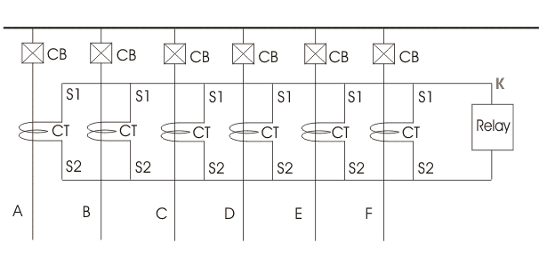

Now, let us apply KCL at node X. As per KCL at node X,
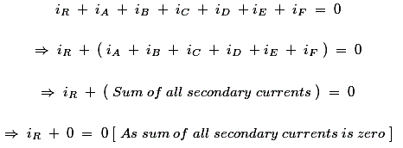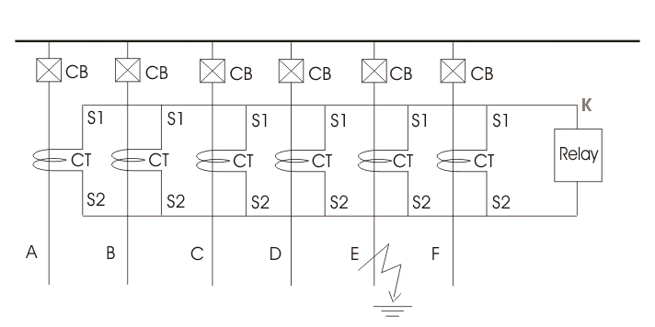
This differential busbar protection scheme is also referred as current differential protection of busbar.

Differential Protection of Sectionalized Bus
During explaining working principle of current differential protection of busbar, we have shown a simple non sectionalized busbar. But in moderate high voltage system electrical bus sectionalized in than one sections to increase stability of the system. It is done because, fault in one section of bus should not disturb other section of the system. Hence during bus fault, total bus would be interrupted.
Let us draw and discuss about protection of busbar with two sections.
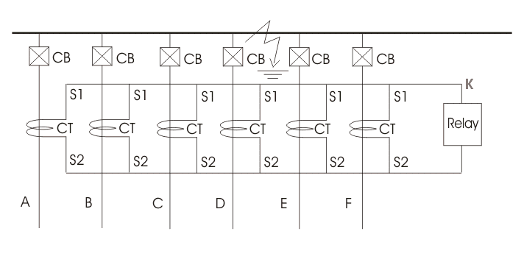
This section busbar differential protection scheme operates in some manner simple current differential protection of busbar.
That is, any fault in zone A, with trip only CB1, CB2 and bus CB.
Any fault in zone B, will trip only CB₅, CB₆ and bus CB.
Hence, fault in any section of bus will isolate only that portion from live system.
In current differential protection of busbar, if CT secondary circuits, or bus wires is open the relay may be operated to isolate the bus from live system. But this is not desirableDC Circuit of Differential Busbar ProtectionA typical DC circuit for busbar differential protection scheme is given below.

Protection of Lines or Feeder
As the length of electrical power transmission line is generally long enough and it runs through open atmosphere, the probability of occurring fault in electrical power transmission line is much higher than that of electrical power transformers and alternators. That is why a transmission line requires much more protective schemes than a transformer and an alternator.
Protection of line should have some special features, such as-
- During fault, the only circuit breaker closest to the fault point should be tripped.
- If the circuit breaker closest the faulty point, fails to trip the circuit breaker just next to this breaker will trip as back up.
- The operating time of relay associated with protection of line should be as minimum as possible in order to prevent unnecessary tripping of circuit breakers associated with other healthy parts of power system.
These above mentioned requirements cause protection of transmission line much different from protection of transformer and other equipment of power systems. The main three methods of transmission line protection are –
- Time graded over current protection.
- Differential protection.
- Distance protection.

Time Graded Over Current Protection
This may also be referred simply as over-current protection of electrical power transmission line. Let’ discuss different schemes of time graded over current protection.

Protection of Radial Feeder
In radial feeder, the power flows in one direction only, that is from source to load. This type of feeders can easily protected by using either definite time relays or inverse time relays.
Line Protection by Definite Time Relay
This protection scheme is very simple. Here total line is divided into different sections and each section is provided with definite time relay. The relay nearest to the end of the line has minimum time settin 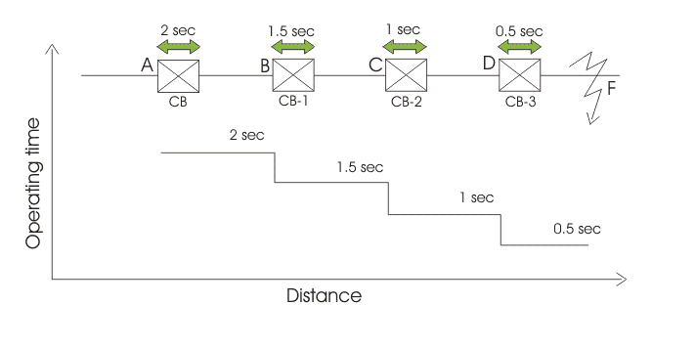g while time setting of other relays successively increased, towards the source.
For example, suppose there is a source at point A, in the figure below
At point D the circuit breaker CB-3 is installed with definite time of relay operation 0.5 sec. Successively, at point C an other circuit breaker CB-2 is installed with definite time of relay operation 1 sec. The next circuit breaker CB-1 is installed at point B which is nearest of the point A. At point B, the relay is set at time of operation 1.5 sec.
Now, assume a fault occurs at point F. Due to this fault, the faulty current flow through all the current transformers or CTs connected in the line. But as the time of operation of relay at point D is minimum the CB-3, associated with this relay will trip first to isolate the faulty zone from rest part of the line. In case due to any reason, CB-3 fails to trip, then next higher timed relay will operate the associated CB to trip. In this case, CB-2 will trip. If CB-2 also fails to trip, then next circuit breaker i.e. CB-1 will trip to isolate major portion of the line.

Advantages of Definite Time Line Protection
The main advantage of this scheme is simplicity. The second major advantage is, during fault, only nearest CB towards the source from fault point will operate to isolate the specific position of the line.

Disadvantage of Definite Time Line Protection
If the number of sections in the line is quite large, the time setting of relay nearest to the source, would be very long. So during any fault nearer to the source will take much time to be isolated. This may cause severe destructive effect on the system.

Over Current Line Protection by Inverse Relay
The drawback as we discussed just in definite time over current protection of transmission line, can easily be overcome by using inverse time relays. In inverse relay the time of operation is inversely proportional to fault current.
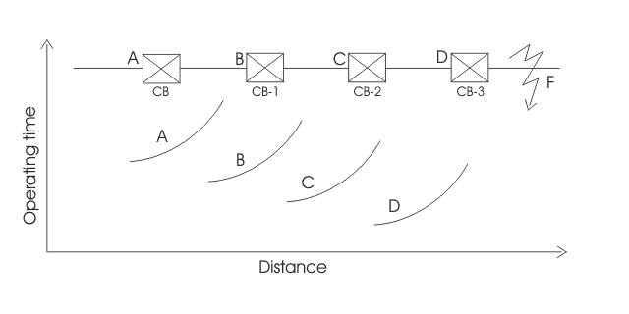
In the above figure, overall time setting of relay at point D is minimum and successively this time setting is increased for the relays associated with the points towards the point A.
In case of any fault at point F will obviously trip CB-3 at point D. In failure of opening CB-3, CB-2 will be operated as overall time setting is higher in relay at point C.
Although, the time setting of relay nearest to the source is maximum but still it will trip in shorter period, if major fault occurs near the source, as the time of operation of relay is inversely proportional to faulty current.

Over Current Protection of Parallel Feeders
For maintaining stability of the system it is required to feed a load from source by two or more than two feeders in parallel. If fault occurs in any of the feeders, only that faulty feeder should be isolated from the system in order to maintain continuity of supply from source to load. This requirement makes the protection of parallel feeders little bit more complex than simple non direction over current protection of line as in the case of radial feeders. The protection of parallel feeder requires to use directional relays and to grade the time setting of relay for selective tripping.
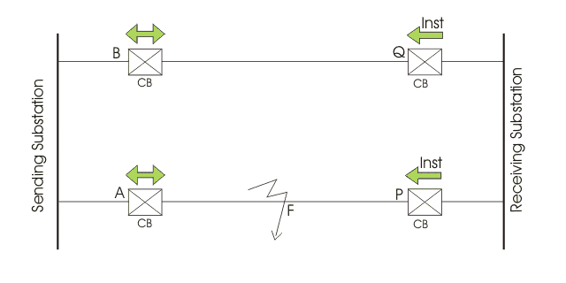
There are two feeders connected in parallel from source to load. Both of the feeders have non-directional over current relay at source end. These relays should be inverse time relay. Also both of the feeders have directional relay or reverse power relay at their load end. The reverse power relays used here should be instantaneous type. That means these relays should be operated as soon as flow of power in the feeder is reversed. The normal direction of power from source to

Transformer Protection and Transformer Fault
The general winding faults in transformer are either earth faults or inter-turns faults. Phase to phase winding faults in a transformer is rare. The phase faults in an electrical transformer may be occurred due to bushing flash over and faults in tap changer equipment. Whatever may be the faults, the transformer must be isolated instantly during fault otherwise major breakdown may occur in the electrical power system.
Incipient faults are internal faults which constitute no immediate hazard. But it these faults are over looked and not taken care of, these may lead to major faults. The faults in this group are mainly inter-lamination short circuit due to insulation failure between core lamination, lowering the oil level due to oil leakage, blockage of oil flow paths. All these faults lead to overheating. So transformer protection scheme is required for incipient transformer faults also. The earth fault, very nearer to neutral point of transformer star winding may also be considered as an incipient fault.
Influence of winding connections and earthing on earth fault current magnitude.
There are mainly two conditions for earth fault current to flow during winding to earth faults,
- A current exists for the current to flow into and out of the winding.
- Ampere-turns balance is maintained between the windings.
The value of winding earth fault current depends upon position of the fault on the winding, method of winding connection and method of earthing. The star point of the windings may be earthed either solidly or via a resistor. On delta side of the transformer the system is earthed through an earthing transformer. Grounding or earthing transformer provides low impedance path to the zero sequence current and high impedance to the positive and negative sequence currents.

Small and Large Motor Protection Scheme
The electric motor is most essential drive in modern era of industrialization. From fractional hp AC motor used for different home appliances to giant synchronous motor and induction motor of up to 10,000 hp used for different industrial applications, should be protected against different electrical and mechanical faults for serving their purposes smoothly. The motor characteristics must be very carefully considered in selecting the right motor protection scheme.
The abnormalities in motor or motor faults may appear due to mainly two reasons –
- Conditions imposed by the external power supply network,
- Internal faults, either in the motor or in the driven plant.
Unbalanced supply voltages, under-voltage, reversed phase sequence and loss of synchronism (in the case of synchronous motor) come under former category. The later category includes bearing failures, stator winding faults, motor earth faults and overload etc.
The degree of motor protection system depends on the costs and applications of the electrical motor.

Small Motor Protection Scheme
Generally motors up to 30 hp are considered in small category. The small motor protection in this case is arranged by HRC fuse, bimetallic relay and under voltage relay – all assembled into the motor contractor – starter itself.
Most common cause of motor burn outs on LV fuse protected system is due to single phasing. This single phasing may remain undetected even if the motors are protected by conventional bimetallic relay. It can not be detected by a set of voltage relays connected across the lines. Since, even when one phase is dead, the motor maintains substantial back emf on its faulty phase terminal and hence voltage across the voltage relay is prevented from dropping – off.
The difficulties of detecting single phasing can be overcome by employing a set of three current operated relays as shown in the small motor protection circuit given below.
The current operated relays are very simple instantaneous relays. There are mainly two parts in this relay one is a current coil and other is one or more normally open contacts (NO Contacts). The NO contacts are operated by the mmf of the current coil. This relay is connected in series with each phase of the supply and backup by HRC fuse. When the electrical motor starts and runs the supply current passes through the current coil of the protective relay. The mmf of the current coil makes the NO contacts closed. If suddenly a single phasing occurs the corresponding current through the current coil will falls and the contacts of the corresponding relay will become to its normal open position. The NO contacts of the all three relays are connected in series to hold – in the motor contractor. So if any one relay contact opens, results to release of motor contractor and hence motor will stop running.
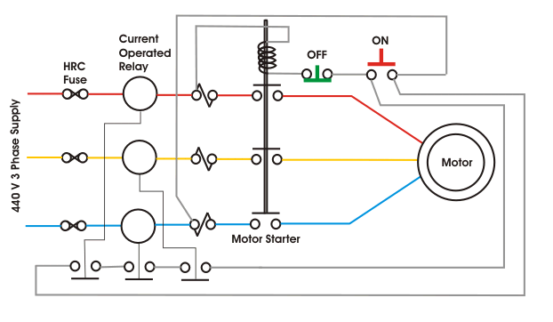
Large Motor Protection
Large motor specially induction motors require protection against-
- Motor bearing failure,
- Motor over heating,
- Motor winding failure,
- Reverse motor rotation.
As the thermal over loading or over heating of the motor may lead to insulation failure and damage of winding, hence for proper motor thermal overload protection, the motor should be protected against the following conditions
- Mechanical over loading,
- Stalling of motor shaft,
- Low supply voltage,
- Single phasing of supply mains,
- Unbalancing of supply mains,
- Sudden Loss and rebuilding of supply voltage.
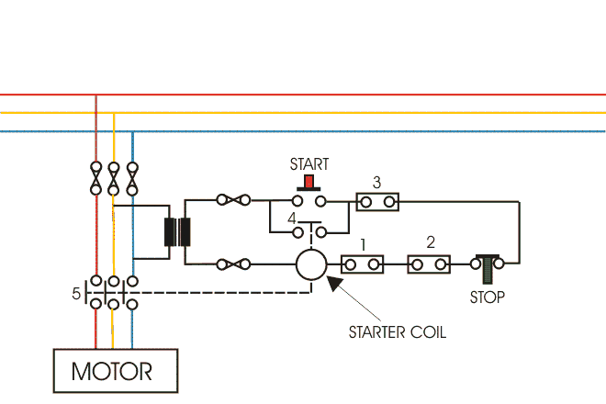
Experiment No.10

Aim:
To determine the di- electric strength of transformer oil.
Apparatus Required:
One insulating test set cell of transformer oil.
Description of the test set:
The set test which operates on 230v, 50hz supply has been mainly two transformers. One is the toroidal wound autotransformer used to supply steeples continuously variable voltage the other H.T. Transformer operates at low flux density ensuring distortion free output voltage .It is a 60kv. 0.5 capacity Transformer , it so designed that S/c current of the secondary is more than 20mA at all voltage above 10kv. The max s/c current does not exceed 200mA thus preventing the unnecessary pitting of electrodes. The test consist of an overload relay which trips and disconnects the H.T. Transformer when the breakdown occurs across the gaps. The oil to be put in the cells. Only after removing a plastic enclosure provided. When the enclosures is removed, it actuates micro switch shutting of the supply to the unit. A zero return interlock arrangement makes it obligatory to bring the H.T. voltage to zero after every breakdown test. Test panel board of the test set consists of voltage control push, a moving ion voltmeter to indicate the voltage applied in KV, three indicator lamps to indicate the mains ‘ON’ and H.T. ‘OFF’ . It also consists of main switch, a, H.T., ON switch and a H.T. off switch.
Transformer Oil Testing Kit
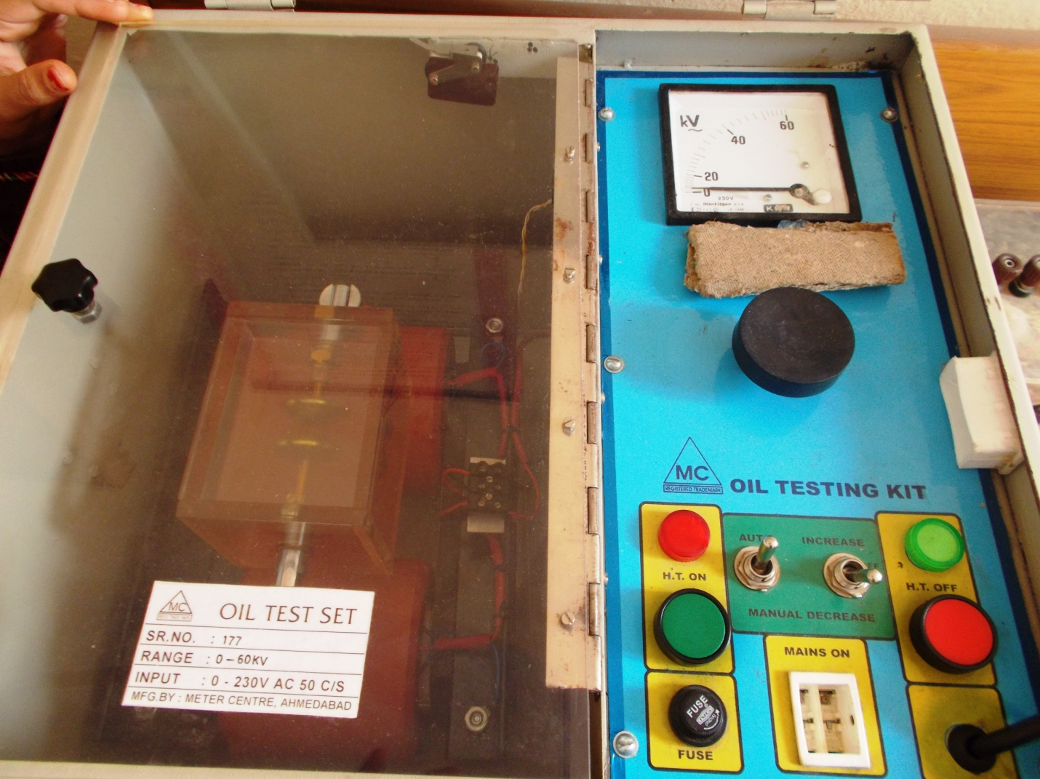

Preparation of The Sample :
- The sampling vessel containing the test oil shall be gently against and turned over several times in such a way as to ensure as for as possible a homogeneous distribution of the impurities contains in the oil without causing the formation of air bubbles.
- Immediately before use, the shall be cleaned by rising with test oil before proceeding to the final fittings
- Immediately after this, the sample should be poured down in to the test cell, slowly in order to avoid air bubbles forming (a clean glass rod may be used)
- The oil temp. at the time of test shall be same as that of the ambient air, preferably in the neighborhood at 27 and noted.
Procedure :
Operation Method
First check the gap of electrodes with go & no go gauges provided in the exp. Fill the oil under test in the oil cup fit the oil cup in the oil test set at the clamp stand close the plastics top and see the micro switch beneath closes.
Connect the main plug switch to A.C. main supply 230v 50hz. As per panel lay out shown above switch on the H.T. on Toggle switch and other toggle switch on the position. Now push on the H.T. on push and keep toggle switch on the. position you will not the H.T. voltage will go on incr. till the breakdown of insulation and H.T. voltage will denote the Breakdown voltage of the oil.
You can repeat this experiment.
Result:

