RGPV SOLUTION BE-3001 MATHEMATICS-III DEC 2017
Branch: EC/EI/EE
1. (a) Find Fourier series for 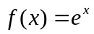in the interval 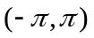
Solution : Given : 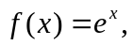 …….…….(1)
Here, 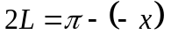i.e. 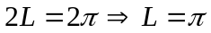
Suppose the Fourier series of  with period 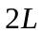 is,
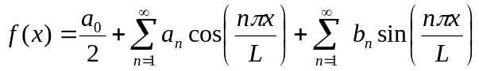
⇒ 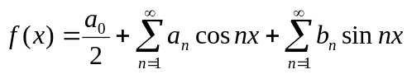 [Since 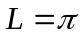] …………(2)
Now, 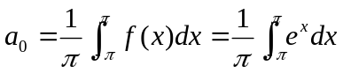
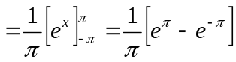
⇒ 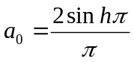
and 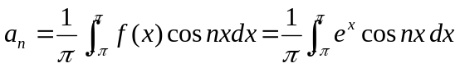
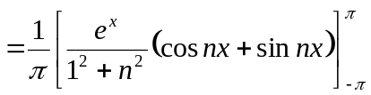
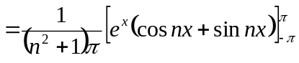
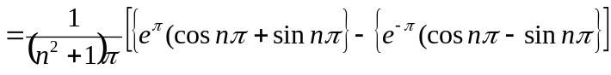
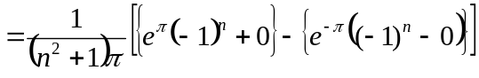
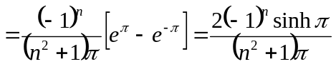
∴ 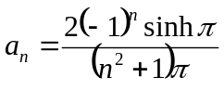
Now, 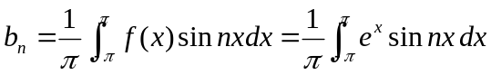
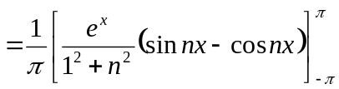
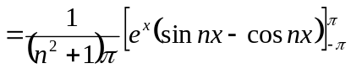
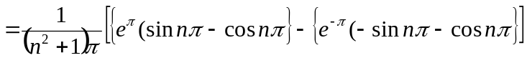
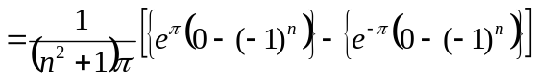
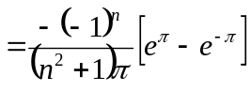
∴ 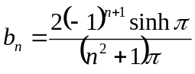
Putting in equation (1), we get
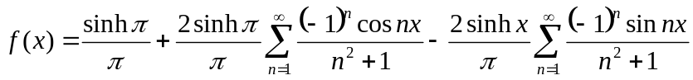 Answer
(b) Express f(x)=x as a half range sine series in 0 < x < 2
Solution : Given : 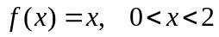 ………(1)
Here, 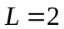
Suppose the Half range sine series of is,
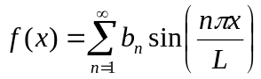
⇒ 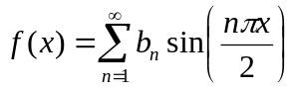 [Since 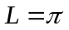] ……(2)
Now, 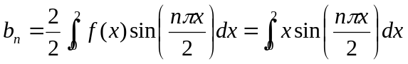
⇒ 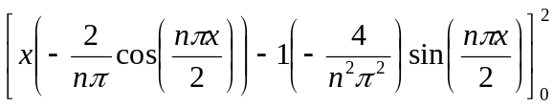
⇒ 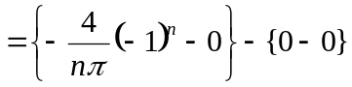
⇒ 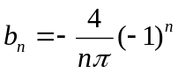
Putting in equation (1), we get
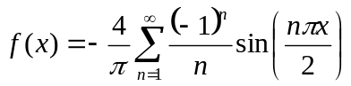 Answer
2. (a) Find Fourier cosine transform of 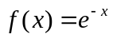
Solution : Given the function : 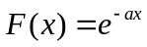
The Fourier cosine transform of  is given by,
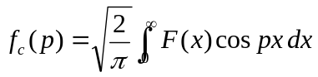
⇒ 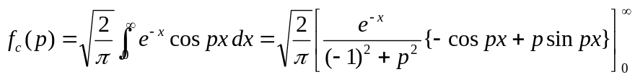
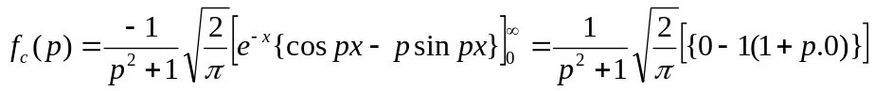
Thus 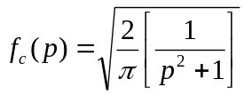 Answer
(b) Find a Fourier series of represent 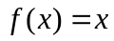 from 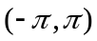.
Solution : Given : 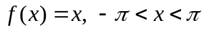 …….(1)
Here, 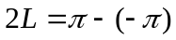i.e. 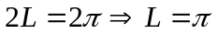
Suppose the Fourier series of with period 2L is,
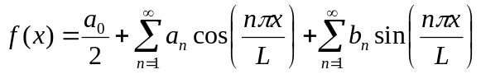
⇒ 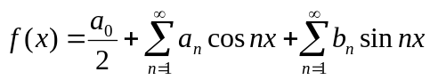 [Since ] ……(2)
Now, 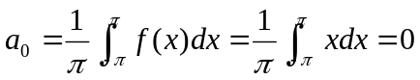 [Since odd]
and 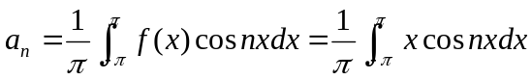 [odd)
⇒ 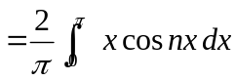
⇒ 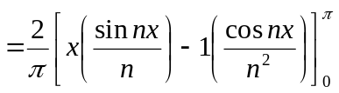
⇒ 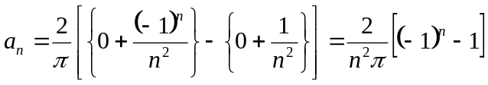
and 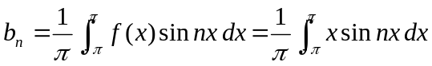
⇒ = 0 [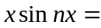odd)
Putting in equation (1), we get
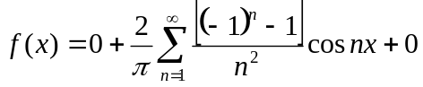
⇒ 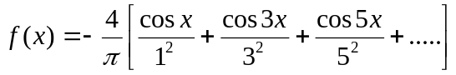 Answer
3. (a) Find Laplace transform of the following functions :
(i). 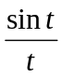 (ii). 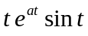
Solution : (i). Let 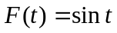
∴ 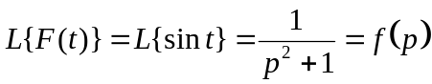
By Laplace transform of division of t, we have
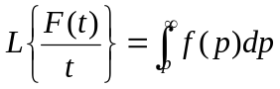 …………(1)
∴ 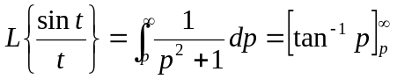
⇒ 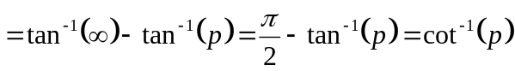 Answer
(ii). 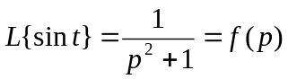
By Multiplication property, we have
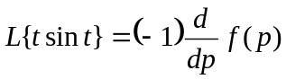
⇒ 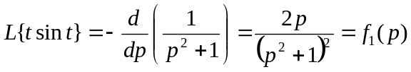
By First Shifting property
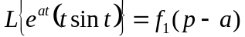
⇒ 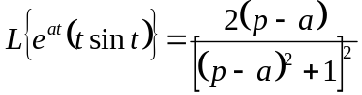 Answer
(b) Using convolution theorem to find inverse Laplace transforms of 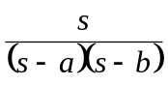
Solution : Given 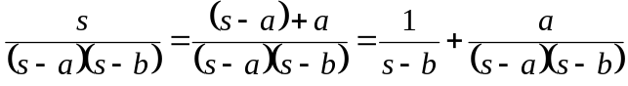
Now 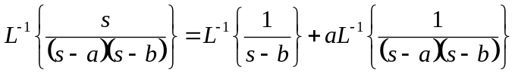
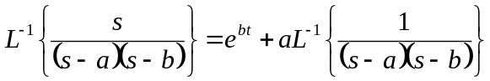 ……….(1)
Suppose 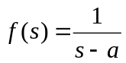 and 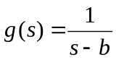
∴ 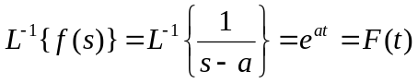
And 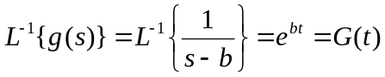
By Convolution theorem of Inverse Laplace transform, we have
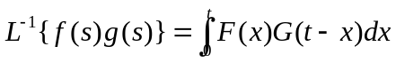
∴ 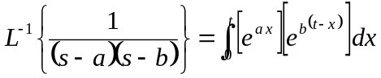
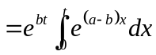
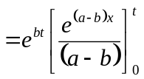
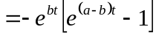
=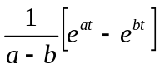
Putting in equation (1), we get
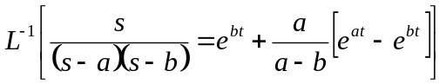 Answer
4. (a) Test the analyticity of the function 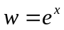
Solution : Suppose 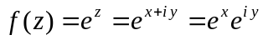
⇒ 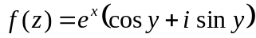
⇒ 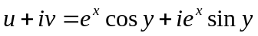
Equating on both sides, we get
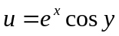and 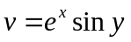
Partially differentiating with respect to, x and y, we get
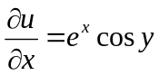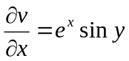
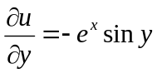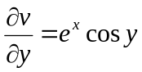
Clearly, 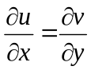and 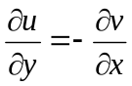
Therefore, C-R equation is satisfied, then given function is analytic everywhere
(b) Using Cauchy’s residue theorem, evaluate the real integral 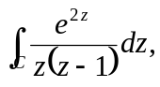
Where c is the circle 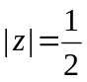
Solution : Given, 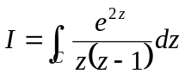
The pole of integrand is given by,
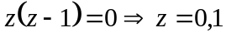
Now, 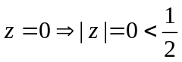 [Lies within C]
and z = 1 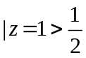 [Outside the region of C]
By Cauchy integral formula,
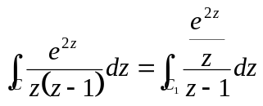
⇒ 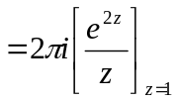
⇒ 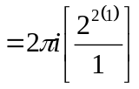
⇒ 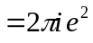
Thus, 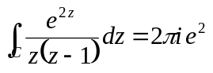 Answer
5. (a) Show that the function 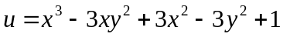 is harmonic and find its harmonic conjugate.
Solution : Given :
Partially differentiate w.r.t. x and y respectively
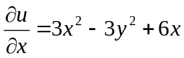 and 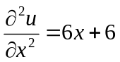 ………….(1)
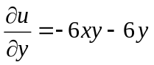 and 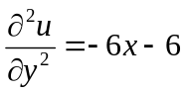 …………..(2)
Adding (1) and (2), we get
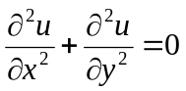
∴ u is harmonic function.
To Find Conjugate function v
Now, 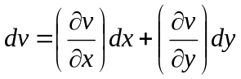
⇒ 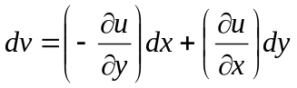 [by Cauchy-Riemann Equation]
⇒ 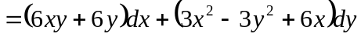
Integrating both sides, we get
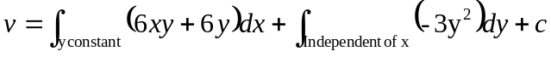
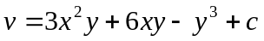 Answer
(b) Evaluate 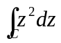, where c is the straight line joining the points (0, 0) and (2, 2).
Solution : The equation of straight line joining the points (0, 0) and (2, 2) is
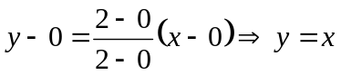 and 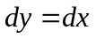
Since 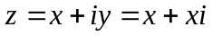 so that 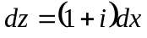
and 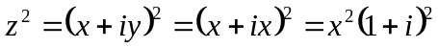
Now, 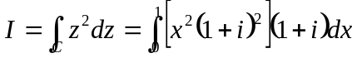
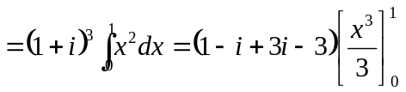
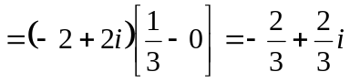
∴ 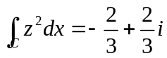 Answer
6. (a) Evaluate the directional derivative of the function 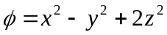 at the point P (1, 2, 3) in the direction of the line PQ where Q has coordinates (5, 0, 4).
Solution : Given the scalar function is
Now, 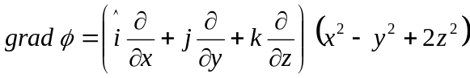
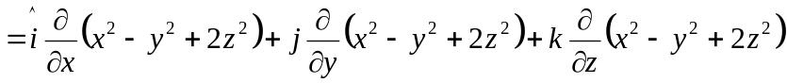
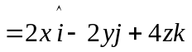
∴ 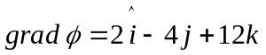 at P(1, 2, 3)
Suppose 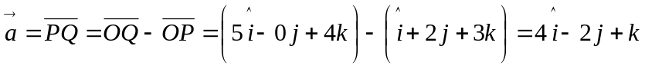
Let a be unit vector along the direction of 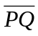, then
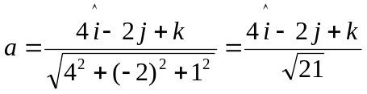
The D.D. of scalar function at the point P(1, 2, 3) in the direction of is
D.D. = a. grad
⇒ 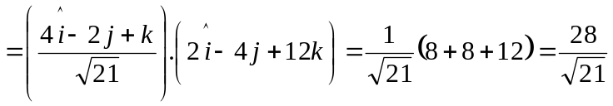
∴ 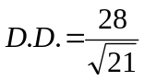 Answer

(b) Use Stoke’s theorem to evaluate 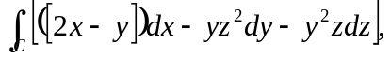 where c is the circle 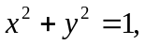 corresponding to the surface of sphere of unit radius.
Solution : Given 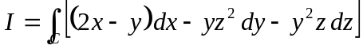
∴ 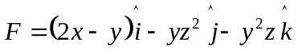
By Stock’s theorem we have
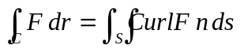
Now, 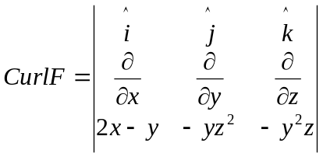
= 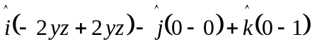
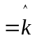
Since the surface on the dy-plane, then 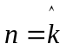
And 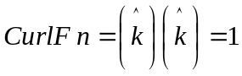
The projection on XY-plane then we have
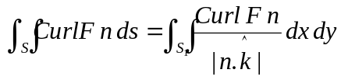
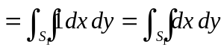
= Area of circle in xy plane
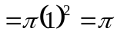
Hence, 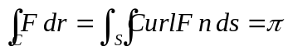 Answer

7. (a) A vector field is given by 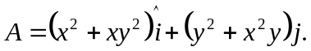 Show that the vector field is irrotational.
Solution : Given 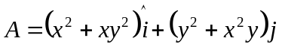
Now, 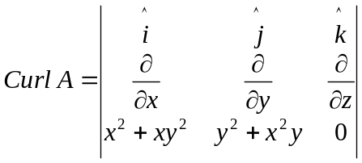
⇒ 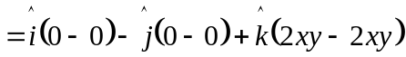
⇒ 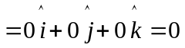
∴ A is irrotational vector. Answer
(b) Define the divergence of a vector field and show that the vector
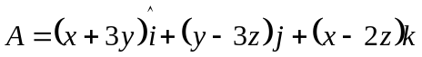 is solenoidal.
Solution : In vector calculus, the divergence is an operator that measures the magnitude of a vector field’s source or sink at a given point; the divergence of a vector field is a (signed) scalar. For example, for a vector field that denotes the velocity of air expanding as it is heated, the divergence of the velocity field would have a positive value because the air expands. If the air cools and contracts, the divergence is negative.
Now 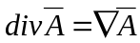
⇒ 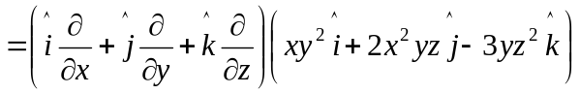
⇒ 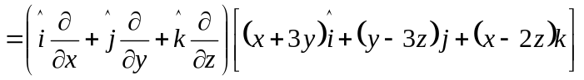
⇒ 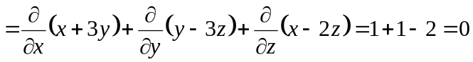
∴  is solenoidal. Hence Proved

8. (a) Using Laplace transform, solve 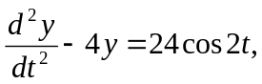 given that 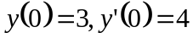
Solution : Given the dirrerential equation is,
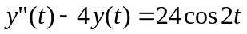 ………..(1)
With initial condition are: 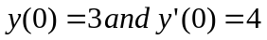
Taking Laplace transform of (1) on both sides, we get
⇒ 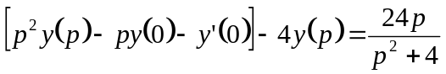
Putting the initial values, 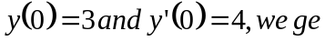
∴ 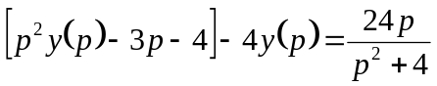
⇒ 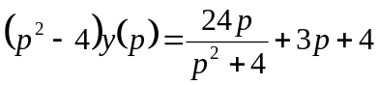
⇒ 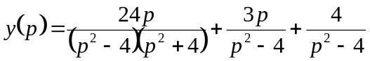
⇒ 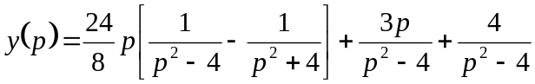
⇒
⇒ 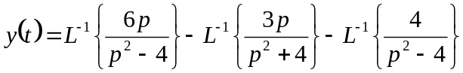
⇒ 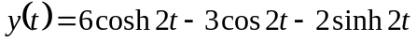
Thus, Answer
(b) Find the following:
(i). 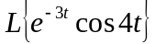 (ii). 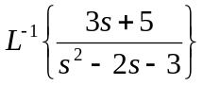
Solution : (i). 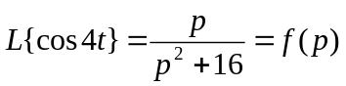
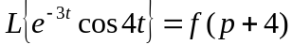
⇒ 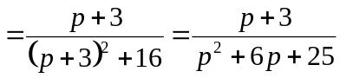
∴ 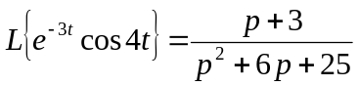 Answer
(ii). 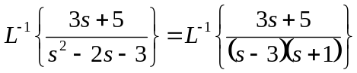
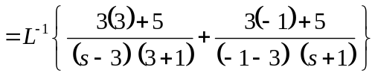
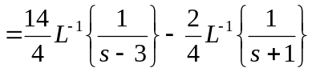
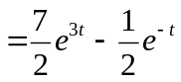
∴ 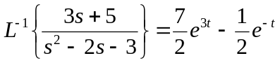 Answer

*** **** ***

