EECS215 HW1

Yuan Qin, yqin7, 95124670

Lai Man Tang, laimt, 33166471

1.

A. Men optimality:

step1:

|  |  |  |  |  |
| --- | --- | --- | --- | --- |
| Man # | Men’s preference table | | | |
| 1 | 1 | 2 | 3 | 4 |
| 2 | 2 | 1 | 4 | 3 |
| 3 | 3 | 4 | 1 | 2 |
| 4 | 4 | 3 | 2 | 1 |

|  |  |  |  |  |
| --- | --- | --- | --- | --- |
| Women # | Women’s preference table | | | |
| 1 | 4 | 3 | 2 | 1 |
| 2 | 3 | 4 | 1 | 2 |
| 3 | 2 | 1 | 4 | 3 |
| 4 | 1 | 2 | 3 | 4 |

Step 2:

|  |  |  |  |  |
| --- | --- | --- | --- | --- |
| Man # | Men’s preference table | | | |
| 1 | 1 | 2 | 3 | 4 |
| 2 | 2 | 1 | 4 | 3 |
| 3 | 3 | 4 | 1 | 2 |
| 4 | 4 | 3 | 2 | 1 |

|  |  |  |  |  |
| --- | --- | --- | --- | --- |
| Women # | Women’s preference table | | | |
| 1 | 4 | 3 | 2 | 1 |
| 2 | 3 | 4 | 1 | 2 |
| 3 | 2 | 1 | 4 | 3 |
| 4 | 1 | 2 | 3 | 4 |

Step 3:

|  |  |  |  |  |
| --- | --- | --- | --- | --- |
| Man # | Men’s preference table | | | |
| 1 | 1 | 2 | 3 | 4 |
| 2 | 2 | 1 | 4 | 3 |
| 3 | 3 | 4 | 1 | 2 |
| 4 | 4 | 3 | 2 | 1 |

|  |  |  |  |  |
| --- | --- | --- | --- | --- |
| Women # | Women’s preference table | | | |
| 1 | 4 | 3 | 2 | 1 |
| 2 | 3 | 4 | 1 | 2 |
| 3 | 2 | 1 | 4 | 3 |
| 4 | 1 | 2 | 3 | 4 |

Step 4:

|  |  |  |  |  |
| --- | --- | --- | --- | --- |
| Man # | Men’s preference table | | | |
| 1 | 1 | 2 | 3 | 4 |
| 2 | 2 | 1 | 4 | 3 |
| 3 | 3 | 4 | 1 | 2 |
| 4 | 4 | 3 | 2 | 1 |

|  |  |  |  |  |
| --- | --- | --- | --- | --- |
| Women # | Women’s preference table | | | |
| 1 | 4 | 3 | 2 | 1 |
| 2 | 3 | 4 | 1 | 2 |
| 3 | 2 | 1 | 4 | 3 |
| 4 | 1 | 2 | 3 | 4 |

B. Women optimality:

Step1:

|  |  |  |  |  |
| --- | --- | --- | --- | --- |
| Women # | Women’s preference table | | | |
| 1 | 4 | 3 | 2 | 1 |
| 2 | 3 | 4 | 1 | 2 |
| 3 | 2 | 1 | 4 | 3 |
| 4 | 1 | 2 | 3 | 4 |

|  |  |  |  |  |
| --- | --- | --- | --- | --- |
| Man # | Men’s preference table | | | |
| 1 | 1 | 2 | 3 | 4 |
| 2 | 2 | 1 | 4 | 3 |
| 3 | 3 | 4 | 1 | 2 |
| 4 | 4 | 3 | 2 | 1 |

Step 2:

|  |  |  |  |  |
| --- | --- | --- | --- | --- |
| Women # | Women’s preference table | | | |
| 1 | 4 | 3 | 2 | 1 |
| 2 | 3 | 4 | 1 | 2 |
| 3 | 2 | 1 | 4 | 3 |
| 4 | 1 | 2 | 3 | 4 |

|  |  |  |  |  |
| --- | --- | --- | --- | --- |
| Man # | Men’s preference table | | | |
| 1 | 1 | 2 | 3 | 4 |
| 2 | 2 | 1 | 4 | 3 |
| 3 | 3 | 4 | 1 | 2 |
| 4 | 4 | 3 | 2 | 1 |

Step 3:

|  |  |  |  |  |
| --- | --- | --- | --- | --- |
| Women # | Women’s preference table | | | |
| 1 | 4 | 3 | 2 | 1 |
| 2 | 3 | 4 | 1 | 2 |
| 3 | 2 | 1 | 4 | 3 |
| 4 | 1 | 2 | 3 | 4 |

|  |  |  |  |  |
| --- | --- | --- | --- | --- |
| Man # | Men’s preference table | | | |
| 1 | 1 | 2 | 3 | 4 |
| 2 | 2 | 1 | 4 | 3 |
| 3 | 3 | 4 | 1 | 2 |
| 4 | 4 | 3 | 2 | 1 |

Step 4:

|  |  |  |  |  |
| --- | --- | --- | --- | --- |
| Women # | Women’s preference table | | | |
| 1 | 4 | 3 | 2 | 1 |
| 2 | 3 | 4 | 1 | 2 |
| 3 | 2 | 1 | 4 | 3 |
| 4 | 1 | 2 | 3 | 4 |

|  |  |  |  |  |
| --- | --- | --- | --- | --- |
| Man # | Men’s preference table | | | |
| 1 | 1 | 2 | 3 | 4 |
| 2 | 2 | 1 | 4 | 3 |
| 3 | 3 | 4 | 1 | 2 |
| 4 | 4 | 3 | 2 | 1 |

C.

|  |  |  |  |  |
| --- | --- | --- | --- | --- |
| Man # | Men’s preference table | | | |
| 1 | 1 | 2 | 3 | 4 |
| 2 | 2 | 1 | 4 | 3 |
| 3 | 3 | 4 | 1 | 2 |
| 4 | 4 | 3 | 2 | 1 |

|  |  |  |  |  |
| --- | --- | --- | --- | --- |
| Woman # | Women’s preference table | | | |
| 1 | 4 | 3 | 2 | 1 |
| 2 | 3 | 4 | 1 | 2 |
| 3 | 2 | 1 | 4 | 3 |
| 4 | 1 | 2 | 3 | 4 |

Pf: Assume this matching is not a stable matching, then there exist an unstable pair which some man and some woman prefer each other to their current matching pair. We look at Woman 1 who has a higher rank on man 1’s preference table, however woman 1 only prefers man 4 to her present matching, so the current matching of (1,2) is stable. Then look at woman 2 and 1 who has higher ranks on man 2’s preference table, however woman 1 and 2 do not prefer man 2 to their present matchings, so the current matching of (2,4) is stable. The same situation happens with man 3 and man 4. So all these four pairs are stable, which is contradictory with our assumption. So this matching is stable.

2.

A. g4<g3<g1<g5<g2<g7<g6

B.

a.Outer loop: T = O(n);

Inner loop:T= $(n-1)+(n-2)+(n-3)+...+1=\frac{(n-1)*(n-2)}{2}=\frac{1}{2\left(n^{2}-3n+2\right)}≤\frac{1}{2\left(n^{2}+2n^{2}\right)}≤\frac{3}{2n^{2}}=O(n^{2})$

So the total running time is O($n^{3}$)

b.T = $\frac{\left(n-1\right)*\left(n-2\right)}{2}×n=\frac{1}{2\left(n^{2} -3n+2\right)}×n≥\frac{1}{2n^{3}}=Ω\left(n^{3}\right)$

As both T = $Ω(n^{3})$ =O($n^{3}$), so T= $Θ(n^{3})$.

c.Pseudo-code:

Curr = 0;

For i from 1 to n:

Curr = A[i];

For j from i+1 to n:

Curr += A[j];

B[i,j] = Curr;

Endfor

Endfor

3.

A. Assume G contains extra edge e that do not belong to T which has N-1 edges, then the G has N edges which form a cycle c. When DFS traversal from the root node along the cycle c, it will generate a single path since all nodes connect each other in the cycle c. However in BFS algorithm, it will generate at least two branches from the root node. The tree t’ generate by DFS is not equal to the tree T generate by BFS, which is a contradiction. Therefore, G must not contain any extra edges. In other words, G = T.

1. The graph is not a DAG, because this graph has two disconnected part A and B. Part A has at least one directed cycle. Though part B is a DAG.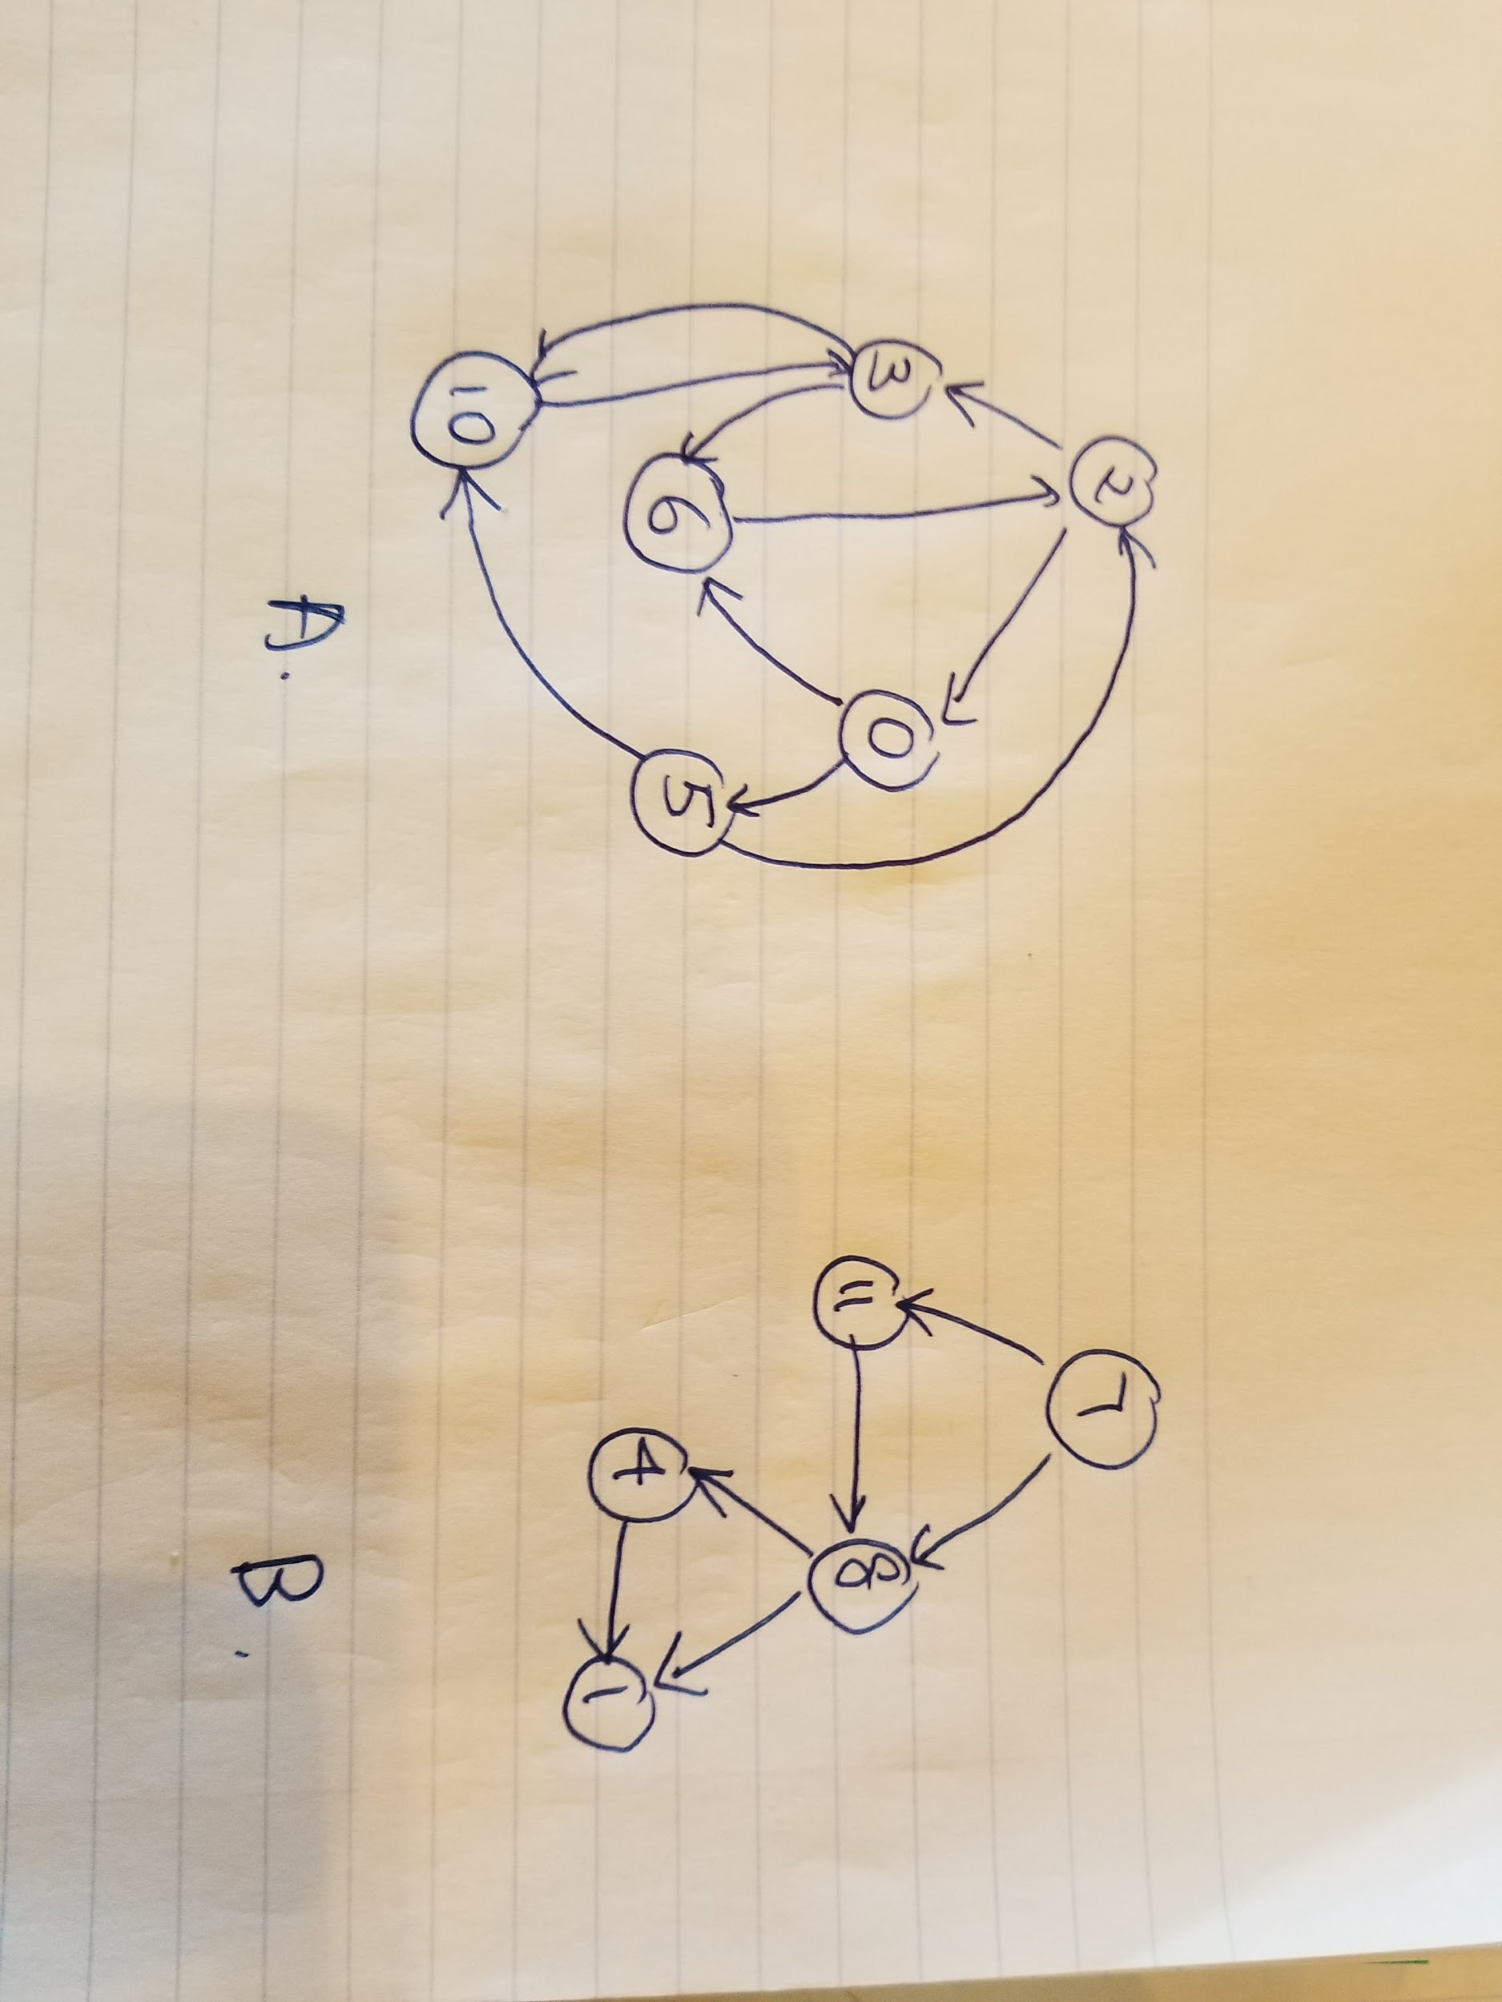
2. To find a cycle in a graph using Floyd’s Cycle-Finding Algorithm:

FCF(u)

Walker = u

Jumper = u

While Walker, Jumper and Jumper->next is not empty

Walker moves one step

Jumper moves two steps

If Walker meets Jumper:

Contain cycle

End if

End while

If Walker never meet Jumper

Do not contain cycle

End if