9/24/2016

Laluna Team

international school of duy tan university 2016

APPYCO SOFTWARE

Final project for Project Management subject.

APPYCO SOFTWARE

PREPARED BY: Laluna Team

DANANG CITY. Saturday, September 24, 2016

TEAM’s MEMBER:

Ly Bao Khanh

Dao Thi Ngoc Lien

Doan Diep Linh

Phan Phuoc Vung

Contents

I. Software Requirement Specification Docs 3

1. NAME OF PROJECT: 4

2. START DATE – END DATE: 4

3. VISION AND SCOPE 4

4. SHORT DECRIPSTION 4

5. LIST AN ACTORS 5

6. LIST AN USECASES 5

7. CONTEXT DIAGRAM 5

8. USECASE DIAGRAM 6

9. PROTOTYPE 7

II. Work-breakdown Structure 0

1. PROCESS-WBS 1

2. PRODUCT-WBS 0

III. Plan 1

1. ESTIMATE TASKS 1

2. DEFINE CRITICAL TASKS AND DURATIONS 2

3. DEFINE SOFTWARE PROJECT PLAN 3

IV. Earn Value 5

# Software Requirement Specification Docs

## NAME OF PROJECT

Appyco Software

## START DATE – END DATE

|  |  |
| --- | --- |
| Start date | 07/21/2016 |
| End date | 12/16/2016 |

## VISION AND SCOPE

* Target customers: user who need to edit their photo more beautiful
* Statement of need: photo capture, photo filtering, photo sharing…
* Product name: Appyco soft
* Product category: application software
* Benefit Statement: free, easy to use, beautiful interface, convenient
* Competitive analysis: Our products are free, and have friendly interface, functionality, ease of use
* Product differentiation photo filtering, convenient, store large data

## SHORT DECRIPSTION

For software users who need to edit their photo more beautiful. The Appyco Software is a application software which are free, easy to use, beautiful interface. Unlike other systems have usually update, have new beautiful interface,

But also you can edit and filtering the photos more beautiful not only you can sharing the photos with your friends.

## LIST AN ACTORS

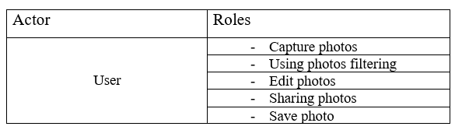

## LIST AN USECASES

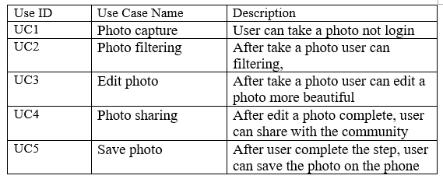

## CONTEXT DIAGRAM

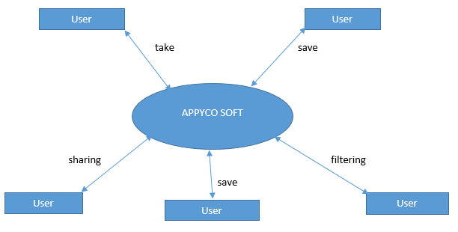

## USECASE DIAGRAM

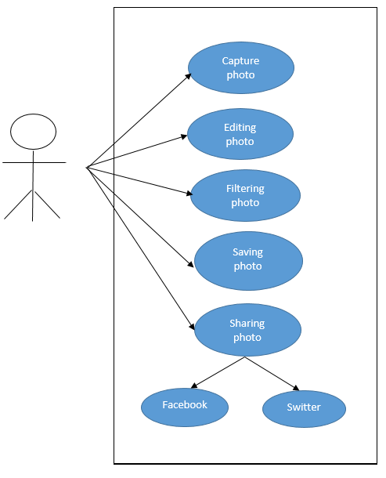

## PROTOTYPE

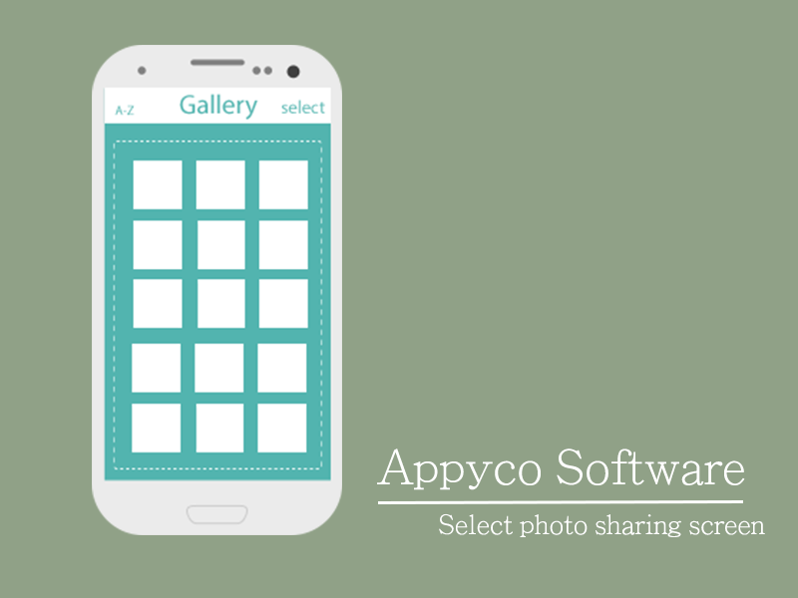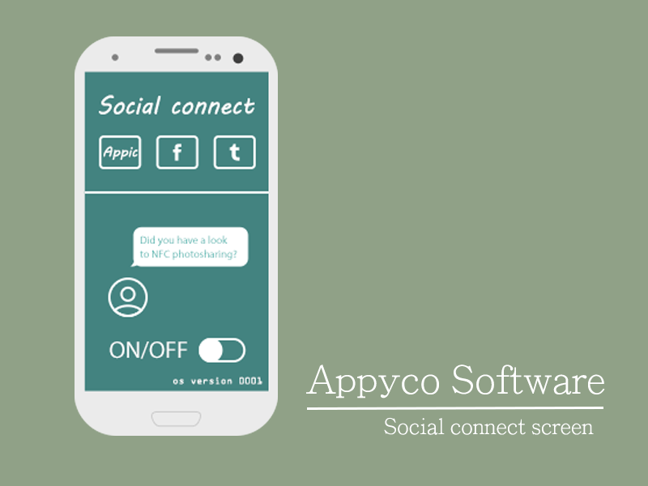

# Work-breakdown Structure

## PROCESS-WBS

## PRODUCT-WBS

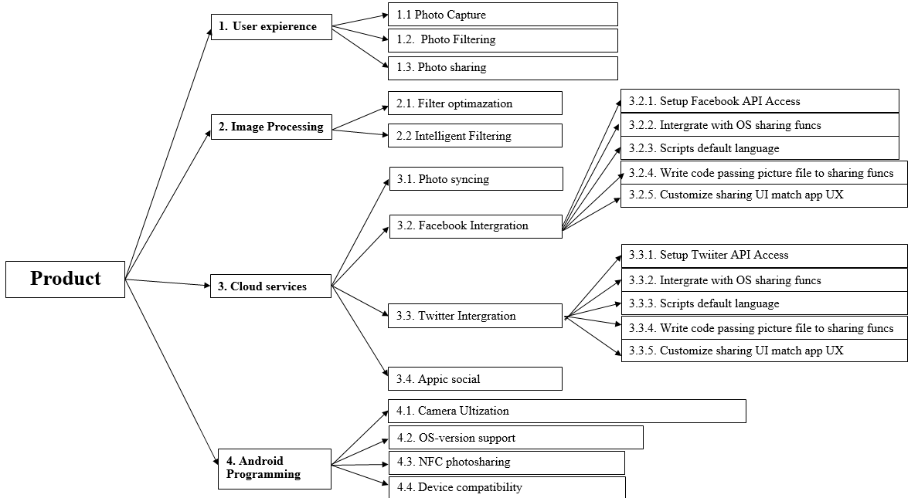

# Plan

## ESTIMATE TASKS

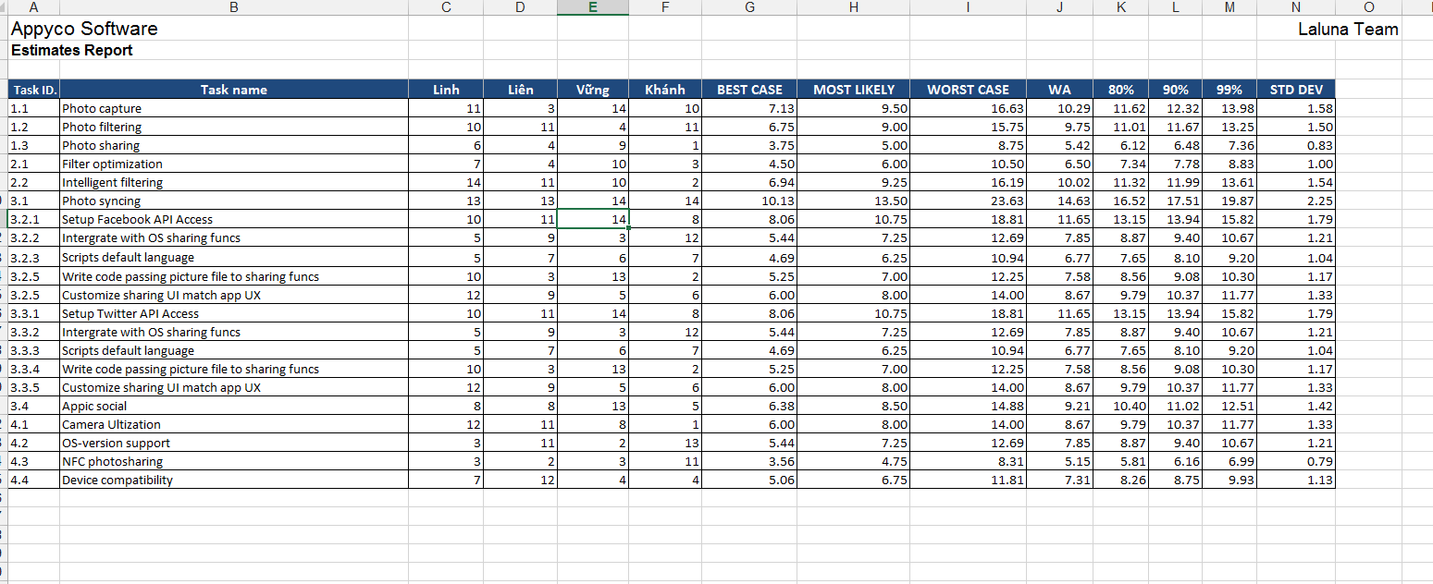

## DEFINE CRITICAL TASKS AND DURATIONS

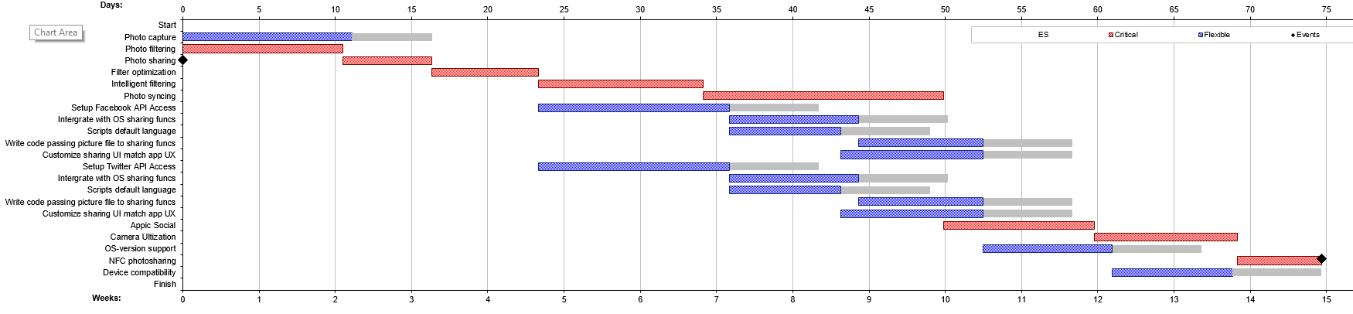

## DEFINE SOFTWARE PROJECT PLAN

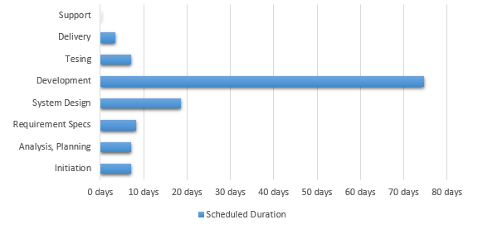

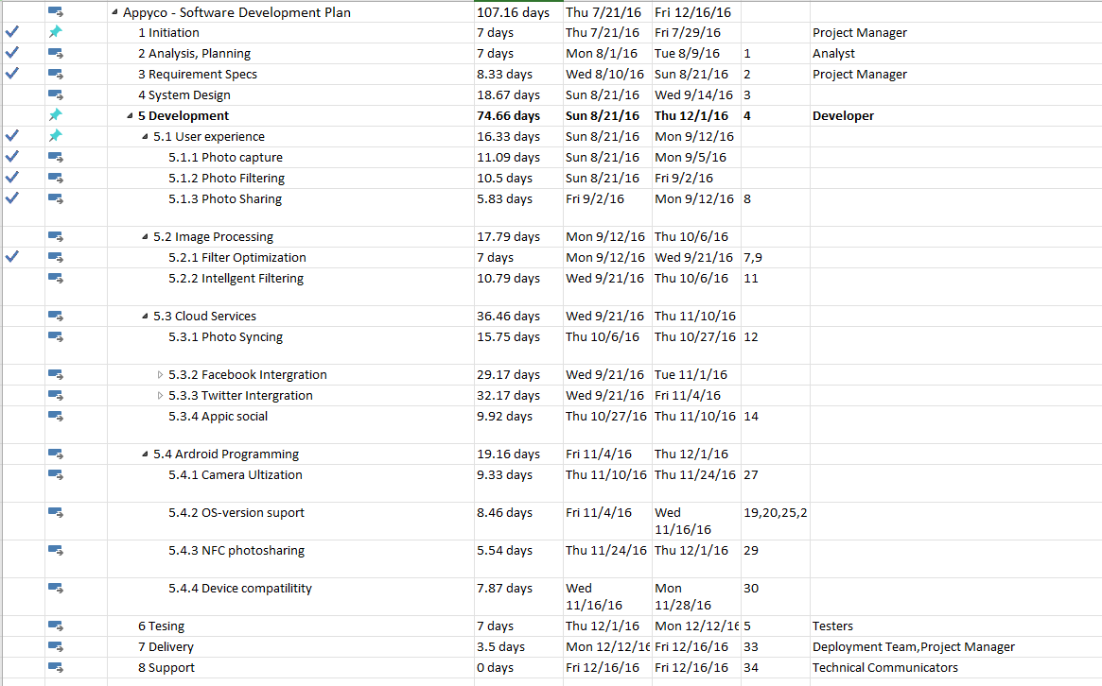

# Earn Value

