AS IT IS
Buck Enters Church at Start of Hunting Season
November 18, 2021
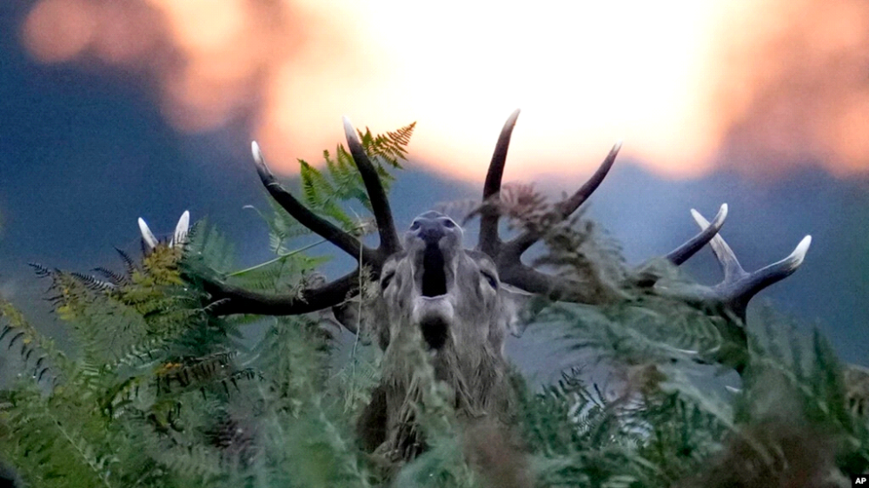A red deer stag bellows at sunrise during the rutting (breeding) season which takes place during autumn, in Bushy Park, south west London, Oct. 13, 2021. (AP Photo/Matt Dunham)

Church is a place where people may seek comfort during difficult times. It can be considered a sanctuary – a place that provides safety or protection. Usually, that safety or protection is meant for humans…not massive woodland creatures.

But in the state of Michigan, a huge buck entered a church on the first day of hunting season. Hunting season there begins on November 15. A buck is a male deer. The animals are prized targets for many hunters. In this case, the church served as a sanctuary for the buck by protecting it from hunters.

Religious leaders at the church Grace Sturgis found the buck inside the church’s main gathering room.

A video the church posted on Facebook shows the buck walking around the church. Then it climbed the stairs to a second-floor seating area.
Pastors Amanda and Luke Eicher and Justin Wickey blocked a hallway with large pieces of wood. They wanted to keep the animal away from the rest of the church.

Amanda Eicher said of the animal, “I was amazed at how big he was.”

The buck did not appear to have any gunshot wounds. But it was bleeding a little from what appeared to be cuts from glass, Amanda Eicher told the Kalamazoo Gazette. This buck, however, jumped through a window and back into the wild before anyone had a chance to get close enough to know for sure.

Besides the broken window, the only other damage in the church was blood stains on the floor.

Amanda Eicher said she and others found humor in the situation.

“We all need reasons to laugh, especially with the hard seasons from the past two years,” Amanda Eicher said. “I’m glad we could provide some laughs.”

I’m Anna Matteo.

Writers for the Associated Press wrote this story. Anna Matteo adapted it for VOA Learning English. Ashley Thompson was the editor.
__________________________________________________

Words in This Story
church -n. a building for public and especially Christian worship

pastor -n. a spiritual overseer

hallway -n. an entrance hall

amaze -v. to fill with wonder

stain -n. a soiled or discolored spot

