1. Clone from github

$ git clone <https://github.com/cmusv-sc/riskadvisor-ibm.git>

1. Create IBM Bluemix and set up CF command-line tool

https://www.ng.bluemix.net/docs/#cli/index.html#cli

1. Modify the host and name field on manifest.yml to an unique value. This would be a part of the URL of the application.
2. Install and use Apache ANT to build the application

$ ant

1. Use CF to login to IBM Bluemix

$ cf login

Enter your IBM ID when asked

1. Push to IBM Bluemix using the CF application

$ cf push

1. Attach MongoDB, IBM Analytics for Hadoop, Auto-Scaling, Monitoring and Analytics services to the application

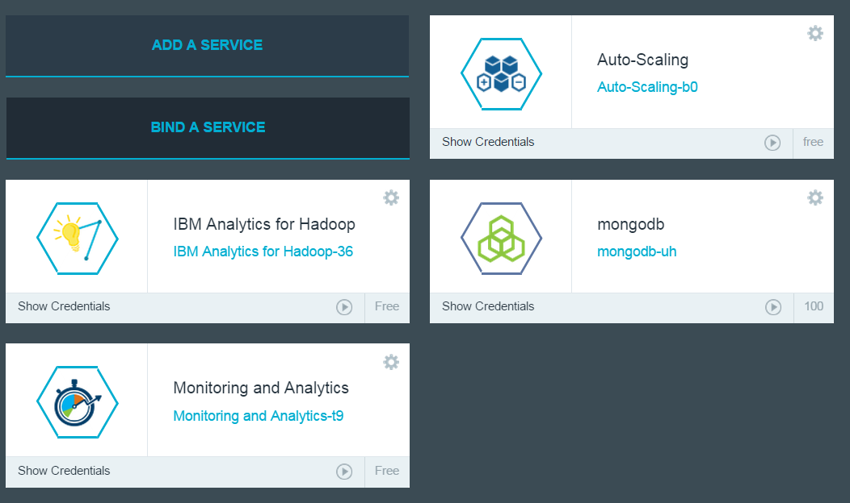

1. Get the MongoDB credentials by clicking on the Show Credentials link on the attached MongoDB service

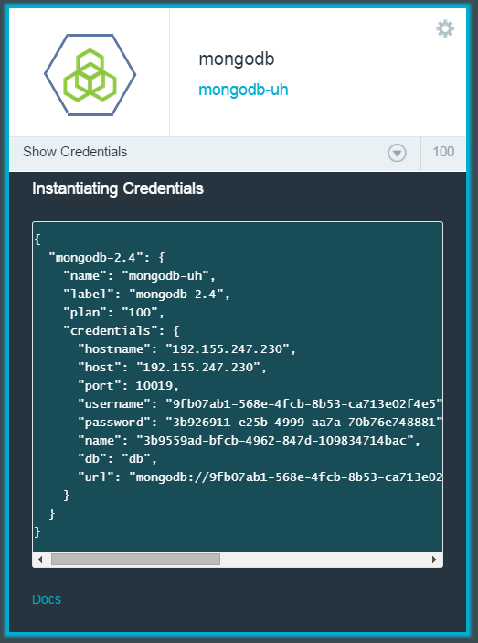

1. Change the HOST, PORT, USERNAME, and PASSWORD on MongoConstants.java so that they match the credentials from the MongoDB service

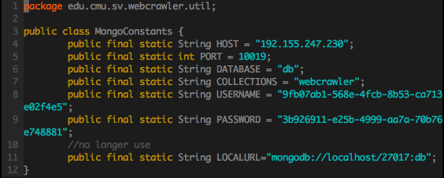

1. Get the IBM Analytics for Hadoop credentials by clicking on the Show Credentials link on the attached IBM Analytics for Hadoop service, record it down for future use.

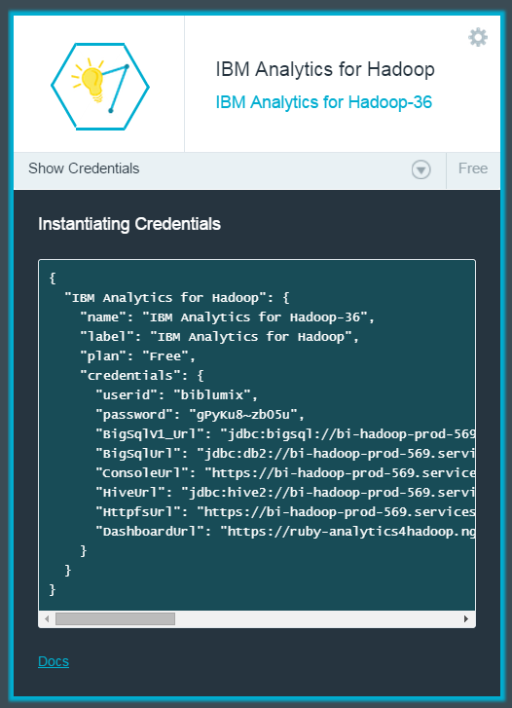

1. Change the USERNAME, PASSWORD, CONSOLE_URL on BigInsights.java so that they match the credentials from the IBM Analytics for Hadoop service

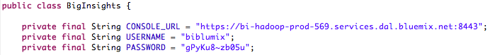

1. Download the Biginsights library for eclipse from Biginsights conole and install it in Eclipse (eclipse has to be of version 4.2 exactly as of date 12/04/2014).
2. Import the Biginsights project to eclipse. Right click the project name and select Biginsights Publish (or the like). Follow the steps and input your credentials noted from step 8. Choose your application category. Accept the default setting afterwards and finish the procedure of publishing the biginsights application. Check your Biginsights console to see if your application is successfully pushed.
3. Go to the application section in your Biginsights console, click to enter your application section. Choose management tag. Choose the category you just pushed your application in. Deploy your application. The application is now good to use.
4. Set up Scaling Rules for Auto-Scaling, if you want.
5. Push to IBM Bluemix using the CF application

$ cf push

1. Access the web app url: **web-app-url**/dummy to initialize the web app.

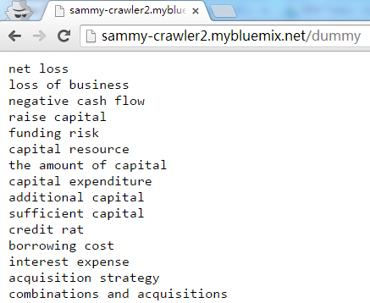

1. Click the Crawler tab, and type in the company name, and choose between 10K and 10Q, then begin to Crawl! (Warning: some company 10K/10Q files don’t contain risk factor chapter, so there will be no result, for example, IBM 10Q). You’ll get a notification on the page when job finishes.

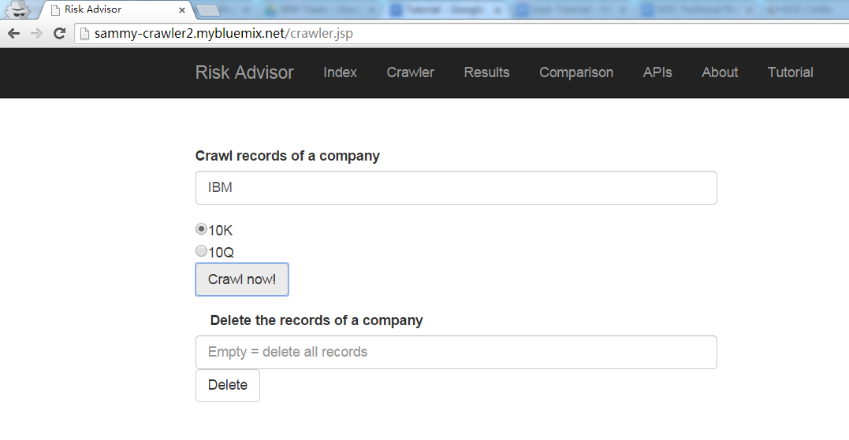

1. Click the Results tab, and type in the company name, you’ll see the result.

