PROJECT TEAM 1 -- CIS 043 SOFTWARE DEVELOPMENT WITH JAVA PROGRAMMING FALL 2017

# GPA CALCULATOR

Student HUB

Mission College CIS 043

Dan Lee

Henry Pham

Qiye Hu

December 12, 2017

CONTENTS

**Contents**

**1 Introduction**

**2 Project Analysis and Design**

2.1 Project requirement and Functions

2.2 UML Diagram

2.3 Case Flow Chart

2.4 GPA Calculator

**3 Source Code:**

Main Menu

GPA Calculator

GUI Command

Hub Test

Add Class

Log in Screen

ReadInfo

SaveName

**4 Test Plan and Result**

**5 Conclusion**

1 INTRODUCTION

**1 Introduction**

The purpose of this program is to show you how to calculate your GPA during the semester using Java GUI program language. Calculating your GPA (Grade Point Average) is easy and essential. Knowing your GPA is important in evaluating your improvement and determining your

Academic standing for any given semester. The first thing that your future employer will look at in resume is your GPA because your grades can tell a lot about you as a person. Therefore it’s important to know how to calculate your GPA and see what you need to improve. Follow the steps below to calculate your GPA in Java GUI.

**2.1 Project requirement and Functions**

* Calculate GPA
* Save GPA
* Save classes
* Create report of all classes

The program takes a user's name and saves it indefinitely, or until data is reset. After entering a name, users will be able to calculate their GPA and add classes to a report. Their GPA will be on display on the main menu after being calculated. The report is available to the users on demand.

**2.2 UML Diagram**

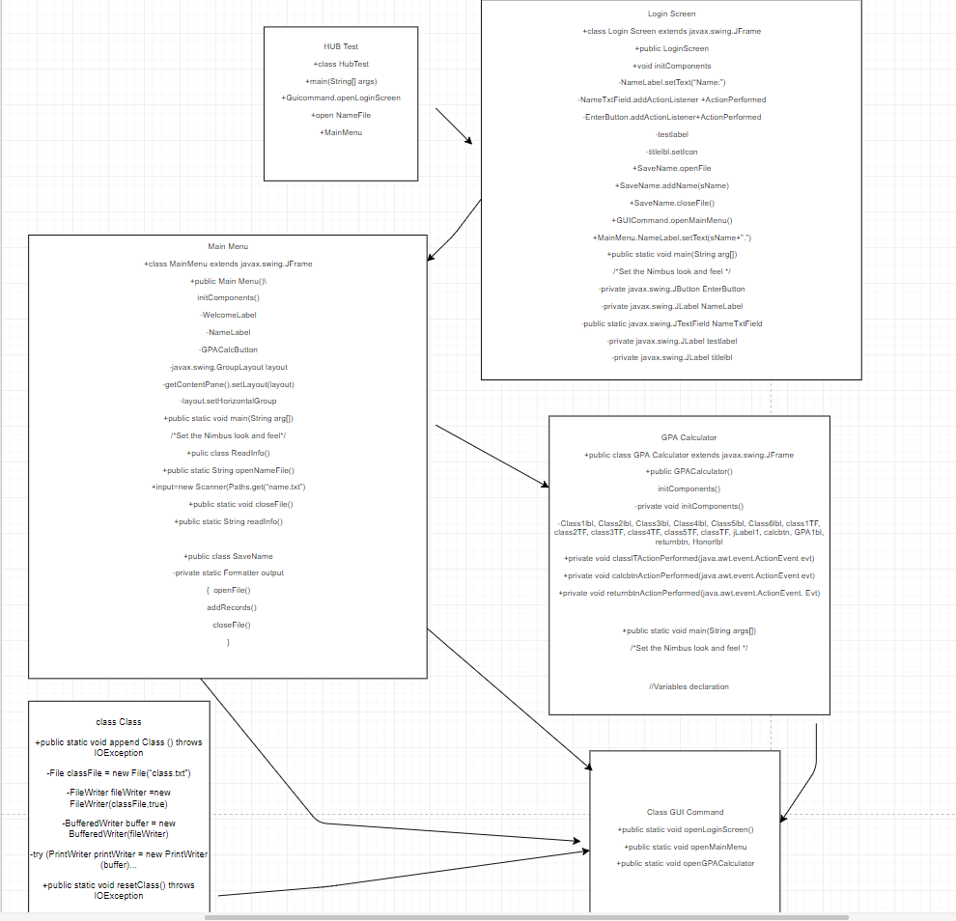

**2.3 Case Flow Diagram**

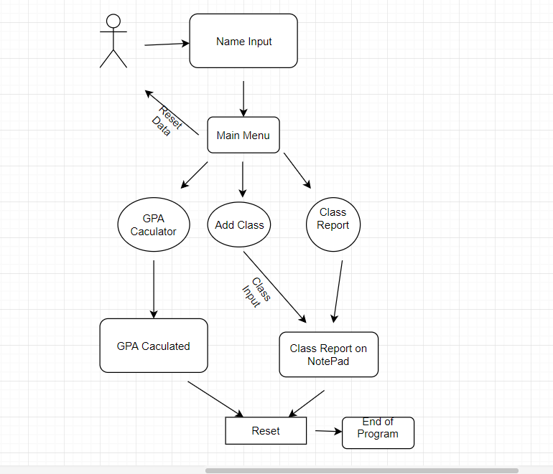

**2.4 GPA Calculator**

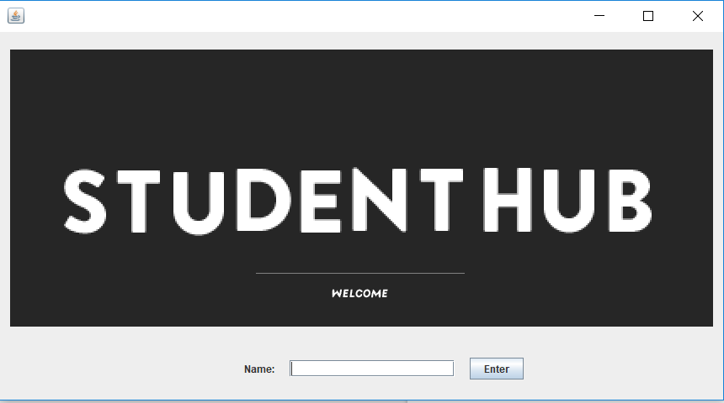

Fig. 1 Front Page

The user begins at the login screen by typing the user’s name.

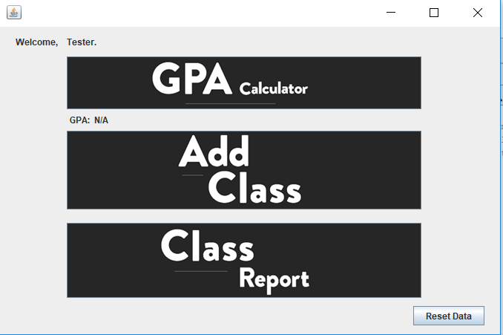

Fig. 2 Menu Page

The user can choose between calculating their GPA and adding class to their class report, which would keep track of their classes. The user can also click on class report to see their records. The user may also click reset data to exit out of the program.

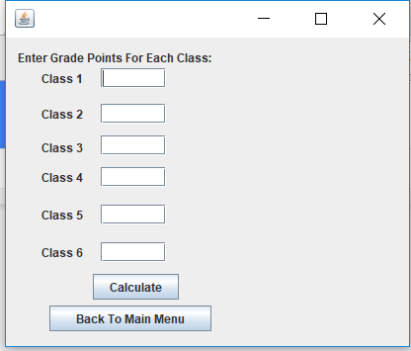

Fig. 3 Inputting GPA

When the user clicked onto the “GPA Calculator”, they are presented with this page, this page allows the user to input their grades for 6 different classes, which can then be used to calculate their GPA by clicking on the “Calculate” button. The user may also click “Back To Main Menu” to go back to the previous page.

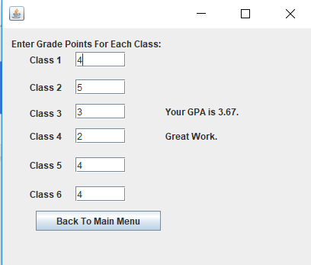

Fig. 4 Calculation

The user is presented with their GPA, the comment will change depending on the GPA the user obtains. The user may click “Back To Main Menu” to continue using the program.

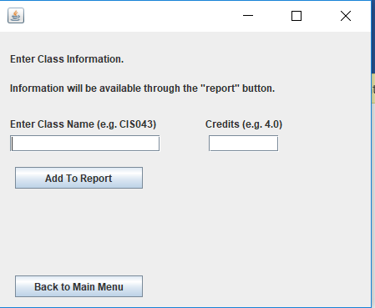

Fig. 5 Add Class

Through the “Add Class” button, the user is able to add class information to their “Class Report”, which helps the user to keep track of their classes.

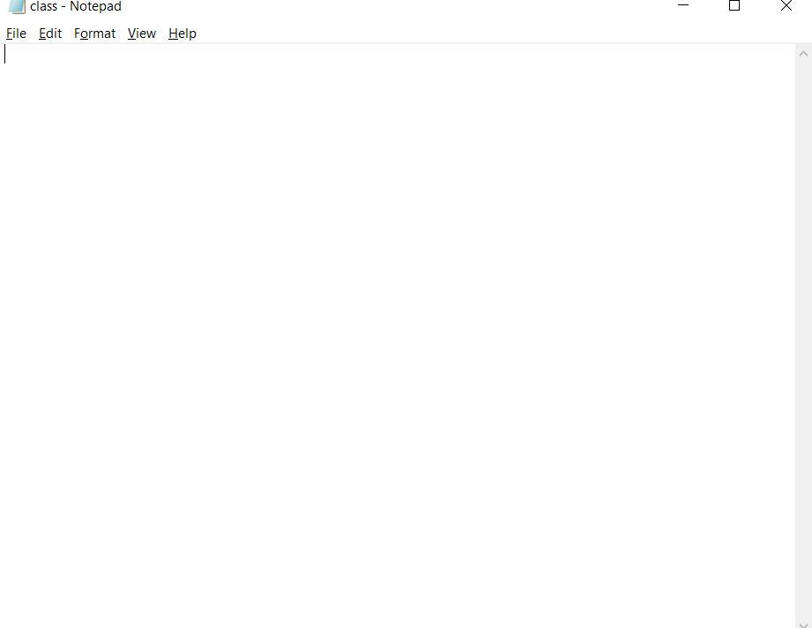

Fig. 6 Class Report

By click the “Class Report”, a notepad titled “class” appears, showing the classes that the user has input through the “Add Class” button.



Fig. 7 Reset Data

The “Reset Data” button located at the lower right hand corner of the menu enables the user to exit out the program and thus reset all the information that has been recorded.

**3 Source Code:**

Main Menu:

package hubtest;

import java.io.IOException;

import java.util.logging.Level;

import java.util.logging.Logger;

/**

*

* @author Dan Lee

*/

public class MainMenu extends javax.swing.JFrame {

/**

* Creates new form MainMenu

*/

public MainMenu() {

initComponents();

}

/**

* This method is called from within the constructor to initialize the form.

* WARNING: Do NOT modify this code. The content of this method is always

* regenerated by the Form Editor.

*/

@SuppressWarnings("unchecked")

// <editor-fold defaultstate="collapsed" desc="Generated Code">

private void initComponents() {

WelcomeLabel = new javax.swing.JLabel();

NameLabel = new javax.swing.JLabel();

GPACalcButton = new javax.swing.JButton();

AddClassbtn = new javax.swing.JButton();

resetbtn = new javax.swing.JButton();

GPAlbl = new javax.swing.JLabel();

GPALabellbl = new javax.swing.JLabel();

runReportBtn = new javax.swing.JButton();

setDefaultCloseOperation(javax.swing.WindowConstants.EXIT_ON_CLOSE);

WelcomeLabel.setText("Welcome,");

GPACalcButton.setIcon(new javax.swing.ImageIcon(getClass().getResource("/hubtest/gpacalc.png"))); // NOI18N

GPACalcButton.addActionListener(new java.awt.event.ActionListener() {

public void actionPerformed(java.awt.event.ActionEvent evt) {

GPACalcButtonActionPerformed(evt);

}

});

AddClassbtn.setIcon(new javax.swing.ImageIcon(getClass().getResource("/hubtest/addclass.png"))); // NOI18N

AddClassbtn.addActionListener(new java.awt.event.ActionListener() {

public void actionPerformed(java.awt.event.ActionEvent evt) {

AddClassbtnActionPerformed(evt);

}

});

resetbtn.setText("Reset Data");

resetbtn.addActionListener(new java.awt.event.ActionListener() {

public void actionPerformed(java.awt.event.ActionEvent evt) {

resetbtnActionPerformed(evt);

}

});

GPALabellbl.setText("GPA:");

runReportBtn.setIcon(new javax.swing.ImageIcon(getClass().getResource("/hubtest/classreport.png"))); // NOI18N

runReportBtn.addActionListener(new java.awt.event.ActionListener() {

public void actionPerformed(java.awt.event.ActionEvent evt) {

runReportBtnActionPerformed(evt);

}

});

javax.swing.GroupLayout layout = new javax.swing.GroupLayout(getContentPane());

getContentPane().setLayout(layout);

layout.setHorizontalGroup(

layout.createParallelGroup(javax.swing.GroupLayout.Alignment.LEADING)

.addGroup(javax.swing.GroupLayout.Alignment.TRAILING, layout.createSequentialGroup()

.addGap(0, 0, Short.MAX_VALUE)

.addComponent(resetbtn)

.addGap(21, 21, 21))

.addGroup(layout.createSequentialGroup()

.addGroup(layout.createParallelGroup(javax.swing.GroupLayout.Alignment.LEADING)

.addGroup(layout.createSequentialGroup()

.addGap(94, 94, 94)

.addComponent(GPALabellbl)

.addPreferredGap(javax.swing.LayoutStyle.ComponentPlacement.RELATED)

.addComponent(GPAlbl, javax.swing.GroupLayout.PREFERRED_SIZE, 38, javax.swing.GroupLayout.PREFERRED_SIZE))

.addGroup(layout.createSequentialGroup()

.addGap(21, 21, 21)

.addComponent(WelcomeLabel)

.addPreferredGap(javax.swing.LayoutStyle.ComponentPlacement.RELATED)

.addGroup(layout.createParallelGroup(javax.swing.GroupLayout.Alignment.LEADING)

.addComponent(NameLabel, javax.swing.GroupLayout.PREFERRED_SIZE, 324, javax.swing.GroupLayout.PREFERRED_SIZE)

.addGroup(layout.createParallelGroup(javax.swing.GroupLayout.Alignment.TRAILING, false)

.addComponent(GPACalcButton, javax.swing.GroupLayout.Alignment.LEADING, javax.swing.GroupLayout.PREFERRED_SIZE, 0, Short.MAX_VALUE)

.addComponent(AddClassbtn, javax.swing.GroupLayout.PREFERRED_SIZE, 0, Short.MAX_VALUE)

.addComponent(runReportBtn, javax.swing.GroupLayout.Alignment.LEADING, javax.swing.GroupLayout.PREFERRED_SIZE, 478, javax.swing.GroupLayout.PREFERRED_SIZE)))))

.addContainerGap(106, Short.MAX_VALUE))

);

layout.setVerticalGroup(

layout.createParallelGroup(javax.swing.GroupLayout.Alignment.LEADING)

.addGroup(layout.createSequentialGroup()

.addContainerGap()

.addGroup(layout.createParallelGroup(javax.swing.GroupLayout.Alignment.BASELINE)

.addComponent(WelcomeLabel)

.addComponent(NameLabel, javax.swing.GroupLayout.PREFERRED_SIZE, 14, javax.swing.GroupLayout.PREFERRED_SIZE))

.addPreferredGap(javax.swing.LayoutStyle.ComponentPlacement.UNRELATED)

.addComponent(GPACalcButton, javax.swing.GroupLayout.PREFERRED_SIZE, 71, javax.swing.GroupLayout.PREFERRED_SIZE)

.addPreferredGap(javax.swing.LayoutStyle.ComponentPlacement.RELATED)

.addGroup(layout.createParallelGroup(javax.swing.GroupLayout.Alignment.LEADING)

.addComponent(GPALabellbl, javax.swing.GroupLayout.DEFAULT_SIZE, 16, Short.MAX_VALUE)

.addComponent(GPAlbl, javax.swing.GroupLayout.DEFAULT_SIZE, 16, Short.MAX_VALUE))

.addGap(7, 7, 7)

.addComponent(AddClassbtn, javax.swing.GroupLayout.PREFERRED_SIZE, 106, javax.swing.GroupLayout.PREFERRED_SIZE)

.addGap(18, 18, 18)

.addComponent(runReportBtn, javax.swing.GroupLayout.PREFERRED_SIZE, 101, javax.swing.GroupLayout.PREFERRED_SIZE)

.addPreferredGap(javax.swing.LayoutStyle.ComponentPlacement.RELATED, 11, Short.MAX_VALUE)

.addComponent(resetbtn)

.addContainerGap())

);

pack();

}// </editor-fold>

private void GPACalcButtonActionPerformed(java.awt.event.ActionEvent evt) {

// TODO add your handling code here:

GUICommand.openGPACalculator();

dispose();

}

private void AddClassbtnActionPerformed(java.awt.event.ActionEvent evt) {

// TODO add your handling code here:

GUICommand.openInputClass();

dispose();

}

private void resetbtnActionPerformed(java.awt.event.ActionEvent evt) {

try {

// TODO add your handling code here:

GUICommand.resetData();

} catch (IOException ex) {// catches exception

Logger.getLogger(MainMenu.class.getName()).log(Level.SEVERE, null, ex);

}

dispose();

}

private void runReportBtnActionPerformed(java.awt.event.ActionEvent evt) {

try {

// TODO add your handling code here:

GUICommand.openReport();

} catch (IOException ex) {

Logger.getLogger(MainMenu.class.getName()).log(Level.SEVERE, null, ex);

}

}

/**

* @param args the command line arguments

*/

public static void main(String args[]) {

/* Set the Nimbus look and feel */

//<editor-fold defaultstate="collapsed" desc=" Look and feel setting code (optional) ">

/* If Nimbus (introduced in Java SE 6) is not available, stay with the default look and feel.

* For details see http://download.oracle.com/javase/tutorial/uiswing/lookandfeel/plaf.html

*/

try {

for (javax.swing.UIManager.LookAndFeelInfo info : javax.swing.UIManager.getInstalledLookAndFeels()) {

if ("Nimbus".equals(info.getName())) {

javax.swing.UIManager.setLookAndFeel(info.getClassName());

break;

}

}

} catch (ClassNotFoundException ex) {

java.util.logging.Logger.getLogger(MainMenu.class.getName()).log(java.util.logging.Level.SEVERE, null, ex);

} catch (InstantiationException ex) {

java.util.logging.Logger.getLogger(MainMenu.class.getName()).log(java.util.logging.Level.SEVERE, null, ex);

} catch (IllegalAccessException ex) {

java.util.logging.Logger.getLogger(MainMenu.class.getName()).log(java.util.logging.Level.SEVERE, null, ex);

} catch (javax.swing.UnsupportedLookAndFeelException ex) {

java.util.logging.Logger.getLogger(MainMenu.class.getName()).log(java.util.logging.Level.SEVERE, null, ex);

}

//</editor-fold>

/* Create and display the form */

java.awt.EventQueue.invokeLater(new Runnable() {

public void run() {

new MainMenu().setVisible(true);

}

});

}

// Variables declaration - do not modify

private javax.swing.JButton AddClassbtn;

private javax.swing.JButton GPACalcButton;

private javax.swing.JLabel GPALabellbl;

public static javax.swing.JLabel GPAlbl;

public static javax.swing.JLabel NameLabel;

private javax.swing.JLabel WelcomeLabel;

private javax.swing.JButton resetbtn;

private javax.swing.JButton runReportBtn;

// End of variables declaration

}

GPA Calculator

package hubtest;

/**

*

* @author Dan Lee

*/

public class GPACalculator extends javax.swing.JFrame {

/**

* Creates new form GPACalculator

*/

public GPACalculator() {

initComponents();

}

/**

* This method is called from within the constructor to initialize the form.

* WARNING: Do NOT modify this code. The content of this method is always

* regenerated by the Form Editor.

*/

@SuppressWarnings("unchecked")

// <editor-fold defaultstate="collapsed" desc="Generated Code">

private void initComponents() {

Class1lbl = new javax.swing.JLabel();

Class2lbl = new javax.swing.JLabel();

Class3lbl = new javax.swing.JLabel();

Class4lbl = new javax.swing.JLabel();

Class5lbl = new javax.swing.JLabel();

Class6lbl = new javax.swing.JLabel();

class1TF = new javax.swing.JTextField();

class2TF = new javax.swing.JTextField();

class3TF = new javax.swing.JTextField();

class4TF = new javax.swing.JTextField();

class5TF = new javax.swing.JTextField();

class6TF = new javax.swing.JTextField();

jLabel1 = new javax.swing.JLabel();

calcbtn = new javax.swing.JButton();

GPAlbl = new javax.swing.JLabel();

returnbtn = new javax.swing.JButton();

Honorlbl = new javax.swing.JLabel();

errorlbl = new javax.swing.JLabel();

setDefaultCloseOperation(javax.swing.WindowConstants.EXIT_ON_CLOSE);

Class1lbl.setText("Class 1");

Class2lbl.setText("Class 2");

Class3lbl.setText("Class 3");

Class4lbl.setText("Class 4");

Class5lbl.setText("Class 5");

Class6lbl.setText("Class 6");

class1TF.addActionListener(new java.awt.event.ActionListener() {

public void actionPerformed(java.awt.event.ActionEvent evt) {

class1TFActionPerformed(evt);

}

});

jLabel1.setText("Enter Grade Points For Each Class:");

calcbtn.setText("Calculate");

calcbtn.addActionListener(new java.awt.event.ActionListener() {

public void actionPerformed(java.awt.event.ActionEvent evt) {

calcbtnActionPerformed(evt);

}

});

returnbtn.setText("Back To Main Menu");

returnbtn.addActionListener(new java.awt.event.ActionListener() {

public void actionPerformed(java.awt.event.ActionEvent evt) {

returnbtnActionPerformed(evt);

}

});

javax.swing.GroupLayout layout = new javax.swing.GroupLayout(getContentPane());

getContentPane().setLayout(layout);

layout.setHorizontalGroup(

layout.createParallelGroup(javax.swing.GroupLayout.Alignment.LEADING)

.addGroup(layout.createSequentialGroup()

.addGroup(layout.createParallelGroup(javax.swing.GroupLayout.Alignment.LEADING)

.addGroup(layout.createSequentialGroup()

.addGap(36, 36, 36)

.addGroup(layout.createParallelGroup(javax.swing.GroupLayout.Alignment.LEADING)

.addGroup(layout.createSequentialGroup()

.addGroup(layout.createParallelGroup(javax.swing.GroupLayout.Alignment.LEADING, false)

.addGroup(layout.createSequentialGroup()

.addComponent(Class6lbl)

.addGap(18, 18, 18)

.addComponent(class6TF, javax.swing.GroupLayout.PREFERRED_SIZE, 66, javax.swing.GroupLayout.PREFERRED_SIZE))

.addGroup(layout.createSequentialGroup()

.addComponent(Class5lbl)

.addGap(18, 18, 18)

.addComponent(class5TF))

.addGroup(layout.createSequentialGroup()

.addComponent(Class4lbl)

.addGap(18, 18, 18)

.addComponent(class4TF))

.addGroup(layout.createSequentialGroup()

.addComponent(Class3lbl)

.addGap(18, 18, 18)

.addComponent(class3TF))

.addGroup(layout.createSequentialGroup()

.addComponent(Class2lbl)

.addGap(18, 18, 18)

.addComponent(class2TF))

.addGroup(layout.createSequentialGroup()

.addComponent(Class1lbl)

.addGap(18, 18, 18)

.addComponent(class1TF)))

.addGap(52, 52, 52)

.addGroup(layout.createParallelGroup(javax.swing.GroupLayout.Alignment.LEADING, false)

.addComponent(GPAlbl, javax.swing.GroupLayout.DEFAULT_SIZE, 152, Short.MAX_VALUE)

.addComponent(Honorlbl, javax.swing.GroupLayout.DEFAULT_SIZE, javax.swing.GroupLayout.DEFAULT_SIZE, Short.MAX_VALUE)

.addComponent(errorlbl, javax.swing.GroupLayout.DEFAULT_SIZE, javax.swing.GroupLayout.DEFAULT_SIZE, Short.MAX_VALUE)))

.addGroup(layout.createSequentialGroup()

.addGap(52, 52, 52)

.addComponent(calcbtn))))

.addGroup(layout.createSequentialGroup()

.addContainerGap()

.addGroup(layout.createParallelGroup(javax.swing.GroupLayout.Alignment.TRAILING)

.addComponent(returnbtn, javax.swing.GroupLayout.PREFERRED_SIZE, 164, javax.swing.GroupLayout.PREFERRED_SIZE)

.addComponent(jLabel1, javax.swing.GroupLayout.Alignment.LEADING))))

.addContainerGap(42, Short.MAX_VALUE))

);

layout.setVerticalGroup(

layout.createParallelGroup(javax.swing.GroupLayout.Alignment.LEADING)

.addGroup(layout.createSequentialGroup()

.addContainerGap()

.addComponent(jLabel1)

.addGroup(layout.createParallelGroup(javax.swing.GroupLayout.Alignment.LEADING)

.addGroup(layout.createSequentialGroup()

.addGap(3, 3, 3)

.addGroup(layout.createParallelGroup(javax.swing.GroupLayout.Alignment.BASELINE)

.addComponent(Class1lbl)

.addComponent(class1TF, javax.swing.GroupLayout.PREFERRED_SIZE, javax.swing.GroupLayout.DEFAULT_SIZE, javax.swing.GroupLayout.PREFERRED_SIZE)))

.addGroup(layout.createSequentialGroup()

.addGap(12, 12, 12)

.addComponent(errorlbl, javax.swing.GroupLayout.PREFERRED_SIZE, 21, javax.swing.GroupLayout.PREFERRED_SIZE)))

.addPreferredGap(javax.swing.LayoutStyle.ComponentPlacement.RELATED)

.addGroup(layout.createParallelGroup(javax.swing.GroupLayout.Alignment.BASELINE)

.addComponent(class2TF, javax.swing.GroupLayout.PREFERRED_SIZE, javax.swing.GroupLayout.DEFAULT_SIZE, javax.swing.GroupLayout.PREFERRED_SIZE)

.addComponent(Class2lbl))

.addPreferredGap(javax.swing.LayoutStyle.ComponentPlacement.UNRELATED)

.addGroup(layout.createParallelGroup(javax.swing.GroupLayout.Alignment.LEADING)

.addGroup(layout.createParallelGroup(javax.swing.GroupLayout.Alignment.BASELINE)

.addComponent(class3TF, javax.swing.GroupLayout.PREFERRED_SIZE, javax.swing.GroupLayout.DEFAULT_SIZE, javax.swing.GroupLayout.PREFERRED_SIZE)

.addComponent(GPAlbl, javax.swing.GroupLayout.PREFERRED_SIZE, 20, javax.swing.GroupLayout.PREFERRED_SIZE))

.addComponent(Class3lbl, javax.swing.GroupLayout.Alignment.TRAILING))

.addPreferredGap(javax.swing.LayoutStyle.ComponentPlacement.UNRELATED)

.addGroup(layout.createParallelGroup(javax.swing.GroupLayout.Alignment.LEADING)

.addComponent(Honorlbl, javax.swing.GroupLayout.Alignment.TRAILING, javax.swing.GroupLayout.PREFERRED_SIZE, 20, javax.swing.GroupLayout.PREFERRED_SIZE)

.addGroup(layout.createParallelGroup(javax.swing.GroupLayout.Alignment.BASELINE)

.addComponent(Class4lbl)

.addComponent(class4TF, javax.swing.GroupLayout.PREFERRED_SIZE, javax.swing.GroupLayout.DEFAULT_SIZE, javax.swing.GroupLayout.PREFERRED_SIZE)))

.addGap(18, 18, 18)

.addGroup(layout.createParallelGroup(javax.swing.GroupLayout.Alignment.BASELINE)

.addComponent(Class5lbl)

.addComponent(class5TF, javax.swing.GroupLayout.PREFERRED_SIZE, javax.swing.GroupLayout.DEFAULT_SIZE, javax.swing.GroupLayout.PREFERRED_SIZE))

.addGap(18, 18, 18)

.addGroup(layout.createParallelGroup(javax.swing.GroupLayout.Alignment.BASELINE)

.addComponent(Class6lbl)

.addComponent(class6TF, javax.swing.GroupLayout.PREFERRED_SIZE, javax.swing.GroupLayout.DEFAULT_SIZE, javax.swing.GroupLayout.PREFERRED_SIZE))

.addPreferredGap(javax.swing.LayoutStyle.ComponentPlacement.UNRELATED)

.addComponent(calcbtn)

.addPreferredGap(javax.swing.LayoutStyle.ComponentPlacement.RELATED)

.addComponent(returnbtn)

.addContainerGap(15, Short.MAX_VALUE))

);

pack();

}// </editor-fold>

private void class1TFActionPerformed(java.awt.event.ActionEvent evt) {

// TODO add your handling code here:

}

private void calcbtnActionPerformed(java.awt.event.ActionEvent evt) {

// TODO add your handling code here:

errorlbl.setText(" ");

String sC1 = class1TF.getText();

Double c1 = GUICommand.validateGPA(sC1);

String sC2 = class2TF.getText();

Double c2 = GUICommand.validateGPA(sC2);

String sC3 = class3TF.getText();

Double c3 = GUICommand.validateGPA(sC3);

String sC4 = class4TF.getText();

Double c4 = GUICommand.validateGPA(sC4);

String sC5 = class5TF.getText();

Double c5 = GUICommand.validateGPA(sC5);

String sC6 = class1TF.getText();

Double c6 = GUICommand.validateGPA(sC6);

double[] gpa = {c1,c2,c3,c4,c5,c6};

double counter = 0.0;

for (int i =0;i<6;i++)

{

if (gpa[i]>0)

counter++;

}

Double GPAverage = (c1+c2+c3+c4+c5+c6)/counter;

String sGPA = String.format("%.02f", GPAverage); //use to save to file

String sGPAverage = String.format("Your GPA is %.02f.", GPAverage);

GPAlbl.setText(sGPAverage);

SaveName.createGPAFile();

SaveName.addGPA(sGPA);

SaveName.closeFile();

String genius = String.format("You are an IRL Jimmy Neutron.");

String summa = String.format("Awesome!");

String magna = String.format("Great Work.");

String cum = String.format("C's get degrees.");

String fail = String.format(":(");

int honor = GPAverage.intValue();

if (GPAverage == 4)

Honorlbl.setText(summa);

else if ( honor == 3)

Honorlbl.setText(magna);

else if(honor==2)

Honorlbl.setText(cum);

else if(honor<2)

Honorlbl.setText(fail);

else if(GPAverage>4)

Honorlbl.setText(genius);

calcbtn.setVisible(false);

}

private void returnbtnActionPerformed(java.awt.event.ActionEvent evt) {

// TODO add your handling code here:

GUICommand.returnToMain();

dispose();

}

/**

* @param args the command line arguments

*/

public static void main(String args[]) {

/* Set the Nimbus look and feel */

//<editor-fold defaultstate="collapsed" desc=" Look and feel setting code (optional) ">

/* If Nimbus (introduced in Java SE 6) is not available, stay with the default look and feel.

* For details see http://download.oracle.com/javase/tutorial/uiswing/lookandfeel/plaf.html

*/

try {

for (javax.swing.UIManager.LookAndFeelInfo info : javax.swing.UIManager.getInstalledLookAndFeels()) {

if ("Nimbus".equals(info.getName())) {

javax.swing.UIManager.setLookAndFeel(info.getClassName());

break;

}

}

} catch (ClassNotFoundException ex) {

java.util.logging.Logger.getLogger(GPACalculator.class.getName()).log(java.util.logging.Level.SEVERE, null, ex);

} catch (InstantiationException ex) {

java.util.logging.Logger.getLogger(GPACalculator.class.getName()).log(java.util.logging.Level.SEVERE, null, ex);

} catch (IllegalAccessException ex) {

java.util.logging.Logger.getLogger(GPACalculator.class.getName()).log(java.util.logging.Level.SEVERE, null, ex);

} catch (javax.swing.UnsupportedLookAndFeelException ex) {

java.util.logging.Logger.getLogger(GPACalculator.class.getName()).log(java.util.logging.Level.SEVERE, null, ex);

}

//</editor-fold>

/* Create and display the form */

java.awt.EventQueue.invokeLater(new Runnable() {

public void run() {

new GPACalculator().setVisible(true);

}

});

}

// Variables declaration - do not modify

private javax.swing.JLabel Class1lbl;

private javax.swing.JLabel Class2lbl;

private javax.swing.JLabel Class3lbl;

private javax.swing.JLabel Class4lbl;

private javax.swing.JLabel Class5lbl;

private javax.swing.JLabel Class6lbl;

private javax.swing.JLabel GPAlbl;

private javax.swing.JLabel Honorlbl;

private javax.swing.JButton calcbtn;

private javax.swing.JTextField class1TF;

private javax.swing.JTextField class2TF;

private javax.swing.JTextField class3TF;

private javax.swing.JTextField class4TF;

private javax.swing.JTextField class5TF;

private javax.swing.JTextField class6TF;

public static javax.swing.JLabel errorlbl;

private javax.swing.JLabel jLabel1;

private javax.swing.JButton returnbtn;

// End of variables declaration

}

GUI Command

package hubtest;

import java.io.IOException;

import java.lang.NumberFormatException;

/**

*

* @author Dan Lee

*/

public class GUICommand {

public static void openLoginScreen()

{

LoginScreen loginScreen = new LoginScreen();

loginScreen.setVisible(true);

}

public static void openMainMenu()

{

MainMenu mainMenu = new MainMenu();

mainMenu.setVisible(true);

MainMenu.GPAlbl.setText(ReadInfo.openGPAFile());

}

public static void openGPACalculator()

{

GPACalculator gpaCalculator = new GPACalculator();

gpaCalculator.setVisible(true);

}

public static Double validateGPA(String sX)

{

double x = 0.0;

try

{

if (sX != null && sX.trim().isEmpty()) //takes care of no input exception

x = 0.0;

else

x = Double.parseDouble(sX);

}

catch (NumberFormatException numberFormatException)

{

System.err.printf("%nException: %s%n", numberFormatException);

GPACalculator.errorlbl.setText("Enter integers only.");

}

return x;

}

public static boolean validateUsername()

{

return LoginScreen.NameTxtField.getText().trim().isEmpty();

}

public static String validateCredit(String sCredit)

{

double credit;

String validatedCredit = null;

try

{

if (sCredit != null && sCredit.trim().isEmpty()) //takes care of no input exception

{

InputClass.creditErrorLbl.setText("Empty Field.");

validatedCredit = ("___");

}

else if (isNumeric(sCredit) == true)

{

credit = Double.parseDouble(sCredit);

sCredit = String.format("%.02f", credit);

validatedCredit = sCredit;

}

else

InputClass.creditErrorLbl.setText("Try Again.");

}

catch (NumberFormatException numberFormatException)

{

InputClass.creditErrorLbl.setText("Try Again.");

}

return validatedCredit;

}

public static void resetData() throws IOException

{

SaveName.openSaveNameFile();

SaveName.addName("default");

SaveName.closeFile();

SaveName.createGPAFile();

SaveName.addGPA("N/A");

SaveName.closeFile();

Class.resetClass();

}

public static void openInputClass()

{

InputClass inputClass = new InputClass();

inputClass.setVisible(true);

}

public static void returnToMain()

{

String sName;

sName = ReadInfo.openNameFile();

ReadInfo.closeFile();

MainMenu mainMenu = new MainMenu();

MainMenu.NameLabel.setText(sName+ ".");

String sGPA;

sGPA = ReadInfo.openGPAFile();

ReadInfo.closeFile();

MainMenu.GPAlbl.setText(sGPA);

mainMenu.setVisible(true);

}

public static String combineClassWCredit()

{

String sClass = InputClass.classTextField.getText().replaceAll("\\s","");

String sCredit = validateCredit(InputClass.creditTextField.getText()).replaceAll("\\s", "");

String combinedClass;

combinedClass = sClass.concat((" ").concat(sCredit));

return combinedClass;

}

public static boolean isNumeric(String str)

{

try

{

double d = Double.parseDouble(str);

}

catch(NumberFormatException nfe)

{

return false;

}

return true;

}

public static void openReport() throws IOException

{

ProcessBuilder pb = new ProcessBuilder("Notepad.exe", "class.txt");

pb.start();

}

}

Hub Test

package hubtest;

/**

*

* @author Dan Lee

*/

public class HubTest {

public static void main(String[] args)

{

if (ReadInfo.validateName() == true || ReadInfo.openNameFile().equals("default"))

{

GUICommand.openLoginScreen();

}

else

{GUICommand.openMainMenu();

MainMenu.NameLabel.setText(ReadInfo.openNameFile()+ ".");

}

}

}

Add Class

package hubtest;

import java.io.BufferedWriter;

import java.io.File;

import java.io.FileWriter;

import java.io.IOException;

import java.io.PrintWriter;

/**

*

* @author Dan Lee

*/

public class Class {

public static void appendClass() throws IOException

{

File classFile = new File("class.txt");

FileWriter fileWriter = new FileWriter(classFile, true);

BufferedWriter buffer = new BufferedWriter(fileWriter);

try (PrintWriter printWriter = new PrintWriter(buffer)) {

if (classFile.exists() == false)

{

classFile.createNewFile();

}

printWriter.printf("%s%n", GUICommand.combineClassWCredit());

printWriter.close();

}

}

public static void resetClass() throws IOException

{

PrintWriter printWriter = new PrintWriter("class.txt");

printWriter.close();

}

}

Log in Screen

package hubtest;

/**

*

* @author Dan Lee

*/

public class LoginScreen extends javax.swing.JFrame {

/**

* Creates new form LoginScreen

*/

public LoginScreen() {

initComponents();

}

/**

* This method is called from within the constructor to initialize the form.

* WARNING: Do NOT modify this code. The content of this method is always

* regenerated by the Form Editor.

*/

@SuppressWarnings("unchecked")

// <editor-fold defaultstate="collapsed" desc="Generated Code">

private void initComponents() {

NameLabel = new javax.swing.JLabel();

NameTxtField = new javax.swing.JTextField();

EnterButton = new javax.swing.JButton();

testlabel = new javax.swing.JLabel();

titlelbl = new javax.swing.JLabel();

nameErrorlbl = new javax.swing.JLabel();

setDefaultCloseOperation(javax.swing.WindowConstants.EXIT_ON_CLOSE);

setBackground(new java.awt.Color(51, 51, 51));

NameLabel.setText("Name:");

NameTxtField.addActionListener(new java.awt.event.ActionListener() {

public void actionPerformed(java.awt.event.ActionEvent evt) {

NameTxtFieldActionPerformed(evt);

}

});

EnterButton.setText("Enter");

EnterButton.addActionListener(new java.awt.event.ActionListener() {

public void actionPerformed(java.awt.event.ActionEvent evt) {

EnterButtonActionPerformed(evt);

}

});

titlelbl.setIcon(new javax.swing.ImageIcon(getClass().getResource("/hubtest/24135254_1778104882263318_2029930840_n.png"))); // NOI18N

javax.swing.GroupLayout layout = new javax.swing.GroupLayout(getContentPane());

getContentPane().setLayout(layout);

layout.setHorizontalGroup(

layout.createParallelGroup(javax.swing.GroupLayout.Alignment.LEADING)

.addGroup(layout.createSequentialGroup()

.addGroup(layout.createParallelGroup(javax.swing.GroupLayout.Alignment.LEADING)

.addGroup(layout.createSequentialGroup()

.addContainerGap()

.addComponent(titlelbl))

.addGroup(layout.createSequentialGroup()

.addGroup(layout.createParallelGroup(javax.swing.GroupLayout.Alignment.LEADING)

.addGroup(layout.createSequentialGroup()

.addGap(290, 290, 290)

.addComponent(NameLabel))

.addGroup(layout.createSequentialGroup()

.addGap(169, 169, 169)

.addComponent(testlabel, javax.swing.GroupLayout.PREFERRED_SIZE, 43, javax.swing.GroupLayout.PREFERRED_SIZE)))

.addGap(18, 18, 18)

.addGroup(layout.createParallelGroup(javax.swing.GroupLayout.Alignment.LEADING, false)

.addComponent(nameErrorlbl, javax.swing.GroupLayout.DEFAULT_SIZE, javax.swing.GroupLayout.DEFAULT_SIZE, Short.MAX_VALUE)

.addComponent(NameTxtField, javax.swing.GroupLayout.DEFAULT_SIZE, 196, Short.MAX_VALUE))

.addGap(18, 18, 18)

.addComponent(EnterButton)))

.addContainerGap(javax.swing.GroupLayout.DEFAULT_SIZE, Short.MAX_VALUE))

);

layout.setVerticalGroup(

layout.createParallelGroup(javax.swing.GroupLayout.Alignment.LEADING)

.addGroup(layout.createSequentialGroup()

.addContainerGap(21, Short.MAX_VALUE)

.addComponent(titlelbl)

.addPreferredGap(javax.swing.LayoutStyle.ComponentPlacement.UNRELATED)

.addComponent(nameErrorlbl, javax.swing.GroupLayout.PREFERRED_SIZE, 19, javax.swing.GroupLayout.PREFERRED_SIZE)

.addPreferredGap(javax.swing.LayoutStyle.ComponentPlacement.RELATED)

.addGroup(layout.createParallelGroup(javax.swing.GroupLayout.Alignment.BASELINE)

.addComponent(NameLabel)

.addComponent(NameTxtField, javax.swing.GroupLayout.PREFERRED_SIZE, javax.swing.GroupLayout.DEFAULT_SIZE, javax.swing.GroupLayout.PREFERRED_SIZE)

.addComponent(EnterButton))

.addPreferredGap(javax.swing.LayoutStyle.ComponentPlacement.RELATED)

.addComponent(testlabel, javax.swing.GroupLayout.PREFERRED_SIZE, 18, javax.swing.GroupLayout.PREFERRED_SIZE))

);

pack();

}// </editor-fold>

private void NameTxtFieldActionPerformed(java.awt.event.ActionEvent evt) {

// TODO add your handling code here:

}

private void EnterButtonActionPerformed(java.awt.event.ActionEvent evt) {

// TODO add your handling code here:

if (GUICommand.validateUsername() == true )

{

nameErrorlbl.setText("Please enter a name.");

}

else

{

String sName = NameTxtField.getText();

SaveName.openSaveNameFile();

SaveName.addName(sName);

SaveName.closeFile();

GUICommand.openMainMenu();

MainMenu.NameLabel.setText(sName+ ".");

dispose();

}

}

/**

* @param args the command line arguments

*/

public static void main(String args[]) {

/* Set the Nimbus look and feel */

//<editor-fold defaultstate="collapsed" desc=" Look and feel setting code (optional) ">

/* If Nimbus (introduced in Java SE 6) is not available, stay with the default look and feel.

* For details see http://download.oracle.com/javase/tutorial/uiswing/lookandfeel/plaf.html

*/

try {

for (javax.swing.UIManager.LookAndFeelInfo info : javax.swing.UIManager.getInstalledLookAndFeels()) {

if ("Nimbus".equals(info.getName())) {

javax.swing.UIManager.setLookAndFeel(info.getClassName());

break;

}

}

} catch (ClassNotFoundException ex) {

java.util.logging.Logger.getLogger(LoginScreen.class.getName()).log(java.util.logging.Level.SEVERE, null, ex);

} catch (InstantiationException ex) {

java.util.logging.Logger.getLogger(LoginScreen.class.getName()).log(java.util.logging.Level.SEVERE, null, ex);

} catch (IllegalAccessException ex) {

java.util.logging.Logger.getLogger(LoginScreen.class.getName()).log(java.util.logging.Level.SEVERE, null, ex);

} catch (javax.swing.UnsupportedLookAndFeelException ex) {

java.util.logging.Logger.getLogger(LoginScreen.class.getName()).log(java.util.logging.Level.SEVERE, null, ex);

}

//</editor-fold>

/* Create and display the form */

java.awt.EventQueue.invokeLater(new Runnable() {

public void run() {

new LoginScreen().setVisible(true);

}

});

}

// Variables declaration - do not modify

private javax.swing.JButton EnterButton;

private javax.swing.JLabel NameLabel;

public static javax.swing.JTextField NameTxtField;

public static javax.swing.JLabel nameErrorlbl;

private javax.swing.JLabel testlabel;

private javax.swing.JLabel titlelbl;

// End of variables declaration

}

ReadInfo

package hubtest;

import javax.swing.JFrame;

import java.util.Scanner;

import java.io.IOException;

import java.nio.file.Files;

import java.nio.file.Path;

import java.nio.file.Paths;

import java.util.NoSuchElementException;

/**

*

* @author Dan Lee

* NOTE: this class contains open/read methods that are not for name data

*/

public class ReadInfo {

private static Scanner input;

public static String openNameFile()

{

try

{

input = new Scanner(Paths.get("name.txt"));

}

catch (IOException ioException)

{

System.err.println("Error opening file. Terminating.");

System.exit(1);

}

String sName = input.next();

return sName;

}

public static boolean validateName()

{

try

{

return openNameFile().length() == 0; //placeholder to catch the exception

}

catch (NoSuchElementException noSuchElementException)

{

return true;

}

}

public static String openGPAFile()

{

try

{

input = new Scanner(Paths.get("gradepointaverage.txt"));

}

catch (IOException ioException)

{

System.err.println("Error opening file. Terminating.");

System.exit(1);

}

String sGPA = input.next();

return sGPA;

}

public static void closeFile()

{

input.close();

}

}

SaveName

package hubtest;

import java.io.FileNotFoundException;

import java.lang.SecurityException;

import java.util.Formatter;

import java.util.FormatterClosedException;

import java.util.NoSuchElementException;

import java.util.Scanner;

/**save name

*create text files, save data

* @author Dan Lee

* nov 24 2017

* NOTE: this class contains open/save methods that are not for name data

*/

public class SaveName

{

private static Formatter output;

public static void openSaveNameFile() //creates and opens file

{

try

{

output = new Formatter("name.txt");

}

catch (SecurityException securityException)

{

System.err.println("Write permission denied. Terminating.");

System.exit(1);

}

catch (FileNotFoundException fileNotFoundException)

{

System.err.println("Error opening file. Terminating.");

System.exit(1);

}

}

public static void addName(String sName)

{

try

{

output.format("%s", sName);

}

catch (FormatterClosedException formatterClosedException)

{

System.err.println("Error writing to file. Terminating");

}

catch (NoSuchElementException elementException)

{

System.err.println("Invalid input");

}

}

public static void closeFile()

{

output.close();

}

public static void addGPA(String sGPA)

{

try

{

output.format("%s", sGPA);

}

catch (FormatterClosedException formatterClosedException)

{

System.err.println("Error writing to file. Terminating");

}

catch (NoSuchElementException elementException)

{

System.err.println("Invalid input");

}

}

public static void createGPAFile()

{

try

{

output = new Formatter("gradepointaverage.txt");

}

catch (SecurityException securityException)

{

System.err.println("Write permission denied. Terminating.");

System.exit(1);

}

catch (FileNotFoundException fileNotFoundException)

{

System.err.println("Error opening file. Terminating.");

System.exit(1);

}

}

}

**4 Test Plan and Result**

* enter name to be saved by program ✔
* exit program ✔
* relaunch to see if programs asks for another name ✔
* if program doesn’t ask for another name, see if name is displayed on main menu ✔
* check if gpa calculator only takes numeric values ✔
* check if credit text field of "add class”only takes numeric values✔
* check if "reset data" clears all personal data and reopens as if it’s the first time the user is launching (take name)✔

**5 Conclusion**

Overall, the application turned out satisfactory and was definitely was a great learning experience. Many foreign parts of Java were explored by the developer while working on this project, making it a valuable experience as a novice developer. There are many aspects that can be refined for both the user experience and for the developer experience. For example, it would have been nice to add a password system as well as a better way for users to view their transcript reports. The constant opening and closing of windows is also very irritating. In addition, more consistency of the nomenclature would have definitely polished the program. We also need to enable the GPA calculator to be able to calculate the GPA by letter grades. One last function that the program needs to improve on is to add GPA to the Class Report, which would simulate a transcript and automatically calculates the GPA for the student base on their classes and the grades they input. Of course, these blemishes are all part of the learning experience on the journey to becoming competent software developers. That said, our application is definitely a very solid base for further development and refinement in the near future.