* 最短路徑問題 - 動態規劃

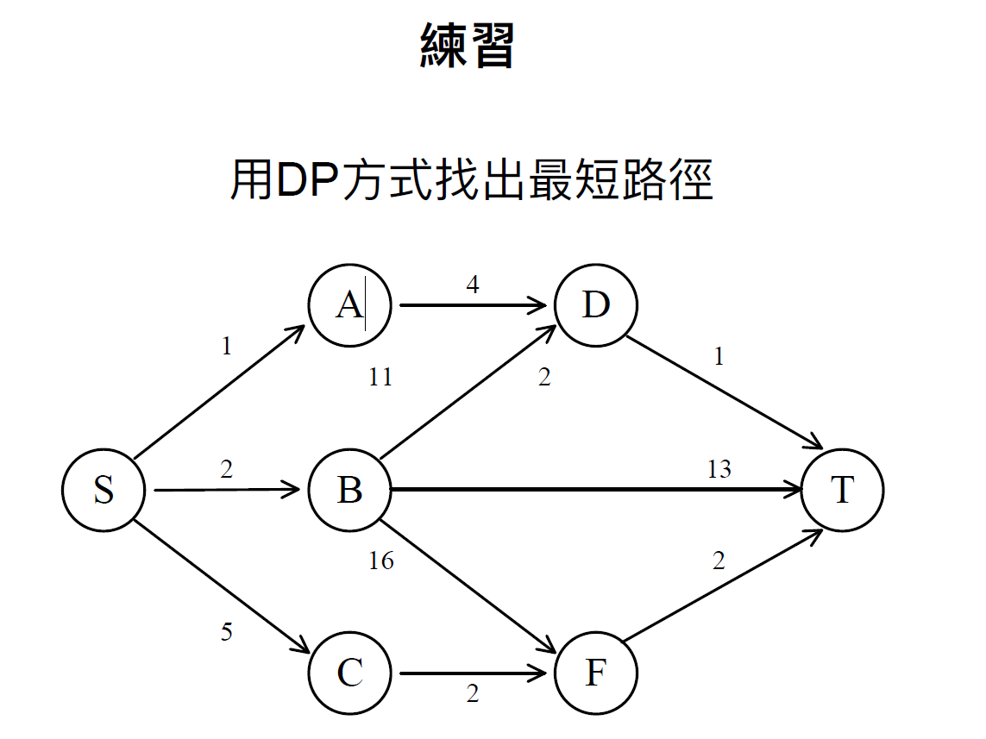

* d(S, A) = 1
* d(S, B) = 2
* d(S, C) = 5
* d(S,D)=min{d(S,A)+d(A,D), d(S,B)+d(B,D)} = min{ 1+4, 2+11 } = 5
* d(S,F)=min{d(S,B)+d(B,F), d(S,C)+d(C,F)} = min{ 2+16, 5+2 } = 7
* d(S,T) = min{d(S, D)+d(D, T), d(S,B)+ d(B,T), d(S, F)+d(F, T)} = min{ 5+1, 2+13, 7+2 } = 6

最短路徑 : 6