* 圖的儲存結構
* 無向圖 – 相鄰矩陣

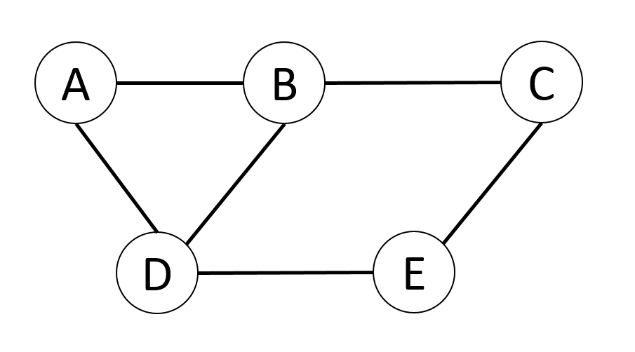

|  |  |  |  |  |  |
| --- | --- | --- | --- | --- | --- |
|  | **a** | **b** | **c** | **d** | **e** |
| **a** | 0 | 1 | 0 | 1 | 0 |
| **b** | 1 | 0 | 1 | 1 | 0 |
| **c** | 0 | 1 | 0 | 0 | 1 |
| **d** | 1 | 1 | 0 | 0 | 1 |
| **e** | 0 | 0 | 1 | 1 | 0 |

* 分支度

|  |  |  |  |  |  |
| --- | --- | --- | --- | --- | --- |
|  | **a** | **b** | **c** | **d** | **e** |
| Degree | 2 | 3 | 2 | 3 | 2 |

* 無向圖 –相鄰串列

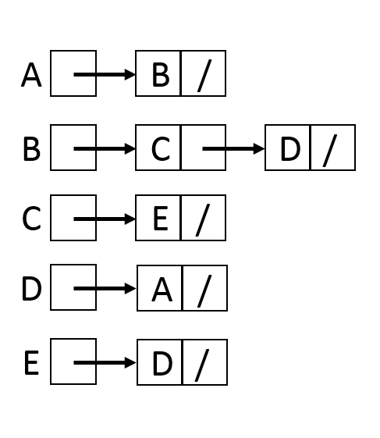

* 有向圖– 相鄰矩陣

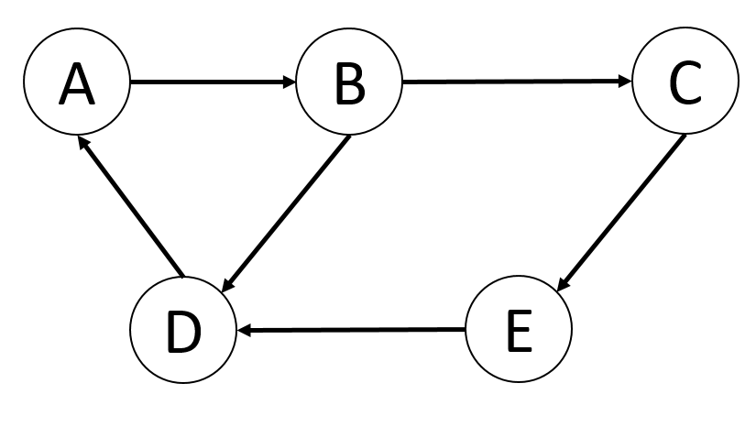

|  |  |  |  |  |  |
| --- | --- | --- | --- | --- | --- |
|  | **a** | **b** | **c** | **d** | **e** |
| **a** | 0 | 1 | 0 | 0 | 0 |
| **b** | 0 | 0 | 1 | 1 | 0 |
| **c** | 0 | 0 | 0 | 0 | 1 |
| **d** | 1 | 0 | 0 | 0 | 0 |
| **e** | 0 | 0 | 0 | 1 | 0 |

* 分支度

|  |  |  |  |  |  |
| --- | --- | --- | --- | --- | --- |
|  | **a** | **b** | **c** | **d** | **e** |
| **Indegree** | 1 | 1 | 1 | 2 | 1 |
| **Outdegree** | 1 | 2 | 1 | 1 | 1 |
| Degree | 2 | 3 | 2 | 3 | 2 |