System tools:

* LIST.OF.REC.LOCKED (ITMMST -> 0DTKA)
* AWForms server (MIS1IDS) -> AWFORMSQUEUE & AWMAILFILES.
* APM3010 – Maintain User Profiles for AP Reports (APRPTPROFILE)
* BOM3020 – Label View Values Plant Master
* RMT2000 - RMA Order Display
* QUO2001 - Quotation Display
* INV2006 – Stock Status Display
* SOP2001 – Sales Order Display
* SOP2002 - Order Line Item Display
* SOP2006 - Shipping Activity Display
* SOPO2006.1S– Bill of Lading Detail
* SOP2019 - Shipment Tracking Display
* SOP2016 – Invoice Display
* SOP4013 – Online Invoice Update (SOPS4013.1)
* SHP4000 - Shipping Workbench
* DRP3000 - Warehouse Master Maintenance
* DRP3015 – Radio Freq. Team Maintenance
* DRP4005 – Warehouse Transfer Shipment (Cut BOL for transfer order directly through Infoflo instead from scanner)
* DRP2021 - BOL Display RF Drill Down
* SYS3002 - Data Definition Maintenance (Database File)
* SYS6050 – Print / Display / Edit / Fax / E-mail of Existing Reports / Files
* SYS9030 - Printer Control Codes Maintenance (Stationery setup is maintained under menu More->Utilities->SB+ Utilities->SB+ Administration->Printers & Terminals->Printer Management->Physical Printer Definition)
* SYS9036 - Report Control Codes Maintenance
* SYS0035 - SB+ Printer Manager (Unix Printer for Infoflo)
* SYS9140 - NT Printer Maintenance (Windows Printer)
* SYS9090 - AWForms Printer Manger
* SYS9060 - Address Book Maintenance
* SYS3004 -> GLM4020 -> General Journal Security (Create J-E from External File)
* SYS3004 -> GLM4000.1 -> General Journal Security (Maintain General Journal (Current Period)
* SYS3005 -> I02 (Sales Region)
* SYS3005 -> I12 (Sales Mgr. codes for Rebate)
* SYS3005 -> I13 (RMA Release Authorization)
* SYS3005 -> I17 (Agent Codes)
* SYS3005 -> I32 (Setup Location Manager for Warehouse – Complaints)
* SYS3005 -> I112 (Assign batch Jobs to Users)
* SYS3005 -> I244 (Additional Sales Office For C/S Mgr)
* SYS3005 -> OER (Sales Operators – Default Sales Office Setup)
* SYS3005 -> COL (User setup for receive credit warning email)
* SYS3005 -> SLS (Sales Person Codes)
* SYS3005 -> I137 (SO Margin Limits)

PIM System Maintenance:

* BOM3300 – PIM Item Maintenance (F8 -> F5 -> F5 Tariff Code + I34)
* BOM3303 – PIM Item Package Display
* BOM3022 – List of Customer Item References
* BOM9000 – Create Item Reference
* BOM3051 - Attribute Grouping - Descriptive Attributes (SOP -> Admin -> Product Creation and Maintenance -> Attributes Maintenance -> Descriptive)
* BOM3008 – Item Master Maintenance – Manufacturing
* BOM3400 – Product Workbench (SOP -> Admin -> Product Creation and Maintenance – Product Workbench)
* MRP8011 – MRP Supply Chain / Excess
* MPP2000 – PlantItem Parameters Display
* MPP3004 – Local Packaging
* MPP2004 – Display of Local Packaging
* SYS3060 – Package Display
* SYS3055 - Dangerous Materials Comments Maintenance
* BOM3015 – Item Package Maintenance -> Legacy
* BOM3076 – Product Workbench (SOP-Admin->Product Creation and Maintenance) -> Legacy

PIC System Maintenance:

* PUR2012 -> Purchasing Internal Control Audit (PUR->Displays->Purchasing)
* PUR3015 -> PO Class Approval Maintenance
* PUR3016 -> SLA Maintenance
* PUR3018 -> SLA Mass Update (IT-MTN -> Update Approver Temporarily or Permanently)
* PUR3020 -> PO User Master Maintenance
* PUR5003 -> Purchase Order Approval Resend and Recall ((PUR->Purchasing))
* SHP4012 -> Warehouse control/access maintenance
* PUR2020 -> Purchase Order Receivers Display (PUR->Displays->Purchasing)
* SYSCON -> PIC.CONSTANT

PIC Menu -> IPEX -> FIN -> Admin

The PO PIC Approval Status will only change from Approved to Open if one of the following data elements are modified:

Afterwards, the PO will need to be re-sent for approval.

Header Screen:

• Frt Terms

• Drop Ship ID

• Name

• Address

Detail Screen:

• Desc (only apply to charge type G & W)

• Stk Qty See note below

• Suppl Cost See note below

• PO Total See note below

NOTE: only If PO total cost changes and is higher than the initial approved amount.

This way, if you change a date and save, you will not need to have the PO re-approved if it was already approved.

SDC System Maintenance (FIN->Ship & Debit):

* SOP3090 -> SD Claim Audit
* SOP3091 -> SD SLA Maintenance
* SOP3092 -> SD Claim Approval Resend/Recall
* SYSCON -> SDC.CONSTANT

TMS Support

* Job DRPS4025.10 is hung due to the fact that it was a timing issue Susan Davis did a transaction close to midnight that spawned the Batch job to start at 24:01, should have been 00:01 next day (Solution: use TECHSUP to kill the user, e.g. SUSDAV, so that the next TMS user who triggered the transaction will have the job waked up to work properly), reset SYSCON table TMS_CTLS attribute 7 from 1 to 0.
* How to clear the consolidated freight in Infoflo?

Go to the Shipping screen (Under DRP: “Customer Order Shipments” screen for Regular Orders and “Warehouse Transfer Shipment” screen for Transfers), change the Consolidation Flag from “Y” to “N”, then enter a 1$ freight amount and F2-Save.

* DRP4023 - TMS Transactions Extract (Status Checking Tool)
* DRP4010 - Radio Freq. Warehouse Maintenance (TMS On/Off)

Printer problem:

* Use the following command to get user's default printer

LIST DMSECURITY = "~userid" USR.PRINT.ID

* Fix BOL Dot Matrix Printer problem: Power off -> Reset Lantronix (little white box located in the back of the printer – Unplug, then put it back) -> Power on -> Use TECHSUP to do a logical printer reset just in case.
* Can't Print Customs Invoice - BOL 404127360 (RT#50135)

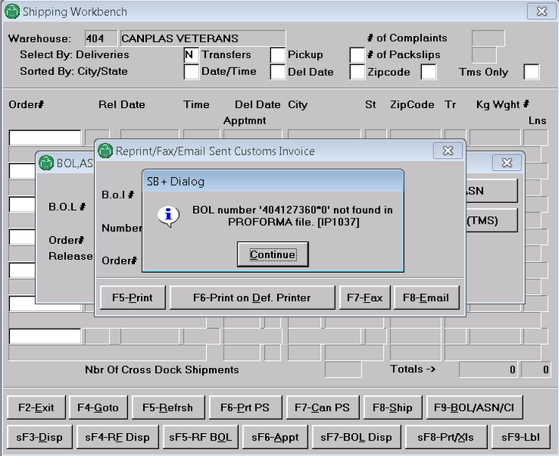

Procedure to allow shipper to print customs invoice: Print BOL->Generate Original Customs Invoice to create the record in PROFORMA by CTM4015 which only Sylvie Messier and IT has access (IPEX->TRANSP->CTM->Maintenance->Generate & Print Original Sent Custom's Invoice) -> Print Customs Invoice by SOP6070 (IPEX->DRP->Reports-> BOL,ASN, Customs Invoice Print/Fax/Email)

Or because the consolidated freight is flagged to Yes and no freight amount is populated, advise the user that he/she has to consolidate the freight amount with others BOL# (contact Béatrice for help in this case).

* Sales order not printed. Ask the user to double check the printer physically to make sure it is powered on and no paper jam occurred then check the printer status though Printer Management with TECHSUP, reset the printer if necessary. If it is not the case, check AWForm server and queue (AWFORMSQUEUE & AWMAILFILES) and see if it is currently running ok.

DRP problems:

* How to change the wrong currency code for BOL?

If the freight estimate amount is not over the limit 120000 (SYSCON->DRP.CONSTANT), then do the following, otherwise increase the limit temporary and press F2 to have system recalculating the freight estimate amount for the corrected currency code, change limit back to where it was before.

1. Open Customer Order Shipments located under menu DRP->Order Shipments

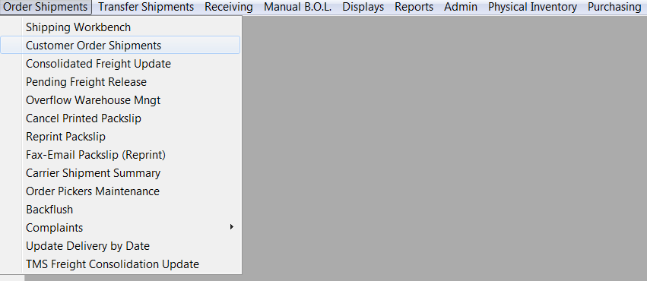

1. Enter sales order # 66755651 with release # 1

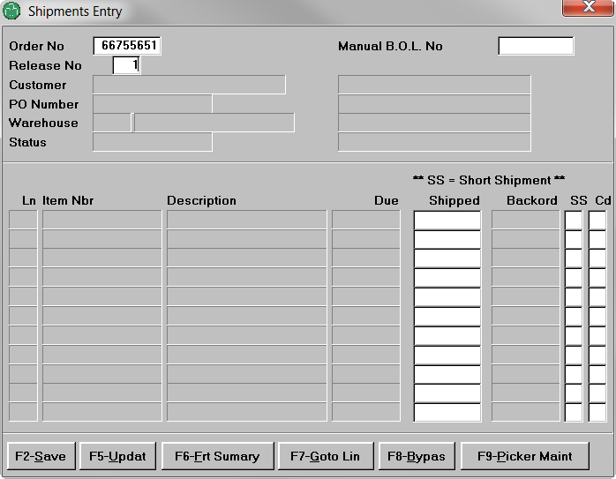

1. Correct the Cur Code on the shipment summary screen.

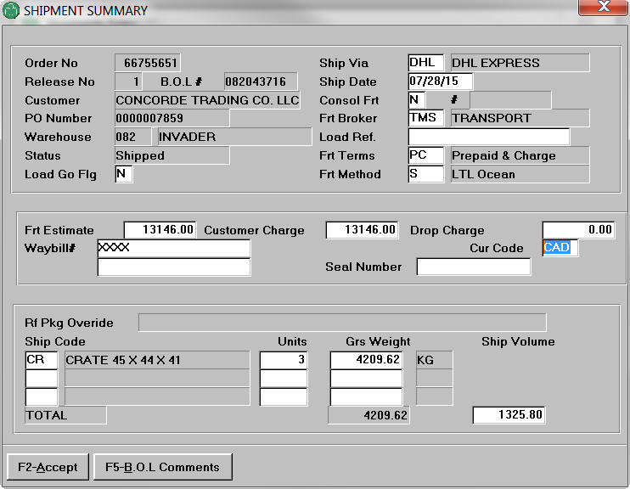

* How to change freight information before it goes to GTT (batch payment process send to AP) which is process during the night in the invoice day run? (Ticket #42191)

IPEX -> DRP -> Transfer Shipments -> Warehouse Transfer Shipment -> Enter transfer order number & release number -> Freight Summary Screen

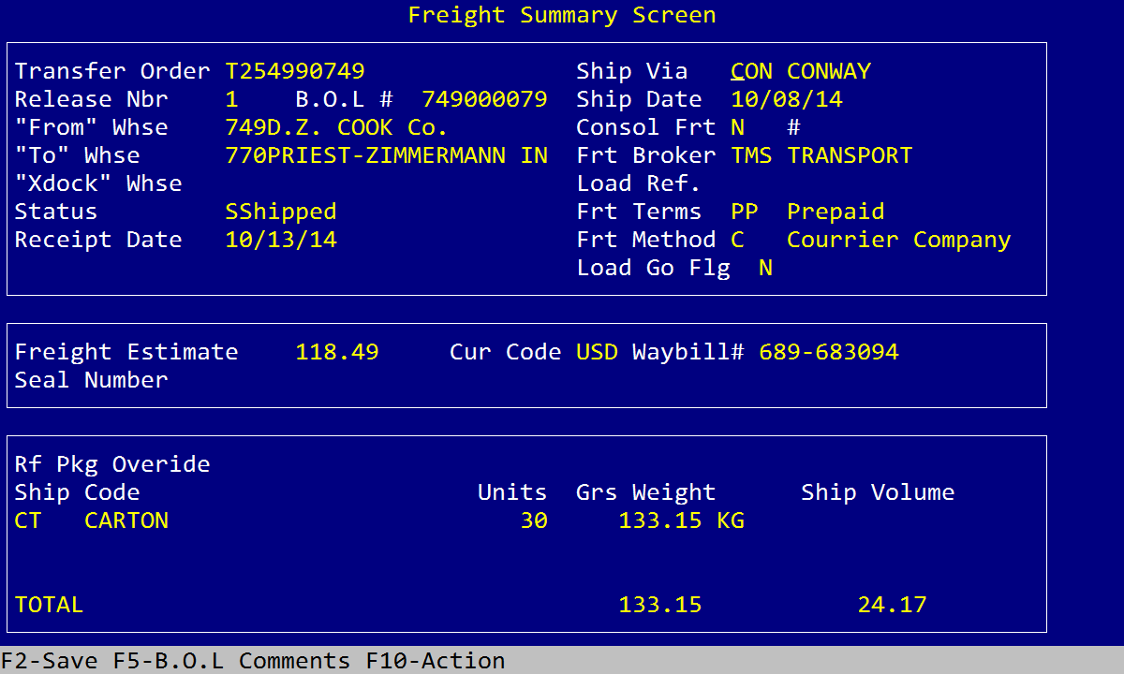

RF Scanner backflush process: MRPMFG -> Radio Freq. Prod :

* Radio Freq. F.G. Production (DRP4042) -> Reopen closed shift (F9)

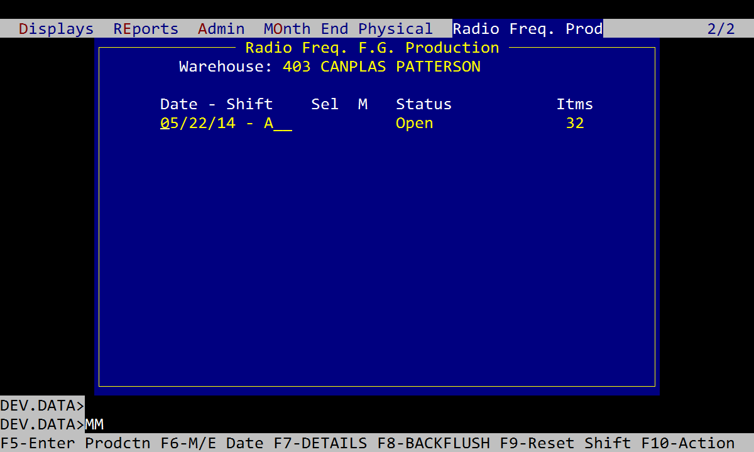

* Radio Freq. F.G. Production – Back Flush Shift Record Lock:

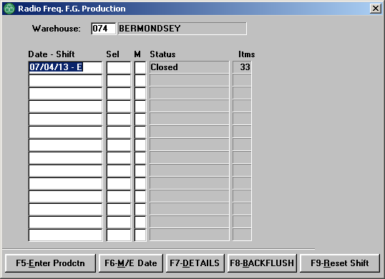

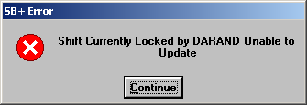

1. OS.ED RFPRODFILE "074*16622*E" (074 is the warehouse number; 16622 is the internal date value of 07/04/13, use /DATE on TCL to get the internal date value; E is the shift code)

2. Remove userid DARAND on location 16

3. Save the record and the lock is now released

* IPEX -> DRP -> Order Shipments -> Shipping Workbench -> F10 -> RADIO Freq -> Team Maintenance (DRP3015)

If an RF user does not exit RF scanner session properly (i.e. hard power off), it could cause an RF order lock, to release this lock go to Team Maintenance in the RADIO Freq menu and use F7 to release the locked order (RFTBLFILE<21>, key=whs*teamid, ex. 704*012) and save.

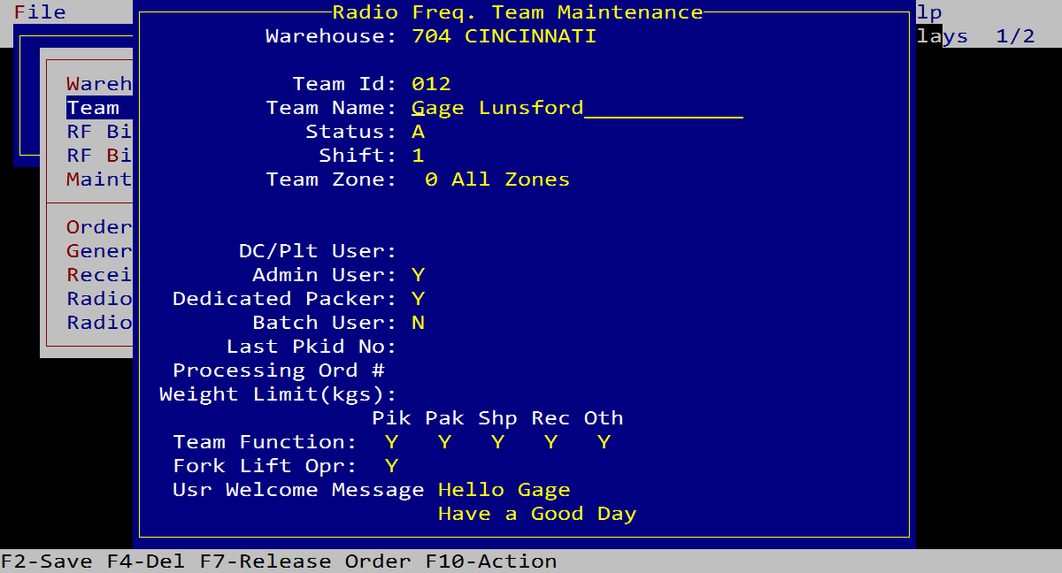

* Manual Backflush process -> MRPMFG -> Production -> Backflush (SFC4020): Unable to post a new shift schedule, press F3 on Production Date and then select Unposted Shifts will solve the issue.

1. Enter warehouse # (use SHP4012 to grant access if required)
2. On Production Date -> Press F3 -> Click on Unposted Shifts

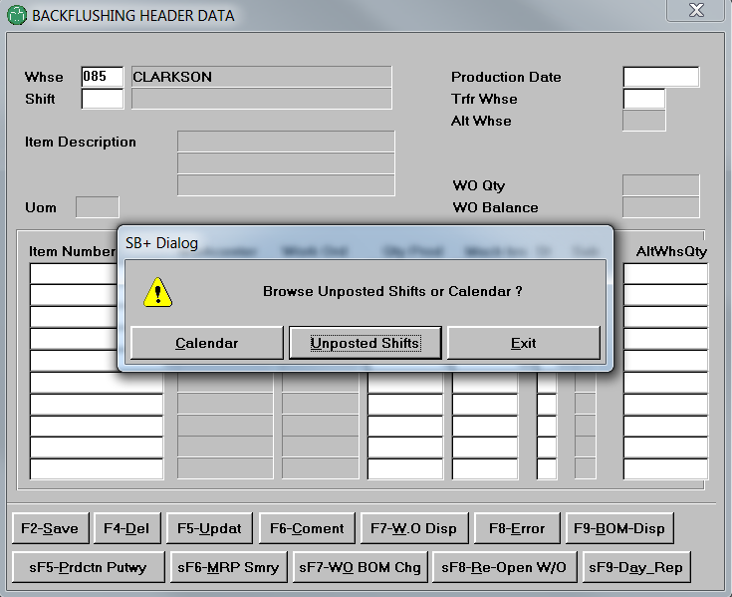

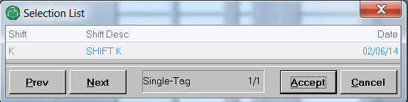

1. Close any unposted shift (open work order) if there is any to be able to do backflushing.

* MRPMFG -> Production -> Backflush (SFC4020): Unable to backflush due to the closed work order, press sF8-Re-Open W/O to reopen the work order (call accounting if not authorized).

P.S. WIP -> attribute<21>-> remove value F

* In case there is an empty post need to be deleted, remove the corresponding record (key -> whs*time*shift) in BACKWIPHDR and/or BACKWIPDET.
* In case there is an error occurred during the backflush Update process and got the record lock, release the record lock in BACKWIPHDR by killing the user session so that the user can delete all error items for the shift to restart the backflush process.

SOP & BOL problems:

* Not able to cut BOL due to preceding SHIPTRN stats flag is “IN PROCESS”. Source: SOPS4010.2 - Read SHIPTRN Record - Line 0137 (IP2221) - SHIPTRN<64> Procedure to fix the situation (RT#18312: O#66620728):

1. LOGTO ACCT.DATA
2. SELECT SHIPTRN = "Order#"*"Rel#"
3. OS.ED SHIPTRN (make sure it's the correct order to modify"
4. Go to line 64
5. Replace IN PROCESS with empty string (R <sp>)
6. FI save the record
7. SHP4000 - Shipping Workbench to pick the order and F8-SHIP to see if the order release could be re-accessed and advise user to try again if everything is ok.

* Complaint can only be cancelled by its originator, upon request, change the originator userid to the person’s userid in order form him/her to be able to cancel the Complaints (LIST PSCCOMPL F4 -> USER_COMPL_ENTERED_BY)
* Not able to kick the order back from DC to Sales office on Shipping Workbench screen (SHP4000): Remove the “IN PROCESS” flag in SHIPTRN<64> for the Order*Rel (Refer to RT#52403) -> IP2221 (SOPS4010.2):

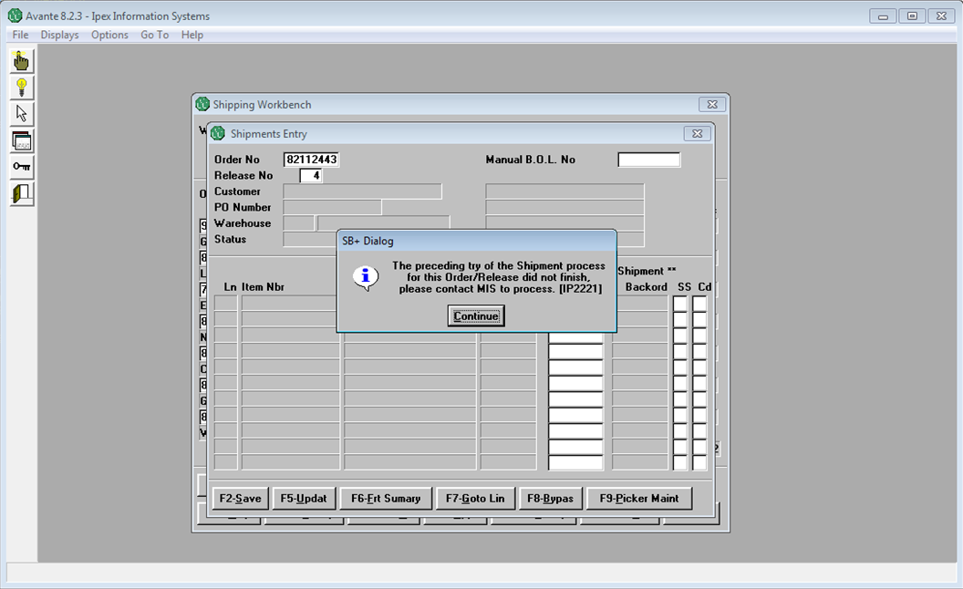

* RMA release, the credit note number is being held in RMTHDR<229>. I13 is used to control the RMA release for authorized user per sales office (RMT4008 - RMA Pricing / Credit Workbench).
* If a user forgets to set the consolidated flag to Y in the Shipping Workbench during the order release, this BOL will not be able to consolidate. To fix this issue, set the consolidated flag in SHIPLADING<34> from N to Y for the desired BOL; In case the freight estimate amount adjustment is required, the fields to adjust is F40 (EST), F44 (DOM), F48 (FC)
* LIST SOHDR F76 -> Check if order is on hold (most likely is due to the customer’s credit limit, those order will not have any new release issued.
* Backlog report setup is in SYSTBL I41, resend to the default printer though SYS6050 upon request (RT 15268).
* LIST MANUALBOL GTT_FLAG - > To check if an manual BOL has already been invoiced and send the estimated freight amount to the 3rd party freight broker (I87 - AVA)
* Re-open a closed complaints – IPEX -> IT-MTN -> Re-Open Closed Complaint (PSC3050)
* LIST DMSECURITY = "[USERID]" USR.PRINT.ID (ask Gervais or Ali to add new printer as an optional one for user to choose)
* Maintain User Profiles for AP Reports (APM3010) for DataWarehouse DetailExpense Supplier report user profile setup.
* SB Client connection profile, if the user is an Infoflo user and selecting MRP as the connection profile, they will be forced to use lowercase userid to login and actually it should be uppercase for Infoflo, so make sure the connection profile is selected as Infoflo other than MRP (RT 15644).
* User’s SBClient windows minimized to the taskbar -> right click on the SBClient icon in the taskbar and select Restore or Maximize to get it back to normal.
* Customer Price Extract – SOP6086 (RT #45988):

1. Multiplier Table -> drive the whole thing which tells what product family customer purchase from us (ask stakeholder for which one to use for the given customer)
2. Net Price -> override Price Table & Multiplier Table
3. Cust Xrf Id -> customer part number
4. Sls Off -> ask user for which one to use
5. F7-Upd XL Template -> Set up the Excel extract report (SYSTBL I276)

* Customer Sales and Pricing Management – ARM9020 -> Set up the multiplier table for the customer

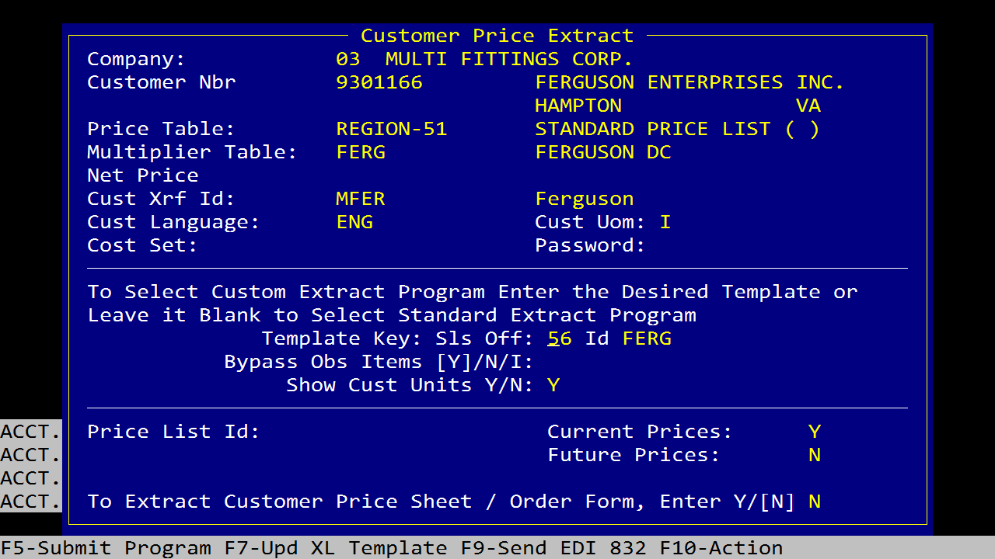



* Multipliers Update – SOP3018

1. F5-PrcClas/PrdLine -> Product family setup
2. F8-Product -> Individual product setup for exception

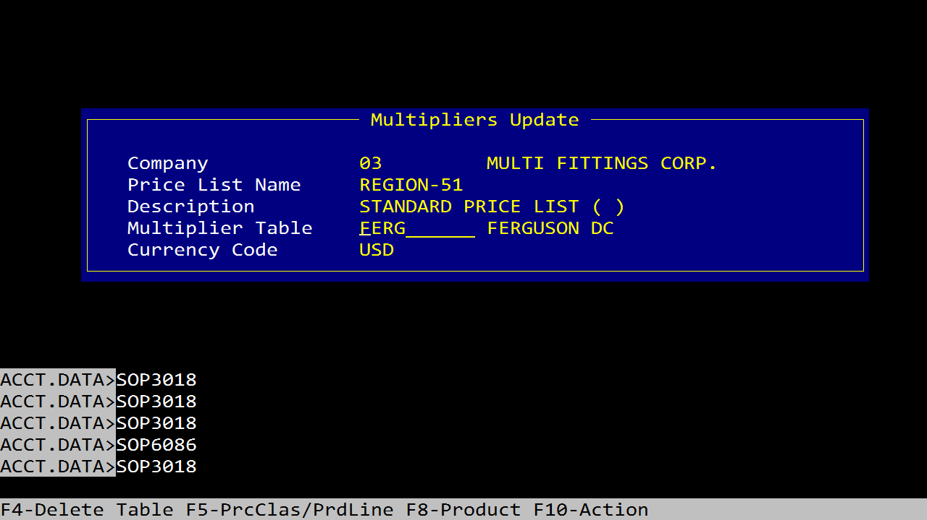

A/R Cash Batch Issue:

* Error message code 8523 (Reference has been paid in cash batch #) -> logic in ARMP4002.40:

Remove the batch # found in CUSTACT<31> and save the record (make a backup of the specific record to CUSTACT.LF1 before making any changes)

Non-Replenish Item with insufficient stock, line “x” must be less than or equal QOH [IP2296] (RT#50571, RT#48677, RT#48683):

* What we need to do as a temp fix is modify the item/whs record to be a R in ITMMST<73>. Once the user is done entering their order, change it back to what it used to be. Rob knows we have this issue and is working on it.

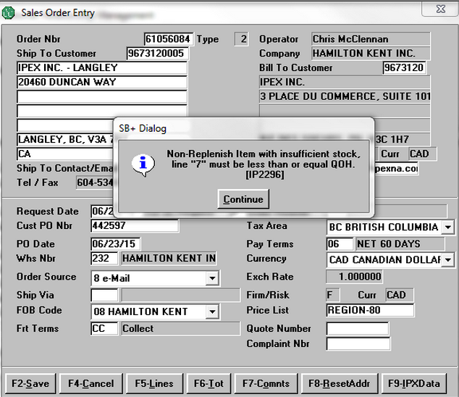

Contact Lisa for this kind of error:

* 