Infosys Springboard Virtual Internship 7.0 Completion Report

Team Details
Batch Number 1
Start date:
Names:
S.no | Name
1
2
3
4
5
6
Internship Duration: 8 Weeks

1. Project Title
Urban Pulse: Smart Urban Mobility and Traffic Intelligence Dashboard

2. Project Objective
- To build a unified, data-driven mobility intelligence platform that integrates transit, ride-hailing, micromobility, traffic and weather data for Bengaluru and Delhi into a single analytical view.
- To design and implement a validated star-schema data model and ETL pipeline that brings 6 core datasets from 5 public sources (GitHub, GTFS feeds, government handbooks, Kaggle and Open-Meteo) into one consistent, analysis-ready structure.
- To deliver 9 interactive Power BI dashboards covering geospatial mobility, transit performance, ride-hailing and micromobility demand, and executive-level city performance reporting.
- To combine transit, traffic and weather signals into a single City Mobility Health Score and an equity-aware Mobility Access Index, giving city planners a data-backed way to monitor performance and identify underserved areas.
- To support cross-city benchmarking through a dedicated comparative dashboard, allowing planners to evaluate Bengaluru and Delhi side by side on mobility health, traffic, transit coverage and population indicators.
- To document the full engineering process — data lineage, ETL logic, dashboard design decisions and testing outcomes — so the platform can be maintained, extended, or handed off beyond the 8-week sprint.

3. Project description in detail
Urban Pulse is an end-to-end mobility analytics platform built over an 8-week sprint by a 5-member team. The team ingested and integrated 6 core datasets — Demographics, Metro, Ride-Hailing, Traffic, Transit and Weather — from 5 external sources (GitHub, GTFS feeds, government handbooks, Kaggle and the Open-Meteo API), spanning the two cities in scope. All datasets were standardized, cleansed and modeled into a star schema (Fact_Trip, Fact_Transit_Event and shared dimension tables) using Power Query and DAX, before being surfaced through 9 interactive Power BI dashboards.
The approach followed a milestone-based agile delivery model split across four two-week sprints: (1) Data Acquisition & Data Modeling, (2) Geospatial & Transit Analytics, (3) Demand Intelligence & Mobility Analytics, and (4) Equity, Forecasting & Finalization. Each milestone was owned by a specific team track and reviewed collectively before moving to the next, with weekly sprint check-ins run against a shared milestone tracker to keep delivery on schedule.
In real-world terms, the platform demonstrates how a city or mobility operator could combine public transit performance, ride-hailing/micromobility demand, traffic congestion and weather signals into a City Mobility Health Score for each city (84.6% for Bengaluru, 77.3% for Delhi, in this build) and an equity-aware Mobility Access Index — giving planners a data-backed way to identify underserved areas, rebalance shared-mobility fleets, and monitor city-wide transportation performance from an Executive Intelligence dashboard for each city, covering over 8,000 bus stops and 4,000 routes in Bengaluru, and 2,000+ bus routes and 36 metro corridors in Delhi.
Each of the 9 dashboards followed the same design discipline: KPI cards for at-a-glance metrics, city and category-level filters for drill-down, and consistent colour and layout conventions so a user moving between dashboards does not have to relearn the interface each time. Before any dashboard was marked complete, it was checked against a shared integration and QA checklist — data refresh accuracy, filter behaviour, visual accuracy against source data, and load performance — so the final suite behaves as one coherent product rather than nine disconnected files.

4. Timeline Overview
Week | Activities Planned | Activities Completed
Week 1 | Identify and connect to data sources (GitHub, GTFS feeds, government handbooks, Kaggle, Open-Meteo) for transit, ride-hailing, traffic, weather and demographic data; scope datasets for Bengaluru and Delhi. | Connected all 5 data sources and began integrating the 6 core datasets (Demographics, Metro, Ride-Hailing, Traffic, Transit, Weather).
Week 2 | Complete dataset integration, validate data quality, and design the star-schema data model (Fact_Trip, Fact_Transit_Event, shared dimensions). | Reached 100% integration status across all 6 datasets, completed data-quality checks, and finalized the star-schema model — Milestone 1 (Data Acquisition & Data Modeling) delivered.
Week 3 | Build geospatial mapping of the bus-stop and metro-station network for both Bengaluru and Delhi; design interactive zoom/pan and drill-down filters. | Mapped the full bus and metro network with interactive zoom/pan; added Bus Stop Name and Metro Line filters for multi-level drill-down.
Week 4 | Rank the busiest stops, break down metro ridership by line, and finalize the combined bus/metro geospatial dashboard. | Delivered Top-15 busiest-stop rankings, line-wise ridership breakdowns, and map-based Smart Mobility dashboards covering both Bengaluru (4,000+ bus routes) and Delhi (2,000+ bus routes, 36 metro routes) — Milestone 2 (Geospatial & Transit Analytics) delivered.
Week 5 | Analyze bike/e-scooter trip demand (Bounce, Yulu) by weekday vs weekend, by hour, and fare/revenue trend across operators. | Built demand-pattern analysis by hour and year-long fare/revenue trend views; compared vehicle-type usage and trip distance vs fare by operator.
Week 6 | Add station-level rebalancing status tracking and rain-impact analysis; finalize the ride-hailing / micromobility dashboard. | Delivered rebalancing status (OK / overstocked / understocked) view, identified morning and evening demand peaks, and completed the Ride-Hailing dashboard — Milestone 3 (Demand Intelligence & Mobility Analytics) delivered.
Week 7 | Design the City Mobility Health Score combining transit, traffic and weather signals; build executive-level KPI tracking. | Built and validated the City Mobility Health Score for both cities (84.6% Bengaluru, 77.3% Delhi); tracked congestion score, average speed and daily ridership alongside citywide coverage metrics.
Week 8 | Finalize the executive rollup, plain-language insights summary, integration testing/QA, and prepare the final presentation. | Delivered single-page Executive Intelligence dashboards for both cities (Bengaluru: 8,000+ bus stops, 4,000+ routes; Delhi: 2,000+ bus routes, 36 metro corridors — both rated "Good" mobility status), completed integration testing, and finalized the presentation — Milestone 4 (Equity, Forecasting & Finalization) delivered.

5a. Key Milestones
Milestone | Description | Date Achieved
Project Kickoff | Team formed (5 members across Data Engineering, Geospatial Analytics, Transit & Ride-Hailing Analytics, Micromobility & Equity Analytics, and BI Leadership); kickoff session covered scope confirmation, data-source shortlisting, tooling setup (Power BI, GitHub) and the sprint cadence for the 8 weeks ahead; data sources identified and project scope finalized. | Week 1
Prototype/First Draft | Milestone 1 completed — 5 data sources and 6 datasets integrated (100% integration status), star-schema data model designed and validated against sample queries, initial data-quality checks passed, and the first working Data Acquisition & Integration dashboard delivered for internal review. | End of Week 2
Mid-Term Review | Milestones 2 and 3 completed and reviewed with mentors — the Smart Mobility geospatial dashboards for both Bengaluru and Delhi, and the Ride-Hailing / Demand Intelligence dashboard, delivered; feedback on filter usability and metric definitions incorporated ahead of the final two milestones. | End of Week 6
Final Submission | Milestone 4 completed — City Mobility Health Score for both cities (84.6% Bengaluru, 77.3% Delhi), the Mobility Access Index, forecasting logic and the Executive Intelligence dashboards finalized; all 9 Power BI dashboards integration-tested, cross-checked against source data, and consolidated across both cities into the final deliverable set. | End of Week 8
Presentation | Final project presentation delivered, covering the complete Urban Pulse platform — problem statement, system architecture, all four milestones, live dashboard walkthroughs for both cities, key insights, and future scope followed by a Q&A session with mentor | Week 8

5b. Project execution details
The project was executed as four two-week milestones, each ending with a working, review-ready Power BI dashboard so progress could be validated incrementally rather than only at the final deadline: Data Acquisition & Data Modeling (Weeks 1–2), Geospatial & Transit Analytics (Weeks 3–4), Demand Intelligence & Mobility Analytics (Weeks 5–6), and Equity, Forecasting & Finalization (Weeks 7–8).
Execution was organized around five functional tracks — Data Engineering (data acquisition, ETL pipelines and the star-schema/database design), Geospatial Analytics (mapping, accessibility and congestion-hotspot analysis), Transit & Ride-Hailing Analytics (reliability metrics, demand and fare-elasticity analysis), Micromobility & Equity Analytics (bike-share utilization, rebalancing prediction and the Mobility Access Index), and BI Leadership (the executive Mobility Health Score, forecasting, sprint coordination and integration QA).
GitHub was used for version control and collaboration, Power BI Desktop/Service for dashboard development and publishing, and PowerPoint for stakeholder-facing reviews at the end of each milestone. Every dataset passed the same integration and data-quality checks before being connected to a dashboard, so all 9 dashboards read from one validated, shared source of truth. Weekly sprint check-ins against a shared milestone tracker kept all four milestones on schedule.

6. Snapshots / Screenshots
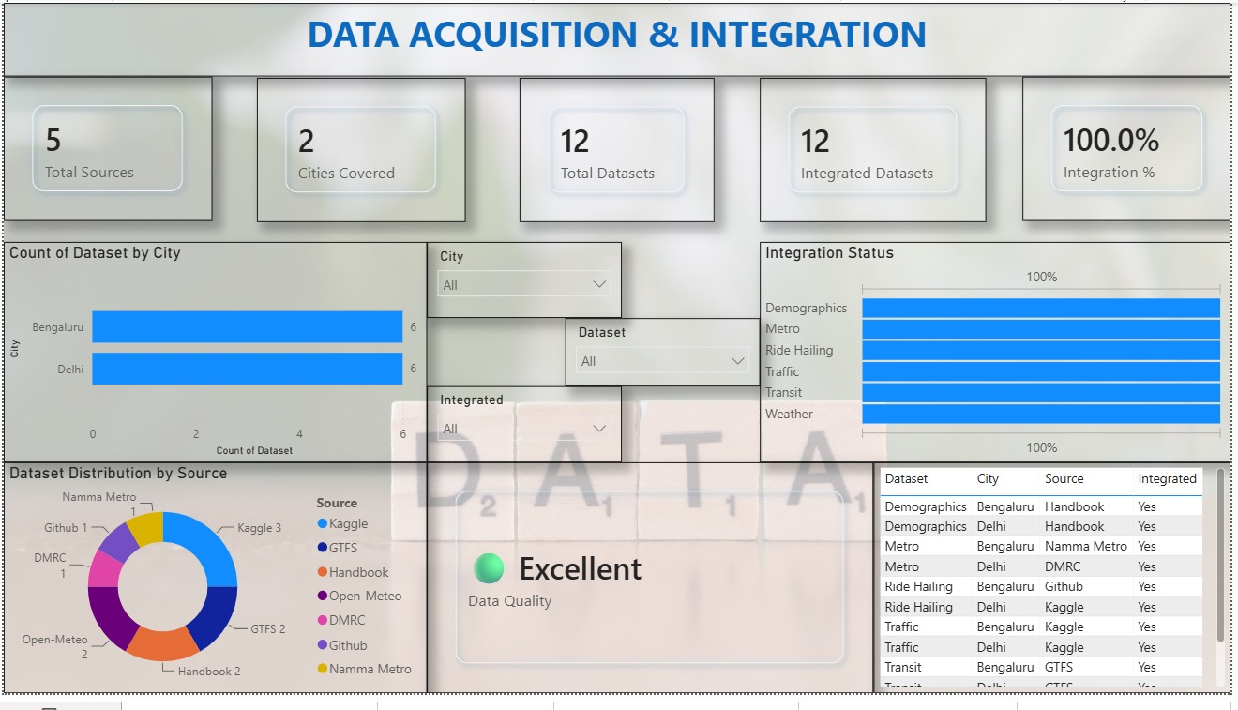
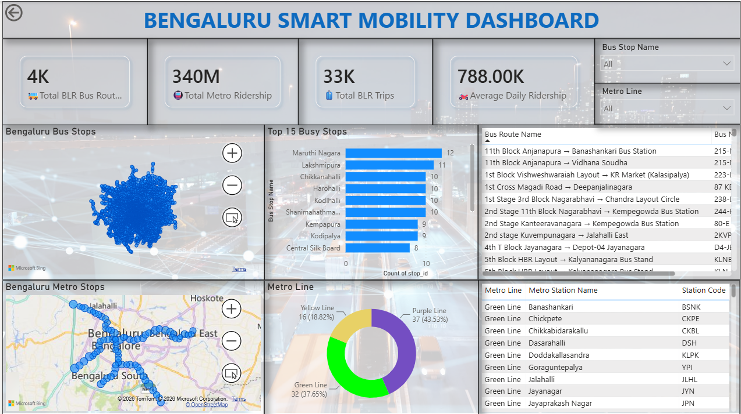
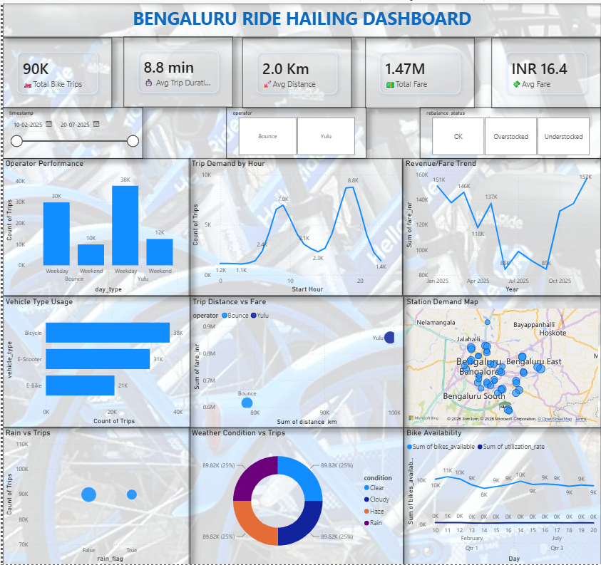
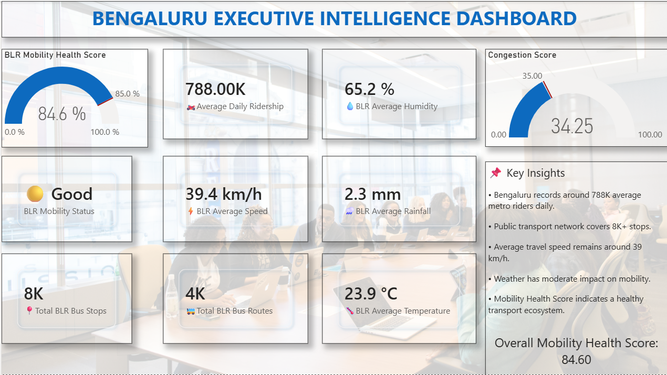
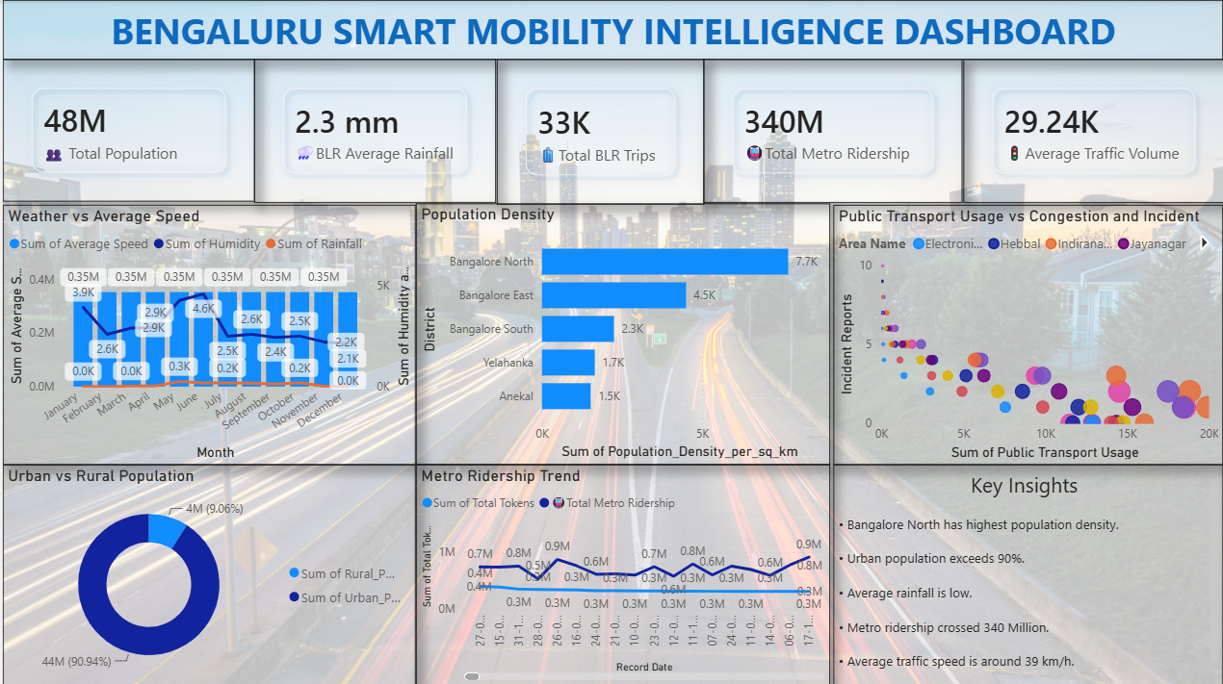
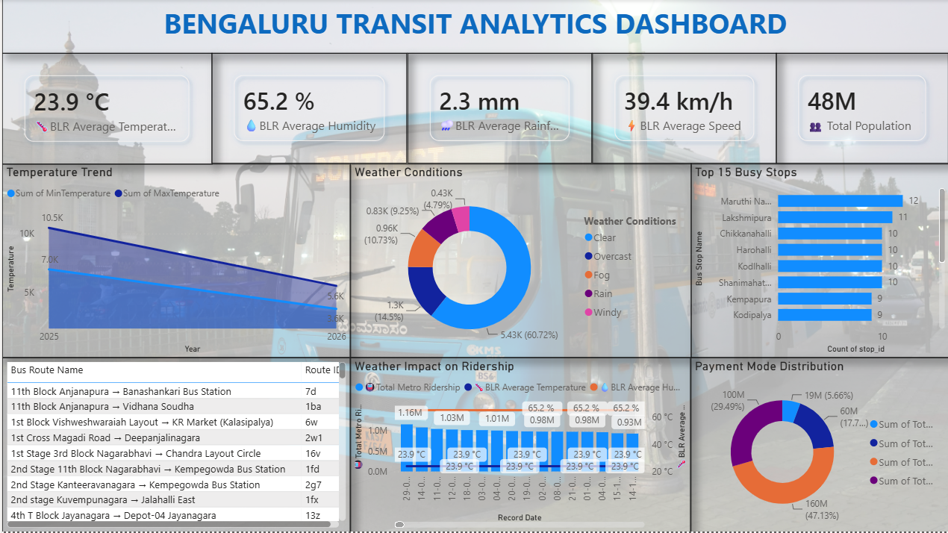
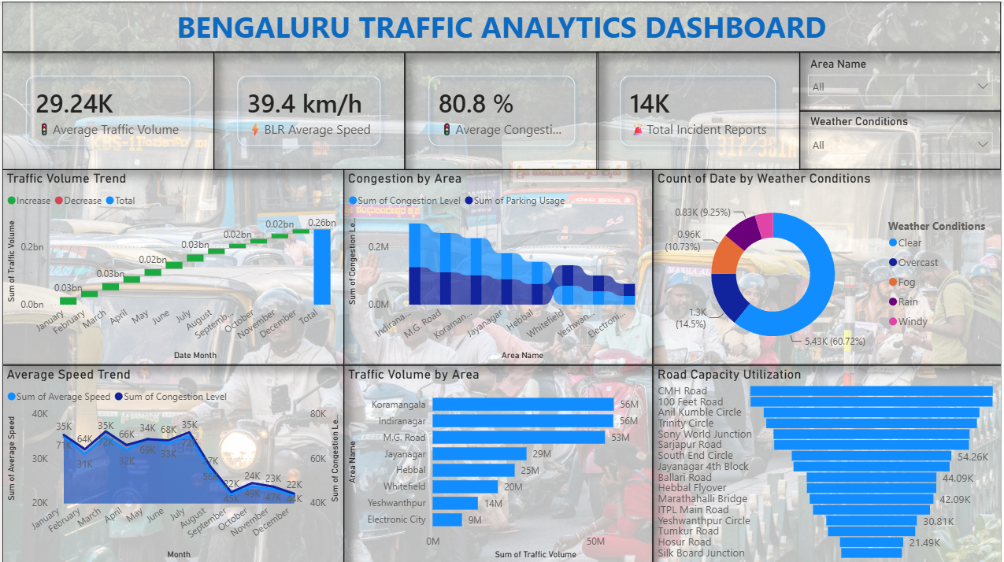
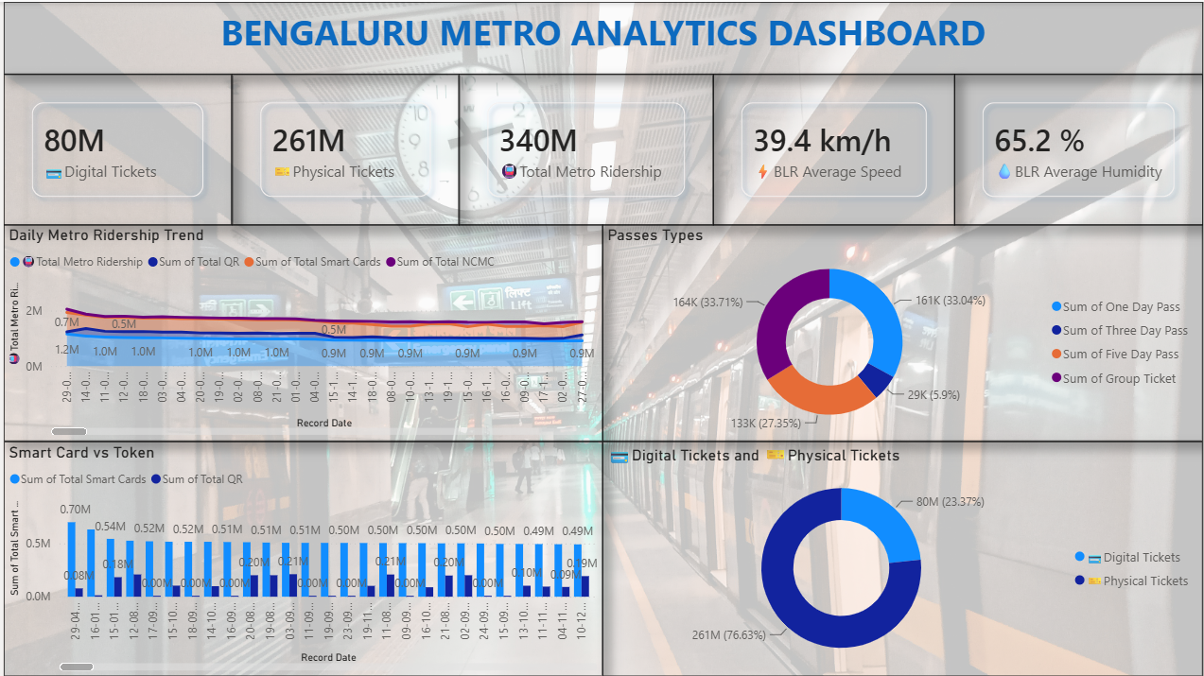
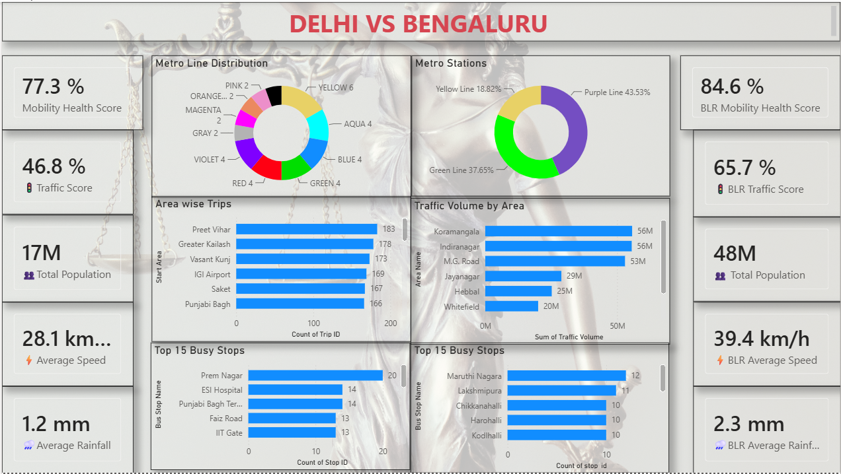
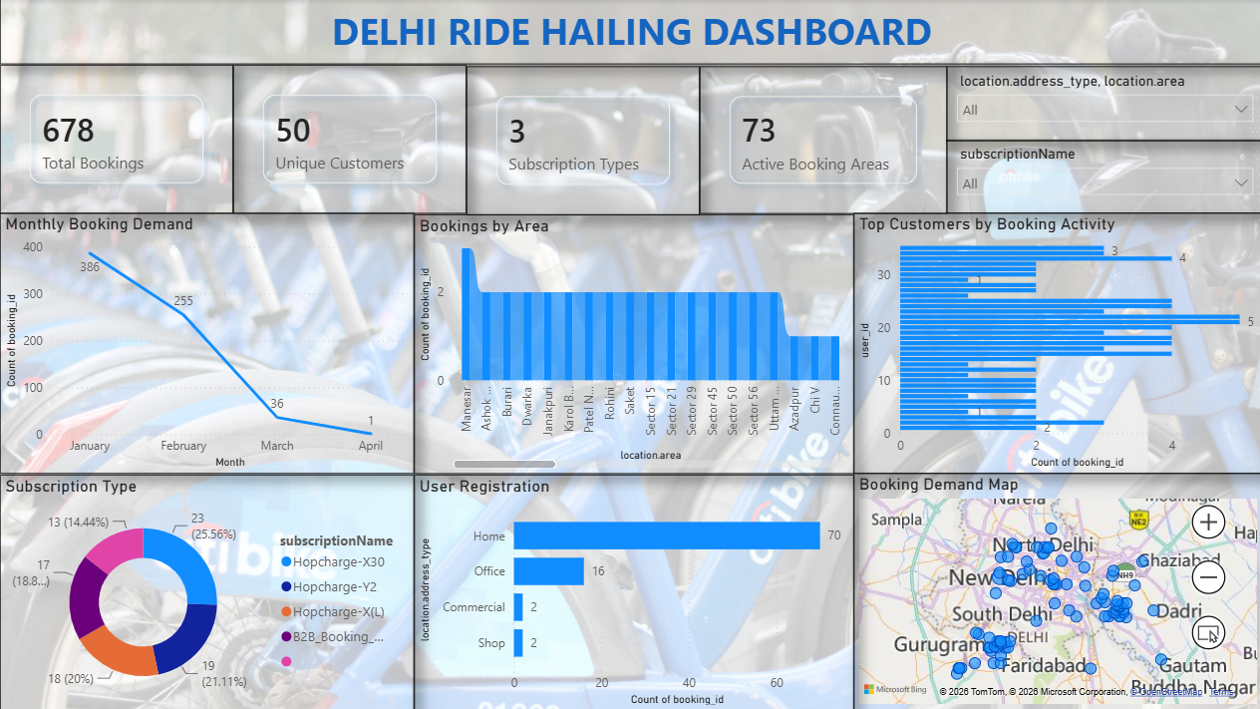
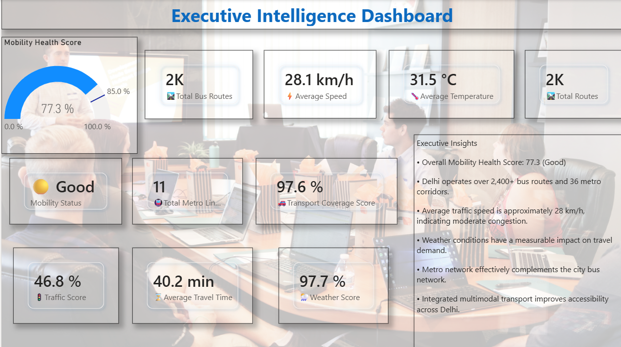
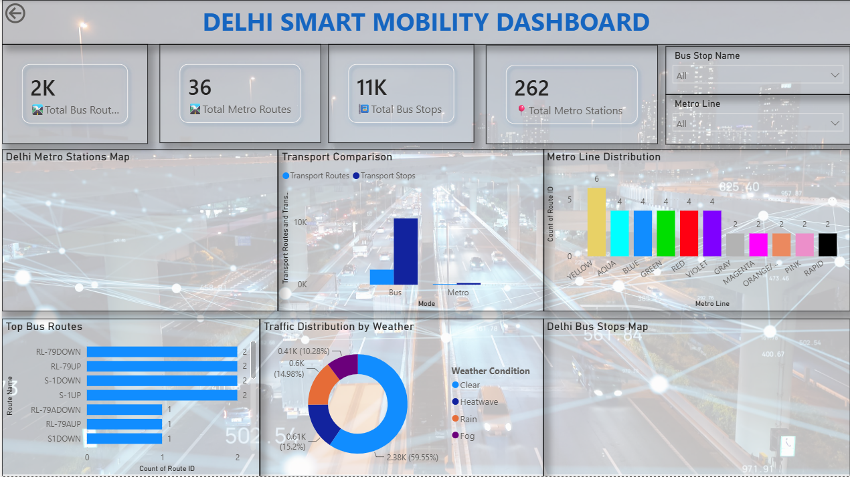
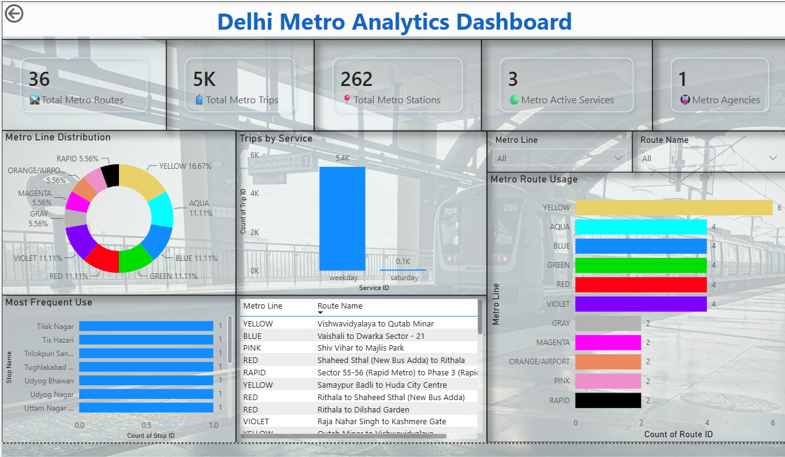
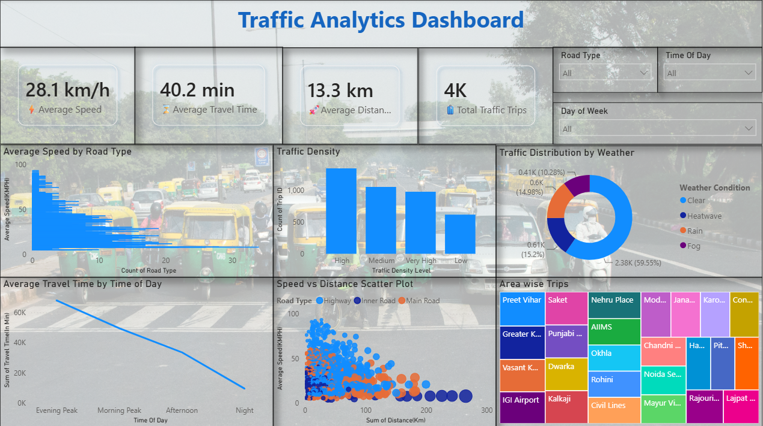
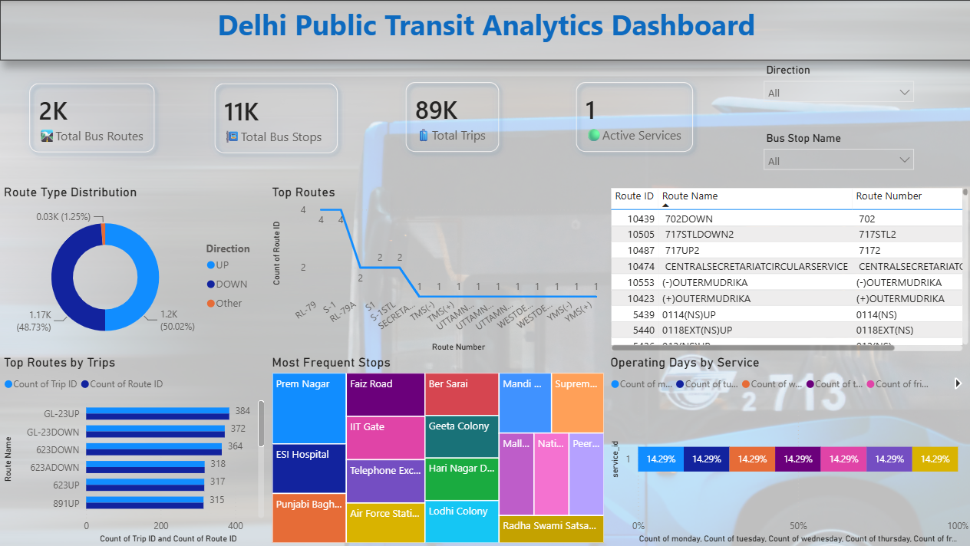
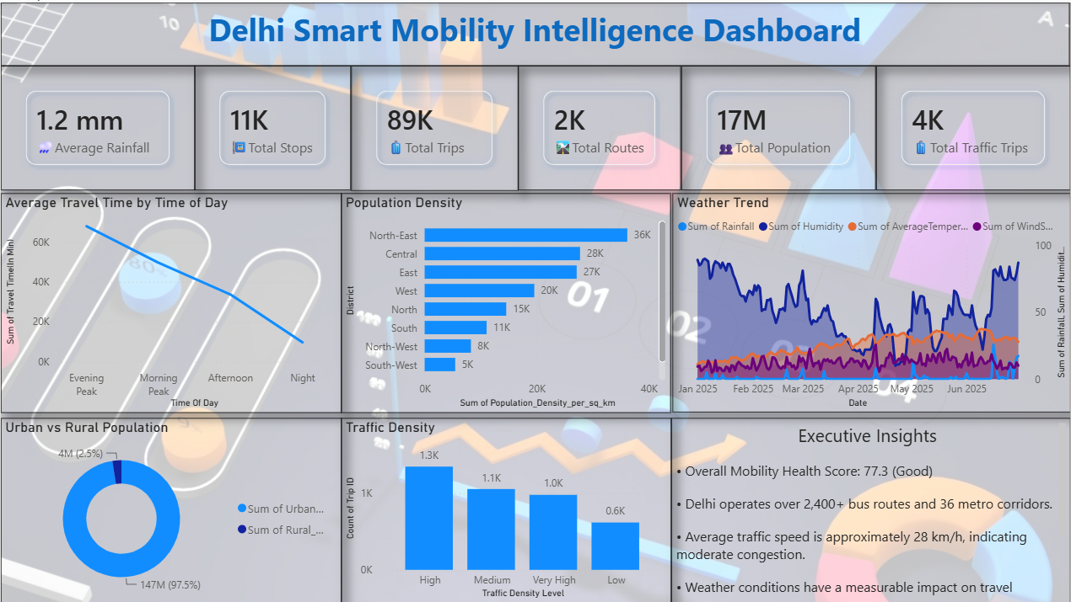
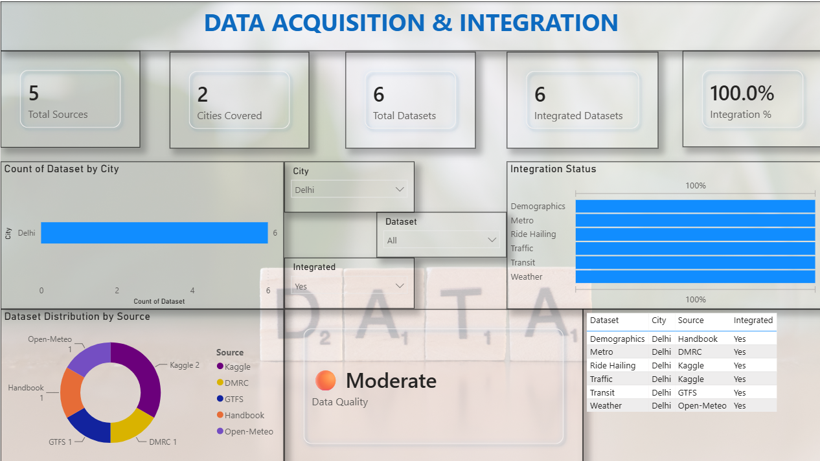

7. Challenges Faced
Several technical, analytical and coordination challenges came up during the 8-week build of Urban Pulse and were addressed as follows:
Heterogeneous Data Formats
Five independent sources — GTFS feeds, ride-hailing exports, bike-share logs and weather APIs — each shipped different schemas, units and identifiers, risking silent data-quality errors downstream. This was resolved by building a standardized schema-mapping layer and automated cleansing workflows before loading data into the shared star schema, so every dashboard reads from one validated source of truth.
Defining a Fair Mobility Access Index
Comparing accessibility across demographic groups needed a normalized, defensible scoring method — an ad-hoc metric would have undermined the equity findings. The team benchmarked the index against transit frequency, walk-time and income-quintile data to produce a normalized 0–100 score that city planners can act on directly.
Dashboard Performance at Scale
Trip-level and transit-event-level fact tables grew large enough to slow interactive filtering, threatening the responsiveness expected of a live dashboard. This was addressed by optimizing the star schema with incremental refresh and pre-aggregated tables, keeping every executive-level view fast under real data volumes.
Coordinating Five Parallel Tracks
Five module owners working independently on a tight 8-week timeline risked integration drift between datasets, naming conventions and delivery dates. Weekly sprint check-ins against a shared milestone tracker caught integration gaps early and kept all four milestones on schedule.
Cross-City Comparability
Bengaluru and Delhi differ sharply in scale and transport mix — 8,000+ bus stops and 4,000+ routes versus 2,000+ bus routes and 36 metro corridors — so raw metrics could not be compared directly without misleading planners. This was solved by normalizing every city-level KPI (mobility health score, access index, congestion score) onto the same 0–100 scale before building the dedicated Bengaluru-vs-Delhi comparative dashboard.

8. Learnings & Skills Acquired
The Urban Pulse project offered strong exposure to data engineering, BI development and mobility analytics. Key learnings include:
- Data Integration & ETL: Learned to standardize, cleanse and merge 6 heterogeneous public datasets from 5 sources into one consistent, analysis-ready structure.
- Power BI & DAX: Gained hands-on experience with Power Query, DAX measures, star-schema data modeling, incremental refresh and geospatial visualizations.
- Composite KPI Design: Learned to design and validate composite indicators such as the City Mobility Health Score and the equity-aware Mobility Access Index.
- Urban Mobility Domain Knowledge: Built a working understanding of transit reliability, ride-hailing and micromobility demand patterns, traffic congestion analysis, and mobility equity.
- Agile, Milestone-Based Delivery: Practiced sprint planning, GitHub-based version control, integration testing and weekly milestone tracking across a 5-person team.
- Stakeholder Communication: Improved skills in presenting technical dashboard work clearly to non-technical stakeholders through milestone reviews.
- Cross-City Data Normalization: Learned to design comparable, scale-independent metrics so mobility indicators from two cities of very different size (Bengaluru and Delhi) could be benchmarked fairly on one dashboard.
- Quality Assurance Process: Developed a habit of validating each dashboard against a shared integration and QA checklist — data refresh accuracy, filter behaviour and visual correctness — before marking any milestone complete.

9. Testimonials from team
The Urban Pulse project gave the team a genuinely collaborative, hands-on data-analytics experience. Team members adapted quickly across five different functional tracks, kept the shared milestone tracker up to date, and stayed engaged through weekly sprint reviews even when balancing academic schedules alongside the internship. Watching the individual dashboards come together into one connected Mobility Health Score was, for the whole team, the moment the project stopped feeling like four separate assignments and became a single platform — a strong reflection of the team's consistency, coordination and pride in the final result. Mentor feedback at each milestone review pushed the team to treat the dashboards as tools a real city planner would actually use, not just internal deliverables, which sharpened decisions on filter design, metric definitions and visual clarity throughout the build. By the final submission, the team felt genuine ownership of Urban Pulse as a product they had shaped from raw data to a working decision-support platform.

10. Conclusion
Overall, this Infosys Springboard internship gave the team an end-to-end, real-world data-analytics experience moving from raw, messy public data to a validated data model and, finally, to a suite of executive-ready Power BI dashboards used to score and monitor city-wide mobility performance. The project reinforced how much of applied data science is data engineering and integration work before any analysis or visualization is possible, and how agile, milestone-based delivery keeps a five-person team aligned on a tight timeline. The skills built here data modeling, BI tool proficiency, geospatial and demand analytics, and communicating findings to non-technical stakeholders align directly with the team members' academic backgrounds in data science and computer science, and with their career interest in data analytics, business intelligence and urban-technology roles. Beyond the technical deliverables, the internship built real comfort with ambiguous, incomplete, real-world data — a transferable skill the team expects to draw on well beyond this project.

11. Acknowledgements
We sincerely thank Infosys Springboard for the opportunity to work on this Virtual Internship 7.0 project and for providing the structure, resources and mentorship that made this 8-week sprint possible. We are grateful to our program mentors for their guidance and feedback at each milestone review, which kept the project grounded and on track. Finally, we thank every member of the team for their commitment across the Data Engineering, Geospatial Analytics, Transit & Ride-Hailing Analytics, Micromobility & Equity Analytics, and BI Leadership tracks — this project was only possible because of that combined effort. We also acknowledge the open-data providers whose public datasets made this project possible — GTFS transit feeds, Kaggle, and Open-Meteo — and the wider Infosys Springboard community for the learning platform and continued support throughout the internship.

