实验七：组合模式
个人与组织：个人必定属于每一个组织，组织可以组合成更大的组织。

(1) 安全组合模式

1.1 UML图
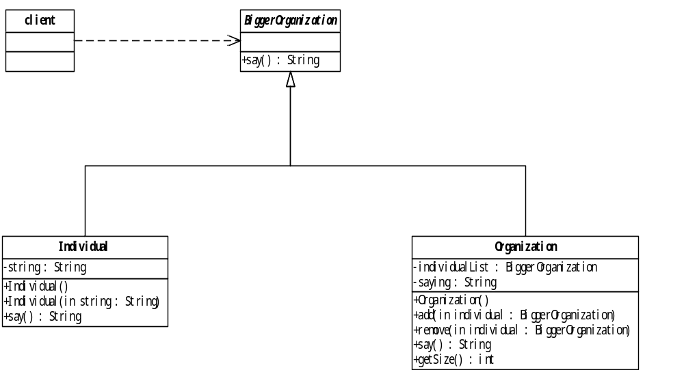

1.2 代码

package cn.edu.scau.cmi.zhouxudong.composite.safe;

public abstract class BiggerOrganization {
public abstract String say();
}

package cn.edu.scau.cmi.zhouxudong.composite.safe;
public class Individual extends BiggerOrganization {
private String string = "个体";
public Individual() {
}
public Individual(String string) {
this.string = string;
}
@Override
public String say() {
return string;
}
}
package cn.edu.scau.cmi.zhouxudong.composite.safe;

import java.util.ArrayList;
import java.util.Iterator;

public class Organization extends BiggerOrganization {

private ArrayList<BiggerOrganization> individualList;
private String saying = "";

public Organization() {
individualList = new ArrayList<BiggerOrganization>();
}

public void add(BiggerOrganization individual) {
if (individual != null) {
individualList.add(individual);
}
}

public void remove(BiggerOrganization individual) {
if (individual != null) {
individualList.remove(individual);
}
}

public Iterator<BiggerOrganization> elements() {
return individualList.iterator();
}

@Override
public String say() {
int len = individualList.size();
for (int i = 0; i < len; i++) {
BiggerOrganization ind = individualList.get(i);
saying = saying + ind.say() + "\n";
}
return saying;

}

public int getSize() {
return individualList.size();
}

}

package cn.edu.scau.cmi.zhouxudong.client;
import cn.edu.scau.cmi.zhouxudong.composite.safe.BiggerOrganization;
import cn.edu.scau.cmi.zhouxudong.composite.safe.Individual;
import cn.edu.scau.cmi.zhouxudong.composite.safe.Organization;
public class CompositeSafeClient {

public static void main(String[] args) {
// TODO Auto-generated method stub

BiggerOrganization ind1 = new Individual("个体1");
BiggerOrganization ind2 = new Individual("个体2");
BiggerOrganization ind3 = new Individual("个体3");

System.out.println(ind1.say());

Organization org = new Organization();
org.add(ind1);
org.add(ind2);
org.add(ind3);
org.remove(ind3);
System.out.println("org组织包括:\n" + org.say());

}

}

实验效果

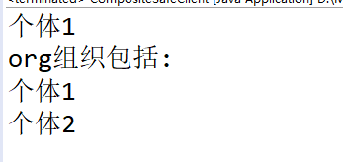

一致性组合模

2.1 UML图
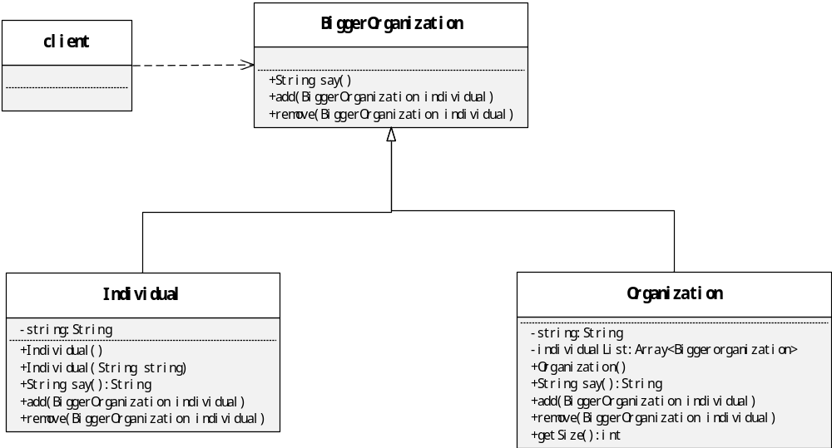

2.2 代码

package cn.edu.scau.cmi.zhouxudong.composite.uniformity;

public abstract class BiggerOrganization {
public abstract String say();

public abstract void add(BiggerOrganization individual);

public abstract void remove(BiggerOrganization individual);
}

package cn.edu.scau.cmi.zhouxudong.composite.uniformity;

public class Individual extends BiggerOrganization {

private String string = "个体";

public Individual() {

}

public Individual(String string) {
this.string = string;
}

@Override
public String say() {
return string;
}

// add方法无效
@Override
public void add(BiggerOrganization individual) {
// TODO Auto-generated method stub
System.out.println("个体不支持add操作");

}

@Override
public void remove(BiggerOrganization individual) {
// TODO Auto-generated method stub
System.out.println("个体不支持remove操作");
}

}

package cn.edu.scau.cmi.zhouxudong.composite.uniformity;

import java.util.ArrayList;
import java.util.Iterator;

public class Organization extends BiggerOrganization {

private ArrayList<BiggerOrganization> individualList;
private String saying = "";

public Organization() {
individualList = new ArrayList<BiggerOrganization>();
}

public void add(BiggerOrganization individual) {
if (individual != null) {
individualList.add(individual);
}
}
public void remove(BiggerOrganization individual) {
if (individual != null) {
individualList.remove(individual);
}
}
public Iterator<BiggerOrganization> elements() {
return individualList.iterator();
}

@Override
public String say() {
int len = individualList.size();
for (int i = 0; i < len; i++) {
BiggerOrganization ind = individualList.get(i);
saying = saying + ind.say() + "\n";
}
return saying;
}
public int getSize() {
return individualList.size();
}

}

package cn.edu.scau.cmi.zhouxudong.client;
import cn.edu.scau.cmi.zhouxudong.composite.uniformity.BiggerOrganization;
import cn.edu.scau.cmi.zhouxudong.composite.uniformity.Individual;
import cn.edu.scau.cmi.zhouxudong.composite.uniformity.Organization;
public class CompositeUniformityClient {
public static void main(String[] args) {
BiggerOrganization ind1 = new Individual("个体1");
BiggerOrganization ind2 = new Individual("个体2");
BiggerOrganization ind3 = new Individual("个体3");
ind1.add(ind2);
ind1.remove(ind2);
System.out.println("\n");
Organization org = new Organization();
org.add(ind1);
org.add(ind2);
org.add(ind3);
org.remove(ind3);
System.out.println("org组织包括:\n"+org.say());
}
}

实验效果

