实验八：适配器模式

(1) 类适配器

1.1 UML图
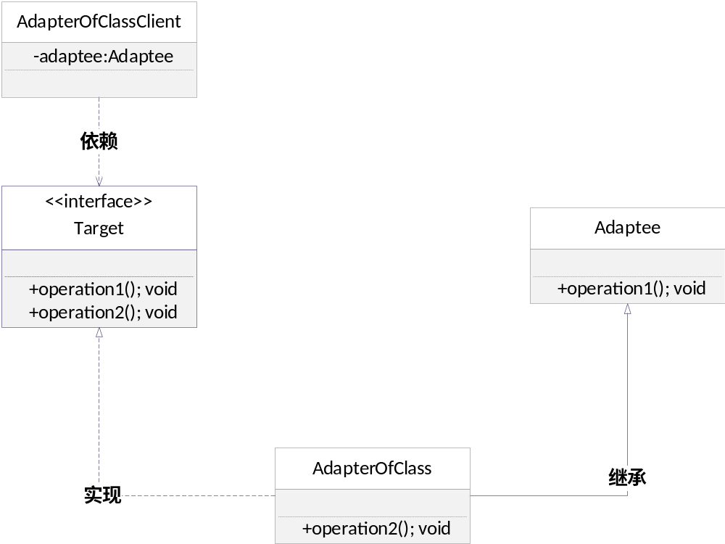

1.2 代码
package cn.edu.scau.cmi.zhouxudong.adapter;

public class Adaptee {

public Adaptee() {
// TODO Auto-generated constructor stub
}

public void operation1(){
System.out.println("这是operation1方法");
}

}

package cn.edu.scau.cmi.zhouxudong.adapter;

public class AdapterOfClass extends Adaptee implements Target {

public AdapterOfClass() {
// TODO Auto-generated constructor stub
}
public void operation2(){
System.out.println("这是operation2方法");
}

}

package cn.edu.scau.cmi.zhouxudong.client;

import cn.edu.scau.cmi.zhouxudong.adapter.AdapterOfClass;
import cn.edu.scau.cmi.zhouxudong.adapter.Target;

public class AdapterOfClassClient {

public static void main(String[] args) {
// TODO Auto-generated method stub

Target adaptee = new AdapterOfClass();

adaptee.operation1();
adaptee.operation2();
}
}

1.3 实现效果
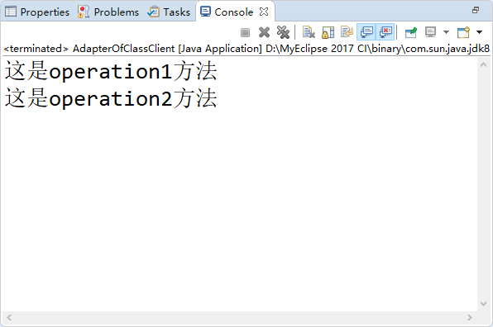

(2) 对象适配器

2.1 UML图
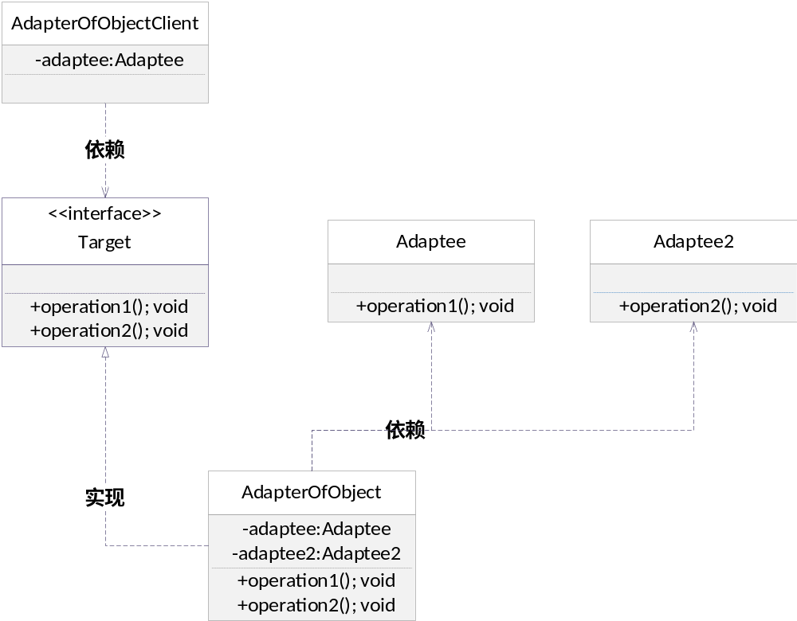

2.2 代码
package cn.edu.scau.cmi.zhouxudong.adapter;

public class Adaptee {

public Adaptee() {
// TODO Auto-generated constructor stub
}

public void operation1(){
System.out.println("这是operation1方法");
}

}

package cn.edu.scau.cmi.zhouxudong.adapter;

public class Adaptee2 {
public Adaptee2() {
// TODO Auto-generated constructor stub
}
public void operation2(){
System.out.println("这是operation2方法");
}
}

package cn.edu.scau.cmi.zhouxudong.adapter;

public class AdapterOfObject implements Target{

private Adaptee adaptee ;
private Adaptee2 adaptee2 ;
public AdapterOfObject() {
// TODO Auto-generated constructor stub
}

public void operation1(){
adaptee.operation1();
}

public void operation2(){
adaptee2.operation2();
}

}

package cn.edu.scau.cmi.zhouxudong.client;

import cn.edu.scau.cmi.zhouxudong.adapter.AdapterOfClass;
import cn.edu.scau.cmi.zhouxudong.adapter.Target;

public class AdapterOfObjectClient {

public static void main(String[] args) {
// TODO Auto-generated method stub

Target tar = new AdapterOfClass();
tar.operation1();
tar.operation2();
}

}

2.3 实验效果
