COMP40610 Visual Exploration Tool Design Document

Student_Name1: Shuhao Guan

Student_Number1: 20211120

Student_Name2: Feixiang Liu

Student_Number2: 21200349

#### *Project Link::*

The whole Project is uploaded to GitHub. The link is: <https://github.com/littlewhitecatdoge/Worldwide_Happiness_Report-data-visualation>

#### *Title:*

Worldwide Happiness Report

#### *Screenshot:*

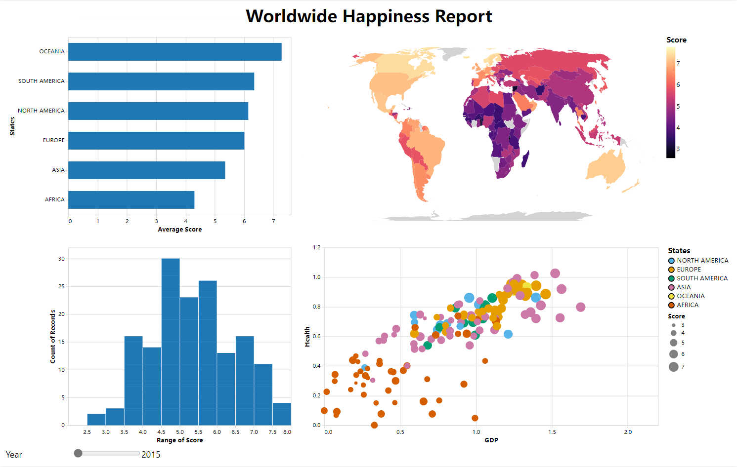

#### *Dataset overview:*

The origin data comes from <https://www.kaggle.com/datasets/unsdsn/world-happiness> and <https://raw.githubusercontent.com/techslides/D3-Maps/master/data/world/world-110m.json>.

1. <https://www.kaggle.com/datasets/unsdsn/world-happiness> contains 2015-2019 world happiness dataset. we select country, rank, happiness scores, economic scores and health scores features from 5 datasets. And then combine them into one dataset by adding a feature called 'year’. What ‘s more we set an extra feature called states to label these countries' states. Check our GitHub file for details of the data pre-processing process [Worldwide_Happiness_Report-data-visualation/clean.ipynb at littlewhitecatdoge · littlewhitecatdoge/Worldwide_Happiness_Report-data-visualation (github.com)](https://github.com/littlewhitecatdoge/Worldwide_Happiness_Report-data-visualation/blob/littlewhitecatdoge/data/clean.ipynb).
2. <https://raw.githubusercontent.com/techslides/D3-Maps/master/data/world/world-110m.json> is a map dataset for displaying the worldwide map. It contains country name feature. So, we can do the map matching with this dataset.

#### *Design* *considerations*

**Overall goal:**

At beginning of designment, Our overall goal with this tool was to 1. Observe the distribution of the happiness in the world, 2. Observe the changes in the happiness of countries around the world over time. 3. Observe the average level of each continent and observe the distribution within each continent. 4. Observe the distribution areas of the two extreme values ​​of the happiness index. 5. Observe the relationship between economic, health, and happiness. Following are the main components in this tool:

1. **Slider**: Year data selection slider
2. **Bar chart**: Average happiness score of each continent
3. **Map chart**: World map of happiness score for each country
4. **Histogram:** Frequency distributing of happiness score
5. **Scatterplot:** Frequency distributing of happiness score

**Slider: Year data selection slider:** At the at the bottom left of the dashboard which can switch the year for the data. By dragging this slider left and right, we can view the visualizations of all happiness report data from 2015 to 2019 from the dashboard

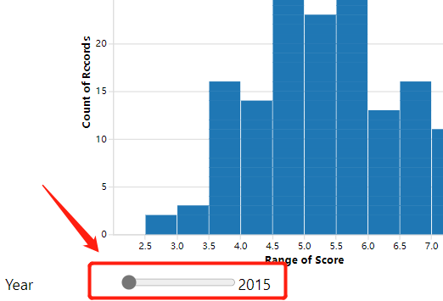

**Bar chart:** Show the average happiness score of each continent and sorted in descending order.X position encodes score of continents (quantitative), Y position encodes continent (nominal), Mark of type point encodes a continent (nominal). For example, we can see that Oceania has the highest average happiness score with 7.285, while Africa has the lowest average happiness score with 4.3.

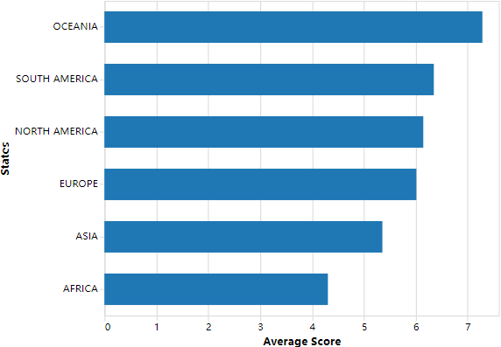

**Map chart:** Since the name of the country is hardly a reminder of the geographical location of that country, we can use geographical information to create a chart. We hope that readers of the chart will be able to see more visually from this chart how the happiness scores of different countries are distributed on the map.

We use bright yellow to indicate that the country has a high happiness score and dark purple to indicate that the country has a low happiness score. These two colors can be distinguished by color blind groups.

X position encodes latitude (quantitative), Y position encodes longitude (quantitative), Color encodes building height (quantitative),Mark of type area encodes one country (nominal)

For example, we can see from the chart below that the predominant colors in North America and Europe are bright, which the predominant colors in Africa are dark. So we can say that the people in North America and Europe are happier than the people in Africa.

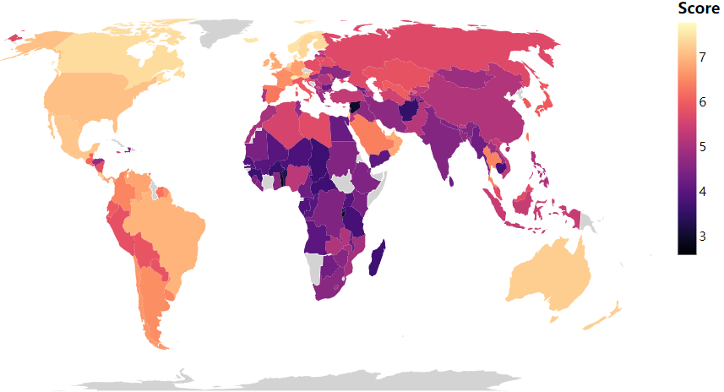

**Histogram**: To observe the distribution of happiness scores clearer for users, we draw this histogram to show the frequency distributing of happiness scores. X position encodes range of score (ordinal), Y position encodes count of records (quantitative), Mark of type point encodes one country. (nominal),As we can see from the graph below, most countries have a happiness score between 4.5 and 6 for the years selected, with a small number of countries having a poor score of around 2.5. This distribution is typical of a normal distribution.

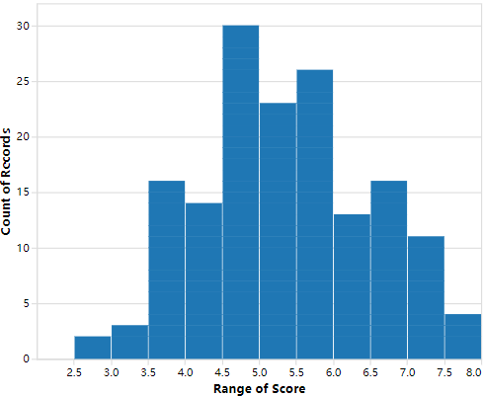

**Scatterplot**: Happiness scores may be influenced by other factors such as economic and health levels. To explore the effect of these factors on happiness scores, we created the chart of relationship between GDP, health levels and happiness scores. We also considered the color-blind group, so we chose these six colors "#56B4E9", "#E69F00", "#009E73", "#CC79A7", "#F0E442" and "#D55E00".

X position encodes GDP score (quantitative), Y position encodes health score (quantitative), Color hue encodes different continent (nominal), Size of type point encodes happiness score (quantitative), Mark of type point encodes one country. (nominal)

We can see from the chart that most of the African countries have low economic and health levels for the years selected, they are mainly located in the bottom left of the map, and it is easy to see that the closer the distribution is to the bottom left, the smaller the point size is, which means they have lower happiness scores; closer to the top right are mainly Asian and European countries, which also have higher happiness scores.

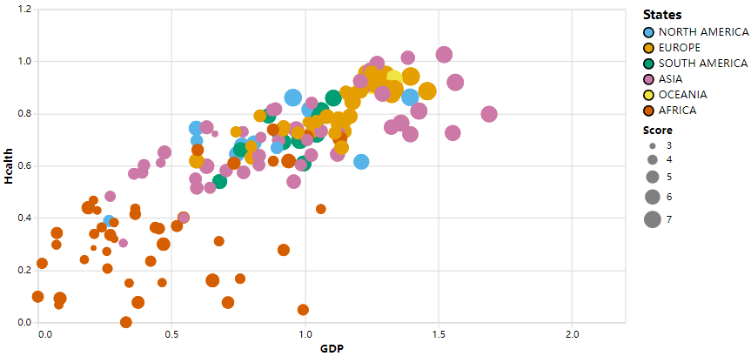

**Chart we dropped**: At the beginning of the project, we chose to use a descending series to show happiness scores for all countries in bar chart. X position encodes score of countries (quantitative), Y position encodes country (nominal) and Mark of type point encodes one country. (nominal). Because the number of countries was too large for us to display all the data in a small screen, we added a thumbnail on the right side to make the chart more visible. However, in the subsequent design we found that the bar chart with all the countries did not show the data well enough to give the reader of the chart a visual impression (we don't think anyone would go through all the contents of the chart!). It only satisfies the curiosity of those who want to know which country has highest happiness score. So, we think it doesn’t make sense to show so much of data.

电脑萤幕画面

#### *Interaction consideration:*

The main interaction approach we have used here is cross-filtering. Users can select subsets of the data in one chart, and this will filter the data in another chart. For example, users can select continents in the Chart1, and this will filter the data presented in other three charts.

In our current design, we can click or hover over the map or data points to see the score and ranking of each country. The reader of the chart can see all the data visually, and the content of the data can be displayed in full on a smaller area. The disadvantage is that we cannot find the top country in the first place.

图示

However, there do have some limitation of these four Charts. Bar chart can do interaction with all other charts. while Histogram can only make change to Map chart and Scatter plot. Scatter plot has the access to Map chart and Histogram. Map can only affect scatter plot. For example, when select bar in Bar chart, you could see the changes in other charts. However, when do select operation in Histogram, only Map chart and Scatter plot will make changes.

Details of each Chart are as following:

**Bar chart:**

We can interact with the mouse by hovering and clicking.

When the mouse is hovered over, the bar will be highlighted, and show the detial.

**Map chart:**

We can interact with the mouse by hovering and clicking.

When the mouse is hovered over, the area will be highlighted, and show the detial.

**Histogram:**

We can interact with the mouse by hovering and dragging.

When the mouse is hovered over, we can see which countries are in that bar.

**Scatter plot**

We can interact with the mouse by hovering, clicking, and dragging.

When the mouse is hovering, the point will be highlighted, and show the detial.

When the mouse is dragged over, corresponding countries will be selected, the data in Histogram and Map chart will change.

And when click, unselected points will be faded, the data visualisation of Map plot will change and show us where the countries are on the map.