1)Basic Inventory- (76. Ultimate Inventory software)

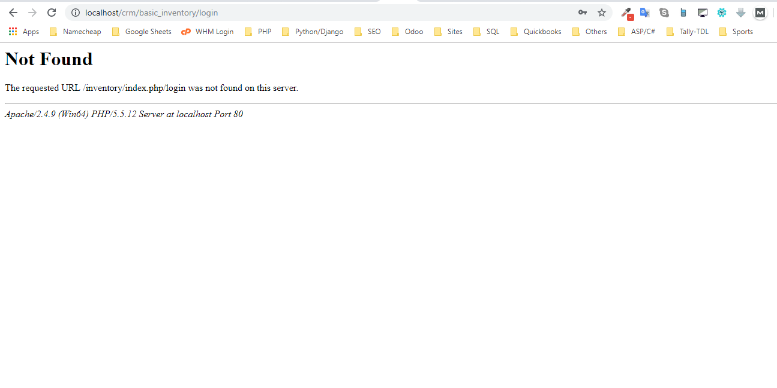

After clicking on Login Button am getting this error.

2) GYM (71. Gym Management and Fitness Management)

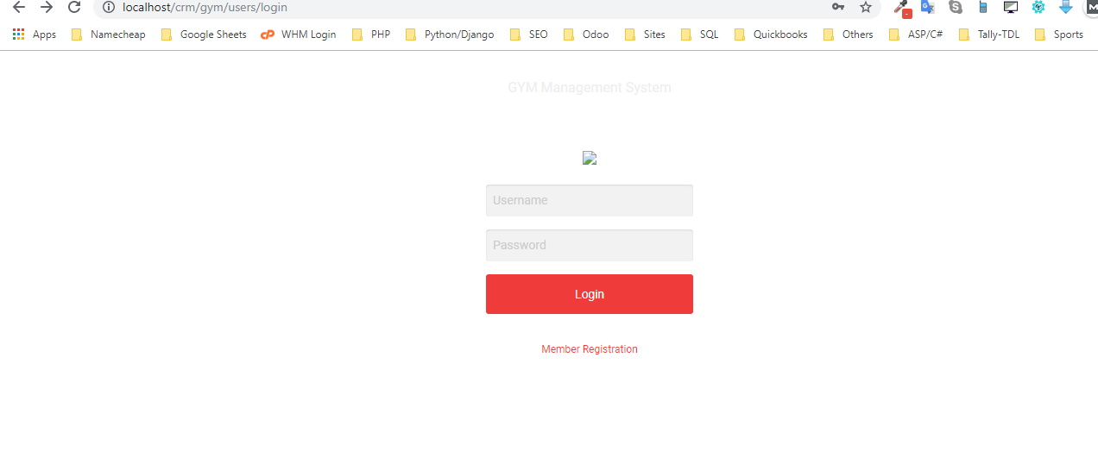

The theme is not loading… Login details not working

3)Ecommerce-1 (12. Multivendor E-commerce website)

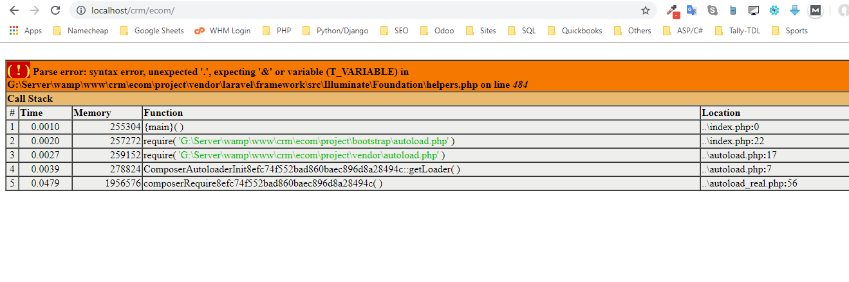

Website on running is showing error.

4) Ecommerce-2 (12. Multivendor E-commerce website)

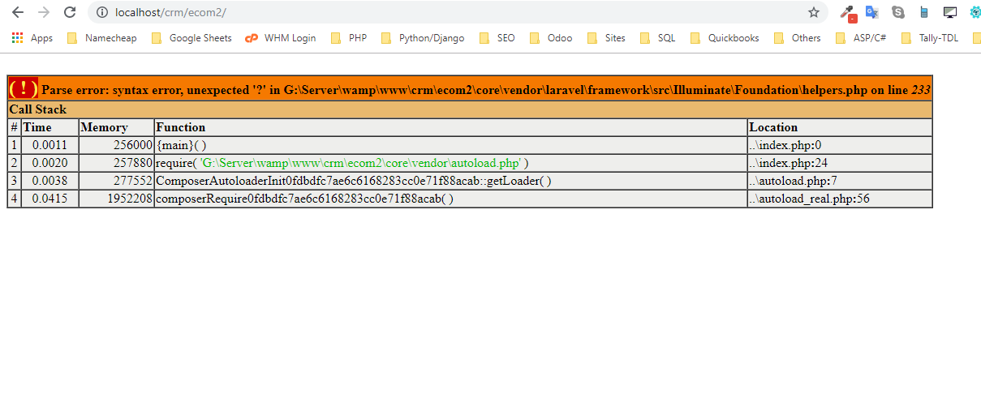

Website not working on loading.. showing this error.

5)Matrimony (19. Matrimonial Software)

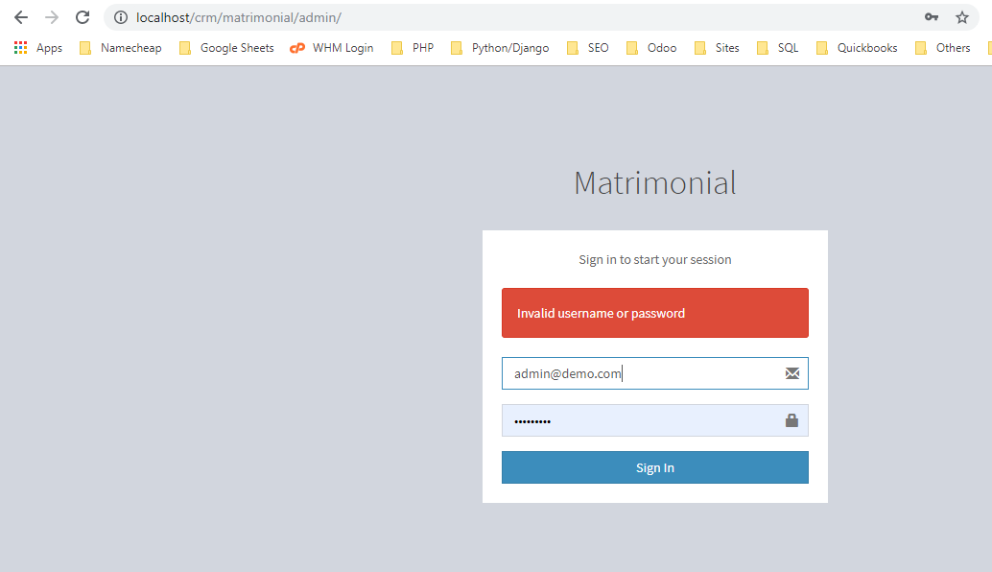

Login Credentials not working..

USER ID: admin@demo.com

PWD: password

6)Travel

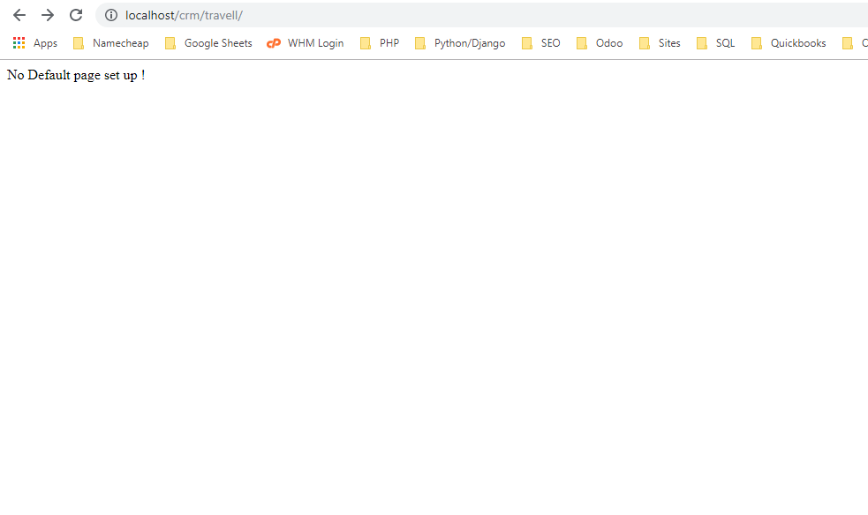

Home page loading shows Error..

7)

Car Workshop

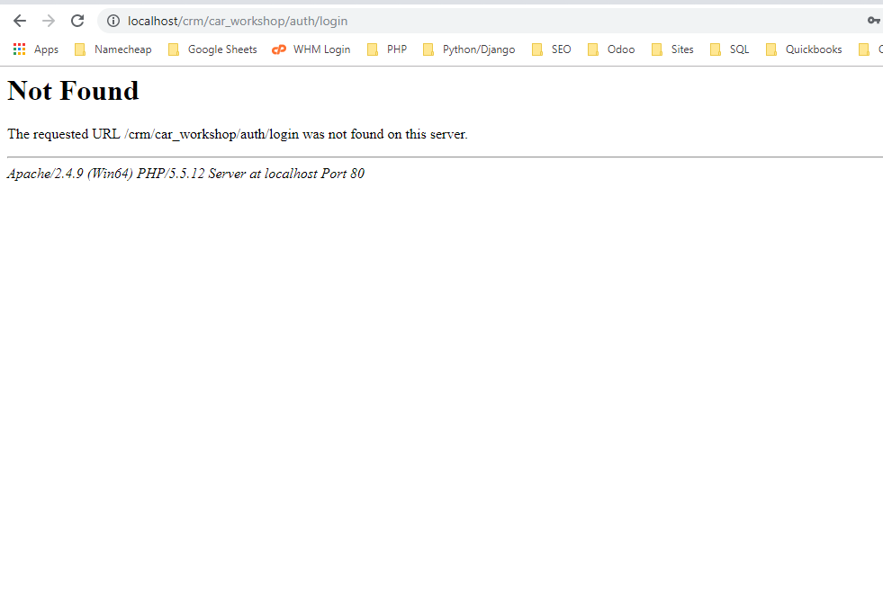

Clicking Login showing this page.. No credentials also given

8) Stock Management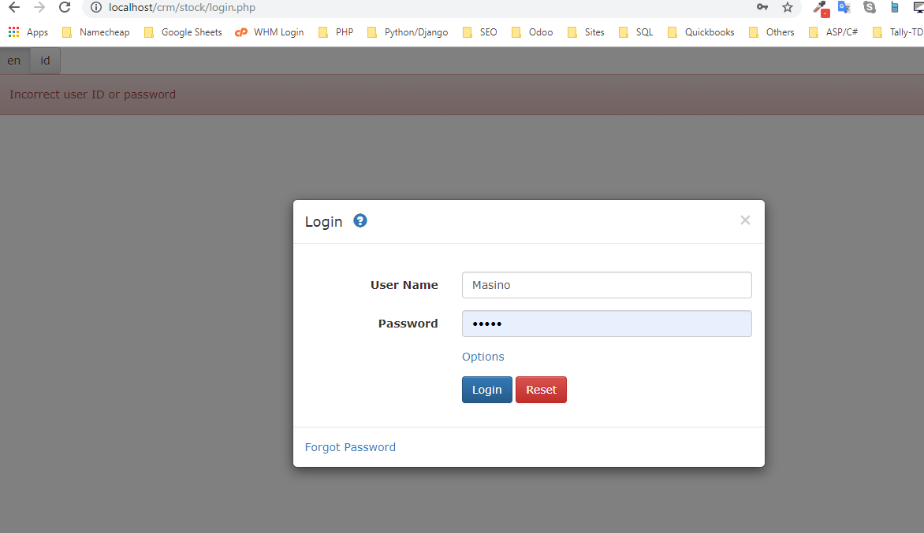

Username & Password – Missing

9)Quiz

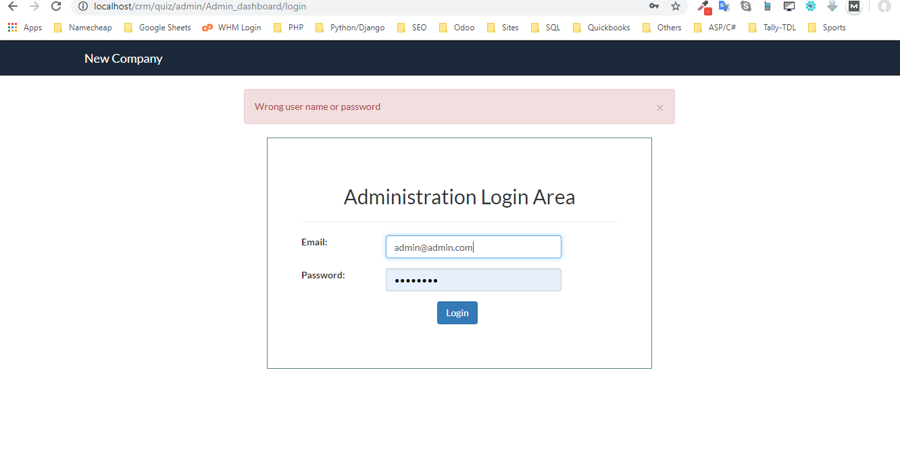

Login details needed

10) Realestate

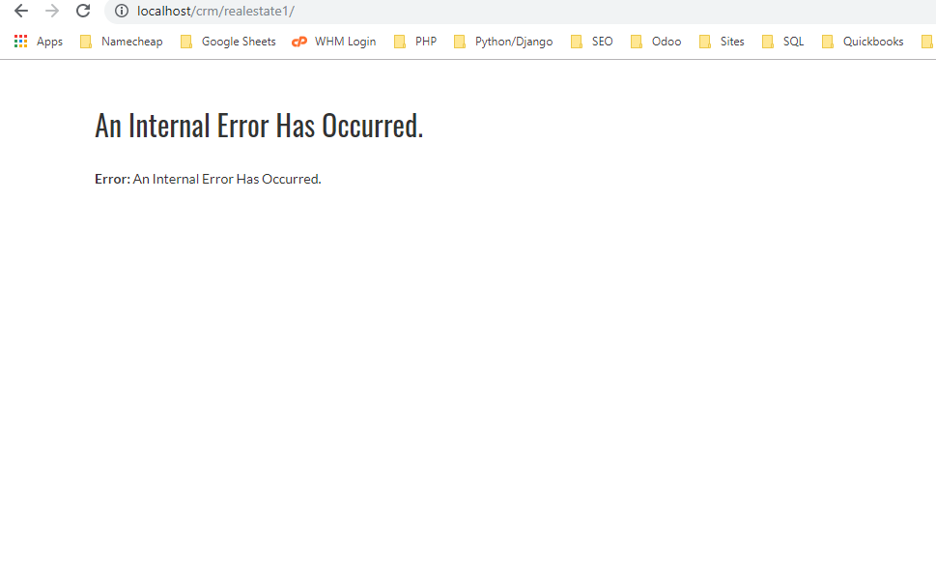

User side having error

11) Multirestaurant

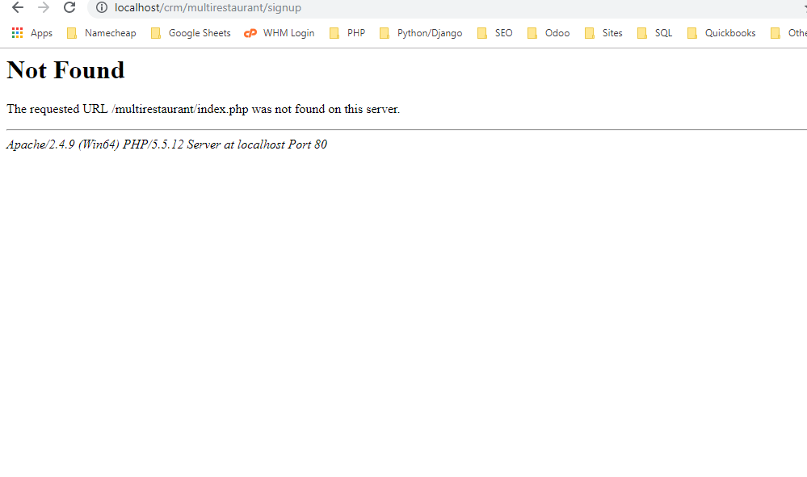

Some links not working

Admin login details all missing

12)Advance Inventory

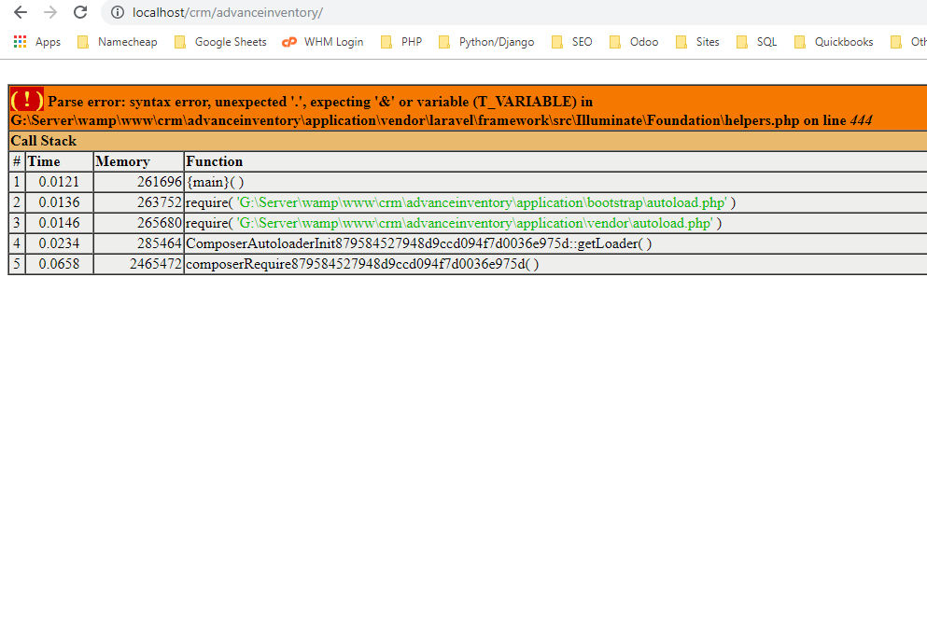

Website loading error

13)Library

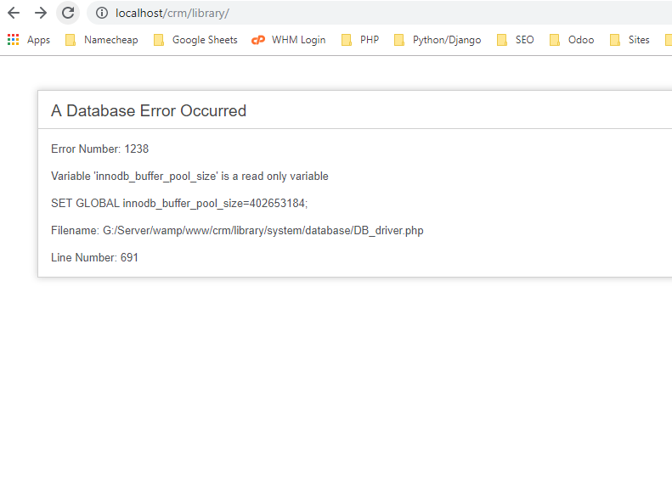

Loading Error

14) Pharmacy

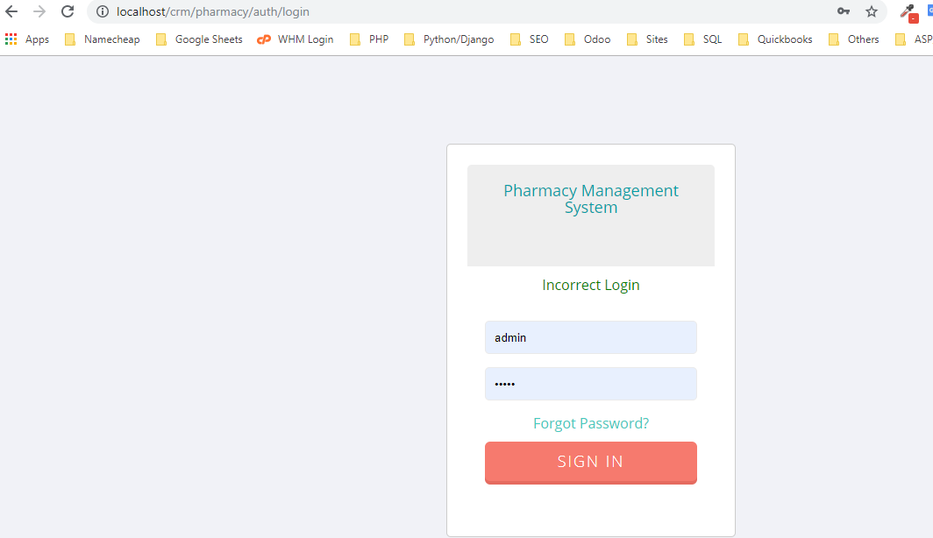

Login Details not working

15) Pharma

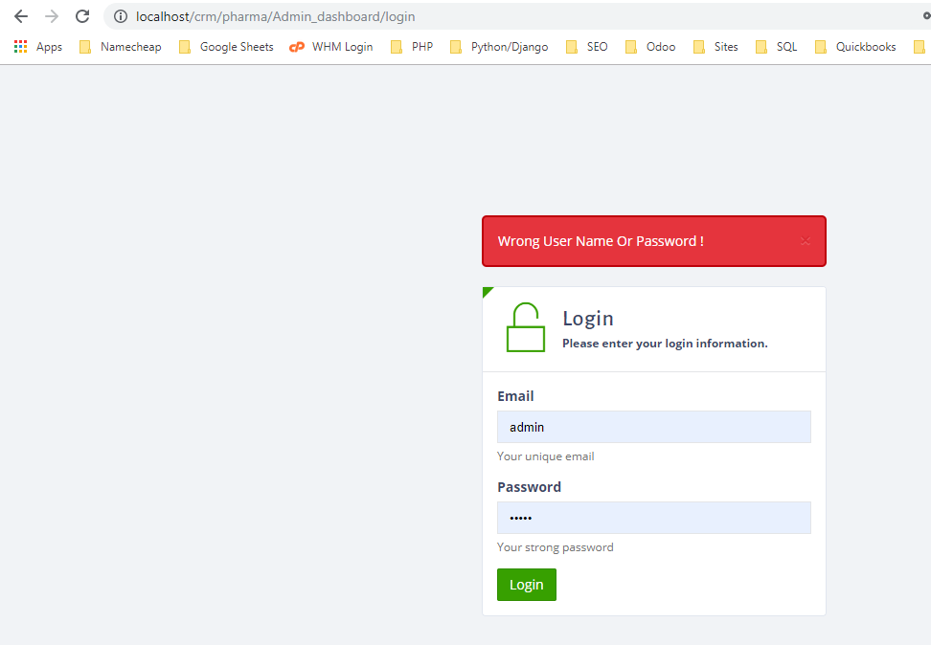

Login Details..pls provide… provided details not working

16)Auction

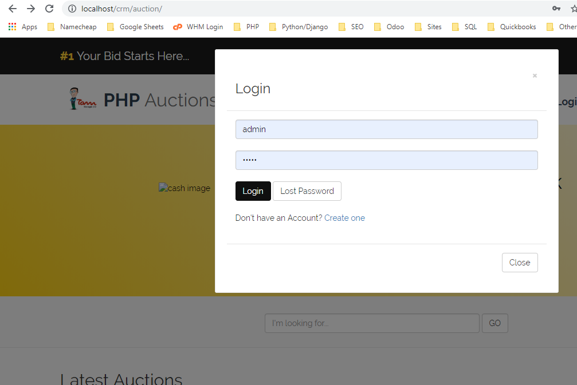

Nothing working.. no signup..no login details

17) Election System

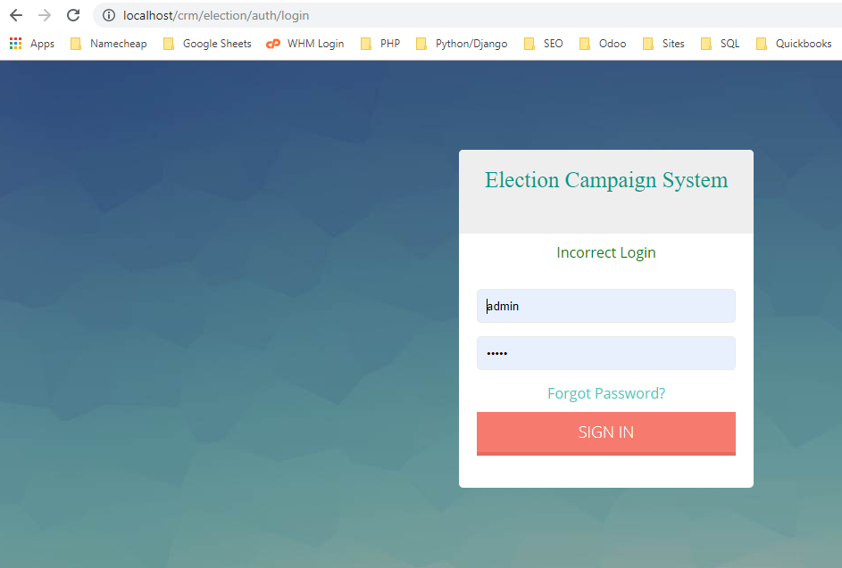

Password not working

18)Online Tutor

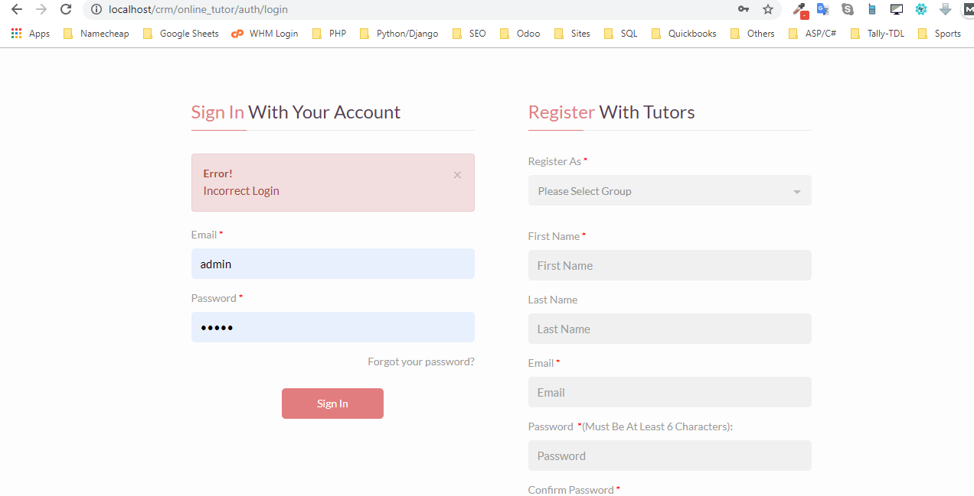

Login details wrong

19)Online Food

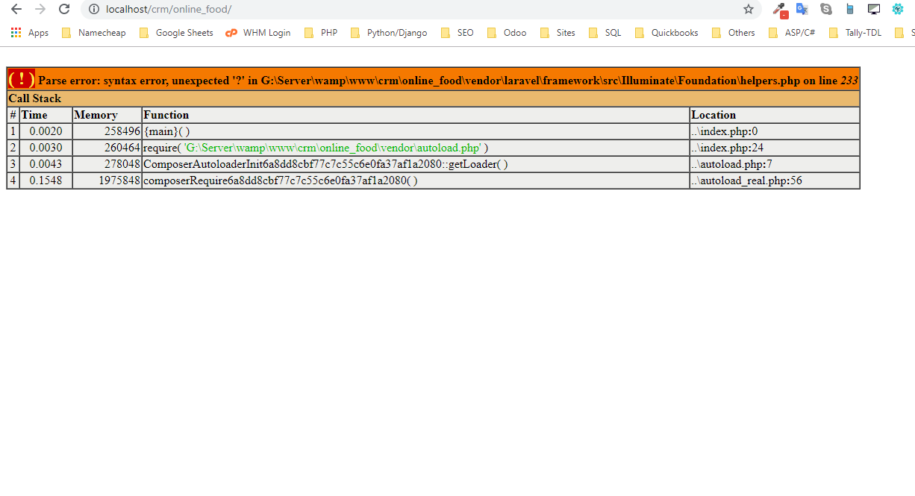

Website loading error.

20) New Travel

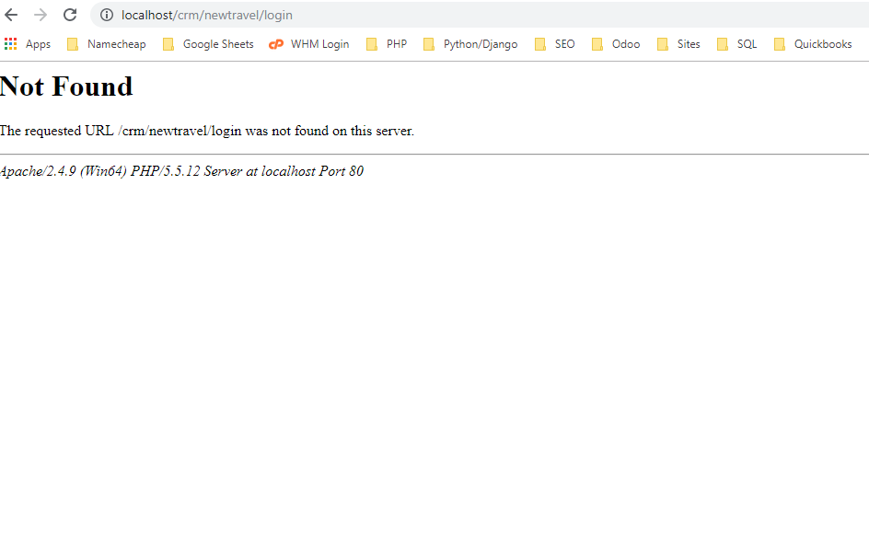

Login not loading… no credentials

21) Crowd Funding

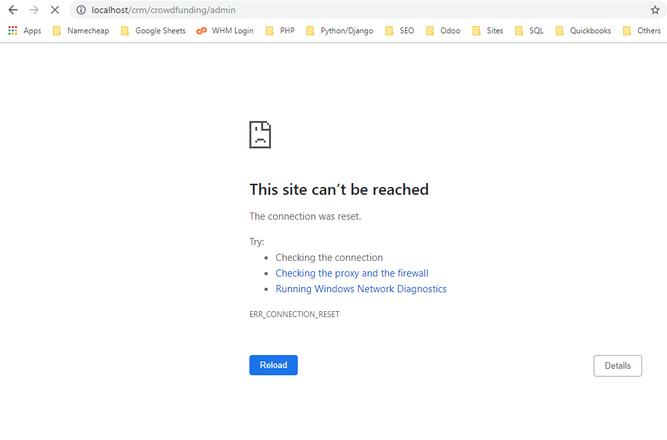

Admin panel not loading…

22)Coaching Centre

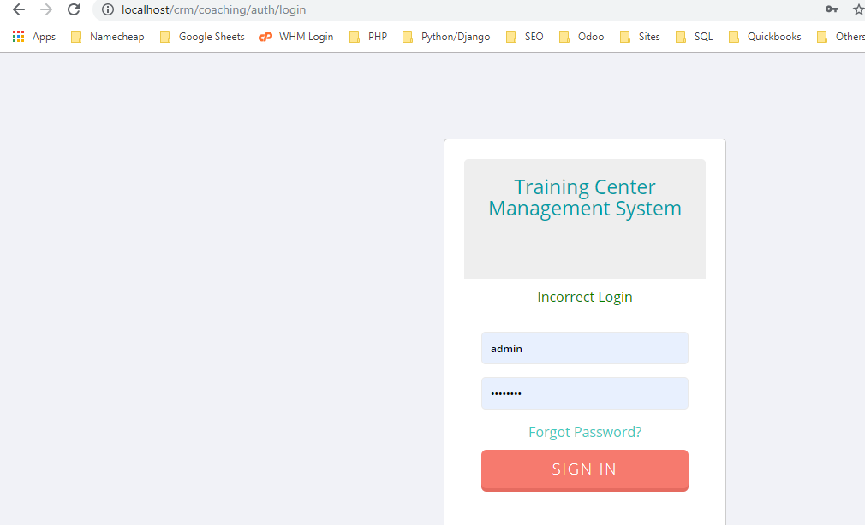

Password details not working

23)Cab

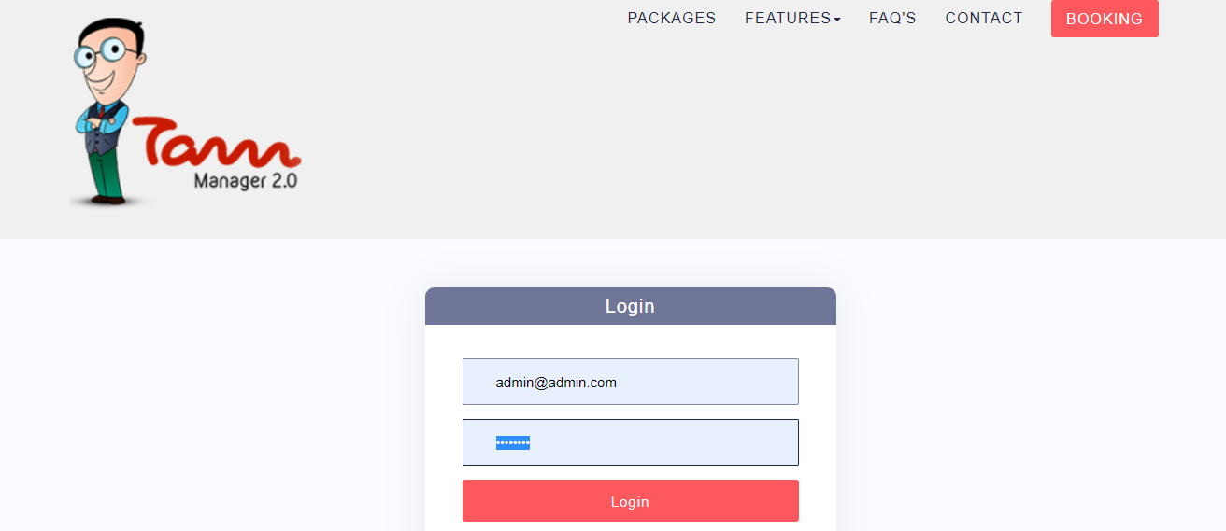

password details not working

24) Freelancer

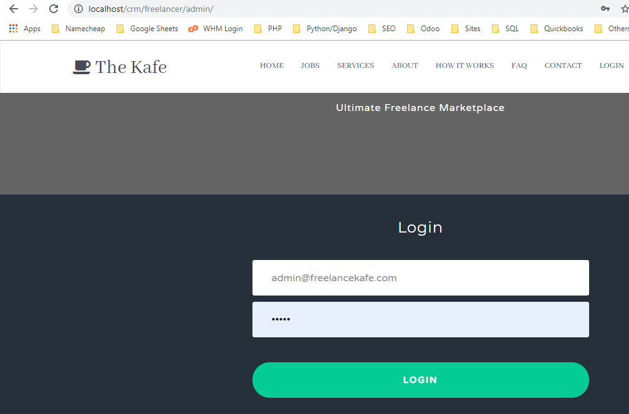

Login details not working

25)Dating

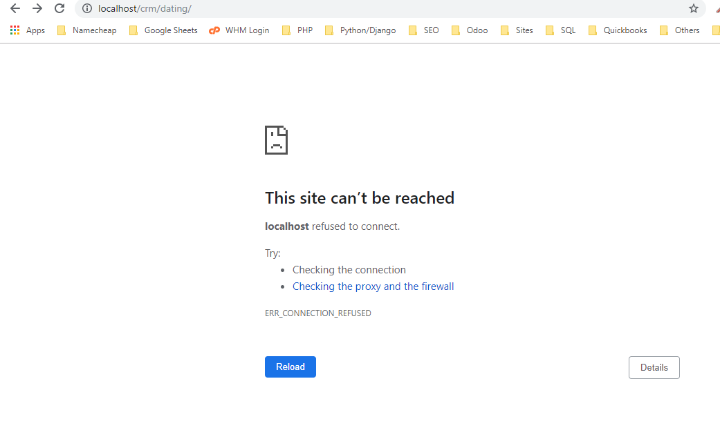

Site loading Error

26)Project Management System

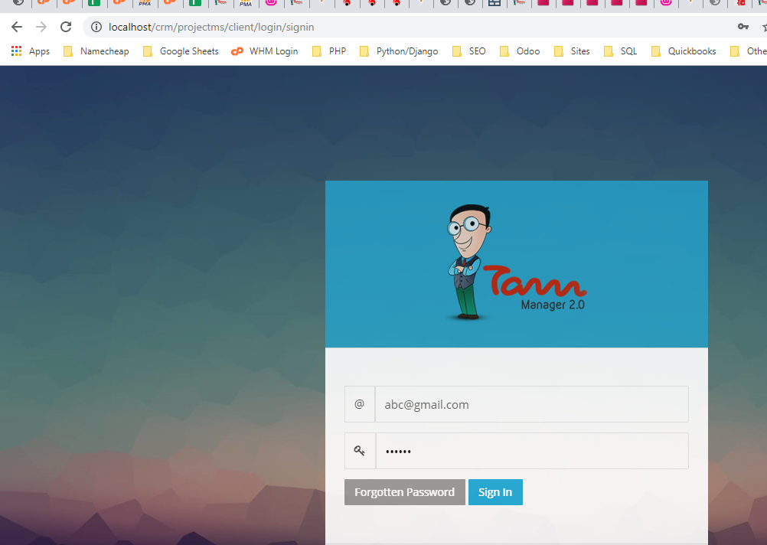

Login details missing..

27)Admin Project

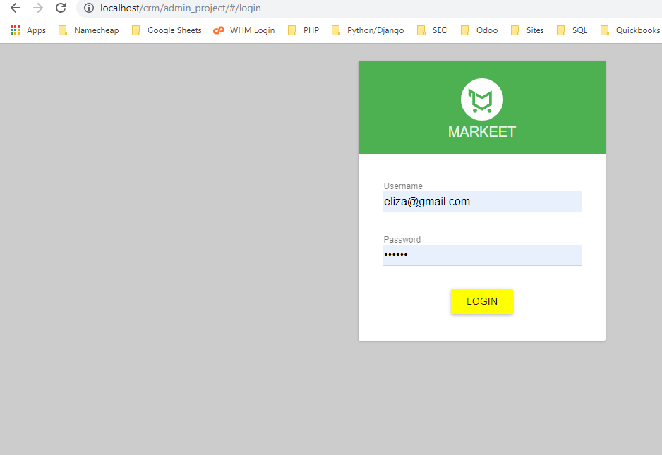

Database file missing

28) Social Store

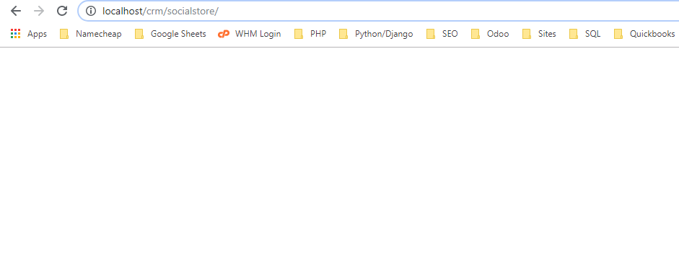

No SQL File present

29)POS Advance

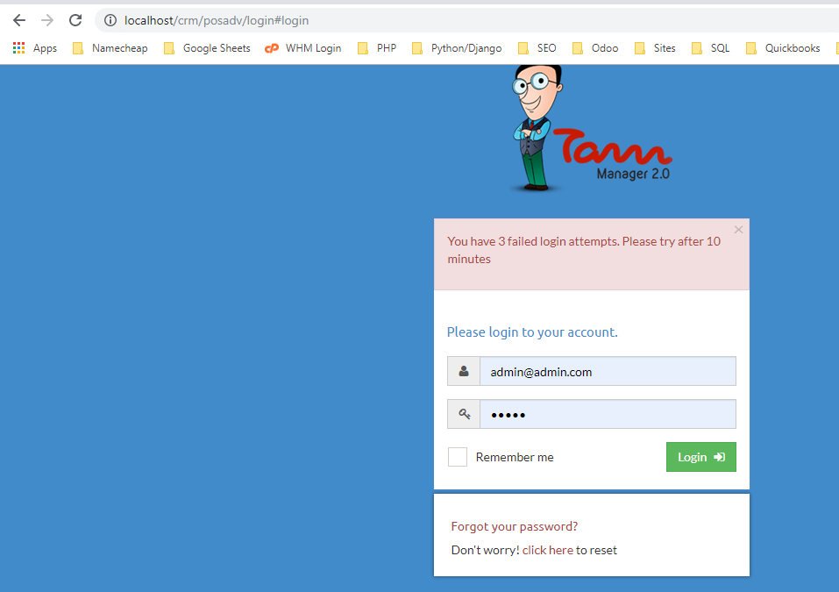

Login Details wrong

30)Fleet

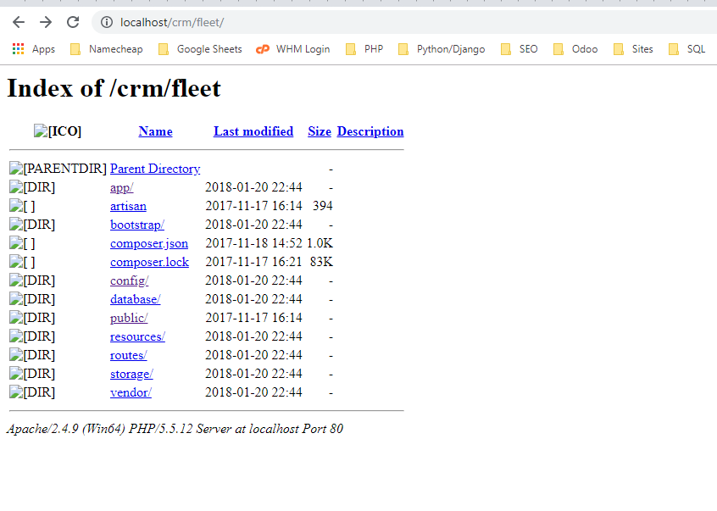

Site Not Loading

31)Eoffice

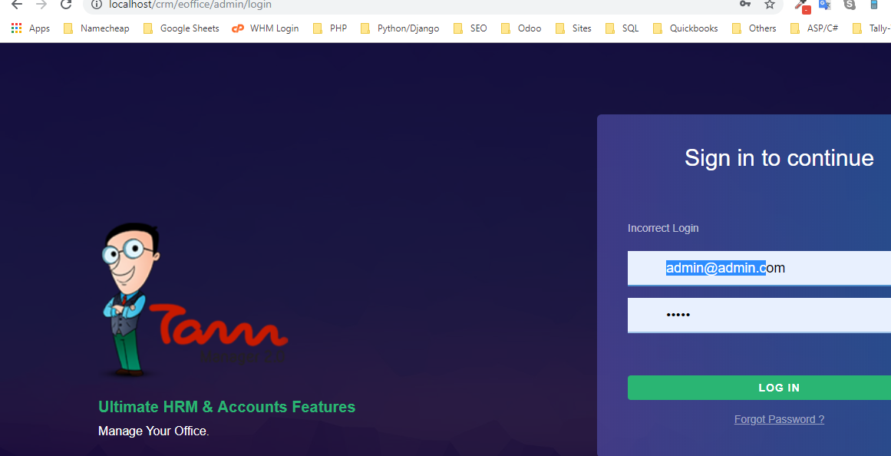

Login details not working

32)Mailer

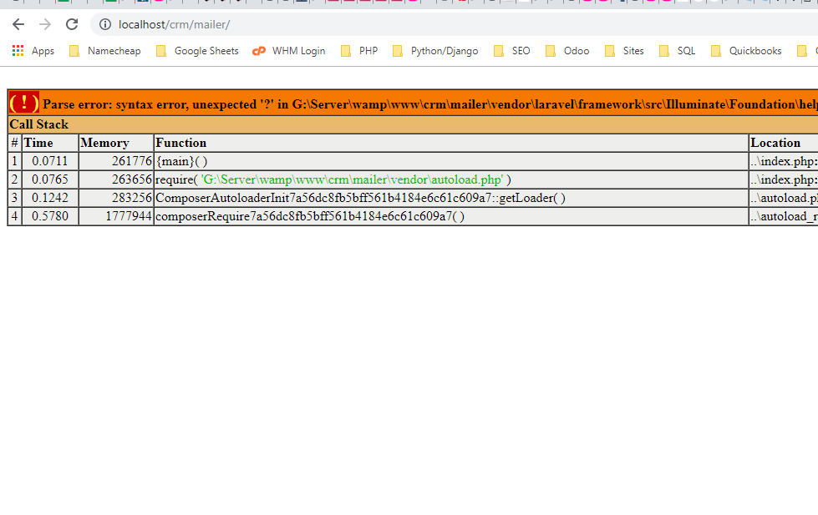

33) Invoice

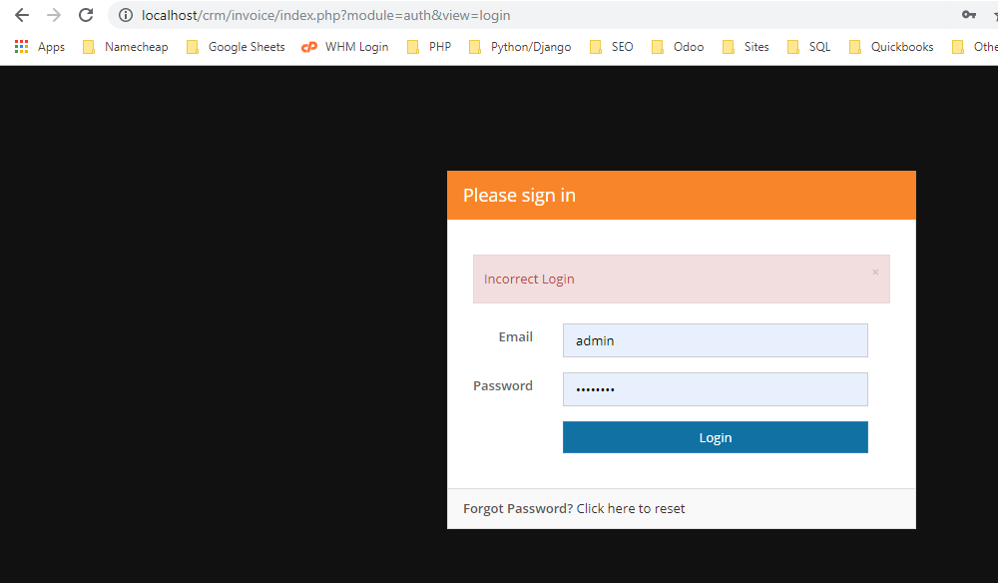

Login details not working

34)GST

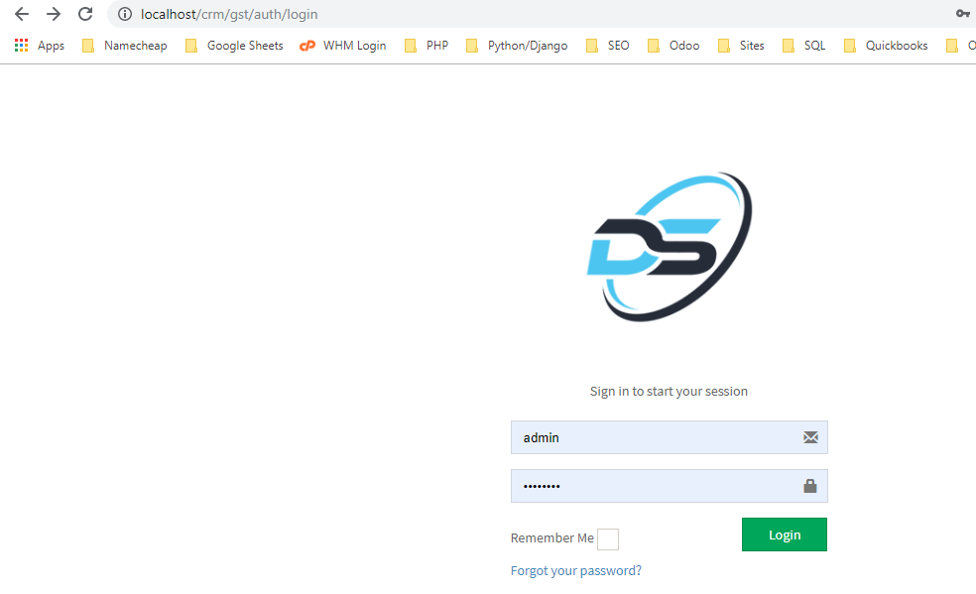

Login details failed

35)Exam Pro

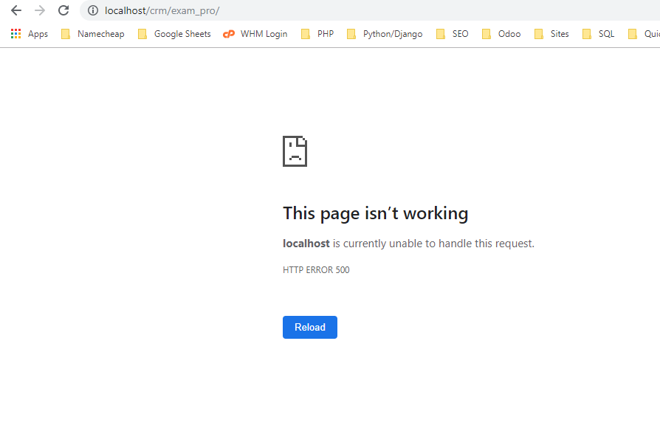

Site Not Loading