21-10-17, 16:06 - JPG Motor: is not the same. O2 have 4 sensors

21-10-17, 16:07 - JPG Motor: i want to order all

22-10-17, 13:02 - Frank Denker: Pre cat sensors are 2x USD 75. After cat sensors are USD 60. Total USD 270. Need to order them. Will take 10 days.

22-10-17, 13:02 - Frank Denker: They only have 3 sensors in stock

22-10-17, 13:03 - Frank Denker: The mustang kit part is in stock at USD 495.

26-10-17, 14:53 - Frank Denker: Sensors take 10 days from ordering. They don't have them in stock.

26-10-17, 14:53 - JPG Motor: **i will pay for u on monday**

26-10-17, 14:54 - Frank Denker: I will invoice you this week then. I trust you will pay us.

26-10-17, 14:54 - JPG Motor: pls order

26-10-17, 14:54 - JPG Motor: 🙏🏼🙏🏼🙏🏼

27-10-17, 20:30 - Frank Denker: Prices I gave you are correct. Kit part ships tomorrow. Shipping cost we don't know yet.

27-10-17, 20:30 - Frank Denker: Sensors we will order.

27-10-17, 20:32 - JPG Motor: **if you get the price , i will send u money**

27-10-17, 20:32 - Frank Denker: Sure.

27-10-17, 20:32 - JPG Motor: 🙏🏼🙏🏼🙏🏼

27-10-17, 20:32 - JPG Motor: thx

27-10-17, 20:32 - Frank Denker: No problem

27-10-17, 20:32 - JPG Motor: 👍🏻

02-11-17, 16:52 - Frank Denker: Address ok?

02-11-17, 16:54 - JPG Motor: ok

02-11-17, 16:56 - Frank Denker: I will mail you the invoice. Please pay this week. Thank you.

02-11-17, 16:57 - JPG Motor: 👍🏻

Email to JPG Motor of 2 November 2017

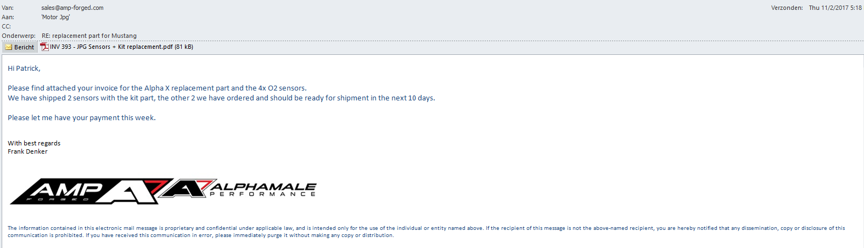

Email to JPG Motor of 6 November 2017

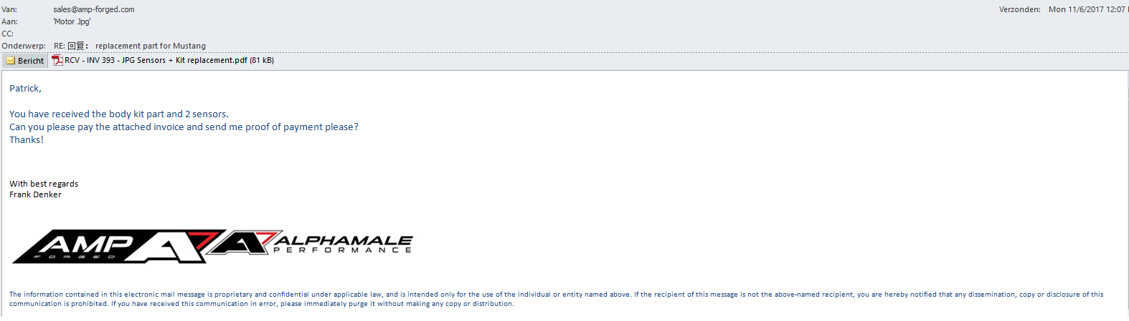

08-11-17, 09:10 - JPG Motor: send me again

08-11-17, 09:28 - Frank Denker: Done

08-11-17, 09:29 - JPG Motor: i check

08-11-17, 09:42 - Frank Denker: Got it?

08-11-17, 09:50 - JPG Motor: 👌

10-11-17, 08:57 - Frank Denker: Did you pay us?

11-11-17, 09:18 - Frank Denker: Hi. I have still not received your payment?

13-11-17, 09:30 - Frank Denker: I sent the goods in good faith you will pay. Did you?

13-11-17, 20:03 - JPG Motor: i backt hk tomorrow, sorry about that.

13-11-17, 20:03 - JPG Motor: **my staft send already**

13-11-17, 20:04 - JPG Motor: i check my bank if i back to hk

13-11-17, 20:51 - Frank Denker: 🙏🏻

20-11-17, 15:59 - Frank Denker: Can you check again please. No money received. Thanks.

20-11-17, 17:26 - Frank Denker: Please?

20-11-17, 23:54 - Frank Denker: Did you pay us?

21-11-17, 14:13 - Frank Denker: Can you please reply?

Email reply from JPG Motor 21 November 2017

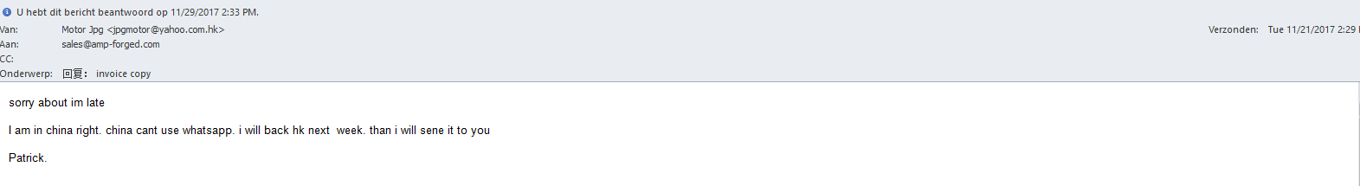

Email to JPG Motor 23 November 2017

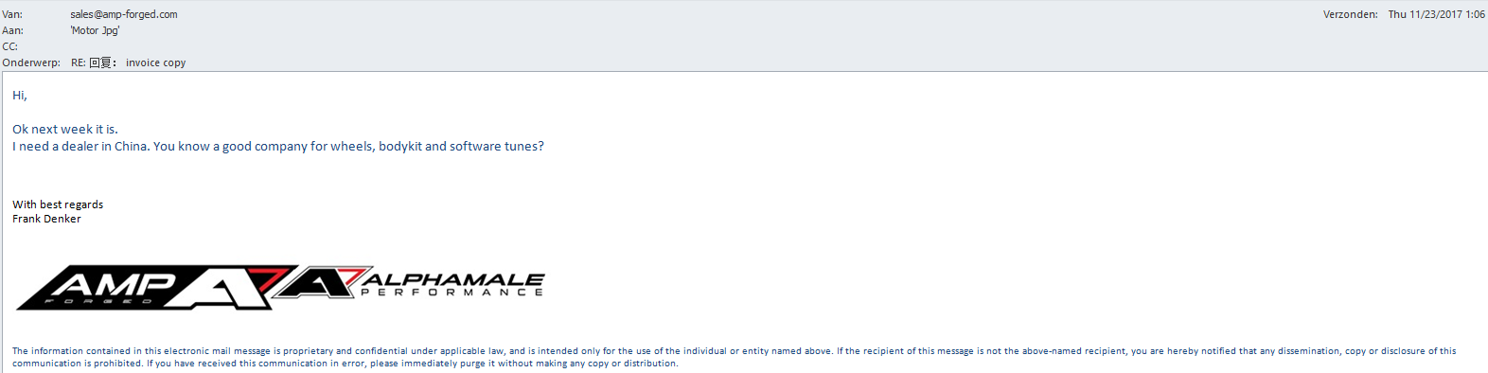

27-11-17, 13:39 - Frank Denker: Are you back from China?

28-11-17, 09:39 - Frank Denker: My whatsapp reached you. Did you pay us now?

29-11-17, 13:10 - Frank Denker: My invoice is 2 weeks old now 😔

Email to JPG Motor 29 November 2017

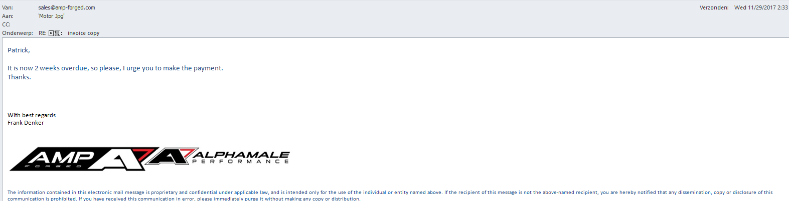

30-11-17, 18:11 - Frank Denker: Patrick what's going on?

01-12-17, 08:56 - Frank Denker: Why no answer?

01-12-17, 14:10 - Frank Denker: Reply please

01-12-17, 14:51 - Frank Denker: On November 8th. I sent you the invoice. It is now December 1. I need you to pay for the parts we sent you.

04-12-17, 09:14 - Frank Denker: Payment needs to be made. I don't want send a debt collector. Please reply.

04-12-17, 09:40 - Frank Denker: Patrick if I don't have a proof of payment today I will send a debt collector.

04-12-17, 20:24 - Frank Denker: I sent you an email. Last attempt.

05-12-17, 14:45 - Frank Denker: I am starting collection procedures today.

Email to JPG Motor 5 December 2017

