Fine-Tuning does NOT provide facts, RAG does. Fine-Tuning changes the way how LLM answers and guide LLM to perform specific tasks.
BitFit
A clever and minimalist fine-tuning strategy that focuses exclusively on adjusting the bias terms of a pretrained model.
What Does “Only Adjusting Bias” Mean?
In neural networks, each layer typically has:
- Weights: the main parameters that transform inputs.
- Biases: scalar offsets added after the weighted sum.
BitFit freezes all weights and only updates the biases during fine-tuning. That means:
- The model’s core representations stay intact.
- Only the additive shifts (biases) are tuned to adapt to the new task.
Prompt Tuning
Using virtual tokens (soft prompts) is generally more reliable and consistent than using natural language prompts, even if both aim to instruct the LLM to perform the same task.
This is because virtual tokens operate closer to the model’s learned representation space (embedding space), allowing them to guide behaviors more directly and precisely, without the ambiguity of human language.
- Natural language is like talking to a skilled assistant: flexible, friendly, intuitive — but potentially inconsistent or vague.
- Virtual tokens are like pressing a dedicated button or flipping a switch in a machine: no creativity, but very precise and repeatable.
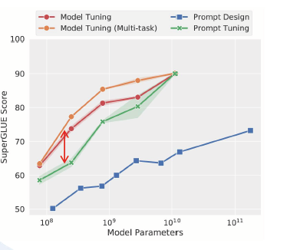
Prompt tuning with virtual tokens is best thought of as a task-specific “automation switch” for large language models. It sacrifices the open-ended, conversational strengths of LLMs in favor of high consistency, reproducibility, and efficiency — making it ideal for industry-scale jobs, not personal, conversational tasks.
Prompt tuning becomes more effective as model size increases, because larger models have more internal knowledge and generalization capacity, allowing small prompt changes (like virtual tokens) to more effectively steer their behavior — even without updating the main parameters.
P-tuning
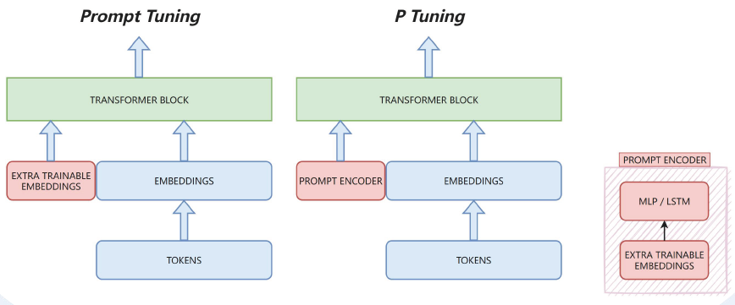
P-Tuning (Prompt Tuning v2)
Concept:
- Instead of using static learnable embeddings, P-Tuning generates virtual prompts using a small trainable neural network (e.g., an LSTM or MLP).
- This allows more expressive and dynamic prompts, especially useful for deep models like GPT-2/3.
Key characteristics:
- Prompts are context-dependent (not fixed vectors).
- Uses a prompt encoder to produce soft prompt embeddings.
- Usually provides better performance than prompt tuning in complex or low-data settings.
Use Prompt Tuning if:
- You want something simple and fast.
- The task is not too complex or the model is shallow.
- Storage size and training efficiency matter a lot.
Use P-Tuning if:
- You want more powerful and expressive prompts.
- The task is complex (e.g. QA, reasoning).
- You have a large model and need strong task adaptation.
History:
Prompt tuning (v1) with static embeddings works well for very large models (e.g. GPT-3). But for smaller models, static prompts don’t provide enough flexibility or signal.
So the authors introduced P-Tuning, where the prompts are learned via a deep LSTM encoder — increasing their expressive power and improving downstream performance on small models (like GPT-2 small / medium).
P-Tuning significantly outperforms prompt tuning for smaller models and even achieves fine-tuning-level performance in some tasks.
Prefix-Tuning
- Instead of updating the entire model, prefix tuning introduces a small set of learnable vectors (called a prefix) that are prepended to the input at every transformer layer, not just the embedding layer.
- These vectors act like virtual tokens that steer the model’s behavior during inference or training.
- The base model remains frozen — only the prefix vectors are trained.
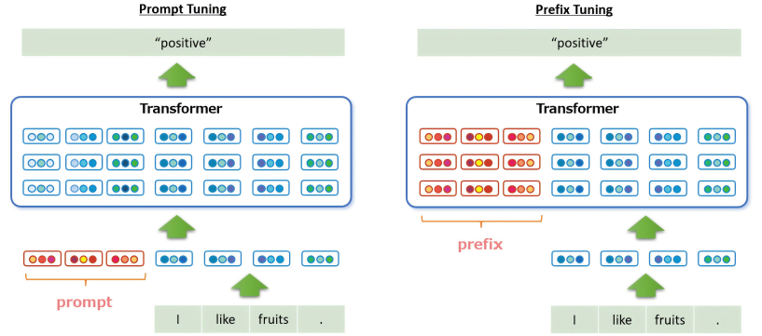
Prompt tuning vs Previs tuning vs P tuning
- Prompt tuning is great for simplicity and speed.
- Prefix tuning offers deeper control by influencing internal attention layers.
- P-Tuning v1 adds sequential modeling power but is more complex.
- P-Tuning v2 brings prefix-style control to encoder-based models.
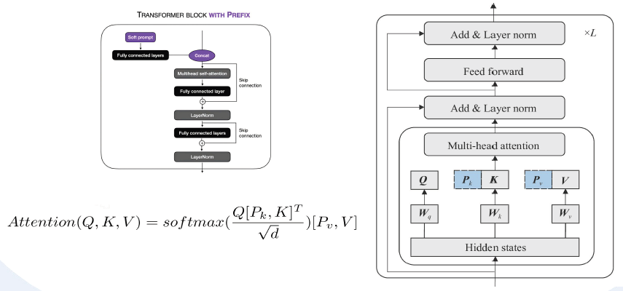
Prefix Tuning prepends learnable prefix vectors (concatenation) — i.e., virtual tokens — not to the actual input, but to the internal attention mechanism in each transformer layer.
The input queries Q stay the same — they're derived from the real input tokens — but they're now attending to both:
- the original keys/values from the input, and
- the prefix keys/values learned specifically for the task.
This is by design:
- Prefix vectors are meant to steer attention, not to overwrite input representations.
- By only modifying K and V, prefix tuning keeps the query flow unaltered, which preserves the original reasoning path of the model while subtly guiding it.
- It’s like adding guiding clues without replacing or changing the model’s core decision-making process.
Think of Q as the question your model is asking at each step.
- Normally, it just looks at other tokens (K/V) in the input to answer.
- With prefix tuning, you insert hint cards (K_prefix, V_prefix) into its memory.
- It doesn’t change the question (Q stays the same), but now it can find answers from both the input and your injected hints.
This makes prefix tuning powerful yet efficient:
- Doesn't require changing the main forward flow of tokens.
- Injects task-specific behavior deep into all attention layers.
- Keeps original model weights completely frozen.
LoRA
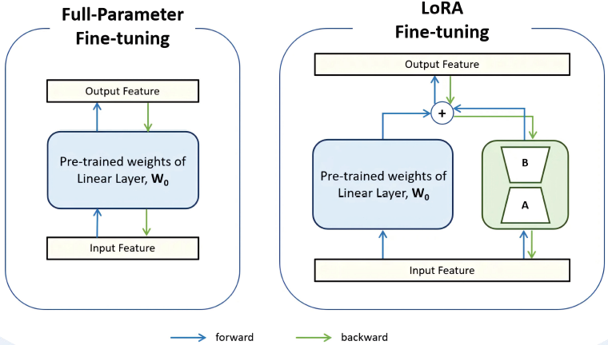
LoRA — short for Low-Rank Adaptation — is a powerful technique for fine-tuning LLM in a parameter-efficient way. Instead of updating the entire model (which can involve billions of parameters), LoRA introduces a small set of trainable low-rank matrices into specific layers, typically the attention or feed-forward layers.
LoRA freezes the original weights and injects small trainable low-rank matrices into the model. These low-rank matrices are learned to adjust the model’s behavior.
Method | Core Idea | Trainable Params | Typical Usage
Prompt Tuning | Add trainable virtual tokens at input | Very low | Good for language tasks, especially with large LLMs
Prefix Tuning | Add trainable tokens to key/value of attention | Low | More powerful than prompt tuning
P-tuning v2 | Embedding + deep virtual tokens | Medium | Good for smaller models
LoRA | Add low-rank matrices to weight updates | Low to medium | Very flexible, strong performance, wide adoption

In LoRA (Low-Rank Adaptation), rank refers to the dimensionality of the trainable matrices used to approximate weight updates during fine-tuning. Instead of updating a full weight matrix W∈R^{d×k}, LoRA decomposes it into two smaller matrices. Rank (r) is a hyperparameter that can be set by us.
- Higher rank → more expressive updates. Can capture complex task-specific patterns, but uses more memory and compute.
- Lower rank → more efficient. Faster training and lower resource usage, but may underfit if the task is complex.
The output of AB must match the shape of the original weight matrix W because it’s being used as an additive update to that frozen weight during the forward pass.
You can use `target_modules` parameter to tell LoRA which layers of the model to apply its low-rank adaptation to.
In LoRA, instead of updating the entire model, you inject low-rank adapters into specific layers — typically linear layers inside attention or feed-forward blocks. The `target_modules` list defines which named submodules LoRA should wrap.
If you omit `target_modules`, LoRA will:
- Auto-select common linear layers known to be effective for the given model (e.g., q_proj, v_proj, dense)
- Use internal heuristics or predefined mappings for popular models like LLaMA, GPT, Falcon, etc.
- Avoid non-linear or non-trainable layers (e.g., activations, LayerNorm, dropout)
Combination
You can combine different Parameter-Efficient Fine-Tuning (PEFT) methods—and it's becoming increasingly common in practice, especially for large language models (LLMs) where balancing efficiency and performance is critical.
Combination | Feasibility | Use Case
LoRA + Prompt Tuning | Common & practical | Complementary tuning (structure + input)
LoRA + BitFit | Easy to combine | Add minor gains without much overhead
Adapter + Prompt Tuning | Seen in multitask setups | Cross-lingual / multitask tuning
LoRA + Adapter | Possible, but rare | Research only – harder to implement/infer
IA³ + LoRA | Experimental | Need careful design to avoid overlap

IA3
Instead of inserting new layers (like Adapters) or decomposing existing ones (like LoRA), IA3 introduces three small learnable vectors per transformer block:
- One for queries (l_q) in the attention mechanism
- One for keys (l_k) in the attention mechanism
- One for values in the MLP layer (l_v)
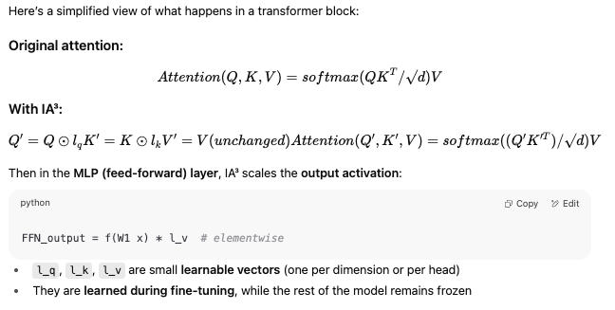
Coding knowledge:
get_peft_model is a utility function that:
- Takes a base model (e.g., a frozen pretrained transformer)
- Adds PEFT layers or modules (like LoRA, IA³, etc.)
- Ensures that only the new PEFT parameters are trainable
Think of it as: “plug PEFT strategy X into model Y.”
- Input: A base model (e.g., from transformers) and a PEFT configuration (e.g., LoraConfig, PromptTuningConfig)
- Output: A modified model with only the PEFT layers/trainable parameters exposed
- Purpose: Efficient fine-tuning with minimal memory and compute overhead
Adapters:
If a model is loaded with 2 adapters:
model_loaded = PeftModel.from_pretrained(net, model_id = "./LoRA1", adapter_name = "LoRA1")
model_loaded.load_adapter("./LoRA2", adapter_name = "LoRA2")
When you check with
model_loaded.active_adapter
You will only see
'LoRA1'
You need to do
model_loaded.set_adapter("LoRA2")
to swith to adapter LoRA2.
This is because by default, only one adapter is active at a time. To use multiple adapters together, you must explicitly fuse or stack them.

