WORK PROPOSAL

This Work proposal (this “Proposal”) is neither binding nor official. The proposal is an estimate of applicability of time for services rendered to The Cash Gift Registry (Aaron Bullock) by thezdinMEDIA (Jacob P. Litwicki). Approximation of time may vary depending on unforeseen circumstances of project.

Services rendered will be billed accordingly:
>> Website development: $3,000.00 with 40% upfront, balance due at completion.
>> Updates & patches: $40/hr, unscheduled, on-call serviceability.

1. WEBSITE DEVELOPMENT

- User interaction with credit account, money transfer, and transfer of funds with the banking institution yet to be named. Also includes “gift purchase” program. (30-40 hrs)
- Creation of user account system will include database structures, security, data storage, user accounts, and all related data, including unique targeted advertising. (20-30 hrs)
- Session data for all user accounts and interaction with advertising and website usability. (5-10 hrs)
- Various user customization features for the “look and feel” of the website and its interactivity. (5 hrs)
- Testing and structure analysis (5-10 hrs)

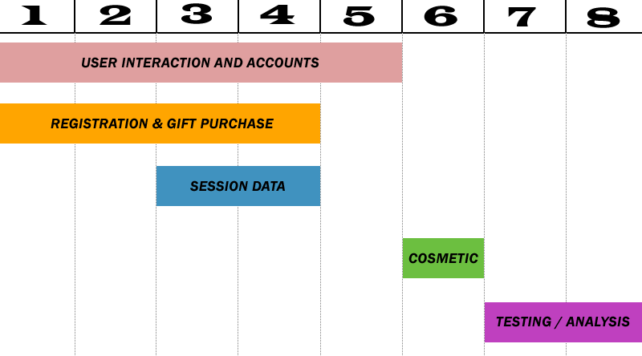

TOTAL ESTIMATED TIME: 60-75 MANHOURS (8 DAYS)

2. UPDATES & PATCHES

- Emergency security issues related to finances and compromised user account data. (N/A)
- Moderate security issues related to website session data. (5 hrs)
- Minor security issues related to advertising “hacks” and website attacks. (2 hrs)
- Cosmetic website updates and changes (2-5 hrs)
- Various other aesthetic updates or changes to the website. (N/A)

3. PROJECT REQUIREMENTS

- SSL Certificate to handle encryption
- Banking merchant account
- Connection to bank for transfer of funds
- Access to advertising database and/or relevant data

