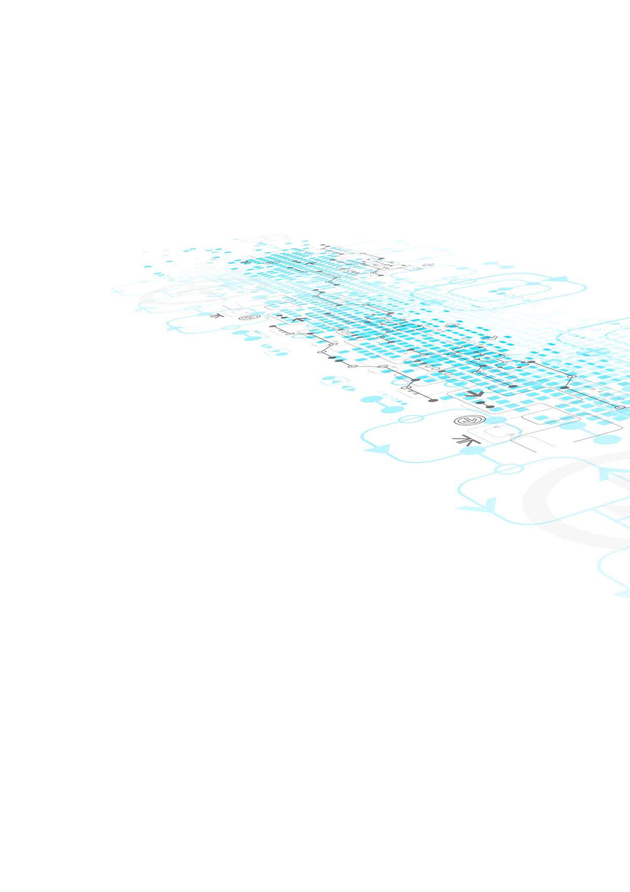

1ST DELIVERABLE

February 11, 2022

Blue Team Members:

Chilka Castro 2030864

Phuong Thanh Nguyen 1934520

Benny Liu 1456415

Ahmad Hawad 2069941

Saqib Ahmad Syed 1974006

Client:

?????

**• Cover Page** including: (6 marks)

• (1 mark) project title,

• (1 mark) date,

• (1 mark) team name,

• (1 mark) names of all team members,

• (1 mark) name of client/sponsor organization, (if available)

• (1 mark) client contact name(s), (if available)

• (2 marks) A statement about using previous work in the deliverable. It is possible that your project will use code and ideas that you developed in another course, or at your place of work. Identify any previous (or concurrent) course project work on which your current project will build. If none, say so.

**• Table of Contents**. (2 marks)

• (5 marks) **Executive Overview**

• **An executive overview (maximum 1 page) summarizes** the major findings of the project to-date and highlights (in words) the elements of the report being submitted. It is more than a table of contents in narrative form. It actually summarizes the contents of the document and contains all the essential information a business executive who does not necessarily have time to read the whole document needs to know to understand the crucial elements of your project at that point. Typically, it is written after the rest of the report is completed.

• (10 marks) **If you have identified a client/sponsor, then:** • Brief description of the client/sponsor and potential user(s) to be served by the proposed system (3 marks). • Include the computer skills and literacy for the client/sponsor and potential user(s) (3 marks). • A description/statement of the business problem to be solved by the implementation project. (4 marks)

**• (22 marks) Brief description of how your team is to be organized:**

• (2 marks) Regular team meetings (when and where, include a sample agenda)

• (1 mark) Online repositories (which ones?) [Github](https://github.com/phgthanhng/SYSDEV-project)

• (2 marks) Communications strategy (how team members are going to communicate with each other, what policies you have established). Discord and Microsoft Teams

• (2 marks) When and how will you meet synchronously?

**• (13 marks) Areas of responsibility (These must change for each deliverable)**

• The team leader for each deliverable will be determined by the instructor

• (6 marks) Client contact (which team member will be the primary client contact for each deliverable, after the first one)

• (7 marks) Reports (who will make sure that the reports are prepared properly, and on time, for each deliverable)

**• (2 marks) Contact information**

• (1 mark) Email addresses for each team member

• (1 mark) Cell or other telephone number for each member

Chilka Castro: [2030864@edu.vaniercollege.qc.ca](mailto:2030864@edu.vaniercollege.qc.ca) | 438-3976747

• **(11 marks) Project Plan,** in the form of a Gantt chart that shows the steps you intend to follow for the remainder of the term, to complete the documentation project, in a timeline designed to meet the due dates for various deliverables. Enter as many detailed activities as you know. This chart and any accompanying description should clearly show for each project step the following items:

• (2 marks) the task name and explanation,

• (2 marks) estimated work time,

• (2 marks) start and completion dates,

• (2 marks) sequence and parallel nature of project steps, and

• (2 marks) resource assignments for each step.

• (1 mark) Include a PDF of the project plan as part of the deliverable.

• (3 marks) Make sure the entire report is correctly spelled and grammatically correct.

• (3 marks) Make sure the entire report is well formatted (appropriate headers and footers, suitable headings and sub-headings, consistent page numbers, etc.)

• (1 mark) Submit one PDF for the entire deliverable