CPE 1150

Lab Number: 1

Basic AC

Measurements

with

Oscilloscope

Team member:

Bruce Liu

2/2/2022

3. OBJECTIVES:

a) use an oscilloscope to determine various parameters of a sine wave,

b) measure phase shift,

c) use a DMM to measure AC voltage.

4. EQUIPMENT:

METEX MS-9150 Generator

DMM

Oscilloscope

Experimenter board

5. COMPONENTS:

1 - 510 Ω ½ watt 5% Resistor

1 - 33 nF Capacitor

6. TEXT REFERENCE:

Circuit Analysis: Theory and Practice (5th Edition):

A.H. Robbins and W.C. Miller

Section 15.4: Frequency, Period, Amplitude and Peak Value

Section 15.6: Voltages and Currents as Functions of Time

Section 15.7: Introduction to Phasors

Section 15.9: Effective (RMS) Values

Section 15.11: AC Voltage and Current Measurement.

Manual Appendix:

Oscilloscope Basic

Conclusion:

The oscilloscope seems to have accuracy in 2 digits after the decimal point. But that is also where the input voltage had a discrepancy as well. So, the source of error is not isolatable.

The oscilloscope measurements also were bouncing in the 0.04V range. I presume this might have been fluctuation from the source voltage from the grid. Since my backup battery at home displays an RMS voltage, and I see that fluctuate between 108-121 V.

I chose to code the sine wave since I wanted to graph that in a hurry. Since that was where my mistake was, I am happy I did it. Since I had an amplitude miscalculation. All I had to do is change a 4 to a 2.

I am uncertain if I chose the right phase shift setting since it turned one wave to a trapezoid wave.

There was a measurement missing so I did that in my home lab. Since the machine is of a different brand. It is easily seen in the pictures.

With the setting on 100 microseconds per division I saw 1 cycle of sine.

Table 5: (measured)

|  |  |  |  |
| --- | --- | --- | --- |
| V­ m­ ­(Volts) | V­ p-p­­­ (Volts) | f (Hz) | T (ms) |
| 2.04 | 4.08 | 1000 | 1.0 |

Table 1: (calculated)

|  |  |  |  |
| --- | --- | --- | --- |
| V­ m­ ­(Volts) | V­ p-p­­­ (Volts) | f (Hz) | T (ms) |
| 2 | 4 | 1000 | 1 |

The values were initially wrong. I realized I got some labels mixed up.

Table 6:

|  |  |  |
| --- | --- | --- |
| Formula with time input | T [μ sec] | V(t)[Volts] range |
| 2 Sin (0) | 0 | -60.00mV |
| 2 Sin (2π * 1000*100*10-6) | 100 | 1.12V |
| 2 Sin (2π * 1000*200*10-6) | 200 | 1.88 V – 1.92V |
| 2 Sin (2π * 1000*300*10-6)  amplitude adjusted off screen | 300 | 1.92 -1.96V |
| 2 Sin (2π * 1000*400*10-6) | 400 | 1.24 V |
| 2 Sin (2π * 1000*500*10-6) | 500 | ­­­40-120 mV |
| 2 Sin (2π * 1000*600*10-6) | 600 | -(1.040 – 1.120) V |
| 2 Sin (2π * 1000*700*10-6) | 700 | -1.840 V |
| 2 Sin (2π * 1000*800*10-6) | 800 | -1.840 V |
| 2 Sin (2π * 1000*900*10-6) | 900 | -(1.160 -1.240) |
| 2 Sin (2π * 1000*1000*10-6) | 1000 | -80.0 mv – 40.0mV |

Table 2:

|  |  |  |
| --- | --- | --- |
| Formula with time input | T [μ sec] | V(t)[Volts] |
| 2 Sin (0) | 0 | 0.0 |
| 2 Sin (2π * 1000*100*10-6) | 100 | 1.175 |
| 2 Sin (2π * 1000*200*10-6) | 200 | 1.902 |
| 2 Sin (2π * 1000*300*10-6) | 300 | 1.902 |
| 2 Sin (2π * 1000*400*10-6) | 400 | 1.175 |
| 2 Sin (2π * 1000*500*10-6) | 500 | 2.449*10-16 |
| 2 Sin (2π * 1000*600*10-6) | 600 | -1.175 |
| 2 Sin (2π * 1000*700*10-6) | 700 | -1.902 |
| 2 Sin (2π * 1000*800*10-6) | 800 | -1.902 |
| 2 Sin (2π * 1000*900*10-6) | 900 | -1.175 |
| 2 Sin (2π * 1000*1000*10-6) | 1000 | -4.898*10-16 |

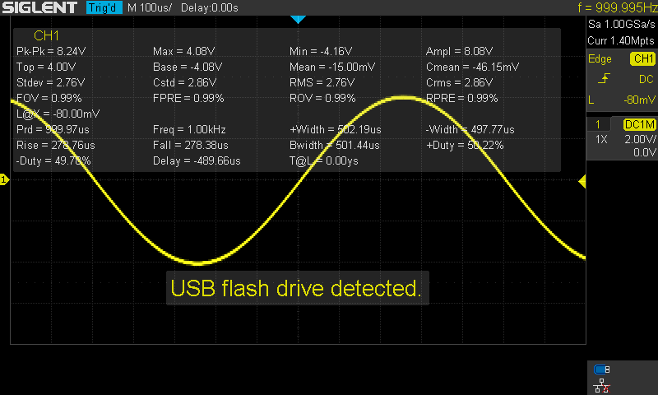

Table 3:

|  |  |
| --- | --- |
| Time base setting | # of cycles |
| 100 µsec / div | 1/10 |
| 200 µsec / div | 1/5 |

The number of cycles match what was predicted.

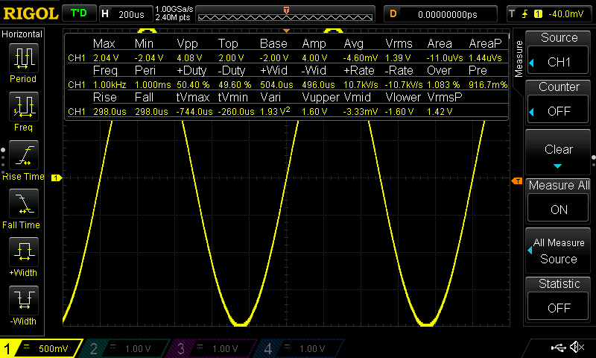

Table 5:

|  |  |  |  |
| --- | --- | --- | --- |
| V­ m­ ­(Volts) | V­ p-p­­­ (Volts) | f (Hz) | T (ms) |
| 2.04 | 4.08 | 1000 | 1.0 |

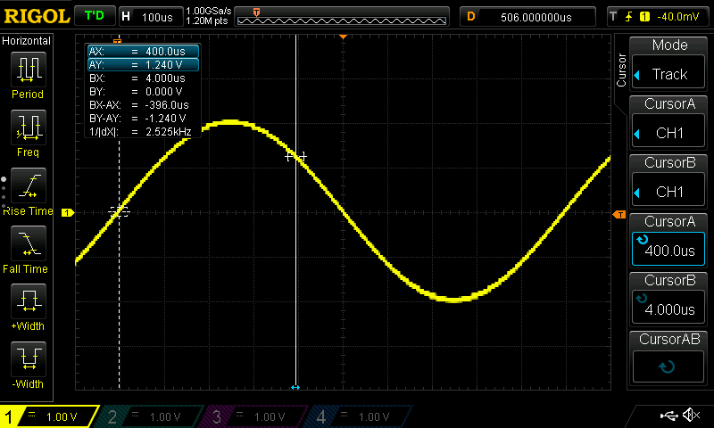

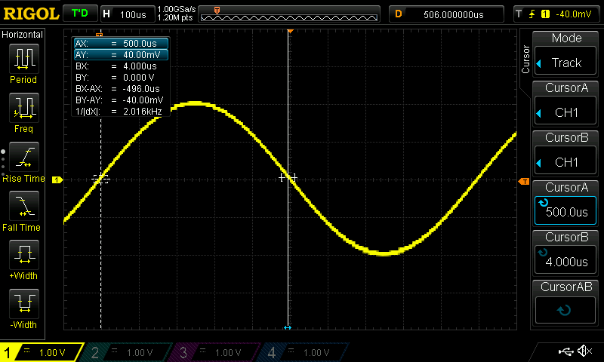

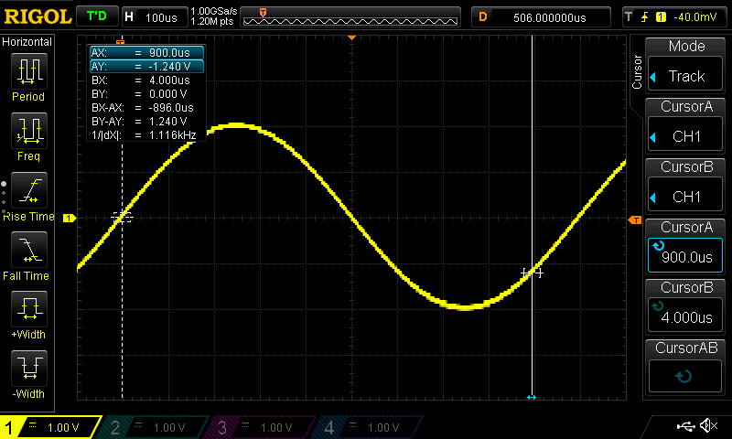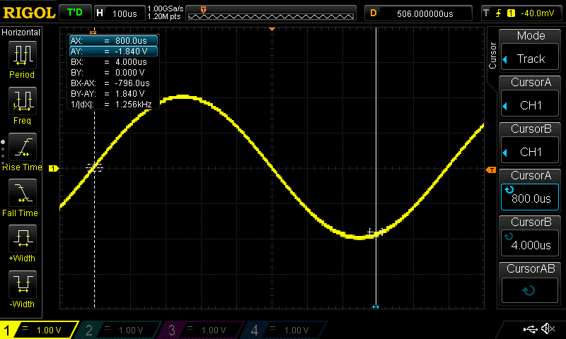



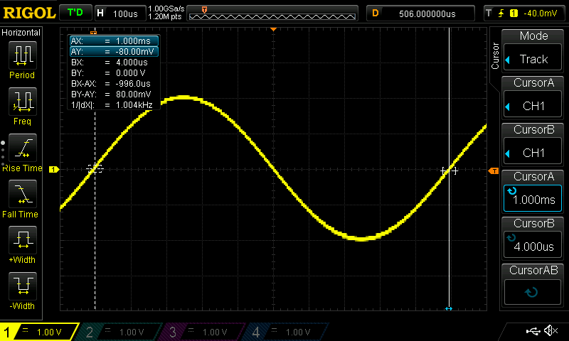

Table 6:

|  |  |  |
| --- | --- | --- |
| Formula with time input | T [μ sec] | V(t)[Volts] |
| 2 Sin (0) | 0 | -60.00mV |
| 2 Sin (2π * 1000*100*10-6) | 100 | 1.12V |
| 2 Sin (2π * 1000*200*10-6) | 200 | 1.88 V – 1.92V |
| 2 Sin (2π * 1000*300*10-6)  amplitude adjusted off screen | 300 | 1.92 -1.96V |
| 2 Sin (2π * 1000*400*10-6) | 400 | 1.24 V |
| 2 Sin (2π * 1000*500*10-6) | 500 | ­­­40-120 mV |
| 2 Sin (2π * 1000*600*10-6) | 600 | -(1.040 – 1.120 ) V |
| 2 Sin (2π * 1000*700*10-6) | 700 | -1.840 V |
| 2 Sin (2π * 1000*800*10-6) | 800 | -1.840 V |
| 2 Sin (2π * 1000*900*10-6) | 900 | -(1.160 -1.240) |
| 2 Sin (2π * 1000*1000*10-6) | 1000 | -80.0 mv – 40.0mV |

Part B

Initial values table

|  |  |  |
| --- | --- | --- |
| Label | Intended values | Measured values |
| Sine Voltage peak to peack | 4V | 4.08V |
| Internal resistance (R1) | 50Ω assumed | 0.384 M ohm |

Vp-p = 2* Vp

Vp-p = 6

Initial values table

|  |  |  |
| --- | --- | --- |
| Label | Intended values | Measured values |
| Sine Voltage peak | 3V | 3V |
| Internal resistance (R1) | 50Ω assumed | 0.384 M ohm |
| Resistor (R2) | 510Ω | 504.40 |
| Capacitor (C1) | 33nF | 32.8 nF |

Channel 1 leads channel 2

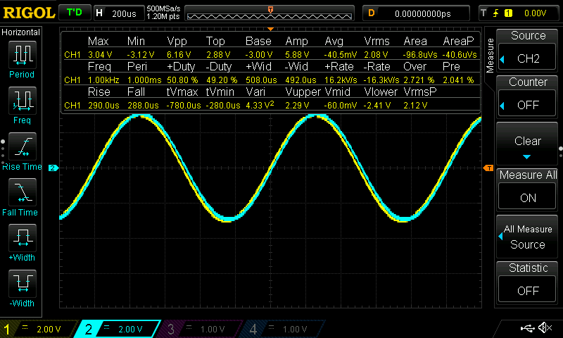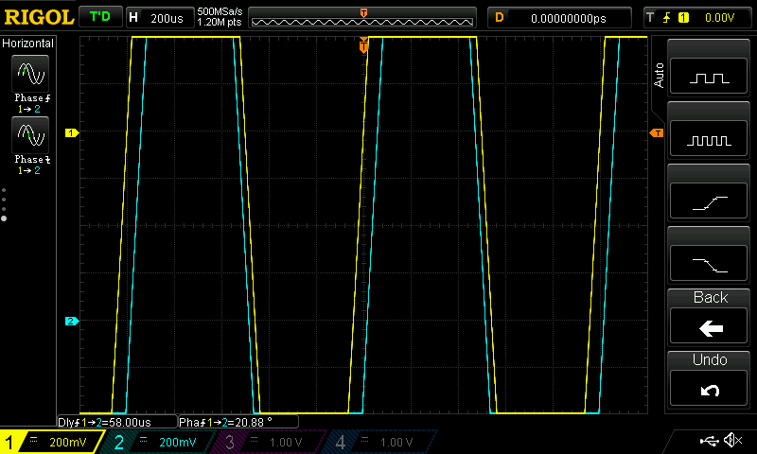

phase shift verification

58.00 *10­­­­­­-6 seconds = T

1/T = f

2πf = ω

ω = 6283.1853 rads

tan­-1(ω t) = 19.384 degrees

part C:

Initial values table

|  |  |  |
| --- | --- | --- |
| Label | Intended values | Measured values |
| Sine Voltage peak to peack | 4V | 4.08V |
| Internal resistance (R1) | 50Ω assumed | 0.384 M ohm |
| Resistor (R2) | 510Ω | 504.40 |
| Capacitor (C1) | 33nF | 32.8 nF1 |

Measurements:

Voltage verification: oscilloscope vs digital multimeter:

Table 7:

|  |  |  |  |  |
| --- | --- | --- | --- | --- |
| Frequency (kHz)  “Inputted” | Frequency (kHz)  “Measured “ | Oscilloscope (V peak)  “Measured” | Oscilloscope (V rms)  “Calculated” | Digital multimeter (V rms)  “Measured” |
| 5 | 5.0 | 2.64 | 1.866 | 1.837 |
| 10 | 10.0 | 1.98 | 1.400 | 1.40068 |
| 100 | 15.0 | 1.52 | 1.074 | 1.0115 |

V­p­ / √2­ = V­rms­

Image proof:

Circuit:

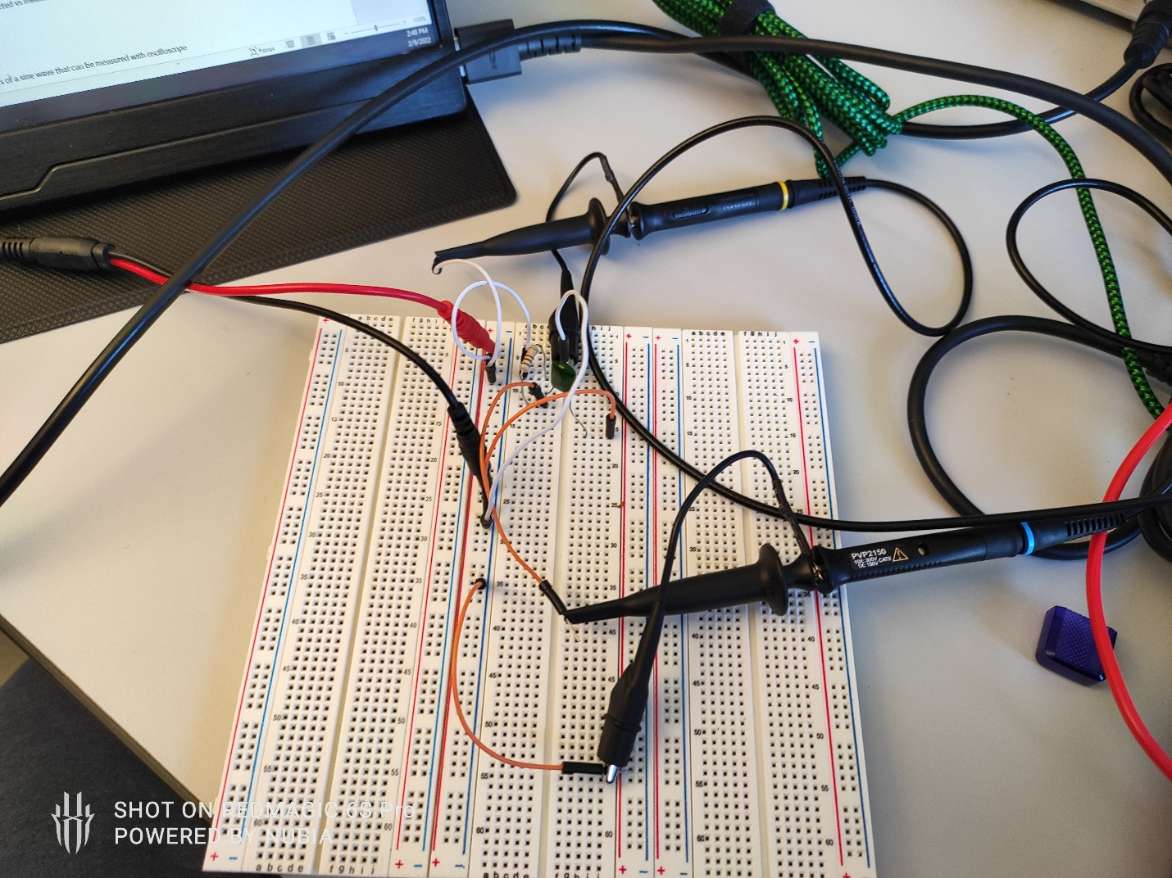

Appendix Prelab:

Table 1:

|  |  |  |  |
| --- | --- | --- | --- |
| V­ m­ ­(Volts) | V­ p-p­­­ (Volts) | f (Hz) | T (ms) |
| 2 | 4 | 1000 | 1 |

Table 2:

|  |  |  |
| --- | --- | --- |
| Formula with time input | T [μ sec] | V(t)[Volts] |
| 2 Sin (0) | 0 | 0.0 |
| 2 Sin (2π * 1000*100*10-6) | 100 | 1.175 |
| 2 Sin (2π * 1000*200*10-6) | 200 | 1.902 |
| 2 Sin (2π * 1000*300*10-6) | 300 | 1.902 |
| 2 Sin (2π * 1000*400*10-6) | 400 | 1.175 |
| 2 Sin (2π * 1000*500*10-6) | 500 | 2.449*10-16 |
| 2 Sin (2π * 1000*600*10-6) | 600 | -1.175 |
| 2 Sin (2π * 1000*700*10-6) | 700 | -1.902 |
| 2 Sin (2π * 1000*800*10-6) | 800 | -1.902 |
| 2 Sin (2π * 1000*900*10-6) | 900 | -1.175 |
| 2 dSin (2π * 1000*1000*10-6) | 1000 | -4.898*10-16 |

Sine Graph plot:

Table 3:

|  |  |
| --- | --- |
| Time base setting | # of cycles |
| 100 µsec / div | 1/10 |
| 200 µsec / div | 1/5 |

Table 4:

Phase shift

ω = 2 π f

f = 1/T

sin (2π ω t+ tan­-1(ω t))

Python code “for prelab calculations” (compiled with anaconda PowerShell and atom text editor):

Run with command in the folder in the same directory as python file with “python main.py”.

Main.py

from CPE_1150_lab_1_Bruce_Liu import Lab_1_CPE_1150

def main():

sine = Lab_1_CPE_1150()

sine.sine_compute()

sine.value_read()

sine.sine_graph()

if __name__ == '__main__':

main()

CPE_1150_lab_1_Bruce_Liu.py

import matplotlib.pyplot as sine_plot

import math

class Lab_1_CPE_1150():

def __init__(self):

self.time_increment = 100* 10**-6

self.peak_voltage = 2.0

self.omega = 2.0 * math.pi * 1000

self.sine_voltage_values = []

self.time_increment_history = []

self.sine_voltage_values_temp = 0.0

def sine_compute(self):

for count in range(0 ,11 ,1):

self.time_increment_history.append(self.time_increment * count)

self.sine_voltage_values_temp = self.peak_voltage * math.sin(self.omega * (self.time_increment * count))

self.sine_voltage_values.append(self.sine_voltage_values_temp)

def sine_graph(self):

sine_plot.plot(self.time_increment_history, self.sine_voltage_values)

sine_plot.suptitle("sine plot")

sine_plot.xlabel("Time in seconds")

sine_plot.ylabel("Voltage")

sine_plot.show()

def value_read(self):

print(self.sine_voltage_values)

print("\n\n")